17 March 2020

Works reminder: Newport Rail Bridge hydro-blasting works
Work is continuing to widen the Newport Rail Bridge. The next stage of these works includes some noisy night works.

March – August 2020
Construction is well underway to widen Newport Rail Bridge. This stage of works will continue until August 2020. Future works are currently programmed for late 2021 and mid-2022.
The current works include:
- removing barriers from the freeway centre median
- installing bridge beams
- replacing bridge bearings
- removing concrete on the bridge edges using a high-pressure water (hydro-blasting), and
- pouring concrete to form the new bridge deck.

Hydro-blasting
From 24 March until late April 2020
Hydro-blasting is noisy work. It uses very high-pressure water to remove concrete on the edges of the existing bridges to expose the internal steel reinforcing bars. The exposed steel bars are then connected to the new beams as part of bridge widening.
Hydro-blasting must be done at night because the machine needs to be set up on the freeway, requiring lane closures. Also, it creates falling water, which means the rail line needs to be closed. The water and concrete debris will be collected and disposed of safely offsite. There will be traffic management in place on The Avenue during these works. Access to properties and sporting clubs will be maintained at all times.
Hydro-blasting is scheduled to get underway on Friday 20 March. We expect the work to be finished in late April. The works will take place from Sunday to Thursday nights, usually from 9:30pm to 4:30am each night. There will be another week of work in June, but we will let you know about this extra work closer to the time.
The nature of the noise created by hydro-blasting means it is likely that it will be heard across a wide
area of the community. The direction the noise will travel will be affected by factors such as wind.

Creating the new bridge deck and piers April – October 2020
Once most of the hydro-blasting is finished, reinforcing steel will be added to the new bridge deck area and concrete will be poured on top followed by asphalt. This work is programmed to be completed by the end of June.
Two new piers for the new carriageway will then be constructed. This work is estimated to take four months and will require traffic management on The Avenue. Again, we will provide more details to nearby community closer to the time.

WES2001.06 (R)

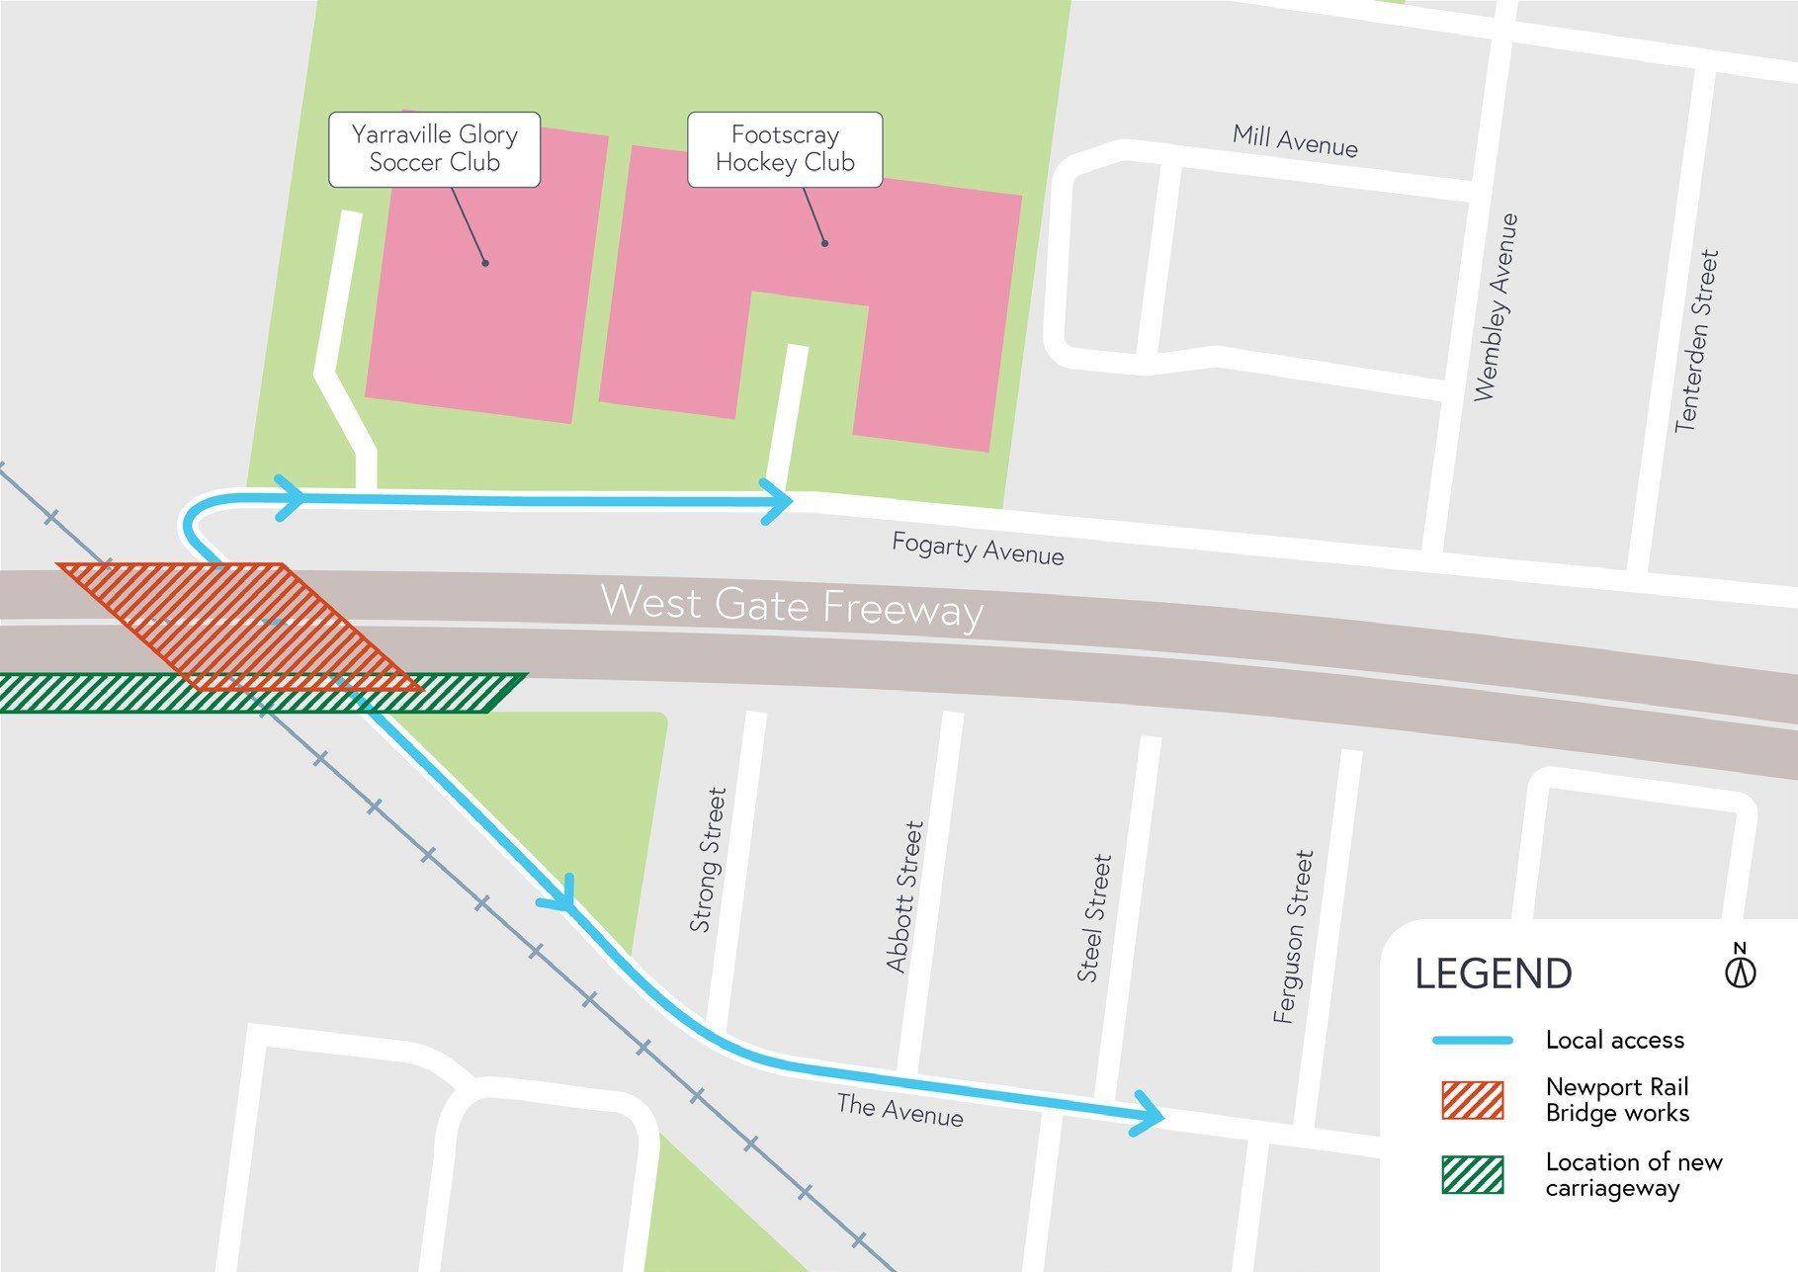
Map of works

What to expect during these works:
- noise at night from high pressure water jets
- additional lighting on the freeway and The Avenue
- traffic management on The Avenue, local access will be maintained to sporting clubs and properties
- construction vehicles will be moving in and out of work areas via our access routes
- increase in construction vehicles using designated routes, including local roads, within residential areas
- traffic changes will be in place. The latest traffic updates are available at
westgatetunnelproject.vic.gov.au/disruptions.
Please note that works are subject to change and could be rescheduled in the event of unexpected impacts to the construction program.
If you have any questions about these night works or want to get in touch with the project team, please contact our 24-hour hotline on 1800 105 105.

Thank you for your patience during these works.

westgatetunnelproject.vic.gov.au info@wgta.vic.gov.au
1800 105 105
West Gate Tunnel Project Info Centre Corner of Somerville Rd and Whitehall St Yarraville VIC 3013

Follow us on social media Please contact us if you would like this
information in an accessible format.

Translation service – For languages other than English, please call 13 14 50.

Authorised by the Victorian Government, 1 Treasury Place, Melbourne

