17 February 2020

Works notification: Strong Street, Spotswood

As part of the West Gate Tunnel Project, we are diverting a large water main pipe that runs under the West Gate Freeway between the Footscray Hockey Club and Strong Street. These works were previously scheduled to start in October 2019.
We will soon begin using specialist equipment to dig and build the new water main pipe under the freeway.

A summary of the works and what you can expect are outlined below.

Water main diversion - end of Strong Street
24 February to late May

These works will be completed during the day and include:

Strong Street waste collection changes
Strong Street residents should place are asked to place their bins on the east side of the court during these works.
All waste collection services have advised that they will reverse their trucks into the street from 24 February until late May.
Please see map over the page.
- Site establishment at the end of Strong Street

- Excavating a section of the road within the construction site, which will include rock breaking

- Retrieving specialist equipment that will dig and build the new water
main under the freeway from the excavated area

- Connecting the new water main pipe to the existing City West Water pipe

- Reinstating the road.

What to expect on Strong Street during these works

- The end of Strong Street will be closed to vehicle access, with pedestrian access still maintained to all properties

- Emergency services vehicles will have access to Strong Street at all times

- Noise from our works during the day from 7am, including breaking rock

- Construction vehicles will gain access from adjacent construction sites to Strong Street. However, intermittent access from Strong Street may be required

- Water spray trucks and street sweepers will be used to manage dust and dirt during the works

- Trucks removing dirt and rock from the site will be covered

- The construction site will be monitored as part of ongoing security across the project area.

Location of works
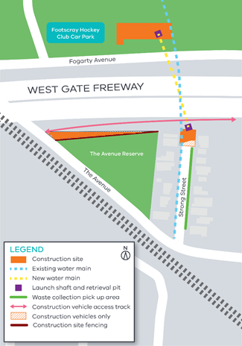

Works will be carried out from Monday to Friday 7am-6pm and Saturday 7am-1pm.
If works are scheduled out of hours, we will provide further information to you before works start.
Please note that works may be rescheduled in the event of bad weather or other unavoidable circumstances.
We thank you for your patience while we are undertaking these critical works.

