6 January 2020 WES2001.05

Works notification: Fogarty Avenue

Construction is continuing along Fogarty Avenue to install new drainage. The drainage improvements are required to protect Stony Creek from any spills from the freeway and also manage run-off from the widened West Gate Freeway.
Works will start Monday 13 January 2020. As part of these works, vehicle access to your driveway will be temporarily unavailable, from Monday 20 January 2020.

Temporary disruption to your driveway access
From Monday 20 January to early March 2020

During this time:
- Fogarty Avenue will be closed between the Muir Street walking and cycling bridge and 216 Fogarty Avenue, while we excavate a trench down the road to install the new drain
- Vehicle access to your driveway will be temporarily blocked, and parking along the closed section of Fogarty Avenue will be temporarily unavailable
- Footpath access to your property will remain.
When you need to move your vehicle:
- Please ensure your vehicle is moved out of your driveway before 7am on the morning of the closure, Monday 20 January 2020.
Where to park your vehicle:
- We recommend you park your vehicle further west along Fogarty Avenue or in the Footscray Hockey Club car park.

Waste collection:
- Please place rubbish bins in the skip bins provided, from week commencing Monday 13 January 2020.
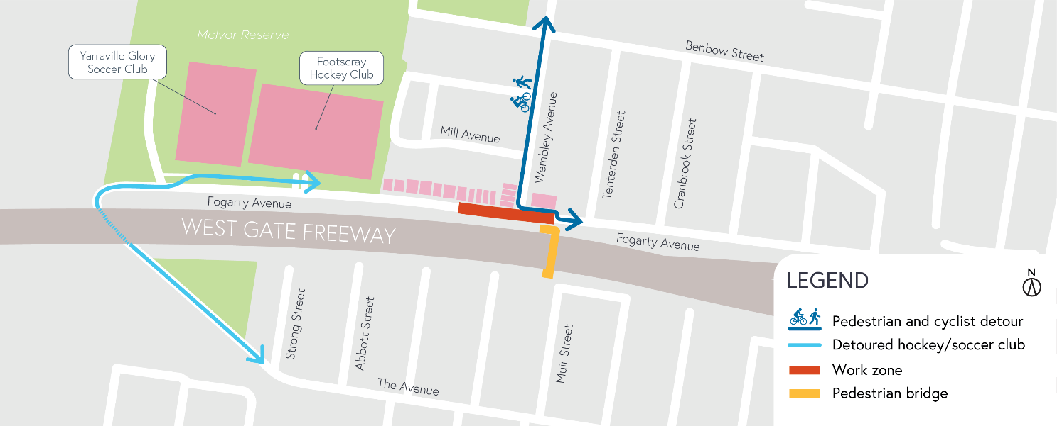
See map of works below

What to expect along Fogarty Avenue during these works:
- an increase in noise from our works during the day including rock breaking activities
- equipment used for these works include excavators, jack hammers, compaction equipment and road saw
- increase in trucks and vehicles entering and exiting our construction site
- intermittent localised vibration from our construction site
- water spray trucks and street sweepers will be used to manage dust and dirt and trucks carrying dirt and rock will be covered
- the construction site will be monitored as part of ongoing security across the project area; and
- traffic changes will be required and signed detours will be in place – latest traffic updates are available at westgatetunnelproject.vic.gov.au/disruptions.
Apologies
We know that the works along Fogarty Avenue have been disruptive and appreciate the patience you have had with us. Once we complete these drainage works, we will be able to continue with completing installation of new noise walls, building the Federation Trail extension and new planting.
While this will mean ongoing traffic impacts in this area, we will endeavour to increase and improve our communication with you and your neighbours, and in the coming week we will be in contact to provide you with opportunities to get a better understanding of what is happening in your neighbourhood, both in the short and long-term.

These works will generally be carried out from Monday to Friday between 7am - 6pm and Saturdays between 7am - 1pm. If there are out of hours works required, advance notice will be provided to directly impacted properties.

Please note that works are subject to change and may be rescheduled in the event of unexpected impacts to the construction program. Thank you for your patience during these works.

