3 August 2020 WES2008.01

Works notification: Dohertys Road
Hello from the new team in the area.
As part of the West Gate Tunnel Project, we will soon begin relocating a watermain along Dohertys Road. We will take over the same area (between Gordon Luck Avenue and Greives Parade) previously occupied by the Western Roads Upgrade project who have recently completed works.
Below is a summary of what you can expect to see in the Dohertys Road area over the coming months.

Relocating a water main along Dohertys Road

Mid August 2020 – mid April 2021
We need to relocate a water main along Dohertys Road as part of the upgrade to the M80 interchange.

The works will take place within an existing work site that currently occupies the north side of Dohertys Road.

These works will include:
- excavating a trench for the new watermain
- installing a new watermain along the north side of Dohertys Road
- removing vegetation on the eastern corner of the Dohertys Road / Grieve Parade intersection
- relocation of two bus stops along Dohertys Road
- closure of Moore Drive from Dohertys Road – a detour will be in place via Whittaker Drive
- night works requiring lane and road closures

New water pipe connection for Altona Memorial Park

Mid November 2020 – mid February 2021
As a result of the watermain relocation outlined above, we need to provide a new water supply into Altona Memorial Park. This will require the construction of a bore beneath Dohertys Road connecting the watermain from the south side of Dohertys Road to the north side.
These works will include:
- setting up a small work site with temporary fencing on the south side of Dohertys Road
- constructing a channel underneath Dohertys Road
- installing a new water pipe connection underneath Dohertys Road.

Subscribe for work and traffic updates
Traffic management will in place on Dohertys Road until April 2021. If you could like to sign up to receive weekly traffic updates or dedicated work updates, please email us on info@wgta.vic.gov.au or call 1800 105 105.

Location of works:

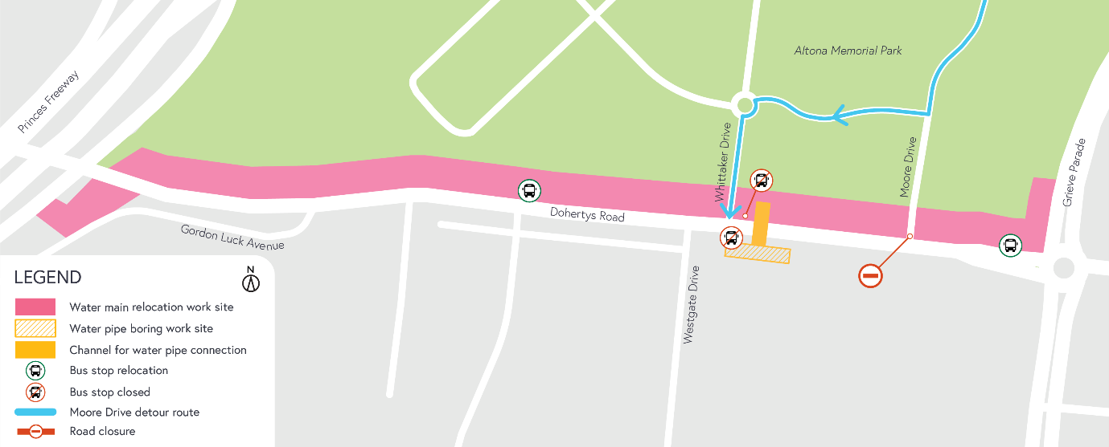

What to expect during these works:
- work will be completed behind safety traffic barriers
- increased noise from our works during the day, including rock-breaking activities
- construction vehicles including excavators, rollers, water trucks and concrete trucks will be moving in and out of the work areas via our access routes
- construction noise from work activities including machinery and trucks and intermittent localised vibration may be experienced
- water spray trucks and road sweepers will be used to manage dust and dirt during works. Trucks removing dirt and rock from the site will be covered
- traffic changes including lane and road closures will be required. Signed detours will be in place.

For the latest updates visit westgatetunnelproject.vic.gov.au/traveldisruptions

Hours of work

Our usual hours of work are Monday to Friday between 7am-6pm, and Saturdays between 7am-1pm. However, night works are sometimes required. When works are scheduled out of hours, or if you are located close to the works, we will provide you with further information before the works start.

Coronavirus COVID-19 update
The health and safety of our workers is our key priority as we continue to deliver the West Gate Tunnel Project, as is supporting social distancing and the wearing of masks in line with current health advice. We have strict protocols in place to protect the safety of our construction workforce and the community. These include enhanced industrial cleaning arrangements, and measures to reduce staff contact, including staggered shifts and physical distancing. For more information and advice about Coronavirus, please visit coronavirus.vic.gov.au.

Please note that works sometimes need to be rescheduled in the event of bad weather or other unavoidable circumstances.

For updates and more information about our works, please visit westgatetunnelproject.vic.gov.au or call us on 1800 105 105.

