EAS1806.03

6 July 2018

Works Reminder: Building demolition – 33 Maribyrnong Street, Footscray.
Building demolition and site establishment works at 33 Maribyrnong Street will be starting from early July 2018 and scheduled to take up to three months. This will the support construction of new bridges over the Maribyrnong River and will involve:
- removing the existing building at 33 Maribyrnong Street, using hand tools and excavators
- removing an electrical substation located within 33 Maribyrnong Street
- vegetation removal around the building and site
- removal of parking for demolition works on Maribyrnong Street
- setting up our facilities, including sheds and offices
- accessing the site from Youell Street

Managing construction
Construction will be actively managed to minimise disruption as much as possible, including:
- clear signage and traffic controllers to direct traffic
- working with residents and businesses to minimise local impacts
- providing regular updates about our works
- monitoring and altering conditions as needed to maintain traffic flow, access and safety
- managing any environmental impacts such as dust
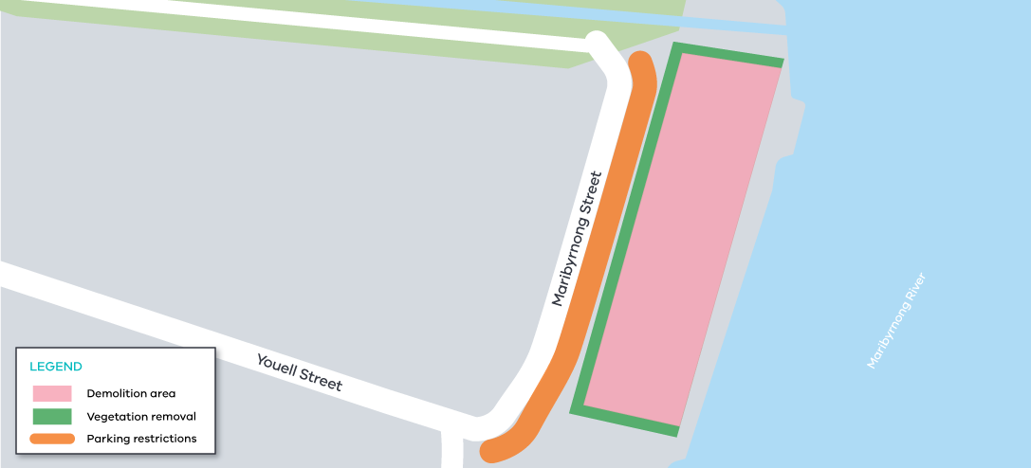
Maribyrnong Street works area

Keeping you moving

We know construction can be disruptive, so we will be actively managing activities in the area to minimise this disruption as much as possible. This management includes:

- clear signage and traffic controllers to direct traffic

- working with residents and businesses to minimise local impacts

- providing regular updates about our works

- monitoring and altering conditions as needed to maintain traffic flow, access and safety

- increasing monitoring and support for enforcement of truck curfews and local destination exemptions.

Please note that works may be rescheduled in the event of bad weather or other unavoidable circumstances.

For updates and more information about our works please visit westgatetunnel.vic.gov.au or contact us using the details below.

Contact us
Please contact us if you have any questions or feedback about these works.

 | westgatetunnelproject.vic.gov.au |  | facebook.com/westgatetunnelproject
 | westgatetunnelproject@wda.vic.gov.au |  | @westgatetunnel
 | 1800 105 105 |  | West Gate Tunnel Project  GPO Box 4509  Melbourne Victoria 3001
 | Interpreter service: 13 14 50

