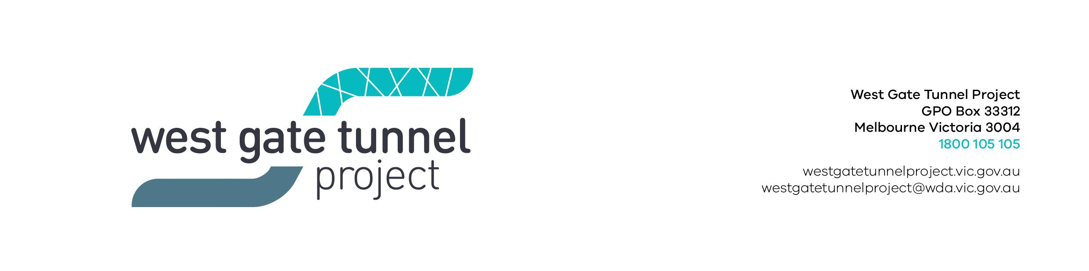

Reference: EAS1804.002

16 April 2018

        - WORKS NOTIFICATION: SITE INVESTIGATIONS AND BUILDING DEMOLITION

Site investigations – Maribyrnong Street, between Footscray Road and Youell Street, Footscray

Late April 2018 – August 2018

Before construction can start on the new bridges over the Maribyrnong River, investigation works are needed to identify utility services in the area and better understand ground conditions along the Maribyrnong River.

Investigation work will include:
- electronic scanning of roads and footpaths
- non-destructive digging to identify underground services such as gas and water
- drilling bore holes up to 40 metres in depth

During these works you may notice more activity in the area, including trucks and traffic management.

Building demolition – 33 Maribyrnong Street, Footscray

June 2018 – August 2018

We will also be setting up a work site to support construction of new bridges over the Maribyrnong River. This will involve:
- removing the existing building at 33 Maribyrnong Street, using hand tools and excavators
- setting up our facilities, including sheds and offices
- accessing the site from Youell Street

This work will take up to four weeks to complete.
Managing construction

Construction will be actively managed to minimise disruption as much as possible, including:

- clear signage and traffic controllers to direct traffic

- working with residents and businesses to minimise local impacts

- providing regular updates about our works

- monitoring and altering conditions as needed to maintain traffic flow, access and safety
- managing any environmental impacts such as dust

Location of works on Maribyrnong Street

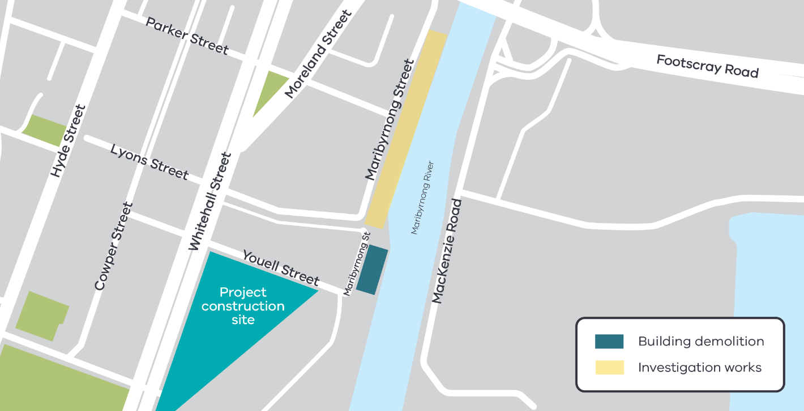

Please note that works may be rescheduled in the event of bad weather or other unavoidable circumstances.

For updates and more information about our works please visit westgatetunnel.vic.gov.au or contact us using the details below.

Contact us
Please contact us if you have any questions or feedback about these works.

 | westgatetunnelproject.vic.gov.au |  | facebook.com/westgatetunnelproject
 | westgatetunnelproject@wda.vic.gov.au |  | @westgatetunnel
 | 1800 105 105 |  | West Gate Tunnel Project  GPO Box 4509  Melbourne Victoria 3001
 | Interpreter service: 13 14 50

