Chapter 3
Description of the action
September 2019

Chapter 3

Description of the action

Introduction
The PER Guidelines require a detailed description of all construction and operational components of the action, including the location of all works to be undertaken, structures to be built and elements of the action that may impact MNES. This chapter includes:
- A description of the action and its construction and operational components
- The location of the works to be undertaken, structures to be built and those elements that may impact MNES
- Information on how the works are proposed to be undertaken, including stages of development and their timing, and the design parameters for those structures and elements that may impact MNES.
The action described in this chapter is based on a ‘reference project’ developed by the North East Link Project (NELP). This represents one feasible means by which the action could be developed within the EPBC boundary (as defined below) to achieve North East Link objectives and environmental outcomes set by the Environmental Performance Requirements (EPRs). For reference, the EES Chapter 27 Environmental Management Framework, which includes the list of recommended EPRs is included in Attachment III. The design of North East Link would be further refined and developed by the contractor appointed by the Victorian Government. However, any modifications to the reference project would need to be consistent with North East Link objectives, meet the EPRs as finalised by the Victorian Minister for Planning, and fall within the EPBC boundary for the action.
Throughout this PER, specific terminology is used to describe the location of the works that form the action:
- The EPBC boundary – the area the action would take place within, based on conservative assumptions made at the time of the referral variation (see ‘Request to accept a Variation of a proposal (EPBC 2018/8142) pursuant to section 156A of the EPBC Act’ dated 30 May 2018 (NELA, 2018)
- The project boundary – the project boundary is contained within the EPBC boundary and defines the maximum extent of the construction impacts of the reference project
- The action on Commonwealth land – this part of the action is defined to assess the impacts relating to Commonwealth land (under sections 26 and 27A of the EPBC Act). The affected Commonwealth land is at Simpson Barracks in Watsonia (including an unfenced area immediately to its south) and a small strip of land to the rear of properties on Elder Street at Watsonia (see Section 3.2.9 of this chapter for further detail). The PER Guidelines refer to a zone within 500 metres of the disturbance footprint as a basis for scoping impacts of the action on Commonwealth land. Further information is provided in Chapter 6 – Impact assessment. Following the transfer of land from Commonwealth to State ownership as discussed in Section 3.2.8, the construction and operation of North East Link would not take place on Commonwealth land.

Description of the action and location of works
This section describes the action to be undertaken and the location of the works to be developed. It includes a discussion of the structures to be built and elements of North East Link which may impact MNES. Sections 3.3, 3.4 and 3.5 describe in more detail the construction and operational components of North East Link.
An overview of North East Link is shown in Figure 3-1. The extent of the action on Commonwealth land is shown in Figure 3-2 and Figure 3-3.
The coordinates for the EPBC boundary and the reference project boundary are provided in PER Appendix E – Project boundary and EPBC boundary coordinates.
As noted in Section 3.1 above, the reference project represents one possible design of North East Link. The design features of the reference project have been used to help define and assess the potential impacts of the action. The design features outlined in the following section are therefore subject to change.
North East Link can be divided into three key elements:
- M80 Ring Road (otherwise known as the Metropolitan Ring Road) to the northern portal – from the M80 Ring Road at Plenty Road, and the Greensborough Bypass at Plenty River Drive, North East Link would extend to the northern portal near Blamey Road utilising a mixture of above, below and at surface road sections. This would include new road interchanges at M80 Ring Road and Grimshaw Street
- Northern portal to southern portal – from the northern portal the road would transition into twin tunnels that would connect to Lower Plenty Road via a new interchange, before travelling under residential areas, Banyule Flats and the Yarra River to a new interchange at Manningham Road. The tunnels would then continue to the southern portal located south of the Veneto Club
- Eastern Freeway – from around Hoddle Street in the west through to Springvale Road in the east, modifications to the Eastern Freeway would include widening to accommodate future traffic volumes and new dedicated bus lanes for the Doncaster Busway. There would also be a new interchange at Bulleen Road to connect North East Link to the Eastern Freeway.

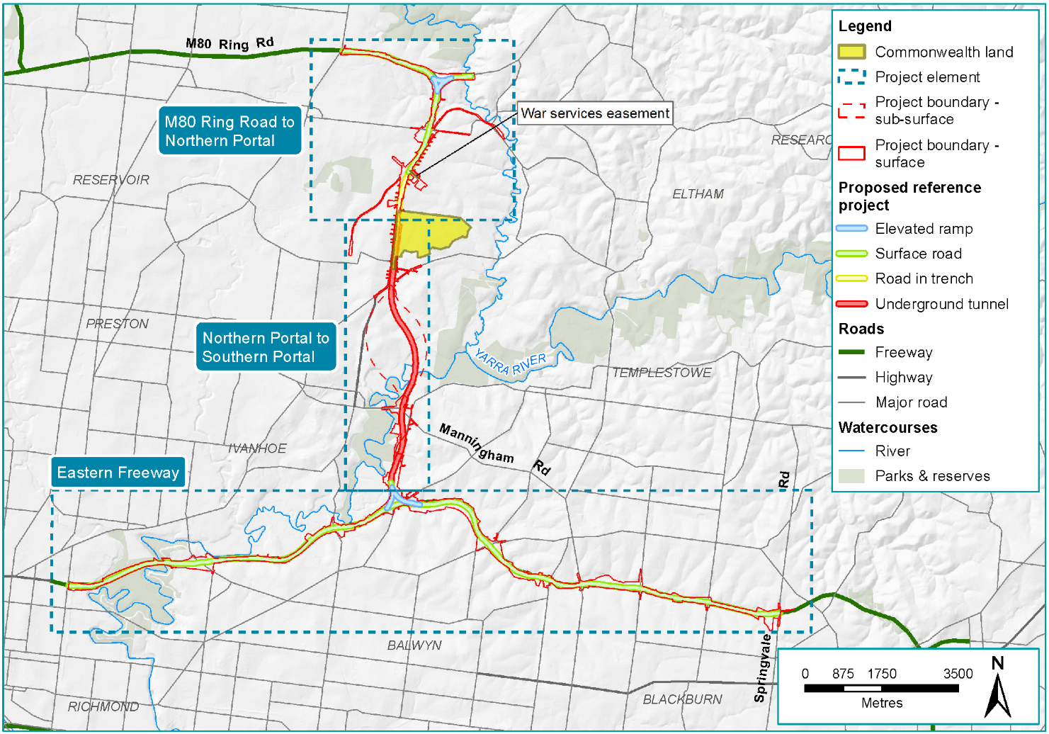
Figure 3-1 Overview of North East Link
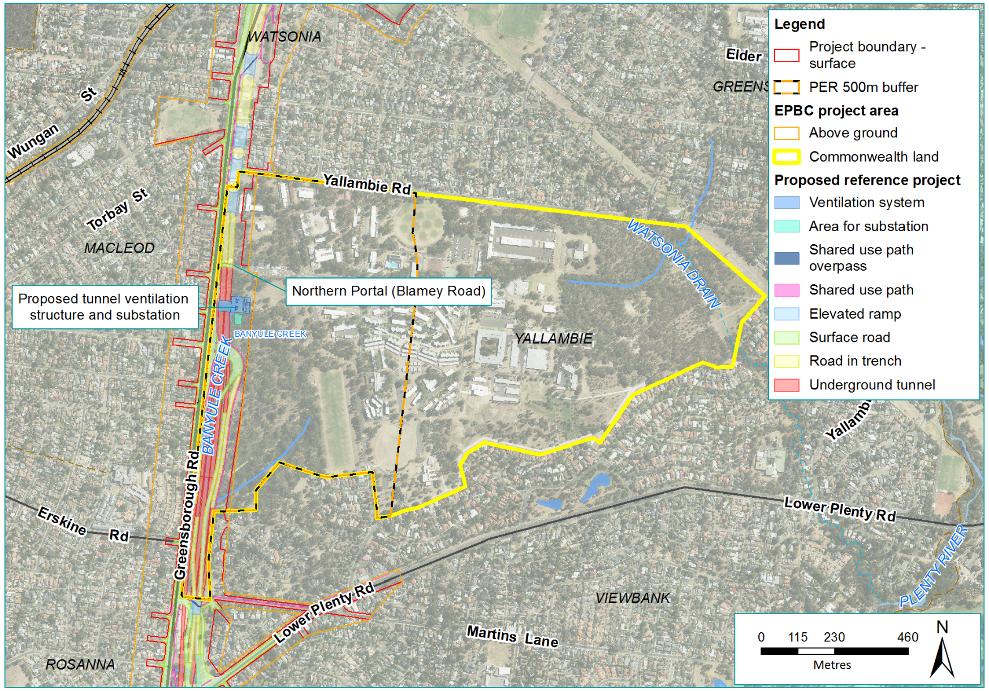
Figure 3-2 Overview of the action at Simpson Barracks
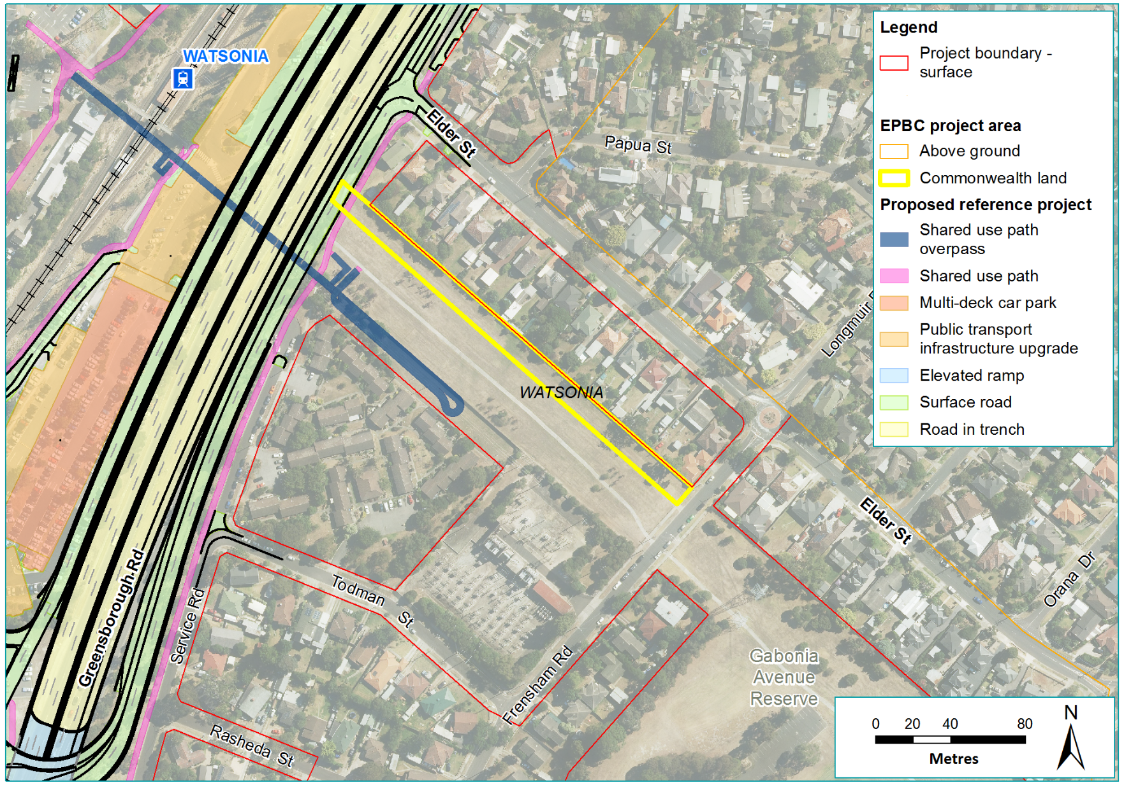
Figure 3-3 Overview of the action at War Services Easement

M80 Ring Road to the northern portal
The design of the M80 Ring Road to the northern portal element of North East Link is shown in Figure 3-4. This element would include:
- New and upgraded road sections
- New land bridges over the new road where it is in a trench
- New interchanges
- Upgrade of the Watsonia railway station car park and extension of the current Hurstbridge rail underpass
- Noise walls to mitigate noise in residential areas
- New and modified walking and cycling paths
- Changes to waterways and drainage features
- Alterations to utilities.
Key design elements of the M80 Ring Road to the northern portal element are summarised in Table 3-1.
Table 3-1 M80 Ring Road to northern portal key design elements
Key design elements | Description
Horizontal alignment and vertical alignment
M80 Ring Road interchange to Grimshaw Street interchange | A new interchange to connect North East Link to M80 Ring Road and Greensborough Bypass would include road widening, grade separation and additional capacity to existing interchanges. At this location North East Link would be at surface, with some elevated structures.
Grimshaw Street interchange to Watsonia railway station | A new interchange to connect North East Link to Grimshaw Street and maintain east-west traffic on Grimshaw Street with a bridge over North East Link would include widening, grade separation and additional capacity to existing interchanges. From this point southwards, North East Link would start its descent below ground.
Watsonia railway station to northern portal | North East Link carriageways would be in a trench adjacent to the Watsonia railway station car park until the northern portal in the vicinity of Blamey Road. Existing roads would be modified and grade separated from North East Link. Greensborough Road would maintain existing local connections. Vegetated land bridges would provide public open space and shared use paths over North East Link.
Land bridges
The reference project includes five land bridges between Grimshaw Street and Lower Plenty Road comprising approximately 8,500 m² of public open space between West Mayling Reserve and Winsor Reserve. The land bridges would provide unimpeded access for pedestrians and cyclists across North East Link as well as informal parkland for recreation.
Waterway modifications
Yando Street Main Drain, Kempston Street Main Drain and Watsonia Station Drain | Waterway crossings where works would occur include:  - Yando Street Main Drain – beneath Greensborough Bypass  - Kempston Street Main Drain – beneath Greensborough Bypass just north of Grimshaw Street  - Watsonia Station Drain – beneath Greensborough Bypass at Watsonia railway station.
Banyule Creek | Banyule Creek would be realigned from near its origins within Simpson Barracks through to Lower Plenty Road. South of Lower Plenty Road, the existing Banyule Creek would not be modified. For more detail see Section 3.2.9.
Location of shared use paths and crossings
Walking and cycling network improvements are proposed in conjunction with the construction of North East Link to improve connectivity and safety for pedestrians and cyclists. They would be designed to be no less than 3 m wide. Figure 3-5 shows the location of the improved shared use paths, including grade-separated crossings over or under North East Link.

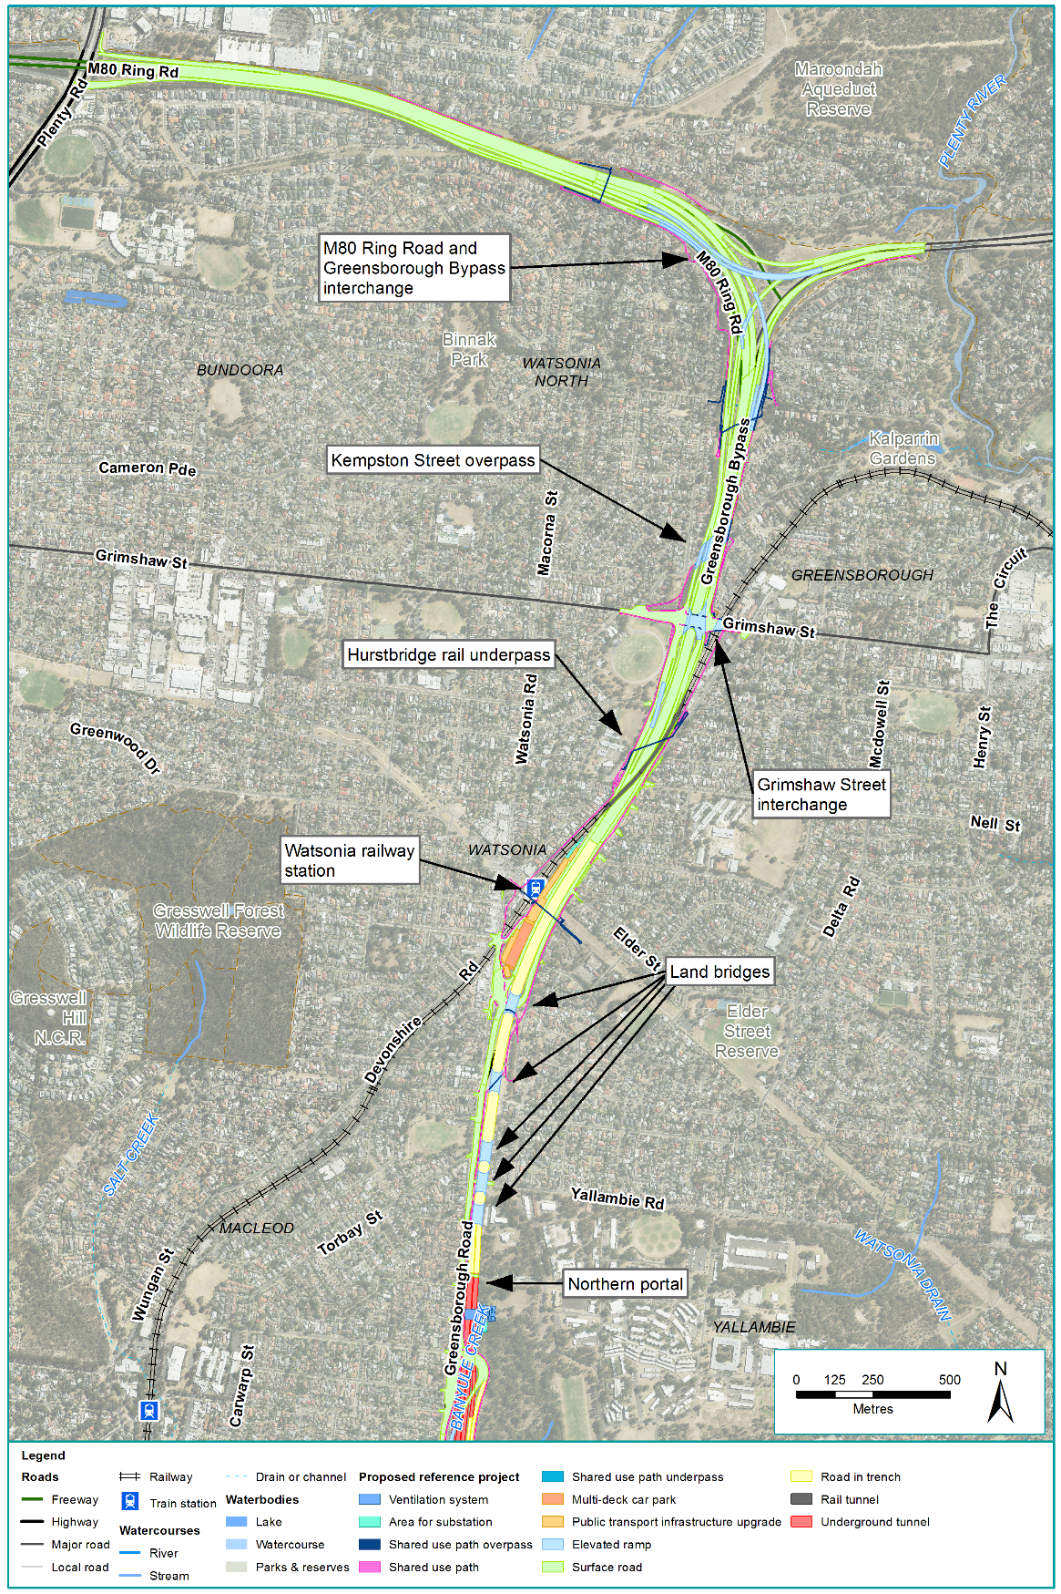
Figure 3-4 M80 Ring Road to northern portal element
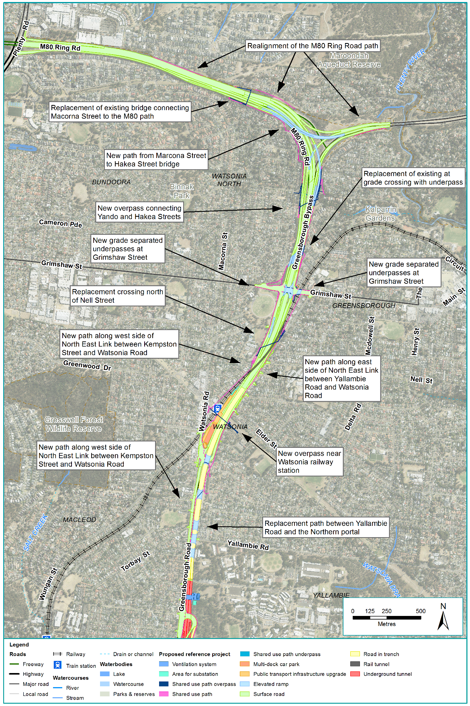
Figure 3-5 New and modified walking and cycling connectivity in the M80 Ring Road to northern portal element

Northern portal to southern portal
The design of the northern portal to southern portal element is shown in Figure 3-6. This element would include:
- A new road extending from the northern portal to the southern portal including twin three-lane tunnels and associated interchanges
- Noise walls to mitigate noise at interchange locations
- New and modified walking and cycling paths
- Changes to waterways and drainage
- Utility works around communications towers and the main sewer along Bulleen Road
- New ancillary infrastructure.
Key design elements of the northern portal to southern portal element are summarised in Table 3-2.
Table 3-2 Northern portal to southern portal key design elements
Key design elements | Description
Horizontal alignment
Lower Plenty Road interchange | This interchange would provide for northbound and southbound vehicle movements onto and off North East Link, as well as provide access via ramps to Lower Plenty Road and Greensborough Road from North East Link.
Tunnels | North East Link would include approximately 6 km of twin three-lane tunnels. The tunnels would be a ‘cut and cover’ design between Blamey Road at Yallambie (the northern portal) and Lower Plenty Road, and a bored tunnel design from Lower Plenty Road through to the southern portal at Bulleen (see Table 3-8). An indicative long section of the tunnels is shown in Figure 3-7. At their deepest point the top of the tunnels would be approximately 40 m underground.
Manningham Road interchange | The Manningham Road interchange would connect North East Link to Manningham Road while maintaining access for eastbound and westbound traffic on Manningham Road. This interchange would consist of a combination of underground and surface infrastructure extending from Bridge Street to Golden Way.  The proposed interchange design would provide a minimum of 10 m from the top of the tunnels to the ground surface at Bridge Street. Ground improvement may be required above the tunnels at Banksia Park, north of Bridge Street. The proposed design includes a northbound direct entry ramp to North East Link at Bulleen Road, at the southbound exit ramp terminal intersection located opposite Avon Street. An alternative design for the Manningham Road interchange is discussed in Chapter 4 – Feasible alternatives.
Southern portal and Bulleen Road | Bulleen Road would be widened and reconfigured to connect to the Manningham Road interchange. The southern portal, south of the Veneto Club, would connect to the Eastern Freeway interchange. Access from Bulleen Road to Thompsons Road would be retained. Most of the road would be at surface level with the exception of a section of Bulleen Road that would be raised into a viaduct to pass over North East Link.
Tunnels
Carriageways | The twin tunnels would be designed and operated with three lanes each way with a vertical clearance of 4.9 m. The shape and dimensions of the tunnels would vary with the construction techniques (see Section 3.3.2). Lanes would be 3.5 m wide with a 1 m left shoulder and 0.5 m right shoulder. The tunnels would have connecting cross passages for emergency and maintenance access at approximately 120-metre intervals.
Ventilation system | Fans and vehicle movements would push air continuously through the tunnels and direct air to ventilation structures (each approximately 40 m tall) located close to the two portals to disperse and dilute vehicle emissions to very low levels. An emergency smoke exhaust system would have additional exhaust points. These structures would be designed in accordance with Environment Protection Authority (EPA) Victoria requirements and the principles, objectives and requirements in the Urban Design Strategy for North East Link.
Power supply | The estimated load to power the operation of the tunnels and associated infrastructure is approximately 14 Megavolt Amps (MVA). A zone substation would be built at the Manningham Road interchange for this purpose. An additional substation would be located at the northern portal to assist with power supply for operation of the tunnels. This northern substation would be built on Commonwealth land, near the ventilation structure.
Water management | The drainage system would be designed to prevent flooding of the tunnels, although some groundwater infiltration into the tunnels is expected. Water treatment facilities are required to treat water captured within the tunnels so it is of a suitable quality for discharge. The treatment facilities would include settlement ponds and recycled water storage tanks and would be located underground within the Manningham Road interchange and at the southern portal. As part of the fire management system, deluge tanks would be required in the vicinity of the northern portal and at the Manningham Road interchange.
Operations centre
A motorway operations centre would be built at the Manningham Road interchange to oversee the operation of North East Link. The operations centre would coordinate services including routine maintenance and incident response. A secondary operations centre would be located at Watsonia railway station car park.
Waterway modifications
Crossings | The Yarra River is the only waterway potentially intersected by North East Link between the northern and southern portals. North East Link would be in tunnels beneath the river and so would avoid any impacts on the river.  An ephemeral wetland and storage dam within Trinity Grammar School Sporting Complex would likely be impacted by the cut and cover section of the tunnels along Bulleen Road. The existing dam would need to be modified to integrate it with the new road design.
Flood mitigation | Flood walls are proposed around the trenches in the vicinity of the northern portal. These would be approximately 1.5 m high from the existing ground level.  Flood protection, including flood gates and early warning systems would be required for the interface between the above-ground and below-ground road connections at the Manningham Road interchange.  Flood protection including flood walls and flood gates would be required at the southern portal. Flood walls around the portal would be up to approximately 8.5 m high from the ground level.
Location of shared use paths and crossings
While the majority of the action south of Lower Plenty Road to the southern portal would be underground in tunnels additional shared use paths or crossings would be provided. New and improved shared use paths and crossings are shown in Figure 3-6 and would include:
- A new shared use path from Banksia Street adjacent to the Yarra River to the Avon Street and Bulleen Road intersection
- A new shared use underpass at Lower Plenty Road
- A new bridge, shared with traffic, across North East Link at Drysdale Street.
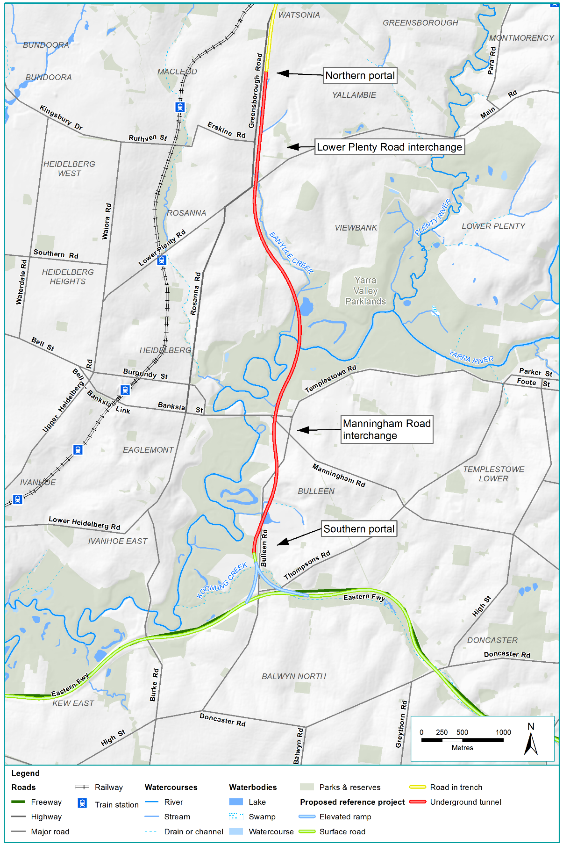
Figure 3-6 Northern portal to southern portal element

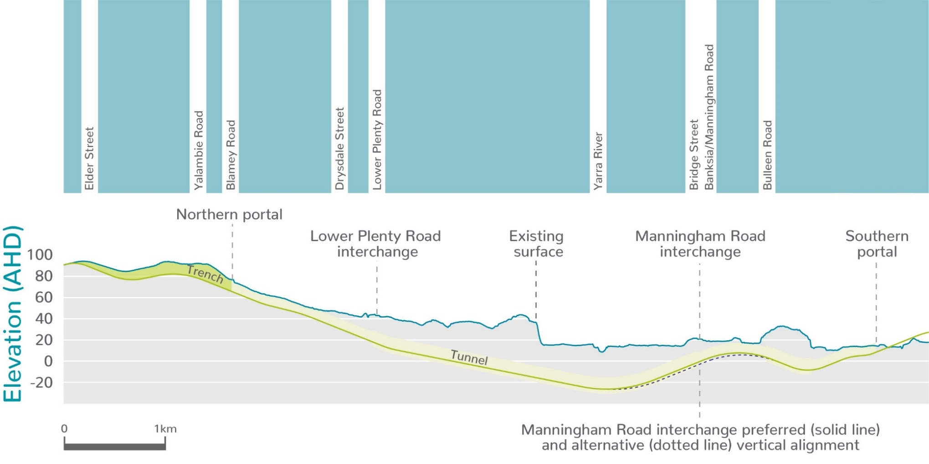
Figure 3-7 Indicative long section of tunnels

Eastern Freeway
The design of the Eastern Freeway element is shown in Figure 3-8, Figure 3-10 and Figure 3-11. This element would include:
- Upgrades to the Eastern Freeway between around Hoddle Street and Springvale Road
- An interchange at Bullen Road to connect to the Eastern Freeway
- A new dedicated busway along the Eastern Freeway (the Doncaster Busway)
- Upgrades to noise walls, including new walls in some areas
- New and modified walking and cycling paths
- Changes to waterways and drainage.
Key design elements of the Eastern Freeway element are summarised in Table 3-3.
Table 3-3 Eastern Freeway key design elements
Key design elements | Description
Horizontal alignment
Hoddle Street to Bulleen Road | The Eastern Freeway would be upgraded to allow for additional traffic capacity while maintaining existing access. Modifications would include widening to allow for more lanes, realignment of the lanes and the addition of the Doncaster Busway.
Eastern Freeway interchange | North East Link would connect to the Eastern Freeway with an interchange at Bulleen Road providing for all movements via ramps between the portal and the Eastern Freeway carriageways. The existing functionality at the Bulleen Road and Thompsons Road interchange would be maintained.
Bulleen Road to Springvale Road | The Eastern Freeway would be upgraded to provide additional traffic capacity while maintaining existing access. Modifications would include widening to allow for more traffic lanes, realignment of the lanes, and the installation of physical barriers to direct traffic flow where traffic would merge and weave, as well as the addition of the Doncaster Busway.
Doncaster Busway | The Doncaster Busway would include two new dedicated bus lanes, one in each direction, between Doncaster Road and Hoddle Street. A new Bulleen Park and Ride facility would be built at the Eastern Freeway interchange and the Doncaster Park and Ride would be reconfigured.
Vertical alignment
At the Eastern Freeway interchange, North East Link would be raised onto viaducts for its transition onto the Eastern Freeway. At their highest point the viaducts would be 10 m above the freeway, decreasing with distance from the interchange, as the viaducts and ramps integrate with the Eastern Freeway.
Waterway modifications
Crossings | Waterway crossings where works would occur include:  - Yarra River – bridge strengthening works at Eastern Freeway and the associated shared use path crossing immediately upstream  - Koonung Creek – at Bulleen Road, and a number of other locations along the Eastern Freeway alignment.
Koonung Creek | Several changes to Koonung Creek would be required to widen the Eastern Freeway:  - Three sections, each 100 to 200 m long would be diverted from their current courses, removed from culverts and placed in a naturalised channel. Works on the floodplain would also provide the required flood storage  - Five sections, varying in length from 100 to 500 m would be converted from existing open channels into a closed culvert system.  For further detail on changes to Koonung Creek see PER Technical Appendix C – Surface water.
Location of shared use paths and crossings
New and improved shared use paths and crossings are shown in Figure 3-12.
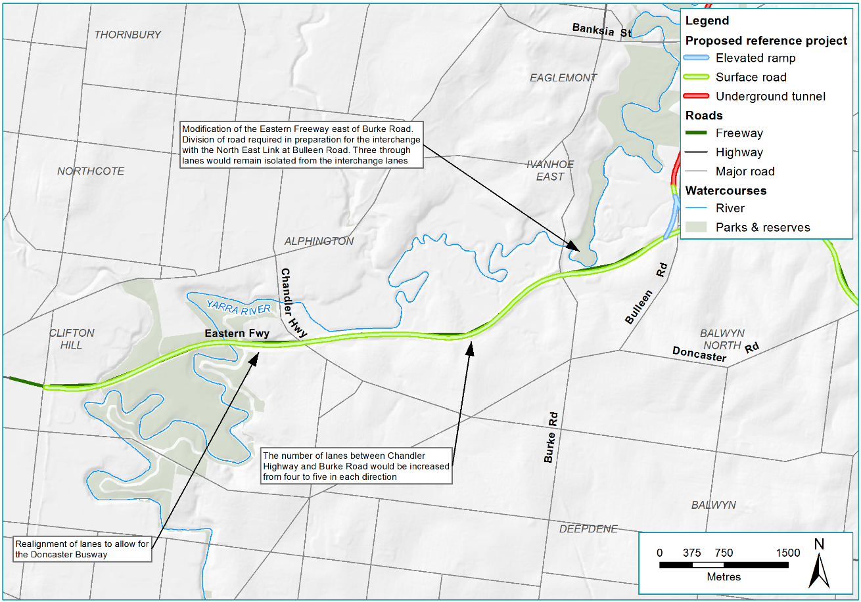
Figure 3-8 Eastern Freeway – Hoddle Street to Bulleen Road
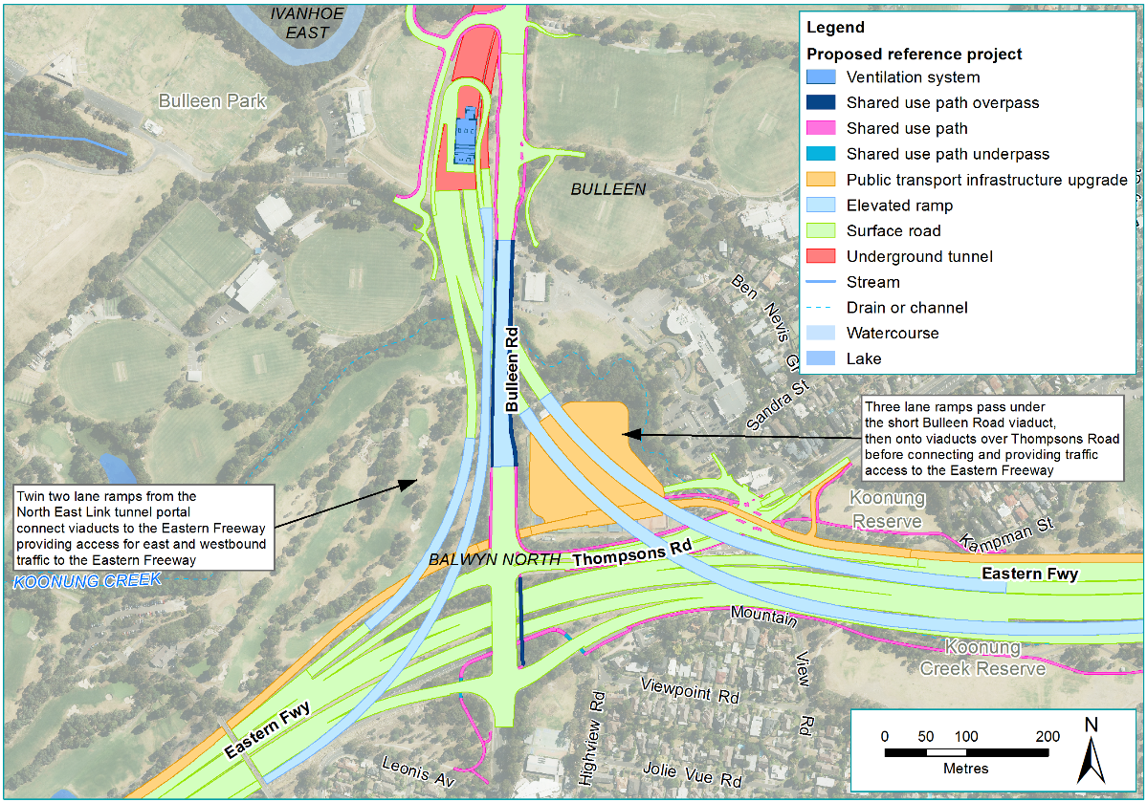
Figure 3-9 Eastern Freeway interchange
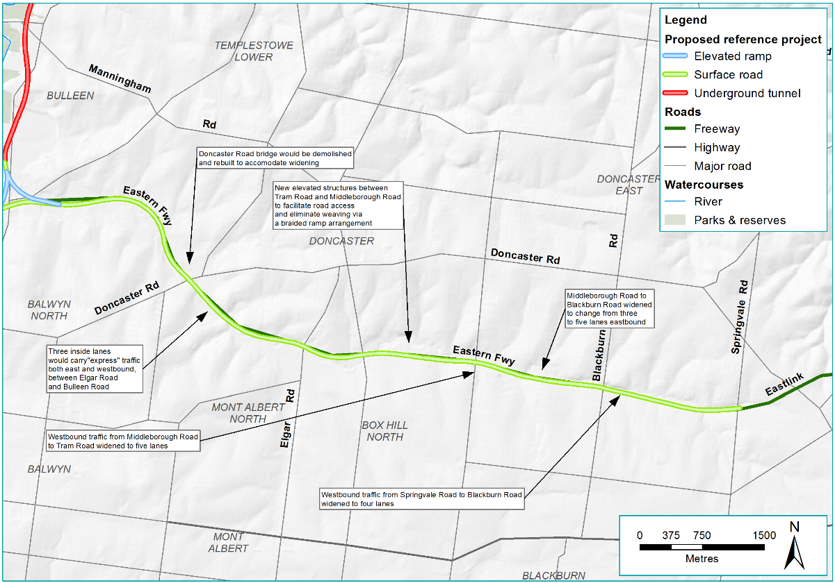
Figure 3-10 Eastern Freeway – Bulleen Road to Springvale Road
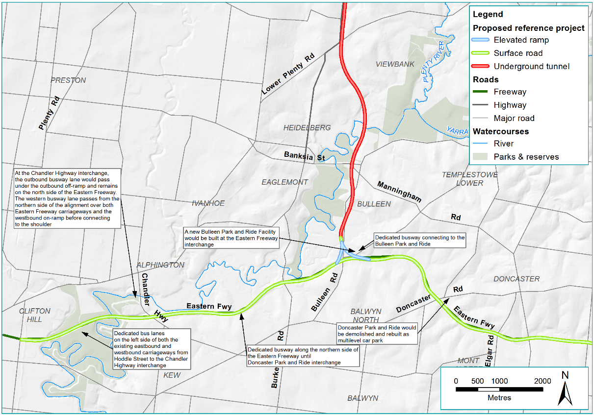
Figure 3-11 Eastern Freeway – Doncaster Busway
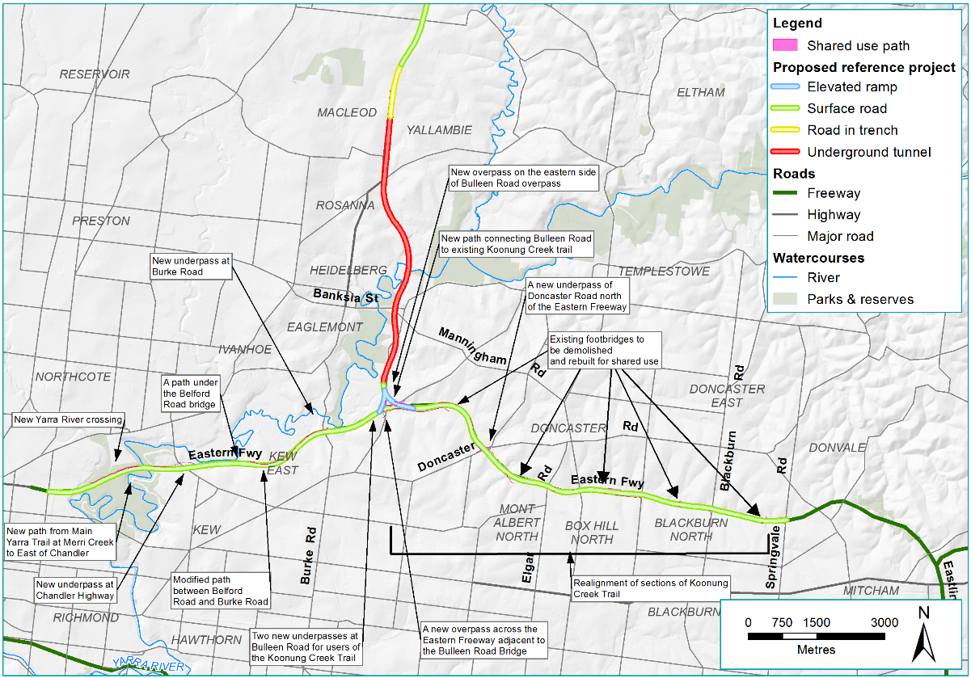
Figure 3-12 New and modified walking and cycling connectivity for Eastern Freeway

Drainage and stormwater management
Drainage and stormwater features utilising water sensitive urban design (WSUD) would be integrated into North East Link to manage hydrology and water quality.
The design would incorporate spill containment for freeway pavements (including ramps) to protect the environment from spills in accordance with AustRoads requirements.
Drainage and stormwater treatment features are proposed in a number of locations including:
- Around the M80 Ring Road interchange
- Grimshaw Street interchange
- Watsonia railway station
- Lower Plenty Road interchange
- Manningham Road interchange (water treatment facility, see Section 3.2.2)
- Bulleen Road near the southern portal
- Between Hoddle Street and Bulleen Road along the northern side of the Eastern Freeway
- In proximity to the Eastern Freeway interchange
- Between Bulleen Road and Blackburn Road on the northern and southern sides of the Eastern Freeway.

Noise walls
North East Link would include new or modified noise walls to achieve its noise objectives. New or modified noise walls would be constructed next to residential zones in various locations. Noise walls would be designed in accordance with the principles, objectives and requirements of the Urban Design Strategy for North East Link.
The action-specific noise objectives for North East Link are set out in Chapter 9 – Impacts on the whole of the environment on Commonwealth land, and PER Technical Appendix D – Commonwealth land. Achieving the noise objectives for North East Link would mean that traffic noise would reduce for some residents along the Eastern Freeway.

Landscape and urban design
North East Link would be designed and delivered by the private sector following a competitive tender process. To guide and asses the final design of North East Link, NELP has developed an Urban Design Strategy that establishes the expectations of the Victoria Government for what the contractor’s design must achieve. The Urban Design Strategy seeks to ensure consistent, high quality and context-sensitive urban design outcomes for North East Link while encouraging innovation and ideas from industry.
While the Urban Design Strategy sets the strategic direction and overarching urban design requirements for North East Link, it is not intended to communicate design plans or proposals. The contractors would use the strategy to develop Urban Design and Landscape Plans to illustrate their proposed design for North East Link for submission to the Minister for Planning for approval.
The Urban Design Strategy has been informed by the following:
- National, state and local policies, legislation, strategies and guidelines relevant to the affected area
- Technical impact assessments undertaken as part of the Environment Effects Statement (EES) for the action, including studies on the potential heritage, land use, social and community, ecology, landscape and visual impacts
- Other key project documents such as the draft North East Link Sustainability Strategy
- Additional urban design analysis to consider site-specific impacts and requirements
- Feedback from the Victorian Government and local councils, the community and other key stakeholders.

Utilities
Key utilities that North East Link would intersect or be in close proximity to would need to be protected, relocated or avoided to maintain their function. These key utilities are summarised in Table 3-4. No utilities have been identified for the Eastern Freeway element.
Table 3-4 Key utilities between the M80 Ring Road to the southern portal element
Utility type | Description
Communication facilities | Three telecommunications towers and two wireless telecommunications stations would be relocated.
Gas | An existing licensed transmission gas main which currently runs along Morwell Avenue at Watsonia and crosses the alignment at Elder Street (opposite Watsonia railway station) would be avoided.
Electricity transmission lines | Electricity transmission lines (66 kV) currently crossing Greensborough Bypass and running along the power easement would be relocated to run into the Watsonia railway station car park. Two 220 kV transmission towers at the Watsonia railway station car park would be moved to the eastern side of North East Link within the power easement.
Pressure reducing station | Melbourne Water’s Watsonia pressure reducing station would be relocated approximately 300 m east of its current location.
Water mains | Due to the relocation of the pressure reducing station, three water mains that currently run east to west immediately north of Drysdale Street and which connect to the station would also need to be relocated.
Sewer | Melbourne Water’s Yarra East Main sewer which currently runs along Bulleen Road would be relocated to avoid a conflict with the North East Link tunnels.

Property acquisition
With the exception of Commonwealth land, the acquisition of private properties would be conducted in accordance with Victoria’s Land Acquisition and Compensation Act 1986.
Two areas of Commonwealth land (at Simpson Barracks and an area behind properties at Elder Street) have been identified as needing to be acquired for North East Link. Victorian Government acquisition powers are not considered to apply to Commonwealth land, so this land must be obtained via a transfer by agreement between the Australian and Victorian governments.
A transfer of this type involves two key steps:
      - The Australian Government Minister responsible for the land, in consultation with the agency that is using the land (if any), must declare the land as surplus to the requirements of their Department
      - After the land is declared surplus, the Australian Government’s Minister for Finance can authorise the commencement of the process for divestment of the land from the Commonwealth and its subsequent transfer to the State.
Table 3-5 outlines the areas that are proposed to be acquired for North East Link.
Table 3-5 Property acquisition required
Property type | Description
Private | Up to 102 commercial and 36 residential properties would be permanently acquired for North East Link. A number of other sites would need to be temporarily occupied during construction. Where possible, construction sites, infrastructure and other aspects to the action have been located to avoid temporary occupation and permanent acquisition. Acquisition would be undertaken in accordance with Victoria’s Land Acquisition and Compensation Act 1986 and Major Transport Projects Facilitation Act 2009.
Public open space | Public spaces used for a variety of environmental conservation, social and recreational purposes (such as parks, walking trails and reserves) may be temporarily acquired for construction activities and compounds. A much smaller amount of public open space would be permanently acquired. New public space would be provided on land bridges built over North East Link in Watsonia.
Commonwealth land at Simpson Barracks | Approximately 11 ha of Simpson Barracks would be required within its western boundary. An additional approximate 2 ha would be required to the south of Simpson Barracks, beyond the fence line and publicly accessible land. This land is owned by the Department of Defence. The area to be purchased is shown in Figure 3-13.
Commonwealth land behind properties on Elder Street, Watsonia (War Service Homes) | The entire area of 2,930 m² (approximately 0.3 ha) would be required for the action. This land is owned by the Director of War Service Homes, with the Secretary of the Department of Veterans’ Affairs identified as the successor in title. The area to be purchased is shown in Figure 3-14.

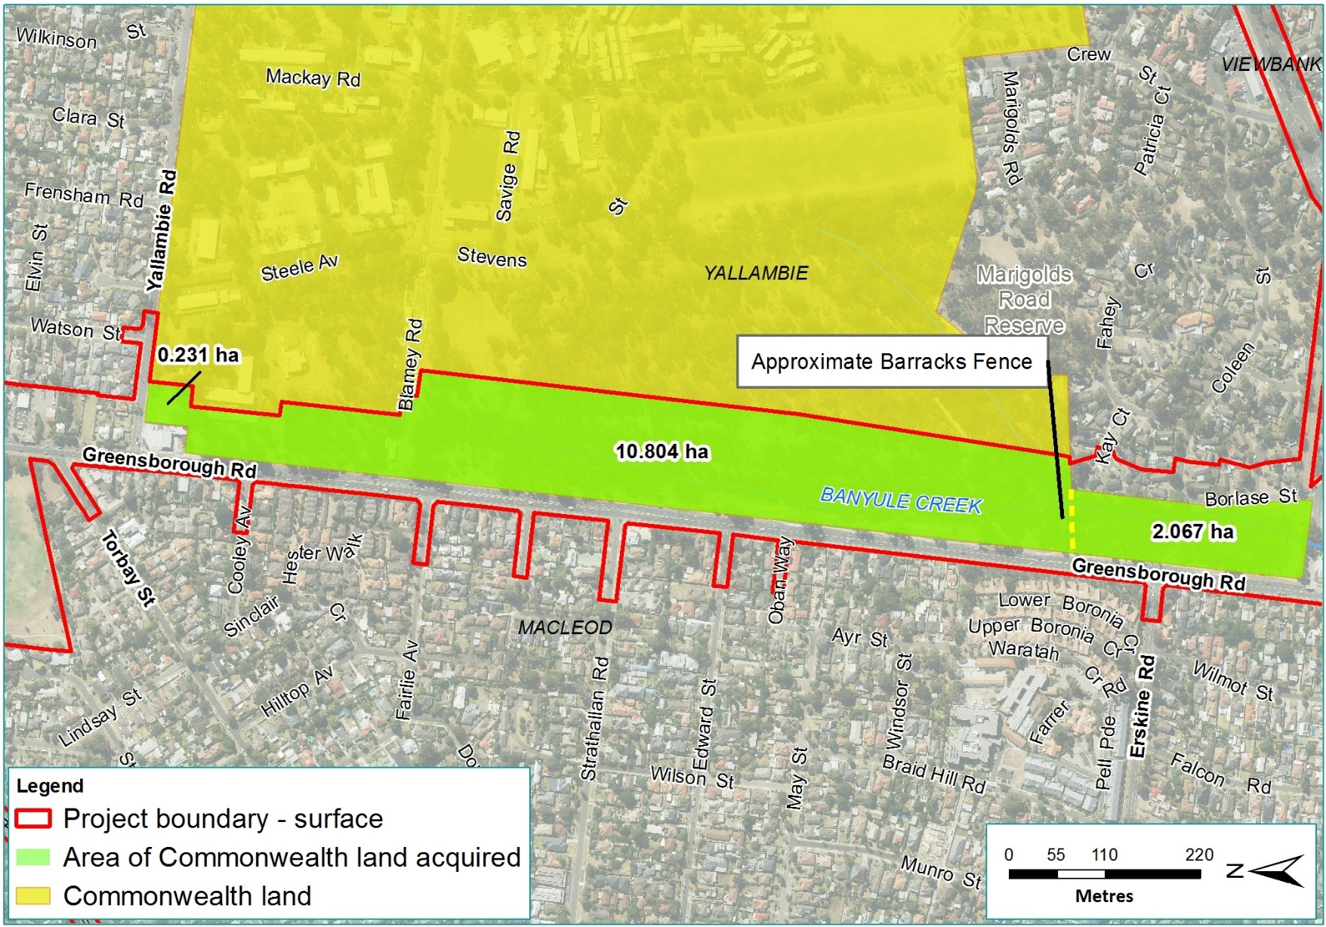
Figure 3-13 Area of Simpson Barracks (and unfenced area to the south) to be acquired
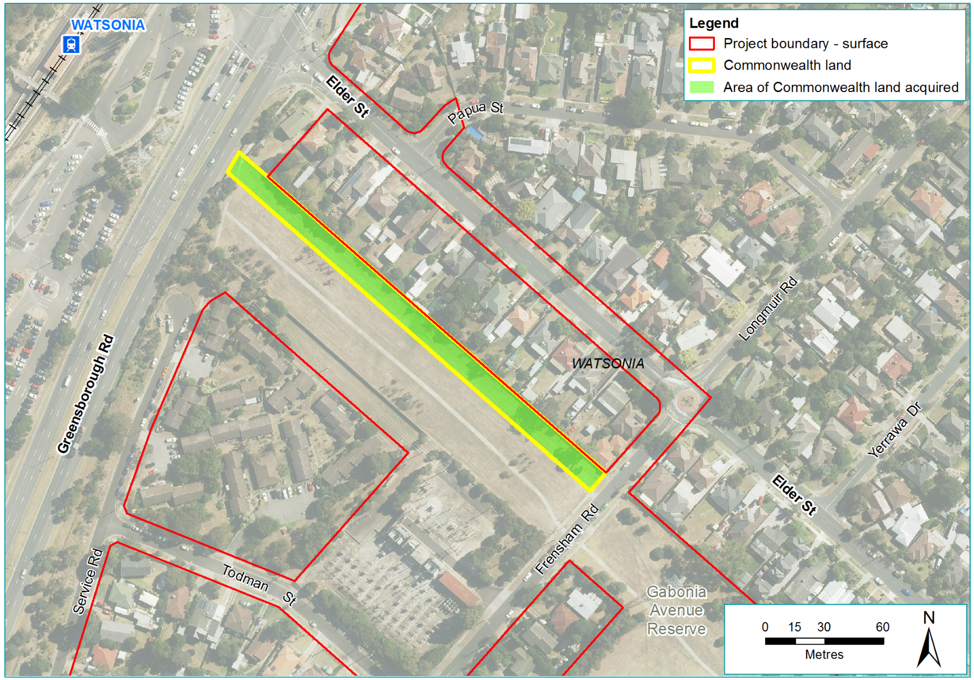
Figure 3-14 War Service Homes Commonwealth land to be acquired

Commonwealth land
The description below encompasses the design of North East Link on Commonwealth land. Table 3-6 summarises the key design elements on Commonwealth land and they are shown in Figure 3-2 and Figure 3-3.
Following the transfer of land from Commonwealth to State ownership discussed in Section 3.2.8, the construction and operation of North East Link would not occur on Commonwealth land.
As noted in Section 3.1 above, the reference project represents one possible design of North East Link. The design features of the reference project have been used to help define and assess the potential impacts of the action. The design features outlined in the following section are therefore subject to change.
Table 3-6 Commonwealth land key design elements
Key design elements | Description
Horizontal alignment
Roads in trench or tunnel | The new North East Link roads, starting south of Watsonia railway station, would be placed in a trench running south parallel to Greensborough Road.  The trenched roads would be on Commonwealth land south of Yallambie Road, and would continue southwards descending towards the northern portal at Blamey Road, where the roads would enter the tunnelled section. The tunnelled roads continue to descend through Commonwealth land and further south after leaving Commonwealth land at Drysdale Street, before the Lower Plenty Road intersection.
Land bridges | The North East Link reference project includes five land bridges. One and a half of these would be on Commonwealth land. Described in Section 3.2.1 above, these two land bridges are located adjacent to Yallambie Road (partly on Commonwealth land) and Cooley Avenue (on Commonwealth land).
Surface roads | Greensborough Road would be retained to maintain existing access to local roads. New ramp connections to North East Link would be provided at Strathallan Road. Surface works, including shared use paths, would also be undertaken along a small strip of Commonwealth land at Watsonia (behind properties at Elder Street) to upgrade Greensborough Road.
Northern portal | The northern portal would be located at Blamey Road, with North East Link entering the tunnelled section of the alignment, while the surface level connection between Blamey Road and Greensborough Road would be maintained.
Lower Plenty Road interchange and ramps | The interchange with Lower Plenty Road would provide for northbound and southbound vehicle movements.  Motorists on Greensborough Road and Lower Plenty Road wishing to travel southbound through the tunnels would enter a ramp from Greensborough Road opposite Strathallan Road. Similarly, northbound motorists in the tunnels wishing to exit onto Greensborough Road or Lower Plenty Road would do so via an exit ramp. This ramp would exit onto Greensborough Road opposite Strathallan Road. This is the only part of the design relevant to Commonwealth land.
Alterations to waterways
At Simpson Barracks, Banyule Creek would be replaced by two pipes, one on either side of the North East Link alignment. These pipes would act as a diversion to connect adjacent catchments.
For further detail on changes to Banyule Creek see PER Technical Appendix C – Surface water.
Ventilation structure
A ventilation structure would be located near the northern portal, just south of Blamey Road. This would include a new substation to provide power for the ventilation structures and operation of the tunnels.
Location of shared use paths and crossings
Shared use paths | - Between Elder Street and Lower Plenty Road.  - The existing Greensborough Bypass Path would also be realigned between the northern portal and Lower Plenty Road.
Shared use crossings | - A new bridge, shared with traffic, across North East Link at Drysdale Street.

Construction methodology
The construction methods outlined in this section relate to the reference project which has provided the basis for the assessment presented in the PER. As noted in Section 3.1, the reference project represents one possible way to deliver the action. The details presented in the following section are therefore subject to change.

Overview of construction works
Construction of North East Link would involve a combination of above and below-ground works. The general categories of construction type are shown in Figure 3-15.
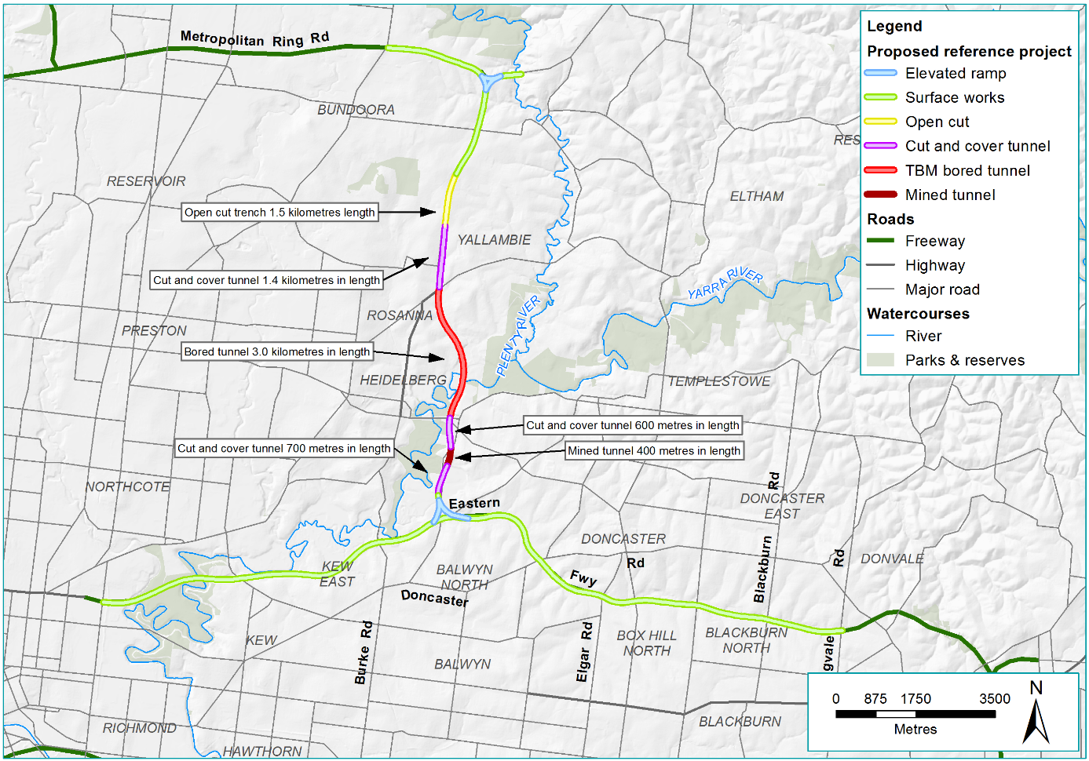
Figure 3-15 North East Link construction methods
The main construction activities associated with these methods are listed in Table 3-7.
Table 3-7 Main construction activities
Construction stage | Activity
Mobilisation activities | - General earthworks including topsoil removal, clearing and grubbing vegetation  - Relocation, adjustment or installation of new utility services  - Demolition of buildings and structures, including site clearance  - Establishment of construction compounds  - Construction of roadworks and curb realignment for temporary access points for construction vehicles  - Relocation and diversion of shared use paths.
Main construction period | - Construction of retaining walls and diaphragm walls including piling  - Major excavations for portal construction  - Construction of TBM launch and retrieval facilities and associated support infrastructure  - Ground treatment to stabilise soils  - Tunnel construction using TBMs, mining and cut and cover techniques  - Storage and removal of spoil  - Construction of cross passages, ventilation structures and access shafts  - Construction of ramps and viaducts at the M80 Ring Road and Eastern Freeway interchanges  - Installation of water quality treatment facilities  - Installation of water sensitive urban design features for surface water run-off management  - Construction of road pavements and installation of road furniture, including traffic management measures to facilitate the works  - Construction of noise walls  - Construction of flood walls  - Construction of ventilation structures and fire safety outlets  - Construction of land bridges to facilitate local connections  - Landscaping and urban design treatments.
Final stages of construction | - Installation of a Freeway Management System  - Installation of fire and life safety equipment in tunnel  - Installation of overhead gantries, signage and other related traffic management systems  - Laying pavement, asphalt and line marking  - Restoration of work areas and construction of shared use paths.

Construction methods
The construction methods that would be used to construct North East Link are summarised in Table 3-8.
Table 3-8 Construction methods
Method | Construction process
Cut and cover tunnels | Cut and cover construction involves using excavation equipment to dig a large trench or rectangular hole in the ground which is then covered by a concrete deck. Cut and cover construction can be undertaken through a top-down or bottom-up configuration. Bottom-up is the method assumed for the reference project, which aligns to the steps identified in Figure 3-16.  This method would be used to dig sections between Blamey Road and Lower Plenty Road, Bridge Street and Golden Way and Rocklea Road and the southern portal.
Bored tunnels | The length of the twin tunnels between Lower Plenty Road and Bridge Street would be constructed using TBMs. This represents the majority of North East Link tunnels.  TBMs can be configured to safely excavate a variety of soil and rock strata (without using drilling and blasting methods) while constructing the lining of the tunnels in segments as excavation progresses. TBMs minimise disruption at surface level, limiting the disturbance to the surrounding ground and producing a smooth tunnel wall. This reduces the cost of lining the tunnels and makes TBMs suitable for use in densely populated urban areas.  Two TBMs would be assembled at the TBM launch site, and driven from south to north (or north to south for the alternative TBM launch site) before being dismantled at the northern portal site. The TBMs would operate 24 hours per day, seven days per week, progressing at an estimated average rate of 60 m per week and producing an average 20,000 m³ of tunnel spoil per week.
Mined tunnels | A short section of the twin tunnels south of the Manningham Road interchange (approximately 400 m long) would be constructed using road headers.  Road headers are preferred for a mined tunnel where the tunnelled section is quite short. For North East Link, the mined tunnel section would be adjacent to Bulleen Road between Avon Street and just south of Rocklea Road. Two road headers would be used with an average production of 1,500 m³ per day, progressing at an estimated rate of up to 10 m per week.
Sewer tunnel | The Yarra East Main sewer would require realignment to avoid conflict with the road tunnels. The realigned sewer would be placed within a tunnel of around 1.8 m diameter and 4 to 16 m below the ground surface.  The sewer tunnel would be constructed on the east side of Bulleen Road, from Avon Street to the Bulleen Road (adjacent to the Bulleen Swim Centre). It would be constructed using a combination of pipe jacking and an open trench method (including a cofferdam) where it crosses the dam adjacent to Trinity Grammar.
Earthworks | Extensive earthworks would be required along the majority of the North East Link alignment including works associated with the M80 Ring Road and Eastern Freeway. The majority of earthworks would involve excavation, including the cut and cover and trench structures, with minor embankment fills. For further detail on spoil management see Section 3.3.10.
Ground improvement | Ground improvement is a construction process used to change the properties of soil to make the ground more suitable for construction.  For North East Link, ground improvement would be required at the southern end of the TBM tunnels, just north of Bridge Street. The ground improvement would stabilise ground conditions over the top of the tunnels where there is a small distance to the ground surface. It would involve injecting grout into boreholes to control the permeability of the soil to ensure stability of the ground above the tunnels.
Freeway widening | Widening of the M80 Ring Road and the Eastern Freeway would provide the additional lanes and turning movements that North East Link would introduce to the road network.  Road widening would occur into the median or beyond the road shoulders depending on the location. A typical sequence for widening into the median would involve:  - Establishing traffic management measures  - Shifting traffic towards the outside shoulders to create the median work area  - Constructing median widening  - Shifting traffic to accommodate a temporary staging area for other works such as new viaducts  - Line marking and then shifting traffic onto the final alignment.  Before widening works started, construction areas would be separated from vehicle traffic using safety barriers in accordance with the Road Management Act 2004 (Vic) and associated regulation requirements.
Bridge construction | North East Link would require the construction of new bridges and the upgrade of existing bridges and elevated structures. These include road bridges, foot bridges and land bridges. Several bridge design options are available including precast concrete, steel box girder, voided slab, match cast segmental and incrementally launched bridge superstructures. Piers, beams, decks and parapets would be constructed from either end of the bridge or from above at a safe clearance to traffic.  Road widening would generally occur before bridge works started so that traffic could be diverted clear of proposed bridge approaches and supporting pier locations. Once road widening is complete, traffic could be moved around safe work zones created for bridge foundation works (piling) through to pier construction and superstructure installation.  Once completed, bridge works could be easily isolated from live traffic and brought online through temporary lane closures, barriers and signage.

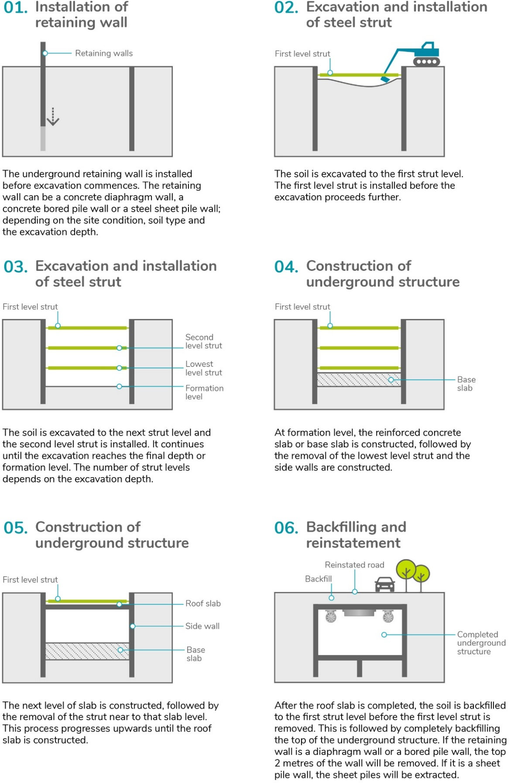
Figure 3-16 'Bottom-up' cut and cover construction method

Potential construction compounds
A reasonable area for materials laydown would be required at each construction compound (because construction would not employ a just-in-time logistics strategy). Potential construction compounds required for North East Link are summarised in Table 3-9.
Table 3-9 Potential construction compounds for the action
Method | Construction process
Overview of potential construction compounds | A number of potential construction compounds have been identified and are shown in Figure 3-17 and Figure 3-18. All potential compounds are subject to ongoing discussions with local councils and key stakeholders. The activities undertaken at these locations would include offices, construction laydown, staff amenities as well as vehicle and equipment storage and spoil management.
Primary tunnelling works areas | A primary tunnelling work area would be located within a construction compound for the tunnelling works, workshops and storage facilities for the works. This would be located at Bridge Street, extending south to Golden Way and is described as the southern TBM launch site. An alternative option located near Blamey Road is described as the northern TBM launch site, and is described in Chapter 4 – Feasible alternatives.  The southern TBM launch site would include primary workshops and storage facilities and an acoustic shed. A satellite site facility would be established adjacent to the northern TBM retrieval site in the area adjacent to the northern side of Lower Plenty Road.

Construction workforce
The construction workforce would vary in size during the construction of North East Link. The workforce is expected to peak at around 2,800 people across the whole of the alignment. A large on-site workforce would require access to and from major work areas.

Construction materials
A variety of construction materials would be required. These include concrete, steel, asphalt, imported fill, pre-cast concrete lining segments, imported crushed rock and imported cement treated crushed rock. Excavated spoil would be reused where possible although certain elements of North East Link such as road pavement and structural embankments require material of a higher quality which cannot be generated from excavated spoil.
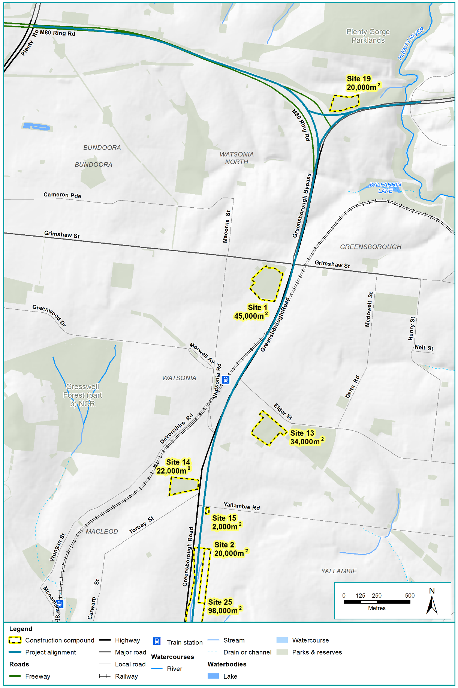
Figure 3-17 Potential construction compounds from the M80 Ring Road to northern portal
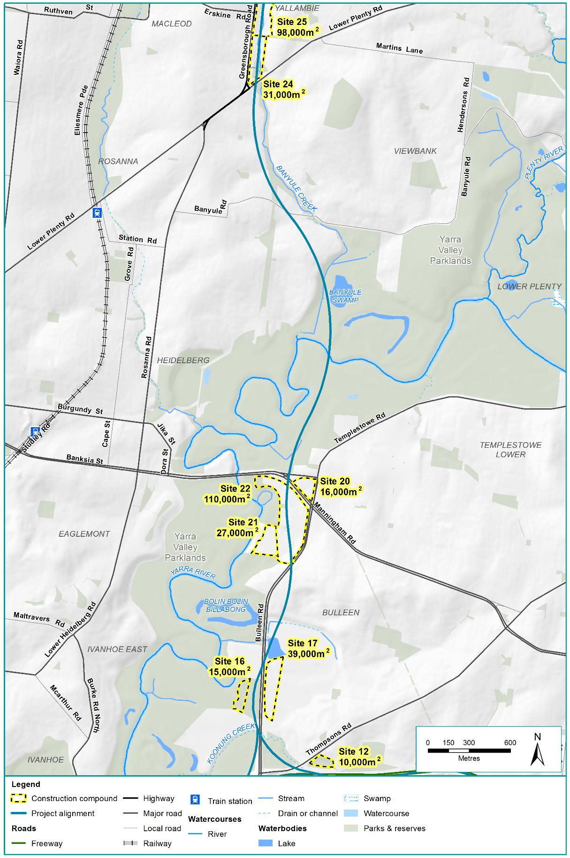
Figure 3-18 Potential construction compounds from northern portal to southern portal
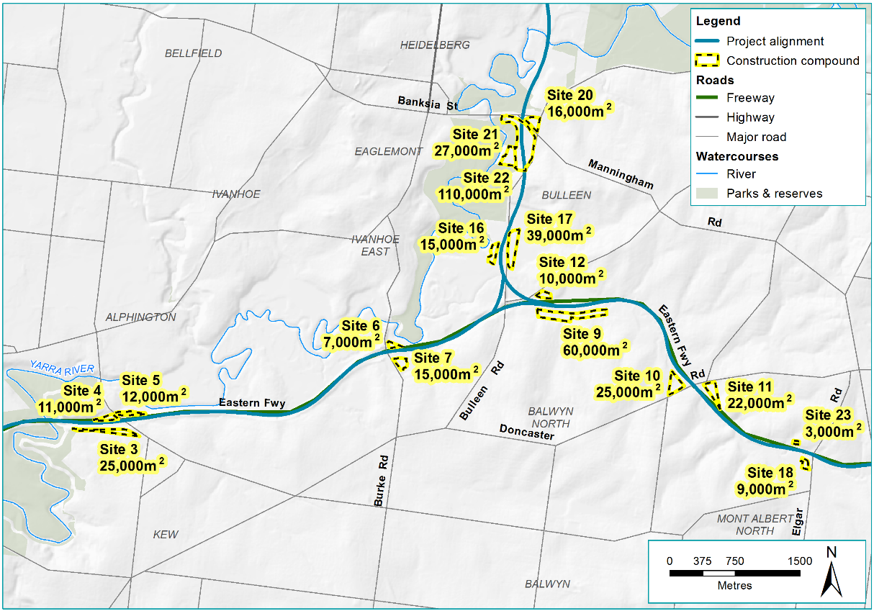
Figure 3-19 Potential construction compounds across the Eastern Freeway (west of Bulleen Road)
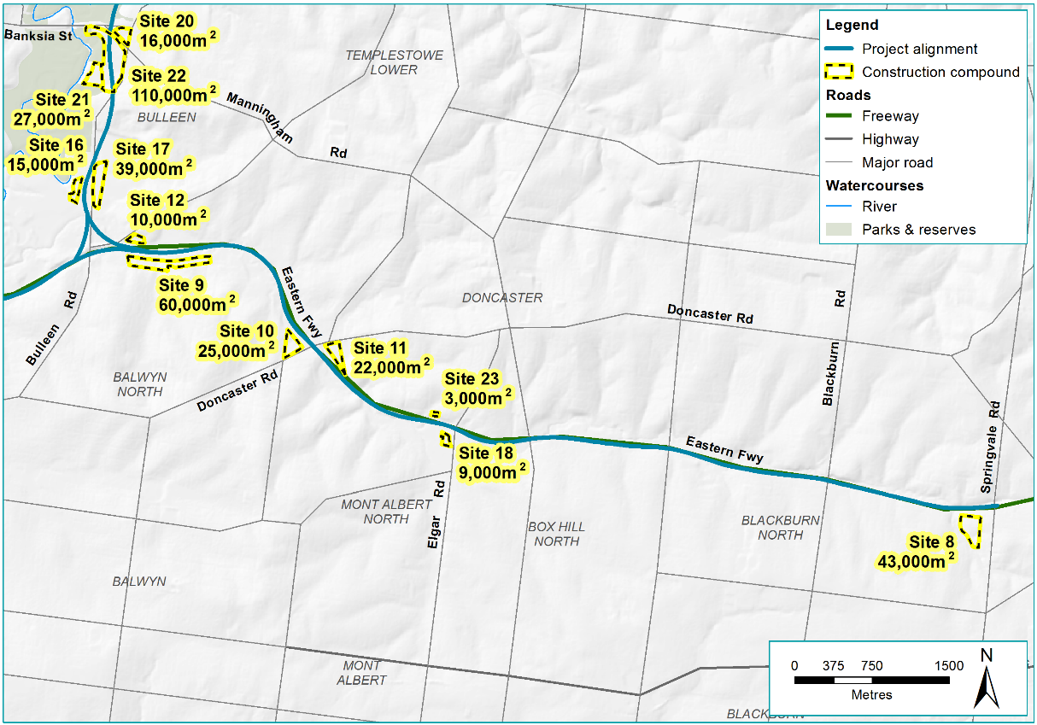
Figure 3-20 Potential construction compounds along the Eastern Freeway (east of Bulleen Road)

Traffic and transport management during construction
Table 3-10 details the traffic and transport management that would be undertaken during construction.
Table 3-10 Traffic and transport management
Management | Description
Construction traffic generation | Construction vehicle and truck movements for Commonwealth land areas are described in Chapter 9 – Impacts on the whole of the environment on Commonwealth land. Further details are provided in PER Technical Appendix D – Commonwealth land.
Access, road closures and changed traffic arrangements | - Effective management of traffic impacts on roads, footpaths and bike paths adjacent to North East Link during its construction is crucial to project delivery. Contractors would prepare and implement Transport Management Plans identifying appropriate construction traffic routes, temporary diversions and measures to manage local traffic disruptions.  - Transport Management Plans would be developed and approved before construction started.  - Local and emergency vehicle access would be maintained.  - Access to businesses and residences near construction locations would be maintained where practicable or alternative arrangements provided.
Public transport | Passenger operations would be temporarily disrupted due to works around Watsonia railway station. It is anticipated that a mix of after last before first, weekend, and extended week-long occupations would be required to complete the bridge widening works.
Car parking | Existing car parking at Watsonia railway station and at the Doncaster Park and Ride could be affected during construction. At these locations temporary car parking would be provided at nearby locations to maintain existing levels of available parking. Separate car parking would be provided for construction staff.
Pedestrians and cyclists | Pedestrian and cycling connectivity would be maintained during construction.

Power
Additional power supply capacity would be required to power the TBM, with a new zone substation at the Manningham Road interchange. Upgrades to the 66 kV network would also be required.

Surface water management
The works in various floodplains would mean a loss of floodplain storage, due to flood walls and freeway embankment encroaching on the floodplain. Compensatory flood storage would be needed. This would occur at the following locations:
- At the Manningham Road interchange (approximately 27,000 m³)
- Between Thompsons Road and Doncaster Road (approximately 1,000 m³)
- Between Doncaster Road and Elgar Road (approximately 10,000 m³)
- Between Tram Road and Middleborough Road (approximately 20,000 m³).

Groundwater management
Groundwater management is a critical consideration for structures designed and built below ground. Two types of structure can be used to manage groundwater; drained or tanked structures. These are described in Table 3-11.
Table 3-11 Groundwater management terms
Term | Description
‘Drained’ structure (in the context of groundwater only) | Refers to a permeable structure, which allows for the seepage of groundwater into the structure. In the case of the trench section, it can be built as a drained structure as it would sit above the water table, and so there should not be any seepage of groundwater into the structure.
‘Tanking’ is a term used to describe ’waterproofing’ structures below ground | When a structure is tanked, it is designed to be sealed and aims to prevent groundwater leaks into the structure. In the case of the TBM bored tunnels for North East Link, precast segments would be made off-site and brought to site to line the tunnel. Once these segments are installed, the tunnels would become tanked structures.

The proposed approach to groundwater management is as follows:
- The trench section adjacent to Watsonia railway station to near Blamey Road would be designed to be drained during construction as well as operation
- The cut and cover tunnel sections from Blamey Road to Lower Plenty Road would be managed in two parts. The northern part would be drained during construction and operation. The southern part would be drained during construction, and tanked once North East Link is operating. The cut and cover section at the Manningham Road interchange and at Bulleen would be designed to be partially drained during construction and then tanked during operation
- The bored tunnels beneath the Banyule Flats and Warringal Parklands would be constructed using a closed face pressurised TBM and immediately lined with precast concrete sections to minimise groundwater inflows during construction and operation
- The mined tunnels would be drained during construction and tanked during operation.
Ground improvement (described in Table 3-8) also considers some aspects of groundwater and its management.
Groundwater that is captured or extracted during construction could be reused during the construction process, assuming the groundwater is of acceptable quality. It could also be carted off-site via truck, or disposed of via other surface water bodies. If the groundwater is not of acceptable quality, it is possible it could be disposed of via sewer.
Disposal of groundwater must comply with relevant legislation and guidelines at all times. Groundwater disposal is discussed further in PER Technical Appendix B – Groundwater.

Spoil and waste management
Spoil is waste material brought to the surface during the course of an excavation, tunnelling, dredging or mining. North East Link would generate spoil during construction which would be used within the EPBC boundary or transported away from North East Link via designated haulage routes.

Spoil generated
The indicative spoil volume generated (estimated based on in situ volumes) is 6,100,000 m³.

Spoil management
Spoil generated by the action on Commonwealth land would mostly be associated with the cut and cover construction of the tunnels. A spoil management facility would be established at the primary tunnelling work site for spoil from the tunnels. A smaller spoil management facility would also be established at the TBM retrieval site.
Spoil management at these sites would include measures to prevent silt run-off to waterways and to suppress dust. This spoil management could consist of covering of stockpiles and trucks, and other associated measures. More detail on spoil management is provided in Chapter 9 – Impacts on the whole of the environment on Commonwealth land, and in PER Technical Appendix D – Commonwealth land technical report.
Opportunities to reuse spoil would be investigated as set out below (Waste management). Nevertheless, spoil that could not be reused would be removed. A number of potential disposal sites have been identified for surplus spoil and other opportunities may be identified when construction is underway. During detailed design, the contractor would be required to adopt waste management practices consistent with Victoria’s Environment Protection Act 1970 when assessing options for spoil management.

Spoil haulage routes
Construction haulage routes have been identified to provide construction-related traffic with efficient access to the freeway and arterial road network and between worksites, minimising the impact on local traffic and local roads wherever possible. The indicative primary and secondary haulage routes are shown in Figure 3-21.
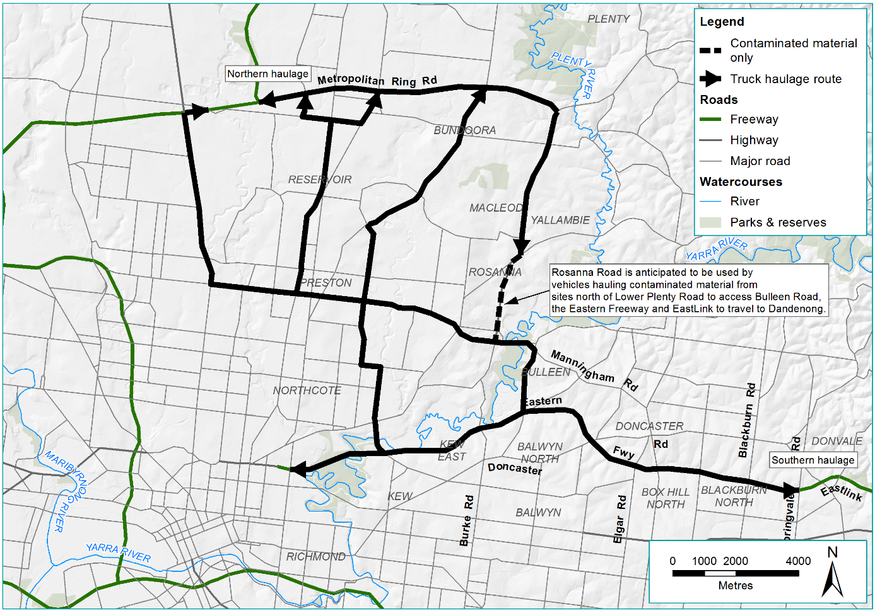
Figure 3-21 Indicative construction haul routes

Waste management
Waste management would be undertaken in accordance with the principles set out in the Environment Protection Act and waste management hierarchy shown in Figure 3-22. Construction waste streams such as concrete, metal, green wastes and spoil would be segregated for recycling or reuse.
Waste disposal methods would be selected based on the classification of waste material in the EPA Victoria Industrial Waste Resource Guidelines. All wastes generated by North East Link would be transported, managed and disposed of in accordance with the relevant EPA Victoria requirements.
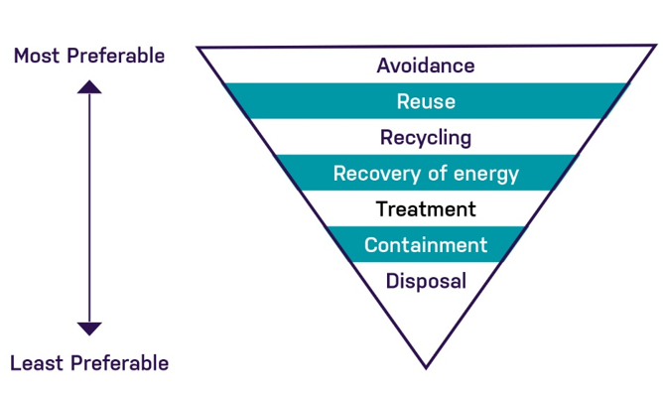
Figure 3-22 Waste management hierarchy
Source: EPA Victoria, Waste, image, viewed 17 May 2018 <http://www.epa.vic.gov.au/your-environment/waste>

Construction health, safety and environment
Construction works would be required to comply with the noise, vibration, surface water, groundwater, waste management and air quality requirements of the Environment Protection Act and other legislation.
Monitoring would be carried out to measure settlement, dust, surface water, groundwater, noise and vibration consistent with regulatory requirements and best construction practice to minimise impacts on the amenity of adjacent properties, including open spaces. Appropriate practices to ensure safe working in an operating rail environment would be established, including delineation of the worksite from live rail operations and ‘after last and before first’ working arrangements, security fencing to protect public safety and adherence to Metro Trains Melbourne site access permits.
Further information regarding monitoring, management plans, and associated work requirements is provided in Chapter 10 – Proposed avoidance and mitigation measures.

Activities on Commonwealth land
Following the transfer of land from Commonwealth to State ownership discussed in Section 3.2.8, the construction of North East Link would not take place on Commonwealth land.
As noted in Section 3.1, the reference project represents one possible way to deliver the action. The details presented in the following section are therefore subject to change.

Overview of construction works
Works occurring on Commonwealth land would include:
- Demolition
- Vegetation removal
- Construction of North East Link carriageways in:
  - Trench (open cut excavation)
  - Tunnels (cut and cover and TBM excavation)
- Road ramp construction
- Surface road works, including shared use paths and land bridges
- Power substation construction
- Northern portal ventilation structure construction
- Installation of flood protection
- Laydown areas and construction compounds (potentially including the northern portal launch site).
More details of the main construction works in this area are provided in Table 3-12 below.

Construction methods
The construction methods that would be used to construct the action are outlined in Table 3-12.
Table 3-12 Construction methods for the Commonwealth land area
Term | Construction method
Earthworks | The majority of earthworks would involve excavation, including for the trench structure, with minor embankment fills. The trench would extend from Watsonia railway station to the northern portal.
Cut and cover tunnels | Cut and cover construction involves using excavation equipment to dig a large trench or rectangular hole in the ground which is then covered by a concrete deck. Cut and cover construction can be conducted through a top-down or bottom-up configuration. Bottom-up is the method assumed for the reference project, which aligns to the steps identified in Figure 3-16.  The cut and cover method would be used to dig sections of North East Link between Blamey Road and Lower Plenty Road.  This section of work would include modifying Lower Plenty Road to allow connections to Greensborough Road and to North East Link inner north and southbound carriageways. The new ramps located at Strathallan Road would be located on Commonwealth land.
Surface works | Roadworks, and ramp and shared use path construction would occur along Greensborough Road and at the Lower Plenty Road interchange.  The interchange works would consist of surface works, the realignment of roads, and the construction of new ramps between Strathallan Road and Lower Plenty Road.  Shared use path surface works would also occur parallel to the road works from Elder Street through to Lower Plenty Road.

Potential construction compounds
The area that North East Link would impact is defined by the project boundary. All construction for North East Link would be contained within this footprint. A map showing the Commonwealth land area, the project boundary, and the potential construction compounds, along with the construction type is shown in Figure 3-23.

Water management during construction
The water management methods for Commonwealth land are summarised in Table 3-13.
Table 3-13 Commonwealth land construction management methods
Management | Description
Surface water management | As described in Section 3.2.9 above, Banyule Creek would be replaced by two pipes, one on either side of the North East Link alignment. Aside from the flood walls proposed around the trenches in the vicinity of the northern portal (approximately 1.5 m high from the ground level), other surface water management would be determined by the contractor in accordance with all relevant management plans.
Groundwater management | The groundwater management on Commonwealth land and the surrounding area would differ depending on the type of construction:  - From Watsonia railway station to Blamey Road, the trench would be drained during construction and operation. The trench would be above the groundwater table so no seepage into the structure would occur  - From Blamey Road to midway between Oban Way and Erskine Road, the tunnels would be drained during construction and operation. This section of the tunnels would be above the groundwater table so no seepage into the structure would occur  - From between Oban Way and Erskine Road to Lower Plenty Road, the cut and cover tunnels would be drained during construction, and tanked during operation. This means that during construction there may be some groundwater seepage and management, but during operation the tanked structure would be waterproof, with no seepage.  See Section 3.3.9 for descriptions of captured groundwater management.
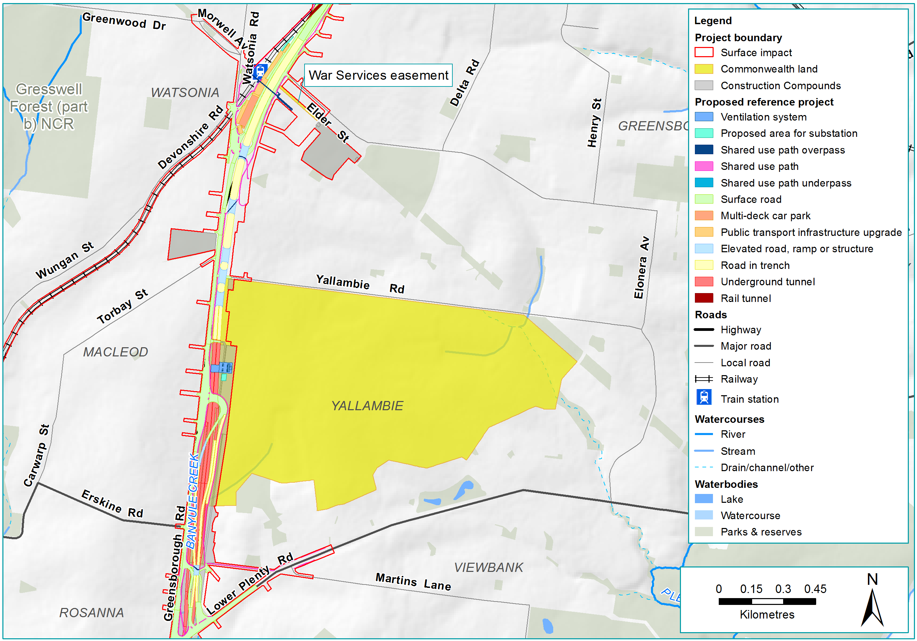
Figure 3-23 Construction in the vicinity of Commonwealth land

Operation aspects
It is anticipated that North East Link would be operational in 2027, following completion of construction. This section outlines how North East Link would operate. Following the transfer of land from Commonwealth to State ownership discussed in Section 3.2.8, the operation of North East Link would not take place on Commonwealth land.

Key operational and maintenance activities
Following construction of North East Link, the key operation and maintenance phase activities would include:
- Operation and maintenance of new road infrastructure, including tunnels
- Operation and maintenance of Freeway Management System
- Operation and maintenance of the tolling system
- Operation of North East Link motorway control centres
- Operation and maintenance of the tunnel ventilation system
- Operation and maintenance of water treatment facilities
- Operation and maintenance of the motorway power supply (substations)
- Maintenance of landscaping, paths, and drainage and stormwater treatment feature areas.

Road closures and changed traffic arrangements
The following permanent road closures on the existing network would be required, all related to the placement of the Manningham Road interchange.
- Greenaway Street – between Manningham Road and Bulleen Road
- Kim Close – adjacent to Greenaway Street
- Avon Street – access from Avon Street to Bulleen Road
- Nell Street – access to Nell Street from Greensborough Road
- Thompson Street – access from Thompson Street to Greensborough Road
- Temby Street – access from Temby Street to Greensborough Road.

Traffic management
A Freeway Management System is proposed for North East Link and the Eastern Freeway to manage traffic flows and deal with incidents during operation.
Toll-free roads for local trips would be maintained between the Eastern Freeway and the M80 Ring Road. Between the M80 Ring Road and Watsonia Road, Greensborough Road would be rebuilt on either side of North East Link and kept open for local toll-free trips. Between Watsonia Road and Lower Plenty Road, Greensborough Road would run next to North East Link and be kept open for local toll-free trips. Bulleen Road would also remain toll-free.
North East Link does not propose any new truck curfews. VicRoads has permanently implemented curfews on a number of roads, and these have been included in the strategic modelling. No additional truck bans have been considered in the strategic modelling. Over-dimensional vehicles and placarded vehicles would not be permitted to use the North East Link tunnels.

Public transport
Existing on-road bus services would be retained and public transport would be enhanced with the Doncaster Busway and associated bus station, and the Park and Ride facility.
North East Link would be located close to Watsonia railway station. Access across North East Link and into the Watsonia railway station precinct would be maintained. Works associated with the North East Link crossing of the Hurstbridge rail line near Grimshaw Street may require modification of the rail signalling and electrical networks along this line.

Staging of development and timing
An indicative construction schedule for the reference project is shown in ---Figure 3-24. The schedule is subject to further detailed analysis. As noted in Section 3.1 the reference project represents one possible design of the action, and so the indicative schedule represents one possible timeline for the action, and is subject to change.
A summary of the construction hours proposed for North East Link is summarised in Table 3-14.
Table 3-14 Construction hours for North East Link
Location | Normal construction hours
Above ground areas | - 7 am – 6 pm Monday to Friday  - 7 am – 1 pm Saturdays
Tunnelling support areas including:  - Site offices, staff amenities and car parking  - Precast tunnel lining storage area  - Spoil management facilities  - Water treatment plant  - Storage yard for construction materials  - Vehicles and equipment | - 24 hours per day, 7 days per week  - Truck movements on curfew roads (see Section 3.5.3) to be limited to 6 am – 10 pm
Due to the nature and volume of the required works, some construction activities would need to be undertaken outside of the normal daytime working hours in Table 3-14. Anticipated works during evening and night time would include:
- Works within the M80 Ring Road, Eastern Freeway and arterial road reserves
- Works over or in the immediate vicinity of the Hurstbridge rail line
- Tunnelling works
- Spoil handling and transport
- Delivery of oversized equipment and materials.
A Construction Noise and Vibration Management Plan would be developed and implemented to minimise noise impacts, including from evening and night time activities that are unavoidable and cannot meet the construction noise targets.

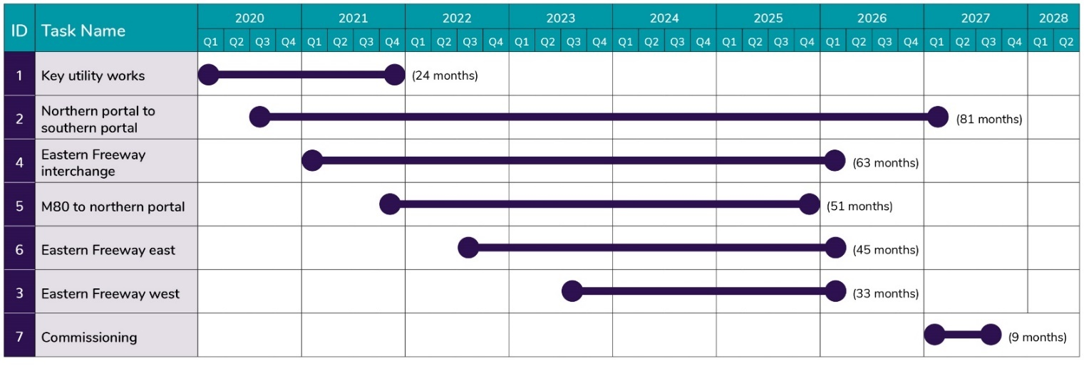
Figure 3-24 Indicative construction schedule
*Key utilities works includes key utility relocations and power substation construction.

