Chapter 6
Impact assessment
September 2019

Chapter 6

Impact assessment

Overview
This chapter describes how relevant impacts of North East Link on Matters of National Environmental Significance (MNES) and the environment on Commonwealth land have been assessed. This chapter responds to Section 2.5 of the Public Environment Report (PER) Guidelines.
Four technical reports were prepared to inform the PER and assessment of impacts. These reports are provided in the PER Technical Appendices A to D. Impacts and their significance were assessed taking into account relevant Environment Protection and Biodiversity Conservation (EPBC) Act Significant Impact Guidelines. Figure 6-1 provides an overview of this process.
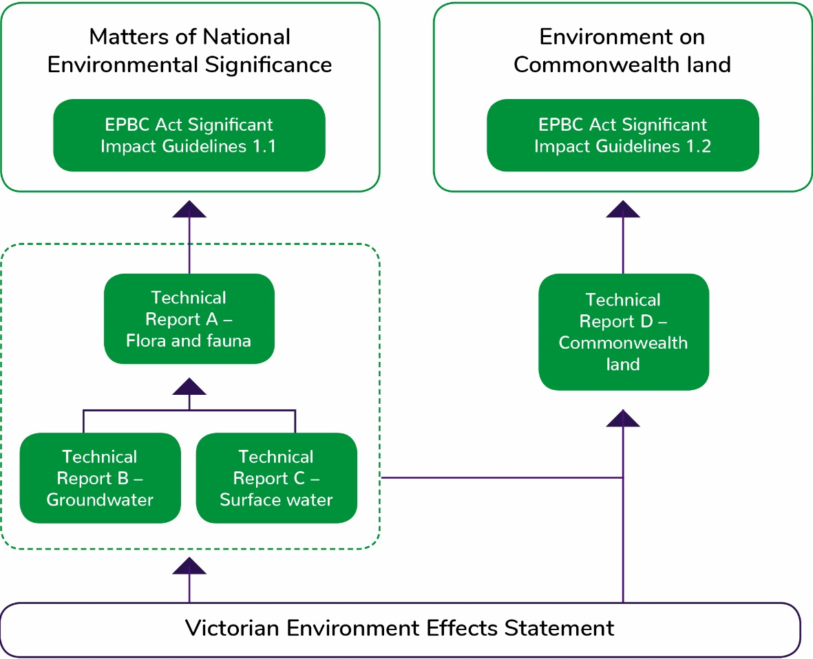
Figure 6-1 Assessment approach
- PER Technical Appendix A – Flora and fauna technical report provides a detailed assessment of the potential presence and relevant impacts on ecological MNES; specifically, listed threatened species and communities and migratory species. Potential impacts on MNES were assessed using the Commonwealth Environment Protection and Biodiversity Conservation Act 1999 (‘EPBC Act’) Significant Impact Guidelines 1.1 Matters of National Environmental Significance.
- PER Technical Appendix B – Groundwater technical report and PER Technical Appendix C – Surface water technical report describe the water resources that may support MNES and provide an assessment of potential water-related impacts. These technical reports describe the groundwater modelling and surface water quality assessment carried out and have provided supporting information to inform PER Technical Appendix A – Flora and fauna technical report.
- PER Technical Appendix D – Commonwealth land technical report contains an assessment of potential impacts on the whole-of-environment matters on Commonwealth land. Potential impacts were assessed using the EPBC Act Significant Impact Guidelines 1.2 Actions on, or impacting upon, Commonwealth land, and actions by Commonwealth agencies. PER Technical Appendix D – Commonwealth land technical report was informed by the findings of the ecology, groundwater and surface water assessments where relevant to Commonwealth land.
In addition to these technical reports the North East Link Project (NELP) has prepared a comprehensive Environment Effects Statement (EES) under the Victorian Environment Effects Act 1978. While separate to this PER, the EES process has informed the scope and focus of the PER technical studies and development of measures to avoid and mitigate potential impacts.
The EES is supported by 18 technical reports covering:
- Aboriginal cultural heritage  - Air quality  - Arboriculture  - Business  - Contamination and soil  - Ecology  - Greenhouse gas  - Ground movement  - Groundwater | - Historic heritage  - Human health  - Land use  - Landscape and visual impacts  - Social  - Surface noise and vibration  - Surface water  - Traffic and transport  - Tunnel vibration.

Impact assessment process
The PER technical reports set out the potential impacts of North East Link that were identified and assessed by technical specialists. Each report describes the relevant existing environment with respect to MNES and Commonwealth land, and the potential direct and indirect impacts of the construction and operation of North East Link. Measures to avoid, mitigate and where required, offset, identified impacts were considered iteratively for the impact assessment.
The impact assessment process has informed and been informed by community and stakeholder engagement (refer Chapter 14 – Consultation) and the development of the reference project (refer Chapter 3 – Description of the action). Figure 6-2 shows this process.
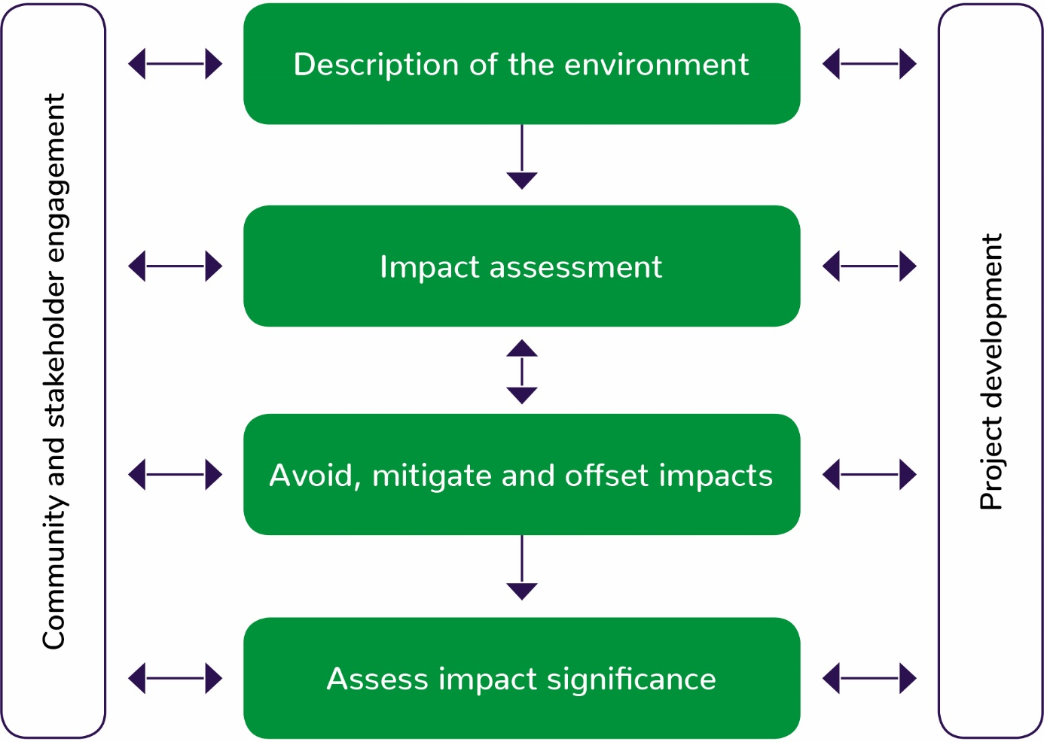
Figure 6-2 Impact assessment process

Description of the environment
Each technical specialist identified and characterised the environmental assets, values and uses that North East Link might impact. These assessments focused on the potential presence of or habitat for MNES, water resources that may support MNES, and the environment on Commonwealth land.
Each assessment considered:
- History, current use and condition of environmental assets and values
- Significance of environmental assets, values and uses
- Sensitivity or vulnerability to impacts.
The geographic area (study area) for each assessment differed for each technical study to reflect differences in the extent of risks and impacts for each discipline. In some cases, the study area extends beyond the project boundary or Commonwealth land boundary described in Chapter 3 – Description of the action. For example, the surface water assessment assesses the potential for works within the project boundary to change surface water quality and flows downstream, outside the project boundary.
The description of the environment is summarised in Chapter 5 – Description of the environment and detailed in the PER Technical Appendices A – D.

Impact assessment
The changes that would result from the construction and operation of North East Link are called impacts. Impacts can be positive or negative. Impacts can be a direct result of an action, or can occur indirectly, such as impacts on habitat for MNES due to a change in groundwater conditions. The nature and extent of any impact is measured against the current environmental conditions, considering the differences between the project and ‘no project’ scenarios.
The following factors were considered when assessing potential impacts:
- Severity, including the intensity, duration, timing and frequency, and scale or geographic extent of impacts
- The relationship between different impacts on the environment
- The likely effectiveness of measures to avoid and mitigate adverse impacts
- The likelihood that any given environmental impact would occur
- Whether any impacts are likely to be unknown, unpredictable or irreversible
- Benchmarks and requirements set by statutory requirements, policies and guidelines
- Community expectations
- The principles of Ecologically Sustainable Development and objects and requirements of the EPBC Act.
In some cases, specific methods for impact assessment were developed by technical specialists and, where relevant, these are documented in the PER Technical Appendices A – D.
The assessment of relevant impacts is summarised in Chapter 7 to Chapter 9 and detailed, together with maps, in the PER Technical Appendices A – D.

Avoid, mitigate and offset impacts
Measures to avoid and mitigate impacts were developed in response to the impact assessment to reduce impacts on MNES and the environment on Commonwealth land.
These measures include refinements to the reference project and specification of measures to avoid and mitigate environmental impacts during the construction and operation of North East Link.
The final reference project is described in Chapter 3 – Description of the action. A consolidated list of avoidance and mitigation measures and the framework for implementing these measures is provided in Chapter 10 – Proposed avoidance and mitigation measures.
Where impacts could not be reduced through avoidance and mitigation measures, environmental offsets have been proposed in accordance with the EPBC Act Environmental Offsets Policy (DSEWPAC, 2012) and the Victorian Guidelines for the removal, destruction or lopping of natural vegetation (DELWP, 2017). These are described in Chapter 11 – Offsets.

Assess impact significance
The significance of relevant impacts was assessed against the EPBC Act Significant Impact Guidelines for each MNES and the environment on Commonwealth land. The assessment also addressed the requirements of the PER Guidelines (Sections 2.5.1, 2.5.2 and 2.5.3) and the Significant Impact Guidelines 1.1 and 1.2. This assessment took into account the current environmental context and the likely effectiveness of measures to avoid, mitigate and offset potential impacts.
The potential significance of impacts is documented in Chapter 7 to Chapter 9 and the PER Technical Appendices A – D.

Cumulative impacts
Cumulative impacts are difficult to measure, particularly for an area that has been continually disturbed and urbanised over the past 100+ years. Cumulative impacts were therefore assessed qualitatively. The cumulative impact assessment considered other projects with similar scale and activities to North East Link as well as the history, current use and condition of environmental assets and values within the project boundary.
A number of major infrastructure projects will be under construction in Melbourne at the same time proposed for North East Link, including the West Gate Tunnel Project and the Metro Tunnel. These projects are similar in nature, and have the potential for similar impacts as North East Link, albeit in different geographical areas.
In addition, an upgrade of the M80 Ring Road (otherwise known as the Metropolitan Ring Road) where it intersects with the northern end of North East Link is planned. Activities associated with this upgrade are scheduled to occur before the proposed start of North East Link construction.
The nature and extent of future works by the Department of Defence at Simpson Barracks is currently unknown.
Where impacts from more than one of these activities have the potential to affect the same assets, values or uses as North East Link, cumulative impacts could result. These impacts have been considered, where relevant, in each of the PER technical reports.

Facilitated impacts
Facilitated impacts are those which result from actions which are enabled by North East Link. An example of a facilitated impact is greenhouse gas emissions from new vehicle trips that would unlikely have occurred if a new road had not been constructed.
Facilitated impacts are easier to identify in rural or wilderness settings where the relationship between one project and future developments can be isolated. In an urban setting where a project would contribute to a complex wider system and pattern of land uses, it is very difficult to assign such specific relationships.
North East Link would redistribute existing traffic around Melbourne, facilitating more efficient travel and linking people with jobs rather than creating new trips to new destinations that are currently inaccessible. Accordingly, North East Link is not considered likely to facilitate further impacts on MNES or the environment on Commonwealth land at a local, regional, state or national scale.

