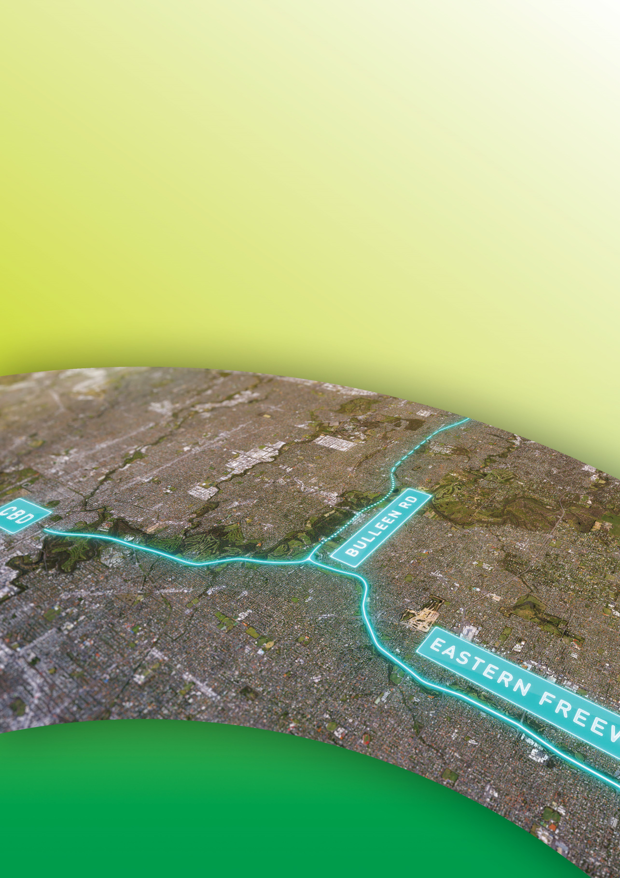
Public Environment Report

Attachment V

List of persons and agencies consulted
during the PER
September 2019

Attachment V
List of persons and agencies consulted during the PER
As required by Section 1.2 of the PER Guidelines for the Content of a Draft Public Environment Report (DoEE, 2018), this attachment contains a list of persons and agencies consulted during the preparation of the PER (Table V-I and Table V-II). The list includes those that were contacted specifically regarding the PER.

The PER was developed in parallel with preparation of the North East Link Environment Effects Statement under the Victorian Environment Effects Act 1978. Technical studies involved consultation with various persons, agencies and the community to inform both assessments. Consultation that contributed to the preparation of the draft PER, is summarised in Table V-I below. Consultation that occurred during the exhibition of the draft PER is summarised in Table V-II below.

Refer to Chapter 14 – Consultation for more detail on the extensive consultation program undertaken with stakeholders and communities to support the environmental assessments and the development of North East Link as part of the preparation of the draft PER. Chapter 14 also describes the consultation undertaken and proposed through the exhibition and as part of finalising the PER.

Table V-I Persons and agencies consulted during the preparation of the draft PER

Stakeholder | Interest | Consultation during the preparation of the draft PER | Key contacts
Department of the Environment and Energy | Administers the process of assessment under the EPBC Act. | Consultation regarding the PER and the scope of assessment including:  - Discussions about North East Link EPBC referral  - Discussions about the PER Guidelines for the action  - A visit to site accompanied by North East Link Project (NELP) on 20 June 2018  - Regular telephone conferences to clarify aspects of the PER Guidelines  - Reviews of PER and subsequent discussions on comments received. | Alexandra Dunbar/Lucy Butterfield/David Carter.  Assessments and Governance Branch.
Department of Defence | Owner of Simpson Barracks and oversees operation, administration and management. | Confirmation of the accuracy of draft history, description, use and historical heritage values of Commonwealth land at Simpson Barracks.  Discussions related to potential for impacts on the operation of Simpson Barracks from the construction and operation of North East Link.  Discussions relating to the property transfer of the Commonwealth land within the Project boundary.  Reviews of PER and subsequent provision of comments
Department of Defence – Management of Simpson Barracks | Responsible for activities at Simpson Barracks. | Regular contact throughout the assessment phase with the Simpson Barracks management to discuss ongoing issues in relation to the action.  An information ‘drop-in’ session on  19 September 2018 with a presentation to the management team and Q&A session.  Discussions related to potential for impacts on the operation of Simpson Barracks from the construction and operation of North East Link.  Discussions relating to the property transfer of the Commonwealth land within the Project boundary.  Reviews of PER and subsequent provision of comments. | John Papanikalou Base Manager Simpson Barracks & Sites.  Mick Lawlor, Assistant Base Manager, Simpson Barracks and Sites.  Captain Rob Glanvill, Estate Planning.  Jess Potts, Assistant Director, Estate Planning.

Stakeholder | Interest | Consultation during the preparation of the draft PER | Key contacts
Department of Defence – Defence Estate Environment team | Responsible for environmental management and conservation of natural resources on Defence estates. | Regular contact throughout the assessment phase with the Environment team to discuss ongoing issues in relation to the action.  Meetings to discuss translocation of Matted Flax-lily. | Robert Cameron, Environment and Sustainability Manager, South East Zone/Service Delivery Division, Estate and Infrastructure Group.  Anne-Marie Tenni, Assistant Director Environment & Sustainability SEZ, South East Zone/Service Delivery Division, Estate and Infrastructure Group.  Tim McKay, Environmental Planning, Assessment & Compliance, Environment & Engineering Branch, Department of Defence.

Table V-II Persons and agencies consulted during the exhibition of the draft PER

Stakeholder | Interest | Consultation during the exhibition of the draft PER | Key contacts
Department of the Environment and Energy | Administers the process of assessment under the EPBC Act. | Discussions following the exhibition of the draft PER regarding next steps in the process. | Alexandra Dunbar/Lucy Butterfield/David Carter.  Assessments and Governance Branch.
Department of Defence – Defence Estate Environment team | Responsible for environmental management and conservation of natural resources on Defence estates. | Regular contact throughout the exhibition and post-exhibition phases with the Environment team to discuss various aspects of the action.  Meetings following the exhibition of the PER to discuss groundwater and flora and fauna impacts. | Robert Cameron, Environment and Sustainability Manager, South East Zone/Service Delivery Division, Estate and Infrastructure Group.  Anne-Marie Tenni, Assistant Director Environment & Sustainability SEZ, South East Zone/Service Delivery Division, Estate and Infrastructure Group.  Tim McKay, Environmental Planning, Assessment & Compliance, Environment & Engineering Branch, Department of Defence.

