- ASSESSMENT FRAMEWORK

SECTION PAGE SECTION PAGE

  - Introduction 4.2
  - Objectives 4.2
  - Evaluation framework 4.4
  - EES assessment 4.5
    - Studies responding to draft EES evaluation objectives in Section 4
of the Scoping Requirements 4.7
    - Studies responding to Section 3.5
of the Scoping Requirements 4.7
    - Existing conditions 4.7
4.4.4 Impact assessment 4.8
4.4.5 Risk assessment 4.8
4.4.6 Environmental management 4.10
4.4.7 Integrated assessment 4.11
  - Consultation 4.11
  - Key approvals 4.11

Introduction
4.2 Edithvale and Bonbeach Environment Effects Statement | Assessment Framework

This chapter describes how the EES for the Edithvale and Bonbeach level crossing removal projects has been prepared. It also describes how the environmental risks and potential impacts of the projects have been investigated and the development of the Environmental Management Framework (EMF).

Objectives
The objectives of the assessment framework for the Edithvale and Bonbeach level crossing removal projects are to:
- set out how the three matters specified in the Scoping Requirements issued by the Minister for Planning are assessed:
  - groundwater
  - biodiversity
  - contaminated and acid sulfate soils
- set out how any additional matters identified during preparation of the EES are assessed
- identify potential adverse environmental effects that require management
- provide a risk-based approach to enable a comparative evaluation of potential effects
- ensure the EES responds to statutory approval requirements, policies and guidelines that apply to the projects
- identify any changes to the projects’ design or construction methodology necessary to address risks to the environment
- develop a robust EMF for the projects.
This assessment framework demonstrates how different components of the EES assessment process outlined
Environment
‘Environment’ is a broad term that includes ecological, cultural, social, heritage, health, safety and economic aspects.
in Figure 4.1 come together to provide a comprehensive assessment of the potential environmental effects of the Edithvale and Bonbeach level crossing removal projects and how this informs the approach to the environmental management of the projects.
The relationship between the components of the process are also shown in Figure 4.1 and described in further detail in this chapter.

Figure 4.1 Components of the EES assessment process
Edithvale and Bonbeach Environment Effects Statement | Assessment Framework 4.3

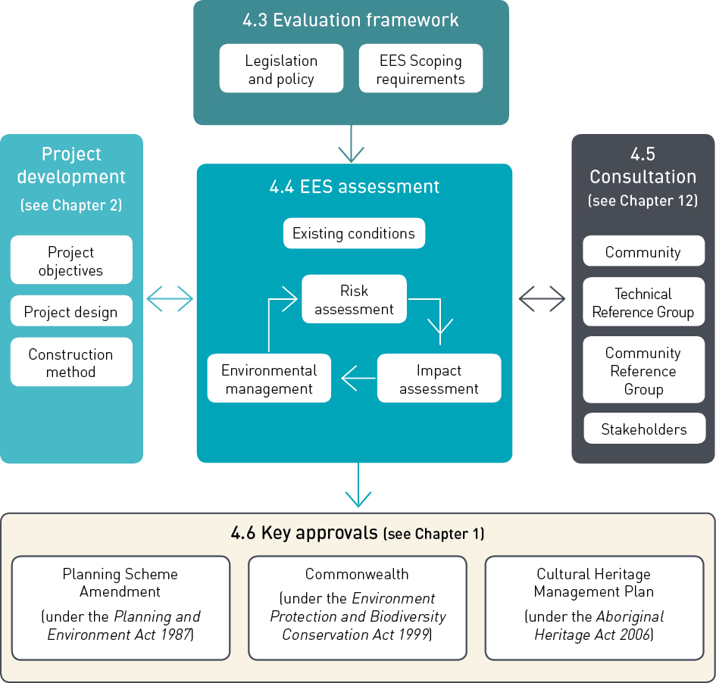

Evaluation framework
The legislation, policies and guidelines relevant to the draft EES evaluation objectives established by the Scoping Requirements for the Edithvale and Bonbeach level crossing removal projects are outlined in Table 4.1. This is the regulatory framework which drives much of the assessment presented in the EES. The table indicates where further information can be found within the EES main report, attachments and technical reports.
A complete list and description of all applicable legislation, policy and guidelines considered for the EES is provided in Attachment I Legislation and policy.

Table 4.1 EES draft evaluation objectives and corresponding legislation, policy and guidelines

Draft evaluation objectives | Key legislation | Policies and guidelines | Further information
Groundwater  To minimise effects on the regional groundwater regime  and quality, particularly as they might impact on the hydrology  of the Edithvale- Seaford Wetlands and elsewhere on other beneficial users. | Environment Protection and Biodiversity Conservation Act 1999  National Environment Protection Council Act 1994  Environment Protection Act 1970  Water Act 1989  National Water Quality Management Strategy 1994 | State Environment Protection Policy (Groundwaters of Victoria)  National Environment Protection (Assessment of Site Contamination) Measure (NEPC 2013) | Chapter 5 Modelling the water environment  Technical Report A  Groundwater
Biodiversity  To avoid, minimise and/ or offset adverse effects on native vegetation, listed threatened species and ecological communities, listed migratory species,  the Ramsar listed Edithvale-Seaford Wetlands, other protected flora and fauna and groundwater dependent ecosystems. | Environment and Biodiversity Protection Act 1999  Planning and Environment Act 1987, including Kingston Planning Scheme  Flora and Fauna Guarantee Act 1988  Wildlife Act 1975  Fisheries Act 1995  Catchment and Land Protection Act 1994 | Guidelines for the removal, destruction or lopping of native  vegetation (DELWP 2017) | Chapter 6 Edithvale- Seaford Wetlands and groundwater dependent ecosystems  Chapter 8 Potential local impacts at Edithvale and Bonbeach  Technical Report B Ecology: Wetlands and Groundwater Dependent Ecosystems  Technical Appendix D Ecology: Project Areas

Draft evaluation objectives | Key legislation | Policies and guidelines | Further information
Acid sulfate soils and contamination  To prevent adverse environmental or health effects from disturbing, storing or influencing the transport/movement of contaminated or  acid-forming material. | Environment Protection Act 1970  Planning and Environment Act 1987  Catchment and Land Protection Act 1994 | State Environmental Protection Policy (SEPP), Prevention and Management of Contamination of Land  Industrial Waste Resource Guidelines  Industrial Waste Management Policy (Waste Acid Sulfate Soils) Special Gazette S125 published on 18 August 1999  Best Practice Environmental Guidelines (BPEG), Environmental Guidelines for Major Construction Sites | Chapter 7  Acid sulfate soils and contamination  Chapter 8  Potential local impacts at Edithvale and Bonbeach  Technical Report C Acid Sulfate Soils and Contamination

EES assessment
The Scoping Requirements issued by the Minister for Planning require a focus on three key issues: groundwater, biodiversity, and contamination and acid sulfate soils. The Scoping Requirements include specific draft evaluation objectives for each of these issues that have been used to guide the EES assessment.
The EES and supporting assessments have therefore focused on these three key areas.
LXRA has also undertaken a range of other studies to identify any other potential adverse environmental effects of the projects to ensure that they are identified, avoided, minimised or effectively managed.
The EES assessment has used a systematic risk-based approach to understanding the existing environment, the potential impacts of the projects on the environment and to evaluate the effectiveness of measures to avoid, minimise or manage the risk of impact. The process is set out in Figure 4.2 and described in Sections 4.4.1 to 4.4.7.

Figure 4.2 The EES assessment framework
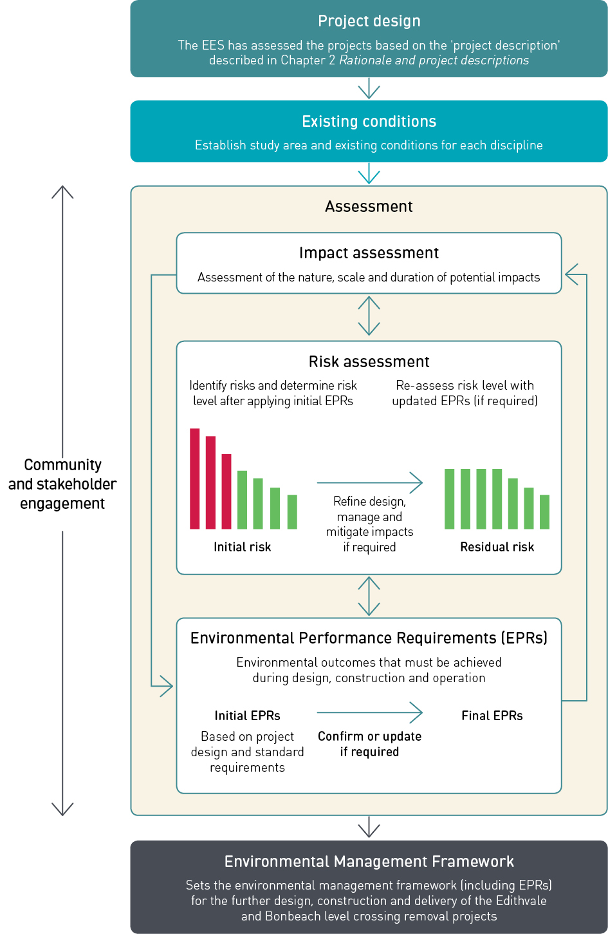

    - Studies responding to draft EES evaluation objectives in Section 4 of the Scoping Requirements
Studies responding to the draft evaluation objectives cover the following:
- Groundwater
- Biodiversity, with a particular emphasis on groundwater dependent ecosystem, such as the Edithvale-Seaford Wetlands that could be affected by the projects
- Contamination and acid sulfate soils.
The studies on these aspects are provided in Technical Reports A to C and discussed in detail in Chapters 5 to 7. These three studies have undergone a peer review by an independent specialist.

Studies responding to Section 3.5 of the Scoping Requirements
LXRA has also undertaken a range of studies to address the remaining environmental aspects potentially affected by the projects. These studies will inform the preparation of an EMF to address Section 3.5 of the Scoping Requirements.
Studies were undertaken to address the following issues:
- ecology (within the project areas)
- surface water
- land use and planning
- traffic
- noise and vibration
- air quality
- landscape and visual
- business
- social
- Aboriginal cultural heritage
- historic cultural heritage.

Existing conditions
The assessment of the current condition of the environment is called an existing conditions assessment. An existing conditions assessment identifies the environmental context for the projects and provides the baseline conditions for the impact assessment. Each of the 14 specialist studies completed for this EES undertook an existing conditions assessment, which collectively provides the environmental context for the projects.
Each study considered the area within which potential effects could occur (the zone of influence, or study area). In some cases, this area extends beyond the project areas presented in Chapter 1 Introduction.
For example, the existing conditions assessment for air quality considered the current air quality at and around the Edithvale and Bonbeach project areas, and the location of residences, schools and parks close to the project areas that could be affected by changes to air quality, whereas the existing conditions assessment for the landscape and visual impact assessment considered an area of 500 metres from the proposed infrastructure. Beyond this distance, it was anticipated that the combined effects of distance, intervening landform, built form and vegetation would combine to ensure there are no potential landscape and visual effects.
The existing conditions for each of the specialist studies are summarised in EES Chapters 5 to 8 and detailed in the specialist Technical Reports A to N.

Peer review

The following specialist studies were independently peer reviewed:
- Groundwater
- Ecology: Wetlands and Groundwater Dependent Ecosystems
- Acid Sulfate Soils and Contamination.

The reviewer considered the assumptions, methodology, assessment criteria and scope applied in the reports. They also reviewed the results to ensure their consistency with the methodology adopted. The final peer review reports are appended to the three specialist reports listed.

Impact assessment
A change that would result from the implementation of the projects is called an impact. The nature and extent of any impact is measured against the existing conditions assessment.
The following factors may be considered when determining the significance of potential environmental impacts of the projects:
- magnitude, extent and duration of impact on aspects of the environment
- the relationship between different impacts on the environment
- the likely effectiveness of measures to avoid, minimise and manage impacts
- the likelihood that any given environmental impact would occur
- benchmarks and requirements set by statutory requirements and environmental approvals
- the policies and guidelines that apply to the proposed projects
- community expectations
- the principles of ecologically sustainable development as defined in the Ministerial guidelines for assessment of environmental effects (DSE 2006).
The impact assessments for each of the specialist studies are summarised in Chapters 7-11 and detailed
in the specialist Technical Reports A to N. The studies recommended EPRs to manage and mitigate impacts. Where potential impacts were determined to be unacceptable, the specialists identified additional or revised EPRs that could be adopted to reduce risks and impacts. Where additional EPRs were identified, the risk assessment was revised to determine the residual risk, taking into account the final EPRs.

Risk assessment
The risk assessment was conducted using an approach which is consistent with AS/NZS ISO 31000:2009 Risk Management Process.
The overall risk management process involves the following steps:
- establishment of the context of the risk assessment
- risk identification
- risk analysis
- risk evaluation
- risk treatment.

Definition of risk
Risk can be defined as a combination of:
- the likelihood of an event occurring
- the magnitude of potential consequences of the event.
The risk assessment combines the likelihood of an impact occurring and the consequences if that impact was to occur, to arrive at an overall risk rating.

Assigning likelihood of risks
For the purposes of this risk assessment, the likelihood was determined in consideration of both the likelihood of an event occurring, and the likelihood of that event causing an impact. An overall likelihood rating was assigned using the guide in Table 4.2 below which has been used for other EESs in Victoria.

Table 4.2 Likelihood guide

Qualitative descriptors | Basis
Certain | Certain, or as near to as makes no difference
Almost certain | One or more incidents of a similar nature has occurred here
Highly probable | A previous incident of a similar nature has occurred here
Possible | Could have occurred already without intervention
Unlikely | Recorded recently elsewhere
Very unlikely | It has happened elsewhere
Highly improbable | Published information exists, but in a slightly different context
Almost impossible | No published information on a similar case

Assigning the consequences of risks
In this risk assessment, the consequences of a risk occurring was assigned by specialists using a consequence guide.
Consequence levels may be described in terms of multiple factors (e.g. magnitude, extent and duration).
The purpose of the consequence guide is to achieve consistency when estimating consequence levels across the different technical disciplines (such as air, noise, visual, ecology) and over four main categories (social, environmental, economic and public health and safety).
The consequence guide in Table 4.3 presents an example of the type of information included in the consequence table. A full version of the consequence table is provided in the risk report (EES Attachment II Environmental risk report) and has specific consequence descriptions for each of the specialist investigations.

Table 4.3 Example consequence guide

Qualitative descriptors | Negligible | Minor | Moderate | Major | Extreme
Generic Consequence Description | Minimal, if any impact for some communities.  Potentially some impact for a small number (<10)  of individuals | Low level of impact for some  communities, or high impact for a small number (<10) of individuals | High level of impact for some  communities, or moderate impact for communities area-wide | High level of impact for communities area-wide | High level of impact state-wide

The consequence table used in the risk assessment is based on similar guides used in other Victorian EESs and has been tailored for this EES based on advice and input from the study specialists.

Risk workshops
The risk assessment process included workshops with a wide range of experts including the specialists responsible for preparing the technical assessments that inform the EES, design engineers, construction specialists and community engagement and consultation specialists.

The risk workshops involved the following steps:
Risk profile
A risk profile is a bar graph which summarises the outputs of the risk assessment so that easy comparison can be made between major, moderate and minor risks.
- risk identification
- risk analysis
- risk evaluation.
A list of potential risks was developed for each project with subject matter specialists, and provided to workshop attendees for review prior to the workshop. Cumulative risks from the concurrent construction of both projects were also considered. This preliminary list was then reviewed at the workshop and amended with input from workshop participants.

Risks were analysed by assigning likelihood and consequence ratings.
The likelihood of occurrence for each of the risks was estimated for the construction phase of the projects and the operation phase as relevant. The subject matter specialists were asked to use their expert knowledge and assign best estimate consequences for the risks relevant to their discipline.
The likelihood and consequence ratings assume that any management and mitigation measures to reduce the level of risk are in place (see Section 4.4.6 below).
The outputs from the workshops were entered into a risk model, which produced risk profiles showing the overall risk level, as well as individual components (environment, social, economic and public health and safety) that contribute to the risks.
The level of risks and potential impacts have been continually reviewed throughout the EES assessment process and have been updated as necessary in light of specialist investigations and as understanding of the potential impacts of the projects has increased.

Environmental management
The Environmental Performance Requirements (EPRs) define the environmental outcomes that must be achieved during design, construction and operation of the Edithvale and Bonbeach level crossing removal projects, regardless of the detailed design solutions adopted.
The 14 technical specialists developed an initial set of EPRs as part of their impact assessments. These initial EPRs were based on compliance with legislation and standard requirements that are typically incorporated into the delivery of construction contracts for rail projects. These assessments evaluated the environmental effects of the projects and the proposed construction methodologies. Through the risk assessment process outlined above, the initial set of EPRs was refined to a final set of EPRs.
A complete list of EPRs is set out in Chapter 9 Environmental Management Framework.

Avoid, minimise or manage hierarchy

The EES assessment framework adopts the following approach when a potential environmental impact is identified:

      - Avoid the impact – through changing a design parameter or construction approach
      - Minimise the impact – if an impact cannot be avoided, the design or construction approach would be changed so that the potential impacts are minimised
      - Manage the impact – if an impact cannot be avoided or minimised, effective management controls would be put in place to ensure
that the potential impacts are reduced to acceptable levels.

Integrated assessment
Each specialist has worked closely with others to ensure that any relationships between the different studies that inform the EES have been identified.
To fully identify and assess potential impacts, the EES has given consideration to the existing conditions and potential impacts relevant not only to each aspect of the environment in isolation, but also impacts that may result when various aspects of the environment are considered together.
This may include the use of data collected by another discipline, or the reliance on one study’s result to inform the assessment in another study. The clearest example of this is the critical dependency the wetland ecology assessment has on the outputs of the groundwater modelling. Without the modelling results, the potential impacts to the Ramsar listed Edithvale-Seaford Wetlands cannot be determined.
EPRs for individual specialist topics do not operate in isolation. In assessing impacts and risk, the impact assessment studies have cross-referenced EPRs from other technical areas as relevant.
The interactions were identified through concurrent preparation of the scopes for each technical assessment, scheduling assessments simultaneously to ensure necessary information was available and the integrated risk-based approach outlined above.

Consultation

Consultation was undertaken during the early investigations, options assessment and design

development stages of the projects. As discussed in Chapter 12 Community and stakeholder

engagement, LXRA undertook significant community consultation prior to the preparation

of the EES to help understand concerns ahead of determining a design solution.
During the EES phase, councils and relevant government agencies were engaged through the EES Technical Reference Group (TRG). The TRG provided advice to the project team on key issues and concerns from their respective areas of interest. This ongoing engagement has enabled the key issues and interests of state and local government to be incorporated into the EES.
A Community Reference Group (CRG) was also formed with an independent chairperson to strengthen links with the community and to share information about the ongoing development of the projects. The CRG would continue to meet through the further development and delivery of the projects. The group supported broader engagement activities including community workshops and one-on-one meetings. This engagement provided an understanding of the concerns and preferred outcomes of local residents, businesses and other interested parties and ensured that these were considered in the design and assessment process.
Chapter 12 Community and stakeholder engagement describes where community and stakeholder feedback has informed the project design development and the EES.

Key approvals

As discussed in Chapter 1 Introduction, the key approvals required for the projects are:
- Commonwealth approval by the under the Environment Protection and Biodiversity Conservation Act 1999
- Planning Scheme Amendment under the Planning and Environment Act 1987
- Cultural Heritage Management Plan (CHMP) under the Aboriginal Heritage Act 2006.
These are summarised in Chapter 1 Introduction with details of the applicable legislation provided in Attachment I Legislation and policy.

This page has intentionally been left blank

