May 2025

#### Works Notification

Overnight closure of the Doncaster Road and High Street intersection

#### We're upgrading the Eastern Freeway with new express lanes, new traffic management technology, Melbourne's first express busway and a seamless connection to North East Link.

#### What we're doing

​As part of the Eastern Freeway Upgrades, we're building a new Doncaster Road interchange. To keep traffic moving through the area during construction, we're building a temporary Ringwood-bound exit ramp. Traffic will shift on to the new temporary exit ramp from late May 2025.

To prepare for the traffic shift, we're working at night along Doncaster Road and High Street to move barriers, place asphalt in new areas, install new traffic signals and adjust line marking.

To complete works safely, there will be:

* An overnight full road closure of the Doncaster Road and High Street intersection
* Four overnight closures of the existing Ringwood-bound exit ramp
* Speed reductions and lane closures along Doncaster Road and High Street.

Please look for signs on the road for dates and times. Traffic management will be in place to guide motorists around the works.

#### When we'll work

We'll be working at night along Doncaster Road and High Street from Monday 26 May to Friday 30 May, between 9pm and 6am each night.

#### What to expect

* Construction vehicles, trucks and workers in the area
* Noise, light towers, vibration and dust from machinery and equipment.

Please note that these works and dates are subject to weather conditions, any changes will be re-notified to the community.

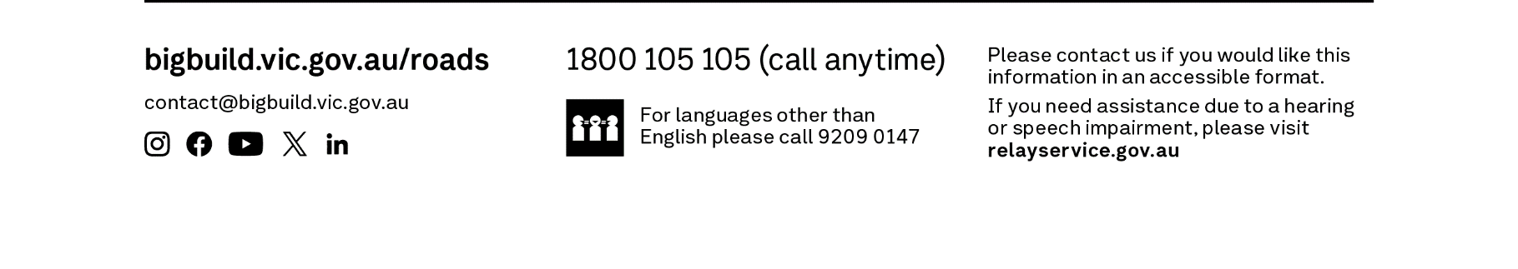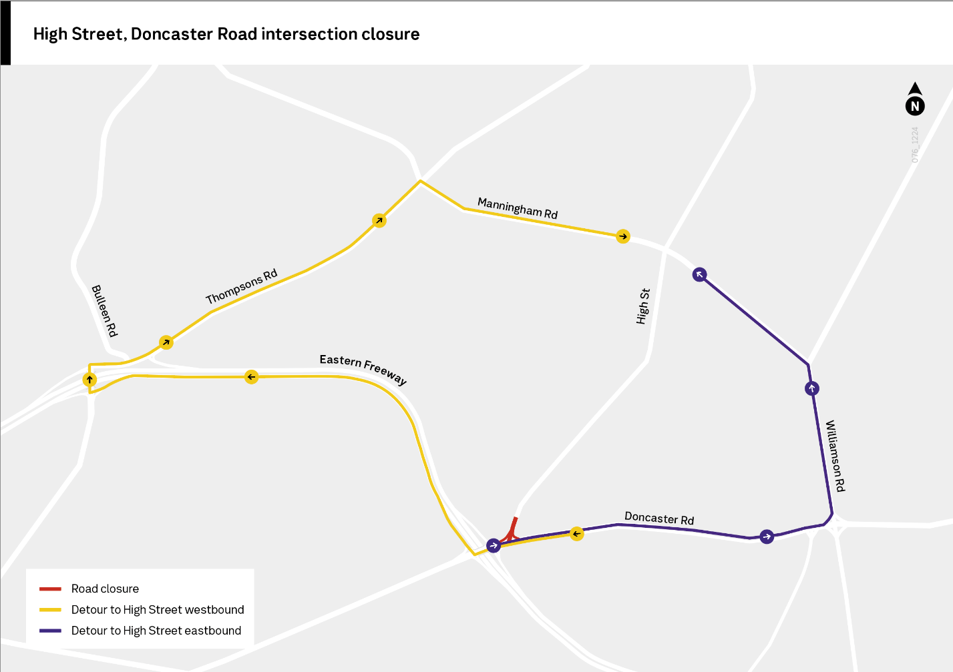

#### Managing impacts

We carefully manage our works in line with the project's strict environmental performance requirements including:

* Scheduling noisier works early in the evening, where possible
* Monitoring noise and vibration levels with real time monitoring, when required
* Minimising light spill with targeted lighting
* Preventing dust and water runoff with environmental controls

#### Keeping in touch

As works on the Eastern Freeway Upgrades progress, we've started sending out weekly email updates with specific details on night works to ensure that residents have the latest information on upcoming night works near you. If you would like to be included in the weekly email, please call us on 1800 105 105 or email us at contact@bigbuild.vic.gov.au to sign up.