Tuesday 13 March 2018

The West Gate Tunnel Project

The West Gate Tunnel Project is Victoria’s long overdue alternative to the West Gate Bridge that will take trucks off local roads in the inner west, create 6000 jobs and slash congestion all the way along the M1 corridor.

It will upgrade the West Gate Freeway and link it to the city and CityLink, with new tunnels under Yarraville and bridges over the Maribyrnong River. Construction is now underway.

There are three construction precincts: West Gate Freeway, Tunnels and Port to City.

You are in the West Gate Freeway precinct.

Current construction activity in the West Gate Freeway precinct

Works have started in the Williamstown Road area, where the new inbound tunnel entrance will be located. We will be building a temporary inbound exit ramp at Williamstown Road and widening the freeway over Williamstown Road.

Traffic barriers are also being progressively installed along the West Gate Freeway and ramps, between Grieve Parade and Williamstown Road. While barriers are in place an 80km/h speed limit will be in effect.

The latest traffic updates will always be available at westgatetunnelproject.vic.gov.au.

Upcoming construction activity in the West Gate Freeway precinct

Over the coming months, we will continue site investigations, including geotechnical, surveying and underground service investigations, in a number of locations along the freeway and surrounding areas.

Our team will also be preparing for freeway widening works by clearing work areas, relocating utilities and removing roadside vegetation.

There may be some localised changed traffic conditions both during these works and construction. You can keep up to date on disruptions on the project website westgatetunnelproject.vic.gov.au.

Work hours

Traffic barrier installation, project investigations and lane changes on the West Gate Freeway will occur overnight.
Our standard working hours are:
- 7am-6pm, Monday to Friday
- 7am-3pm on Saturdays.

We will notify you if work is going to occur in residential areas outside these hours.

You can read more about how we are managing construction impacts in the Construction Overview.

Property condition surveys

We will be contacting property owners closest to major works in the coming months to offer a property condition survey. Properties will be inspected before and after construction. If there is any damage resulting from the project, it will be fixed. Owners will be provided with a copy of the condition survey for their records.

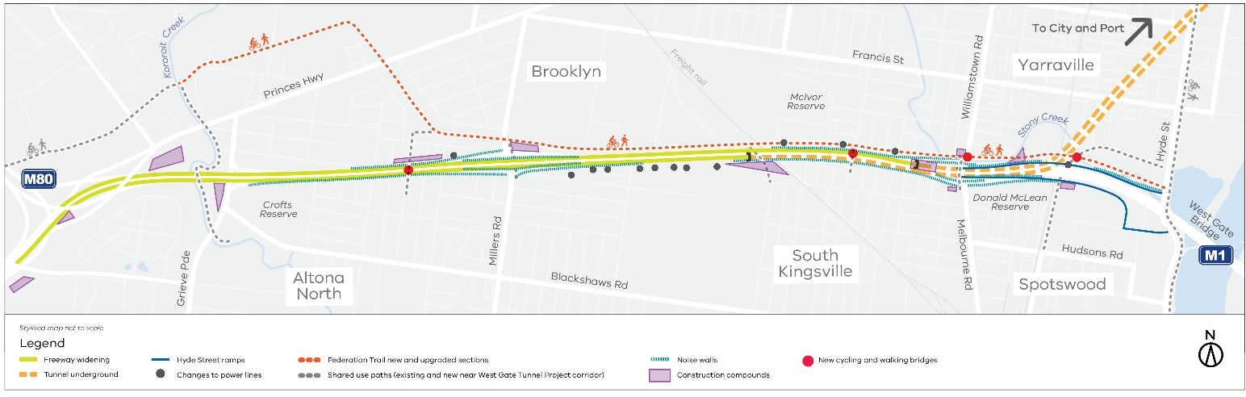
Map of the West Gate Freeway precinct

Keeping you informed

We have a dedicated team who will keep you informed about construction activities in your area. You will hear from us through:
- Community notifications
- Regular newsletters
- Doorknocks
- Phone calls, emails and SMS
- Social media
- Local events and information sessions
- Updates in local newspapers
Our West Gate Tunnel Project Visitor Information Centre will also open this year, providing a one-stop-shop for project information and enquiries.
Thank you for your interest in the project. If you need more information or would like to provide feedback, please get in touch via the details below.
Contact us
westgatetunnelproject.vic.gov.au
westgatetunnelproject@wda.vic.gov.au
1800 105 105
facebook.com/westgatetunnelproject
@westgatetunnel
West Gate Tunnel Project
GPO Box 4509
Melbourne Victoria 3001
Interpreter service: 13 14 50

