Reference: WES1902.09
25 February 2019
Works notification – The Avenue reserve

Installation of new power poles

As we widen the West Gate Freeway from four lanes to six in each direction, we need to safely relocate existing power lines that currently run along the West Gate Freeway. This means will are installing six new power poles in the reserve near the corner of the Avenue and Strong Street.
Installation of new power poles
4 March 2019 – 8 March 2019
These works will include:
- delivery of the six poles to the reserve near the corner of The Avenue and Strong Street;
- drilling holes into the ground to prepare for installation of the poles; and
- installing the poles (between 10 and 14metres in height) by standing them up with a crane.

These works will generally be carried out from Monday to Friday between 7am - 6pm and Saturday between 7am - 3pm. When works are scheduled out of hours and may have a direct impact on you, we will provide further information before the works start.
What you could expect:
- the reserve will be closed during these works;
- an increase in construction vehicles within the area;
- construction noise can be expected during the day from our machinery and trucks;
- the current pedestrian and vehicle access arrangements will remain in place; and
- water spray trucks to help manage dust and dirt and loads will be covered when dirt and rock are being transported.

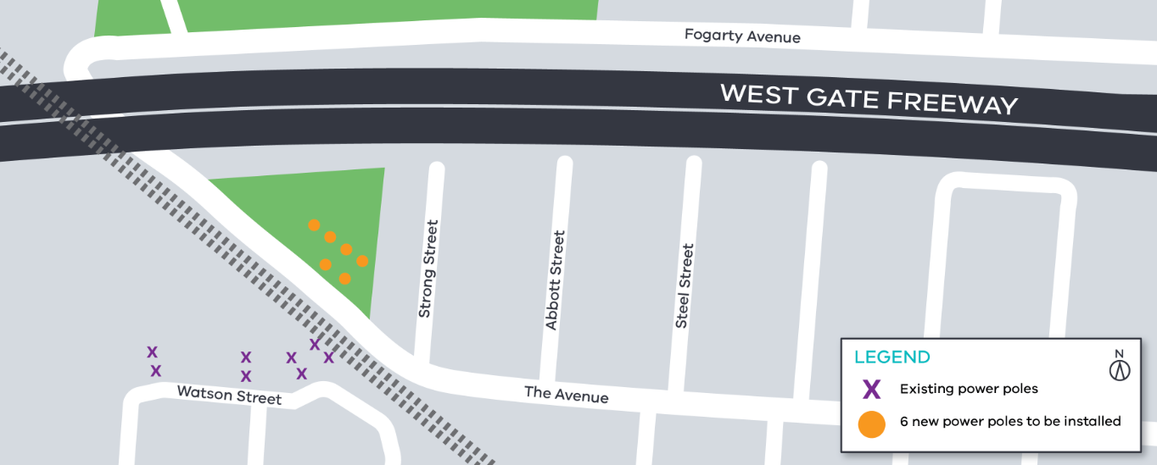
Please note that works may be rescheduled in the event of bad weather or other unavoidable circumstances.
Power pole installation location
Contact us
Please contact us if you have any questions or feedback about these works.
 | westgatetunnelproject.vic.gov.au |  | facebook.com/westgatetunnelproject
 | info@wgta.vic.gov.au |  | @westgatetunnel
 | 1800 105 105 |  | West Gate Tunnel Project  GPO Box 4509  Melbourne Victoria 3001
 | Interpreter service: 13 14 50

