Reference: WES1907.02
8 July 2019

Works notification: Monopole and lattice tower installation
July – October 2019
To make way for the widening of the West Gate Freeway, we need to safely relocate some high voltage power lines to three new monopoles, and one new lattice tower. Once these power lines have been relocated, we will remove the two existing lattice towers next to the West Gate Freeway.

The three new monopoles and lattice tower will be located within our construction area next to the Italian Social Club (see map over page).
Monopole footing installation
June – July 2019

We have been busy undertaking preparatory works in the area prior to construction of the concrete footings for the new monopoles and lattice tower. These works are currently underway and include excavating a hole to fill with steel and concrete to support the structure – this is known as piling. We are also pouring and curing concrete foundations for the new structures.

Installation of monopoles and lattice tower
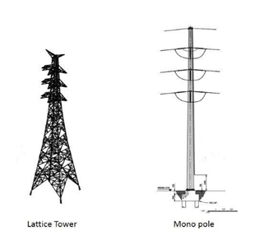
Late July – October 2019
Once the concrete foundations have been completed, we will be installing the new monopoles and lattice tower, and removing the old lattice towers.

These works include:
- Assembling the new monopoles and lattice tower using large cranes and elevated work platforms
- Moving power lines from the existing high voltage towers to the new monopoles and lattice tower, and finally
- Removing the two existing lattice towers.

What to expect during these works:
- Construction vehicles, including excavators, trucks and cranes using Kyle Road to access the construction site
- Construction noise from trucks, piling rigs, compaction equipment, rock hammers and general construction machinery
- Dust and dirt will be minimised by using water spray trucks, street sweepers and covering dirt and rock when it is being transported
- Possible lane closures of the West Gate Freeway at night.

Latest traffic updates will be available at www.westgatetunnelproject.vic.gov.au/traveldisruptions

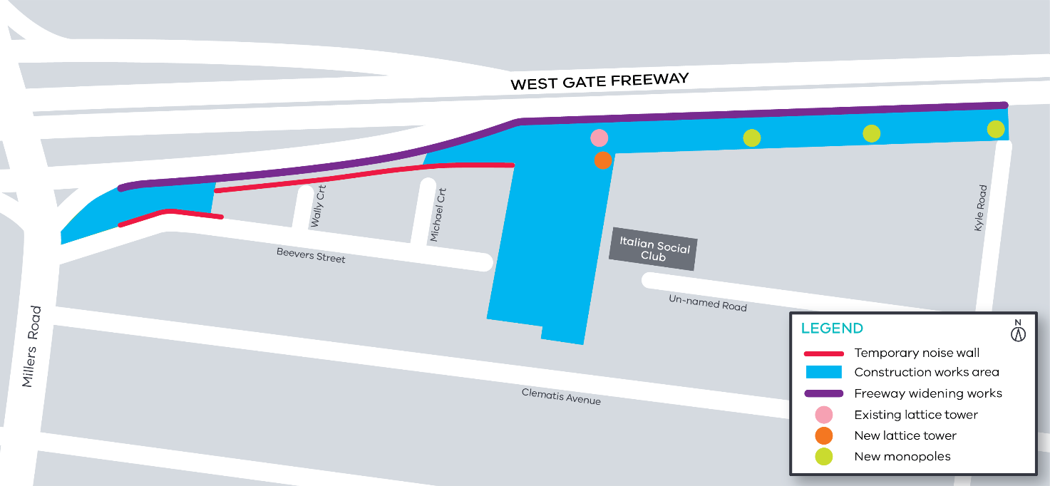
Map of area of works

The works will be undertaken between 7am - 6pm Monday to Friday and 7am – 1pm on Saturdays. If works are required outside of these times, or have a direct impact on you, we will provide further information prior to works starting.

For updates and more information about our works, please visit westgatetunnel.vic.gov.au or contact us using the details below.
Contact us
Please contact us if you have any questions or feedback about these works.
 | westgatetunnelproject.vic.gov.au |  | facebook.com/westgatetunnelproject
 | info@wgta.vic.gov.au |  | @westgatetunnel
 | 1800 105 105 |  | West Gate Tunnel Project  GPO Box 4509  Melbourne Victoria 3001
 | Interpreter service: 13 14 50

