10 June 2020 WES2006.04

Works notification: Temporary road closure

Work is continuing on Fogarty Avenue to connect new drainage pipes into the West Gate Freeway system. As part of these works, Fogarty Avenue will be temporarily closed in sections between Tenterden and Highgate streets.

Temporary closure of Fogarty Avenue
mid June 2020 to early July 2020
- vehicle access along Fogarty Avenue between Highgate and Cranbrook streets will be temporarily blocked from mid-June to late June 2020
- vehicle access along Fogarty Avenue between Cranbrook and Tenterden streets will be temporarily blocked from late June to early July 2020
- footpath access will be maintained, and
- parking along sections of Fogarty Avenue will be temporarily unavailable during this time – please see the map below for location details.

Please note that the closure of Fogarty Avenue near The Boulevard will also continue until end of June so we can progress with drainage works in the area. See map for location details.
We thank you for your patience while we complete these works.

Where to park your vehicle:
- ensure you do not park your vehicle on Fogarty Avenue in the following locations and times. Access will be blocked and you will be unable to access your vehicle.
  - Highgate and Cranbrook streets from mid June to late June 2020
  - Cranbrook and Tenterden streets from late June to early July 2020
- we recommend that you park your vehicle along the remaining sections of Fogarty Avenue or either on Tenterden, Cranbrook or Highgate streets during these works.

Noise wall panel removal

In order to safely undertake these works, we’ll need to remove sections of noise wall, adjacent to the work areas – please see the map below for location details. Alternative noise mitigation will be in place until the permanent noise wall is installed.

What you could expect:
- parking restrictions in sections along Fogarty Avenue
- an increase in the number of construction vehicles in the area
- an increase in construction noise from our machinery and trucks
- water spray trucks to help manage dust and dirt and covered loads when dirt and rock when are being transported
- traffic changes will be required and signed detours will be in place – latest traffic updates are available at www.westgatetunnelproject.vic.gov.au/traveldisruptions.

Works area
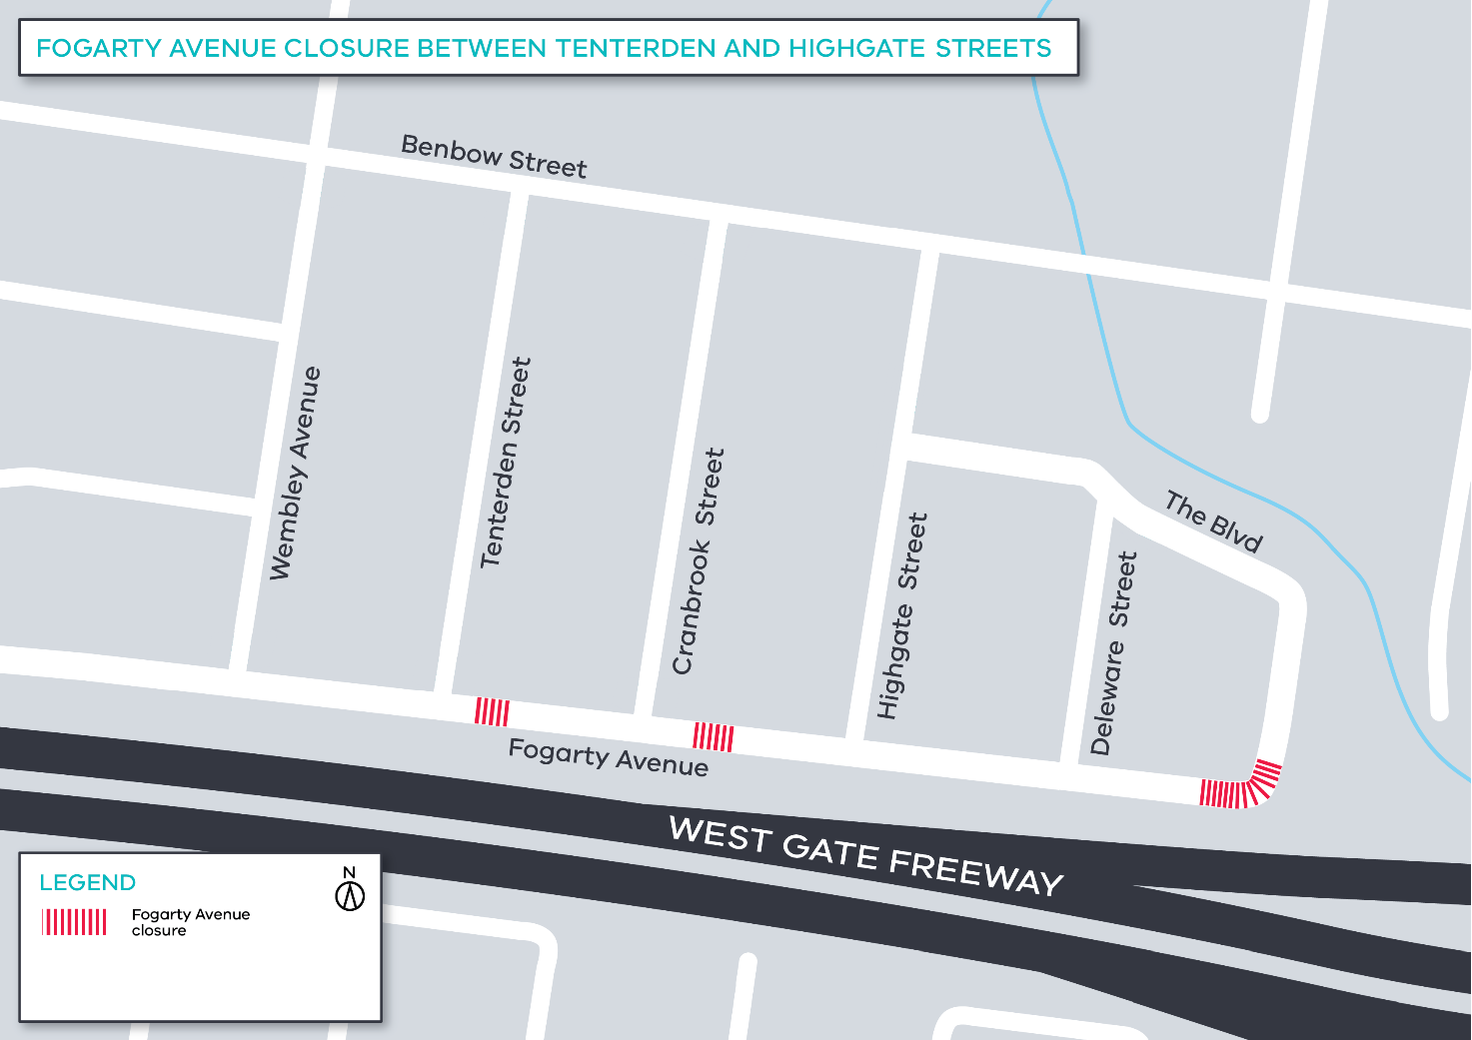

Hours of work

These works will generally be carried out from Monday to Friday between 7am - 6pm and Saturdays between
7am - 1pm, however some night works may be required. When works are scheduled out of hours and may have a direct impact on you, we will provide further information to you before works start.
Coronavirus COVID-19 update

The health and safety of our workers is our key priority as we continue to deliver the West Gate Tunnel Project, as is supporting physical distancing measures in line with current health advice. We have strict protocols in place to protect the safety of our construction workforce and the community. These include enhanced industrial cleaning arrangements and measures to reduce staff contact including staggered shifts and physical distancing. For more information and advice about Coronavirus, please visit coronavirus.vic.gov.au.
For updates and more information about our works, please visit westgatetunnelproject.vic.gov.au or call us on 1800 105 105.
Please note that works may be rescheduled in the event of bad weather or other unavoidable circumstances.

