11 May 2020

Works notification: The Rosala Avenue overpass will be closed and removed overnight on Saturday 23 May 2020
To make way for widening the West Gate Freeway, we need to close and safely remove the existing pedestrian overpass which connects Rosala Avenue and Richards Court.
The West Gate Freeway will be closed overnight between Williamstown Road and the M80 Interchange while the overpass is removed. A fully signed detour route will be in place during the closure, with details on the project website.
Construction of the new overpass is taking longer than initially planned and while we don’t yet have a definite date, we expect the new overpass will be installed later this year.
Unfortunately, this means we have to remove the existing overpass before the new one is installed so we can continue widening the West Gate Freeway. This is because the next stage of widening involves moving traffic to the outer lanes of the freeway where the ramps of the existing overpass are located.

WES2004.02

Alternative access arrangements: courtesy shuttle bus
We are running a courtesy shuttle bus for pedestrians to cross between the north and south sides of the West Gate Freeway. The trial shuttle bus service will be free for users. It will run between 7am and 10pm seven days a week. The route will include a drop-off and pick-up at Altona Gate Shopping Centre. See map over the page for location of bus stops. Please remember social distancing measures in line with current health advice when using the shuttle bus.
We will run the service at its current schedule for one month. After this time, depending on user demand, we will assess the frequency and continuation of the service. Check out the website for more details and updates about this service.
If you require special assistance during this time, please contact us using the details over the page.

When
- the existing pedestrian overpass will be removed overnight on Saturday 23 May 2020
- the piers and ramps will be demolished over the following week during day works
- the new walking and cycling overpass will be installed later this year.

What to expect during these works
- using saw cutters at night to separate the existing overpass into two segments
- lifting the overpass segments from the piers using a crane, and placing onto trucks for removal
- removing the piers and ramps from the end of Rosala Avenue (south side) and adjacent to Richards Court (north side)
- where possible, construction lights will be directed away from homes when working at night
- the overpass will be recycled; the concrete will be mixed with other pavement rock to build new roads, and the steel will be reused for many purposes.

Walking and cycling detour, and bus stops and routes
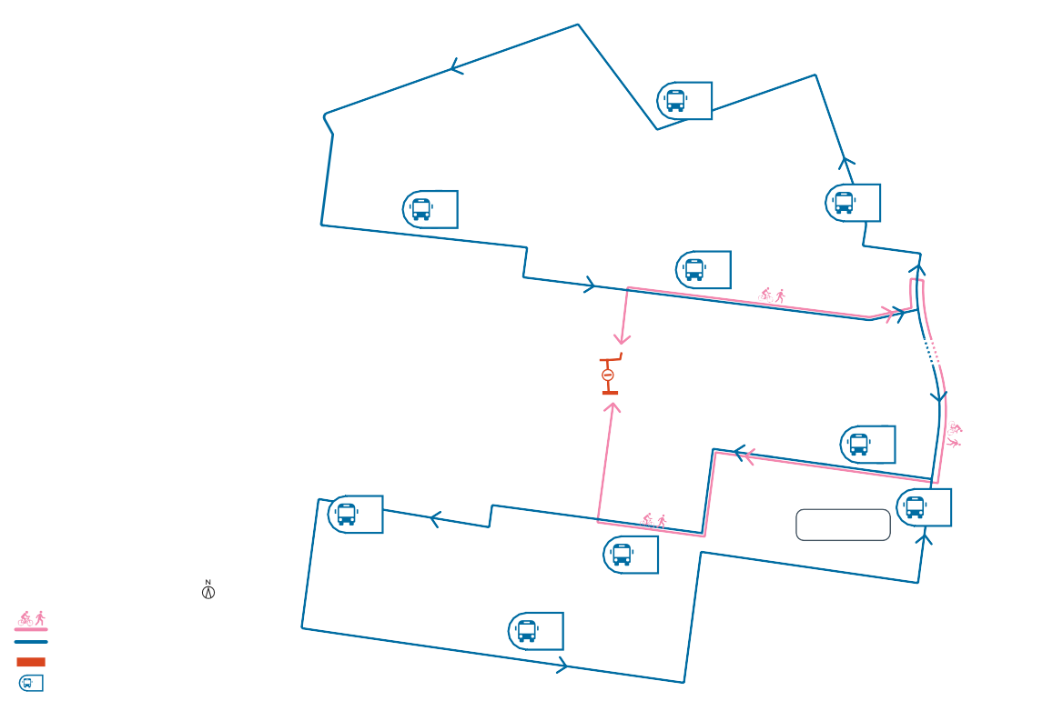
While there is no walking and cycling overpass in place, pedestrians and cyclists should use the detour as shown below.
2
3
1
4
5
7
9
Altona Gate
6
LEGEND
Pedestrian and cyclist detour Courtesy shuttle bus
Overpass removed
8
#
Courtesy bus stop
Paw Paw Road
Cypress Avenue
Primula Avenue
Heather Avenue
Richards
Court
Burgess Street
Lynch Road
Millers Road
Geelong Road
Stenhouse Avenue

Works will be carried out from Monday to Friday between 7am to 6pm and Saturdays between 7am to 1pm, with out-of-hours and night works required. Advance notice of night works will be provided to directly impacted residents.
Duosa Road
Glade Avenue
Beuron Road
Blackshaws Road
Gadsden Street
Knapp Street
Misten Avenue
Rosala Avenue
Chambers Road
Millers Road
West Gate Freeway

Muir Street pedestrian overpass
The Muir Street overpass will also be removed on Saturday 23 May 2020 for the reasons outlined above.

Covid-19 update
The health and safety of our workers is our key priority as we continue to deliver the West Gate Tunnel Project, as is supporting physical distancing measures in line with current health advice. We have strict protocols in place to protect the safety of our construction workforce, including enhanced industrial cleaning arrangements, and measures to reduce staff contact, including staggered shifts and physical distancing. For more information and advice about Coronavirus, please visit coronavirus.vic.gov.au

Please note works could be rescheduled in the event of bad weather or other unavoidable circumstances. We thank you for your patience while we carry out these important works.
The latest traffic updates are available at www.westgatetunnelproject.vic.gov.au/traveldisruptions

westgatetunnelproject.vic.gov.au info@wgta.vic.gov.au
1800 105 105
West Gate Tunnel Project Info Centre Corner of Somerville Rd and Whitehall St Yarraville VIC 3013
Follow us on social media Please contact us if you would like this
information in an accessible format.

Translation service – For languages other than English, please call 13 14 50.

Authorised by the Victorian Government, 1 Treasury Place, Melbourne

