16 September 2020 WES2009.02

Works reminder: Installation of new Rosala Avenue walking and cycling overpass
Following on from our notification to you in May, we are progressing works to build the new walking and cycling overpass over the West Gate Freeway (between Rosala Avenue and Richards Court).This is on track to open later in 2020.
As part of these ongoing works, there will be an increase in construction activity taking place in your area until November 2020.
Below is a summary of the activities you can expect to see in the area throughout September until November.

September to November
- Installing the 60-metre overpass structure and constructing the new walking and cycling path, including pour concrete overnight.
- From early October to early November, work will continue to install the cladding and balustrades on the overpass.
- Expected opening of the new overpass. We will be providing further updates on the opening time closer to the date.

We will be installing the new overpass structure overnight in the week beginning 21 September 2020.

What to expect during these works

- night works when we need to install the new overpass structure over the freeway and complete construction activities such as pouring concrete
- more activity with an increase in construction traffic and equipment in your area
- traffic changes on the freeway when we are installing the overpass and pouring concrete. Signed detours will be in place.

For the latest traffic updates visit westgatetunnelproject.vic.gov.au/traveldisruptions.

Hours of work
Works will be carried out from Monday to Friday between 7am to 6pm and Saturdays between 7am to 1pm, with out-of-hours and night works required. Advance notice of night works will be provided to directly impacted residents.

Works area

While there is no walking and cycling overpass in place, pedestrians and cyclists should use the detours currently in place.

We are also still running the courtesy shuttle bus for pedestrians to cross between the north and south sides of the West Gate Freeway. Please check the website for more details on the timetable.

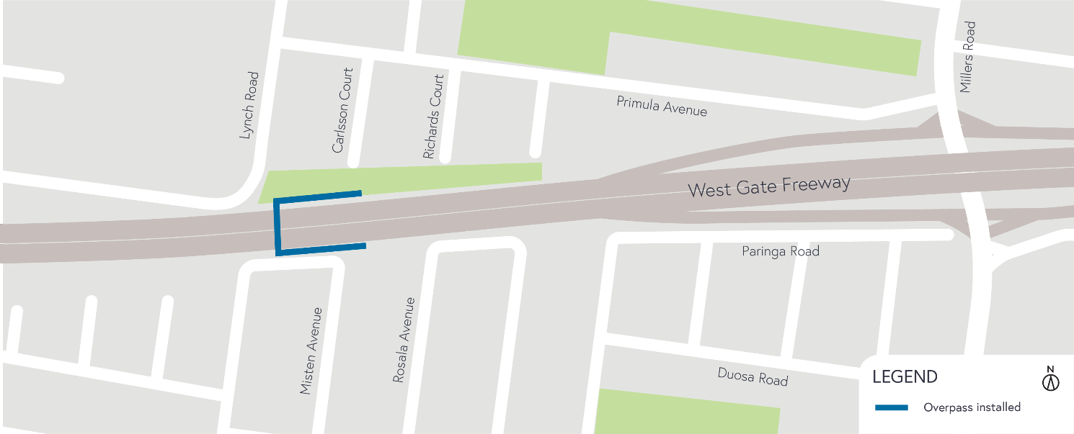

Covid-19 update
The health and safety of our workers is our key priority as we continue to deliver the West Gate Tunnel Project, as is supporting social distancing and the wearing of masks in line with current health advice. We have strict protocols in place to protect the safety of our construction workforce and the community. These include enhanced industrial cleaning arrangements, and measures to reduce staff contact, including staggered shifts and physical distancing. For more information and advice about Coronavirus, please visit coronavirus.vic.gov.au.
Thank you
We appreciate our work can be disruptive and thank you for your understanding and cooperation, particularly during these unprecedented and challenging times.
Please note that works are subject to change and may be rescheduled in the event of unexpected impacts to the construction program.

For updates and more information about our works, please visit westgatetunnelproject.vic.gov.au or call us on 1800 105 105.

