1 February 2021 WES2102.02

Works reminder: Millers Road / West Gate Freeway nightworks
Further to our notification in December, we wanted to let you know we are restarting works to widen the West Gate Freeway and upgrade the Millers Road interchange.
As we continue to work on these important upgrades, here is a summary of the activities you can expect in the area from next week and through to April:
- installing brackets on to the bridge above the Millers Road interchange to complete strengthening works
- removing scaffolding from the Millers Road interchange, once we have strengthened the bridge above
- installing temporary support structures on Millers Road so that we can install beams
- pour concrete onto newly installed beams to join them together and continue widening the freeway in the centre
- closing Millers Road in both directions (under the West Gate Freeway) and the inbound entry ramp most nights from 9pm to 5am. For latest information on the dates and detour routes, visit www.bigbuild.vic.gov.au/disruptions
What to expect during these works:
- ongoing night works to progress strengthening and widening works
- construction vehicles including forklifts, elevating work platforms and cranes
- works taking place up to seven days a week, including nightworks from 9pm to 5am
- construction noise from work activities including machinery and trucks
- water spray trucks and road sweepers will be used to manage dust and dirt during works
- pedestrian access will always be maintained. Please follow instructions of traffic controllers
- traffic changes including lane and road closures will be required. Signed detours will be in place.
Hours of work
Our usual hours of work are Monday to Friday between 7am-6pm, and Saturdays between 7am-1pm. However, for the activities mentioned above, we will need to work at night, between 9pm and 5am. This is so we can close roads and ramps to give us the space needed to work safely.
Traffic impacts

As mentioned, Millers Road in both directions and the inbound entry ramp will be closed most nights from 9pm to 5am. On-road signs will be in place to advise of detours and work zone speed limits on the freeway will be enforced. For latest updates, dates of closures and detour route information visit www.bigbuild.vic.gov.au/disruptions
Work area
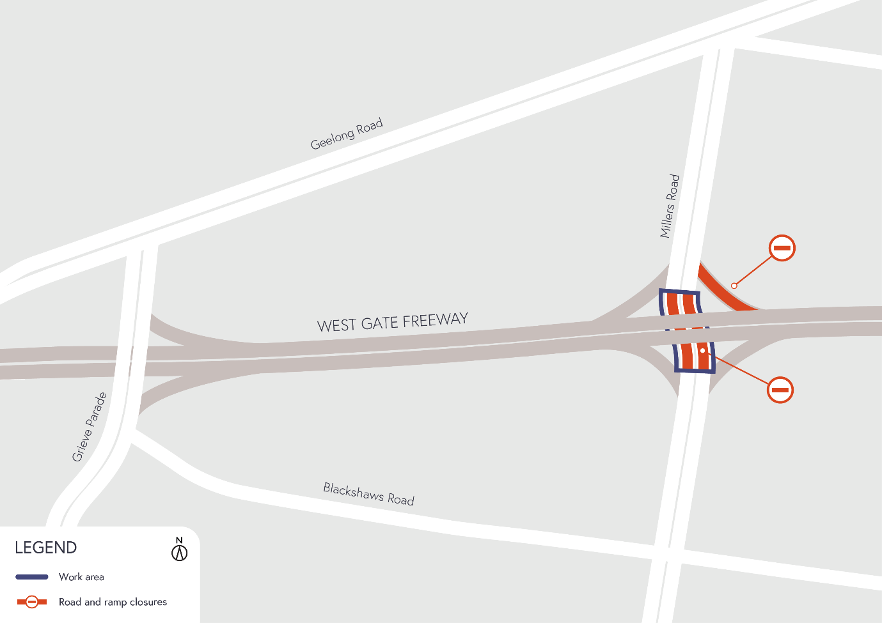

Please note that works are subject to change and may be rescheduled in the event of unexpected impacts to the construction program. Thank you for your patience during these works.
For updates and more information about our works, please visit westgatetunnelproject.vic.gov.au or call us on 1800 105 105.

