26 July 2018

The West Gate Tunnel Project

The West Gate Tunnel Project will upgrade the West Gate Freeway and link it to the city and CityLink, with new tunnels under Yarraville and bridges over the Maribyrnong River. Construction is now underway.

The West Gate Tunnel Project is a partnership between the Victorian Government and Transurban, and will be built by the CPB Contractors and John Holland Joint Venture.

There are three construction precincts: West Gate Freeway, Tunnels and Port to City.

You are in the Port to City precinct.

Upcoming construction activity in the Port to City precinct

We have started setting up the work site on Footscray Road at the old Melbourne Market site, including setting up site offices, bringing in machinery and installing fencing. We plan to start building the new river crossings over the Maribyrnong River in late 2018 and the new elevated road above Footscray Road from early 2019. Preparatory works for this will begin later this year and will require temporary realignment of the shared use path and localised tree removal. We will provide specific notifications of these works before they begin.

As part of our works in the Port to City precinct, we will be extending Wurundjeri Way to connect with Dynon Road, improving connections to the port and providing connections from the West Gate Freeway to CityLink and the CBD via an elevated road. We will start these works in early 2019.

There may be some localised changed traffic conditions while we do these works. You can keep up to date on disruptions on the project website westgatetunnelproject.vic.gov.au

You can read more about how we are managing construction impacts in the enclosed Construction Overview.

Keeping you informed

We have a dedicated team who will keep you informed about construction activities in your area. You will hear from us through:
- Community notifications
- Regular newsletters
- Phone calls, emails and SMS
- Social media
- Local events and information sessions
- Updates in local newspapers

You can visit us at the West Gate Tunnel Project Visitor Information Centre for project information and enquiries. This is located on the corner of Whitehall Street and Somerville Road, near Yarraville Gardens. It is open Monday to Fridays 10am to 5pm and Saturdays 10am to 4pm. Parking and pedestrian access is via Somerville Road.

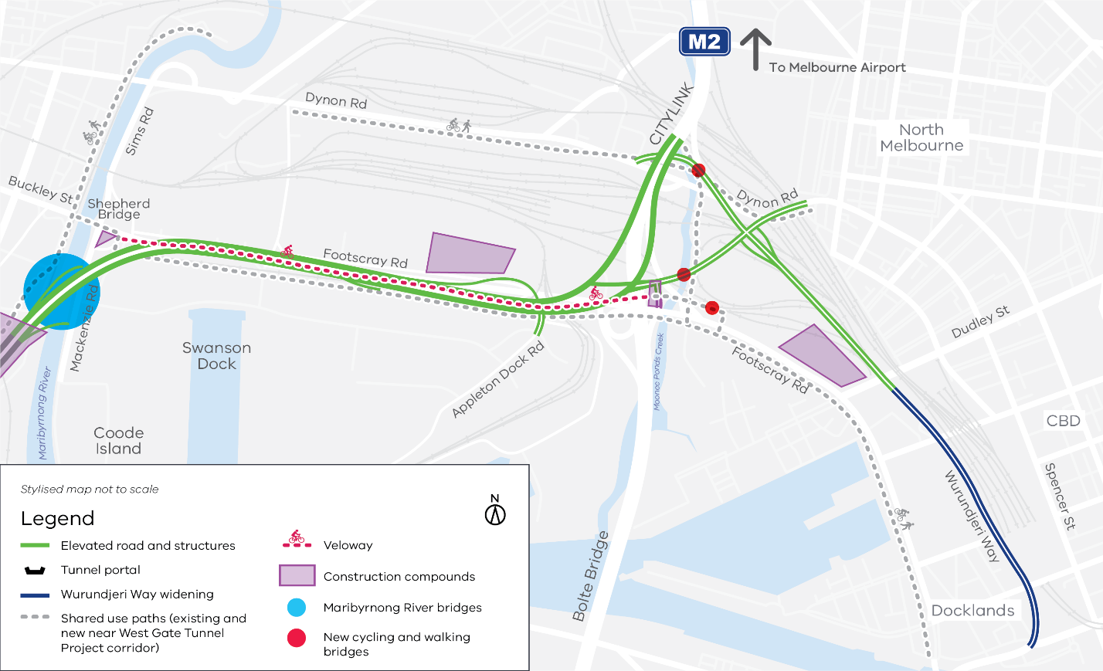
Map of the Port to City precinct
Contact us
Subscribe to email updates at westgatetunnelproject.vic.gov.au
westgatetunnelproject@wda.vic.gov.au
1800 105 105 – our team is available 24 hours a day, 7 days a week
facebook.com/westgatetunnelproject
@westgatetunnel
West Gate Tunnel Project
GPO Box 4509
Melbourne Victoria 3001
Interpreter service: 13 14 50
Thank you for your interest in the project. If you need more information or would like to provide feedback, please get in touch via the details below.

