Chapter 1
Introduction
September 2019

Chapter 1

Introduction

Purpose of the Public Environment Report
North East Link is a proposed new road project that was referred to the Australian Government’s Department of the Environment and Energy (DoEE) under the Environmental Protection and Biodiversity Conservation Act 1999 (EPBC Act) on 18 January 2018. On 13 April 2018, a delegate of the Minister for the Environment and Energy determined North East Link was a ‘controlled action’ due to the likely significant impacts on the following matters of national environmental significance (MNES) that are protected under Part 3 of the EPBC Act:
- Listed threatened species and communities (Sections 18 and 18A)
- Listed migratory species (Sections 20 and 20A)
- The environment of Commonwealth land (Sections 26 and 27A).
The delegate of the Minister for the Environment and Energy also determined the action would be assessed by Public Environment Report (PER). On 10 July 2018, DoEE provided guidelines for the preparation of the PER: Guidelines for the content of a draft public environment report – North East Link Project, Melbourne, Victoria (EPBC 2018/8142). These are referred to as the PER Guidelines. The guidelines are provided as Attachment I – PER Guidelines.
This PER contains information about the action and its relevant impacts in accordance with the PER Guidelines, enabling stakeholders and the relevant Minister to understand the environmental consequences of the proposal relevant to the above MNES. The PER was finalised following exhibition of the draft PER and the receipt of public and stakeholder comments. This final PER takes account of the comments received on the draft PER and includes a summary of such comments and how those comments have been addressed. The Australian Government’s Department of the Environment and Energy will consider this final PER along with the submissions received on the draft PER and will determine whether to approve the action under the EPBC Act and, if so, on what conditions.
Assessment of the action by the PER assessment process under the EPBC Act is separate from the Victorian Environment Effects Statement (EES) assessment process concurrently being undertaken under Victoria’s Environment Effects Act 1978. The EES assessment process considers a wide range of potential environmental effects associated with the action, which includes the development of an Environmental Management Framework (EMF) and Environmental Performance Requirements (EPRs). The PER assessment process is concerned with the relevant impacts of the action on the MNES.

General information

Title of the action
The title of the action is North East Link.

Designated proponent
The proponent for the North East Link project is the State of Victoria through the Major Transport Infrastructure Authority (MTIA), an administrative office in relation to the Department of Transport. MTIA details are summarised in Table 1-1.
North East Link Project (NELP) is the division within MTIA that is responsible for developing and delivering North East Link on behalf of the Victorian Government. This includes preparation of the North East Link business case, stakeholder and community engagement, undertaking relevant technical studies assessing impacts, developing the reference project, preparing impact assessment reports and documents, applying for key approvals required for the development of North East Link and project procurement.
Table 1-1 Proponent details
Proponent details
Name | Major Transport Infrastructure Authority
Contact details | Duncan Elliott (North East Link Project Chief Executive Officer)
Postal address | Level 13, 121 Exhibition Street, Melbourne 3000

Location of the action
North East Link would traverse Melbourne’s north-eastern suburbs. The action would include:
- Surface works along the M80 Ring Road (otherwise known as the Metropolitan Ring Road) east of Plenty Road and a new interchange linking the M80 Ring Road, Greensborough Bypass and North East Link
- Surface works to construct North East Link south of the M80 Ring Road through to Yallambie and Macleod
- Works to place North East Link in twin tunnels between Yallambie and Bulleen, with new interchanges at Lower Plenty Road and Manningham Road to link North East Link with the local area
- A new interchange connecting North East Link to the Eastern Freeway at Bulleen Road
- Widening of the Eastern Freeway largely within the road reserve from Chandler Highway through to Springvale Road
- Construction of a new dedicated busway (the Doncaster Busway) from Doncaster Road to Hoddle Street
- Walking and cycling connections (shared use paths) from the M80 Ring Road to the Eastern Freeway.
An overview of North East Link is shown in Figure 1-1.
Further detail about North East Link is provided in Chapter 3 – Description of the action.
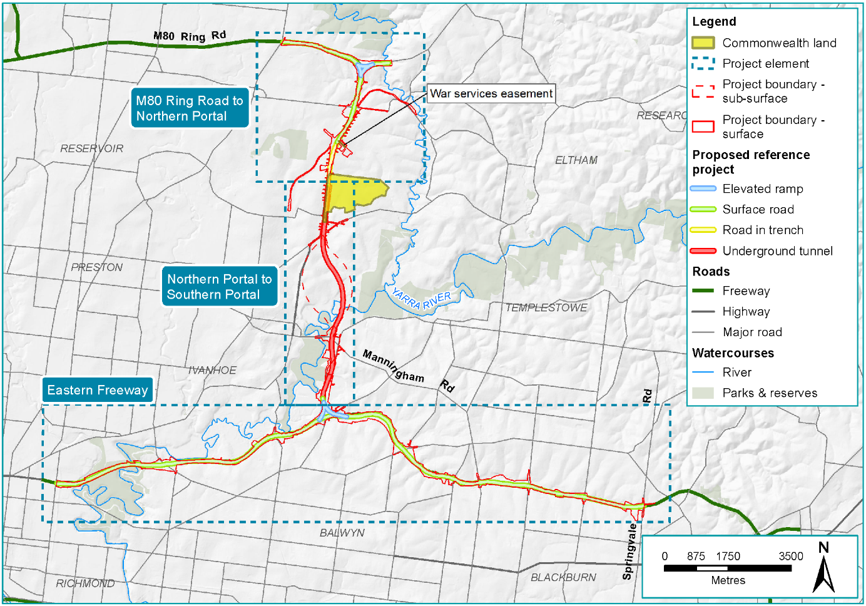
Figure 1-1 Overview of North East Link

Background to the development of the action
Melbourne is Australia’s fastest growing capital city, with an estimated 30 per cent of Australia’s population growth occurring in Melbourne in 2016. If current trends continue, Melbourne is expected to become a city of eight million people by 2051 (DELWP, 2016a). While some of Melbourne’s future growth will occur in the inner suburbs, most of the growth is expected to occur in the outer suburbs along four main corridors: north, north-west, west and south-east (DELWP, 2016a).
Population, economic and spatial changes will continue to increase pressure on Melbourne’s infrastructure and services, with a growing demand for travel putting the city’s transport networks under strain. Key transport challenges faced by Melbourne include poor cross-city movements, inefficient freight movement between Melbourne’s north and south-east, and congestion and heavy vehicles on local and arterial roads.
North East Link is a proposed new freeway-standard road connection that would complete the missing link in Melbourne’s metropolitan ring road, giving the city a fully completed orbital connection for the first time. North East Link would connect the M80 Ring Road to the Eastern Freeway, and includes upgrades to the Eastern Freeway and new dedicated bus lanes for the Doncaster Busway between Doncaster and the city.
North East Link would provide a safe and efficient freeway connection for up to 135,000 vehicles per day by 2036, reducing travel times, getting trucks off local roads and linking key growth areas in the north and south-east.
A more detailed discussion of the objectives and drivers for the action is provided in Chapter 2 – Objectives of the action.

How the action relates to other actions in the region affected by the action
North East Link is one component of a series of projects aimed at improving the efficiency of Melbourne’s transport network and to accommodate population growth.
A number of major infrastructure projects have been, or will be under construction in Melbourne at or about the same time as the proposed North East Link. Other transport projects underway or in planning in Melbourne’s north and east that would interact or share similarities with North East Link were identified in the North East Link business case (NELA, 2018a). These projects are outlined in Table 1-2 and shown in Figure 1-2.
Table 1-2 Other projects with links to North East Link
Project | How the project relates to North East Link
City-wide projects
West Gate Tunnel  The West Gate Tunnel project provides an alternative to the West Gate Bridge. It includes widening the existing West Gate Freeway, constructing a new tunnel to link the West Gate Freeway with the Maribyrnong River and a new elevated road above Footscray Road connecting the Maribyrnong River with the Port of Melbourne. | The West Gate Tunnel also aims to reduce congestion, provide alternative connections and has a similar scale and impacts as North East Link. While located almost on opposite sides of Melbourne, North East Link would impact the West Gate Tunnel with regard to changing the city’s traffic movements and in the management of its impacts (specifically tunnel spoil and where it can be delivered).
Metro Tunnel  The Metro Tunnel is adding a 9 km twin rail tunnel to Melbourne’s CBD network CBD, with five new stations. | The Metro Tunnel is focused on public transport rather than private vehicle movements, although its scale and management of impacts are similar to North East Link (specifically the Metro Tunnel’s spoil and where it can be delivered).
M80 Ring Road upgrade  The M80 Ring Road upgrade is occurring from Laverton to Greensborough, and includes an increase to four lanes in each direction from the Princes Freeway to the Western Highway, and from two to three lanes from Plenty Road to Greensborough Highway. | The M80 Ring Road upgrade would intersect with the northern end of North East Link. The upgrade activities are scheduled to occur before construction of North East Link is proposed to start, so cumulative impacts are not expected. North East Link would include an upgrade of the M80 Ring Road interchange to enable a smooth transition between North East Link, the M80 Ring Road and Greensborough Bypass.
Local projects
Heidelberg and Rosanna rail duplication  This project is duplicating the rail track between Heidelberg and Rosanna and removing two level crossings. It aims to deliver additional services and improve reliability on the Hurstbridge and South Morang rail lines. A new bus route between Greensborough and Diamond Creek is also planned. | The Hurstbridge rail line runs parallel to much of North East Link’s proposed alignment and intersects at its northern end. The improvements to train services due to the duplication are likely to boost user numbers, reducing traffic congestion on the roads. North East Link also seeks to reduce congestion on local roads, complementing the aims of the rail duplication.
Mernda rail extension  The Mernda rail extension project is extending the South Morang rail line to Mernda and includes three new stations, bus connection improvements and new shared use paths. | The rail extension encourages the use of multiple modes of public transport. While the rail line would not intersect with North East Link, the rail extension and North East Link both aim to ease traffic congestion in local areas.
Bell and High streets level crossing removal  The removal of level crossings on the Mernda rail line at Bell Street in Preston and High Street in Reservoir are part of the Victorian Government’s program to remove 50 dangerous and congested level crossings across the city. | The removal of the level crossings seek to ease traffic congestion around the local areas. While the Mernda rail line would not intersect with North East Link, the flow on effects on the traffic networks are complementary to the aims of North East Link.
Chandler Highway widening  Widening of Chandler Highway to six lanes and construction of a new bridge to the west of the existing bridge. | Widening Chandler Highway will help prevent the current traffic bottlenecks that occur in this area, allowing for ease of traffic movement and shorter trips. North East Link would reconfigure the current Eastern Freeway interchange with Chandler Highway, to enable a smooth transition between North East and Chandler Highway.
Yan Yean Road and Plenty Road upgrades  Upgrades to Plenty Road and Yan Yean Road in Plenty. | Yan Yean Road and Plenty Road are local feeder roads for traffic from the north to access the M80 Ring Road, and anywhere further south. These roads provide traffic that would likely use North East Link. North East Link would influence the flow of traffic around the M80 Ring Road interchange and so impact the use of these roads.

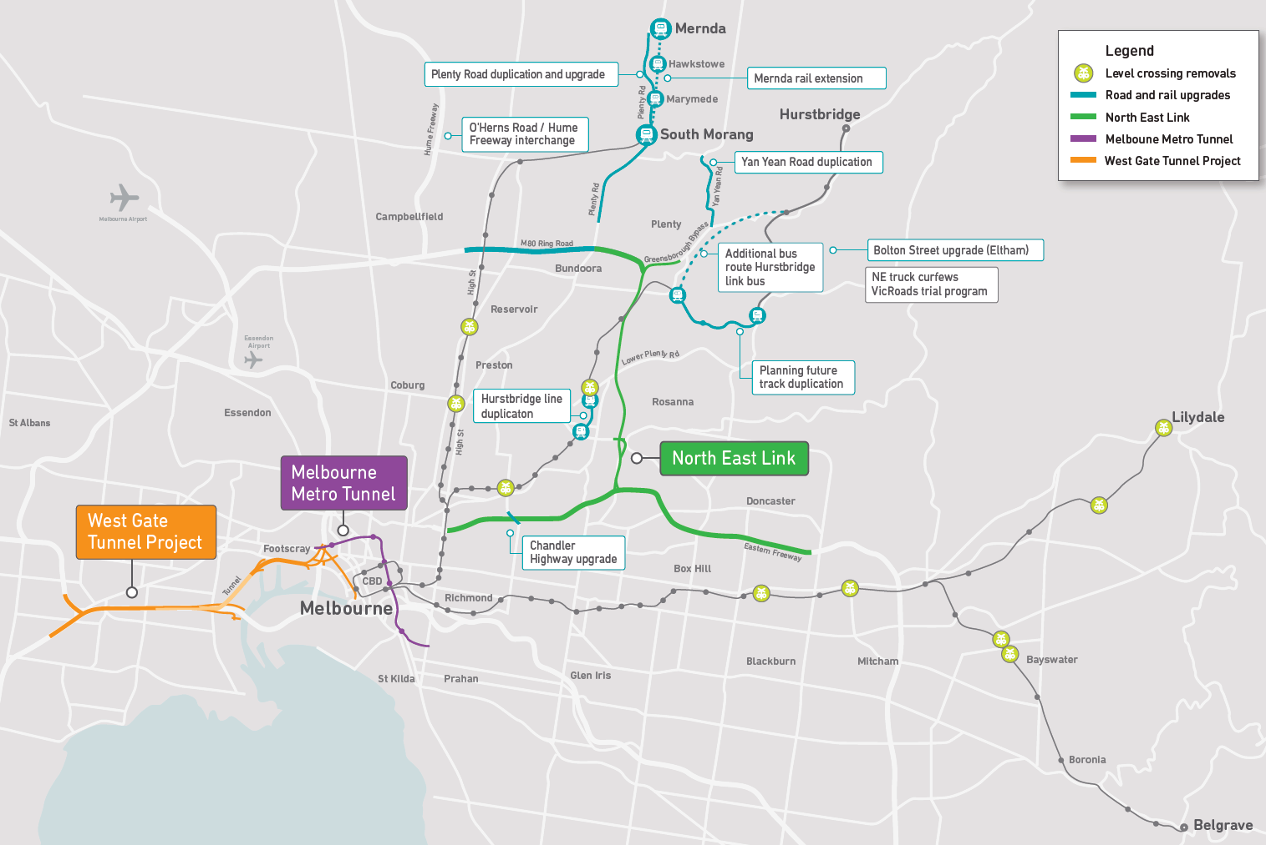
Figure 1-2 Other projects with links to North East Link

Current status of the action
North East Link is currently being assessed under Australian and Victorian environmental laws to determine if its environmental impacts and effects can be appropriately managed to achieve environmental outcomes consistent with the objectives of the action, as identified in the business case (NELA, 2018a).
For the purposes of assessment, NELP has developed a North East Link reference project comprising a feasible means by which the action could be developed. Through the assessment and informed by technical studies, NELP has also developed a set of Environmental Performance Requirements (EPRs) setting the relevant environmental outcomes or standards that would need to be met in developing and implementing the action. Being outcomes focused, the EPRs provide a level of flexibility in the ultimate design of the action, allowing the private sector contractor to determine the best way to achieve those requirements for optimum results.
Procurement of the primary package of work for the proposed action commenced in late 2018 and will continue concurrently with the assessment and approvals processes. Subject to NELP obtaining all key approvals for the action in late 2019, the contract for the primary package would be awarded in mid-late 2020.
Several separate work packages would be procured to deliver North East Link including:
- A primary package as an availability Public Private Partnership (PPP) to design and construct the tunnels and operate and maintain the entire North East Link corridor
- Secondary packages to design and construct aspects of North East Link.

Consequences of not proceeding with the action
If the proposed action does not proceed, the road network in the north-east would become increasingly congested and its performance would significantly deteriorate, with:
- Significant increases in cross-city and orbital movements resulting in traffic congestion increases
- Continued freight movement increases between the north and south-east with particular impacts on Rosanna Road
- Increased traffic volumes on local and arterial roads
- A decline in average vehicle speeds
- Impacts on performance of on-road public transport services in the area which do not have prioritised lanes.
Consequences of this congestion could include the ongoing fragmentation of labour markets, poor business-to-business travel and diminished access to jobs. This would impose higher costs on business and households, limit the productive potential of the city and constrain the economic competitiveness of Melbourne and Victoria.

PER structure and content
This PER has been prepared in accordance with the PER Guidelines, and is informed by a range of technical studies carried out to assess the potential impacts of the action.
The structure of the PER aligns closely with the structure of the PER Guidelines as shown in Attachment II – PER Content guide. The only exception to the structure of the PER Guidelines is that the PER addresses the relevant impacts, avoidance and mitigation measures and residual impacts of the action together for the relevant protected matter, and not in separate sections of the report. The EPBC Act regulations also provide guidance in relation to the development of PERs, with the relevant provisions of the regulations also considered for this PER.
Also addressed throughout the PER are the objectives of the EPBC Act, including elements such as providing for the protection of the environment and MNES and promoting biodiversity, as well as achieving a cooperative approach to environment protection and management and the principles of ecologically sustainable development.
The PER comprises:
- An executive summary which presents the key findings of the PER
- The PER main report
- Attachments – documents pertaining to the assessment and approval process and response to comments received on the draft PER
- Technical appendices containing supporting technical reports.

