6 September 2021

Construction at the Northern Tunnel Portal, Whitehall Street and Surrounding Areas.
Between now and the end of February 2022, the West Gate Tunnel Project will be doing more work at the Northern Tunnel Portal on Whitehall Street and in the surrounding areas.
If any of the works are expected to be particularly disruptive, we will be in touch before they begin.

Traffic disruptions will be updated on the Big Build website and weekly traffic email alert. Sign up for emails at westgatetunnelproject.vic.gov.au/contact/register-for-updates.

 | Impact | Date
 | Occasional nightworks (9pm to 5am) | 1 September to January 2022
 | Truck movements in the area | 1 September to January 2022
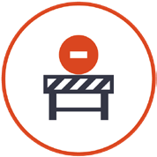 | Occasional lane closures on local Yarraville roads | 1 September to January 2022
 | Ongoing traffic management on Harris street between  Cowper and Whitehall Street | September to February 2022
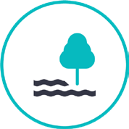 | Vegetation management around Harris, Parker and  Youell street | September to December 2021

We would like to keep in touch … electronically!
We know how important it is to keep in touch, so we’d like to offer some other options for updates, including email, SMS and phone calls. To sign up for electronic updates, we ask that you provide us with your name, address, email address and phone number via one of the following:
- Email us with your details at info@wgta.vic.gov.au
- Call 1800 105 105 and provide our team with your details
- Go online and enter your details at westgatetunnelproject.vic.gov.au/contact/register-for- updates

Northern Tunnel Portal at Whitehall Street construction works
Ongoing

We’re continuing construction work at our Northern Tunnel Portal site along Whitehall Street between Youell Street and Somerville Road.
You may notice minor construction noise from the Northern Tunnel Portal, as well as truck movements to and from the site.
We are building sections of the roof and road decks which are both integral parts of the project. The roof deck supports the tunnel ventilation system which will maintain safe air quality in and outside the tunnels, while the road deck is the new road in and out of the tunnels. Read more about tunnel ventilation and air quality at: westgatetunnelproject.vic. gov.au/about/keytopics/tunnel-ventilation-and-air- quality
The construction works includes building walls, concrete pours and installing concrete segments.

Lyons Street and Billy Button Creek
September – November 2021

The bridges over Billy Button Creek are expected to be completed by November. These bridges are located within our worksite and will be used by our construction vehicles and machinery, before becoming publicly accessible towards the end of the West Gate Tunnel Project’s construction phase.
Minor construction noise and vibration may be experienced during these works.
These works include on site concrete pours and placement of precast concrete segments over Billy Button Creek.
We are also building embankment structures which will connect the new tunnel to the new bridges across the Maribyrnong River.

Harris Street walking and cycling path
September 2021 – February 2022

From September, works will start on the new walking and cycling path for Harris Street, which will connect from Hyde Street to a new bridge over Whitehall Street.
Construction noise and truck movements will be expected during these works. We’ve planned these works for the day; however, some activity will be needed at night when there is minimal traffic around Whitehall Street.
These works will take place in two stages:
From September 2021 to February 2022, stage one will include trimming and vegetation management, and utility
relocation along Harris and Whitehall Streets and in Hanmer Reserve (Yarraville Gardens). Piling and column construction will also be undertaken along Harris Street.
Construction will be focused along Harris Street but there will be some activity in the garden area. The dog park, sporting field and picnic areas will all still be available for use.
Stage two is planned to start in 2023 and will include construction of the elevated walking and cycling path that crosses Whitehall Street and pedestrian upgrades to Harris Street.
Traffic management will be in place on Harris Street between
Cowper and Whitehall street for the works during stage one. We will be in touch before any disruptive works.

Preparatory works for bridge construction over the Maribyrnong River
October – December 2021
Noise and occasional road closures on Maribyrnong Street are expected during these works.
We will be installing large steel components and precast concrete panels to form the new bridges that link the West Gate Tunnel to the elevated roadway above Footscray Road.
Preparatory works will start in October and include trimming and management of vegetation, as well as alterations to Maribyrnong Street including temporary removal or relocation of carpark spaces.
Installation of the bridge girders for the bridges over the Maribyrnong River is planned to start early 2022.
We will be in touch before any disruptive works.

Ongoing groundwater monitoring in Yarraville
You may see our team carrying out water sampling as part of our regular groundwater monitoring requirements to confirm that groundwater is behaving as expected.
These works may include traffic changes for drivers on local roads and occasional nightworks, however there will be minimal noise impacts to surrounding residents and businesses.
We’ll be in touch if the works will be disruptive.

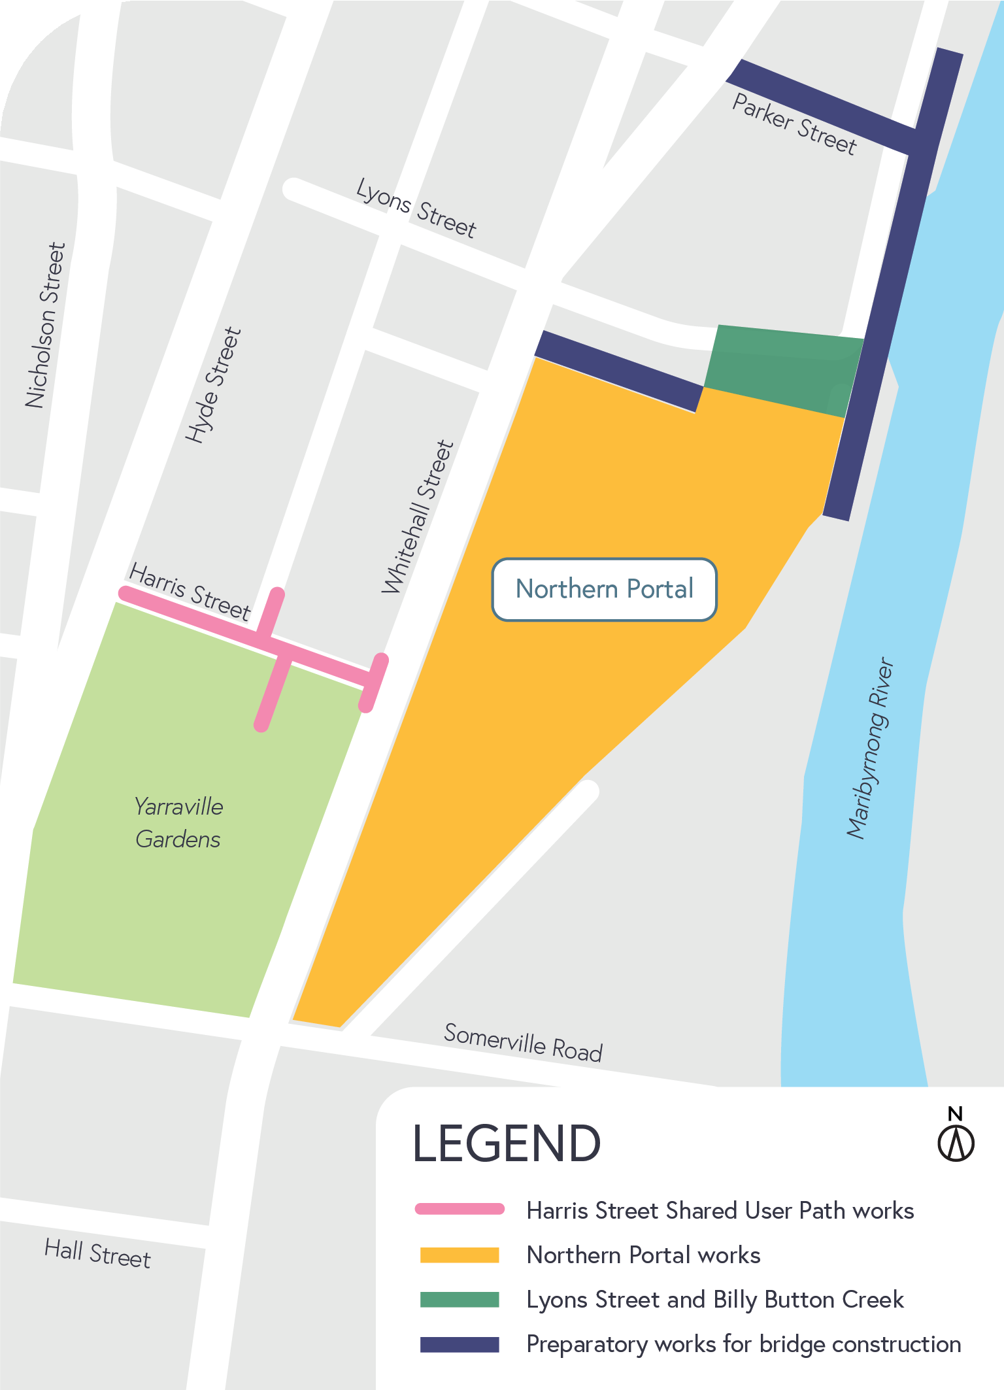
Where are the works?

LEARN MORE
To learn more about the impacts, or any of the construction activities mentioned, please don’t hesitate to give the team a call on 1800 105 105 or email us on info@wgta.vic.gov.au

More detail on what you can expect during these works
- Works will be completed primarily during the day with only occasional nightworks.
- Construction vehicles will be moving in and out of the area including excavators, concrete trucks, cranes, and rollers.
- Minor vibration and noise may be experienced during works.
- Water-spray trucks and road sweepers will be used in local streets around our worksites, keeping local roads clear during construction.
- Changes in traffic conditions may be experienced during these activities.

Thank you
We appreciate our work can be disruptive and thank you for your understanding. Works may be rescheduled in the event of unexpected impacts.
For updates or questions, please call 1800 105 105, email us at info@wgta.vic.gov.au or visit westgatetunnelproject.vic.gov.au

westgatetunnelproject.vic.gov.au info@wgta.vic.gov.au
1800 105 105
West Gate Tunnel Project Info Centre Corner of Somerville Rd and Whitehall St Yarraville VIC 3013
Follow us on social media Please contact us if you would like this
information in an accessible format.

Translation service – For languages other than English, please call 13 14 50.

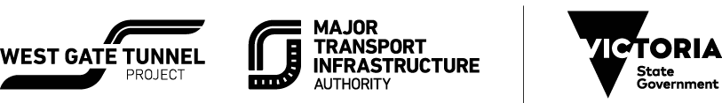

Authorised by the Victorian Government, 1 Treasury Place, Melbourne

