5 October 2021

West Gate Freeway works – Hyde Street to Kororoit Creek Road Bridge
The West Gate Tunnel Project team will continue works on and close to the West Gate Freeway between Hyde Street and the Kororoit Creek Road Bridge over the coming months.
If the works are expected to be particularly disruptive, we will get in touch with affected households before they begin.
Information about traffic disruptions will be updated on social media and bigbuild.vic.gov.au/disruptions. Signed detours will also be in place.
What you need to know

 | Impact | Date
 | Short term noisy nightworks. | Ongoing – early-2022
 | Increased truck movements in the area. | Ongoing
 | Lighting during night works. | Ongoing
 | Occasional lane and / or ramp closures, including:  - West Gate Freeway, entry and exit ramps  - The Avenue, Spotswood underneath the West Gate Freeway  - Simcock Avenue, Spotswood  *Check the Big Build website, our weekly traffic email alert and signage for updated details on traffic impacts and recommended detour routes. | Ongoing
 | Road closures, including:  - Williamstown Road under the West Gate Freeway (nightly from 9pm to 5am)  - The Avenue underneath the West Gate Freeway  (intermittent)  - Simcock Avenue (intermittent) | Ongoing until early-2022

LEARN MORE
To learn more about the impacts above, or any of the construction activities mentioned below, please don’t hesitate to give the team a call on 1800 105 105 or email us on info@wgta.vic.gov.au

WES2110.01

Installation of permanent noise walls between Grieve Parade and Williamstown Road

Ongoing until early-2022
We’re continuing to remove temporary noise walls and install permanent new noise walls alongside the West Gate Freeway between Grieve Parade and Williamstown Road to reduce traffic noise impacts on nearby households. More than 2,200 of the 3,300 permanent concrete panels have already been installed.
We will be using cranes to install large concrete and acrylic panels. This work will be carried out at night so we can utilise lane closures on the freeway to allow more room to work.
Properties adjacent to the freeway between Grieve Parade and Williamstown Road may notice increased noise levels during works.
The project team will be in touch with impacted households if the works are expected to be disruptive.

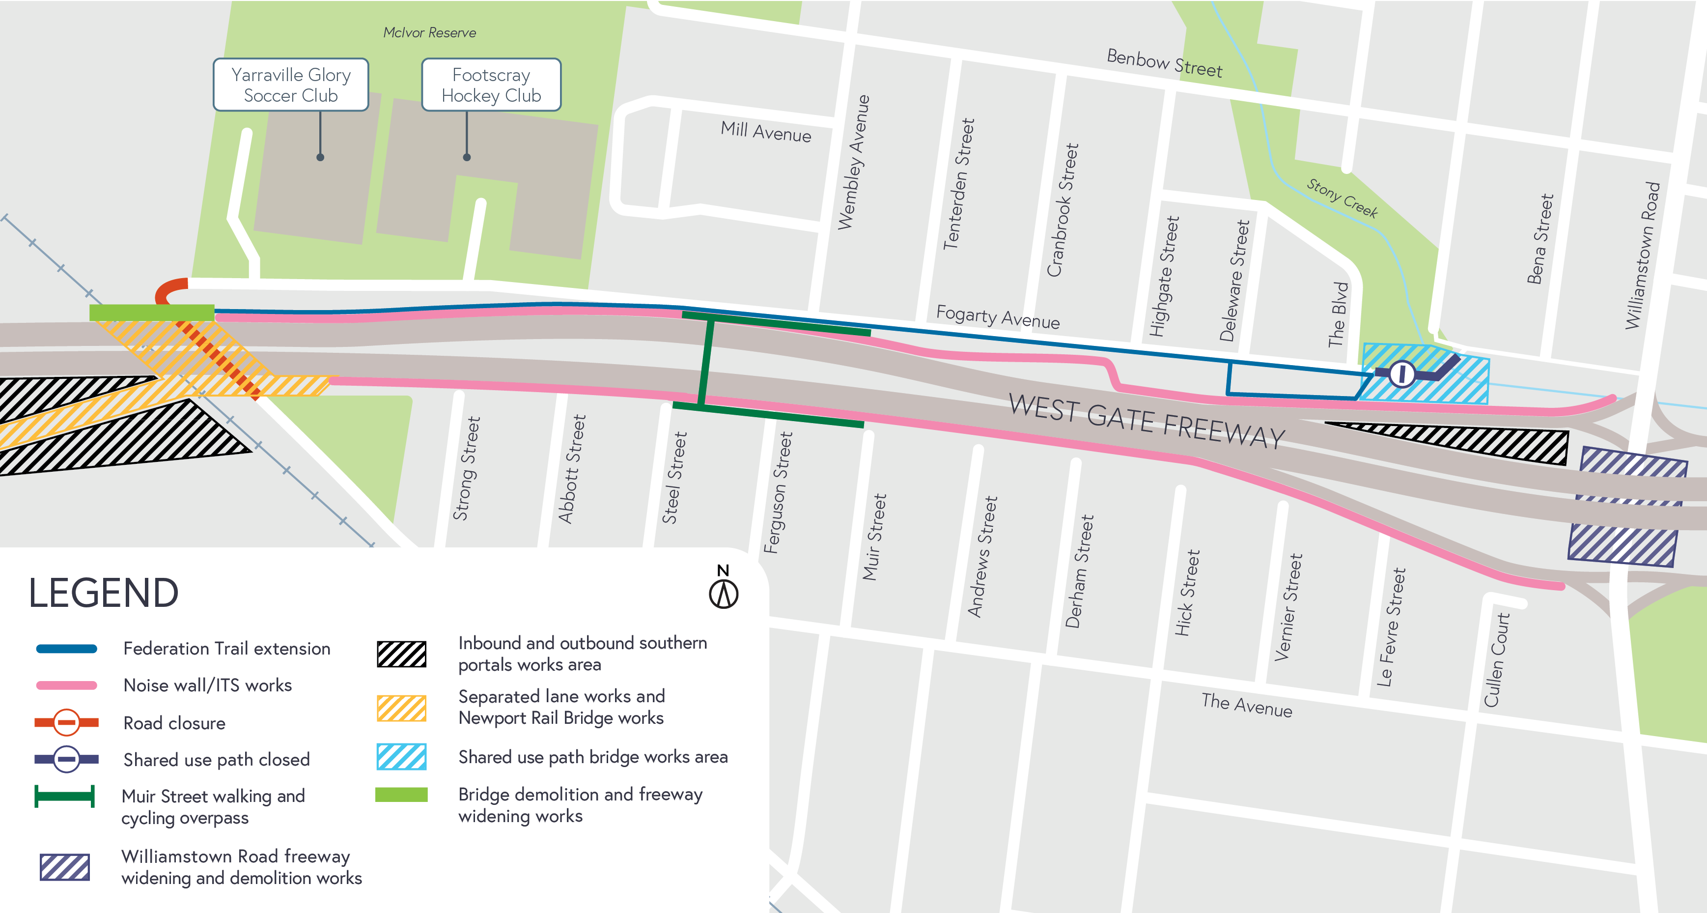
Freeway works near Williamstown Road

Nightly closures of Williamstown Road from 8pm to 6am
Ongoing nightly closures of Williamstown Road under the West Gate Freeway will continue. This is needed as we continue to build the two Hyde Street ramps that will go over Williamstown Road, creating new connections for trucks into and out of the local industrial area.
We will also continue our freeway widening and bridge strengthening works in the area which will include a period of noisy, demolition works at night-time. This is currently scheduled to occur in November and December during the overnight road closures, subject to change.
For the latest updates, dates of closures and detour route information visit: bigbuild.vic.gov.au/disruptions.

Freeway widening works near Newport Rail Bridge and The Avenue

Ongoing until early-2022
Freeway widening works above the Newport Rail Line and The Avenue are continuing with intermittent closures of the link underneath the West Gate Freeway.
Works include demolition and pavement construction. Traffic management will be in place in this area until March 2022.
Increased noise levels may be noticeable during these works
– including during the demolition of a section of the northern bridge in late-2021.
If overnight works are required and expected to be disruptive to residents, the project team will be in direct contact with residents.

*Please note map above indicates location of works between Newport Rail Line and Williamstown Road. Works taking place in other project areas are described in work summaries on this page.

Simcock Avenue works

Ongoing until late-2022

Utility relocations and works to build the connection to the freeway from Simcock Avenue will continue until late-2022.

Intermittent lane and road closures will be in place on Simcock Avenue and the Booker Street intersection until late-2022.
Once we have completed our works in the area, the road will be re-surfaced. During lane closures, traffic will continue to travel east (towards the city) along Simcock Avenue, one way only.
Signed recommend detour routes for traffic (via Hudsons Road) and heavy vehicles (via Douglas Parade / Burleigh Street / Hall Street) will remain in place during these Simcock Avenue traffic impacts.

Update on the Southern Inbound and Outbound Tunnels Portals

Ongoing

Works will continue at the Southern Inbound and Outbound portals, which includes installing concrete segments, concrete pours, excavation works and spoil removal.

Intelligent traffic systems (ITS)

Ongoing
We continue ITS works along the edges of the freeway, between Kororoit Creek Road and Hyde Street.
These works include light pole removal and installation, permanent and temporary lighting, cable hauling, traffic signal works, installation of above and below ground cables, trenching and other site investigations.
Some ITS works will take place at night-time to reduce impact on freeway traffic and create safe working areas for our crews.

Federation Trail walking and cycling path extension

Ongoing

We continue to work on the extension of Federation Trail alongside Fogarty Avenue, as well as the new walking and cycling bridge that will go over the Williamstown Road citybound exit ramp.
These works will include excavating dirt and pouring concrete for the new path, as well as building the structures to support the bridge that will go over the Williamstown Road citybound exit ramp.
If you want to ‘ride through’ this section – check out the video here:

More detail on what you can expect during the works:
- Construction vehicles moving in and out of the area including excavators, cranes, rollers and water and concrete trucks. The main access to the sites will be from the West Gate Freeway, with additional access on designated truck routes.
- Construction noise, including intermittent short-term noise, from machinery such as cranes, excavators and high-pressure water to demolish sections of bridge / freeway including near Newport Rail Bridge and Williamstown Road.
- Night works at Williamstown Road, and along the freeway between Kororoit Creek Road, Altona and Hyde Street, Yarraville.
- Vibration may be experienced during freeway widening works.
- Water-spray trucks and road sweepers used in the local streets around our worksites, keeping local roads clear during construction.
- Freeway lane closures and road closures will be required. Signed detours will be in place and traffic
updates available at bigbuild.vic.gov.au/disruptions.

Thank you
We appreciate our work can be disruptive and thank you for your understanding. Works may be rescheduled in the event of unexpected impacts.
For updates or questions, please call 1800 105 105, email us at info@wgta.vic.gov.au or visit

westgatetunnelproject.vic.gov.au

westgatetunnelproject.vic.gov.au info@wgta.vic.gov.au
1800 105 105
West Gate Tunnel Project Info Centre Corner of Somerville Rd and Whitehall St Yarraville VIC 3013
Follow us on social media Please contact us if you would like this
information in an accessible format.

Translation service – For languages other than English, please call 13 14 50.

Authorised by the Victorian Government, 1 Treasury Place, Melbourne

