December 2021 TUN2201.02

Construction at the Northern Portal on Whitehall Street and surrounding areas
Between now and the end of March, the West Gate Tunnel Project will be doing more work at the Northern Portal on Whitehall Street and throughout Yarraville.
If any of these works are expected to be particularly disruptive, we will be in touch before they begin.

What to expect during these works:

 | Impact | Date
 | Occasional nightworks (9pm to 5am) | December 2021 to  March 2022
 | Minor noise and vibration | December 2021 to  March 2022
 | Truck movements in the area | Ongoing
 | Occasional lane closures on local Yarraville roads – including Whitehall Street | December 2021 to  March 2022
 | Ongoing traffic management on Harris Street between Cowper and Whitehall Street | December 2021 to  March 2022

We would love to keep in touch…electronically!
We know how important it is to keep in touch, so we’d like to offer some options for updates, including email, SMS and phone calls. To sign up for electronic updates, we ask that you
provide us with your names, address, email address and phone number via one of the following:
- Email us with your details at info@wgta.vic.gov.au
- Call 1800 105 105 and provide our team with your details.
- Go online and enter your details at bigbuild.vic.gov.au/projects/west-gate-tunnel-project

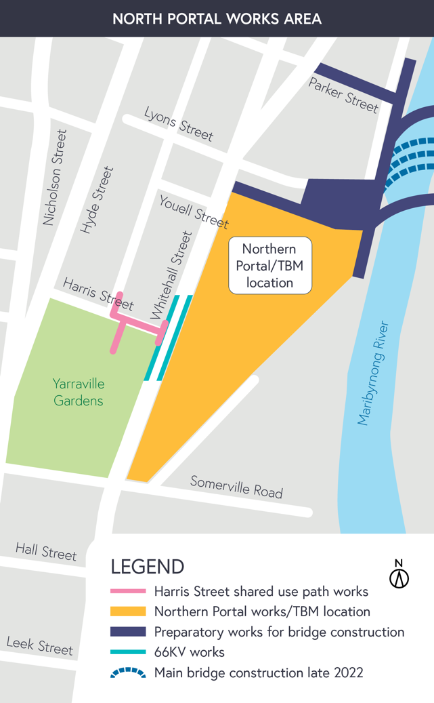
Northern Portal at Whitehall Street
Ongoing
We’re continuing construction work at our Northern Portal site along Whitehall Street between Youell Street and Somerville Road.
You may notice minor construction noise from within the site as well as truck movements to and from the site.
We will continue building sections of the road deck in preparation for the smoke ducts to be installed in March. The smoke ducts are an integral part of the ventilation system which will maintain safe air quality in and outside the tunnels.
Other construction works include concrete pours, installing precast concrete units and building walls.

Tunnelling
Early 2022

Tunnelling for the West Gate Tunnel Project is expected to commence in early 2022. The
Northern Portal site, on the corner of Youell and Whitehall Streets, is where each of the tunnel boring machines (TBM) will start their journey. Bella, the first TBM, will commence first to build the 4km outbound tunnel, with Vida, the second TBM, launching several weeks later to construct the 2.8km inbound tunnel.
Most residents and businesses along the tunnel alignment are not expected to experience any ground borne noise or vibration impacts from construction.
We will be in touch with more information about tunnelling closer to the commencement date.

Harris Street walking and cycling path
Ongoing – March 2022

Work will continue on the new walking and cycling shared path on Harris Street which will connect Hyde Street to a new bridge over Whitehall Street.
Piling works and column construction will take place along Harris Street between Cowper Street and Whitehall Street. You may have noticed a large rig set up along Harris Street, this will drill through rock and dig down deep enough for the column construction to then take place. Traffic management is in place on Harris Street between Cowper and Whitehall Street for the duration of these works.
Works also include utility relocation along Harris Street and Whitehall Street.

Kindred Studios and Kindred Café are still open for business with several access routes available
for pedestrians.

Whitehall Street electrical works
January – March 2022
From January, The WGTP in partnership with Jemena will be working to relocate and elevate the existing overhead electrical conductors on Whitehall Street.
Works on the southbound lane will commence from late January and northbound works will commence from February, with all works to be completed by March.
Lane closures will be in place during these works, with traffic management in place to through access.

Maribyrnong River
From March 2022
Construction of the bridges over the Maribyrnong River will start from March 2022. The bridge on and off ramps will be built first, followed by the main bridge in late 2022.
These works will require an occupation on Maribyrnong Street,north of Parker Street. More information will be shared with the community prior to works starting.

Gas works on Maribyrnong Street
January – March 2022
Gas works will continue along Maribyrnong Street in January. Gas pipe installation will continue north along Maribyrnong Street and will be expected to finish in March.

Hyde Street ramps
Ongoing
Construction activities to build the new Hyde Street ramps between the West Gate Freeway near Williamstown Road and Hyde Street is continuing.
These ramps will create new connections for trucks into and out of the local industrial area.

These works will continue to require occasional overnight closures of Williamstown Road under the West Gate Freeway – traffic impacts will be communicated via the Big Build website and our weekly traffic email alert.
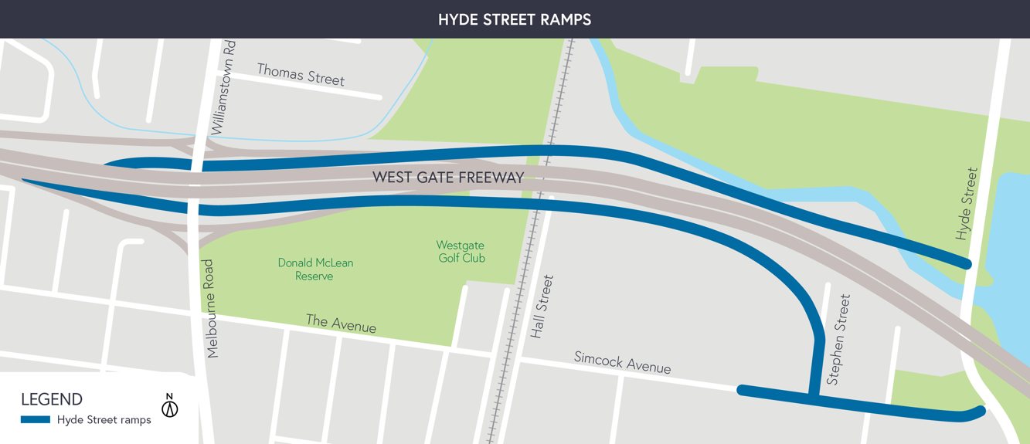

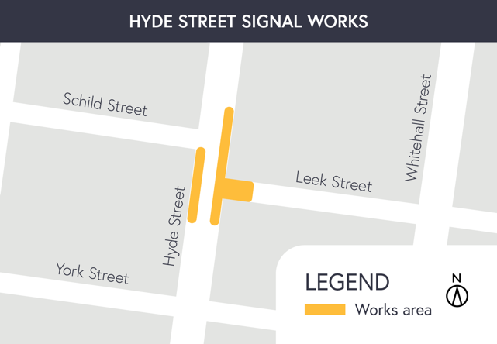
Traffic signal works Hyde Street and Leek Street
Late January

Traffic signal works will be undertaken on the traffic lights on Hyde Street at intersection of Leek Street.
These works will be undertaken during the day with traffic management in place for the duration.
Impacted properties will be notified prior to works starting.

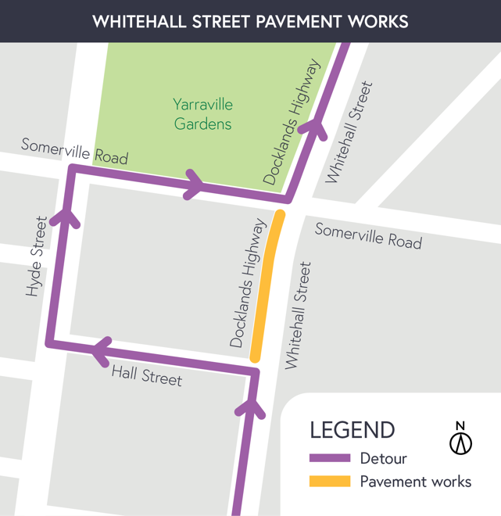

Pavement works on Whitehall Street
January 16th

Pavement works will be undertaken at night on Whitehall Street northbound between Hall Street and Somerville Road.
A detour will be in place via Hall Street, Hyde Street and Somerville Road.
Traffic management will be in place between 8pm to 5am.

Ongoing monitoring in Yarraville
You may see our team carrying out water sampling as part of our regular groundwater monitoring requirements to confirm that ground water is behaving as expected.
You may also see the ground monitoring team around the local streets and local parks installing further ground monitoring equipment in preparation for tunnelling.
These works may include traffic changes for drivers on local roads and occasional nightworks, however there will be minimal noise impacts to surrounding residents and businesses.
We’ll be in touch if the works will be disruptive.

More information on what you can expect during these works
Works will be completed primarily during the day with only occasional nightworks.
Construction vehicles will be moving in and out of the area including excavators, concrete trucks, cranes and rollers.
Minor vibration and noise may be experienced during these works.
Water-spray trucks and road sweepers will be used in local street around our worksites, keeping local roads clear during construction.
Changes in traffic conditions may be experienced during these activities.

Thank you
We appreciate our work can be disruptive and thank you for your understanding. Works may be rescheduled in the event of unexpected impacts.
For updates or questions, please call 1800 105 105,
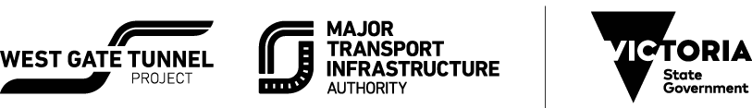
email us at info@wgta.vic.gov.au or visit westgatetunnelproject.vic.gov.au
westgatetunnelproject.vic.gov.au info@wgta.vic.gov.au
1800 105 105
West Gate Tunnel Project Info Centre Corner of Somerville Rd and Whitehall St Yarraville VIC 3013

Follow us on social media
Translation service – For languages other than English, please call 13 14 50.
Please contact us if you would like this
information in an accessible format.
Authorised by the Victorian Government, 1 Treasury Place, Melbourne

