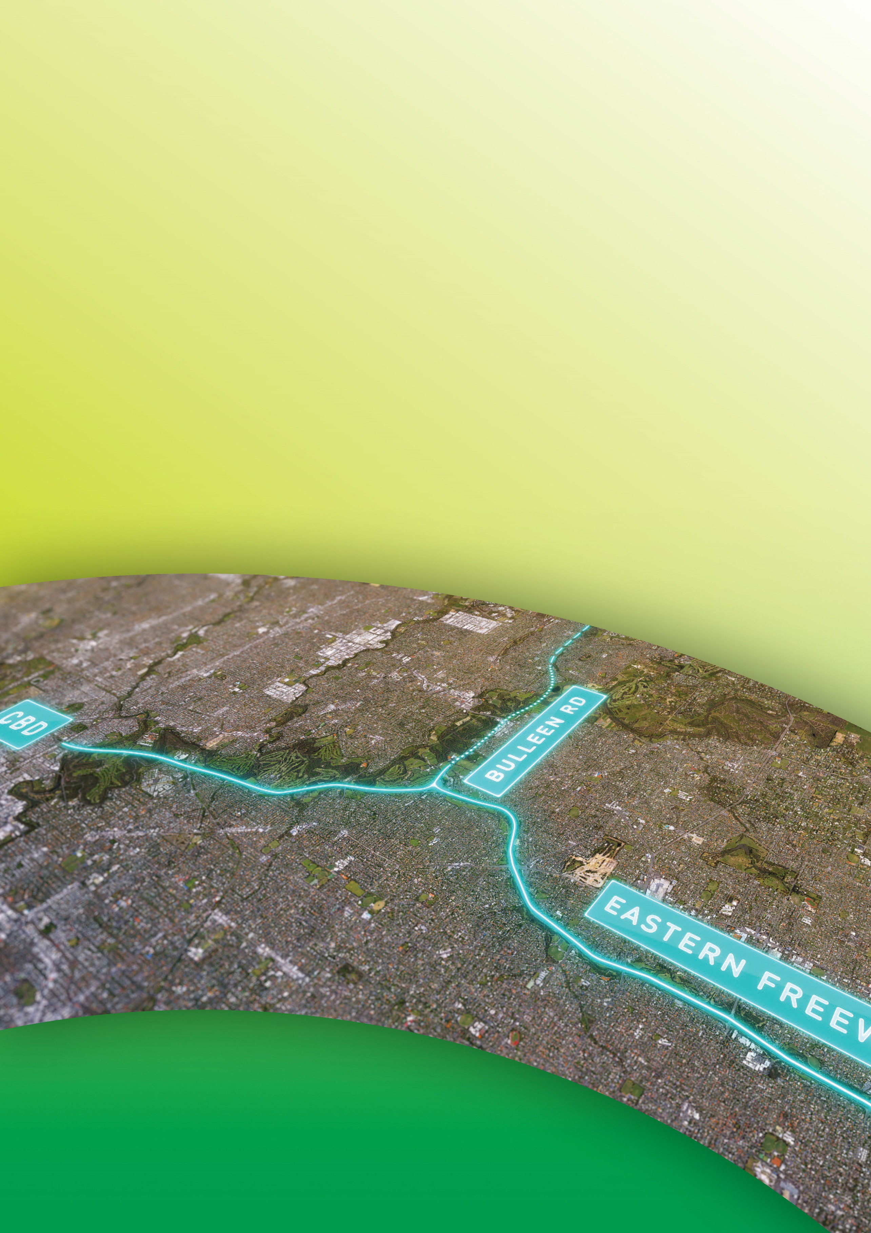
Public Environment Report

Attachment VI
Name of persons

involved in preparing the
PER and the work done
by each of these persons
September 2019

Contents
Attachment VI Name of persons involved in preparing the PER and the work
done by each of these persons VI-1

Tables
Table VI-1 PER writing and coordination team VI-1
Table VI-2 Technical assessments (grouped by discipline) VI-2

Attachment VI
Name of persons involved in preparing the PER and the work done by each of these persons
Table VI-1 PER writing and coordination team

Name | Organisation | Project title/role | Input into PER
Jesse Parsons-Jones | North East Link Project | Environment Advisor, Land, Planning and Environment | Critical review  Proponent representative
Katie Watt | North East Link Project | Director – Land, Planning and Environment | Critical review and approval  Proponent representative
Martin Juniper | North East Link Project | Senior Environment Specialist, Land, Planning and Environment | Critical review  Proponent representative
Michael Crossman | North East Link Project | Manager – Environment, Land, Planning and Environment | Critical review and approval  Proponent representative
Robert Medley | North East Link Project | Senior Environment Advisor, Land, Planning and Environment | Critical review  Proponent representative
Ashleigh Grose | GHD | Environmental Planner, Environment, Social and Planning team | Primary author
Clare Forrest | GHD | Senior Consultant, Environment, Social and Planning team | Primary author
Erin Davis | GHD | Environmental Planner, Environment, Social and Planning team | Primary author

Public Environment Report

Name | Organisation | Project title/role | Input into PER
Hadleigh Pedler | Clayton Utz | Senior Associate, Environment, Social and Planning team | Primary author  – Commonwealth land report
Hugh Kerr | GHD | Senior Environmental Scientist, Environment, Social and Planning team | Primary author  – Commonwealth land report
Kerrie Aldous | Aecom | Specialist coordinator, Environment, Social and Planning team | Primary author
Megan Shaw | GHD | Technical Director Environment, Environment, Social and Planning team | Primary author Critical review
Monique Roser | GHD | Discipline Manager, Environment, Social and Planning team | Primary author Critical review
Tim Righetti | GHD | Spatial and GIS consultant, Environment, Social and Planning team | Spatial analysis and mapping
Zoe Sellwood | GHD | PER Coordinator, Environment, Social and Planning team | PER coordination  Primary Author

Table VI-2 Technical assessments (grouped by discipline)

Name | Organisation | Technical discipline/role | Input into PER
Timothy Wills | GHD | Ecology (Flora) – Lead Technical Director Botany | PER Technical Appendix A  – Ecology  Primary author
Richard Retallick | GHD | Ecology (Fauna) – Lead Senior Zoologist | PER Technical Appendix A  – Ecology  Primary author
Patrick Maiden | GHD | Ecology (Aquatic) – Lead Technical Director  Aquatic Ecology | PER Technical Appendix A  – Ecology Primary author
Gavin Hay | GHD | Surface water – Lead  Technical Director – Flood Hydrology and Hydraulics | PER Technical Appendix C  – Surface water  Primary author
Timothy Anderson | GHD | Groundwater – Lead  Technical Director Hydrogeology | PER Technical Appendix B  – Groundwater  Primary author

Name | Organisation | Technical discipline/role | Input into PER
Jonathan Howell-Meurs | Andrew Long and Associates | Aboriginal cultural heritage  – Lead  Heritage advisor | PER Technical Appendix D  – Commonwealth land  Primary author
David Mathews | Andrew Long and Associates | Aboriginal cultural heritage Heritage advisor | PER Technical Appendix D  – Commonwealth land  Primary author
Bruce Dawson | Golder Associates | Air quality – Lead  Principal Environmental Consultant | PER Technical Appendix D  – Commonwealth land  Primary author
Michael Pocock | Golder Associates | Air quality  Senior Environmental Scientist | PER Technical Appendix D  – Commonwealth land  Primary author
Simon Howe | Landscape Dept | Arboriculture – Lead Consultant Arborist | PER Technical Appendix D  – Commonwealth land  Primary author
Marianne Stoettrup | Matters More | Business – Lead Economist | PER Technical Appendix D  – Commonwealth land  Primary author
Alex Jepsen | GHD | Business  Senior Environmental Planner | PER Technical Appendix D  – Commonwealth land  Primary author
Mark Clough | GHD | Contamination and soil – Lead  Technical Director  – Contamination Assessment and Remediation | PER Technical Appendix D  – Commonwealth land Primary author
David Quinn | GHD | Contamination and soil  Senior Environmental Engineer | PER Technical Appendix D  – Commonwealth land  Primary author
Tom Young | GHD | Greenhouse gas – Lead Technical Director  – Environmental Works Approvals | PER Technical Appendix D  – Commonwealth land Primary author
Claire Marshall | GHD | Greenhouse gas Environmental Engineer | PER Technical Appendix D  – Commonwealth land  Secondary author
Steve Macklin | GHD | Ground movement – Lead  Technical Director – Tunnelling and Engineering Geology | PER Technical Appendix D  – Commonwealth land  Primary author

Public Environment Report

Name | Organisation | Technical discipline/role | Input into PER
Stephen Kerris | GHD | Ground movement  Senior Geotechnical Engineer  – Tunnels | PER Technical Appendix D  – Commonwealth land  Primary author
Kate Gray | Lovell Chen | Historic heritage –Lead  Principal Heritage  – Lovell Chen | PER Technical Appendix D  – Commonwealth land  Primary author
Michael Cook | Lovell Chen | Historic heritage Heritage Consultant | PER Technical Appendix D  – Commonwealth land  Primary author
Suzanne Zahra | Lovell Chen | Historic Heritage  Senior Associate Heritage  – Lovell Chen | PER Technical Appendix D  – Commonwealth land  Primary author
Jackie Wright | EnRisk | Human health – Lead Principal/Director EnRisk | PER Technical Appendix D  – Commonwealth land  Primary author
Brad George | GHD | Land use – Lead  Principal – Planning and Environmental Assessment | PER Technical Appendix D  – Commonwealth land  Primary author
Phillipa Cances | GHD | Land use Senior Planner | PER Technical Appendix D  – Commonwealth land  Primary author
Alastair McKenzie | GHD | Land use Senior Planner | PER Technical Appendix D  – Commonwealth land  Primary author
Allan Wyatt | XURBAN | Landscape and visual – Lead Landscape Architect | PER Technical Appendix D  – Commonwealth land  Primary author
Laura Farrell | GHD | Landscape and visual  Senior Consultant – Landscape Strategy | PER Technical Appendix D  – Commonwealth land  Primary author
Emma Davis | GHD | Landscape and visual  Landscape Strategy Consultant | PER Technical Appendix D  – Commonwealth land  Primary author
Pallavi Mandke | GHD | Social and community – Lead  Technical Director  - Engagement, communication and Communities  National Technical Lead  - Social Impact Assessment | PER Technical Appendix D  – Commonwealth land Primary author

Name | Organisation | Technical discipline/role | Input into PER
Natalie Gardner | GHD | Social and community Urban Planner | PER Technical Appendix D  – Commonwealth land  Primary author
Carmen Lau | GHD | Social and community  Social Sustainability Consultant | PER Technical Appendix D  – Commonwealth land  Primary author
Lauren Harding | GHD | Social and community  Senior Social Sustainability Consultant | PER Technical Appendix D  – Commonwealth land  Primary author
Adrian White | SLR Consulting | Surface noise and vibration  – Lead  Principal Acoustic Consultant | PER Technical Appendix D  – Commonwealth land  Primary author
Gustaf Reutersward | SLR Consulting | Surface noise and vibration  – Lead  Principal Acoustic Consultant | PER Technical Appendix D  – Commonwealth land  Primary author
David Lindsey | SLR Consulting | Surface noise and vibration Principal Acoustic Consultant | PER Technical Appendix D  – Commonwealth land  Primary author
Tony Frodsham | SmedTech | Traffic and transport – Lead Principal Transport Consultant | PER Technical Appendix D  – Commonwealth land  Primary author
Louisa Jenkinson | SmedTech | Traffic and transport Transport Consultant | PER Technical Appendix D  – Commonwealth land  Primary author
John Heilig | Heilig & Partners | Tunnel and vibration – Lead Principal – Heilig & Partners | PER Technical Appendix D  – Commonwealth land  Primary author

