- MODELLING THE WATER ENVIRONMENT

SECTION PAGE SECTION PAGE

  - What is groundwater? 5.3
    - How groundwater moves 5.3
    - Why groundwater levels change 5.5
    - Groundwater concepts 5.6
  - Methodology 5.7
    - Task 1: Preliminary assessments 5.8
    - Task 2: Site investigations 5.8
    - Task 3: Numerical groundwater model
  - Model results 5.24
    - Edithvale 5.24
    - Bonbeach 5.32
  - Construction impact assessment 5.34
  - Operation impact assessment 5.35
    - Edithvale 5.35
    - Bonbeach 5.55

 | development | 5.9 | 5.7 | Conclusion | 5.62
5.2.4 | Task 4: Wetland hydrological model | 5.10
5.2.5 | Task 5: Risk and impact assessment | 5.11
5.3 | Existing conditions | 5.14
5.3.1 | Edithvale-Seaford Wetlands | 5.14
5.3.2 | Aquifers | 5.19
5.3.3 | Groundwater levels | 5.19
5.3.4 | Groundwater flow | 5.19
5.3.5 | Groundwater flow rate | 5.21
5.3.6 | Groundwater recharge and discharge | 5.21
5.3.7 | Groundwater quality | 5.21

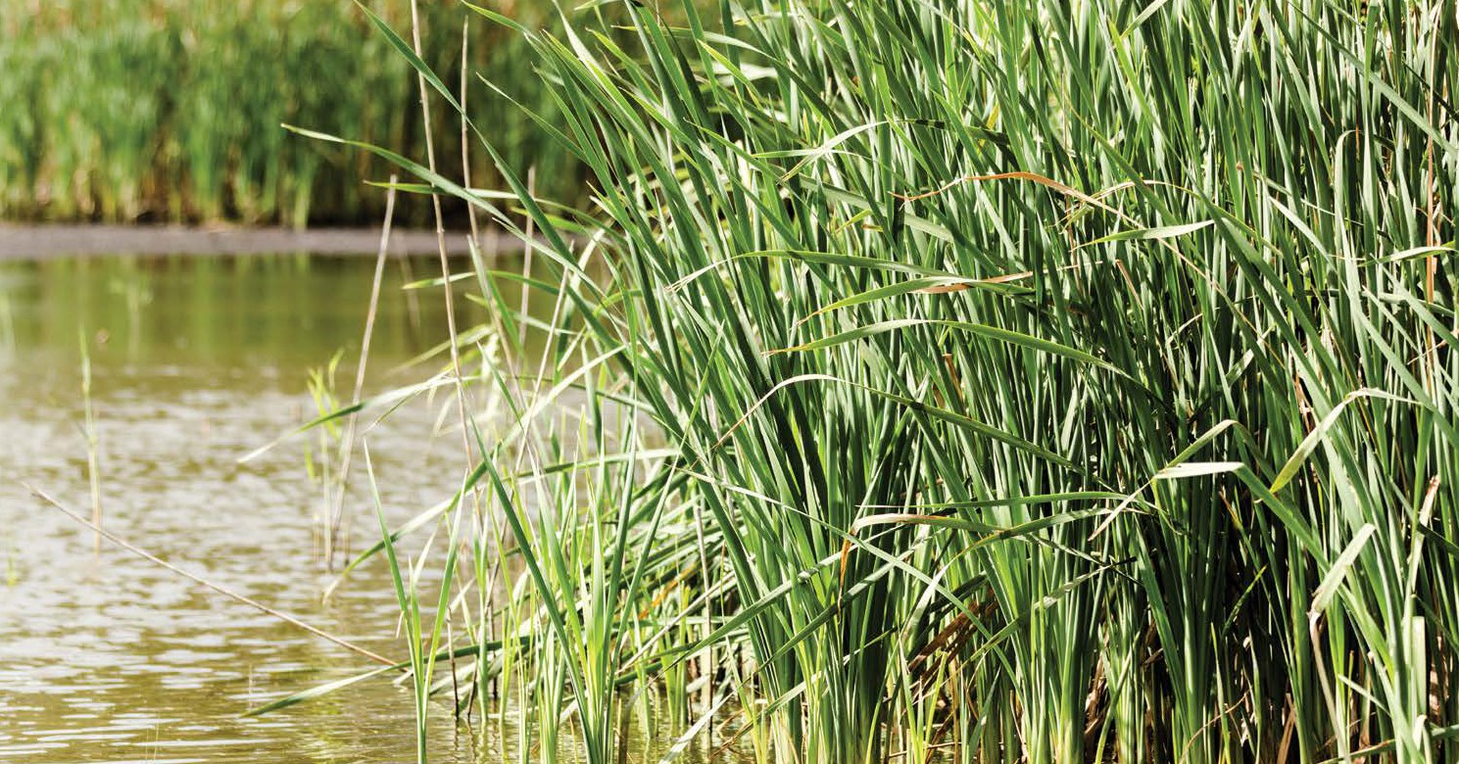

This chapter summarises the methodology adopted to assess potential impacts of the projects on the groundwater regime, the local hydrology and water balance of the Edithvale Wetland portion of the Edithvale-Seaford Wetlands, and ecosystems that depend on the existing water regimes in these systems. This chapter also presents the results of water and groundwater modelling and discusses the potential impacts that result from changes to the groundwater regime.
The Scoping Requirements for the EES include the following evaluation objective:
- Groundwater – to minimise effects on the regional groundwater regime and quality, particularly as they might impact on the hydrology of the Edithvale-Seaford Wetlands and elsewhere on other beneficial uses.
To assess the potential effects on the groundwater regime, several modelling approaches were developed, including a regional numerical groundwater model and local wetland hydrological model for Edithvale Wetland. The key findings of the models are presented below, with detailed modelling reports included in Technical Report A Groundwater. Chapter 6 Edithvale-Seaford Wetlands and groundwater dependent ecosystems contains relevant ecology information and assessment of related impacts, including those that may arise due to the predicted changes to groundwater discussed in this chapter.
The study area incorporates the project area as defined in Chapter 2 Rationale and project descriptions as well as the broader area bound by Port Phillip Bay in the west, Patterson River in the south, the eastern extent of the Edithvale Wetland portion of the Ramsar site in the east and Lochiel Avenue to the north.
A summary of the key findings from this chapter is presented in Table 5.1.

Table 5.1 Summary of key findings

Topic | Key finding
Edithvale | The proposed trench at Edithvale has the potential to exacerbate existing water logging as a result of groundwater intersecting with the surface. The project would be designed to  avoid this impact and ensure no significant impacts to the environment occur. A engineering solution has been developed and modelled using the peer reviewed groundwater model prepared for the EES to demonstrate this outcome is achievable.
Bonbeach | Groundwater flows in a different direction at Bonbeach compared to Edithvale and mounding is not predicted to cause water logging at this project.

  - Edithvale and Bonbeach Environment Effects Statement | Modelling the water environment

What is groundwater?

Groundwater is water located beneath the earth’s surface. It is found in vast quantities, usually occurring through the filling of pores and fractures between grains of soil or rock, similar to how a sponge holds water. Groundwater is studied through the branch of geology called hydrogeology.
Groundwater is sourced from water that originates above the ground – either from rain that has seeped into the soils, or from surface water from rivers, streams and other waterways that has seeped into the subsurface. Groundwater relies upon this connection with rainfall and surface water to be ‘recharged’, and as a result, it is a finite resource. It slowly flows into underground soil and rock layers. There are two main types of these layers:
    - aquifers – are geological materials such as unconsolidated sediments (gravel, sand or silt), permeable rock or fractured rock that could contain water. Groundwater generally flows within an aquifer as they are typically permeable
    - aquitards – are soil or rock layers that could store water but are relatively impermeable, which limits the amount of groundwater flow that could occur.
The upper surface of the zone of saturation within an aquifer is known as the ‘water table’, which occurs at atmospheric pressure. Above the water table is the unsaturated zone, which occurs at lower than atmospheric pressure and can extend from the ground surface to the water table. The unsaturated zone can include moisture that is retained in soil and rock through capillary action, which occurs where a liquid can flow in narrow spaces without the assistance of external forces like gravity.
Both the saturated and unsaturated zones can intersect the ground surface at rivers, streams, lakes and wetlands. Groundwater (typically from within the unsaturated zone), can be relied upon as a water source for flora (vegetation such as trees when it occurs within the root zone of the vegetation). Fauna (for either land or water-based animals) may rely upon groundwater also. Within the project areas, examples of ecosystems that could potentially show some dependence on groundwater include the flora along the coastal dune and the flora and fauna within Edithvale Wetland and Wannarkladdin Wetlands.

    - How groundwater moves
Like in a river, groundwater flows from areas of high water elevation to areas of low water elevation. Therefore groundwater will flow from topographic high points, towards topographic depressions and low points (refer to Figure 5.1).
A groundwater flow regime describes the movement of groundwater through rocks and soil, which is driven by recharge and discharge processes. Recharge and discharge could be considered as the ‘input’ and ‘output’ of an aquifer system, and are variable and dependent on several factors such as climate (low rainfall means less water is available to be recharged) and land use (more impermeable surfaces means less water is available to be recharged).
For this study, groundwater flow regimes have been characterised as being ether local or regional. These characterisations are related to depth and length of flow paths.
- Local groundwater flow regimes describe local variations in flow directions in response to local undulations in topography. Such local regimes occur close to the ground surface and are seasonally dynamic, responding to temporal variations in recharge processes. Local flow regimes are usually associated with shallow groundwater. Figure 5.1 provides a conceptual example of local flow through the arrow indicating shallow groundwater flowing towards the wetland.
- Regional groundwater flow regimes describe regional variations in flow directions driven by regional differences in topography and the location of regional recharge and discharge zones. Such regional regimes typically occur on a catchment scale, with groundwater flowing over distances of several kilometres at depths greater than the local regimes. Since most parts of the regional flow regimes are deep, they are less responsive to seasonal variations in groundwater recharge. Figure 5.1 provides a conceptual example of regional flow through the deeper arrow indicating groundwater flow towards the bay.

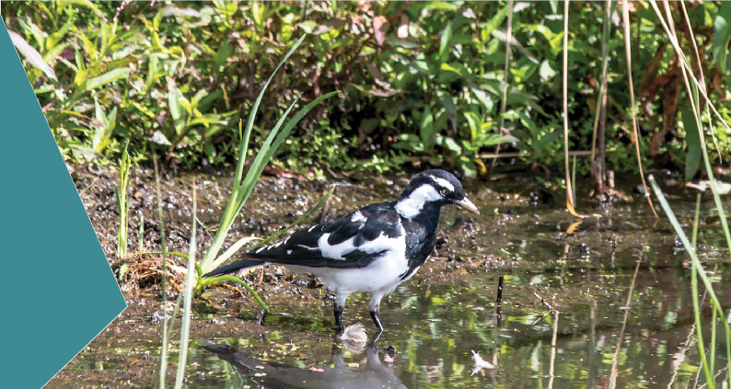At the Edithvale and Bonbeach project sites there is an interaction between local and regional groundwater flows.
The local groundwater flow regimes at the project area are influenced by the surface topography which includes a coastal dune network. The rail line has been constructed generally along the top of this dune network. To the east of the dunes, local groundwater tends to flow in an easterly direction inland. To the west of the dune network, local groundwater tends to flow west toward Port Phillip Bay. At Bonbeach, local groundwater flows in a generally south to south westerly direction towards Patterson River.
The interaction between local and regional groundwater regimes are shown in Figure 5.1.

Figure 5.1 Conceptual diagram of groundwater flow

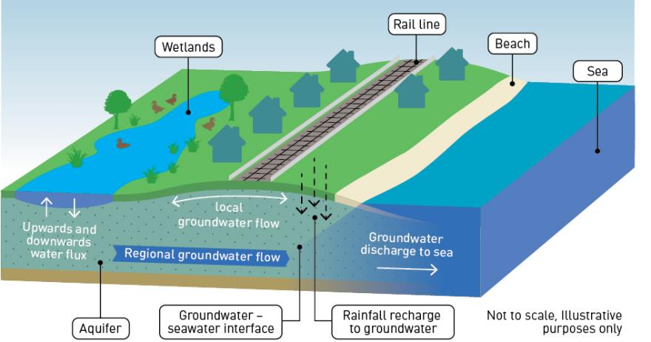

    - Why groundwater levels change
The depth to the water table changes over time and is subject to the geology, landscape setting, land use and climate. Within the project areas, groundwater levels are generally shallow, which is typical of relatively flat coastal settings that occur close to sea level.
While fluctuations in the water table occur naturally (for example, the water table would become deeper during a drought due to less rainfall recharge), human-induced water table fluctuations could also occur. The most relevant project-induced changes to the water table are outlined below and shown conceptually in Figure 5.2:
- Groundwater ‘drawdown’ refers to the lowering of the water table from the existing groundwater level. This occurs through removing water from the aquifer system, for example by extracting groundwater by pumping, or obstructing the flow of groundwater, similar to surface water levels dropping downstream of a dam. Figure 5.2 shows the potential water table drawdown that could occur on the coastal side of the rail trench due to the pile walls required for the project.
- Groundwater ‘mounding’ refers to the raising of the water table from the existing groundwater level. This occurs through adding water to the aquifer system, for example by increased recharge, or by obstructing the flow of groundwater, similar to surface water levels rising upstream of a dam. Figure 5.2 shows the potential water table mounding that could occur on the inland side of the rail trench due to the pile walls required for the project.

Figure 5.2 Conceptual diagram of potential groundwater drawdown and groundwater mounding

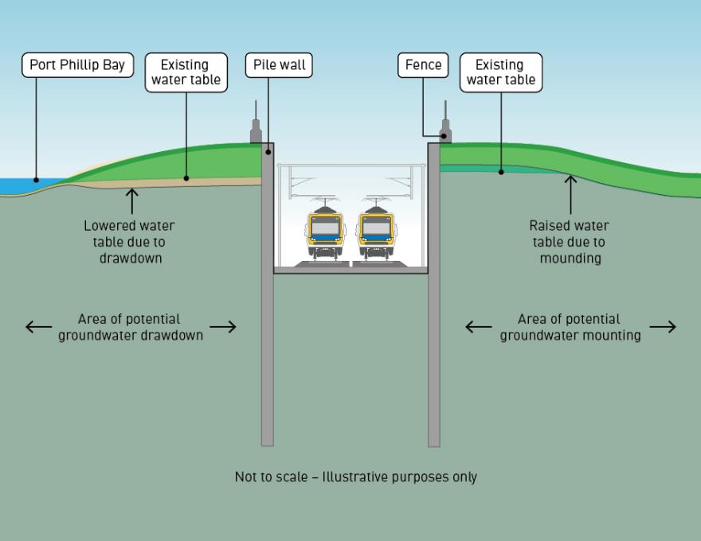

    - Groundwater concepts
Groundwater can have many and varied uses that may benefit people and the environment – these are generally referred to as ‘beneficial uses’. The main beneficial uses of groundwater relevant to the projects are outlined below:
- Groundwater users – Groundwater has long been used as a water resource in Australia, a continent with historically low and unreliable surface water resources. In Victoria, groundwater resources are used primarily for agriculture irrigation purposes, with use being typically seasonal, as irrigators usually pump groundwater in late spring and summer to address rainfall deficits. In addition, groundwater can be used for industrial or commercial purposes, for municipal supply or for stock or domestic purposes. Stock or domestic users are individuals living in both rural and urban areas who use groundwater for a variety of
purposes such as garden watering, general household use (e.g. toilet flushing) and drinking water for stock. There are a number of groundwater bores in the Edithvale and Bonbeach area installed for the domestic use of groundwater.
The use of groundwater for purposes other than stock and domestic purposes requires an extraction licence to be issued by the relevant water corporation, which is Southern Rural Water within the project areas. Uses other than ‘stock and domestic’ require a ‘take and use’ licence to be issued by the water corporation. Such licences would typically be issued to agribusiness users such as irrigators, commercial and industrial users. It is likely that additional unregistered groundwater users exist within the project area, based on the shallow depth to groundwater and likely high groundwater quality.
- Groundwater dependent ecosystems (GDEs) – A GDE is an ecosystem that is dependent on groundwater to meet all, or some of its water requirements to maintain its communities of plants and animals, ecological processes and ecosystem services.
The types of GDEs which are most likely to occur in the study area include:
- Terrestrial communities that obtain at least part of their water requirements from groundwater, but are not totally reliant on surface waters
- Wetland communities in which groundwater provides at least seasonal water logging or inundation.
Surface water levels in wetlands are maintained by groundwater discharges known as baseflow. Groundwater can flow (discharge) into a wetland, if the wetland water level is lower than the surrounding groundwater level (refer to Figure 5.3).
The degree of groundwater dependence is reliant on the location setting (e.g. topography, geology, climate, surface water drainage, water table depth and vegetation rooting depth) and can be temporally variable (e.g. some vegetation may rely on groundwater during drought periods).

Figure 5.3 Groundwater dependent ecosystem

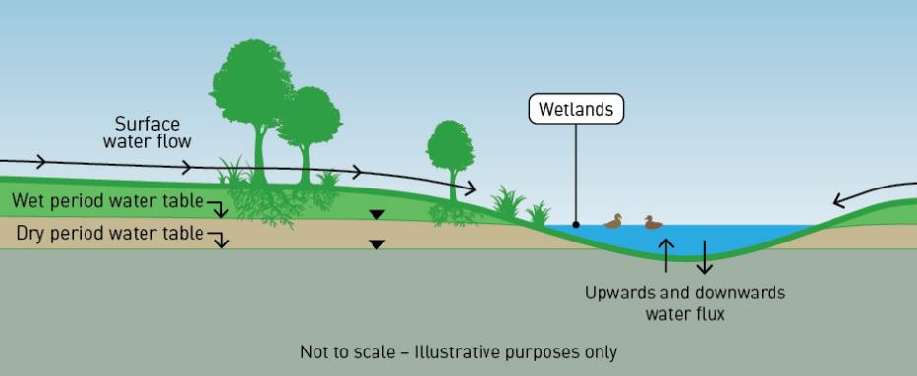

5.2 Methodology
To assess the potential impacts of the projects on the regional groundwater regime, the local hydrology and water balance of Edithvale Wetland, and ecosystems that depend on the existing water regimes in these systems, the following key tasks were undertaken as set out in Figure 5.4.

Figure 5.4 Methodology undertaken for modelling the water environment

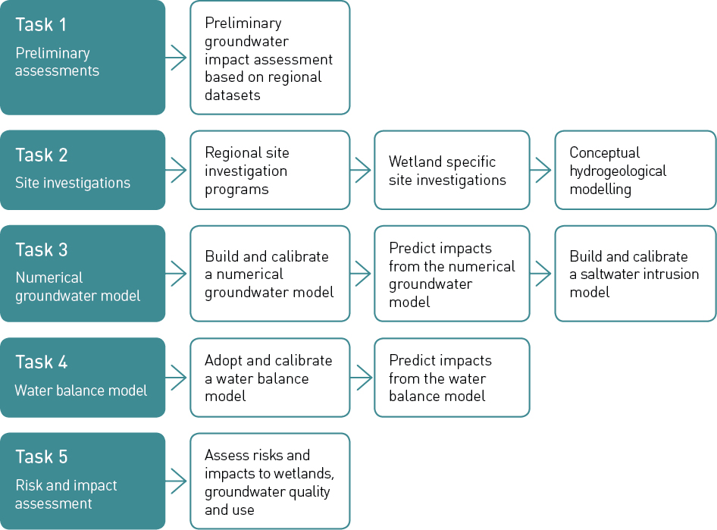

    - Task 1: Preliminary assessments
Prior to the Minister’s requirement for an EES, a preliminary groundwater model was developed to predict potential effects on the groundwater regime associated with the proposed rail trenches. This model identified key risks resulting from the projects, including:
- potential impacts to GDEs, particularly Edithvale Wetland
- potential for acid sulfate soil activation
- an increase in the frequency, duration and extent of existing water logging in areas close to the proposed trenches.

Task 2: Site investigations

Regional site investigation
A regional geotechnical, hydrogeological and environmental site investigation program was conducted along the Frankston rail line, between Cheltenham in the north and Frankston in the south. This program involved the drilling of boreholes to assess the properties of soil and rock (geotechnical investigation), installation, monitoring and testing of groundwater monitoring bores (hydrogeological investigation) and opportunistic sampling of soil and groundwater for contaminants of potential concern (environmental investigation).
The investigation included the drilling of 146 geotechnical bores and the installation of groundwater monitoring bores in 121 of these bores. The purpose of this investigation was to improve the understanding of existing ground conditions and groundwater levels, quality and permeability within the various aquifers, facilitate salinity profiling and improve understanding of the vertical and horizontal movement of groundwater within and between aquifers, as they relate to the project areas near the rail trenches.

Wetland site investigation
A hydrogeological and ecological site investigation program was conducted within Edithvale Wetland to inform groundwater and hydrological modelling, and inform the assessment of potential impacts to sensitive receptors as a result of the projects. The monitoring objectives for the wetland site investigation were to:
- improve understanding of local surface water and groundwater levels and quality trends within the wetlands
- improve understanding of local groundwater-surface water interactions
- improve understanding of temporal reliance of identified ecological vegetation to surface water and groundwater, to inform the ecological assessment
- improve understanding of local interactions between various aquifers
- validate numerical groundwater and hydrological model outputs.
This investigation included the installation of five shallow surface water level gauges. Data loggers were deployed in each gauge to record surface water levels at hourly intervals. Surface water was sampled and analysed at selected wetland cells.
A total of nine groundwater monitoring bores were also installed at the Edithvale Wetland. Data loggers were deployed in each bore to measure groundwater levels at hourly intervals. Groundwater sampling and analysis was undertaken at each bore to assess groundwater quality at the wetlands. The purpose of the surface water and groundwater samples was to compare the chemical signatures of surface water with those of groundwater, to inform the understanding of local connectivity across the Edithvale Wetland. This enabled the conceptualisation of water inflows and outflows to the wetlands to be updated. It also informed the conceptualisation of the wetland system as it relates to the project areas. Groundwater permeability was also tested in each bore to estimate the flow rate of groundwater in the relevant aquifers, which formed inputs to the modelling undertaken.
Opportunistic sampling and laboratory analysis of clay encountered during groundwater bore drilling was also undertaken, to confirm the low permeability of these units and inform the conceptualisation of flow systems at the Edithvale Wetland.
The surface water gauges and groundwater monitoring bores installed for this investigation remain in place and are central to a local groundwater and surface water monitoring program at Edithvale Wetland.

Task 3: Numerical groundwater model development

Building the numerical groundwater model
A numerical groundwater model was developed to predict potential groundwater drawdown and mounding effects associated with the proposed rail trenches. The model used available topographical, lithological and hydrological data.

Topographical, lithological and hydrological data

Topography refers to the elevation of the earth’s surface, usually measured with respect to average sea level. Ground surface elevation is typically above sea level, but inland depressions can occur, usually forming terminal hydrological features, such as the Edithvale-Seaford Wetlands.
Hydrology refers to the study of water above the ground surface, and includes rivers, creek, lakes,
wetlands, the sea and man-made features such as ponds, channels and culverts.
Natural hydrological features may interact with groundwater.
The physical characteristics of geological layers are described by lithological data, which can include rock or soil types, colour, grain sizes, texture and structure. The relationships of lithology with respect to depositional time period is referred to as stratigraphy, or when discussing aquifers, hydrostratigraphy.

Model calibration
For a groundwater model to be used to make predictions about future groundwater conditions, it must be demonstrated that the model can plausibly simulate observed groundwater behaviour. Calibration is a process wherein certain parameters of the model such as recharge and flow rates are altered and numerous individual ‘models’ are run repeatedly until the solution matches field-observed values within an acceptable level of accuracy.
The model was calibrated using hydrological and climate data from the last 20 years (commencing in January 1997), including:
- groundwater level data obtained from DELWP Water Measurement Information System, including measurements from the regional State Observation Bore Network
- groundwater data obtained from the DELWP Victorian Aquifer Framework, a statewide dataset
- local groundwater and surface water level data from relevant locations provided by Melbourne Water
- lithological data obtained from the regional geotechnical investigation undertaken between Cheltenham and Frankston
- groundwater level and hydraulic conductivity data obtained from the local groundwater monitoring network installed for the projects between Cheltenham and Frankston.
Calibration included running the model for the period 1997 to 2017 and then matching the predictions of the model to the actual historical groundwater levels from 121 groundwater monitoring bores drilled and
installed specifically for the project and 16 regional State Observation Bore Network with validated, long-term monitoring data. The 20-year model period was selected as it covers a period of extreme climatic conditions that included the 'Millenium Drought' and above average rainfall from 2010 to 2011. The Millennium Drought commenced with low rainfall conditions in late 1996, and by 2003 it was recognised as the worst drought recorded in Australia since European settlement.

Numerical groundwater model predictions
The numerical groundwater model was used to estimate potential changes to the groundwater regime around Edithvale and Bonbeach, as well as potential changes to local groundwater flow regimes at Edithvale Wetland resulting from the projects.
An ‘initial assessment’ was undertaken which included modelling of project operation based on an initial trench design. The results of the initial assessment showed that further design mitigation of impacts to the groundwater flow regime would be required at Edithvale, but not at Bonbeach.
A ‘mitigated assessment’ was subsequently undertaken based on a revised trench design, which assumed that an engineering solution was in place to minimise impacts to the groundwater flow regime, reduce initial risks and was used to assess residual risks. The results of the initial assessment and the mitigated assessment are discussed in Section 5.4.

Saltwater intrusion model
An assessment was undertaken of the potential significance of salinity changes as a result of the projects, through modelling of the changes in salinity concentrations within each relevant aquifer, based on the initial assessment. The numerical model comprised a two dimensional cross-section, taken along a representative west to east cross section alignment where the greatest changes in the elevation of the water table were predicted, based on the initial assessment.
The model was run over a 100-year simulation period, to predict the potential changes to the salinity concentration profile over the design life of the project. A longer period was adopted for the saltwater intrusion modelling (compared to the numerical groundwater model described previously) since changes to groundwater salinity resulting from saltwater intrusion could feasibly take hundreds of years before impacts are identified.

Task 4: Wetland hydrological model

Wetland hydrological model
A wetland hydrological model was built specifically for the projects using eWater Source, Australia’s national hydrological modelling platform, to simulate detailed wetland hydraulics. The model represents the processes needed to quantify the wetland water balance including inflow, rainfall, evaporation and discharge, which the groundwater model is not designed to simulate in sufficient detail.

Water balance

The difference between a wetland’s water inflows and outflows is known as its ‘water balance’.
When averaged over a long period, the inflows appear to balance the outflows. However, at any

time, one or more components of the balance may dominate. For example, heavy rainfall will cause water levels to rise temporarily.
Alternatively, if groundwater levels decline, the wetland may become drier because groundwater inflows, or ‘baseflows’ decrease.

The wetland hydrological model enabled an integrated simulation of:
- the total wetland water balance (stormwater, baseflow and overland flow inputs; and evaporation, leakage to groundwater, and surface outflows)
- movements of surface water through and between wetland cells according to the relevant details of control structures such as weirs and pipes
- the resulting hydraulic dynamics of the wetlands, including wet versus dry wetland bed, and water depths, which are critical to assessing potential effects and risks of the projects to wetland ecological function.
The groundwater inflow/outflow component of the model was informed by outputs of the numerical groundwater model, which itself simulates the variable wetting and drying of each wetland cell using water level data provided by Melbourne Water, in conjunction with wetland bathymetry data. Bathymetry is the study and mapping of the underwater depth of the wetland floor, which was used to assess water levels. Refer to Chapter 6 Edithvale-Seaford Wetlands and groundwater dependent ecosystems for further information and to Appendix G of Technical Report A Groundwater for the wetland hydrological modelling report.

Following initial groundwater model calibration, the wetland hydrological model was updated to reflect the estimated groundwater inputs and outputs to/from the wetlands over the 20-year model period.
For consistency, the same model period (1997-2017) was adopted in the wetland hydrological model and the numerical groundwater model. The model was subsequently recalibrated using observed wetland water levels to ensure its predictions of the future incorporated all available data.
For predictive modelling purposes, changes to groundwater discharge to/from the wetlands, as estimated by the groundwater model were incorporated into the wetland hydrological model. This enabled simulation of potential changes and risks to wetland hydraulics and ecology.

Wetland hydrological model predictions
The outputs from the groundwater and wetland hydrological models were used to quantify potential impacts and risks to GDEs, including the ecological function at Edithvale Wetland.
Potential changes to wetland water levels and wetland surface area were predicted by modelling scenarios with alternative baseflow and stream leakage, estimated by the numerical groundwater model, including:
  - potential changes to baseflow considering hydrogeological parameter uncertainty
  - potential changes to baseflow considering potential effects of climate change.

Task 5: Risk and impact assessment
A groundwater impact assessment was undertaken to quantify groundwater risks, based on the potential effects of the projects, as simulated using the various model predictions. The assessment considered potential impacts including:
- direct, indirect and cumulative risks to receptors
- sensitivity of the receptors to changes in flow regimes, water quality and water levels.
Risks were assessed during the construction and design/operation phases of the projects. Design and operation are considered together because the design determines how the trenches would affect
groundwater in operation. For further details refer to Attachment II Environmental Risk Report. Changes to groundwater levels and groundwater flow regimes could occur following the construction of the pile walls, which as described in Chapter 2 Rationale and project descriptions, would obstruct groundwater through-flow. Because of these identified potential impacts, the pile wall configurations proposed at Edithvale and Bonbeach include measures that minimise potential impacts to groundwater, including stepped depths of impermeable piles.
Based on the likely depths that the pile walls would be installed, the most significant risk to groundwater resulting from the project would be caused by changes to local groundwater flow regimes, as described in Section 5.1.1. Regional flow regimes typically relate to deeper aquifers that are less likely to be affected by the projects. The risk of changes to groundwater flow regimes would commence during construction as soon as the pile walls are installed, and would continue for the life of the asset. Given the short period of
construction (12-18 months) compared to the duration of operation (assumed to be at least 100 years), and to avoid repetition, changes to groundwater have been addressed as an ‘operation’ risk.
The impact assessment focused on project induced groundwater flow regime impacts resulting from groundwater level drawdown and mounding as a result of the projects. These include:
- short term construction impacts
- interference with local groundwater users
- interaction with existing contaminated or potentially contaminated groundwater
- changes to groundwater levels in the vicinity of GDEs (particularly Edithvale Wetland)
- potential for water logging
- potential for subsidence impacts
- potential for acid sulfate soil activation
- potential for saltwater intrusion.

Short term construction impacts
Short-term groundwater impacts such as groundwater ‘drawdown’ could occur during project construction. The potential for short-term impacts to groundwater (during construction) was assessed by way of a two- dimensional model program called PlaxFlow. Site specific lithological data and hydrogeological data obtained from field investigations were input to the computer program to undertake geotechnical analysis of deformation, stability and groundwater flow.
A model was set up to investigate:
- the drawdown versus time on either side of the pile walls
- the volume and flow rates of groundwater into the excavations.

Local groundwater users
Existing groundwater users were identified from the publicly available Water Measurement Information System and through liaison with Southern Rural Water.
The assessment involved comparing the available drawdown in each identified existing groundwater bore against the modelled predictions. If the interference at a bore exceeded 10 per cent of the available
drawdown (in other words a 10 per cent or greater reduction in groundwater level within a bore), this would represent the potential to result in a measurable impact on the rate at which groundwater could be extracted from a groundwater bore.

Existing groundwater contamination
Potential groundwater contamination sources may be present at locations along the Frankston rail alignment.
There is potential for the projects to interfere with existing offsite groundwater contamination through project induced changes to groundwater flow paths that could occur during project construction or operation. Such interference could include redirection or redistribution of existing contaminant plumes in groundwater.
The groundwater model predictions were used to consider the potential interaction with existing identified or inferred groundwater contamination. The impacts associated with these potential interactions are assessed in Chapter 7 Acid sulfate soils and contamination.

Groundwater dependent ecosystems and surface water features
The types and occurrence of GDEs at Edithvale Wetland were identified through desktop database searches and physical field surveys discussed in Chapter 6 Edithvale-Seaford Wetlands and groundwater dependent ecosystems.
For Edithvale Wetland, a detailed assessment of the potential effects of the proposed project construction options on wetland ecological function was undertaken utilising the wetland hydrological model outputs. The wetland hydrological model facilitated translation of the changes in groundwater inflows and outflows at the wetlands, as simulated by the groundwater model, into changes in the wetting and drying cycles (frequencies and durations) at Edithvale Wetland. The changes to the wetting and drying cycles of specific areas of mapped habitat types across the wetlands were assessed.
For other GDEs, the assessment involved overlaying identified GDEs with the modelled mounding and drawdown outputs. A qualitative assessment was undertaken to consider potential impacts to these features as a result of the proposed projects.
These outputs feed directly into the broader ecological impact assessment of GDEs including the Edithvale Wetland (Chapter 6 Edithvale-Seaford Wetlands and groundwater dependent ecosystems).

Water logging potential
Outputs from the numerical groundwater model were used to identify changes to the area currently showing groundwater levels at, or close to the ground surface under existing conditions. The assessment was undertaken quantitatively through spatial analysis, with the aim of predicting impacts relating to groundwater mounding, including water logging, impacts to vegetation, soil salinity or existing subsurface infrastructure.

Subsidence
Groundwater drawdowns predicted by the groundwater model were used to assess the potential for subsidence to occur as a result of the Edithvale and Bonbeach level crossing removals.
The risk of damage to buildings and other infrastructure would be dependent on the amount of settlement that may occur, and the tolerance of structures to such movement.

What is subsidence?

Groundwater-related subsidence is the sinking (subsidence) of land resulting from groundwater drawdown.
Land subsidence occurs when groundwater is withdrawn from certain types of saturated soil, such as fine-grained sediments. The soil compacts because the water is partly responsible for holding the ground up.

When the groundwater drains from pore spaces within the soil layers, the vertical load is redistributed from the water within the soil and
onto the soil, which compacts the soil due to the redistributed load.
The related ground subsidence that occurs as a result of the reduction in water pressure
in the soil layers can damage nearby structures or utilities.

Acid sulfate soil impacts
Acid sulfate soils contain higher concentrations of iron sulfides, or the products of sulfide oxidisation. Acid sulfate soils are safe when left undisturbed. When disturbed, the sulfides come into contact with oxygen, break down and generate sulfuric acid. This means that lowering of the water table in these sediments would have the potential to result in acidification of the soils through the introduction of oxygen, which, in turn can lead to acidification
of groundwater. The generation of acid can degrade concrete foundations and slabs in contact with soils and groundwater. It can also result in the discharge of acidified groundwater to surface water systems, potentially affect ecosystems that rely on groundwater and cause acid runoff from soils.
Groundwater level change predictions from the groundwater model were used to inform the coastal acid sulfate soil (CASS) assessment of the potential for activation of acid sulfate soils as a result of the Edithvale and Bonbeach level crossing removals. Refer to Chapter 7 Acid sulfate soils and contamination.

Saltwater intrusion
There is a natural subsurface interface between where relatively fresh groundwater discharges to saline seawater along the coast. Figure 5.5 provides a conceptual diagram of the project areas, which shows both local and regional groundwater flow regimes discharging at the coast, as denoted by the blue arrows.
Seawater is denser and heavier than fresh water and naturally forms a saltwater wedge, shown in Figure 5.5, by the subsurface interface. The wedge can extend a few kilometres inland under the coastline into fresher quality aquifers. Under stable natural conditions, this saltwater wedge is natural and not a concern.
Changes to the location of the saltwater wedge can occur due to onshore activities that affect groundwater. For example, groundwater pumping or deep subsurface excavations could draw in groundwater from coastal aquifers and resultantly draw in seawater further inland, where it could increase the salinity of fresher quality aquifers.
In the context of the projects, the potential for saltwater intrusion exists due to installation of permanent ‘pile walls’. These subsurface structures would cause a reduction in groundwater throughflow across the
rail trench, resulting in groundwater drawdown on the coastal side of the rail trench. Groundwater drawdown could trigger the upwards movement of deeper saline groundwater. This effect is called saltwater intrusion (refer to Figure 5.5).
The outputs of the numerical saltwater intrusion model were used to improve the approximation of the shape and distance of the potential saltwater wedge intrusion on-shore, as well as actual temporal flow and salinity changes at the coast, as a result of the projects.

Figure 5.5 Conceptualising saltwater intrusion at the study area

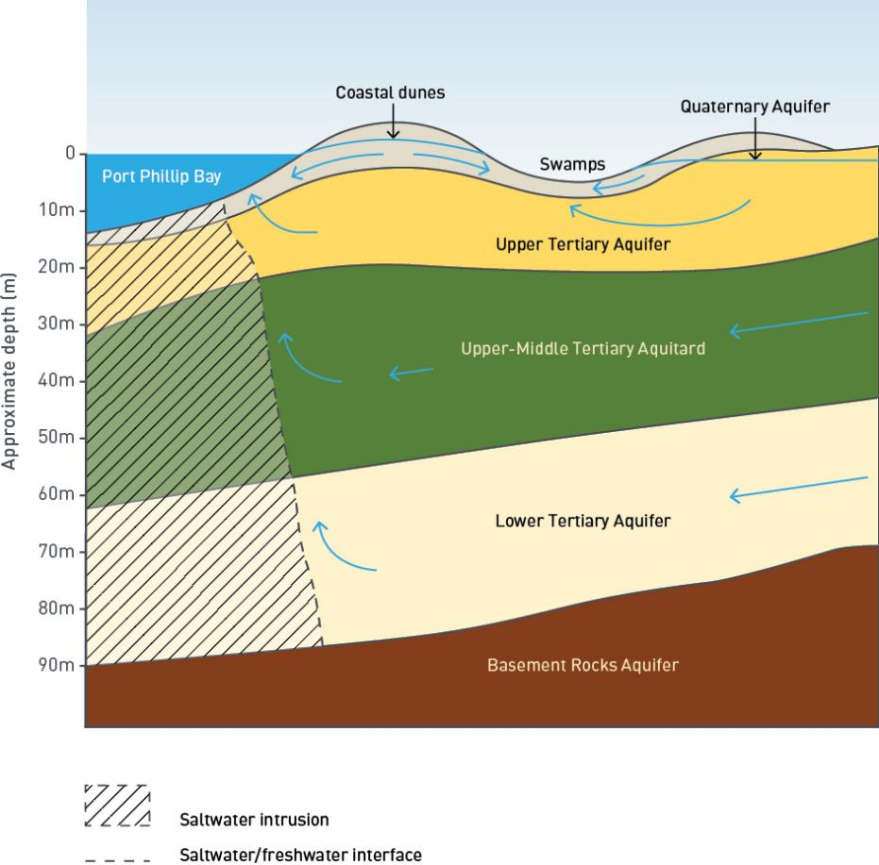

Existing conditions

Edithvale-Seaford Wetlands
The Edithvale-Seaford Wetlands are the last few remnants of the once extensive Carrum-Carrum Swamp that originally extended between Mordialloc and Frankston, at the time of the first European Settlement in the area.
The Carrum-Carrum Swamp historically occupied an area of 5,360 hectares and was fed by waters from the Dandenong Creek, Eumemmerring Creek, the Mordialloc Creek and the Boggy Creek catchments. Many of these wetlands and associated drainage lines have been modified or developed to alleviate historic water logging. That is, the Edithvale-Seaford Wetlands are now hydrologically engineered features, which perform entirely different hydrologic functions compared to the natural setting. The Edithvale-Seaford Wetlands are now separated by Patterson River and the combined sites are declared Wetlands of International Importance under the Ramsar Convention protocol. In designating a wetland as a Ramsar site, countries agree to establish and oversee a management framework aimed at conserving the wetland and ensuring its wise use. Wise use under the Convention is broadly defined as maintaining the ecological character of a wetland.

While the Ramsar listing of the wetlands is a combined listing, the Seaford Wetland and Edithvale Wetland are hydraulically separate features, with the Patterson River forming a hydraulic divide.
While the Seaford Wetlands is also part of the Edithvale-Seaford Wetlands Ramsar site, it is not considered further in this EES due to the hydraulic disconnection and limited potential for impacts as a result of the projects construction or operation –
therefore the EES uses the term ‘Edithvale Wetland’, rather than the Edithvale-Seaford Wetlands, unless reference is being made
to the formal name of the wetland complex. It should be noted that no portion of the Edithvale- Seaford Wetlands occurs within the project areas.

Edithvale Wetland configuration
The Edithvale Wetland contains diverse habitat including shallow freshwater marsh, permanent open freshwater wetlands and brackish to saline ponds. At its closest point, Edithvale Wetland is situated approximately one kilometre east of the Edithvale project area and 1.5 kilometres northeast of the Bonbeach project area. Edithvale Road divides Edithvale Wetland into northern and southern sections.
Edithvale Wetland comprises numerous interconnected water bodies (wetland cells)
of varying size and depth. The interconnections between the cells are important in controlling the movement of water from the eastern cells that receive surface water inflows and the western cells that discharge to the Centre Main Drain.
Figure 5.6 provides a plan of the surface water catchment that drains into the different
components of Edithvale Wetland. Figure 5.6 shows that the surface water catchment extends from the high point of the coastal dune in the west, to the Mornington Peninsula Freeway (M11) in the east. The western portion of the catchment drains to Centre Main Drain, while the eastern portion drains to specific cells within Edithvale Wetland. Edithvale Wetland receives most of its water from runoff obtained from a highly urbanised catchment.

Edithvale and Bonbeach Environment Effects Statement
| Modelling the water environment 5.15

Figure 5.6 Edithvale Wetland surface water catchment
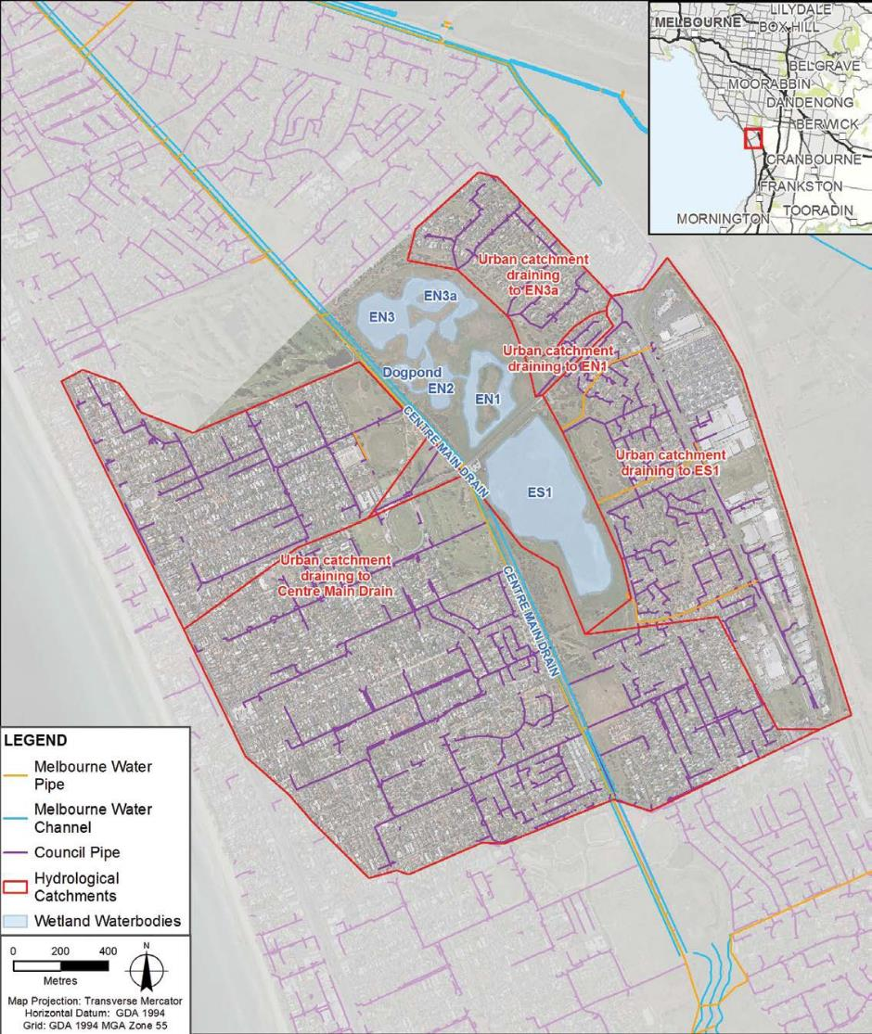

Figure 5.7 provides a conceptual cross section of Edithvale Wetland, specifically highlighting the interaction between individual wetland cells. The wetland cells are described below.

Southern portion of Edithvale Wetland
The southern section of the Edithvale Wetland comprises one wetland cell (ES1), which includes sections of variably shallow fresh to brackish swamp. The natural landform of the southern wetland was excavated to a very shallow depth in 1987, thus altering the natural hydrology and surface water quality to one that is
fresh to brackish. It is unlikely that these excavations penetrated beyond the surficial soil layer. The southern portion of Edithvale Wetland lies at higher elevation compared with the northern wetland component, and thus drains into the northern portion of Edithvale Wetland via a drainage pipe beneath Edithvale Road.

Northern portion of Edithvale Wetland
The northern section of the wetlands comprises a series of constructed wetland cells (EN1, EN2, EN3 and the Dog Pond) that all function differently. Stormwater drains enter the wetlands via litter traps and sediment ponds at EN3. Similar to ES1, wetland cell EN1 comprises sections of variably shallow fresh to brackish swamp. EN2 includes deeper excavations that are unlikely to have penetrated the underlying clay layer or subsequent underlying aquifers.
The base of the two northern-most ponds (EN3 and EN3a) were excavated through an underlying clay layer and into the subsequent underlying sand material (potentially sediments of the Brighton Group Formation, which represents the Upper Tertiary Aquifer), resulting in a permanent connection between shallow groundwater and surface water at these locations. The excavations altered the natural hydrology, surface water quality and local groundwater flow regime to one that is brackish to saline.
One additional cell (Dog Pond) is located north of EN2 and receives overflow water from that cell. Two additional wetland cells (EC1 and EC2) are located in the northern section of the wetlands, to the west of Centre Main Drain. These cells are situated outside of the Ramsar boundary.

Centre Main Drain
Centre Main Drain is a seven kilometre long retarding basin, extending from Patterson River in the south to Mordialloc Creek in the north. There is a pump station at both the northern and southern outlets of Centre Main Drain.
Centre Main Drain is the principal means of discharge for the wetland during wet periods. Centre Main Drain is orientated approximately north-south along the western boundary of Edithvale Wetland.
The primary connection between the wetland and the drain occurs at wetland cell EN3 to the north west of the complex. There are two PVC pipes linking the wetland to the drain and during very wet periods, cell EN3 can spill overland to the drain.
At Edithvale Wetland and north of Thames Promenade, Chelsea Heights, Centre Main Drain flows northerly towards Port Phillip Bay via Mordialloc Creek.

Figure 5.7 Edithvale Wetland conceptual cross section
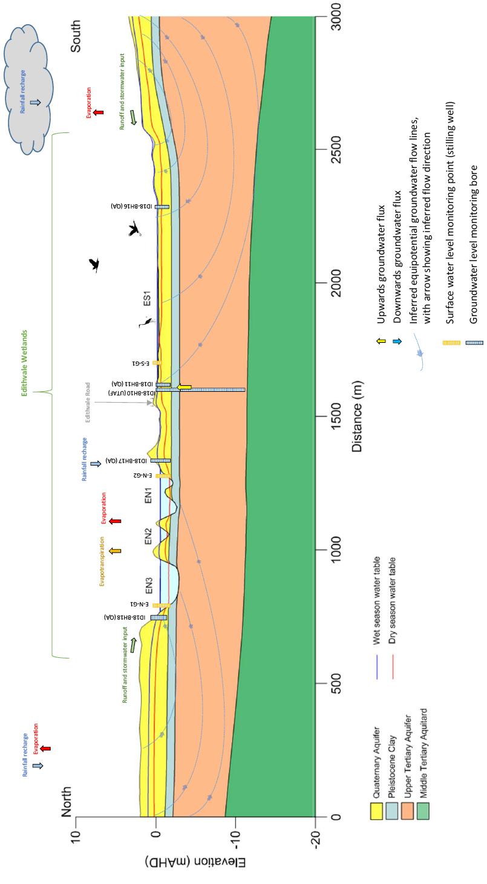
Figure 5.7
Edithvale Wetland conceptual cross section
ID18‐BH16 (QA)

Aquifers
Based on the geology and likely depth of the trenches, three main hydrogeological units (aquifers/aquitards) have been identified within the study area (refer to Figure 5.7):
- Quaternary Aquifer – occurs at depths of 0.3 to 5 metres below ground level at Edithvale and 0.1 to 8.2 metres below ground level at Bonbeach
- Upper Tertiary Aquifer – occurs at depths of 9.6 to 17 metres below ground level at Edithvale and 3.5 to 14 metres below ground level at Bonbeach
- Upper – Middle Tertiary Aquitard – occurs at depths of 22.3 to 33.5 metres below ground level at Edithvale and 30 to 38.4 metres below ground level at Bonbeach.

Groundwater levels
Groundwater levels can be referenced either as ‘groundwater elevations’ (measured to metres above the Australian Height Datum, AHD) or as ‘depth to groundwater’ (measured to metres below ground level, bgl). These levels vary depending on aquifer and geomorphic setting.
At the Edithvale Wetland, the Quaternary Aquifer and Upper Tertiary Aquifer show groundwater elevations below sea level (-0.5 mAHD), which given the low topography at the wetlands, equates to depths to groundwater as shallow as 0.2 metres below ground level and as deep as 1.2 metres below ground level.
Within the project areas at Edithvale and Bonbeach, the Quaternary Aquifer and Upper Tertiary Aquifer show shallow groundwater elevations above sea level (<1.3 mAHD), which equate to depths to groundwater as shallow as 0.8 metres below ground level and as deep as 5.9 metres below ground level.
Given the study area was historically part of a regional swamp, shallow groundwater levels do occur naturally. East of the coastal sand dune at Edithvale, the water table can be close to or at the ground surface during wet climatic periods, typically for short time periods. An example of this is the flooding of Edithvale Road, Edithvale following the 4 February 2011 storm event, which closed Edithvale Road to through-traffic for 11 days.

Groundwater flow

Regional groundwater flow
Based on the regional groundwater monitoring bore network installed between Cheltenham and Frankston, along with available data from regional State Observation Bore Network, the regional groundwater flow direction is inferred to be west to south-westerly at Edithvale, based on July 2017 monitoring data.
The east to west transect of monitoring bores at Bonbeach and Edithvale indicate a decline in groundwater levels towards Port Phillip Bay, consistent with the regional groundwater flow regime, which indicates discharge towards Port Phillip Bay.

Local groundwater flow
The local groundwater flow regime at the project areas is influenced by the surface topography which include a coastal dunes network which forms a local 'flow divide'. Local groundwater flows in different directions on each side of the flow divide, while overall, the regional groundwater flow direction is towards the coast (refer Figure 5.8). The railway has been constructed generally along the top of this dune network. To the east of the flow divide created by the dune network, local groundwater tends to flow in an easterly direction inland. To the west of the dunes local groundwater tends to flow west toward Port Phillip bay. At Bonbeach, the local groundwater flows in a generally south to south westerly direction towards Port Phillip Bay and Patterson River. While groundwater flow predominately occurs towards the bay, consistent with the regional flow regime, local variations in ground surface topography result in local changes to groundwater flow. The most notable aspect of the local flow regime is the easterly flow of shallow groundwater from the coastal dune inland.
Similarly, the groundwater monitoring bores to the south of Patterson River locally indicate a northward shallow groundwater flow towards the river. Patterson River therefore acts as a groundwater discharge feature as described previously, separating groundwater flow to the north of the river from that to the south.
Groundwater level measurements collected in August 2017 at Edithvale Wetland indicate that the hydraulic gradient at the wetland is relatively flat. Groundwater marginally flows towards the topographic low point of the wetlands – Centre Main Drain.
Centre Main Drain is aligned along the western boundary of the wetland and given its depth with respect to shallow groundwater, likely receives seasonal groundwater discharges.

Figure 5.8 Local groundwater flow regime (indicated by red arrows)
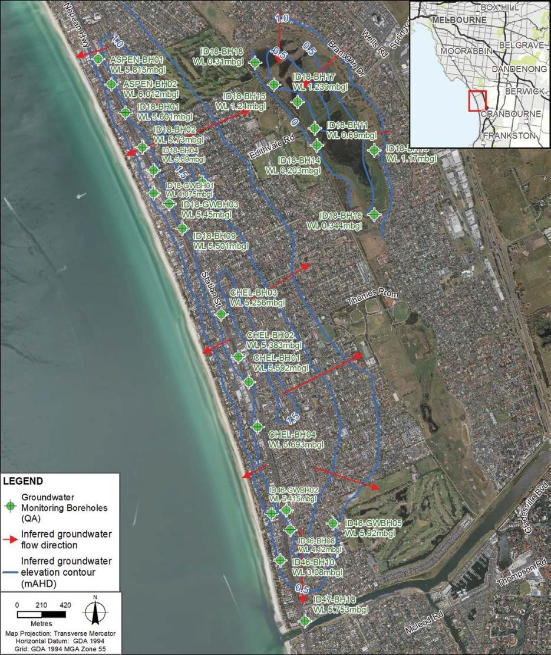

5.20 Edithvale and Bonbeach Environment Effects Statement | Modelling the water environment

Groundwater flow rate
The rate that groundwater can flow is controlled by its permeability (hydraulic conductivity), which is a measure of how easily water can move through porous spaces and fractures in soil or rock.
At Edithvale, the average permeability within the Quaternary Aquifer is three metres per day and 0.8 metres per day within the Upper Tertiary Aquifer.
At Bonbeach, the average permeability within the Quaternary Aquifer is 0.3 metres per day and 0.07 metres per day within the Upper Tertiary Aquifer.

Groundwater recharge and discharge
Across the study area, groundwater recharge is primarily via rainfall, particularly in the sandy coastal dune sediments of the Quaternary Aquifer. Leakage of surface water from the Edithvale Wetland into the Quaternary Aquifer may also be a local recharge source for this aquifer. The concepts of groundwater recharge and discharge are broadly illustrated in Figure 5.1 and conceptualised specifically for Edithvale
Wetland in Figure 5.7. Land uses such as residential, commercial or industrial uses act to reduce the amount of permeable ground surface area potentially available for groundwater recharge. While this should not be discounted, available groundwater level data indicates that groundwater recharge in response to significant rainfall events, does occur across the study area.
At some locations, deeper groundwater within the Upper Tertiary Aquifer discharges to the overlying Quaternary Aquifer, representing a groundwater recharge source for the shallow Quaternary Aquifer.
The regional groundwater regime includes discharge across the study area, for all aquifers, to Port Phillip Bay. Local flow regimes also occur, such as towards Patterson River in Bonbeach, and locally towards Edithvale Wetland in the shallow Quaternary Aquifer and Upper Tertiary Aquifer, in areas situated east of the coastal dune system.
In the context of the projects, there is more potential for the project to impact upon local groundwater flow regimes, based on the likely depths that the pile walls would be installed, as described in Section 5.1.2.

Groundwater quality
The Environment Protection Act 1970 (EP Act) sets out the legislative framework to protect the environment in Victoria. The EP Act introduced the term ‘beneficial use’, which relates to a use of the environment
or any element or segment of the environment where it is conducive to public benefit, welfare, safety, health or aesthetic enjoyment. Beneficial uses as they relate to groundwater require protection from the effects of waste discharges, emissions or deposits.
State Environment Protection Policies (SEPPs) are instruments created under the EP Act that set out more detailed requirements and guidelines to protect environmental values and human activities (beneficial uses) from the effects of pollution, waste and environmental degradation.
State Environment Protection Policy (Groundwaters of Victoria) 1997 provides a framework for the protection of groundwater, as well as the clean-up and management of polluted groundwater throughout Victoria. The policy defines the beneficial uses to be protected based on the quality of the groundwater in the area, measured as Total Dissolved Solids (TDS) and through the designation of ‘beneficial uses’. SEPP (Groundwaters of Victoria) adopts TDS as the most appropriate groundwater quality indicator to define ‘segments’ of the groundwater environment, as it represents a highly variable physical parameter that can be measured in all groundwater and is the most common determinant of uses of groundwater. There are five groundwater segments (A1, A2, B, C and D) defined in the SEPP (Groundwaters of Victoria) based on groundwater salinity. The segment of groundwater determines the beneficial uses to be protected. The gradation between segments is outlined in Table 5.2.

The quality of groundwater at the Edithvale Wetland in the Quaternary Aquifer ranges from brackish (Segment B) to saline (Segment D). Elsewhere
in Edithvale and at Bonbeach, the Quaternary Aquifer shows fresh groundwater quality, ranging from Segment A1 to A2. Each of these segments include potable water supply as a beneficial use. The underlying Upper Tertiary Aquifer however, shows more variable groundwater quality, ranging from 360 mg/L TDS (Segment A1) to 4,700 mg/L TDS (Segment C) at Bonbeach. As a conservative approach, the water table aquifer within the project areas is classified as Segment A1 for this assessment and identifying beneficial uses of groundwater to be protected.
In accordance with SEPP (Groundwaters of Victoria), the beneficial uses requiring protection for groundwater of this quality are outlined in Table
5.2. The relevance of some beneficial uses that are protected under Segment A1 in the project areas is questionable, including:
  - Potable water supply – the relevance of potable water supply as a beneficial use in the project areas is questionable since the area is highly urbanised, expected bore yields are low and there are reticulated water supplies in place
  - Potable mineral water supply – there are no known mineral or spring groundwater sources in the study area
  - Industrial water use – expected bore yields are too low to maintain the high yields required for commercial/industrial purposes.

5.22 Edithvale and Bonbeach Environment Effects Statement | Modelling the water environment

Table 5.2 Protected beneficial uses of groundwater segments

Beneficial use | Segments (mg/L TDS)
 | A1  (0-500) | A2 (501  -1,000) | B (1,001  -3,500) | C (3,501  -13,000) | D  (> 13,000)
Maintenance of ecosystems
Groundwater must be of a certain quality to maintain ecosystems in surface water bodies such as the Edithvale Wetland and Patterson River
Potable water supply
Groundwater must be safe to drink or to use for food preparation
Desirable
Acceptable
Potable mineral water supply
Agriculture, parks and gardens
Groundwater of this quality must be suitable for watering crops or for irrigating public parks and gardens
Stock watering
Groundwater must be of an acceptable quality to be used as a drinking water supply for livestock
Industrial water use
Groundwater of this quality must be suitable for industrial processes, including general use such as washing down equipment, vehicles or work areas
Primary contact recreation
Groundwater must be suitable for
a surface water body in which people swim or to fill a swimming pool
Buildings and structures
Subsurface structures such as building foundations that are in contact with groundwater must be protected from contamination that may cause degradation or corrosion of those structures

Model results
The proposed rail trenches would extend below the ground surface and at some locations, below the water table. The pile walls required for the rail trenches, described in Chapter 2 Rationale and project descriptions, would create an obstruction to the existing groundwater flow regime, which is understood to include westerly flow towards the coast at Edithvale and south-westerly flow towards the coast and Patterson River at Bonbeach.
The predictive modelling described in Section 5.2.3 was used to quantify the potential impacts of pile walls on groundwater at the Edithvale and Bonbeach level crossing removal sites. As described in the methodology (see Section 5.2.3), to understand the effect of the trenches on groundwater levels the model incorporated
20 years of data collected from an existing network of regional groundwater monitoring bores, as well as data collected from 121 bores installed more recently along the Frankston rail corridor and locally within the Edithvale Wetland. The model, once calibrated (i.e. running and correcting parameters within the model to align predicted outputs with observed data), was run nearly 200 times to predict the magnitude and extent of changes in groundwater levels.
Groundwater level changes were predicted by the model to occur locally as a result of the pile walls at Edithvale and Bonbeach. These predicted groundwater level changes are represented by either:
- groundwater mounding (predicted to occur on the inland side of the pile walls)
- groundwater drawdown (predicted to occur on the coastal side of the pile walls).
The amount and extent of both groundwater mounding and drawdown are highly sensitive to the climatic condition at a given point in time. The outputs of the model discussed below are presented as model year 5 and year 12, which represent historic wet (model year 5, 2002) and historic dry (model year 12, 2009) years within the model simulation period. As documented in the Groundwater Modelling Technical Report, included in Technical Report A Groundwater, model year 5 represents a period when the water table was locally elevated by higher than average recharge, with a greater volume of groundwater throughflow towards the coast compared to drier years. Conversely in model year 12, there is less recharge and less groundwater throughflow, resulting in less mounding of groundwater on the up gradient (inland) side of the pile walls.
In assessing the potential changes to groundwater flow regimes, model year 5 represents the most conservative output as it is the year of greatest predicted impact. For this reason, model year 5 is used as the basis of the assessments within this EES.

Edithvale
At Edithvale, the pile wall would be constructed west of the local ‘flow divide’ created by the dune network. Therefore, local groundwater flow from the flow divide occurs in both an easterly direction inland, and in a westerly direction towards the coast. Since the overall regional groundwater flow is towards the coast, the pile wall could cause groundwater mounding on the eastern side (inland) of the pile wall and as a result drawdown on the western side (coastal) of the pile wall. Figure 5.9 provides a cross section illustrating the predicted changes in groundwater levels at Edithvale in model year 5 and model year 12, both with the project (with pile walls) and without the project (without pile walls) based on the initial assessment. As discussed previously, Figure 5.9 demonstrates the model predictions of greater mounding during wet climatic periods (model year 5). Since the study area are topographically flat, vertical exaggeration has been applied (vertically exaggerated by 30 times) to Figure 5.9 to demonstrate the subtle changes in groundwater levels predicted with the project in place.
Figure 5.10 shows a plan view of the predicted area of groundwater impact during model year 5. The predicted groundwater level changes are represented by either:
- groundwater mounding (shown as negative values to represent an increase in groundwater levels on the inland side of the trench)
- groundwater drawdown (shown as positive values to represent a decrease in groundwater levels on the coastal side of the trench).
Figure 5.10 demonstrates that during model year 5, groundwater mounding is predicted to result in an increase in groundwater levels of up to 0.9 metres within 50 metres of the rail trench. Groundwater
drawdown is predicted to result in decreases in groundwater levels of up to 1.4 metres within 50 metres of the rail trench.

Figure 5.9 Predicated groundwater level changes at Edithvale (west to east)
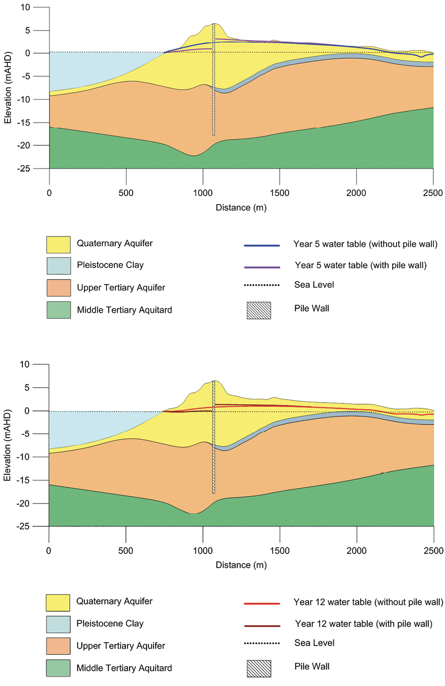

Figure 5.10 Predicted area of groundwater mounding and drawdown at Edithvale based on the initial assessment
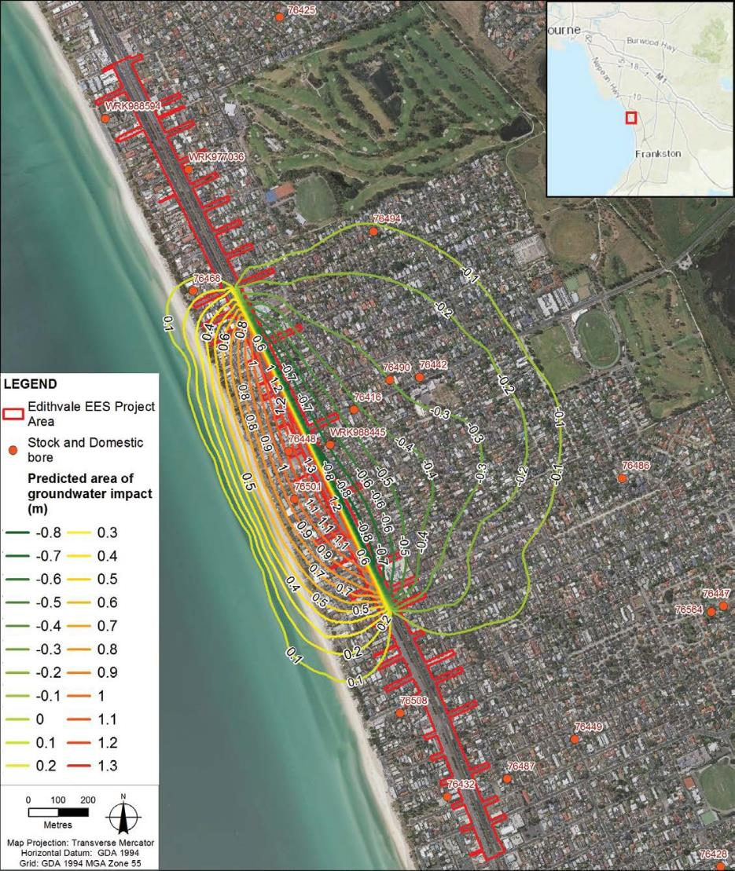

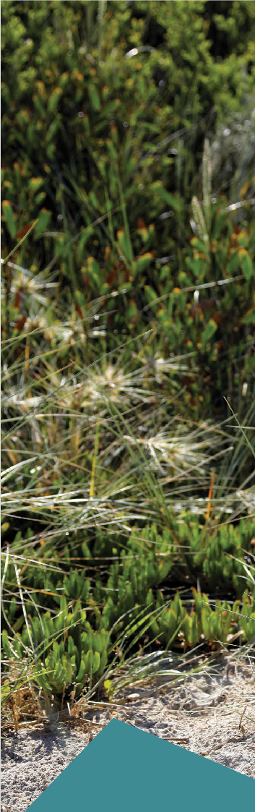

Figure 5.11 shows that for the period of greatest modelled impact (model year 5), groundwater drawdown and mounding impacts that are greater than 0.1 metres do not intersect Edithvale Wetland.
The 0.1 metre contour has been adopted as the minimum contour for defining the extent of predicted area of groundwater impact.
Because model parameters are uncertain, with a plausible range of values, the same ratio of parameters may be obtained with different combinations of parameter values, resulting in more than one plausible realisation of the same model. Confidence limits associated with the model output represent the degree of certainty
in the results. After running the model 196 times, a statistical analysis of the results provided
an indication of the proportion of outputs that produce a particular result.
For example, the 1st percentile confidence limit represented the level of impact exceeded in only one per cent of model runs. In other words, most of the model runs (99 per cent of them) predict effects on groundwater that are equal to or less than the impact shown in the left-hand pane
of Figure 5.11. This indicates that the area of groundwater mounding that is predicted to occur in 99 per cent of the models does not intersect Edithvale Wetland. The 0.1 metre contour occurs as close as 250 metres to the Edithvale Wetland, 99 per cent of the time.
Conversely, very few of the model runs
(one per cent of them) resulted in predicted impacts to groundwater that are less than shown in the right-hand pane of Figure 5.11 (the 99th percentile confidence limit). The 1st and 99th percentile estimates were used to present the most and least impacted cases, respectively, based on the initial assessment. The 50th percentile shows the model predictions for which half the model runs produce impacts less than that shown.

Edithvale and Bonbeach Environment Effects Statement
| Modelling the water environment 5.27

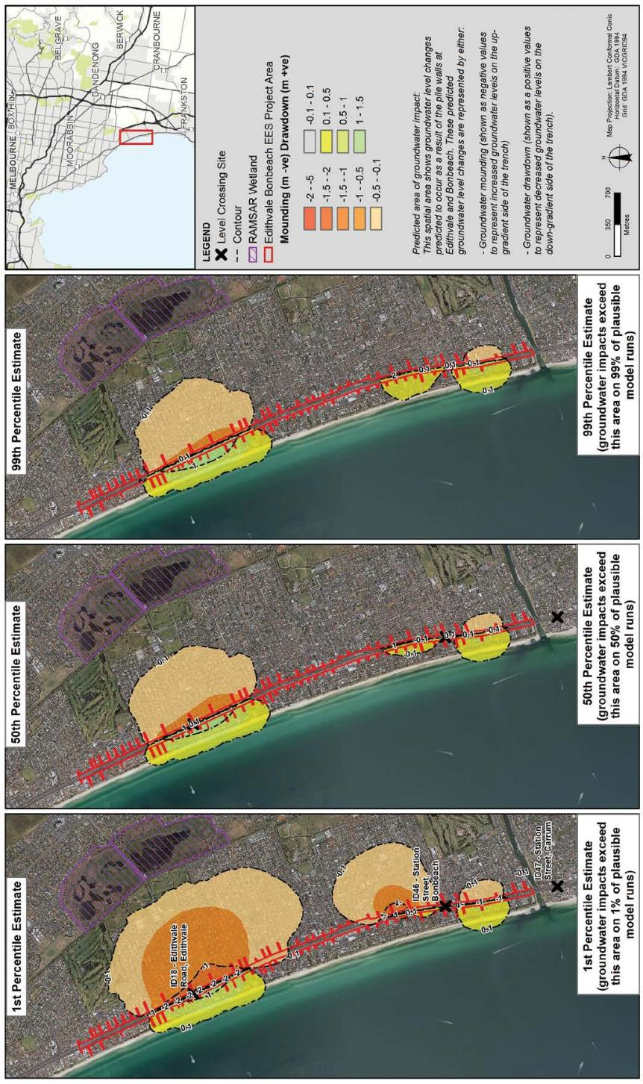
Figure 5.11 Modelled water table changes and uncertainty analysis at Edithvale and Bonbeach

Groundwater management
The low-lying nature of the Edithvale project area means that it is prone to naturally shallow groundwater levels, with potential for groundwater levels to reach the ground surface during wet climatic periods. This process occurs periodically under existing conditions at Edithvale and is referred to as ‘water logging’.
Through the risk and impact assessment process (discussed in Section 5.6), it was identified that the pile wall configurations outlined in Section 5.2.5 and described in Chapter 2 Rationale and project descriptions at Edithvale could result in additional water logging at Edithvale. For clarity, it should be noted that water logging is predicted to occur at Edithvale if the project is not built, but that the proposed pile walls could result in an increase in the frequency that water logging could occur at Edithvale. Water logging was not predicted to occur at Bonbeach, neither under existing conditions, nor as a result of the Bonbeach project.
To manage the risk of increased water logging associated with the pile walls, an engineering solution which would improve the throughflow of groundwater around the pile walls compared to the predictions obtained from the initial assessment, was developed for the Edithvale level crossing removal project. A preliminary assessment of the engineering solution was undertaken and is presented in Appendix H of Technical Report A Groundwater. The assessment outlines:
  - performance criteria that should be considered in the development of an engineering solution to manage groundwater during the detailed design at Edithvale
  - an assessment of effectiveness of a potential engineering solution, in the context of minimising changes to groundwater levels caused by the project.
One example of a potential engineering solution that could enable the local groundwater regime to flow around the rail trench was identified and modelled to demonstrate its effectiveness. In considering a potential engineering solution, performance outcomes were developed to form a framework for development of technical designs. Ultimately, the solution would need to ensure that the difference in groundwater levels on either side of the trench would not result in:
  - groundwater mounding that increases water logging at ground level
  - groundwater drawdown that could cause ground subsidence and adverse impact to subsurface structures
  - degradation to groundwater quality that would preclude beneficial use of groundwater (salinity, contaminants, acid sulfate soils)
  - changes to groundwater that would have significant impacts on GDEs.
The above performance criteria have been consolidated within performance requirement EPR_GW2 (refer Chapter 9 Environmental Management Framework), which the final constructed design must meet. The performance of the final constructed design would be monitored to confirm it is not having an
impact on groundwater levels and quality beyond those set out in EPR_GW2. A Groundwater Management and Monitoring Plan would be developed for the project, to manage predicted and potential impacts to groundwater following construction of the pile walls (EPR reference GW3). The engineering solution developed for this EES demonstrates that EPR_GW2 could be achieved to mitigate the potential impacts predicted at Edithvale. The engineering solution is outlined below and discussed in Section 5.6.1. Prior
to construction of the trench, an independent peer review would be undertaken by appropriately qualified specialists to confirm that the proposed engineering solution, or any variation or alternative to it, would achieve EPR_GW2 (EPR reference GW4).
The engineering solution modelled for this EES comprises the installation of a passive horizontal drain, which is an underground pipe that would be installed around the outside of, and adjacent to, the pile walls. The pipe would be installed at a depth that is permanently below the naturally variable water table, and perforated to allow groundwater inflow and outflow. The same numerical groundwater model developed in the initial assessment was used to model the engineering solution, based on the same 20-year model period.
Groundwater mounding and drawdown predicted in the initial assessment would be caused by the creation of a pressure difference either side of the trench. The passive horizontal drain would provide a permeable connection across the rail trench, reducing this potential pressure difference and minimising the difference in groundwater levels on either side of the trench. Figure 5.12 provides a schematic representation of the passive horizontal drain.

Figure 5.12 Schematic representation of the passive horizontal drain

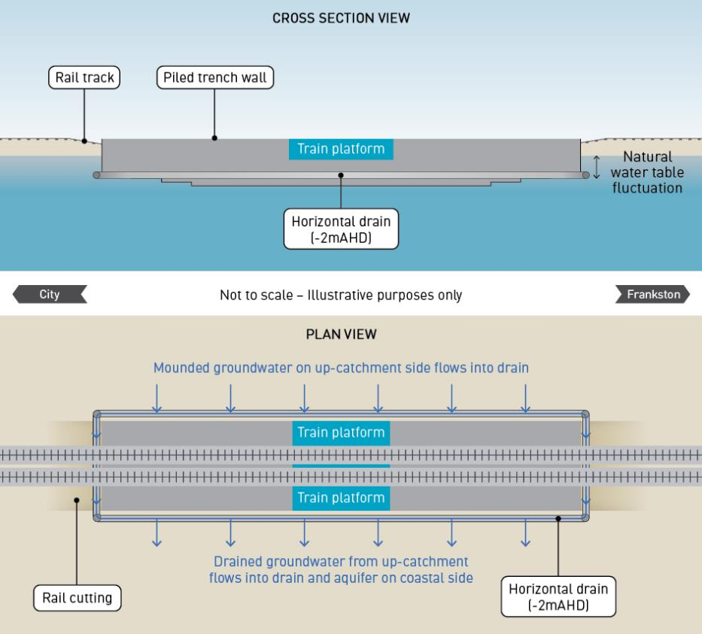

A full description of the potential engineering solution, the groundwater modelling method and results and an assessment of effectiveness based on the ‘mitigated assessment’ are included in Appendix H of Technical Report A Groundwater.
Based on the mitigated assessment, the predicted groundwater level changes were less compared with the initial assessment at Edithvale. Figure 5.13 shows that at Edithvale, implementing the engineering solution could result in:
- Groundwater mounding (increase in groundwater level) of up to 0.2 metres within 50 metres of the rail trench, reducing to less than 0.1 meters within approximately 150 metres of the rail trench. As per the initial assessment, the mitigated assessment does not show predicted changes to groundwater level that extend to the Edithvale Wetland.
- Groundwater drawdown (decrease in groundwater level) of up to 0.3 metres within 50 metres of the rail trench, reducing to 0.2 metres within approximately 100 metres of the rail trench, which does not extend to areas of coastal dune vegetation.

Figure 5.13 Predicted area of groundwater mounding and drawdown at Edithvale based on the initial assessment (left) and mitigated assessment (right)
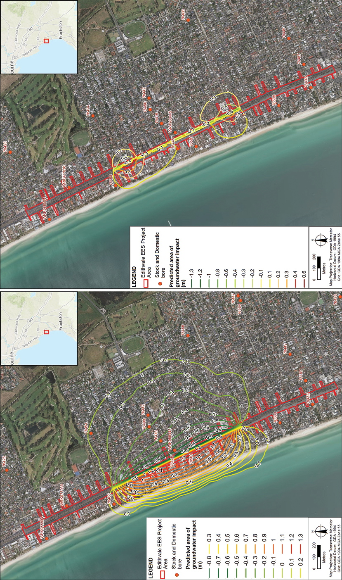

    - Bonbeach
The initial assessment included groundwater modelling at Bonbeach, based on the pile walls of the trench described in Chapter 2 Rationale and project descriptions.
Based on the initial assessment at Bonbeach, groundwater mounding (increase in groundwater level) of up to 0.4 metres within 50 metres of the rail trench was predicted, along with groundwater drawdown (decrease in groundwater level) of up to 0.7 metres within 50 metres of the rail trench.
The groundwater mounding and drawdown predicted through the initial assessment at Bonbeach was significantly less in terms of magnitude and extent of potential impacts, when compared to the model predictions for Edithvale:
- The predicted increase in groundwater levels at Bonbeach (0.4 metres) was less than half of the predicted increase at Edithvale (0.9 metres). The predicted decrease in groundwater level at Bonbeach (0.7 metres) was also half of that predicted to occur at Edithvale based on the initial assessment (1.4 metres).
- The spatial area predicted to be impacted by groundwater level changes at Bonbeach was smaller compared to potential impacts predicted through the initial assessment at Edithvale, refer to Figure 5.14. Specifically:
- mounding at Bonbeach is approximately ten times smaller than at Edithvale
- drawdown at Bonbeach is approximately two times smaller than at Edithvale.
The reduced magnitude and extent of mounding and drawdown at Bonbeach is due to multiple factors, including:
- The difference in the local groundwater flow regime, which results in a groundwater flow direction that is perpendicular to the pile wall at the Edithvale level crossing removal site, resulting in greater impedance of groundwater throughflow. At the Bonbeach level crossing removal site, groundwater flow is locally towards the south, towards Patterson River. At areas where the flow line is parallel to the pile wall,
less impedance on groundwater throughflow is predicted.
- The locations of the pile walls in relation to the location of local groundwater ‘flow divides’ at Edithvale and Bonbeach. The ‘flow divide’ separates westward groundwater flow (towards Port Phillip Bay) from eastward flow (towards Edithvale Wetland and Wannarkladdin Wetlands):
- At Bonbeach, the pile wall would be constructed at the location of the ‘flow divide’ and would theoretically have limited effect on the water table at Bonbeach because it has limited opportunity to interrupt the lateral flow of groundwater across the rail trench.
- At Edithvale, the pile wall would be constructed west of the ‘flow divide’. Therefore, groundwater flow from the flow divide occurs both easterly towards Edithvale Wetland and westerly towards the coast. Since there is a component of groundwater flow towards the coast, the pile wall would theoretically cause groundwater mounding on the eastern side (inland) of the pile wall and resultant drawdown on the western side (coastal) of the pile wall.
The uncertainty analysis discussed in Section 5.4 indicates that at Bonbeach, potential groundwater mounding impacts predicted to occur through the initial assessment at Bonbeach, do not intersect Wannarkladdin Wetlands. The analysis indicates that 99 per cent of model runs predict the 0.1 metre contour to occur 400 metres from Wannarkladdin Wetlands (left pane in Figure 5.11).
A mitigated assessment was not undertaken for Bonbeach, since the risks identified through the initial assessment were considered sufficiently low, such that further mitigation beyond the project design would not be required. The pile wall configuration proposed includes measures that minimise potential impacts to groundwater, including stepped depths of impermeable piles. Refer to Chapter 2 Rationale and project descriptions for further information.

Figure 5.14 Predicted area of groundwater mounding and drawdown at Bonbeach based on the initial assessment
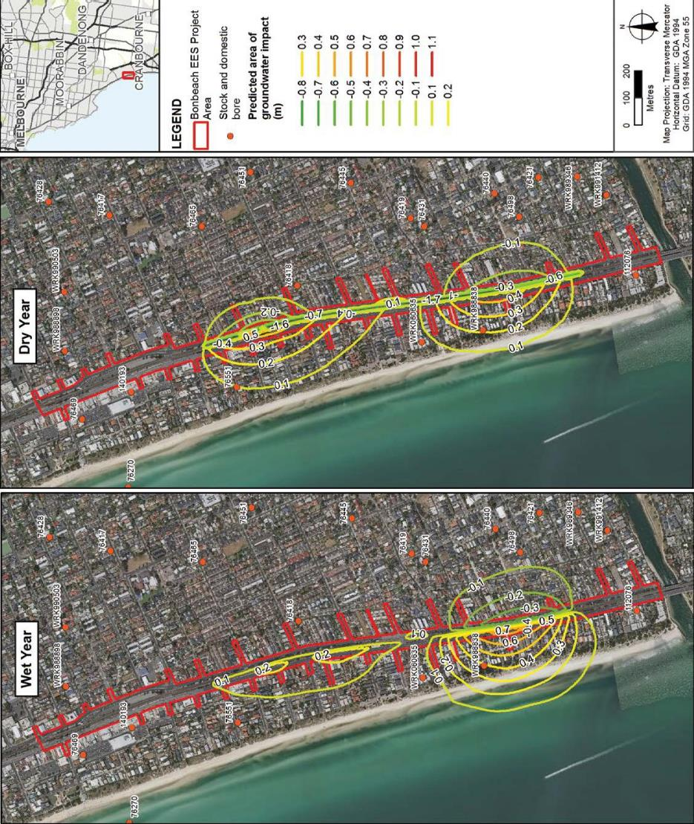

Construction impact assessment
An assessment of risks and impacts to groundwater posed by the projects was undertaken in accordance with the method described in Chapter 4 Assessment framework. One groundwater risk was identified for the construction phase of the Edithvale and Bonbeach level crossing removal projects, which is outlined in Table 5.3 and discussed below.
The only risks pertaining to groundwater during construction could be caused by groundwater drawdown. Groundwater mounding is not anticipated to occur during construction, since there would not be a noticeable impedance of groundwater flow while the pile walls were being constructed.

Table 5.3 Groundwater risks – construction

Risk ID | Event name | Potential impact pathway | Initial EPR | Initial risk | Final EPR | Residual risk
GW58 | Interference with users – Edithvale | Drawdown on the down gradient side of trench impacts groundwater availability for groundwater users. | EPR GW1 –  Rail trench design  EPR GW3 –  Groundwater Management and Monitoring Plan  EPR CL4  Acidic and/or contaminated groundwater (construction) | Negligible | As initial EPR | Negligible
GW65 | Interference with users – Bonbeach | Drawdown on the down gradient side of trench impacts groundwater availability for groundwater users. | EPR GW1 –  Rail trench design  EPR GW3 –  Groundwater Management and Monitoring Plan  EPR CL4  Acidic and/or contaminated groundwater (construction) | Negligible | As initial EPR | Negligible

Groundwater drawdown during construction (risk GW58 and GW65)
During excavation of the trenches at Edithvale and Bonbeach, there is potential for groundwater inflow to the excavation and groundwater drawdown to occur. Since the pile walls would be constructed prior to the trench excavations, groundwater drawdown is expected to be limited to groundwater that occurs between the pile walls. The construction approach described in Chapter 2 Rationale and project descriptions would minimise interaction with groundwater that occurs beyond the pile walls.
To verify this, site investigations and a construction phase dewatering model were used to assess the potential impact to groundwater and existing groundwater users as a result of short term drawdown associated with construction dewatering. The model predicted that negligible groundwater drawdown would occur beyond the pile walls as a result of the construction phase, because excavations occur inside the impermeable trench.
Groundwater dewatering, if required, would be limited to groundwater within the trench during construction.
The project description in Chapter 2 Rationale and project descriptions provides conservative design assumptions that have been used to assess impacts. Based on the project description, the trench could require up to 1,000 metres of trench excavation below the water table, which would result in a total groundwater discharge estimated to be up to 24 cubic metres per day, which is considered to be
readily manageable.
As the groundwater drawdown outside the trench is predicted to be negligible at Edithvale and Bonbeach during the construction phase, associated impacts related to groundwater level changes are not anticipated during project construction. Specifically:
- interference with existing users of groundwater is not anticipated during project construction
- impacts to the beneficial use of groundwater are not anticipated during project construction
- induced migration of existing identified contamination plumes is not anticipated during project construction.
The risk of drawdown of groundwater levels on the down gradient side of the trench and impact on groundwater availability to existing or potential future users was assessed as negligible. The rail trenches would be designed within the parameters outlined in Chapter 2 Rationale and project descriptions (EPR reference GW1). Collection, treatment, disposal and handling of seepage water that does enter the excavation would be carried out in accordance with the Construction Environmental Management Plan (CEMP), developed in accordance with EPA Victoria requirements (EPR reference CL4). Monitoring of groundwater levels and quality would be carried out in accordance with the Groundwater Management Plan (EPR reference GW3).

Operation impact assessment

Edithvale
An assessment of risks and impacts to groundwater posed by the projects was undertaken in accordance with the method described in Chapter 4 Assessment framework. An initial risk assessment was undertaken to assess potential risks to the environment arising from the implementation of the project at Edithvale. Through the risk and impact assessment process, a need to manage groundwater at Edithvale was identified to reduce the potential changes to groundwater levels caused by the pile walls and associated impacts.
To manage potential impacts predicted through the initial assessment, an EPR was developed which would reduce the magnitude and extent of project induced groundwater level changes at Edithvale. As outlined
in Section 5.4, an engineering solution was developed and modelled to demonstrate that a mitigation measure could be adopted to minimise the impact of the project on groundwater levels to the extent that the performance outcomes in EPR_GW2 could be achieved. The risks were then reassessed to determine the residual project risk based on this additional performance requirement. The initial and residual groundwater
risks identified for the operation phase of the Edithvale level crossing removal project are outlined in Table 5.4.
Risks associated with activation of acid sulfate soils as a result of groundwater drawdown (risk GW60) and contaminant migration as a result of groundwater mounding (risk GW62) are discussed in Chapter 6 Acid sulfate soils and contamination.

Table 5.4 Edithvale groundwater risks – operation

Risk ID | Risk name | Risk pathway | Initial EPR | Initial risk | Final EPR | Residual risk
GW58 | Interference with users – Edithvale | Drawdown on the down gradient side of trench impacts groundwater availability for groundwater users. | EPR GW1 –  Rail trench design | Minor | EPR GW1 –  Rail trench design  EPR GW2 –  Groundwater performance outcomes  EPR GW3 –  Groundwater Management and Monitoring Plan | Negligible
GW59 | Subsidence  – Edithvale | Drawdown on the down gradient side of trench could result in subsidence of unconsolidated  subsurface sediments resulting in adverse impact to structures. | EPR GW1 –  Rail trench design  EPR GM1 –  Pre- construction condition survey  EPR GM2 –  Repairs to properties due to vibration, subsidence  or ground movement | Negligible | EPR GW1 –  Rail trench design  EPR GW2 –  Groundwater performance outcomes  EPR GM1 –  Pre- construction condition survey  EPR GM2 –  Repairs to properties due to vibration, subsidence  or ground movement | Negligible
GW60 | CASS  activation – Edithvale | Drawdown on the down gradient side of trench and mounding on up-gradient side of trench could  result in changes in groundwater levels, which could give rise to acidification of CASS and/or mobilise any existing acidity and groundwater acidification affecting beneficial uses of land and groundwater. | EPR GW1 –  Rail trench design | Moderate | EPR GW1 –  Rail trench design  EPR GW2 –  Groundwater performance outcomes  EPR GW3 –  Groundwater Management and Monitoring Plan  EPR CL5 –  Acidic and/or contaminated groundwater (operation) | Negligible

Risk ID | Risk name | Risk pathway | Initial EPR | Initial risk | Final EPR | Residual risk
GW61 | Water logging – Edithvale | Mounding on the up-gradient side of trench results in  increasing the spatial area and duration that the subsurface experiences groundwater levels at or near the  ground surface. | EPR GW1 –  Rail trench design | Moderate | EPR GW1 –  Rail trench design  EPR GW2 –  Groundwater performance outcomes  EPR GW3 –  Groundwater Management and Monitoring Plan | Negligible
GW62 | Contaminant migration – Edithvale | Mounding on the up-gradient side  of trench, drawdown on down gradient side of trench,  and groundwater physically diverted either to the north or south along the up-gradient side of the trench could  alter contamination plume migration adversely impacting on beneficial uses of land and groundwater. | EPR GW1 –  Rail trench design | Moderate | EPR GW1 –  Rail trench design  EPR GW2 –  Groundwater performance outcomes  EPR GW3 –  Groundwater Management and Monitoring Plan  EPR CL1 –  Spoil Management Plan  EPR CL4 –  Acidic and/or contaminated groundwater (construction)  EPR CL5 –  Acidic and/or contaminated groundwater (operation) | Minor
GW63 | Foundations  – Edithvale | Mounding on the up-gradient side of trench could  result in increasing the spatial area and duration that existing subsurface foundations experience groundwater levels at or near the ground surface. | EPR GW1 –  Rail trench design  EPR GW3 –  Groundwater Management and Monitoring Plan | Minor | EPR GW1 –  Rail trench design  EPR GW2 –  Groundwater performance outcomes  EPR GW3 –  Groundwater Management and Monitoring Plan | Negligible

Risk ID | Risk name | Risk pathway | Initial EPR | Initial risk | Final EPR | Residual risk
GW64 | Saltwater intrusion – Edithvale | Drawdown on the down gradient side of trench could result in inland migration of the saltwater wedge and salinisation of aquifers, resulting in change in beneficial  use of groundwater of land and groundwater. | EPR GW1 –  Rail trench design  EPR GW3 –  Groundwater Management and Monitoring Plan | Moderate | EPR GW1 –  Rail trench design  EPR GW2 –  Groundwater performance outcomes  EPR GW3 –  Groundwater Management and Monitoring Plann | Negligible
EG72 | Edithvale Wetland – Edithvale | Groundwater mounding leading to altered hydrological regime and/or water quality resulting  in a change in ecological character (habitat and/or food availability) that exceeds the limit of acceptable change for critical components, processes and systems to the extent that the Edithvale-  Seaford Wetlands no longer meet criteria for listing as a Ramsar site. | EPR GW1 –  Rail trench design | Negligible | EPR GW1 –  Rail trench design  EPR GW2 –  Groundwater performance outcomes  EPR GW3 –  Groundwater Management and Monitoring Plan  EPR FF8 –  GDE Monitoring and Mitigation Plan (Edithvale Wetland) | Negligible

Interference with groundwater users (risk GW58)
During operation, predicted groundwater drawdown on the down-gradient side of the trench has the potential to impact the availability of groundwater for existing registered groundwater users. As defined in Section 5.1.3, existing groundwater users access groundwater either through licensed extraction bores or ‘stock and domestic’ bores.
All licensed groundwater extraction bores are situated beyond the predicted area of drawdown of the projects, therefore, the existing licensed groundwater extractions are not predicted to be impacted by the project.
Based on initial assessment and during the period of greatest modelled impact, there are three stock and domestic bores identified through the DELWP Water Measurement Information System and located within the predicted area of drawdown of the Edithvale level crossing removal project (refer to Figure 5.15). The initial assessment predictions for the period of greatest modelled impact (model year 5) suggest that:
- Bore 76,448 is inferred to be dry under existing conditions and would remain dry based on the predicted drawdown at this location
- the available drawdown (standing water) within bore 76,501 is predicted to reduce by approximately
0.5 metres
- the available drawdown (standing water) within bore 76,468 is predicted to reduce by less than
0.1 metres, which is considered unlikely to impact upon yield of this bore.
Each of these identified existing bores are over 35 years old, potentially indicating that the bores have reached, or are close to reaching their reasonably expected operational life.
The rail trench would be designed within the parameters outlined in Chapter 2 Rationale and project descriptions (EPR reference GW1). The rail trench must be designed to ensure the project does not result

in groundwater level changes that would preclude beneficial uses of groundwater (EPR reference GW2). In order to achieve this environmental performance requirement, the design would need to reduce the magnitude and extent of groundwater level change at Edithvale.
A description of a potential engineering solution and results from the mitigated assessment are included in full in Appendix H of Technical Report A Groundwater. The model predictions from the mitigated assessment indicate that the implementation of EPR_GW2 would reduce the likelihood of groundwater level drawdown at Edithvale
to less than 0.2 metres within 80 metres of the rail trench. Prior to construction of the trench, an independent peer review would be undertaken by appropriately qualified specialists to confirm that the proposed engineering solution, or any variation or alternative to it, would achieve EPR_GW2 (EPR reference GW4).
Based on these controls, impacts to the groundwater available to existing users caused by groundwater drawdown have been reduced to a negligible risk.

Figure 5.15 Stock and domestic bores potentially impacted by groundwater drawdown
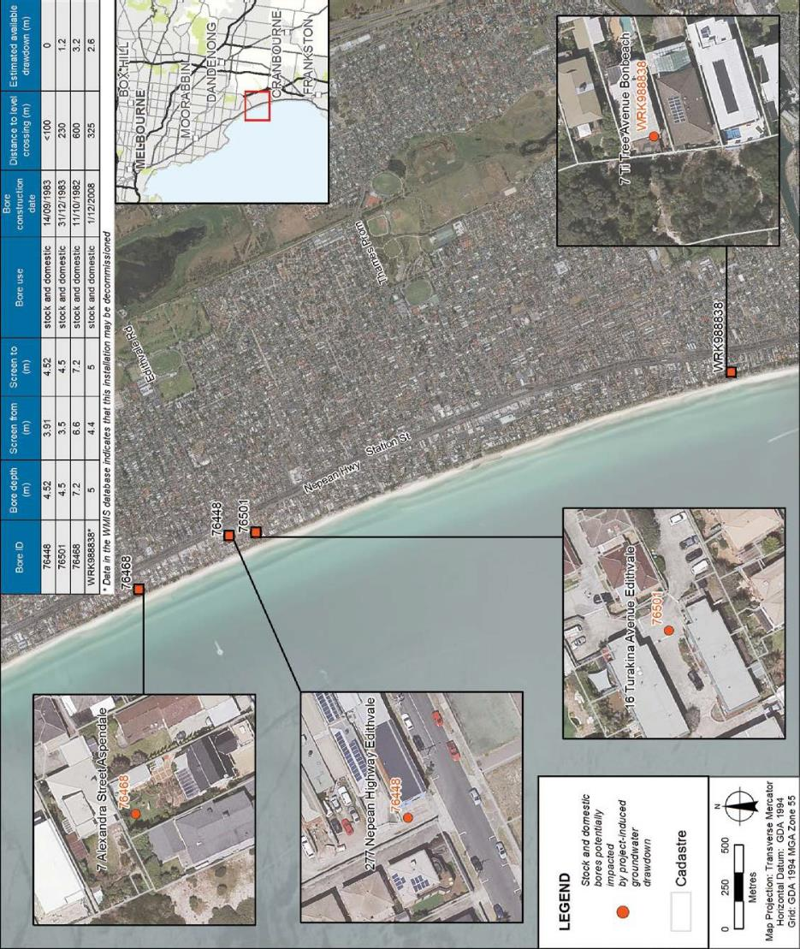

Subsidence (risk GW59)
Groundwater drawdown may result in land subsidence when the water table is lowered at locations where certain types of saturated soils are present, such as soft, fine-grained sediments. When groundwater drains from pore spaces within the soil layers, the vertical load is redistributed onto the soils, which compacts the soil due to the redistributed load. The related ground subsidence that occurs as a result of the reduction in water pressure and increase in load on the soil specifically, has the potential to damage nearby structures or utilities.
It is possible that land subsidence could impact existing infrastructure that is located within the area of predicted groundwater drawdown, by:
- inducing or rejuvenating existing cracking in settlement sensitive facades and architectural finishings
- local minor impact on settlement sensitive underground services
- local minor impact on roads and pavement.
The risk of damage to buildings and other infrastructure would be dependent on the amount and type of settlement that may occur, and the tolerance of structures to such settlement:
- Uniform settlement could occur when land subsidence or settlement occurs evenly or at the same rate throughout all portions of a structure. Structural damage caused by uniform settlement is limited.
- Differential settlement could occur when subsidence or settlement occurs unevenly or at differing rates between different portions of a structure. Differential settlement may cause serious structural problems, particularly in tall buildings and could result in bending of structural elements and cracking in structures.
Based on groundwater modelling undertaken in the initial assessment, groundwater drawdown outside the pile wall excavation is estimated to be around 1.4 metres within 50 metres of the trench excavation. Data from a number of geotechnical bores along the Frankston railway line suggests that soils below the water table are relatively competent, except for a thin layer of soft and compressible swamp deposits. The swamp deposits were found to be one to two metres in thickness, occurring at around 10 metres depth. In areas where 1.5 metres of compressible soil is present, surface settlement may be up to 10 millimetres. Settlement would be restricted to the coastal side of the rail trench where groundwater drawdown is predicted.
It is considered that project induced settlement in the order of 10 millimetres due to groundwater drawdown would be unlikely to cause impact in itself, unless buildings or other infrastructure are highly sensitive to movement. The initial risk level at Edithvale associated with settlement was assessed as minor.
The rail trench would be designed within the parameters outlined in Chapter 2 Rationale and project descriptions (EPR reference GW1). The rail trench must be designed to ensure groundwater level changes (as a result of the project) do not result in groundwater drawdown that could cause ground subsidence and adverse impacts to subsurface structures (EPR reference GW2). At Edithvale, to achieve EPR_GW2 implementation of a mitigation measure is required to manage potential changes to groundwater levels and associated impacts. This mitigation would include modifications to the rail trench design, such as the engineering solution described in Section 5.4 (Model results) to minimise project induced changes to groundwater levels. Achieving EPR_GW2 would require a reduction in the likelihood of groundwater level drawdown at Edithvale to less than 0.3 metres within 50 metres of the rail trench, and therefore reduce the residual risk of subsidence to negligible. A Groundwater Management and Monitoring Plan would be implemented to ensure groundwater throughflow is maintained (EPR reference GW3).
The following management measures are proposed to maintain subsidence impacts caused by groundwater drawdown at a negligible risk level:
- an appraisal of existing structures and their potential to be impacted would be undertaken at the detailed design stage (EPR reference GM1)
- for properties and assets affected by subsidence, required repair work would be undertaken or other actions agreed with the property owner, where impacts are attributable to the projects (ERP reference GM2).

Water logging at the ground surface (risk GW61)
The low-lying nature of the Edithvale project area means that it is prone to naturally shallow groundwater levels, with potential for groundwater levels to reach the ground surface during wet climatic periods. This process occurs periodically under existing conditions at Edithvale and is referred to as ‘water logging’.
Groundwater mounding on the up-gradient (inland) side of the trench at Edithvale could result in raising of groundwater levels locally at Edithvale, potentially increasing the area and duration of water logging during certain climatic periods.
Groundwater modelling initially assessed the trench without any form of engineering solution to mitigate project induced changes to groundwater. This assessment was used to understand the impacts of water logging at the ground surface. In a portion of the study area at Edithvale (inland of the rail trench), groundwater levels were predicted to mound and result in a water table that occurs at shallower levels or at the ground surface under certain climatic conditions. Under these conditions water logging is likely to occur. Figure 5.16 shows the area at Edithvale that could potentially be affected by shallower groundwater levels as a result of the project, during the period of greatest modelled impact (model year 5). It is worth noting that during a drier period, the area potentially affected by shallower groundwater levels and water logging
is predicted to be smaller.
The groundwater model predicted that mounding of the shallow water table may result in impacts at Edithvale, which could include:
  - increased soil moisture content
  - up to a 11 per cent increase in the frequency and duration of groundwater occurring at the ground surface at Edithvale
  - up to a 25 per cent increase in the frequency and duration of groundwater occurring less than 0.5 metres from the ground surface at Edithvale
  - in the order of 25 hectares (25,000 square metres) affected by water logging at the ground surface, in addition to approximately 30 hectares that is modelled to be currently affected.
Modelling of the trench without any form of engineering solution to mitigate project-induced changes to groundwater suggested that the project would need to manage risks associated with an increase in the duration of occurrence of groundwater levels that were predicted to occur near the ground surface at Edithvale. Impacts from shallower groundwater levels caused by the project could include temporary,
but recurrent increases in subsurface moisture, which could potentially cause wet/boggy ground surface conditions (water logging). These would be most notable in unsealed surface areas, such as public parks, fields and residential backyards. Existing bores may also not be equipped to appropriately manage an increase in groundwater levels, and may result in leakage of groundwater from the bores.
Potential water logging impacts caused by groundwater mounding represent a moderate initial risk
at Edithvale, primarily due to social impacts, such as moderate impacts on existing and potential future land uses, most notably the wet/boggy ground surface conditions described above. This would result
in a significant and long-term impact to a substantial number of residential properties up-gradient (inland) of the rail trench, across an area of approximately 25 hectares (25,000 square metres).
Water logging as a result of groundwater mounding was considered to be a key project risk that could only be mitigated through changes to the rail trench design for the project. The change in design is guided by the performance requirements outlined under EPR_GW2 , which states that ‘the tanked rail trenches at Edithvale and Bonbeach must be designed to ensure that groundwater level changes as a result of the projects do not result in groundwater mounding that increases water logging at the ground level.’
The change in design would limit groundwater level change caused by the project by providing a pathway (such as a passive horizontal drain) for groundwater to flow across the rail trench, and flow towards the groundwater discharge zone (Port Phillip Bay). Implementation of EPR_GW2 would reduce the magnitude and extent of project induced groundwater level changes at Edithvale. This would reduce the likelihood
of increases in the occurrence of water logging and reduce the residual risk of water logging at Edithvale to negligible.

A description of a potential engineering solution and results of groundwater modelling undertaken to inform the mitigated assessment, are summarised in Section 5.4 and included in full in Appendix H of Technical Report A Groundwater. The potential engineering solution (passive horizontal drain) was developed as a proof of concept example, and modelled to demonstrate that it could provide groundwater flow around the trench and minimise the impact of the project on groundwater levels to the extent that EPR_GW2 can be achieved.
Figure 5.17 demonstrates the effectiveness of the potential engineering solution (passive horizontal drain). The light blue line in Figure 5.17 shows the modelled water table depth relative to ground level under existing conditions, i.e. with no project in place at Edithvale. This data indicates that there were multiple periods in the 20 year simulation period (most notably between model year 7
and model year 9), where the water table depth occurred at or near the ground surface.
The dark blue line in Figure 5.17 shows the modelled water table depth relative to ground level, with the unmitigated project in place at Edithvale. This data indicates that the same periods of potential water logging identified with no project in place still occur, and additional periods of potential water logging (e.g. between model year 5 and model year 7) also occur. The duration of existing potential water logging periods is also increased due to the unmitigated project at Edithvale.
The red dashed line in Figure 5.17 shows the modelled water table depth relative to ground level, with the mitigated project in place at Edithvale
(i.e. with the passive horizontal drain in place). This data indicates that groundwater levels are very similar to the existing conditions with no project in place. The model indicates that with the engineering solution in place to mitigate changes to groundwater levels, no additional periods of water logging would occur, and no increases in water logging duration would occur.
The performance of the installed rail trench would be monitored to confirm it is not having an impact on groundwater levels, in order to ensure that a groundwater level change does not result in groundwater mounding that increases water logging at the ground level (EPR reference GW3). A management and monitoring program would be implemented to maintain groundwater throughflow of the drainage infrastructure
(EPR reference GW3).

5.42 Edithvale and Bonbeach Environment Effects Statement | Modelling the water environment

Figure 5.16 Predicted impacts to water table depth at Model Year 5 (period of greatest modelled impact) based on the initial assessment
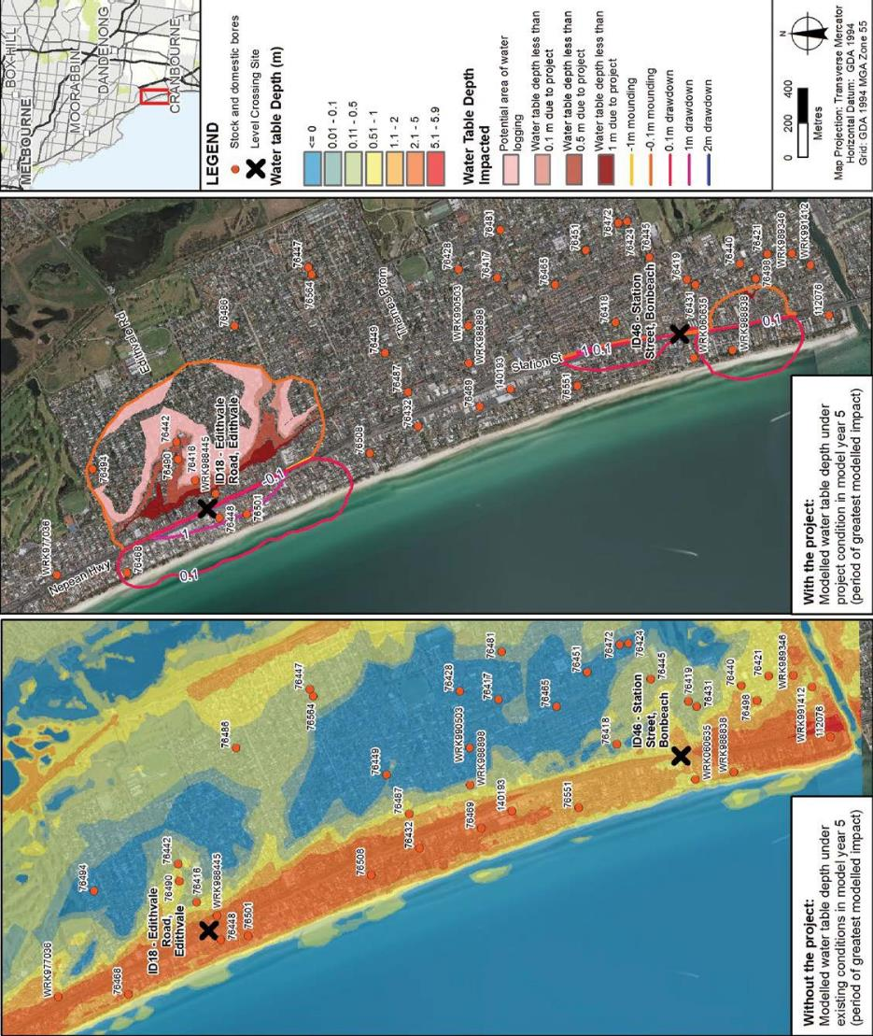

Figure 5.17 Effectiveness of engineering solution – predicted groundwater levels relative to ground level

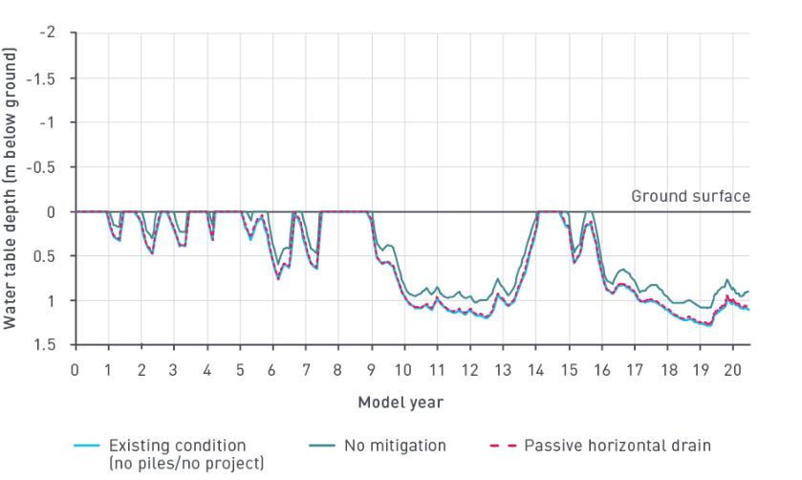

Impacts to foundations due to water logging (risk GW63)
The permanent pile walls at Edithvale could raise the water table as groundwater flow is impeded, which could increase soil moisture content at, or near the ground surface or result in water logging, which could impact existing subsurface structural foundations.
The area of predicted mounding at Edithvale is largely residential, with properties in this area likely
to contain variable footing systems that typically extend less than 0.5 metres below the ground surface. Larger buildings could contain foundations that extend less than one metre from the ground surface. This means that at certain locations, during certain climatic periods (most notably during wet years), existing foundations may already contact the water table under existing conditions.
Based on the initial assessment, there is the potential that shallow groundwater could detrimentally impact existing subsurface foundations within the project area, by increasing the contact time of shallow foundations with the water table.
While the condition of existing subsurface foundations remains unknown, impacts relating to this risk could include increased timber degradation, rising damp, softening or contracting of clay soils. Shallower groundwater levels could result in increased deterioration of concrete and steel subsurface structures, which would reduce their integrity. Shallower groundwater levels could also have an adverse impact on underground tanks and swimming pools, due to uplift or additional pressures acting on the walls of these subsurface structures.
The area at Edithvale predicted through the initial assessment to be affected by a depth to water table of less than one metre due to the project is shown in Figure 5.16. This area extends from the low-lying areas east of the rail line and the coastal sand dune, approximately coinciding with Bridges Avenue, 600 metres east of the rail line at Edithvale, Lochiel Avenue to the north and Elsie Grove to the south.
Based on modelling of the initial assessment, the project would result in a broader occurrence of shallow water table (shallower than one metre below ground surface), however the occurrence, frequency and duration of such shallow groundwater intersecting existing foundations is considered highly improbable. Therefore, impacts to foundations represent a minor initial risk.

The rail trench would be designed within the parameters outlined in Chapter 2 Rationale and project descriptions (EPR reference GW1). The rail trench must be designed to ensure groundwater level changes (as a result of the project) do not result in groundwater mounding that increases the potential for water logging (EPR reference GW2). Compliance with EPR_GW2 would also reduce the likelihood of impacts
to foundations as a result of water logging at Edithvale and therefore the residual risk is negligible.
The performance of the project would be monitored to confirm it is not impacting on groundwater levels beyond the groundwater performance outcomes outlined in EPR_GW2. A management and monitoring program would be implemented to maintain groundwater throughflow via project drainage infrastructure (EPR reference GW2).

Saltwater intrusion (risk GW64)
Under natural conditions, an interface of waters of different salinity naturally occurs at the subsurface between the coast and the shore, due to the density contrast between saline seawater and fresher groundwater.
In coastal aquifers, the salinity of groundwater increases with depth due to the presence of this interface.
The process of saltwater intrusion can occur due to onshore activities that affect groundwater, such as groundwater drawdown. As groundwater levels become deeper onshore, the subsurface interface has the potential to migrate landward. This could impact the water quality of groundwater, which may become more saline due to the mixing of seawater and fresher groundwater. While groundwater may flow at a particular rate, the movement and mixing of seawater and groundwater would occur at a much slower rate.

Groundwater salinity

Salinity is the measure of total soluble (or dissolved) salt (mineral constituents) in water. The salt content of groundwater is measured as Total Dissolved Solids (TDS). TDS is recorded in milligrams of dissolved solid in one litre of water (mg/L).
Owing to its typically long contact time with mineral-rich soils or rocks, groundwater

naturally contains salts and minerals and can be naturally saline. Natural variations in groundwater salinity could occur, due to
temporal or climatic changes, or due to human influence.
In Victoria, the beneficial use of groundwater is largely determined through its salinity concentration.

Groundwater modelling to inform the initial assessment predicted that groundwater drawdown would occur on the down-gradient (coastal) side of the trench at Edithvale during operation. Groundwater drawdown may result in impacts resulting from a changed (deeper) water table, including impacts that are specific to aquifers situated near the coast. Specifically, groundwater drawdown may result in saltwater intrusion, such that relatively fresh groundwater may become more saline.
Groundwater modelling was undertaken to assess the significance of potential project-induced changes to groundwater salinity. Salinisation of groundwater could impact the beneficial uses of groundwater, which are protected under the SEPP (Groundwaters of Victoria). A change in the beneficial uses of groundwater as a result of a change in groundwater segment, regardless of whether the use is realised or not, considered
pollution under SEPP (Groundwaters of Victoria). Examples of known uses at Edithvale that could be impacted by this change include maintenance of ecosystems (vegetation on the coastal sand dune) and agriculture, parks and gardens (garden watering). Based on the current understanding of the groundwater quality, all beneficial uses identified under SEPP (Groundwaters of Victoria) apply to groundwater in this area including potable (drinking) water, maintenance of ecosystems, agricultural parks and gardens, stock watering, industrial water use, primary contact recreation and buildings and structures.

Groundwater salinity in the water table aquifer is spatially, and likely temporally variable, owing to the complex local groundwater flow regimes described previously in Section 5.1.1. Across the Edithvale project area, the water table aquifer shows fresh groundwater quality ranging from 220 mg/L TDS (Segment A1) to 620 mg/L TDS (Segment A2), each of these segments include potable water supply as a beneficial use.
Limited site-specific data obtained during this investigation indicated that groundwater within the study area could occur within Segment A1 and Segment A2, with no spatial trends apparent based on available data. As a conservative approach, the water table aquifer within the project area has been classified as Segment A1 for the purpose of this assessment and identifying beneficial uses of groundwater to be protected.
The underlying Upper Tertiary Aquifer shows variable groundwater quality, ranging from 1,300 mg/L TDS (Segment B) to 9,900 mg/L TDS (Segment C) at Edithvale. These segments exclude potable water supply as a beneficial use. Trends in the variability of salinity in the water table aquifer have not been identified owing to the limited site specific temporal data obtained during this investigation, which does not consider temporal seasonal variability or longer-term averages in TDS. Salinity trends are, however, likely to be influenced
by local natural (e.g. variable recharge) and anthropogenic (e.g. leaking reticulated water mains or urban drainage infrastructure) factors.
Saltwater intrusion modelling based on the initial assessment was used to obtain an indication of the potential magnitude and the rate of change in salinity as caused by the projects at Edithvale and Bonbeach.
A two-dimensional cross-sectional model was constructed and applied along a representative location within the area. The model was considered representative across the Edithvale and Bonbeach project areas, owing to the following points:
- similar hydrogeological setting conceptualised at Edithvale and Bonbeach
- the cross-section line was centred on the location of maximum predicted impacts to groundwater levels to conservatively estimate impacts across both project areas
- the cross-section line was orientated to intersect the location of existing groundwater monitoring bores, to facilitate model calibration and validation.
As described in Section 5.2.3, the model was run for a 100-year period, to predict potential changes to salinity concentrations. The model calibration indicated that it takes more than 10,000 years for the saltwater wedge to migrate inland from the coastal boundary and reach a steady state condition. This implies that the current location of the saltwater wedge and associated mixing zone would have developed over thousands of years.
Figure 5.18 presents the predicted salinity concentration contours (TDS concentration) after 100 years of project operation, showing a decline in salinity concentration on the up-gradient side (inland) of the trench, and the rise in salinity concentration on the down gradient side (coastal) of the trench.

Figure 5.18 Existing and impacted (after 100 years) salinity concentration contours
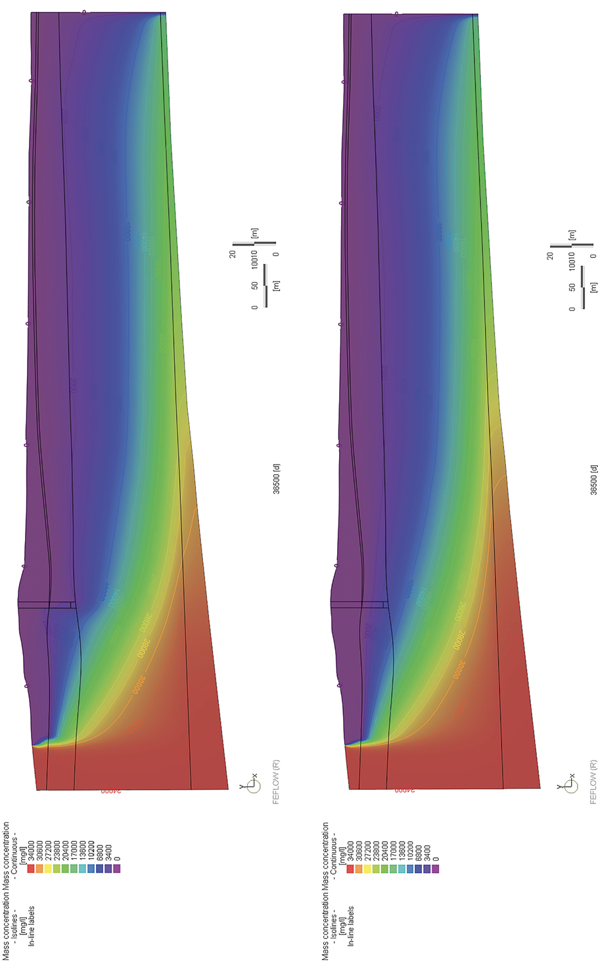

Based on the initial assessment, groundwater modelling indicates that drawdown of the water table due to the pile walls has the potential to cause an upward movement of the saltwater wedge. The saltwater wedge however, is predicted to respond slowly to the drawdown and mounding effect, with small changes in salinity of shallow groundwater possibly not evident for several years to decades.
While the saltwater wedge is predicted to move slowly, the salinity of shallow groundwater would be expected to vary seasonally in response to natural climate variations, including changes in groundwater recharge and evaporation. The range of seasonal salinity variations may be comparable to the predicted change in salinity caused by the movement of the saltwater wedge.
Based on the initial assessment, groundwater modelling has predicted the change in salinity in the water table aquifer to be in the order of hundreds of milligrams per litre TDS, and not thousands of milligrams
per litre. While these predicted changes in salinity concentrations are minor in that they are within the range of typical variation in salinity for the water table aquifer, the consequence of these predicted changes could be considered moderate, as they could result in the loss of one or more beneficial uses of groundwater.
Given the small changes in concentrations predicted, it would be difficult to differentiate between the minor differences in concentrations that may result due to saltwater intrusion, from expected seasonal and temporal variability in salinity in the water table aquifer.
Irreversible impacts are predicted to occur at Edithvale over a period of 100 years, with model predictions indicating a similar predicted increase in the salinity of shallow groundwater, with and without the effect of climate change (a 0.8 metre increase in sea level and a 53 per cent reduction in recharge).
Predicted changes to groundwater quality as a result of saltwater intrusion have the potential to change the classification of the water table aquifer from Segment A1 to Segment A2 of the SEPP (Groundwaters of Victoria) in some portions of the water table aquifer. Based on the initial assessment, this prediction has been modelled to occur over a period of approximately 25 years, commencing from the installation of the pile walls. After 25 years, minor increases in salinity are predicted to continue. The classification of the water table aquifer would likely not increase beyond Segment A2 of the SEPP (Groundwaters of Victoria), over a period of approximately 100 years commencing from the installation of the pile walls. It should be noted that site specific groundwater data collected from Edithvale indicate that under existing conditions, the water table aquifer exhibits, at some locations, groundwater quality classified as Segment A2.
As demonstrated through the model predictions, even without the project, climate change effects have been modelled to increase groundwater salinity in the water table aquifer during the project life (100 years). This prediction is represented by the blue line in the hydrograph shown in Figure 5.19. As such, it is conceivable that without the project, climate change effects have the potential to change the classification
of the water table aquifer from Segment A1 to Segment A2 of the SEPP (Groundwaters of Victoria) locally within the water table aquifer.

Figure 5.19 Predicted change in salinity (mg/L)

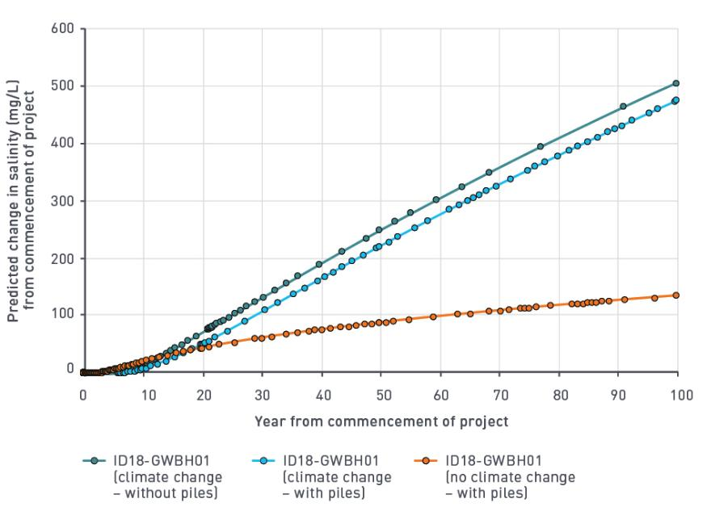

The only beneficial use that would be impacted by these project predictions is a change in the classification of use of groundwater for potable water use from desirable (Segment A1) to acceptable (Segment A2). Under existing conditions at Edithvale, there are potentially background levels of water quality indicators other than TDS (such as selected metals) that may be detrimental to protected beneficial uses, including potable use. As such, there is potential that even under existing conditions, one or more protected beneficial uses does not apply to groundwater in the project area.
Based on the initial assessment, the magnitude and spatial extent of saltwater intrusion impact would be expected to result in consequences that are moderate at Edithvale. At Edithvale, saltwater intrusion impacts represent a moderate initial risk, largely due to the higher magnitude and large spatial extent of drawdown predicted, compared to Bonbeach.
The rail trench would be designed within the parameters outlined in Chapter 2 Rationale and project descriptions (EPR reference GW1). The rail trench must be designed to ensure the project does not result in degradation to groundwater quality that would preclude beneficial use of groundwater (salinity) (EPR reference GW2). To achieve this performance requirement, implementation of a mitigation measure at Edithvale is required to manage potential project induced changes to groundwater levels and quality. This mitigation would include modifications to the rail trench design to minimise changes to groundwater levels, which would result in reduced likelihood of changes to groundwater quality. As such, EPR_GW2 would reduce the likelihood of saltwater intrusion impacts at Edithvale and therefore, the residual risk associated with saltwater intrusion is negligible. Similar modifications to the trench design are not required at Bonbeach to enable compliance with EPR_GW2 because of the lower magnitude and extent of drawdown, which result in sufficiently low resultant risks.
The performance of the installed rail trench would be monitored to confirm it is not having an impact on groundwater levels, to ensure that a groundwater level change does not result in degradation to groundwater quality that would preclude beneficial use of groundwater (salinity) (EPR reference GW3). A management
and monitoring program would be implemented to maintain groundwater throughflow of the drainage infrastructure (EPR reference GW3).

Groundwater regime at Edithvale Wetland (risk EG72)
The groundwater model and the wetland hydrological model were used in the initial assessment to assess the potential impacts of groundwater mounding as a result of the project. The wetland hydrological model was used to assess the risk of groundwater mounding as a result of the project and its potential to impact the existing groundwater regime at Edithvale Wetland, which could result in loss of habitat at Edithvale Wetland.
The groundwater model, based on the initial assessment, predicted groundwater mounding to occur
up-gradient (inland) of the pile walls at Edithvale. The groundwater modelling was used to simulate subtle changes to the baseflow of the Edithvale Wetland water balance, as a result of project-induced mounding of the water table.
As detailed in Section 5.4 (Model results) during the period of greatest modelled impact (model year 5) based on the initial assessment at Edithvale, groundwater drawdown and mounding impacts that are greater than 0.1 metres do not intersect Edithvale Wetland. The 0.1 metre contour has been adopted as the minimum contour for defining the extent of predicted area of groundwater impact.
Uncertainty analysis indicated that even the 1st percentile confidence limit (left pane in Figure 5.11, which represents a worst case scenario, groundwater drawdown and mounding at Edithvale and Bonbeach does not intersect Edithvale Wetland. The 0.1 metre groundwater mounding contour occurs no closer than 250 metres from the Edithvale Wetland based on the initial assessment. An engineering solution would be implemented at Edithvale to minimise predicted impacts to the groundwater flow regime. An assessment of the engineering solution outlined in this chapter has been undertaken in Section 5.4 (Model results) and in Chapter 2 Rationale and project descriptions, which demonstrated that mounding would occur over 1,000 metres away from the wetlands with the engineering solution in place.
Under existing conditions (i.e. without the project), the water table is simulated by the groundwater model to locally and seasonally intersect the ground surface along the western boundary (Centre Main Drain) of the Edithvale Wetland, particularly at low points near the intersection with Edithvale Road. With the projects in place, the increase in volume of water discharging into Centre Main Drain is predicted to be negligible, equating to less than 0.02 per cent change in groundwater discharge rate, which is within the range of natural variability.

The wetland hydrological model was used to assess the potential subtle changes to surface water levels within the wetlands. The model showed that even without the engineering solution in place, there is a negligible risk of changes to the hydrological regime at Edithvale Wetland. Because of this, the hydrological model was not re-run to consider the engineering solution. Figure 5.20 shows minor changes between existing water levels and predicted water levels. A summary of model outcomes are provided below:
  - the existing and predicted modelled wetland surface water levels are comparable (note the intersecting ‘proposed’ and ‘existing’ lines shown in Figure 5.20)
  - the predicted modelled wetland surface water levels occur within the range of existing surface water level variability
  - the average increase for all wetland cells across the 20-year model period was 0.4 millimetres, with peak surface water level changes typically occurring for less than one day
  - almost all of the modelled differences between existing and predicted (modelled) wetland surface water levels result from a slightly different distribution of surface water between wetland cells (i.e. no net change in water volume, but rather, a change in apportioning of volume between wetland cells)
  - the wetland hydrological modelling predicts that very minor changes to baseflow (as a result of the project) leads to equally minor changes to the wetland water levels, with no discernible changes to the wetted extent
  - the impacts on wetland water quality were predicted to be negligible, relative to the estimated existing variability in water quality.
Predictive uncertainty analysis was also undertaken on the wetland hydrological model. A summary of the one per cent and 99th per cent confidence limits are summarised below:
  - Surface water level changes for the groundwater parameter uncertainty simulations are negligible and difficult to discern in the context of the existing water level variability.
  - Peak surface water level changes ranging from a decrease of 0.42 metres to an increase of 0.50 metres are not sustained and rapidly correct on subsequent days.
  - Sustained surface water level changes ranged from a decrease of 0.14 metres to an increase of 0.32 metres. These impacts mainly occurred in wetland cell EN2 (which does not currently exhibit a wetting/ drying regime). Impacts were predicted when the wetlands were relatively full. While these water level changes are sustained over a period of time they are not sustained in the long term with no inter-annual change in water levels.
Modelling of the wetland also illustrated the impacts on wetland extents and possible changes to habitat type and quantity. In general, minor changes are shown between existing water levels and predicted water levels. The modelling predicted that very minor changes to baseflow (as a result of the project) leads to equally minor changes to the wetland water levels, with no discernible changes to the wetted extent. These are shown in Figure 5.20 and Figure 5.21.
Figure 5.20 shows the surface water extent at Edithvale Wetland in January 2011 (a wet period), for both the existing condition and the project (proposed) condition, based on the initial trench design. Figure 5.21 shows the surface water extent at Edithvale Wetland in March 2016 (a dry period), for both the existing condition and the project (proposed) condition, based on the initial assessment. Neither period shows discernible changes to the wetted extent.

Figure 5.20 Predicted changes to water extent at Edithvale Wetland (January 2011 – wet period)
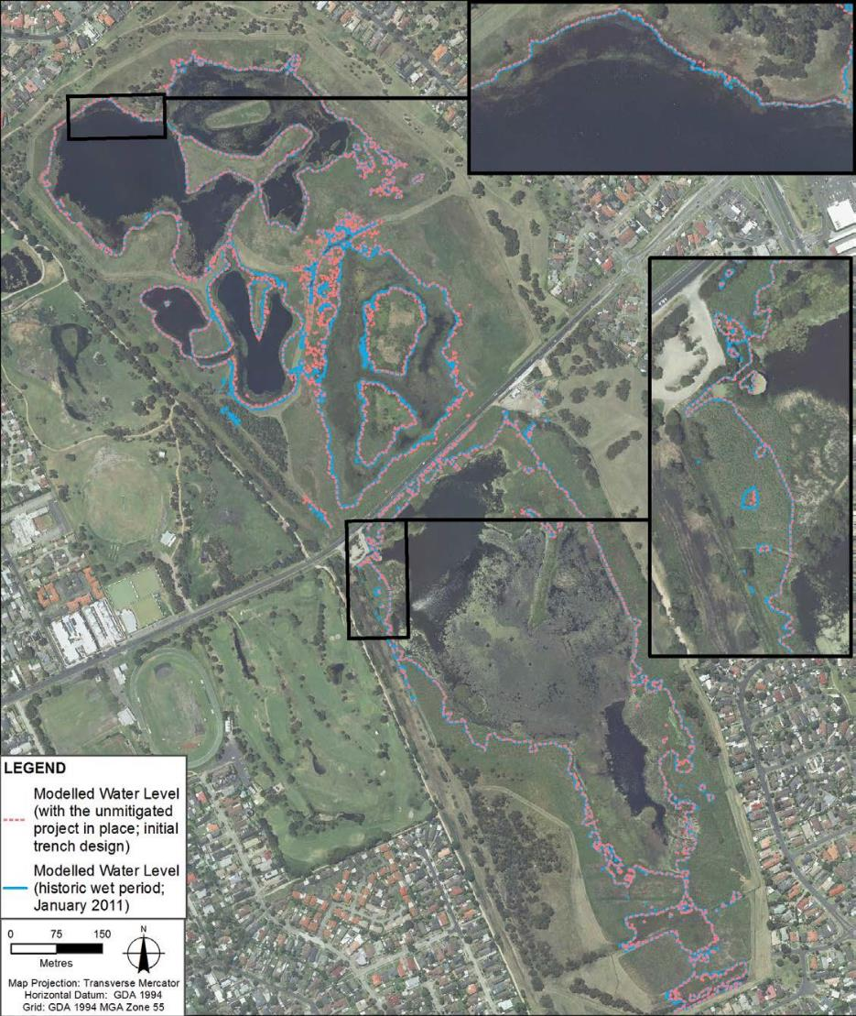

Figure 5.21 Predicted changes to water extent at Edithvale Wetland (March 2016 – dry period)
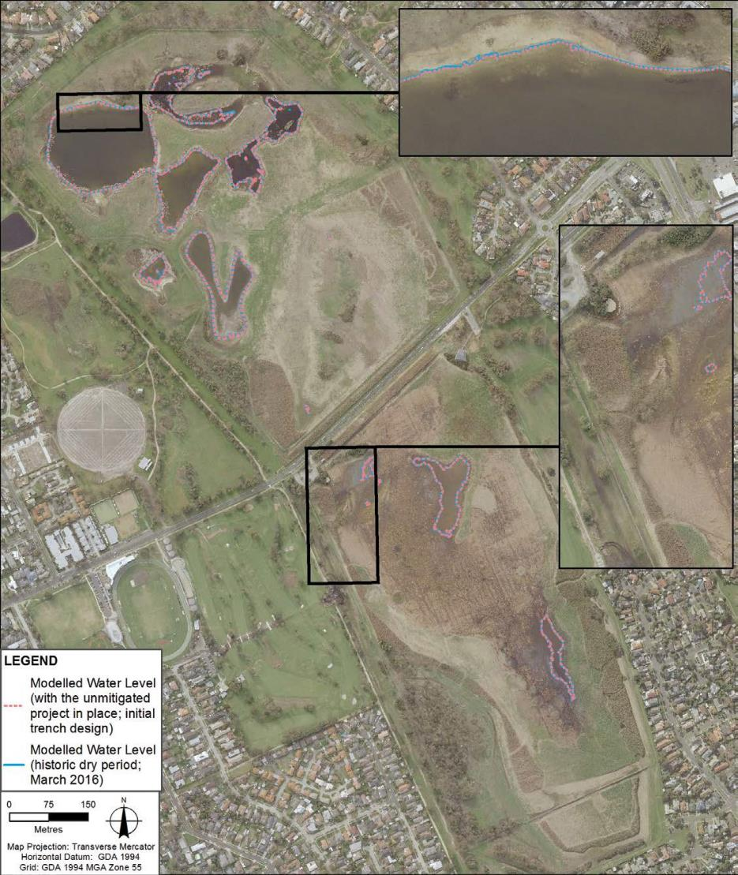

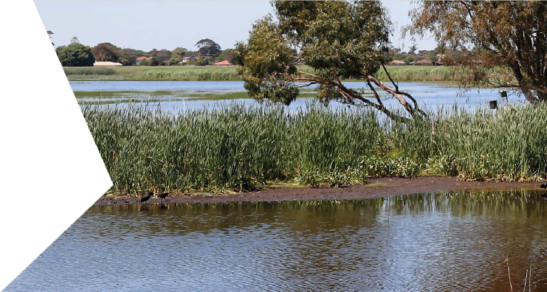A detailed summary of the modelled outcomes is provided in Appendix G of Technical Report A Groundwater.
Impacts and mitigation on the extent of habitat and associated impacts on waterbird diversity and abundance and capacity to meet Ramsar listing criteria of the Edithvale Wetland section of the Edithvale-Seaford Wetlands Ramsar site are discussed in Chapter 6 Edithvale-Seaford Wetlands and groundwater dependent ecosystems, along with discussion on the potential impacts to Wannarkladdin Wetlands.
At Edithvale, implementation of an engineering solution is required to manage potential changes to groundwater levels. EPR_GW2 states that the rail trench at Edithvale must be designed to ensure that groundwater level changes (as a result of the project) do not result in changes to groundwater that would have significant impacts on groundwater dependent ecosystems. This mitigation would include modifications to the rail trench design to minimise changes to groundwater levels.
A potential engineering solution (passive horizontal drain) was developed and modelled to inform the mitigated assessment, to demonstrate that groundwater could be maintained around the trench and minimise the impact of the project on groundwater levels, to the extent that EPR_GW2 can be achieved.
Implementation of EPR_GW2 would further reduce the likelihood of impacts to the Edithvale Wetland by reducing the magnitude of predicted groundwater mounding from 0.1 metres at 500 metres from Edithvale Wetland (based on the initial modelled trench design), to 0.1 metres at over 1,000 metres away from Edithvale Wetland (based on the engineering solution).
A description and preliminary assessment of a potential engineering solution is presented in Section 5.4 (Model results). The performance of the installed rail trench would be monitored to confirm it is not having an impact on groundwater levels, in order to ensure that groundwater level changes do not result in changes to groundwater that would have significant impacts on groundwater dependent ecosystems (EPR reference GW3). A Groundwater Dependent Ecosystem Monitoring and Mitigation Plan would be implemented at Edithvale Wetland if a change to groundwater level or quality that is not in accordance with EPR_GW2 is observed (EPR reference FF8). This would include monitoring of groundwater and surface water levels and quality at representative and strategic locations within and around the Edithvale Wetland. Refer to Chapter 6 Edithvale-Seaford Wetlands and groundwater dependent ecosystems for further detail.
A management and monitoring program would be implemented to maintain groundwater throughflow of the drainage infrastructure (EPR reference GW3).
The residual risk of impacts to the Edithvale Wetland remains at negligible.

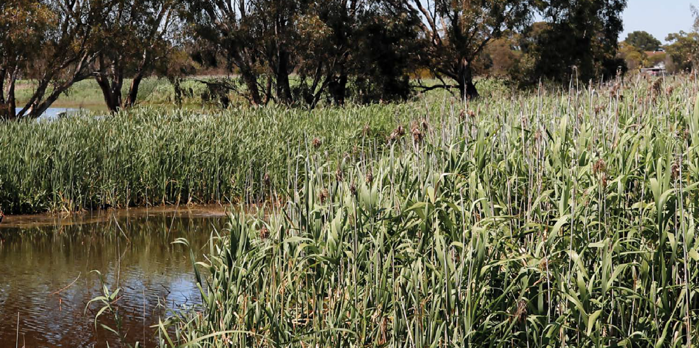
5.6.2 Bonbeach
An initial risk assessment was undertaken to assess potential risks to the environment arising from the implementation of the project at Bonbeach. As discussed in Section 5.4 (Model results), the predicted groundwater mounding and drawdown at Bonbeach is significantly less when compared to the model predictions from the initial assessment at Edithvale.
After the initial risk assessment, an EPR was developed which would reduce the magnitude and extent of project induced groundwater level changes. EPR_GW2 states that the rail trenches at Edithvale and Bonbeach must be designed to ensure groundwater level changes (as a result of the projects) do not result in:
  - groundwater mounding that increases water logging at ground level
  - groundwater drawdown that could cause ground subsidence and adverse impact to subsurface structures
  - degradation to groundwater quality that would preclude beneficial use of groundwater (salinity, contaminants, CASS)
  - changes to groundwater that would have significant impacts on GDEs.
Based on findings of the initial assessment, the risk and impact assessment process did not identify a requirement to modify the initial design at Bonbeach in order to reduce changes in groundwater levels to meet EPR_GW2. That is, the risks caused by groundwater level changes at Bonbeach were considered sufficiently low, such that mitigation, beyond the project design, would not be required. The pile wall configuration proposed includes measures that minimise potential impacts to groundwater, including stepped depths of impermeable piles. Refer to Chapter 2 Rationale and project descriptions for further detail. A Groundwater Management and Monitoring Plan would be developed for the project to manage predicted and potential impacts to groundwater following construction of the pile walls (EPR reference GW3).
As a result, the initial and residual groundwater risks identified for the operation phase of the Bonbeach level crossing removal project do not change, and are outlined in Table 5.5.
Risks associated with activation of acid sulfate soils as a result of groundwater drawdown (risk GW67) and contaminant migration as a result of groundwater mounding (risk GW69) are discussed in Chapter 7 Acid sulfate soils and contamination.

Table 5.5 Bonbeach groundwater risks – operation

Risk ID | Risk name | Risk pathway | Initial EPR | Initial risk | Final EPR | Residual risk
GW65 | Interference with users – Bonbeach | Drawdown on the down-gradient side of trench impacts groundwater availability for groundwater users. | EPR GW1 –  Rail trench design | Minor | EPR GW1 –  Rail trench design  EPR GW2 –  Groundwater performance outcomes | Minor
GW66 | Subsidence – Bonbeach | Drawdown on the down gradient side of trench could result in subsidence of unconsolidated  subsurface sediments resulting in adverse impact to structures. | EPR GW1 –  Rail trench design  EPR GM1 –  Pre – construction condition survey  EPR GM2 –  Repairs to properties due to vibration, subsidence  or ground movement | Negligible | EPR GW1 –  Rail trench design  EPR GW2 –  Groundwater performance outcomes  EPR GM1 –  Pre – construction condition survey  EPR GM2 –  Repairs to properties due to vibration, subsidence  or ground movement | Negligible
GW67 | CASS  activation – Bonbeach | Drawdown on the down-gradient side of the trench could result in changes in groundwater levels, which could give rise to activation of  CASS and/or mobilise any existing acidity and groundwater acidification affecting beneficial uses of land and groundwater. | EPR GW1 –  Rail trench design | Minor | EPR GW1 –  Rail trench design  EPR GW2 –  Groundwater performance outcomes  EPR GW3 –  Groundwater Management and Monitoring Plan | Minor

Risk ID | Risk name | Risk pathway | Initial EPR | Initial risk | Final EPR | Residual risk
GW68 | Water logging  – Bonbeach | Mounding on the up-gradient side of trench results in  increasing the spatial area and duration that the subsurface experiences groundwater levels at or near the  ground surface. | EPR GW1 –  Rail trench design  EPR GW3 –  Groundwater Management and Monitoring Plan | Negligible | EPR GW1 –  Rail trench design  EPR GW2 –  Groundwater performance outcomes  EPR GW3 –  Groundwater Management and Monitoring Plan | Negligible
GW69 | Contaminant migration – Bonbeach | Mounding on the up-gradient side of trench, drawdown on down gradient side of trench, and  groundwater physically diverted either to the north or south along the up gradient side of the trench could alter contamination plume migration adversely impacting on beneficial uses of land and groundwater. | EPR GW1 –  Rail trench design | Negligible | EPR GW1 –  Rail trench design  EPR GW2 –  Groundwater performance outcomes  EPR GW3 –  Groundwater Management and Monitoring Plan  EPR CL1 – SMP  EPR CL4 –  Acidic and/or contaminated groundwater (construction)  EPR CL5 –  Acidic and/or contaminated groundwater (operation) | Negligible
GW70 | Foundations – Bonbeach | Mounding on the up-gradient side of  trench could result in increasing the spatial area and duration that existing subsurface foundations experience groundwater levels  at, or near the ground surface. | EPR GW1 –  Rail trench design | Negligible | EPR GW1 –  Rail trench design  EPR GW2 –  Groundwater performance outcomes  EPR GW3 –  Groundwater Management and Monitoring Plan | Negligible

Risk ID | Risk name | Risk pathway | Initial EPR | Initial risk | Final EPR | Residual risk
GW71 | Saltwater intrusion – Bonbeach | Drawdown on down- gradient side of trench could result in inland migration of the saltwater wedge and salinisation of aquifers, resulting in change  in beneficial use of groundwater. | EPR GW1 –  Rail trench design | Negligible | EPR GW1 –  Rail trench design  EPR GW2 –  Groundwater performance outcomes  EPR GW3 –  Groundwater Management and Monitoring Plan | Negligible
EG80 | Wannarkladdin Wetlands – Bonbeach | Groundwater mounding leading to altered hydrological regime and/or water quality resulting in loss of native vegetation and/or fauna habitat associated with Wannarkladdin Wetlands. | EPR GW1 –  Rail trench design | Negligible | EPR GW1 –  Rail trench design  EPR GW2 –  Groundwater performance outcomes  EPR GW3 –  Groundwater Management and Monitoring Plan | Negligible

Interference with groundwater users (risk GW65)
During operation, groundwater drawdown is predicted on the down-gradient side of the trench at Bonbeach, which has the potential to impact the availability of groundwater for existing registered groundwater users. As defined in Section 5.1.3, users access groundwater either through licenced extraction bores or ‘stock and domestic’ bores.
All licensed groundwater extraction bores are situated beyond the predicted area of drawdown of the projects based on the initial assessment. Therefore, the existing licensed groundwater extractions are not predicted to be impacted by the project.
There is one stock and domestic bore (WRK988838) identified through the DELWP Water Measurement Information System located within the predicted area of drawdown of the Bonbeach level crossing removal project (refer to Figure 5.15. Groundwater modelling to inform the initial assessment suggests that at this bore, the predicted drawdown equates to small reductions in the available drawdown (standing water), which is considered unlikely to impact upon the amount of groundwater available from this bore.
The data obtained from the DELWP Water Measurement Information System indicates that the identified stock and domestic groundwater bore may have been decommisioned and may no longer be operational.
A bore census undertaken on 23 November 2017, aimed at identifying the stock and domestic bore (WRK988838), which according to Southern Rural Water’s records (which do not provide a specific address), would be situated around 7 Ti-Tree Avenue, Bonbeach. The bore (WRK988838) was not clearly identified during the census. The census highlighted the presence of several additional groundwater bores at residential properties on Ti-Tree Avenue, Bonbeach. Since these bores are not on Southern Rural Water’s register and water use is not registered with Southern Rural Water, an accurate location, construction details or use cannot be confirmed for these unregistered bores.

Numerous properties were identified with ‘bore water in use’ signage at the front of the properties. Identifying the precise location and construction details of these bores would require notification to the landowner and agreement of the landowner for LXRA to undertake this assessment. Such an approach also relies upon the assumption that only those sign posted properties have existing groundwater bores installed. Such an extensive investigation was not undertaken for the EES, as the assessment assumed that bores were present.
While potential impacts to one existing groundwater user (WRK988838) have been identified, the status of this bore, and potential additional unregistered bores was not able to be confirmed. There is a chance that the registered bore was either decommissioned or destroyed, or simply not used by the current residents.
The rail trench would be designed within the parameters outlined in Chapter 2 Rationale and project descriptions (EPR reference GW1). The rail trench at Bonbeach would be designed to ensure that groundwater level change does not result in precluding beneficial uses of groundwater (EPR reference GW2). Minor impacts to a small number of individuals could possibly occur as a result of groundwater drawdown caused by the pile walls at Bonbeach, resulting in a minor risk.

Subsidence (risk GW66)
Potential impacts relating to subsidence as a result of groundwater drawdown have been described previously in Section 5.6.1 (risk GW59). At Bonbeach, groundwater drawdown of up to 0.7 metres is predicted within 50 metres of the rail trench, with drawdown of up to 0.3 metres predicted near the coastline approximately 150 metres from the rail trench.
Data from a number of geotechnical bores drilled along the Frankston railway line to inform the EES suggest that soils below the water table are relatively competent, except for a thin layer of soft and compressible swamp deposits. The swamp deposits were found to be one to two metres in thickness, occurring at around 10 metres depth. In areas where 1.5 metres of compressible soil is present, surface settlement may be up
to 5 millimetres. Settlement would be restricted to the coastal side of the rail trench where groundwater drawdown is predicted.
The resultant risk of subsidence caused by the project is directly related to the magnitude and extent of drawdown predicted, combined with the presence of a thin layer of soft and compressible soil. It is considered that project induced settlement in the order of 5 millimetres due to groundwater dewatering would be very unlikely to cause moderate impacts in itself, unless buildings or other infrastructure are highly sensitive to movement.
The nature and condition of existing buildings and infrastructure is not known. It is possible that minimal ground movement could induce or rejuvenate existing cracking in settlement sensitive facades and architectural finishings. Local minor impact on settlement sensitive buried services and infrastructure within the area of predicted groundwater drawdown is also possible.
At Bonbeach, subsidence is considered to be a negligible risk as settlement is estimated to be minimal. No further mitigation is required since subsidence is very unlikely to occur, and if it did, would not result in major impact on existing or potential future land uses.
The rail trench would be designed within the parameters outlined in Chapter 2 Rationale and project descriptions (EPR reference GW1). The rail trench must be designed to ensure groundwater level changes (as a result of the project) do not result in groundwater drawdown that could cause ground subsidence and adverse impacts to subsurface structures (EPR reference GW2). A management and monitoring plan program would be implemented to ensure groundwater throughflow is maintained (EPR reference GW3).
The following management measures are proposed to maintain subsidence impacts caused by groundwater drawdown at a negligible risk level:
  - an appraisal of existing structures and their potential to be impacted would be undertaken at the detailed design stage (EPR reference GM1)
  - for properties and assets affected by subsidence, required repair work would be undertaken or other actions agreed with the property owner, where impacts are attributable to the projects (ERP reference GM2).

Water logging at the ground surface and impacts to foundations (risks GW68 and GW70)
The numerical groundwater model was used to assess the impacts of water logging at the ground surface. In a portion of the study area at Bonbeach, groundwater mounding is predicted to occur based on the initial assessment, resulting in a shallower water table (refer to Figure 5.14).
The assessment predicted that water logging does not occur under existing conditions at Bonbeach and is considered very unlikely to occur as a result of the project, based on the initial assessment largely owing to:
- the deeper water table at Bonbeach, which is typically deeper than one metre below ground surface, even during the period of greatest modelled impact
- the more complex local groundwater flow regime at Bonbeach, which acts to disperse groundwater flow towards Port Phillip Bay and Patterson River.
The rail trench would be designed within the parameters outlined in Chapter 2 Rationale and project descriptions (EPR reference GW1). The rail trench must be designed to ensure groundwater level changes (as a result of the project) do not result in groundwater mounding that increases the potential for water logging (EPR reference GW2).
Water logging impacts, including impacts to foundations are not predicted at Bonbeach, therefore the risk is negligible. No further mitigation is required as water logging is very unlikely to occur at Bonbeach, and if it did, would not result in major impact on existing or potential future land uses.

Saltwater intrusion (risk GW71)
Groundwater modelling to inform the initial assessment predicted that groundwater drawdown would occur on the down-gradient (coastal) side of the trench at Bonbeach during operation. Groundwater drawdown may result in impacts resulting from a changed (deeper) water table, including impacts that are specific to aquifers situated near the coast. Specifically, groundwater drawdown may result in saltwater intrusion, such that relatively fresh groundwater may become more saline.
Groundwater modelling was undertaken to assess potential project-induced changes to groundwater salinity. Salinisation of groundwater could impact the beneficial uses of groundwater, which are protected under the SEPP (Groundwaters of Victoria).
Similar to Edithvale, the water table aquifer within the project area is classified as Segment A1 for the purpose of this assessment and identifying beneficial uses of groundwater to be protected.
Trends in the variability of salinity in the water table aquifer have not been identified owing to the limited site-specific temporal data obtained during this investigation, which does not consider temporal seasonal variability or longer-term averages in TDS. Salinity trends are however, likely to be influenced by local natural (e.g. variable recharge) and anthropogenic (e.g. leaking reticulated water mains or urban drainage infrastructure) factors.
Saltwater intrusion modelling was used to obtain an indication of the potential magnitude and the rate of change in salinity as caused by the project in the study area. Section 5.6.1 (risk GW64) outlines the predicted changes to groundwater salinity in the project area as a result of movement of the saltwater wedge. The modelling indicated that drawdown of the water table due to the pile walls, has the potential to cause upward movement of the saltwater wedge.
Saltwater intrusion impacts at Bonbeach would be expected to be minor compared to the predictions for Edithvale, given the lesser extent of drawdown predicted to occur at Bonbeach.
The modelling has predicted the change in salinity to be in the order of:
- less than 500 mg/L TDS in the Quaternary Aquifer over a period of decades
- less than 750 mg/L TDS in the Upper Tertiary Aquifer over a period of decades
- less than 1,000 mg/L TDS in the Upper – Middle Tertiary Aquitard over a period of decades.
These changes in salinity would occur on the down gradient side of the pile wall (between the coast and the pile walls), within the predicted area of drawdown at Bonbeach (23 hectares).

Predicted changes to groundwater quality as a result of saltwater intrusion has the potential to change the classification of the water table aquifer from Segment A1 to Segment A2 of the SEPP (Groundwaters of Victoria) in some portions of the water table aquifer that could currently be classified as Segment A1. However, it is important to note that variable water quality (i.e. less than 700 mg/L TDS) exists within the water table aquifer at Bonbeach. Groundwater quality of the water table aquifer at Bonbeach would not exceed Segment A2 of the SEPP (Groundwaters of Victoria) over a period of 100 years.
The only element of protected beneficial use that could be impacted by the project predictions is the change of potable water supply from desirable to acceptable, in selected locations within the project area. As mentioned previously, some locations within the project area show water quality consistent with acceptable potable water supply under existing conditions.
The increase in salinity caused by the movement of the saltwater wedge would likely be in the range of seasonal salinity variations in the water table aquifer. During the project life cycle, it is highly probable that either natural variations (e.g. those caused by climate change) or changed conditions induced by the project, could increase groundwater salinity in the water table aquifer. Even without the project, climate change effects have been modelled to increase groundwater salinity in the water table aquifer during the project life and have the potential to change the classification of the water table aquifer from Segment A1 to Segment A2 of the SEPP (Groundwaters of Victoria) in some portions of the water table aquifer.
At Bonbeach, saltwater intrusion impacts represent a minor risk under the initial assessment, which is lower than the same risk at Edithvale due to the smaller extent of drawdown predicted at Bonbeach, and reduced saltwater intrusion impacts.
The rail trench would be designed within the parameters outlined in Chapter 2 Rationale and project descriptions (EPR reference GW1). The rail trench must be designed to ensure groundwater level changes (as a result of the project) do not result in degradation to groundwater quality that would preclude beneficial use of groundwater (salinity) (EPR reference GW2). The saltwater intrusion risk at Bonbeach would be managed
through a monitoring and an impact verification approach (EPR reference GW3), and implementation of salinity management measures (if required), through the Groundwater Quality Mitigation Plan (EPR reference CL5).
If required, EPR_CL5 could be developed to identify measures to maintain or manage the beneficial use of groundwater affected by salinisation.

Groundwater regime at Wannarkladdin wetlands (Risk EG80)
The numerical groundwater model predicted groundwater mounding to occur up-gradient (inland) of the pile walls at Bonbeach, with impacts of up to 0.1 metres predicted less than 200 metres to the
east of the rail trench. Mounding of 0.1 metres is predicted to occur approximately 1,500 metres from Wannarkladdin Wetlands.
Figure 5.11 in Section 5.4 (Model results) shows that based on uncertainty analysis, the 1st, 50th and 99th percentile confidence predictions groundwater mounding does not impact Wannarkladdin Wetlands.
The 1st percentile confidence limit shows that 0.1 metres of groundwater mounding is predicted approximately 700 metres west of Wannarkladdin Wetlands, resulting in an almost impossible likelihood of moderate impacts to the wetlands, including changes to wetland baseflow.
Impacts and mitigation on the extent of habitat and abundance of native vegetation/fauna of the Wannarkladdin Wetlands are discussed in Chapter 6 Edithvale-Seaford Wetland and groundwater dependent ecosystems. Chapter 6 concludes that impacts on habitat and species diversity are not expected as a result of the level crossing removal project at Bonbeach.
The risks caused by groundwater level changes at Bonbeach were considered sufficiently low such that mitigation, beyond the project design outlined in Chapter 2 Rationale and project descriptions would not be required. The
pile wall configuration proposed includes measures that minimise potential impacts to groundwater, including stepped depths of impermeable piles. A Groundwater Management and Monitoring Plan would be developed for the project, to manage predicted and potential impacts to groundwater following construction of the pile walls (EPR reference GW3). This EPR includes triggers for additional monitoring of ecology.
The residual risk of impacts to the Wannarkladdin Wetlands remains at negligible.

Conclusion

The projects would be designed within the parameters outlined in Chapter 2 Rationale and project descriptions (EPR reference GW1). The rail trenches at Edithvale and Bonbeach would be designed to ensure groundwater level changes (as a result of the projects) do not result in the following potential impacts identified as higher risks during the assessment undertaken for this EES (EPR reference GW2):
- groundwater mounding that increases water logging at ground level
- groundwater drawdown that could cause ground subsidence and adverse impact to subsurface structures
- degradation to groundwater quality that would preclude beneficial use of groundwater (salinity, contaminants, CASS)
- changes to groundwater that would have significant impacts on GDEs.
The performance of the installed rail trenches would be monitored to confirm they are not having an impact on groundwater levels and quality beyond those set out above (EPR reference GW2). A Groundwater Management and Monitoring Plan (EPR reference GW3) would be implemented to the satisfaction of EPA Victoria and relevant water authorities to manage predicted and potential impacts to groundwater following construction
of the piled trench walls. The plan would include clear trigger levels for changes in groundwater level and quality that would require mitigation plans to be implemented. A management and monitoring plan would be implemented to maintain groundwater throughflow of the drainage infrastructure required at Edithvale (EPR reference GW2).
Predictive groundwater modelling based on the parameters included in Chapter 2 Rationale and project descriptions was used to assess the risks outlined above. Groundwater levels are predicted to increase on the up gradient (inland) side of the pile walls and decrease on the down gradient (coastal) side of the pile walls, as groundwater throughflow is impeded by the pile walls.

Edithvale
The risks caused by groundwater level changes at Edithvale were initially predicted to be greater than at the Bonbeach level crossing removal site based on modelling to inform the initial assessment.
At Edithvale, groundwater mounding (increase in groundwater level) of up to 0.9 metres within 50 metres of the rail trench was predicted from the initial modelling based on the parameters outlined in Chapter 2 Rationale and project descriptions. Groundwater drawdown (decrease in groundwater level) of up to 1.4 metres within 50 metres of the rail trench was predicted from the initial modelling.
Because of the impacts predicted through the initial assessment for Edithvale, potential modifications to the design were considered, to minimise the impacts.
An engineering solution was developed and modelled to demonstrate that groundwater could flow around the trench, thus maintaining the existing groundwater flow regime and minimising the impact of the project on groundwater levels to the extent that the performance outcomes in EPR_GW2 could be achieved.
The engineering solution that was modelled comprises a passive horizontal drain, which is an underground pipe that would be installed around the outside of, and adjacent to, the pile walls. The pipe would be installed at a depth that is permanently below the naturally variable water table, and perforated to allow water inflow and outflow.
The modelling indicated that the engineering solution would reduce impacts to groundwater levels at Edithvale, resulting in:
- groundwater mounding (increase in groundwater level) of up to 0.2 metres within 50 metres of the rail trench
- groundwater drawdown (decrease in groundwater level) of up to 0.3 metres within 50 metres of the rail trench.
The modelled engineering solution would maintain groundwater levels to existing conditions (within acceptable tolerances), such that impacts to groundwater quality resulting from the project would be maintained as close as practicable to background levels.
The final constructed design must meet the performance requirements listed in EPR_GW2 in order to achieve this outcome. Prior to construction of the trench, an independent peer review by an appropriately qualified specialist would be undertaken of the proposed design to confirm that the design would achieve EPR_GW2 (EPR reference GW4).

Bonbeach
The risks caused by groundwater level changes at Bonbeach were considered sufficiently low, such that alteration to the modelled design would not be required in order to achieve the performance outcomes listed in EPR_GW2 (refer Chapter 9 Environmental Management Framework).
At Bonbeach, groundwater mounding (increase in groundwater level) of up to 0.4 metres within 50 metres
of the rail trench was predicted through the initial assessment, along with groundwater drawdown (decrease in groundwater level) of up to 0.7 metres within 50 metres of the rail trench.
The lesser impact predicted at Bonbeach is primarily due to the local groundwater flow regimes, where the local groundwater flow direction is perpendicular to the pile wall at the Edithvale level crossing removal site, resulting in greater impedance of groundwater throughflow. At the Bonbeach level crossing removal site, groundwater flow is locally towards the south, towards Patterson River. At areas where the flow line is parallel to the pile wall, less impedance on groundwater throughflow is predicted.
The locations of the pile walls relative to the location of the local groundwater flow divide at Bonbeach also act to reduce impacts predicted at Bonbeach. At Bonbeach, the groundwater flow divide is inferred to approximately coincide with the rail trench, resulting in limited opportunity for the pile walls to interrupt lateral flow of groundwater across the rail trench.
The modelling identified that the magnitude and extent of groundwater level impacts resulting from the project are highly sensitive to the climatic condition at a given point in time.
To mitigate subsidence impacts caused by groundwater drawdown at Edithvale and Bonbeach, an appraisal of existing structures and their potential to be impacted would be undertaken at the detailed design stage, and repairs undertaken following works if required.

This page has intentionally been left blank

