6 February 2018
Construction Update
Works on Williamstown Road and the West Gate Freeway start 18 February 2018
Construction on the West Gate Tunnel Project has started and will deliver a vital alternative to the West Gate Bridge, provide quicker and safer journeys, and remove thousands of trucks off residential streets.
Keeping you informed
There are three construction precincts; West Gate Freeway, Tunnels and Port to City. You are in the West Gate Freeway precinct.
We will inform you of upcoming activities on a regular basis through letters like this, making sure you have advance notice of work starting in your area. The ways in which the team will communicate with you include:
- Community notifications
- Regular newsletters
- Doorknocks
- Phone calls and SMS
- Email
- Social media
- Updates in local papers
Upcoming construction activity in your area
Works in the coming months of 2018 will be focused around the Williamstown Road area, where the new tunnel entrance will be located, and will include:
Building a temporary inbound exit ramp at Williamstown Road Widening the freeway over Williamstown Road
- Continuing ground, road surface and utilities investigations
- Establishing site facilities on Melbourne Road.

Please see our Construction Overview – West Gate Freeway for information about how construction is being managed to minimise impacts such as dust, noise and traffic changes.
Existing noise walls will remain in place at this stage. We will inform you before works on the new noise walls begin.
Traffic barrier installation, project investigations and lane changes on the West Gate Freeway will occur overnight.
Our standard working hours are: 7am-6pm, Monday to Friday 7am-3pm on Saturdays. We will notify you if work is going to occur in residential areas outside these hours

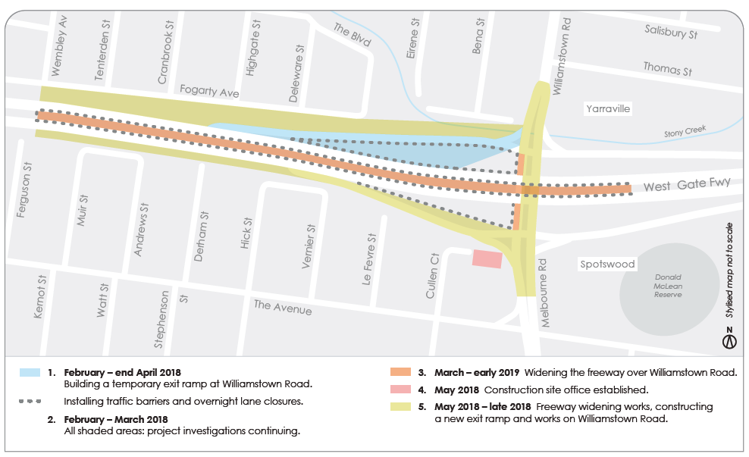
Map showing our work areas around Williamstown Road from 18 February 2018
- Building a temporary exit ramp at Williamstown Road
18 February – end April 2018
The first stage of works will build a temporary inbound exit ramp which will be used while a new exit ramp is built. Traffic will then be moved onto the new ramp while the tunnel entrance is being built.
This will involve:
- Clearing vegetation
- Building the temporary exit ramp for use while the new permanent ramp is built.

We will be working behind traffic barriers, using machinery to clear the site and build the ramp. You may hear general construction activity, including directional reversing beepers from our machinery and trucks. We will be working within strict noise guidelines to minimise disruption for local residents.

2. Project investigations
February – March 2018
Project investigations including geotechnical studies and surveying, and identifying the location of utilities will continue in a number of locations, as shown by the shaded areas on the map above.

3. Widening the West Gate Freeway bridge over Williamstown Road
March – early 2019
Our crews will be working behind traffic barriers on and underneath the freeway to widen the West Gate Freeway over Williamstown Road. All lanes will be maintained during peak periods to minimise traffic disruption, although there may be some overnight lane closures at times.

4. Setting up our Melbourne Road site office
May 2018
We will set up our construction site office on Melbourne Road in May this year. This site office will provide office space and facilities for the local work crew, including parking for up to 20 vehicles.
5. Freeway widening and building the new Williamstown Road exit ramp
May 2018 – late 2018
Work will also start to widen the freeway at the Williamstown Road interchange. These works will involve:
- Vegetation removal along the freeway
- Building retaining walls
- Building sections of new and temporary noise walls
- Building the new inbound exit ramp at Williamstown Road

We will provide more information about the timing and details of these works before we begin in May 2018.
Traffic changes
From Sunday 18 February, traffic barriers will begin to be installed along:
- West Gate Freeway and entry and exit ramps, starting at Williamstown Road and
progressively working towards the M80 interchange
- Williamstown Road, underneath the freeway.

The speed limit on the West Gate Freeway will be reduced to 80km/h while barriers are in place. There will also be night time lane and ramp closures as works progress.
These works and traffic changes may be rescheduled in the event of bad weather or unavoidable circumstances.
Overnight closures: West Gate Freeway lanes and Williamstown Road ramps
Sunday 18 February – Monday 26 February
There will be lane closures and speed reductions in both directions on the West Gate Freeway around Williamstown Road.
- The Williamstown Road inbound exit ramp will be closed on Sunday 18 February from
9pm- 5am
- The Williamstown Road outbound entry ramp will be closed on Monday 19 February from
10pm-5am

Drivers can expect some delays in the area during these closures. The latest traffic updates will always be available at: westgatetunnelproject.vic.gov.au and at traffic.vicroads.vic.gov.au
Talk with the construction team
We want to keep you informed and work together to make things easier during construction.
Please contact us if you have questions about the project’s construction or come along and meet the construction team when we visit your neighbourhood:

- McIvor Reserve, near baseball pavilion
- February 10am-2pm
- Brooklyn Reserve
17 February 10am-2pm
- Donald McLean Reserve
24 February 10am-2pm
Contact us

Do you have a question about the project or these investigations?
If you need more information or would like to provide feedback, please get in touch.
westgatetunnelproject.vic.gov.au
westgatetunnelproject@wda.vic.gov.au
1300 280 939
facebook.com/westgatetunnelproject
@westgatetunnel
West Gate Tunnel Project
GPO Box 4509
Melbourne Victoria 3001
Interpreter service: 13 14 50

