West Gate Tunnel Project
GPO Box 33312
Melbourne Victoria 3004
1800 105 105
westgatetunnelproject.vic.gov.au
info@wgta.vic.gov.au

WES1905.01
28 May 2019

Works notification: Millers Road area
Works are progressing well in the Millers Road area of the West Gate Tunnel project. Recent achievements include completion of piling and retaining walls under the West Gate Freeway on both sides of Millers Road, installation of temporary noise walls along the West Gate Freeway and trenching along Paringa Road to underground some power lines.
This notification explains our upcoming works and what you can expect to see in the Millers Road area over the next few months. We’ll give you more information about each activity closer to the time if you’re likely to be directly impacted by those works.
Our works over the next few months include:

- ongoing widening of the West Gate Freeway, relocation of utilities, and preparatory works including removing trees, excavating and piling for the new permanent noise walls
- building a new temporary noise wall along part of Paringa Road and then removing the existing wall. This is due to happen in June. We’ll provide more details to residents in the area closer to the time
- intermittent night works and road closures to prepare the two freeway bridges above Millers Road for widening and to temporarily move traffic lights on Millers Road - June to September

Millers Road closures
July - August
- changes to the Millers Road footpath under the West Gate Freeway bridges for short periods while we build the new bridge piers
- boring under the West Gate Freeway at the corner of Paringa Road and Chambers Road and trenching along Waites Court and Primula Avenue for a new gas line. Downer Construction will carry out this work for AusNet and they will communicate directly with impacted residents. Work is expected to begin in June.

Millers Road under the West Gate Freeway will be closed in one direction during the night for four weekends between July and August to allow us to prepare the area for widening the West Gate Freeway bridges and Millers Road itself.
Closure weekend | Closure details
1st and 2nd weekends – Southbound closures | Day time - lane closures  Saturdays and Sundays from 8am to 8pm – one lane on Millers Road and one lane on the inbound exit ramp will be closed. | Night time – southbound direction will be fully closed  On Friday and Saturday nights from 8pm to 8am and Sunday night from 8pm to 5am Millers Road southbound will be fully closed. One lane will be closed on each of the two exit ramps.
3rd and 4th weekends – Northbound closures | Day time - lane closures  Saturdays and Sundays from 8am to 8pm – one lane on Millers Road and one lane on the outbound exit ramp will be closed. | Night time – northbound direction will be fully closed  On Friday and Saturday nights from 8pm to 8am and Sunday night from 8pm to 5am – Millers Road northbound will be fully closed. One lane on each of the two exit ramps will be closed.
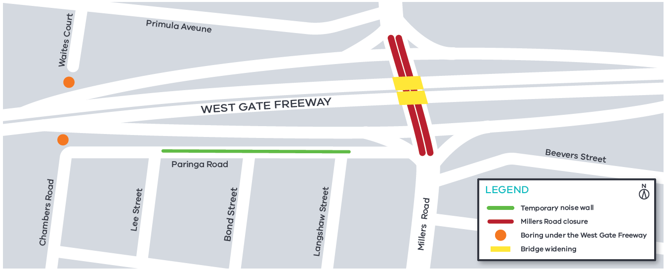

During the closures, we’ll construct a second northbound right-turn lane and an extra southbound through-lane on Millers Road. Near the work, the Millers Road speed limit will be set at 40kph during the day.
Detours will be in place during the full closures of Millers Road and road users are advised to avoid the area if they can. We estimate the detours will add five to 10 minutes to motorists’ journeys.
The West Gate Freeway and the footpath on Millers Road under the freeway will remain fully open at all times.
Keep an eye out for more advertising closer to the time to confirm dates.

Widening the freeway bridges
September 2019 to January 2020
The freeway bridges over Millers Road need to be widened to accommodate the widened freeway.
To connect the existing road surface and bridge to the new lanes, we need to prepare each edge of the existing bridge. This will be done using a method called hydro-demolition which involves using high- pressure water.
Hydro-demolition is noisy work. It must be done at night because it creates a lot of water which will require sections of Millers Road directly beneath the work area to be closed intermittently. We expect this work will take approximately six weeks and is programmed to take place during September and October. The new bridge beams are expected to be craned into place in November 2019.

What you can expect to see
Over the next few months, you could experience:
- construction vehicles on local streets
- noise, dust, dirt and vibration associated with construction. Please note we have methods in place to minimise the disturbance from these activities
as much as possible. Methods include using water spray trucks to reduce dust, and covering dirt and rock while they’re being transported
- night works
- road closures.

Traffic impacts
Please note, on-road signs will be in place to advise of detours and work zone speed limits on the freeway will be signed and enforced. For the latest updates and detour route information visit: westgatetunnelproject.vic.gov.au/traveldisruptions

Hours of work
Our usual hours of work are Monday to Friday between 7am-6pm, and Saturdays between 7am-1pm. However, night works are sometimes required. When works are scheduled out of hours, or if you are located close to the works, we will provide you with further information before the works start.

Thank you
We appreciate our work can be disruptive and we thank you for your understanding and cooperation.

Sign Up To Our Weekly Traffic Alerts
Subscribe to our weekly traffic emails to keep up to date.
Every Thursday you will get an email letting you know what is coming up for the week about all things traffic.
Send an email to info@wgta.vic.gov.au to subscribe.
1800 105 105
westgatetunnelproject.vic.gov.au
info@wgta.vic.gov.au
Please note, works may be rescheduled in the event
of bad weather or other unavoidable circumstances.

