31 July 2020 WES2007.03

Works notification: Hyde Street Ramps
Work on the Hyde Street Ramps is progressing on both sides of the West Gate Freeway between Williamstown Road and Hyde Street. We’ve recently completed the Thomas Street temporary access bridge and installed the West Gate Golf Club and Donald McLean Reserve safety nets.
As works continue, below is a summary of what you can expect to see in the area until October 2020 and ongoing.
New ramp – north side of the freeway, including elevated shared use path:
This ramp on the northern side of the freeway will provide a new exit ramp for inbound traffic from the West Gate Freeway to a new signalised intersection at Hyde Street.

piling in Stony Creek Reserve is ongoing for the northern ramp and is expected to continue until January 2021
- construction of the support structures at Hyde Street is due to begin and progresses west towards the Williamstown rail line and will continue for the next 18 months
- start of access track and working platform within the West Gate Golf Course
- identify services on the Williamstown Road inbound entry ramp. This will occur at night when required.
New ramp – south side of the freeway:
This ramp on the southern side of the freeway will provide a new entry ramp for westbound traffic from a new intersection at Simcock Avenue and Stephen Street through to the West Gate Freeway

constructing retaining walls at the Williamstown Road outbound entry ramp

earthworks, piling and concrete works at Williamstown Road outbound entry and exit ramps
- start of access track and working platform within the West Gate Golf Course and Donald McLean Reserve
- identify services on the eastern and western side of the Williamstown rail line, north and south of the West Gate Freeway. This will start in September in preparation for upcoming piling, gantry installation and overhead line works.

Shared use path bridge – Hyde Street Reserve:

piling works in the Hyde Street Reserve continues for the shared use path bridge over Stony Creek.

Hours of work

Our usual hours of work are Monday to Friday between 7am-6pm, and Saturdays between 7am-1pm. However, for a number of the works outlined in this notification night works will be required. When works are scheduled out of hours, or if you are located close to the works, we will provide you with further information before the works start.

What to expect during these works:
- work will be completed behind safety traffic barriers
- construction vehicles including excavators, rollers, piling rigs, water trucks and concrete trucks will be moving in and out of the work areas via our access routes
- construction noise from work activities including machinery and trucks. Vibration may be experienced from piling works
- water spray trucks and road sweepers will be used to manage dust and dirt during works. Trucks removing dirt and rock from the site will be covered
- traffic changes including lane and road closures will be required. Signed detours will be in place.

For the latest updates visit westgatetunnelproject.vic.gov.au/traveldisruptions.

Works area

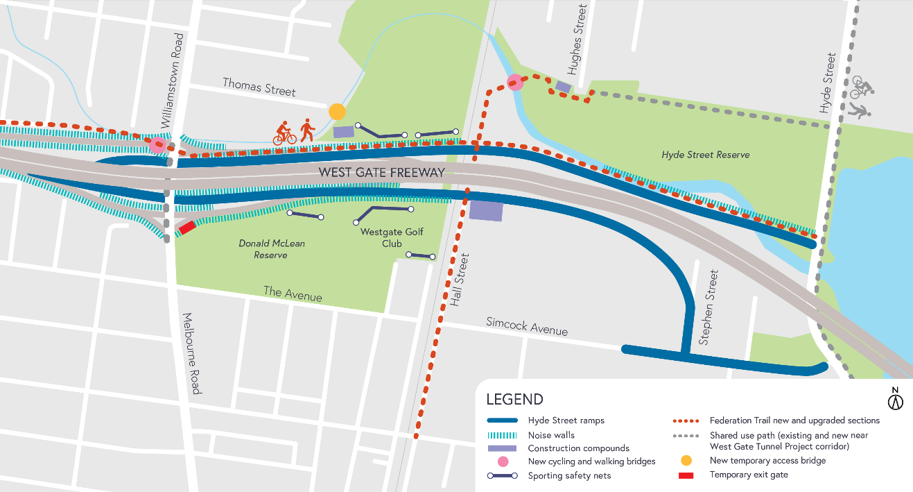

COVID-19 update

The health and safety of our workers is our key priority as we continue to deliver the West Gate Tunnel Project, as is supporting physical distancing measures in line with current health advice. We have strict protocols in place to protect the safety of our construction workforce and the community. These include enhanced industrial cleaning arrangements and measures to reduce staff contact including staggered shifts and physical distancing. For more information and advice about Coronavirus, please visit coronavirus.vic.gov.au.

Please note that works are subject to change and may be rescheduled in the event of unexpected impacts to the construction program. Thank you for your patience during these works.

For updates and more information about our works, please visit westgatetunnelproject.vic.gov.au or call us on 1800 105 105.

