Chapter 3
Legislative Framework

Chapter 3

Legislative Framework

Introduction
This chapter outlines the environmental assessment process and the principal planning, environmental and heritage approvals required for North East Link.
The Victorian legislation governing the environmental assessment of North East Link via an Environment Effects Statement (EES) is the Environment Effects Act 1978 (‘Environment Effects Act’). On 2 February 2018 the Minister for Planning declared the works proposed for North East Link to be public works under the Environment Effects Act, triggering the requirement for an EES.
In the public works order, the Minister specified procedures and requirements applicable to preparation of the EES. The scoping requirements provide further detail on the specific matters to be investigated on the context of the Ministerial guidelines for assessment of environmental effects under the Environment Effects Act. In response to the Minister’s public works order, this EES has been prepared in accordance with the scoping requirements.
The EES will be publicly exhibited, during which time the public may review the EES documentation and make written submissions. The EES will then be reviewed and considered by an independent Inquiry and Advisory Committee before the Minister for Planning finalises the assessment of the environmental effects of North East Link. The Minister’s assessment will consider all relevant information, including the EES documentation, public submissions, North East Link Project's (NELP's) response to submissions, information provided by NELP and other submitters, and the report from the Inquiry and Advisory Committee. Decision-makers are required to consider the Minister’s assessment in determining whether to issue project approvals and on what conditions.
The key approvals for North East Link under Victorian legislation are:
- Amendments to the Banyule, Boroondara, Manningham, Nillumbik, Whitehorse, Whittlesea and Yarra Planning Schemes under Victoria’s Planning and Environment Act 1987 ‘(Planning and Environment Act’). If approved, the planning scheme amendments will facilitate the use and development of the project
- Works approval for the installation of the road tunnel ventilation system under Victoria’s Environment Protection Act 1970 (‘Environment Protection Act’).

Additionally, a Cultural Heritage Management Plan (CHMP) has been prepared in accordance with the requirements of Victoria’s Aboriginal Heritage Act 2006 in parallel with the preparation of the EES. The works assessed in this EES cannot commence until the CHMP is approved by the Wurundjeri Woi-wurrung Cultural Heritage Aboriginal Corporation, and Aboriginal Victoria.
Transport Integration Act 2010 (Vic)
Whilst not requiring a specific approval, the Transport Integration Act 2010 (Vic) is a significant legislative consideration for North East Link as it establishes a framework for an integrated and sustainable transport system in Victoria.
The planning of North East Link has been undertaken having regard to the requirements of this Act. An evaluation of the project against the transport system objectives of the Act is provided in Chapter 2 – Project rationale.

The Australian Government’s Minister for the Environment has decided that North East Link is a ‘controlled action’ under section 75 of the Environment Protection and Biodiversity Conservation Act 1999 (Cwlth) (‘EPBC Act’) (EPBC 2018/8142) because of the potential for significant impact on matters of national environmental significance and on the environment of Commonwealth land, requiring assessment and approval under the EPBC Act. The relationship between the EES process and approval under the EPBC Act is explained in Section 3.4.
North East Link has been declared a major transport project under Victoria’s Major Transport Projects Facilitation Act 2009 (‘MTPF Act’) for the purposes of project delivery. These provisions will apply once the area of land required for the project has been declared under the MTPF Act. This would occur following a decision on the planning approval.
A number of other approvals are potentially required under Victorian legislation for the project to proceed. Details of these are included in Section 3.6. Secondary consents, including various plans and procedures will be required as a part of the Environmental Performance Requirements (EPRs), Environmental Management Framework (EMF) and under conditions of key approvals.
The planning, environmental and heritage legislation applicable to North East Link approvals are shown in Figure 3-1.
Many other planning, environmental and heritage laws and policies are relevant to the assessment of environmental effects presented in this EES. These requirements are described and are the basis of the assessments presented in the EES technical chapters and technical reports.

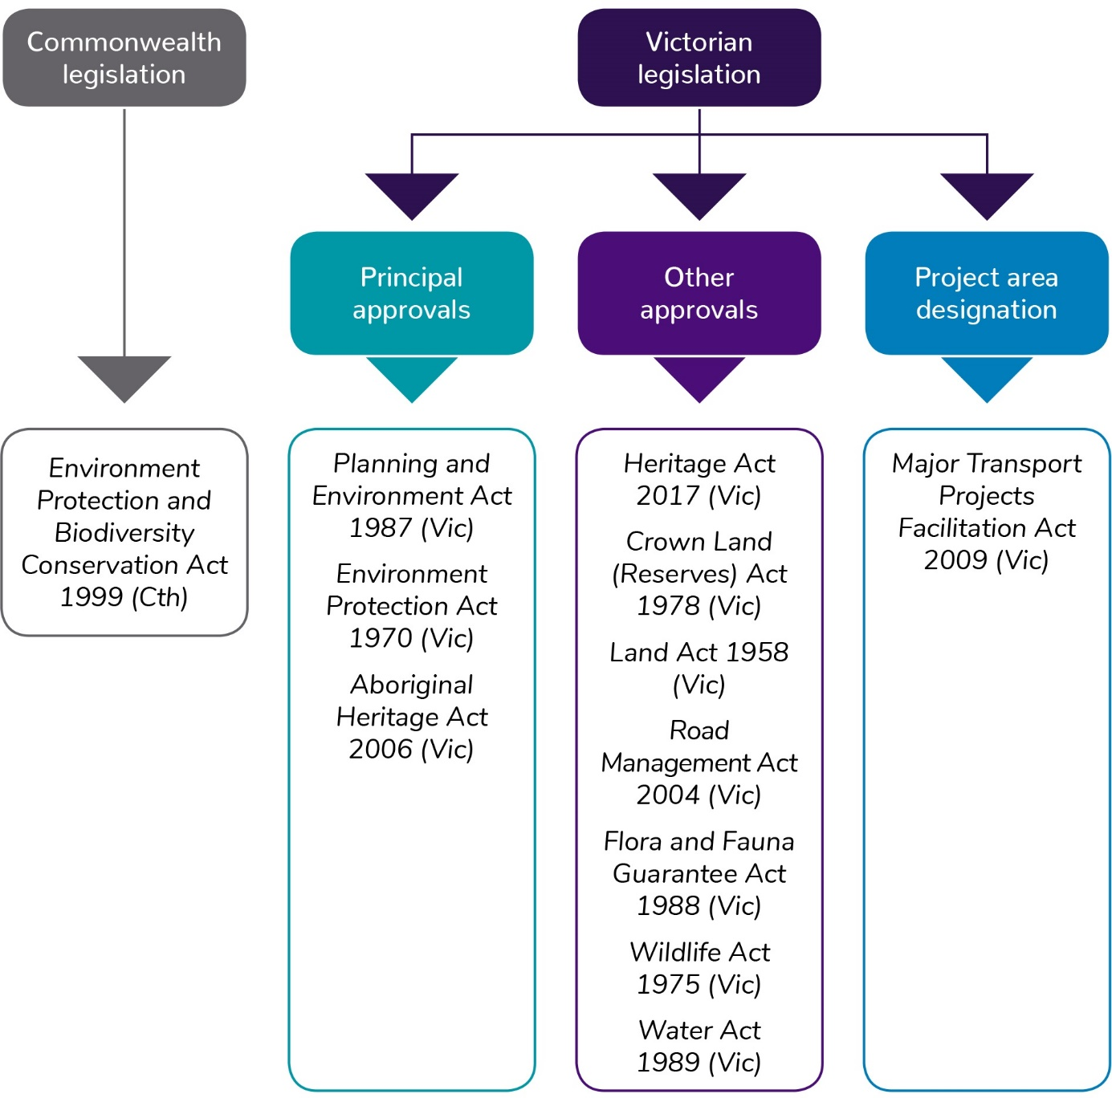
Figure 3-1 Overview of planning, environmental and heritage legislation applicable to North East Link approvals

Environment Effects Act 1978 (Vic)

EES purpose
Victoria’s Environment Effects Act 1978 establishes a process for the Minister for Planning to require the proponent of a project to prepare an EES.
The EES process provides for a comprehensive and integrated assessment of the environmental effects of a project. It enables an assessment to be made as to whether the potential for adverse effects are capable of being managed to achieve acceptable outcomes in accordance with project objectives. It includes the development of an EMF and a set of EPRs for North East Link that will apply to the ongoing design, development and implementation of the project.
The EES does not provide an approval but an assessment of the environmental effects of the project. The Minister’s assessment of the EES should enable statutory decision-makers to make informed decisions about the approvals required for the project to proceed. The EES contains a draft planning scheme amendment to the Banyule, Boroondara, Manningham, Nillumbik, Whitehorse, Whittlesea and Yarra Planning Schemes under the Planning and Environment Act and a works approval application under the Environment Protection Act.

EES process
On 2 February 2018, the Minister for Planning declared North East Link to be ‘public works’ under section 3(1) of the Environment Effects Act. This declaration triggered the requirement for the preparation of an EES to inform the Minister’s assessment of North East Link and the determinations of other decision-makers. The Minister made this decision on the basis that North East Link has ‘the potential for significant environmental effects on a range of environmental values, having regard to the nature of the area within which the project is proposed to be constructed and its dynamic and varied social and community setting’ (see Section 1.3.1 of Chapter 1 – Introduction for further detail about this decision).
Following this decision, the Minister for Planning issued draft EES scoping requirements for public comment, which the Minister then finalised and issued. This EES has been prepared in accordance with scoping requirements issued by the Minister.
This EES assesses the potential effects of North East Link on the environment in accordance with the EES scoping requirements (discussed in Section 4.3 of Chapter 4 – EES assessment framework). It has also been prepared in consultation with stakeholders via the Technical Reference Group (TRG), as required by the EES scoping requirements. The role and membership of the TRG is discussed in Chapter 5 – Communications and engagement. Following the public exhibition of this EES, it will be reviewed by an independent Inquiry and Advisory Committee appointed by the Minister for Planning. The Inquiry and Advisory Committee will consider the EES documentation and public submissions on the EES, the works approval application and the draft planning scheme amendment. The Minister for Planning will consider the report from the Inquiry and Advisory Committee as well as the other matters as discussed above in his assessment of environmental effects of North East Link.
The procedures for the EES assessment process are set out in the public works declaration and are further detailed in the scoping requirements.

Principal approvals
Figure 3-2 shows the processes for Commonwealth and Victorian approvals and the subsequent sections describe the principal approvals in further detail.
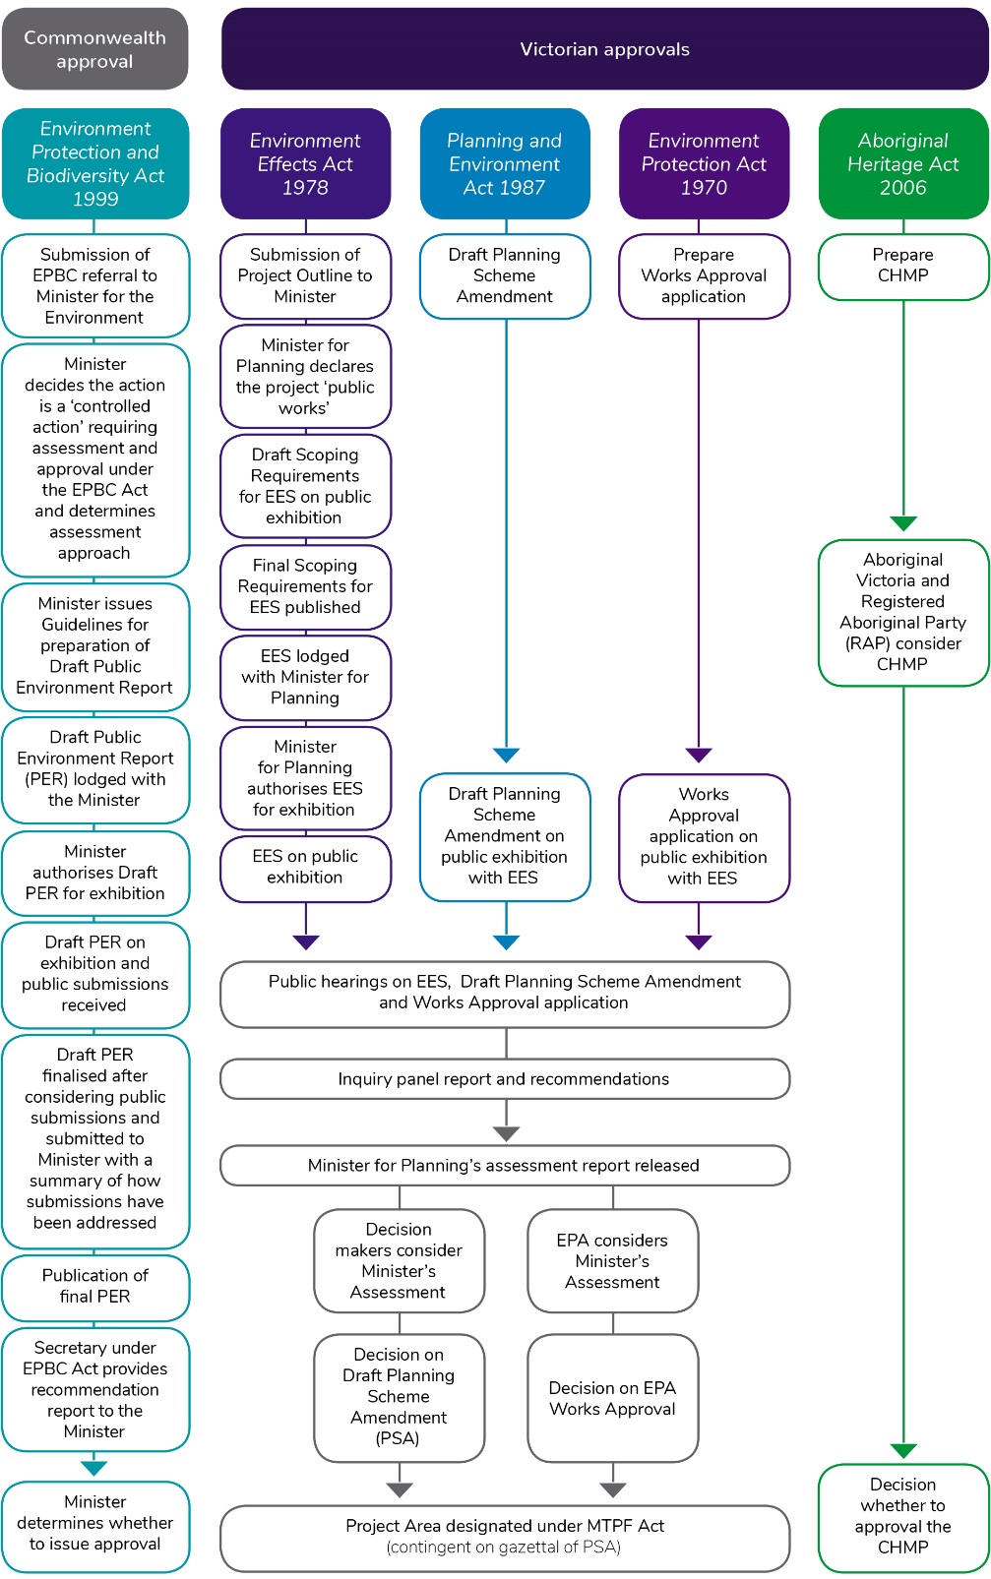
Figure 3-2 Commonwealth and Victorian approvals processes

Planning and Environment Act 1987 (Vic)
The purpose of the Planning and Environment Act is to establish a framework for planning the use, development and protection of land in Victoria in the present and long-term interests of all Victorians. The Act sets out the structure and administration of planning in Victoria and authorises the preparation, adoption and approval of planning schemes and planning scheme amendments.
The project affects land in the municipalities of Banyule, Boroondara, Manningham, Nillumbik, Whitehorse, Whittlesea and Yarra. The planning controls that currently apply to land proposed to be developed as part of the project are identified in Chapter 13 – Land use planning and Technical report E – Land use planning.
An amendment is required to each of these planning schemes under the Planning and Environment Act to:
- Include an Incorporated Document that would authorise the use and development of the land within the project boundary for the purposes of North East Link. The Incorporated Document would exempt project works from the planning permit triggers in the seven planning schemes, provided the works are within the defined project boundary and are carried out in accordance with the conditions for construction and operation set out in the Incorporated Document. This type of planning control has frequently been used on major infrastructure projects and provides a straightforward legal and administrative tool to regulate and control the development of North East Link. Compliance with the Incorporated Document, following preparation, adoption and approval of the planning scheme amendment, will be required by the Planning and Environment Act. Further information on these arrangements is provided in Chapter 27 – Environmental management framework. Under the Incorporated Document, Ministerial approval would be required for:
  - the EMF, which includes the EPRs
  - the Urban Design Strategy
  - the Urban Design Landscape Plans.
Further information on these arrangements is provided in Chapter 27 – Environmental management framework.
- Make the Minister for Planning the responsible authority for administering and enforcing the planning scheme provisions applicable to the use and development of land for the project.
- Introduce a Design and Development Overlay to protect the tunnels and other infrastructure during the construction and operation of North East Link from adverse impacts by developments, and protect proposed developments from adverse impacts resulting from North East Link.
The Planning and Environment Act empowers the Minister for Planning to prepare, adopt and approve planning scheme amendments. Following the release of the Minister’s assessment of the EES, NELP would request the Minister for Planning to prepare, adopt and approve an amendment to the Banyule, Boroondara, Manningham, Nillumbik, Whitehorse, Whittlesea and Yarra planning schemes.
Further information on the planning scheme amendment process is included in Chapter 13 – Land use planning, and the exhibited planning scheme amendment is included as Attachment V to this EES.

Environment Protection Act 1970 (Vic)
The Environment Protection Act establishes the legislative framework for protecting the environment in Victoria. It regulates certain activities with the potential to impact on the environment and prohibits the occupier of 'scheduled premises' from doing any act or thing (including installing any plant, equipment or process) that is likely to cause the discharge or emission of waste to the environment, unless authorised to do so.
Under the Environment Protection (Scheduled Premises and Exemptions) Regulations 2017, ‘road tunnel ventilation systems’ are scheduled premises. Accordingly, a works approval would be required for installation of the tunnel ventilation system. The works approval application shall be assessed by EPA Victoria.
The works approval application for the North East Link tunnel ventilation system is included in Attachment VI. It is supported by the following technical reports:
- Technical report B – Air quality assessment
- Technical report C – Surface noise and vibration assessment
- Technical report R – Greenhouse gas assessment.
An environmental discharge licence from EPA Victoria would be required before the tunnel ventilation system could operate.
A number of State Environment Protection Policies (SEPPs) have been prepared under this Act, which typically set standards, guidelines and environmental quality objectives and indicators to protect beneficial uses of the environment, including noise, surface and groundwater, land contamination and air quality. SEPPs express in law the community’s expectations, needs and priorities for using and protecting the environment.
The design and delivery of the project must otherwise comply with appropriate regulations, SEPPs and guidelines under the Environment Protection Act where they apply to works and other project activities. These compliance requirements, as well as the need to meet the requirements of a works approval and a discharge licence from EPA Victoria, are identified in Chapter 27 – Environmental management framework.

Aboriginal Heritage Act 2006 (Vic)
If a project proponent is required to prepare an EES under the Environment Effects Act, it must also prepare a CHMP for the area in which works are to be carried out. Technical report L contains the Aboriginal heritage impact assessment describing North East Link’s potential impact upon Aboriginal heritage (refer also to Chapter 20 – Aboriginal cultural heritage).
NELP is preparing a CHMP in consultation with the Wurundjeri Woi-wurrung Cultural Heritage Aboriginal Corporation – the Registered Aboriginal Party (RAP) for the project Activity Area – and Aboriginal Victoria who are responsible for evaluating the CHMP for a small section of the project area. When it is finalised, the CHMP will be submitted to the Wurundjeri Woi-wurrung Cultural Heritage Aboriginal Corporation and Aboriginal Victoria for approval.
As required by Section 49 of Victoria’s Aboriginal Heritage Act 2006, construction of the North East Link works assessed in this EES cannot commence until the CHMP has been approved.

Environment Protection and Biodiversity Conservation Act 1999 (Cwlth)
The EPBC Act is established to protect and manage designated matters of national environmental significance. If the Australian Government’s Minister for the Environment decides under the EPBC Act that a project could potentially have a significant impact on matters of national environmental significance or involve Commonwealth land, the project is designated a ‘controlled action’ that must be assessed and approved by the Minister before it can proceed.
The project was referred to the Australian Government’s Department of the Environment and Energy on 17 January 2018. On 13 April 2018 the project was determined to be a ‘controlled action’, requiring assessment and approval under the EPBC Act. The relevant controlling provisions are listed threatened species and communities (sections 18 & 18A), listed migratory species (sections 20 & 20A), and environment on Commonwealth land (sections 26 & 27A).
The referral decision indicated that the proposed action is likely to have a significant impact on the following matters of national environmental significance:
- Matted Flax Lily (Dianella amoena) (endangered)
- Community of Grassy Eucalypt Woodland of the Victorian Volcanic Plain (critically endangered)
- Swift Parrot (Lathamus discolour) (critically endangered)
- Australian Painted Snipe (Rostratula Australia) (endangered)
- Australasian Bittern (Botaurus poiciloptilus) (endangered)
- Macquarie Perch (Macquaria australasica) (endangered)
- River Swamp Wallaby-grass (Amphibromus fuitans) (vulnerable)
- Clover Glyine (Glycine latrobeana) (vulnerable)
- Growling Grass Frog (Litoria raniformis) (vulnerable)
- Australian Grayling (Prototroctes maraena) (vulnerable)
- Latham’s Snipe (Gallinago hardwickii) (migratory)
- The proposed development is likely to have significant impacts on several species on Commonwealth land that are listed as threatened under the EPBC Act and Victoria’s Flora and Fauna Guarantee Act 1988 (Vic).
The Minister for Environment and Energy decided the project would be assessed by Public Environment Report (PER).
Given the project intersects with Commonwealth land, an accredited assessment process is not able to be used under the bilateral agreement between the Australian and Victorian governments for environmental assessment. Consequently, separate processes are required for their respective environmental approvals.
A separate set of assessment documentation, the PER will be consistent with this EES documentation and will inform the Australian Government’s Minister for Environment’s assessment of the environmental effects of the project on Commonwealth land and matters of national environmental significance.

Major Transport Projects Facilitation Act 2009 (Vic)

The purpose of the MTPF Act is to facilitate the delivery of major transport projects declared under the Act. To be declared, the Premier of Victoria must assess the project as a project of 'economic, social or environmental significance to the State or a region of the State’. The Premier may declare a transport project to be a declared project to which either the whole MTPF Act applies or only the delivery provisions apply.
On 28 June 2018, the Premier declared North East Link as a transport project to which the MTPF Act (other than parts 3 and 8) applies.
What are project delivery provisions under the MTPF Act in relation to land?
Project delivery provisions include:
- Temporary occupation of land that may be required for the project
- A process for acquiring all interests in land within the project area
- The power for NELP to restrict access to project areas that have been temporarily occupied
- A streamlined process for the divesting of public land by public authorities and municipal councils.

This means that if the Minister for Planning grants approval for North East Link, the project authority (which at this stage has not been appointed) will be able to use the project delivery provisions to deliver the project, including those relating to:
- Land acquisition and assembly
- Road construction, deviation, closure and management
- Utilities.
On 28 June 2018, the Minister for Roads and Road Safety was appointed as the Project Minister.
On 21 December 2018, the Administrative Arrangements Order was published in the Government Gazette, which transferred the Premier's appointment of the Project Minister from the Minister for Roads and Road Safety to the Minister for Transport Infrastructure, effective from 1 January 2019.
In due course, the Minister will formally appoint a project proponent under section 6 of the Act. Following the Minister for Planning's designation of a project area, the project proponent (which will at that stage become the project authority) will have access to the project delivery powers described above.
For the purposes of Victoria’s Land Acquisition and Compensation Act 1986 (‘LAC Act’), the MTPF Act will be the Special Act (see section 113 of the MTPF Act). For land that is acquired under the LAC Act, any compensation will be assessed in accordance with the Act.

Other approvals
This section provides an overview of other approvals potentially required to enable the delivery of North East Link.

Heritage Act 2017 (Vic)
Victoria’s Heritage Act 2017 regulates the protection and conservation of places of heritage significance listed on the Victorian Heritage Register and archaeological sites and relics listed on the Victorian Heritage Inventory.
Under the Heritage Act, permits for impacts to places on the Victorian Heritage Register under section 102 of the Act, and consents for impacts to places on the Victorian Heritage Inventory under section 124 of the Act would be required. Following the Minister for Planning’s EES assessment, permits would be sought as soon as possible to appropriately manage potential impacts on heritage or archaeological values. An assessment of the potential impacts on places protected under the Heritage Act is contained within Technical report K – Historical heritage and Chapter 19 – Historical heritage.

Crown Land (Reserves) Act 1978 (Vic)
Victoria’s Crown Land (Reserves) Act 1978 provides for the reservation of Crown land for certain public purposes by the Governor in Council and sets out the administrative and legal framework for managing reserved Crown land and the processes for revoking Crown land reservations. Crown land can be reserved for a range of public purposes, including public parks and gardens, the beds and banks of waterways and railways.
North East Link affects reserved Crown land such as the land surrounding Bolin Billabong and the Yarra River in Bulleen. This land would be included in the project boundary of the project and if permanently required may be the subject of orders under the MTPF Act reserving the land for the purposes of the project.

Land Act 1958 (Vic)
Victoria’s Land Act 1958 deals with the sale, grants and occupation of unreserved Crown land in Victoria. The use of unreserved Crown land within the declared project area for the purposes of the project requires a separate order under the MTPF Act.
This order is likely to be used to facilitate development of the project, to the extent that any unreserved Crown land will be impacted by North East Link. Unreserved Crown land within the project boundary designated under the MTPF Act would become temporarily reserved for the purpose of the project.

Road Management Act 2004 (Vic)
Victoria’s Road Management Act 2004 provides the statutory framework for VicRoads, local government and other road authorities to manage the Victorian road network and the coordination of road reserves for roadways, pathways, infrastructure and similar purposes. A road includes the reserve from boundary line to boundary line.
While the Minister for Roads and Road Safety is responsible for administering the Road Management Act, VicRoads is responsible for the management of freeways and arterial roads declared under the Act, while local councils are responsible for municipal roads. For North East Link, consent may be required under the Act for works on these roads.

Flora and Fauna Guarantee Act 1988 (Vic)
Victoria’s Flora and Fauna Guarantee Act 1988 provides a framework for biodiversity conservation in Victoria. The Act provides for the listing of threatened species, communities of flora and fauna and potentially threatening processes. A number of non-threatened flora species are also protected under the Act.
A permit is required to take species protected under the Act from public land, and may also be required to remove protected species from private land in certain circumstances.
A permit is required under this Act for the removal of protected or threatened species within the project area, which may occur as a result of vegetation clearing. An assessment of the potential impacts on protected species is contained within Technical report Q – Ecology and Chapter 25 – Ecology.

Wildlife Act 1975 (Vic)
Victoria’s Wildlife Act 1975 establishes procedures for the protection and conservation of wildlife, the prevention of wildlife becoming extinct and the sustainable use of and access to wildlife. The Act also includes procedures to prohibit and regulate the conduct of persons engaged in activities concerning or related to wildlife.
For North East Link, an authorisation under section 28A of this Act will be required where fauna habitat is required to be translocated. A suitably qualified wildlife ecologist would be engaged to check for fauna occupancy and ensure compliance with this Act.

Water Act 1989 (Vic)
Victoria’s Water Act 1989 promotes the orderly, equitable and efficient use of water resources to make sure that water resources are conserved and properly managed for sustainable use for the benefit of present and future Victorians. The Act regulates the impacts on and use of surface water and groundwater.
North East Link would require the following approvals under this Act:
- A licence to construct, alter, operate or decommission works on, over or under the Merri Creek, Yarra River, Banyule Creek or Koonung Creek (from Melbourne Water)
- A licence to construct groundwater bores for monitoring, dewatering or reinjection (from Southern Rural Water)
- A licence to extract groundwater or for aquifer recharge (from Southern Rural Water).

Yarra River Protection (Wilip-gin Birrarung murron) Act 2017 (Vic)
Victoria’s Yarra River Protection (Wilip-gin Birrarung murron) Act 2017 provides an overarching policy and planning framework to coordinate and harmonise planning for the use, development and protection of the Yarra River, its parklands and other land in its vicinity. A purpose of the Act is to protect the Yarra River and the surrounding parcels of public land as one living and integrated natural entity. The Act also recognises the importance of the Yarra River, and its parklands and associated public places, to the economic prosperity, vitality and liveability of Melbourne and the Yarra Valley.
The Act provides for the preparation of a Yarra Strategic Plan in accordance with Yarra Protection Principles to guide future use and development, and areas for protection within the Yarra corridor. An exemption from the provisions of the Act applies for projects declared under Victoria’s Major Transport Projects Facilitation Act 2009 (including North East Link). However, NELP has considered the long-term community vision within the Yarra Strategic Plan, and has had regard to the Yarra Protection Principles set out in the Act.

