Chapter 10
Proposed avoidance and mitigation measures
September 2019

Chapter 10

Proposed avoidance and mitigation measures

Introduction
This chapter discusses the proposed avoidance and mitigation measures that would be implemented for North East Link to avoid and mitigate the potential impacts identified in Chapters 7 to 9. This chapter responds to Section 2.6 of the Public Environment Report (PER) Guidelines.
The avoidance and mitigation measures discussed in this chapter have informed and been informed by the Victorian Environment Effects Statement (EES) process. Figure 10-1 shows this relationship.
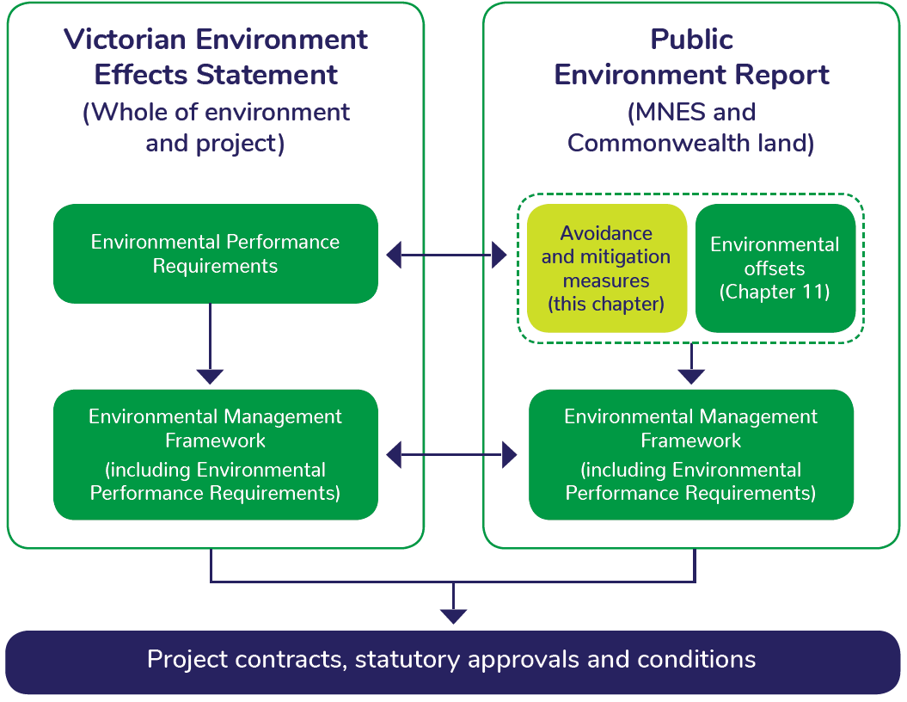
Figure 10-1 Relationship between PER and EES avoidance and mitigation measures

Victorian Environment Effects Statement process
The EES prepared as part of the Victorian approvals process assessed North East Link’s potential environmental effects on the whole of environment. A set of Environmental Performance Requirements (EPRs) were established as a result of this process. The EPRs define minimum environmental outcomes that must be achieved for the design, construction and operation of North East Link. This performance-based approach allows tenderers to determine how EPRs would be achieved while developing and optimising the final North East Link design. This enables a delivery model that is flexible and encourages innovation through the procurement process.
An Environmental Management Framework (EMF) was also developed as part of the EES and describes how EPRs would be implemented. The EMF outlines the governance arrangements to meet Victorian statutory requirements, protect environmental values and sustain stakeholder confidence during delivery of North East Link. It describes roles and responsibilities, requirements for environmental management documentation and requirements for monitoring, auditing and reporting on compliance against the EMF and EPRs. For reference purposes, Attachment III contains the EES EMF.
The EMF and EPRs have been developed specifically to support the key Victorian approvals. They are described briefly in this chapter to provide context on the relationship between the EPRs outlined in the EES and the avoidance and mitigation measures proposed as part of the PER process.
The EMF and EPRs would be reviewed and, where required, updated in response to the Victorian Minister for Planning’s Assessment of the EES. The final, updated version of the EMF and EPRs would be submitted to the Victorian Minister for Planning for approval. Attachment III contains the EPRs proposed by NELP as dated 12 August 2019.
Contractors would be required to comply with the EMF and EPRs as a condition of North East Link project contracts.

PER avoidance and mitigation measures
Measures to avoid, mitigate and offset impacts on matters of national environmental significance (MNES) and Commonwealth land were developed in parallel with and are required by the EPRs. This chapter describes the specific measures that are required by the EPRs to avoid and mitigate impacts on MNES and Commonwealth land.
A set of environmental outcomes has been developed as part of this PER based on the findings of the PER impact assessment process. The environmental outcomes have been developed with consideration to the Australian Department of Energy and Environment’s (DoEE) Outcomes-based conditions policy (2016) Outcomes-based conditions guidance (2016) to support DoEE in setting approvals conditions in response to the PER. Chapter 12 – Environmental outcomes describes these outcomes in more detail. The avoidance and mitigation measures presented in this chapter are designed to enable the environmental outcomes to be achieved.
The environmental outcomes and avoidance and mitigation measures proposed in this chapter and the PER are stand-alone requirements to those specified in the EMF and EPRs. Contractors would be required to comply with the environmental outcomes and any other conditions arising from this PER process as a condition of North East Link project contracts.

Consolidated list of avoidance and mitigation measures
Avoidance and mitigation measures have been proposed to address direct and indirect impacts, including their contribution to any cumulative impacts, on MNES and Commonwealth land. As noted in Chapter 6 – Impact assessment, North East Link is not considered likely to facilitate further impacts on MNES or the environment on Commonwealth land at a local, regional, state or national scale and so measures to address facilitated impacts are not proposed.
This section describes the:
- Environmental outcomes the measures are expected to achieve
- Consolidated list of avoidance and mitigation measures
- Impacts the measures aim to prevent or minimise
- Expected or predicted effectiveness of the measures
- Proposed approach to rehabilitation of disturbed habitat areas
- Statutory or policy basis for measures
- Cost of measures.

Environmental outcomes
Environmental outcomes have been developed for MNES and whole of environment matters on Commonwealth land on which North East Link would likely have a significant impact without measures such as translocation or offsetting. Environmental outcomes have been tailored to North East Link with consideration to the Australian Government’s Environment Protection and Biodiversity Conservation Act 1999 (‘EPBC Act’), Outcomes-based conditions policy 2016 and Outcomes-based conditions guidance 2016.
The matters requiring environmental outcomes were identified as a result of the technical studies carried out for this PER and the EPBC referral prepared for North East Link. Environmental outcomes were developed with consideration to the matter to be protected, the nature and extent of relevant impacts, and the effectiveness of avoidance and mitigation measures in reducing impacts. Environmental outcomes, including the baseline data and proposed monitoring to demonstrate progress towards achieving these are discussed in detail in Chapter 12 – Environmental outcomes.
Environmental outcomes include:
- Outcome 1: Matted Flax-lily
Matted Flax-lily populations directly impacted by North East Link must be translocated in accordance with a Salvage and Translocation Plan prepared to the satisfaction of the Department of Environment and Energy. There must be a net gain in the number of Matted Flax Lily plants/patches due to North East Link, measured by comparing the pre-impact and 10-year post-impact number of Matted Flax-lily plants/patches within the North East Link project boundary and approved translocation recipient sites.
- Outcome 2: Remnant native vegetation on Commonwealth land
Remnant native vegetation removal on Commonwealth land must be minimised to the extent practical. All remnant native vegetation impacted on Commonwealth land due to North East Link must be offset in accordance with the principles of the EPBC Act Offsets Policy and the Victorian Guidelines for the removal, destruction or lopping of native vegetation (DELWP, 2017). Offset sites must be secured to the satisfaction of the DoEE and Victoria’s Department of Environment, Land, Water and Planning (DELWP) before vegetation removal on Commonwealth land starts.
- Outcome 3: Studley Park Gum on Commonwealth land
The Studley Park Gum Management Framework must be implemented to support establishment of a new population of Studley Park Gum by planting Studley Park Gum trees within an appropriate recipient site. A Studley Park Gum Groundwater Dependent Ecosystem Monitoring and Mitigation Strategy would be implemented to mitigate impacts on Studley Park Gum associated with groundwater drawdown.

Avoidance and mitigation measures
Table 10-1 provides a summary list of proposed avoidance and mitigation measures. These measures are discussed in more detail in Chapters 7 to 9 and the technical reports in Appendices A to D. As noted in Section 10.1.1, the avoidance and mitigation measures proposed in this chapter are also required by the EPRs. Relevant EPRs (proposed by NELP dated 12 August 2019) are listed in Table 10-1 for reference purposes only.
All measures listed in Table 10-1 would be implemented by the North East Link Project (NELP) and the contractors appointed by the Victorian Government to carry out works for North East Link. Additional measures that may be taken by other Victorian Government departments or agencies or by local government are outside the scope of this PER.

Table 10-1 Proposed avoidance and mitigation measures
Topic | Statutory or policy basis | Proposed avoidance and mitigation measures | Relevant impacts | Relevant Environmental Performance Requirements (for reference only)
Aboriginal Cultural Heritage | Aboriginal Heritage Act 2006 (Vic)  Aboriginal Heritage Regulations 2007 (Vic) | Comply with the Cultural Heritage Management Plan (CHMP) approved under the Aboriginal Heritage Act 2006. | Removal of place, disturbance of place, disturbance of unregistered Aboriginal cultural heritage (construction). | EPR AH1
Air quality | Environment Protection Act 1970 (Vic)  Environment Protection (Scheduled Premises) Regulations 2017  State Environment Protection Policy (SEPP) – Ambient Air Quality  State Environment Protection Policy (SEPP) – Air Quality Management (AQM)  EPA Victoria publication 480: Best practice environmental management environmental guidelines for major construction sites (1996) | A Dust and Air Quality Management Plan would be developed and implemented to minimise dust and air quality emissions during construction. | Degradation of vegetation and terrestrial habitat through erosion, sedimentation, dust or contamination (construction).  Construction air quality emissions – short term mainly relating to dust and odour emissions due to construction activities affecting nearby receptors (construction).  Construction traffic, air, noise, visual and over-shadowing impacts affecting amenity and on-going use of Commonwealth land (construction).  Social impacts from construction amenity impacts (visual, noise and air quality) (construction).  Air emissions affecting human health (construction). | EPR AQ1
 |  | The tunnel ventilation system would be designed to meet EPA Victoria requirements for air quality and to meet in-tunnel air quality standards for CO and NO₂.  In-tunnel and ambient air quality monitoring programmes would be developed and implemented. If applicable standards or the EPA Victoria Licence conditions are not met report to EPA Victoria and investigate the cause of the exceedance. | Operational traffic, air, noise and visual impacts affecting ongoing use of Commonwealth land (operation).  Social impacts from operational amenity impacts (visual, noise and air quality) (operation).  Changes to the operation of community infrastructure and facilities (operation).  Operational tunnel ventilation structure and surface road emissions affecting nearby receptors (operation).  Air emissions derived from tunnel ventilation and changes in road traffic affecting human health (operation). | EPR AQ2  EPR AQ3  EPR AQ4  EPR AQ5
Business | Planning and Environment Act 1987 (Vic)  Land Acquisition and Compensation Act 1986 (Vic)  Australian Standard AS/NSZ 10002:2014 Guidelines for Complaint Management in Organisations | Acquisition of business properties would be in accordance with the Land Acquisition and Compensation Act 1986. | Displacement of five businesses in Greensborough Road providing services and goods that are used by the Barracks community (construction). | EPR B2
 |  | Utility assets would be protected or, where required, relocated to the reasonable satisfaction of the service provider and/or asset owners. Any damage caused to property or infrastructure as a result of North East Link would be appropriately remedied in consultation with the property or asset owner. | Works to utilities from construction activity disrupt businesses used by the barracks community (construction). | EPR B3  EPR B5
Contaminated land and soil | Dangerous Goods Act 1985 (Vic)  Environment Protection Act 1970 (Vic)  Occupational Health and Safety Act 2004 (Vic)  National Environment Protection (Assessment of Site Contamination) Measures 2013 (ASC NEPM)  PFAS National Environmental Management Plan 2018  Environment Protection (Industrial Waste Resource) Regulations 2009 (Vic)  Occupational Health and Safety Regulations 2007 (Vic)  State Environment Protection Policy (SEPP) – Prevention and Management of Contamination of Land (Vic)  State Environment Protection Policy (SEPP) – Air Quality Management, 2001 (odour) (Vic)  Industrial Waste Management Policy (Waste Acid Sulfate Soils) 1999 (Vic)  AS1940 Storage Handling of Flammable and Combustible Liquids  AS 4482.1-2005 Guide to the investigation and sampling of sites with potentially contaminated soil  Relevant EPA Victoria industrial waste resource guidelines (IWRG).  Victorian Best Practice Guidelines for Assessing and Managing Coastal Acid Sulfate Soil, 2003  EPA Victoria publications:  - 1698 Liquid Storage and Handling Guidelines  - 480 Environmental guidelines for major construction sites  - 655.1 Acid sulfate soil and rock | A Spoil Management Plan would be developed and implemented to guide storage, handling, transport and disposal of spoil during construction. The Spoil Management Plan would contain requirements for managing potential acid sulfate soil, odour, vapour and gas risks and impacts. | Degradation of vegetation and terrestrial habitat through erosion, sedimentation, dust or contamination (construction).  Degradation of vegetation and terrestrial habitat through soil compaction (construction).  Impacts from excavation of contaminated material on Commonwealth land (construction).  Oxidation of acid sulfate soil and rock due to excavation (construction).  Disturbance of buried waste and other unknown contamination on Commonwealth land (construction).  Release of vapours and odours due to disturbance of contaminated land (construction). | EPR CL1  EPR CL2  EPR CL3  EPR CL4  EPR CL6
 |  | Construction Environmental Management Plans and Operation Environmental Management Plans would be developed and implemented. These would include measures to:  - Manage chemicals, fuels and hazardous substances, including incident and emergency response procedures and provision of spill kits on construction sites  - Minimise and manage waste in accordance with the Environment Protection Act 1970 (Vic). | Degradation of vegetation and terrestrial habitat through erosion, sedimentation, dust or contamination (construction).  Degradation of aquatic habitat through erosion, sedimentation, dust or contamination (construction). | EPR CL5  EPR CL6
Flora and fauna | EPBC Act (Cwlth)  Catchment and Land Protection Act 1994 (Vic)  Conservation, Forests and Lands Act 1987 (Vic)  Flora and Fauna Guarantee Act 1988 (Vic)  Fisheries Act 1995 (Vic)  Planning and Environment Act 1987 (Vic)  Water Act 1989  Wildlife Act 1975 (Vic)  State Environment Protection Policy (SEPP) Waters 2018 (Vic)  Guidelines for the removal, destruction or lopping of native vegetation (DELWP, 2017)  AS4970-2009 Protection of Trees on Development Sites | North East Link would be designed and constructed as a twin tunnel under the Yarra River, Banyule flats and associated floodplains to avoid surface impacts. | Removal of vegetation and habitat (construction).  Degradation of aquatic habitat through erosion, sedimentation, dust or contamination (construction).  Degradation of aquatic habitat through waterway modification or construction activities in and around waterways (construction).  Fragmentation of terrestrial wildlife corridors creating barriers to terrestrial fauna movement (construction). | Reference project
 |  | North East Link’s footprint would be refined and minimised during detailed design to minimise removal of native vegetation and fauna habitat and minimise impacts on habitat connectivity and listed threatened species.  NELP proposes to contribute to the conservation of Studley Park Gum by establishing new habitat through the implementation of the Studley Park Gum Management Framework (see PER Technical Appendix A – Flora and fauna technical report). This approach is expected to result in a viable outcome noting that the creation of new habitat for a protected matter is a type of direct offset under the EPBC Act Environmental Offsets Policy. | Removal of vegetation and habitat (construction).  Removal of planted amenity trees (construction).  Fragmentation of terrestrial wildlife corridors creating barriers to terrestrial fauna movement (construction). | EPR AR1  EPR FF2
 |  | A Salvage and Translocation Plan would be developed and implemented for Matted Flax-lily. A draft is presented in PER Technical Appendix A – Flora and fauna technical report. | Removal of vegetation and habitat (including Matted Flax-lily) (construction). | EPR FF7
 |  | A Tree Protection Plan would be developed and implemented for trees to be retained in accordance with AS4970-2009 Protection of Trees on Development Sites. | Removal of vegetation and habitat (construction).  Removal of planted amenity trees (construction).  Death, damage or destabilisation of trees on periphery of construction (construction).  Modification to adjacent soil profiles leading to tree death or damage (construction). | EPR AR2
 |  | Impacts on aquatic habitat values, including those resulting from changes in flows or bank stability would be minimised through design and selection of construction methods for any works on or modifications to waterways. | Degradation of aquatic habitat through erosion, sedimentation, dust or contamination (construction).  Degradation of aquatic habitat through waterway modification or construction activities in and around waterways (construction).  Fragmentation of aquatic wildlife corridors creating barriers to aquatic fauna movement (construction).  Degradation of aquatic habitat through modification of stormwater catchment (operation).  Degradation of aquatic habitat through contaminated runoff (operation). | EPR FF4  EPR SW6  EPR SW8  EPR SW9
 |  | Construction Environmental Management Plans (CEMPs) would be developed and implemented for construction works. These CEMPs would include measures to avoid and mitigate construction impacts including requirements for:  - Protecting native vegetation and habitat to be retained, including through no-go zones. No-go zones would include the Grey-headed Flying-fox Campsite within Yarra Bend Park, Bolin Bolin Billabong, the Plains Grassy Woodland community between Enterprise Drive and the M80 Ring Road (otherwise known as the Metropolitan Ring Road) in Bundoora, the portion of 49 Greenaway Street, Bulleen (former Drive-in) heavily vegetated with trees along the Yarra River, and surface impacts in the Banyule Flats and Warringal Parklands and the Heide Museum of Modern Art.  - Pre-clearance surveys for fauna and measures to manage fauna encountered in accordance with the Wildlife Act 1975 and Fisheries Act 1995.  - Contingency and reporting procedures for the event that a listed threatened species is identified in order to mitigate the potential for significant impacts on the listed threatened species.  - Avoiding the spread or introduction of weeds and pathogens, including vehicle and equipment hygiene requirements.  - Avoiding and minimising impacts on riparian, riverbed and aquatic habitat and fauna connectivity.  - Avoiding or minimising intense noise and vibration impacts (such as from pile driving and similar activities) in or near the Yarra River, and, if these works are required, to the extent practicable, avoiding carrying these out during critical migration or breeding periods for the Australian Grayling as defined within the National Recovery Plan.  - Protecting fauna habitat values in waterbodies that are modified for drainage purposes, including retaining both dead and alive standing trees and to the extent practicable, avoiding works during the typical nesting period for waterbirds (typically September to January). | Removal of vegetation and habitat (construction).  Degradation of aquatic habitat through erosion, sedimentation, dust or contamination (construction).  Degradation of aquatic habitat through waterway modification or construction activities in and around waterways (construction).  Death or injury of fauna during construction (construction).  Disturbance of fauna through noise, vibration or lighting (construction).  Introduction or spread of weeds, pest species or pathogens leading to the reduction of ecological values (construction). | EPR FF1  EPR FF2  EPR FF3  EPR FF4  EPR FF8  EPR FF9
 |  | An Operation Environmental Management Plan (OEMP) would be developed and implemented to manage environmental impacts during operation of North East Link.
 |  | A Groundwater Dependent Ecosystem Monitoring and Mitigation Plan would be developed and implemented. This must be informed by the groundwater modelling and groundwater monitoring and must include (but not be limited to):  - Identification of Groundwater Dependent Ecosystems (GDEs) predicted to be impacted  - Details of the monitoring procedures and program for each relevant GDE including monitoring periods appropriate to each GDE  - Specific procedures to monitor groundwater levels at GDEs predicted to be impacted including monitoring as close as possible to the GDE (considering ecological and access constraints) and for aquatic GDEs monitoring the surface water levels and quality as appropriate  - Identification of relevant monitoring and management programs by Melbourne Water or other authorities and how these are referenced in the Groundwater Dependent Ecosystem Monitoring and Mitigation Plan  - Measures to mitigate monitored changes in water levels and quality that could impact the billabongs or other GDEs, which take into account the natural variability  - Where the survival of Groundwater Dependent Large Trees not requiring removal is predicted to be affected by groundwater drawdown during construction based on groundwater modelling outputs, include measures to maintain the health of large trees.  - In relation to any trees unlikely to survive during operation as a consequence of groundwater drawdown, processes for offsets to be obtained.  This would be informed by the Studley Park Gum Groundwater Dependent Ecosystem Monitoring and Mitigation Strategy which proposes mitigations specific to Studley Park Gum (see PER Technical Appendix A – Flora and fauna technical report). | Groundwater changes during operation resulting in degradation of terrestrial or aquatic ecosystems (operation).  Effect on heritage value from vegetation changes due to groundwater drawdown (construction and operation). | EPR FF6  EPR GW1  EPR GW2  EPR GW3  EPR GW4  EPR GW5
 |  | Native vegetation removed would be offset in accordance with the Victorian Guidelines for the removal, destruction or lopping of native vegetation (DELWP, 2017). Where practicable and appropriate for the landscape and project location, best practice measures would be applied to retain and reinstate topsoil to support growing conditions for native species. Where topsoil cannot be retained or reused for North East Link, alternative opportunities for reuse would be explored. | Removal of vegetation and habitat (construction).  Drawdown of groundwater resulting in degradation of terrestrial or aquatic ecosystems (construction). | EPR FF2
 |  | A Tree Canopy Replacement Plan would be developed and implemented to replace the loss of canopy of native vegetation and amenity plantings and achieve a net gain in tree canopy cover by 2045. The replacement of amenity trees should be at a ratio of 2:1 and commence as soon as possible. The plan would show the location, size and species of replacement trees, in consultation with relevant land managers. The plan would specify requirements to support the long-term viability of replacement plantings including appropriate soil requirements, establishment works and ongoing maintenance.  Where appropriate for the landscape and location, tree replacement and landscaping would use locally indigenous species (utilising seed collected from species within the project boundary where possible) which are suited to the landscape profile and setting being revegetated, and which maximise habitat value and connectivity. | Removal of vegetation and habitat (construction).  Fragmentation of terrestrial wildlife corridors creating barriers to terrestrial fauna movement (construction).  Operational infrastructure preventing the re-establishment of urban forest canopy (operation).  New structures impacting growing conditions of trees (operation). | EPR AR3  EPR FF2
Ground movement | Not applicable | A Ground Movement Plan would be developed and implemented to manage and mitigate ground movement impacts during construction. A geotechnical model and groundwater modelling would inform this plan. Condition surveys would be carried out for property and infrastructure predicted to be affected by ground movement from North East Link, with repair works or other appropriate action taken to address any damage caused by ground movement due to North East Link. | Detrimental changes to soil, surface water or groundwater conditions as a result of tunnel construction on Commonwealth land (construction).  Damage from vibration and ground movement to heritage structures (construction).  Utilities and buildings on Commonwealth land affected by construction related ground movement (construction). | EPR GM1  EPR GM2  EPR GM3  EPR GM4  EPR GW1
Groundwater | Water Act 1989 (Vic)  Water Industry Regulations 2006 (Vic)  State Environment Protection Policy (SEPP) (Waters) 2018 (Vic)  State Environment Protection Policy (SEPP) Prevention and Management of Contaminated Land 2002 (Vic)  VicRoads Integrated Water Management Guidelines (June 2013)  EPA publications:  - 480 Environmental guidelines for major construction sites  - 1698 Liquid Storage and Handling Guidelines  - 275 (1991) Construction techniques for sediment pollution control  - 668 (2006) Hydrogeological assessment (groundwater quality) guidelines  - 669 (2000) Groundwater sampling guidelines.  Ministerial guidelines for groundwater licensing and the protection of high value groundwater dependent ecosystems (2015) (Vic) | A predictive numerical model would be developed in consultation with EPA Victoria to predict changes to groundwater levels, flow and quality to inform mitigation strategies for design and construction of North East Link. | Groundwater changes resulting in degradation of terrestrial or aquatic ecosystems (construction and operation).  Water level decline, depletion of groundwater resources and impacts arising from drawdowns on acid sulfate geological materials or contaminated groundwater (construction and operation). | EPR GW1
 |  | The tunnels would be designed and constructed to avoid and minimise groundwater changes that could impact ecological values. This would occur through:  - Adopting construction methods to avoid the mobilisation of contaminated groundwater and acid sulfate soils  - Implementing engineering control measures and/or ground treatment to manage, mitigate and minimise to the extent practicable groundwater inflow during excavation, construction and operation of tunnels, cross passages and subsurface excavations. | Groundwater changes during operation resulting in degradation of terrestrial or aquatic ecosystems (operation).  Water level decline, depletion of groundwater resources and impacts arising from drawdowns on acid sulfate geological materials or contaminated groundwater plumes (construction and operation).  Project presents a barrier to regional groundwater flow (operation). | EPR GW3  EPR GW4
 |  | A Groundwater Management Plan would be developed and implemented to protect groundwater quality and manage groundwater interception during construction. The Groundwater Management Plan would also contain measures and/or controls to minimise groundwater inflow during construction to excavations and groundwater drawdown. The Groundwater Management Plan would include requirements for contingency measures should groundwater monitoring indicate adverse impacts are occurring.  The Groundwater Management Plan would include measures such as the following where appropriate, but not limited to:  - Selection and use of artificial recharge fluids that would not diminish ground water quality  - Measures to mitigate and minimise oxidation of acid sulfate soil materials and acidification of groundwater  - Assessment of damming and barrier effects  - Subsidence management  - Protection of waterways and potential GDEs from unacceptable groundwater impacts  - Measures to protect water supply for users of existing extraction bores  - Identification, treatment, disposal and handling of contaminated groundwater plumes, groundwater seepage water and/or slurries including vapours in accordance with relevant legislation and guidelines  - Groundwater treatment and disposal consistent with the EPA Victoria waste hierarchy and EPA Victoria requirements. | Localised groundwater quality impacts as a result of spillage or improper handling and application of hazardous materials, including reinjection activities (construction).  Depletion of groundwater resources and impacts arising from drawdowns on acid sulfate geological materials or contaminated groundwater plumes (construction and operation).  Effect on heritage value from vegetation changes due to groundwater drawdown (construction).  Changes to groundwater quality from discharges during construction (construction). | EPR GW3  EPR GW4
 |  | The design of the tunnels and construction methods would be informed by the groundwater modelling and groundwater monitoring. The groundwater monitoring program would be used to:  - Establish baseline water level and quality conditions  - Calibrate the predictive model prior to commencement of construction  - Assess the adequacy of proposed design and construction methods and inform the need for any additional measures or changes to mitigate impacts from changes in groundwater levels, flow and quality.  Monitor and confirm the acceptability of the recovery of the groundwater environment in terms of water level and water quality as predicted by the numerical groundwater model. Acceptability would be assessed with consideration to the Groundwater Dependent Ecosystem Monitoring and Mitigation Plan and other identified beneficial uses of groundwater. | Groundwater changes resulting in degradation of terrestrial or aquatic ecosystems (construction and operation)  Effect on heritage value from vegetation changes due to groundwater drawdown (construction and operation)  Depletion of groundwater resources and impacts arising from drawdowns on acid sulfate geological materials or contaminated groundwater plumes (construction and operation)  Project presents a barrier to regional groundwater flow (operation). | EPR GW2
 |  | Measures would be developed and implemented to manage, monitor and dispose of groundwater inflows during operation of North East Link to comply with relevant legislation and guidelines.  This includes a trade waste agreement from the relevant water authority in accordance with regulatory requirements, where disposal to sewer is proposed. Approval must be obtained from EPA Victoria and any relevant water authority in accordance with regulatory requirements, where discharge to waterways is proposed. | Groundwater changes resulting in degradation of terrestrial or aquatic ecosystems (operation).  Operational impact to groundwater quality through spillage or stormwater runoff (operation). | EPR GW5
Historical heritage | Heritage Act 2017 (Vic)  Guidelines for Investigating Historical Archaeological Artefacts and Sites, Heritage Victoria 2015 | Loss of tree canopy would be mitigated as discussed in relevant sections of this table covering ecology, landscape, and arboriculture. | Visual changes to the setting and sightlines of heritage places (construction). | EPR HH5
 |  | Consultation with Simpson Barracks on the removal of Assembly Place and possible relocation of elements. | Social impacts from acquisition of Commonwealth land (construction).  Planned permanent removal of historic heritage (construction).  Impacts to use and access of a historic heritage place during construction (construction). | EPR HH1  EPR HH2  EPR SC1
Landscape and visual | Planning and Environment Act 1987 (Vic)  Australian Standards AS 4282 -1997 Control of the obtrusive effects of outdoor lighting | Measures would be implemented to minimise light spillage during construction to protect the amenity of adjacent neighbourhoods, parks, community facilities and any known significant native fauna habitat to the extent practicable.  Lighting used during operation of permanent structures would be designed to minimise impacts on significant fauna sites and in accordance with relevant standards, including AS 4282 -1997 Control of the obtrusive effects of outdoor lighting. | Disturbance of fauna through noise, vibration or lighting (construction and operation).  Traffic, air, noise, visual and over-shadowing impacts affecting amenity and on-going use of Commonwealth land (construction and operation). | EPR LV3  EPR LV4
 |  | Temporary and construction works would be designed and carried out in accordance with the UDS guidance on using design to help manage construction impacts. Areas disturbed by temporary and construction works would be reinstated in consultation with the relevant land manager.  Measures to reduce landscape and visual impact would include, where appropriate, temporary landscaping and ensuring that larger features or structures (including viewing portals) are designed, where practicable, to minimise adverse visual impact of project works construction works and provide visual appeal.  Landscaping enhancement (as part of permanent works) would be implemented, where practicable prior to construction. | Landscape and visual changes for receptors that are on Commonwealth land during construction (construction). | EPR LV2
 |  | North East Link would be designed in accordance with the Urban Design Strategy. Urban Design and Landscape Plans would be developed for permanent above-ground buildings and structures. The design response would, to the extent practicable, minimise landscape and visual impacts and maximise opportunities to enhance public amenity. | Social impacts from operational amenity impacts (visual, noise and air quality) (operation).  Changes to the operation of community infrastructure and facilities.  Health effects from changes in traffic and transport, property acquisition, open space and community access (operation).  Landscape and visual changes for receptors that are on Commonwealth land from the operation of the North East Link (operation). | EPR LV1
Land use planning | Planning and Environment Act 1987 (Vic) | Elevated structures and noise walls would be designed to minimise overshadowing and shading impacts, and overlooking to private open space and habitable room windows of residential properties. | Loss or degradation of terrestrial or aquatic habitat through shading (operation).  Amenity impacts on Commonwealth land (operation). | EPR LP4  EPR LV1
 |  | Agreement would be sought on the terms for possession of the Commonwealth land with disruption to be minimised to the extent practical.  North East Link’s footprint would be minimised to the extent practicable.  The planning for the future use and development of land would be carried out in consultation with Commonwealth land managers and agencies responsible for implementing relevant planning policies and strategic plans. | Change of land use within the Simpson Barracks from acquisition or temporary occupation of Commonwealth land (construction).  Health impacts from changes in traffic and transport, property acquisition, open space and community access (operation). | EPR LP1  EPR LP3
Noise and vibration | State Environment Protection Policy (Control of Noise from Commerce, Industry and Trade) No. N-1 (SEPP N-1)  Australian Standards AS 2187.2, Explosives – Storage and use – Use of explosives  Australian Standard 2436 2010 Guide to Noise Control on Construction, Maintenance and Demolition Site (reconfirmed 2016  VicRoads Road Design Note RDN 6-1 Interpretation and application of VicRoads traffic noise reduction policy 2005  VicRoads Traffic Noise Measurement Requirements for Acoustic Consultants – September 2011  EPA Victoria publications:  - 480 Guidelines for major construction sites  - 1254 Noise control guidelines  New South Wales Interim Construction Noise Guideline (ICNG) (2009)  New South Wales Roads and Maritime Services Construction Noise and Vibration Guideline (CNVG) (2016)  New South Wales Roads and Maritime Services Noise Mitigation Guideline (2015)  ASHRAE Chapter 48 Sound and Vibration Control Standards  German Standard DIN 4150 – Part 3 – Structural Vibration in Buildings – Effects on Structures (2016)  British Standard BS6472-1:2008 Guide to evaluation of human exposure to vibration in buildings. Vibration sources other than blasting. | A Construction Noise and Vibration Management Plan, including guideline targets, would be developed and implemented to minimise noise and vibration impacts during construction. | Disturbance of fauna through noise, vibration or lighting (construction).  Fragmentation of aquatic wildlife corridors creating barriers to aquatic fauna movement (construction).  Noise from construction of the project impacts the barracks community, businesses and the ongoing use of the Commonwealth land (construction).  Damage from vibration and ground movement to buildings and heritage structures (construction).  Social impacts from construction amenity impacts (visual, noise and air quality) (construction).  Construction vibration and regenerated noise has amenity impacts on personnel on Commonwealth land (construction).  Health impacts from noise and vibration (construction). | EPR NV3  EPR NV4  EPR HH5
 |  | North East Link would be designed to achieve project traffic noise objectives. Traffic noise would be measured prior to and upon opening, and 10 years after opening of North East Link, in accordance with VicRoads requirements. Remedial action would be taken in the event that measured traffic noise levels exceed the project traffic noise objectives.  Noise attenuation equipment would be included as part of the ventilation structure design to meet SEPP N-1 noise criteria. | Disturbance of fauna through noise, vibration or lighting (operation).  Operational traffic noise changes (operation).  Social impacts and impacts to ongoing use of Commonwealth land from operational amenity impacts (visual, noise and air quality) (operation).  Changes to the operation of community infrastructure and facilities (operation).  Noise from the operation of the tunnel ventilation system (operation).  Health impacts from noise and vibration (operation). | EPR NV1  EPR NV2  EPR NV6  EPR NV13
Social and community | Planning and Environment Act 1987 (Vic)  Australian Standard AS/NSZ 10002:2014 Guidelines for Complaint Management in Organisations. | A Communications and Community Engagement Plan would be developed and include requirements to provide stakeholders with project updates and information on construction activities and potential impacts. | Social impacts from construction amenity impacts for communities on Commonwealth land (visual, noise and air quality) (construction).  Changes to the operation of community infrastructure and facilities near Commonwealth land during construction (construction).  Impacts to use and access to a historic heritage place on Commonwealth land during construction (construction).  Impacts to businesses and ongoing use of Commonwealth land from amenity impacts from construction traffic, air, noise, visual and over-shadowing impacts (construction). | EPR SC2
Surface water | Water Act 1989 (Vic)  Conservation, Forests and Lands Act 1987 (Vic)  Water Industry Regulations 2006 (Vic)  State Environment Protection Policy (Waters) 2018 (Vic)  State Environment Protection Policy Prevention and Management of Contaminated Land 2002 (Vic)  Victorian WorkCover Authority and Australian Standard AS1940 Storage Handling of Flammable and Combustible Liquids  DELWP Integrated Water Management Framework for Victoria (September 2017)  VicRoads Integrated Water Management Guidelines (June 2013)  EPA Victoria publications:  275 (1991) Construction techniques for sediment pollution control  1624 Industrial Waste 2016  1698 Liquid Storage and Handling Guidelines  480 Environmental guidelines for major construction sites  596 (1998) Point source discharges to streams: protocol for in-stream monitoring and assessment  960 (2004) Temporary environmental protection measures for subdivision construction sites  Victoria Stormwater Committee’s Best practice environmental management guidelines for urban stormwater (as published by CSIRO in 1999 with assistance from EPA Victoria and others)  Industrial waste resource guidelines IWRG701 Sampling and analysis of waters, wastewaters, soils and wastes | Discharges and surface water runoff would be designed to meet State Environmental Protection Policy (SEPP) (Waters). | Degradation of aquatic habitat through erosion, sedimentation, dust or contamination (construction).  Degradation of aquatic habitat through waterway modification or construction activities in and around waterways (construction).  Fragmentation of aquatic wildlife corridors creating barriers to aquatic fauna movement (construction).  Stormwater runoff quality and spills (construction). | EPR SW1
 |  | Water sensitive urban and road design principles would be adopted in the stormwater treatment design. | Degradation of aquatic habitat through modification of stormwater catchment (operation).  Degradation of aquatic habitat through contaminated runoff (operation).  Stormwater runoff volume and flooding (operation).  Stormwater runoff quality and spills (operation). | EPR SW11
 |  | North East Link works would be designed to not increase overall flood risk at relevant locations or modify the flow regime of waterways, without the acceptance of the relevant drainage authority or asset owner, and in consultation with other relevant authorities. Modelling of the design of permanent and temporary works would be carried out to assess overall flood risk including considering scenarios such as impacts of climate change including increased rainfall intensity and sea level rise. | Stormwater runoff volume and flooding increase due to construction work and stream diversion (construction).  Erosion affecting waterway stability, habitat and water quality (construction and operation). | EPR SW6  EPR SW13
 |  | Measures would be implemented to manage waste water during construction and operation to prevent unregulated discharges to the environment. | Stormwater runoff quality and spills (construction and operation). | EPR SW3
 |  | The operational stormwater drainage system for freeway pavements (including ramps) would be designed to manage the risk of hazardous spills from traffic accidents and meet AustRoads requirements. | Stormwater runoff quality and spills (operation). | EPR SW2
 |  | A surface water quality monitoring program would be implemented during construction. This would:  - Assess surface water quality in multiple locations at suitable distances upstream and downstream of works to establish baseline conditions  - Be developed in consultation with the EPA Victoria and Melbourne Water  - Be used to inform the development and refinement of the Surface Water Management Plan. | Degradation of aquatic habitat through erosion, sedimentation, dust or contamination (construction).  Degradation of aquatic habitat through waterway modification or construction activities in and around waterways (construction).  Fragmentation of aquatic wildlife corridors creating barriers to aquatic fauna movement (construction).  Stormwater runoff quality and spills (construction).  Erosion affecting waterway stability, habitat and water quality (construction). | EPR SW4
 |  | A Surface Water Management Plan would be developed and implemented in consultation with EPA Victoria that sets out requirements to protect surface water quality and minimise flood related risks during construction. This would include requirements and methods for:  - Best practice sediment and erosion control and monitoring, in general accordance with EPA Victoria publications  - Maintaining the key hydrologic and hydraulic functionality and reliability of existing flow paths, drainage lines and floodplain storage  - Retaining existing flow characteristics to maintain waterway stability downstream of construction  - Location and bunding of any contaminated material (including tunnel spoil and stockpiled soil)  - Works scheduling to reduce flood related risks  - Bunding of significant excavations including tunnel portals and interchanges to an appropriate level during the construction phase.  - Protecting against the risk of contaminated discharge to waterways when working in close proximity to potential pollutant sources (eg landfill or sewer infrastructure)  - Documenting the existing condition of drainage assets potentially affected by the works (including their immediate surrounds) to enable baseline conditions to be established and potential construction impacts on these assets to be assessed and managed. | Degradation of aquatic habitat through erosion, sedimentation, dust or contamination (construction).  Degradation of aquatic habitat through waterway modification or construction activities in and around waterways (construction).  Stormwater runoff volume and flooding (construction).  Stormwater runoff quality and spills (construction).  Erosion affecting waterway stability, habitat and water quality (construction). | EPR SW3  EPR SW5
 |  | Flood Emergency Management Plans would be developed for construction and operation. The management plans would provide measures to manage flood risk to construction sites, tunnel portals, interchanges and substations as well as emergency management procedures. | Degradation of aquatic habitat through erosion, sedimentation, dust or contamination (construction).  Degradation of aquatic habitat through waterway modification or construction activities in and around waterways (construction).  Stormwater runoff volume and flooding (construction and operation). | EPR SW7
 |  | Waterway modifications would be designed to mitigate effects from changes in flow and minimise the potential for erosion, sediment plumes, exposure of contaminated material and visual amenity.  In addition, measures would be implemented to maintain:  - Bank stability in impacted waterways  - Adequate clearances and access for ongoing maintenance of existing drainage assets  - Existing storage and available water supply for impacted stakeholders  - Pre-construction effectiveness of water quality treatment asset performance as originally designed for that asset. | Degradation of aquatic habitat through erosion, sedimentation, dust or contamination (construction).  Degradation of aquatic habitat through waterway modification or construction activities in and around waterways (construction).  Erosion affecting waterway stability, habitat and water quality (construction and operation).  Degradation of aquatic habitat through modification of stormwater catchment (operation).  Degradation of aquatic habitat through contaminated runoff (operation). | EPR SW6  EPR SW8  EPR SW9  EPR SW10  EPR SW14
Sustainability and climate change | Protocol for Environmental Management (Greenhouse Gas Emissions and Energy Efficiency in Industry)  Infrastructure Sustainability Council of Australia rating tool | Sustainability management measures would be implemented including through sustainability targets and the North East Link Sustainability Policy and Sustainability Management Plan.  Best practice measures for energy usage would be applied for the tunnel ventilation system in accordance with the EPA Victoria Protocol for Environmental Management (Greenhouse Gas Emissions and Energy Efficiency in Industry). | Construction activities on Commonwealth land result in the release of greenhouse gas emissions which could contribute to global climate change (construction).  Operational and maintenance activities on Commonwealth land result in greenhouse gas emissions, which could contribute to global climate change (operation). | EPR SCC1  EPR SCC2
Traffic and transport | Planning and Environment Act 1987 (Vic)  Road Management Act 2004 (Vic) | A Transport Management Plan would be developed and implemented to minimise disruption to affected local land uses, traffic, car parking, public transport (rail, tram and bus), pedestrian and bicycle movements and existing public facilities during all stages of construction. Emergency access would be maintained at all times.  The Transport Management Plan would be authorised by the relevant authority (eg the Department of Transport, local council) prior to the commencement of any works and would need to consider the impact of the truck curfew period in minimising the hourly impacts onto the network. | Construction activities such as spoil haulage, materials delivery impacting travel times to and from Commonwealth land, and/or access to Commonwealth land (construction).  Diversions or closures during construction impacting access to Commonwealth land (construction).  Social impacts from changes to access and connectivity on Commonwealth land during construction (construction).  Social impacts from changes to the operation of community infrastructure and facilities during construction (construction).  Impacts to ongoing use of Commonwealth land from amenity impacts from construction traffic, air, noise, visual and over-shadowing impacts (construction).  Changed traffic conditions or altered access to businesses used by the barracks community during construction cause inconvenience (construction).  Health impacts from changes in traffic and transport, property acquisition, open space and community access (construction). | EPR B4  EPR T2  EPR T3
 |  | The design of North East Link would be optimised in consultation with appropriate road management authorities, public transport authorities, relevant land managers and local councils as part of the detailed design process. This would include minimising impacts on travel times for all modes of transport and maintaining or where practicable enhancing traffic movements at interchanges.  Traffic monitoring would be carried out on selected roads (arterial and non-arterial) identified in consultation with the relevant transportation authorities and local council pre-construction, at six monthly intervals during construction, and up to two years after construction. | Impacts to ongoing use of Commonwealth land from operational traffic impacts (operation).  Social impacts from changes to access and connectivity (operation). | EPR T1  EPR T4  EPR T5

Specific impacts
Table 10-1 lists the impacts each avoidance and mitigation measures aims to prevent or minimise. These impacts are described in more detail in Chapters 7 to 9 and the Technical Reports.

Effectiveness
Many of the proposed measures have been applied to manage similar impacts for recent Victorian major transport projects, including the Level Crossings Removal Project, Metro Tunnel and the West Gate Tunnel Project. As the proposed measures also form part of the Victorian EES process they have been subject to comprehensive review and updated in response to comment from a range of Victorian agencies and stakeholders, including DELWP, EPA Victoria and Melbourne Water.
Technical specialists have assessed the expected or predicted effectiveness of avoidance and mitigation measures as part of their impact assessments. The predicted effectiveness of measures was taken into account when assessing the potential significance of impacts on MNES and Commonwealth land. These are discussed further in Chapters 7 to 9.

Reinstatement
The approach to reinstatement of disturbed areas would be developed by each construction contractor and reviewed by an independent environmental auditor. The overall design and construction footprint would be minimised to the extent practicable to reduce the need for reinstatement. Any damage or impacts on third-party property and infrastructure caused by construction would be appropriately remedied in consultation with the property or asset owner. Areas disturbed by temporary and construction works would also be reinstated in consultation with the relevant land manager.
Urban Design and Landscape Plans presenting the final built form of North East Link would be prepared for permanent above-ground buildings or structures (excluding preparatory works) in accordance with the North East Link Project Incorporated Document and submitted to the Victorian Minister for Planning for approval. These would be in accordance with the Urban Design Strategy and include landscape plans.
Where appropriate for the landscape and project location, tree replacement and landscaping would use locally indigenous species, including use of seed from species of local provenance where practical. Species that are structurally diverse would be selected with replanting designed to maximise habitat value and connectivity for native fauna. Tree canopy lost due to North East Link would be replaced with an overall gain in tree canopy cover targeted by 2045.

Statutory and policy basis for measures
The measures proposed are based on relevant national, state and local legislation, policy and guidelines. In some instances, guidance from other Australian states and international approaches have been drawn on to supplement existing Australian or Victorian guidance and drive improved management.
Relevant conservation advices, recovery plans, threat abatement plans and other guidance documents published by the DoEE have been considered.
The statutory and policy basis for each measure is listed in Table 10-1.

Cost
The reference project assessed in this PER represents one technically and commercially feasible design solution for North East Link. The Victorian Government would procure several separate work packages to design, construct and operate North East Link including:
- A primary package as an availability Public Private Partnership (PPP) to design and construct the tunnel and operate and maintain the entire North East Link corridor
- Secondary packages to design and construct aspects of North East Link.
As part of the procurement process, tenderers would be required to demonstrate how their design solution complies with the EMF and EPRs, as well as the environmental outcomes and conditions arising from the PER approval process.
The specific details of avoidance and mitigation measures to be implemented would depend on the successful tenderer’s design and approach. In some cases, measures to avoid and mitigate impacts form part of the overall design and construction methods for North East Link, such as tunnelling under the Yarra River. This means that costs for specific measures cannot be meaningfully estimated as part of this PER.

Agencies responsible for endorsing or approving each measure
The EPRs, including the avoidance and mitigation measures presented in this chapter, would be implemented through a set of environmental documents. The environmental documents would describe in detail how the EPRs would be addressed and complied with during the detailed design, construction and operation of North East Link.
Figure 10-2 shows the roles and responsibilities for developing environmental documents and the agencies and authorities responsible for approving these documents.
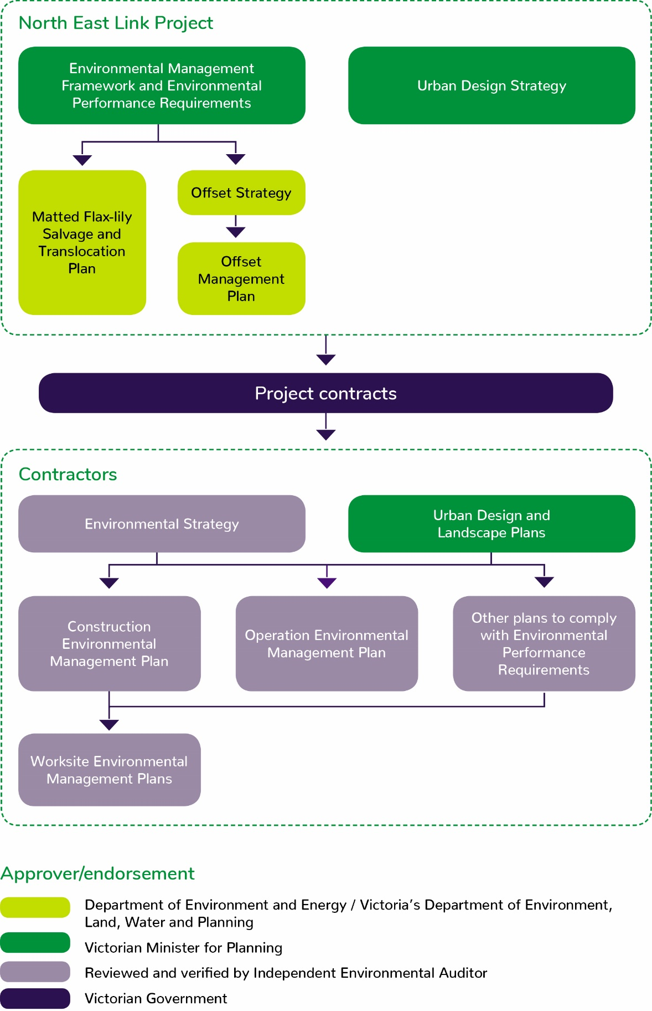
Figure 10-2 Approval/endorsement of environmental documents
Key documents that set the strategic direction and overarching requirements for delivery of North East Link would require approval by the Victorian Minister for Planning prior to construction works commencing. These include the EMF, EPRs and Urban Design Strategy.
In addition, the Minister for Planning would also approve the contractors’ Urban Design and Landscape Plans. The Urban Design and Landscape Plans would show the proposed final design of permanent works for North East Link. The Urban Design and Landscape Plans are required to be in general accordance with the Urban Design Strategy and comply with the EPRs.
Environmental documentation specifically relevant to MNES and Commonwealth land would be submitted to the DoEE for review and approval. These documents include:
- Matted Flax-lily Salvage and Translocation Plan
- Offset Strategy and Offset Management Plan for native vegetation removal on Commonwealth land
- The Studley Park Gum Management Framework and Studley Park Gum Groundwater Dependent Ecosystem Monitoring and Mitigation Strategy.
These plans would also be prepared to the satisfaction of DELWP.
NELP would appoint an independent environmental auditor to review and verify environmental documentation prepared by contractors and to carry out regular audits of compliance with the EMF and EPRs. Contractors would prepare:
- An Environmental Strategy outlining how they would comply with the EMF and EPRs
- A CEMP detailing specific requirements for construction activities
- Worksite Environmental Management Plans containing requirements and maps with environmental controls for specific locations
- An Operation Environmental Management Plan (PPP contractor only) detailing specific requirements for operation and maintenance of North East Link
- Other technical plans required by the EPRs.
All environmental documentation prepared by contractors would be reviewed by the independent environmental auditor and verified as compliant with the EMF and EPRs prior to relevant works commencing.
Environmental documentation would be developed in consultation with and in some cases, to the requirements of other relevant Victorian government agencies and stakeholders, as specified in the EMF and EPRs. Key agencies would include DELWP, EPA Victoria, local councils, land managers and drainage authorities. The Department of Defence would be consulted about the Urban Design and Landscape Plans and CEMP for works at or adjacent to Simpson Barracks.

Maps
No-go zones have been established to protect sensitive sites where surface works are not permitted. These include the Grey-headed Flying-fox camp within Yarra Bend Park, Bolin Bolin Billabong, the Plains Grassy Woodland community between Enterprise Drive and the M80 Ring Road in Bundoora and conditional no go zones in the Banyule Flats and Warringal Parklands including the Heide Museum of Modern Art where surface works would not be permitted as part of the project with the possible exception of activities relating to site investigations, relocation of minor utilities and ground improvement. Figure 10-3 shows these no-go zones.
Worksite Environmental Management Plans (EMPs) would be prepared for each construction site showing the physical location of specific measures to avoid and mitigate impacts on the environment. Worksite EMPs would be based on the detailed design and each contractor’s specific construction methods. Each Worksite EMP would be reviewed by the independent environmental auditor and be certified as complying with the EMF and EPRs prior to works at that site commencing.
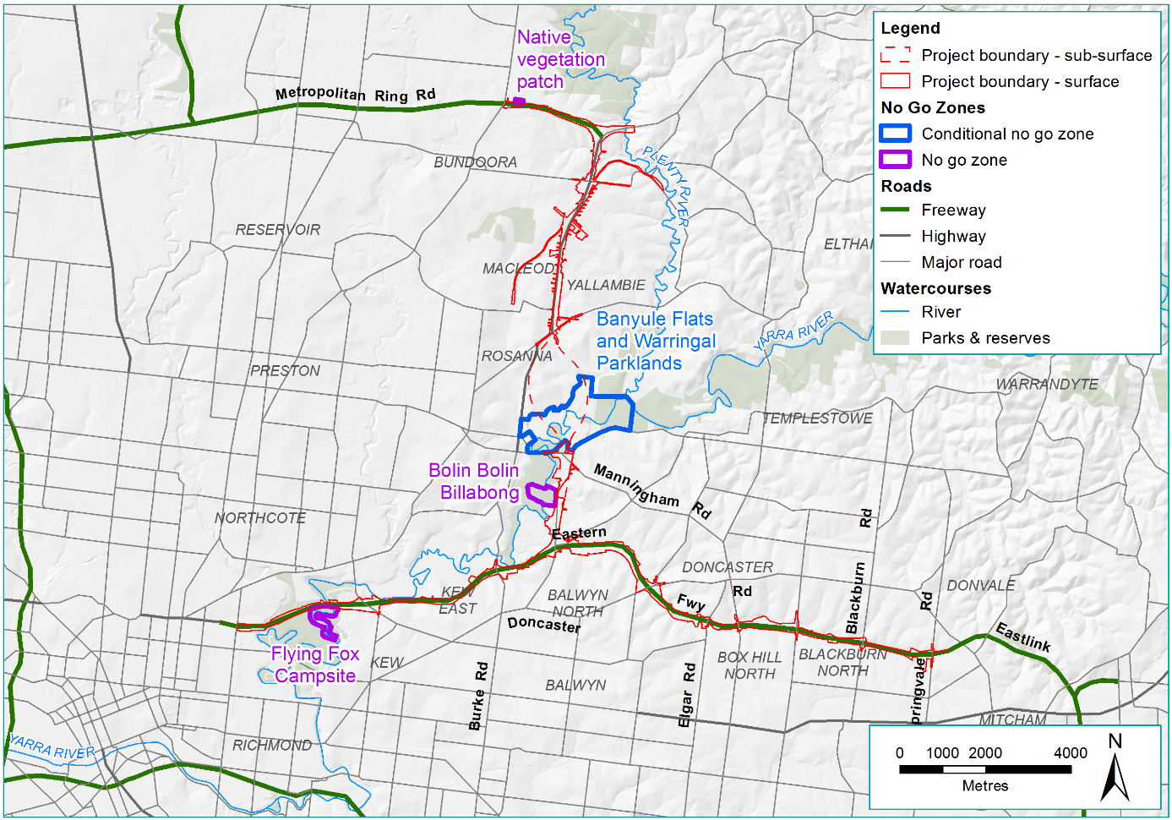
Figure 10-3 No-go zones

