16 July 2021 WES2107.04

M80 ramp weekend closures
From 9pm Friday 30 July until 5am Monday 2 August, and 9pm Friday 13 August until 5am Monday 16 August, the West Gate Tunnel Project team will be closing the M80 outbound ramp from the West Gate Freeway (heading west towards Geelong). This is so we can safely carry out bridge works, including demolition and beam installation.
To help keep traffic moving through the area, access to Plummer Road at Boundary Road will be closed, as well as the right turn access into Spencer Street. Access to businesses on Plummer Road will remain available via Somerleigh Road and/or Leslie Road.
Please follow all traffic controllers on site and detour signage.
 | Impact | Date (subject to change)
 | No access to M80 from West Gate Freeway (heading west).  A detour will be in place via Grieve Parade / Geelong Road / Little Boundary Road / Boundary Road.  A second detour will be in place via the Kororoit Creek Road exit / Princes Freeway (heading east).  Check out the map on the next page. | - 9pm Friday 30 July until 5am Monday 2 August  - 9pm Friday 13 August until 5am Monday 16 August
 | Traffic changes on Boundary Road near M80 overpass.  - No right turn access into Spencer Street from Boundary Road heading west.  - Closure of Plummer Road at intersection with Boundary Road.  Access to Plummer Road businesses is via Somerleigh Road and/or Leslie Road.  Check out the map on the next page. | - 9pm Friday 30 July until 5am Monday 2 August  - 9pm Friday 13 August until 5am Monday 16 August
To minimise disruption to road users we are doing these works over the weekend when traffic volumes are usually lower. Works are required to take place over several days to allow enough time to set-up a temporary work zone, complete the activity and re-open the M80 outbound ramp in time for Monday peak hour traffic.
To learn more about the impacts above, please don’t hesitate to give the team a call on 1800 105 105 or email us on info@wgta.vic.gov.au.

Detour routes to M80 from West Gate Freeway (heading west)

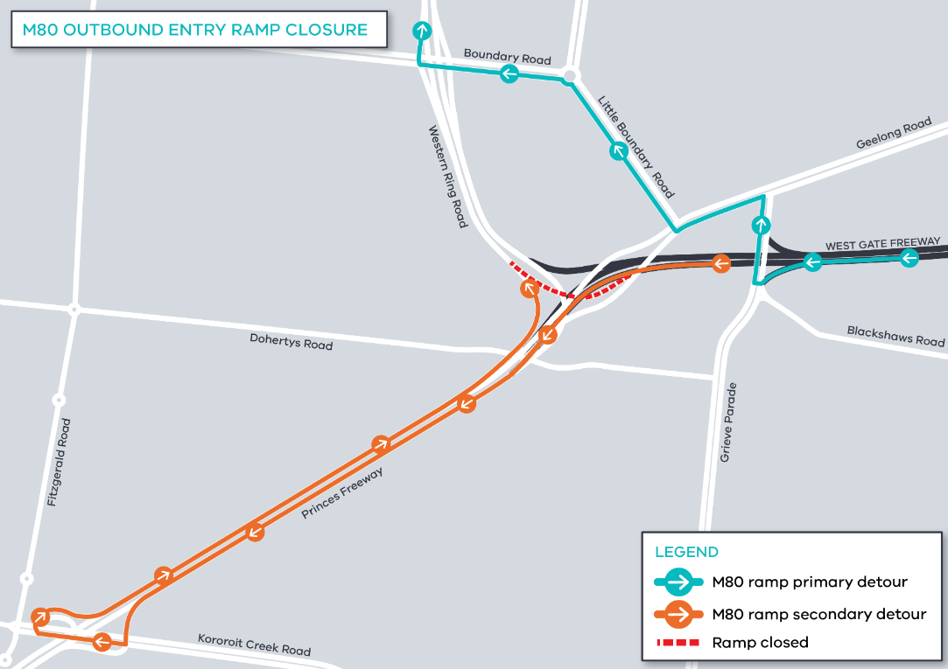

Access to Plummer Road and Spencer Street businesses

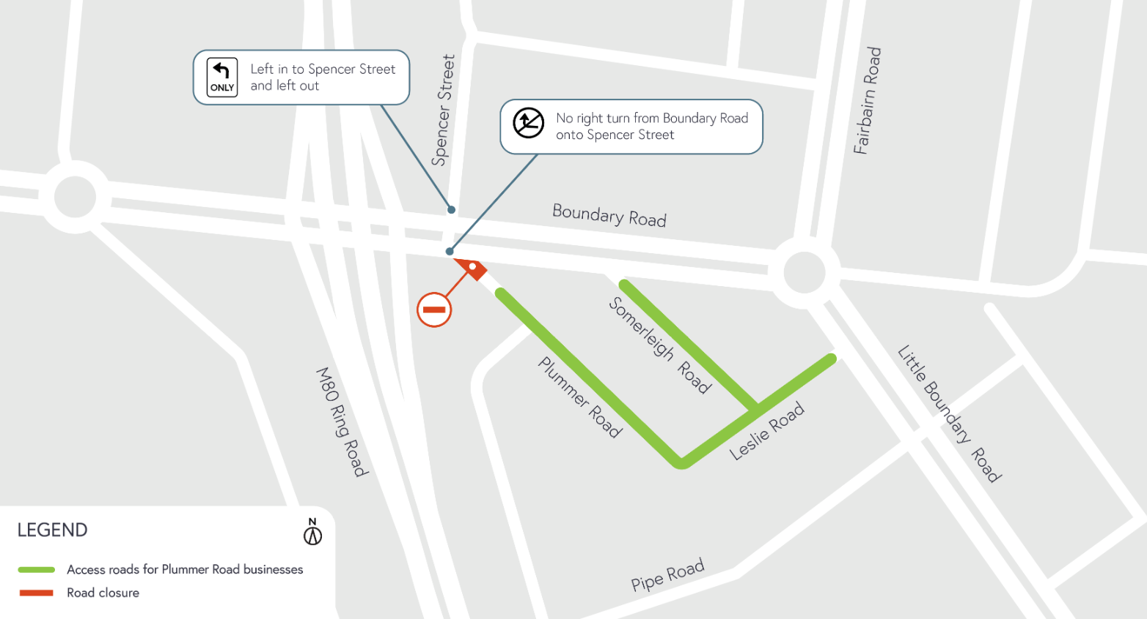

What you can expect during the works:
- Work will be completed behind safety barriers with construction vehicles moving in and out of work areas
- Access to businesses will be maintained – please follow signage and direction of traffic controllers on site
- Traffic impacts and detours. The latest traffic updates are always available at bigbuild.vic.gov.au/disruptions
Subscribe for traffic updates
As mentioned above, we will need to close the M80 outbound ramp off the West Gate Freeway over two weekends. If you would like to sign up to receive weekly traffic alert emails please email us on info@wgta.vic.gov.au or call 1800 105 105.
Alternatively, for latest updates, dates of closures and detour route information visit: bigbuild.vic.gov.au/disruptions.

Hours of work
These works will be done 24 hours a day over the weekend, from 9pm Friday 30 July to 5am Monday 2 August, and 9pm Friday 13 August to 5am Monday 16 August.
If the weather is poor, we will need to reschedule the works. Please follow us on Facebook or sign up to traffic updates for the latest information.
Thank you
We appreciate our work can be disruptive and thank you for your understanding.
For updates or any concerns about these works, please visit westgatetunnelproject.vic.gov.au or call 1800 105 105.

