27 July 2021 WES2107.05

The Avenue and Fogarty Avenue – construction activities and road closures

From 10 August 2021 we will be working on The Avenue under the West Gate Freeway and Fogarty Avenue, which will require ongoing road closures. This is so we can continue widening the freeway above The Avenue, and work on cycling and walking connections along Fogarty Avenue.

To reopen this critical link underneath the freeway as quickly as possible, at times we will need to work 24 hours a day.
Information about traffic disruptions will be updated on social media and the Big Build website and sent out via our weekly traffic email alert.
What you need to know
 | Impact | Dates (subject to change)
 | Traffic changes:  - Closure of the connection between The Avenue and Fogarty Avenue underneath the West Gate Freeway.  Access to Footscray Hockey Club and Yarraville Glory Soccer Club is maintained via Fogarty Avenue. | - First closure: 10 August until late-August 2021.  - Estimated second closure: Early September until mid-September.  - Estimated third closure: Mid-October to mid-November.  - Estimated fourth closure:  For one week in mid-December.
 | Traffic changes:  - Through access maintained between The Avenue and Fogarty Avenue under traffic management. | All other times when road closures are not in place, continuing into early 2022.
 | Traffic changes  - Closures on Fogarty Avenue between Wembley Avenue and Footscray Hockey Club. | Once dates are known, the Project team will have further details about these works and be out in the community in the coming months.
 | Bus route 432 detoured between Stephenson Street and Fogarty Avenue.  Please check PTV’s website for further details. Information will also be available at impacted bus stops. | From first bus on Tuesday 10 August 2021.  Please scan this QR code for further details.
 | Construction noise during the day and at night.  This will include using high pressure water to demolish concrete at night until 11pm. The project team will be in touch directly with impacted households. | Throughout works.  High pressure water works from 10 August until late August, until 11pm each night.
 | Increase in truck movements. | 10 August until early 2022.
 | Occasional night-time lighting. | Throughout works.

If you would like to sign up to receive weekly traffic alert emails, or learn more about the impacts above, please give the team a call on 1800 105 105 or email info@wgta.vic.gov.au.
All proposed work dates are subject to change, so please follow traffic management instructions and detour signage, and visit bigbuild.vic.gov.au/disruptions for the latest updates.
Location of works and traffic impacts
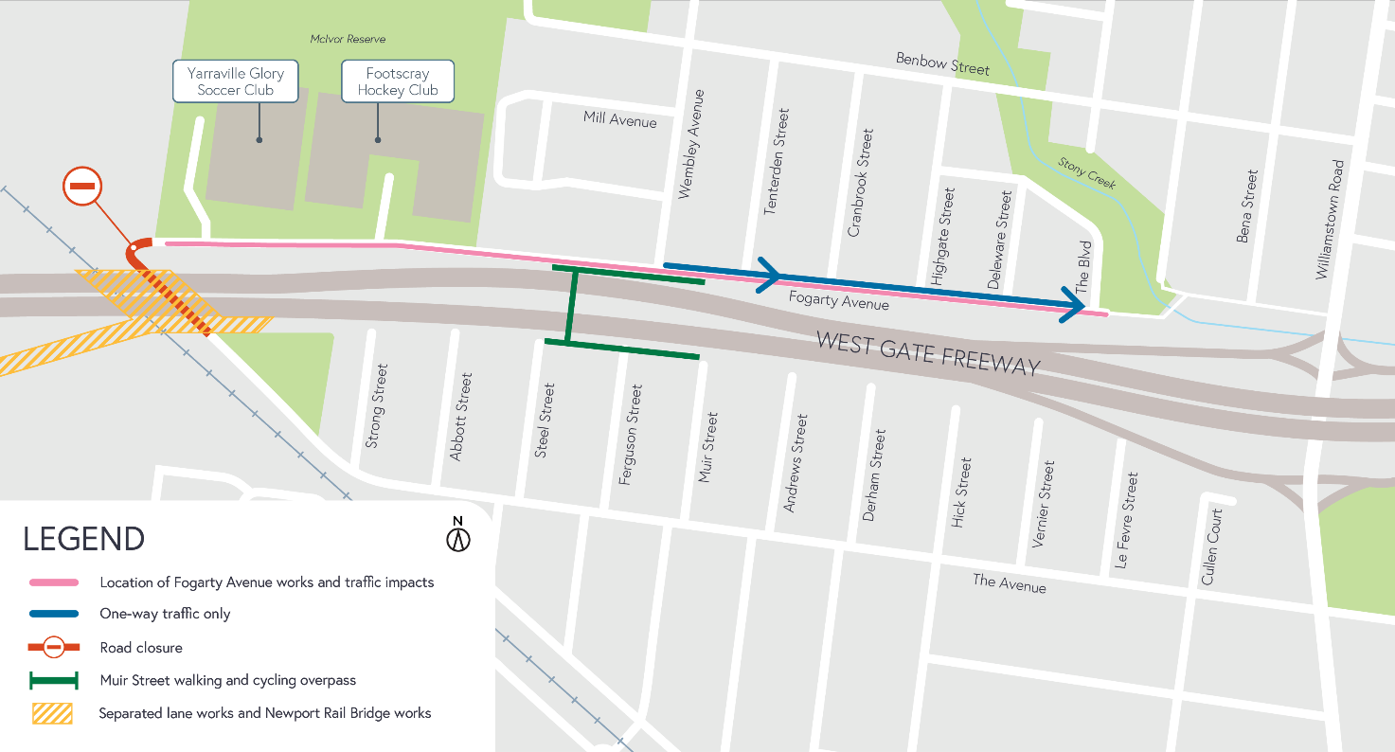

More information about these works
West Gate Freeway widening works
We will be closing The Avenue underneath the West Gate Freeway to carry out important freeway widening works. Works include demolishing the outer edge of one of the bridges using high pressure water, installing barriers and beams on the new bridges, and installing noise wall posts and acrylic panels on the new bridges that sit above The Avenue.
Upcoming works on Fogarty Avenue
Further works to finish the walking and cycling connections, continue installing freeway wide communications systems and installing drainage is required. The project team will have further details about these works and will be out in the community in the coming months.
The one way set up in that is currently in place on Fogarty Avenue east of Wembley Avenue will remain.

What else to expect during these works:
- Work being completed behind safety barriers.
- Construction vehicles moving to and from work areas via approved routes, including Highgate Street, Benbow Street, Severn Street, The Avenue and Fogarty Avenue.
- Workers will be reminded not to park on local streets where appropriate.
- Water spray trucks and road sweepers managing dust and dirt during works. Trucks removing dirt and rocks from the site will be covered.
Thank you
We know ongoing works can be frustrating and cause disruption.
We apologise for any inconveniences experienced and are grateful to community members in and around Fogarty Avenue for your continued patience and cooperation.
As always, for updates or questions about these works, please visit westgatetunnelproject.vic.gov.au or call 1800 105 105 to get in touch with the project team.

