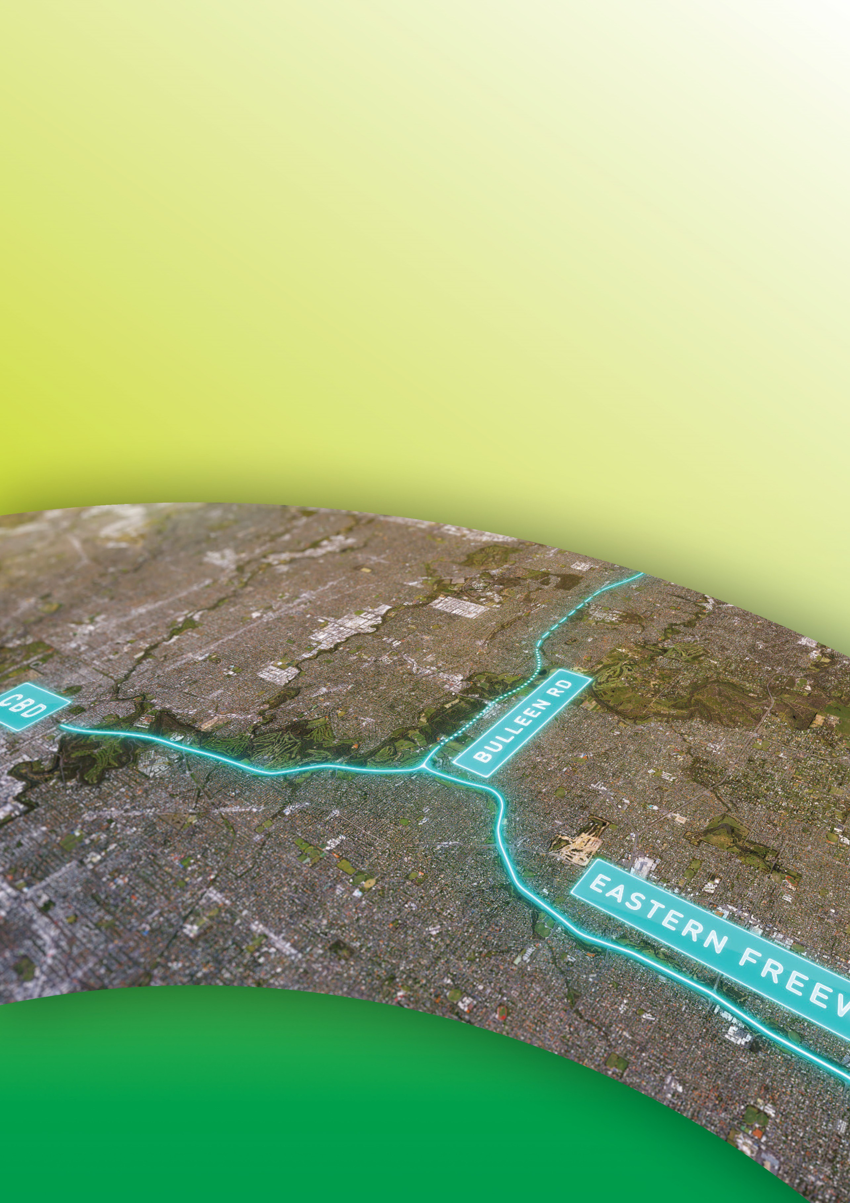
Public Environment Report

Attachment VII Reference list
September 2019

Attachment VII Reference list

Australian Bureau of Statistics. (2015). 5204.0 Australian System of National Accounts. Australia.

Australian Ecosystems. (2007). Ecological assessment of wetlands at the Trinity Grammar School sporting complex. Bulleen: Report prepared for Manningham City Council.

Backhouse, G., Jackson , J., & O'Connor, J. (2008). National Recovery Plan for the Australian Grayling Prototroctes maraena. Melbourne.

Beck, R. (1985). Field observations upon the dwarf galaxiid Galaxiella pusilla (Mack) (Pisces:Galaxiidae) in the South-east of South Australia, Australia. South Australian Naturalist, 60(1), 12–22.

Berra, T. M. (1982). Life history of the Australian grayling, Prototroctes mareana (Salmoniformes: Prototroctidae) in the Tambo River, Victoria. Copeia, 795–805.

Bishop, K., & Bell, J. (1978). Aspects of the biology of the Australian grayling Prototroctes mareana Gunther (Pisces: Prototroctidae),. Australian Journal of Marine and Freshwater Research, 29, 743–761.

Brannelly, L A; Webb, R J; Hunter, D A; Clemann, N; Howard, K; Skerratt, L F; Berger, L; Scheele, B C. (2018). Non-declining amphibians can be important reservoir hosts for amphibian chytrid fungus.

Bray, D. (2016). Eastern Dwarf Galaxias, Galaxias pusilla (Mack 1936). Retrieved October 19, 2016, from http://fishesofaustralia.net.au/home/species/3393

Bray, D., & Thompson, V. (2018a). Macquarie Perch, Macquaria australasica. Retrieved from http://fishesofaustralia.net.au/home/species/1594

Bray, D., & Thompson, V. (2018b). Murray Cod, Maccullochella peelii.
http://fishesofaustralia.net.au/home/species/4655.

Cadwallader, P. L., & Backhouse, G. N. (1983). A Guide to Freshwater Fish of Victoria, Melbourne Vic, Australia. Victorian Government Printing Office, on behalf of the Fisheries and Wildlife Division, Ministry for Conservation.

Cadwallader, P. L., & Eden, A. K. (1979). Observations of the food of the Macquarie Perch Macquaria australasica (Pisces: Percichthyidae), in Victoria. Australian Journal of Marine and Freshwater Research, 30, 401-409.

Carter, O. (2010). National Recovery Plan for the Matted Flax-lily Dianella amoena. East Melbourne: Department of Sustainability and Environment.

Carter, O; Sutter, G. (2010). National Recovery Plan for the Clover Glycine. Melbourne: Victorian Government Department of Sustainability and Environment.

Coleman, R., Raadik , T., Pettigrove, V., & Hoffmann, A. (2016). Taking advantage of adaptations when managing threatened species within variable environments: the case of the dwarf galaxias, Galaxiella pusilla (Teleostei, Galaxiidae). Marine and Freshwater Research - Http://Dx.Doi.Org/10.1071/MF15332.

Commonwealth of Australia. (2013). Survey Guidelines for Australia’s Threatened Orchids: Guidelines for detecting orchids listed as ‘threatened’ under the Environment Protection and Biodiversity Conservation Act 1999. Canberra: Australian Government.

Commonwealth of Australia. (2016). Smart Cities Plan. Canberra: Commonwealth of Australia.

Dahlhaus, P., Brewin, D., Leonard, J., Dyson, P., & Cherry, D. (2004). Port Phillip and Westernport
Groundwater Flow Systems. Melbourne, Victoria : Port Phillip and Westernport Catchment
Management Authority.

DELWP. (2016a). Victoria in Future. Melbourne: State of Victoria Department of Environment, Land, Water and Planning.

DELWP. (2016b). Plan Melbourne 2017-2050. Melbourne: State Government of Victoria.

DELWP. (2017). Guidelines for the removal, destruction or lopping of native vegetation. Melbourne: Victorian Department of Environment, Land, Water and Planning.

DEWHA. (2010). Survey Guidelines for Australia's Threatened Frogs. EPBC Act survey guidelines 6.3.
Department of the Environment, Water, Heritage and the Arts.

DoE. (2014). National Flying-fox Monitoring Viewer. Commonwealth Department of the Environment. Retrieved from http://www.environment.gov.au/webgis-framework/apps/ffc-wide/ffc-wide.jsf

DoEE. (2017a). Frequently asked questions - key threatening processes Australian Government Department of the Environment and Energy. Canberra. Retrieved from http://www.environment.gov.au/system/files/pages/10a10e3d-e677-4c5a-ba9a- 00bfd70d8db2/files/faq-ktp-

DoEE. (2017b). EPBC Act Listed Key Threatening Processes, Australian Government Department of the Environment and Energy. Canberra. Retrieved from http://www.environment.gov.au/cgi- bin/sprat/public/publicgetkeythreats.pl

DoEE. (2017c). Draft National Recovery Plan for Macquarie Perch (Macquaria australasica), Commonwealth of Australia 2017.

DoEE. (2017d). Draft National Recovery Plan for the Grey-headed Flying-fox (Pteropus poliocephalus), Commonwealth of Australia 2017. Available from: http://www.environment.gov.au/system/files/resources/78d5e396-7475-4fc0-8a64- 48c86a1cb2b6/files/draft-reco.

DoEE. (2018). Guidelines For The Content of a Draft Public Environment Report North East Link Project, Melbourne, Victoria (EPBC 2018/8142). Canberra: Department of Environment and Energy.

DoEE. (2018a). Nannoperca obscura — Yarra Pygmy Perch. Department of the Environment, Australian Government. Retrieved July 2, 2018, from http://www.environment.gov.au/cgibin/sprat/public/publicspecies.pl?taxon_id=26177

DoEE. (2018b). Species Profile and Threats Database Macquaria australasica - Macquarie Perch.
Department of the Environment, Australian Government. Retrieved July 1 , 2018, from http://www.environment.gov.au/cgi-bin/sprat/public/publicspecies.pl?taxon_id=66632

DSE. (2005). Clover Glycine Latrobeana; a Nationally Threatened species of the Grassland and Grassy Woodland Communities. Victoria: Department of Sustainability and Environment.

DSE. (2005a). Melbourne: Flying-Fox Campsite Management Plan - Yarra Bend Park. Department of Sustainability and Environment, Victoria. Retrieved from
https://www.wildlife.vic.gov.au/ data/assets/pdf_file/0031/27679/Flying_Fox_Management_ Plan.pdf

DSE. (2009). Yarra Bend Park Flying-fox Campsite: Review of Scientific Research,. Victorian Department of Sustainability and Environment.

DSEWPAC. (2011). Survey guidelines for Australia’s threatened fish - Guidelines for detecting fish listed as threatened under the Environment Protection and Biodiversity Conservation Act 1999. Commonwealth of Australia.

DSEWPAC. (2011a). Nationally threatened ecological communities of the Victorian Volcanic Plain: Natural Temperate Grassland and Grassy Eucalypt Woodland. Retrieved from http://www.environment.gov.au/system/files/resources/e97c2d51-08f2-45e0-9d2f- f0d277c836fa/

DSEWPAC. (2012). Environment Protection and Biodiversity Conservation Act 1999 Environmental Offsets Policy. Canberra : Department of Sustainability, Environment, Water, Population and Communities.

DSEWPAC. (2013). Actions on, or impacting upon, Commonwealth Land, and actions by Commonwealth agencies. Significant impact guidelines 1.2. Canberra: Department of Sustainability, Environment, Water, Population and Communities.

Eamus. (2009). Identifying groundwater dependent ecosystems: a guide for land and water managers. ACT: Australian Government, Land and Water Australia.

Ecology Australia. (2014). Sugarloaf Pipeline Matted Flax-lily (Dianella amoena) Translocation Monitoring: Spring 2014 . Report prepared for Melbourne Water Corporation by Ecology Australia Pty Ltd, Fairfield.

EPA Victoria. (2003). Guideline for Environmental Management: Rapid bioassessment methodology for rivers and streams. Melbourne: EPA Victoria (EPA publication 604).

EPA Victoria. (2018). Water Quality Data. Melbourne. Retrieved from Water Quality Data. Melbourne, Victoria.

EPA Victoria. (2018a). State Environment Protection Policy (Waters).

Geosciences Australia. (2018). Groundwater Dependent Ecosystems. Australian Government Geosciences Australia. Retrieved from http://www.ga.gov.au/scientific- topics/water/groundwater/understanding-groundwater-resources/groundwater-dependant- ecosystems

GHD. (2010). Transient Model Development Report, Port Philip Catchment Management Authority.
Department of Sustainability and Environment, ecoMarkets Project.

Gomon, M., & Bray, D. (2011). Australian Grayling, Prototroctes maraena.
http://www.fishesofaustralia.net.au/home/species/3634.

HLA. (2007). Biodiversity Assessments and Strategies for Simpson Barracks (Section 7 of Biodiversity Assessments and Strategies for Dutson Range, HMAS CERBERUS, West Head Gunnery, Monegeetta Proving Ground, RAAF Base East Sale, Simpson Barracks and Swan Island Report. Department of Defence.

Humphries, P. (2005). Spawning time and early life history of Murray cod, Maccullochella peelii peelii (Mitchell) in an Australian river. Environmental Biology of Fishes , 72, 393–407 . Retrieved from https://doi.org/10.1007/s10641-004-2596-z

Infrastructure Australia. (2016). Australian Infrastructure Plan. Canberra: Australian Government.

Infrastructure Australia. (2018, May 22). Infrastructure Priority List: Australian Infrastructure Plan,
Project and Initiative Summaries, March 2018. Melbourne, Victoria, Australia. Accessed
online: <http://infrastructureaustralia.gov.au/policy- publications/publications/files/Australian_Infrastructure_Plan_refresh-2018.pdf>.

Infrastructure Victoria. (December 2016). Infrastructure Victoria 30-year Infrastructure Strategy.
Melbourne: State of Victoria.

Ingram, B., Barlow, C., Burchmore, J., Gooley, G., Rowland, S., & Sanger, A. (1990). Threatened native freshwater fishes in Australia - some case histories. Journal of Fish Biology, 37(Supplement A) , 175–182.

Jackson, P., & Keohn, J. (1988). A review of biological information, distribution and status of the Australian grayling (Prototroctes maraena). Melbourne: Gunther in Victoria.

Jacobs. (2016). Simpson Barracks Flora and Fauna Monitoring Program 2016 – 2021. Jacobs. (2017). Bolin Bolin Billabong Conceptual Model. Produced for Melbourne Water.
Koehn, J., & Nicol, S. (2014). Comparative habitat use by large riverine fishes. Marine and Freshwater Research, 65, 194-174.

Koehn, J., McKenzie, J., O'Mahony, D., Nicol, S., O'Connor, J., & O'Connor, W. (2009). Movements of Murray cod (Maccullochella peelii peelii) in a large Australian lowland river. Ecology of Freshwater Fish, 18, 594-602. Retrieved from https://doi.org/10.1111

Koster, W. M., Dawson, J. R., Morrongiello, J. R., & Crook, D. A. (2013). Spawning season movements of Macquarie perch (Macquaria australasica) in the Yarra River, Victoria. Australian Journal of Ecology, 61, 386–394.

Koster, W., Amtstaetter, F., Dawson, D., Reich , P., & Morrongiello, J. (2017). Provision of environmental flows promotes spawning of a nationally threatened diadromous fish. Marine and Freshwater Research, 68, 159-166. Retrieved from https://doi.org/10.1071/MF153

Leonard, J. (1992). Port Phillip Region Groundwater Systems Future Use and Management.
Department of Water Resources, Water Victoria, ISBN 0 7306 2698.

Lieschke, J., Grgat, L., & Zampetti, B. (2000). An Assessment of Environmental Flow Requirements for the Plenty River Catchment. Natural Resources and Environment, Freshwater Ecology, Flora and Fauna.

Marchant, S., & Higgins, P. J. (1993). Handbook of Australian, New Zealand and Antarctic Birds Volume 2 – Raptors to Lapwings. Oxford University Press, Melbourne.

McDowell, R. (1996). Freshwater Fishes of South-Eastern Australia . Sydney : Reed Books.

Melbourne Water. (2012). Healthy Waterways Strategy Executive summary (October).

Melbourne Water. (2015). Annual Water Quality Factsheet. Retrieved from https://www.melbournewater.com.au/waterdata/riverhealthdata/waterwayquality/Pages/Wat erway-water-quality-data.aspx

Murray, K., Berger, L., Hunter, D., Hines, H., Mahony, M., Skerratt, L., & Maratelli, G. (2011). Hygiene protocols for the control of diseases in Australian frogs. A report for the Australian Government Department of Sustainability, Environment, Water, Population and Communities

National Murray Cod Recovery Team . (2010). National Recovery Plan for the Murray Cod Maccullochella peelii peelii. Melbourne : Department of Sustainability and Environment.

NELA. (2017). North East Link Community Survey Report May - July 2017. Retrieved from Melbourne: State of Victoria : http://northeastlink.vic.gov.au/news/may-to-july-2017-community-survey- report-released>

NELA. (2018). Request to accept a variation of a proposal (EPBC 2018/8142) pursuant to section 156A of the EPBC Act. Letter to Department of the Environment and Energy. North East Link Authority 30 May 2018.

NELA. (2018a). North East Link Business Case. Melbourne: State Government of Victoria. Available at:
<http://northeastlink.vic.gov.au/project/businesscase>.

NELP. (2018). North East Link Community Engagement Report - April to May 2018, February - March 2018, August to October 2017, May to July 2017. Available at: http://northeastlink.vic.gov.au.

Practical Ecology. (2007). Ecological assessment of wetlands at the Trinity Grammar School sporting complex, Bulleen. Report prepared by Australian Ecosystems for Manningham City Council, August 2007. Melbourne.

Richardson, S., Ervine, E., Froend, R., Boon, P., Barber, S., & Bonneville, B. (2011). Australian Groundwater-dependent Ecosystem Toolbox Part 1: Assessment Framework, Waterlines Report. Canberra: National Water Commission. Retrieved from http://nwc.gov.au/ data/assets/pdf

Ryan, T., O'Connor, J., Lyon, J., Lennie, R., & Lieschke, J. (2003). Fish Fauna and Aquatic Habitat in the Yarra River and Potential Impact of the Henley Golf Course Development.

Saddlier, S., Jackson, J., & Hammer, M. (2010). National Recovery Plan for the Dwarf Galaxias Galaxiella pusilla. Melbourne .

Saunders, & Tzaros. (2011). National Recovery Plan for the Swift Parrot (Lathamus discolor).
Available from: http://www.environment.gov.au/biodiversity/threatened/recovery- plans/national-recovery-plan-swift-parrot-la: Birds Australia, Melbourne.

Sinclair Knight Merz. (2005). Determination of the minimum environmental water requirement for the Yarra River: flow and non-flow related environmental and social issues associated with the Yarra River.

Sinclair Knight Merz. (2012). Yarra River Environmental Flow Study Review - Flow Recommendations Report. Melbourne.

Threatened Species Scientific Committee (TSSC). (2012). Approved Conservation Advice for the Seasonal Herbaceous Wetlands (Freshwater) of the Temperate Lowland Plains. Canberra: Department of Sustainability, Environment, Water, Population and Communities.

Transport and Infrastructure Council. (2017). Key Freight Routes: Road Expenditure and Investment Plans 2016-17 to 2019-20.

Walsh, C., & Webb, J. (2016). Interactive effects of urban stormwater drainage, land clearance and flow regime on stream macroinvertebrate assemblages across a large metropolitan region. Freshwater Science, 324-339.

Walsh, C., Bond, N., & Fletcher, T. (2013). Possible ecological futures for Merri and Darebin creeks, (September).

Waterwatch. (2018). Waterwatch Data Portal. Retrieved May 24, 2018, from www.vic.waterwatch.org.nz

