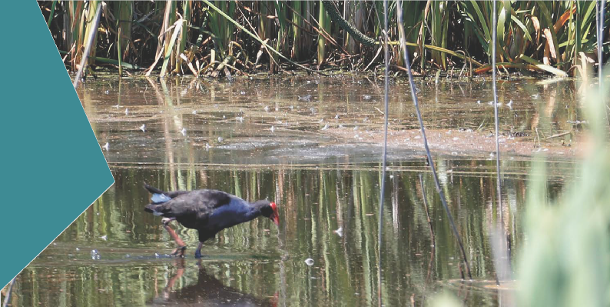

- EDITHVALE-SEAFORD WETLANDS AND GROUNDWATER DEPENDENT ECOSYSTEMS

SECTION PAGE SECTION PAGE

  - Groundwater dependent ecosystems 6.3
  - Groundwater dependent ecosystems
and the level crossings 6.4
  - Methodology 6.8
  - Edithvale-Seaford Wetlands 6.9
    - Existing conditions 6.9
    - Impact assessment 6.11
  - Wannarkladdin Wetlands 6.15
    - Existing conditions 6.15
    - Impact assessment 6.18

6.6 Aspendale to Carrum
Foreshore Reserve 6.19
    - Existing conditions 6.19
    - Impact assessment 6.22
  - Other GDEs within the study area 6.32
    - Existing conditions 6.32
    - Impact assessment 6.33
  - Conclusion 6.35

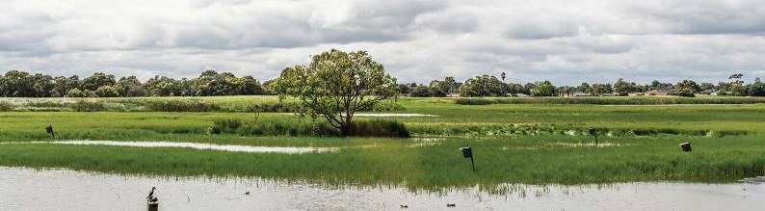

This chapter identifies groundwater dependent ecosystems (GDEs) in close proximity to the Edithvale and Bonbeach level crossing removal projects and assesses the potential effects on them as a result of the predicted changes to groundwater discussed in Chapter 5 Modelling the water environment.
The Scoping Requirements for the EES include the following relevant evaluation objective:
- Biodiversity – to avoid, minimise and/or offset adverse effects on native vegetation, listed threatened species and ecological communities, listed migratory species, the Ramsar listed Edithvale-Seaford Wetlands, other protected flora and fauna and groundwater dependent ecosystems.
To assess the potential effects of the Edithvale and Bonbeach level crossing removal projects on GDEs,
a regional numerical groundwater model and local wetland hydrological model for the Edithvale component of the Edithvale-Seaford Wetlands were developed. The outputs of the models, presented in Chapter 5 Modelling the water environment, form the basis for the groundwater related assessments in this chapter.
Section 4.2 of the Scoping Requirements requires a description of the ecological character of the wetlands and the threatened species that use them. An ecological impact assessment detailing the ecological values of wetlands and other GDEs has been prepared in response to the Scoping Requirements and is provided in Technical Report B Ecology: Wetlands and Groundwater Dependent Ecosystems. The discussion regarding
the Edithvale-Seaford Wetlands is presented in Attachment III Matters of National Environmental Significance.
The study area for this assessment was defined on the basis of the potential extent of groundwater mounding/ drawdown that was identified by the preliminary groundwater modelling. The GDE study area extends from the coast to approximately 2.5 kilometres inland from the Edithvale and Bonbeach project areas.
Ecological impacts within the project areas are the subject of a separate report (Technical Report D Ecology: Project Areas) which is summarised in Section 8.11 of Chapter 8 Potential local impacts at Edithvale and Bonbeach.
The key findings presented within this chapter are summarised in Table 6.1.

Table 6.1 Summary of key findings

Topic | Key finding
Edithvale Wetland | Given the distances between the Edithvale Wetland and the project sites (1.3 kilometres from the existing Edithvale Road level crossing and two kilometres from Bonbeach), the works would not directly impact the Wetland through, for example, loss of vegetation  or disturbance to bird species. Furthermore, the groundwater modelling predicts that the effect of the trenches on regional groundwater would return to background levels more than one kilometre from the Edithvale Wetland, such that the hydrological regime and ecological character of the Wetland would not be affected. The Edithvale-Seaford Wetlands would therefore continue to meet the applicable Ramsar listing criteria.
Groundwater dependent ecosystems | Terrestrial GDE’s exist in a naturally variable environment in which water is accessed via the surface or groundwater. Both sources naturally fluctuate based on long-term climatic conditions and the prevailing weather and as such terrestrial GDE’s must  be adaptable and resilient to these variable conditions. Given the small change in groundwater predicted through the model it is likely changes to vegetation will be minor or negligible.

  - Edithvale and Bonbeach Environment Effects Statement | Edithvale-Seaford Wetlands and groundwater dependent ecosystems

Groundwater dependent ecosystems

GDEs are defined by the Ministerial guidelines for groundwater licensing and protection as: ‘those ecosystems that require access to groundwater to meet all or some of their water requirements so as to maintain the communities of plants and animals and ecological processes they support, and ecosystem services they provide’.
Changes to groundwater have the potential to affect ecosystems that are dependent on it.
GDEs include ecosystems that:
    - rely on the surface expression of groundwater such as wetlands and rivers in which groundwater provides at least seasonal waterlogging or inundation
    - rely on the availability of water beneath the surface (subsurface).
The degree of the dependence on groundwater of a GDE can vary subject to the availability of alternative sources of water (for example rainfall). Groundwater dependence is also determined by factors including topography, water table depth, vegetation type, geology and groundwater quality, and this dependence can vary on a temporal scale.
The extent to which a GDE relies on groundwater determines the degree and nature of impact that changes in groundwater quality and quantity may have on the ecosystem.
It is also important to note that a GDE could persist without a permanent groundwater supply. For instance, in years of drought, access to groundwater may not be essential for the long-term survival of a tree, however tree health may decline. With a return to normal rainfall patterns, tree health would recover and the tree would persist.
Refer to Chapter 5 Modelling the water environment for further information on how the groundwater modelling has provided the basis for an assessment of the potential impacts on GDEs.
Figure 6.1 provides an overview of the ways that GDEs can interact with groundwater.

Figure 6.1 Groundwater dependent ecosystem
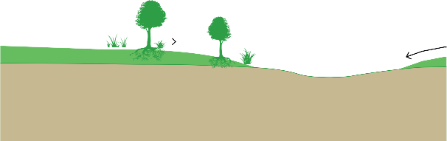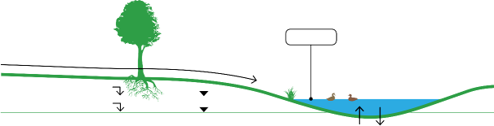

Upwards and downwards water flux
Not to scale – Illustrative purposes only
Wet period water table
Dry period water table
Wetlands
Surface water flow

  - Groundwater dependent ecosystems and the level crossings
A number of GDEs were identified within the study area. The most notable of these is the Edithvale-Seaford Wetlands Ramsar site.
Other areas of GDEs identified in the wider Edithvale and Bonbeach area (refer to Figure 6.2 Part A to Part C):
- Wannarkladdin Wetlands
- Area south of Edithvale Wetland (unnamed)
- Edithvale Common
- Rossdale Golf Course
- Chelsea Bicentennial Park
- Beazley Reserve
- Centre Main Drain
- Patterson River
- Patterson River Golf Course
- Aspendale to Carrum Foreshore Reserve
- Residential areas.
These GDEs were identified in the National Atlas of Groundwater Dependent Ecosystems (administered by the Bureau of Meteorology) and/or the Potential Groundwater Dependent Ecosystem Mapping for the Port Phillip and Westernport Catchment Management Authority (administered by DELWP).
An understanding of the existing ecological condition of ecosystems potentially affected by changes to groundwater was critical to inform an assessment of the potential ecological impacts of the level crossing removals. The existing ecological conditions assessment therefore incorporated:
- verification (by field assessment) of the location and type of GDEs identified in the databases and any other potential GDEs not identified during the desktop assessment
- assessment of the ecological value of identified GDEs (based on literature and fieldwork), and in particular whether they are likely to support threatened and/or migratory species listed under the EPBC Act and/or the FFG Act.
The Edithvale-Seaford Wetlands and the Wannarkladdin Wetlands meet the definition of high value GDEs in the Ministerial Guidelines for Groundwater Licensing and Protection and, for the reasons set out in Section 6.1, are described in Appendix III Matters of National Environmental Significance (Edithvale-Seaford Wetlands).
The Aspendale to Carrum Foreshore Reserve is a largely continuous linear strip of vegetation which is identified by the Kingston City Council as a key natural resource area (areas that contain remnant indigenous vegetation). This vegetation is discussed in Section 6.4 Aspendale to Carrum Foreshore Reserve.
The remaining GDEs identified within the study area are discussed in Section 6.7.

Figure 6.2 Part A: GDEs within the study area
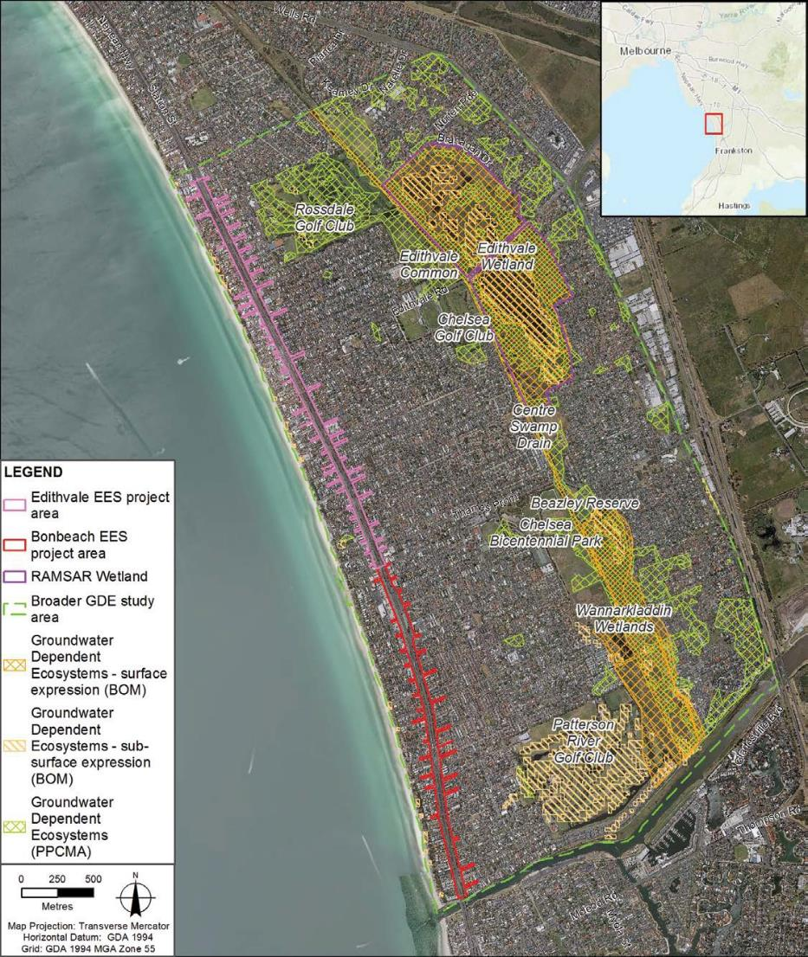

Figure 6.2 Part B: GDEs within the study area
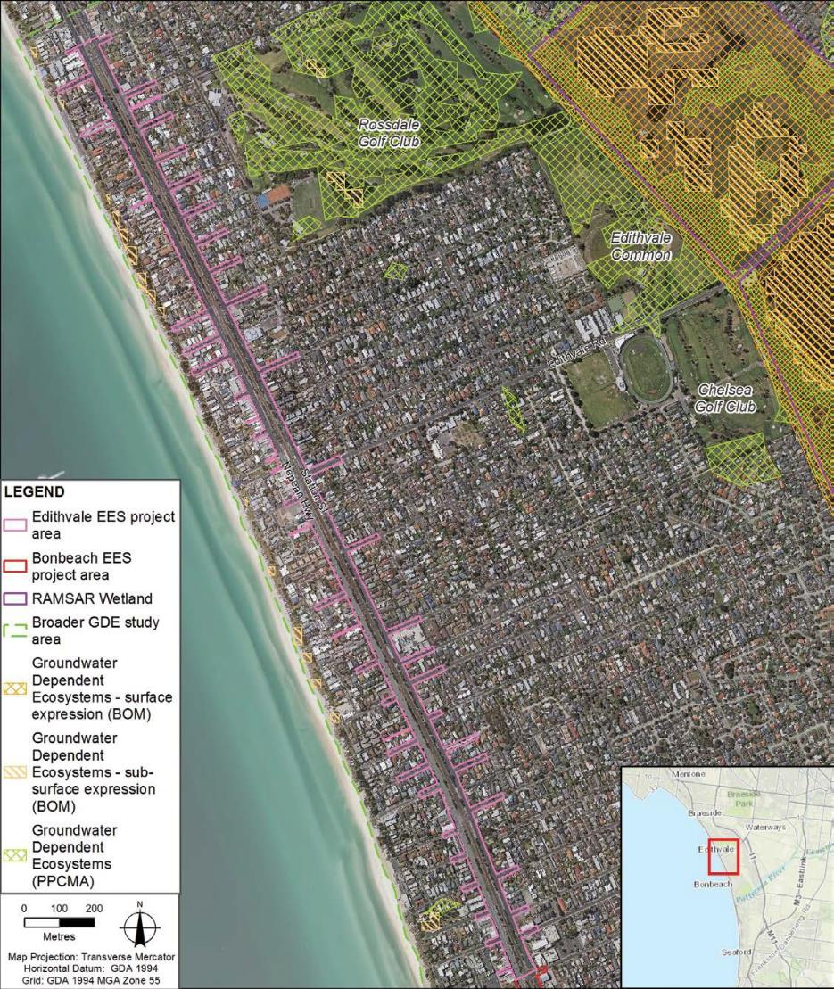

Figure 6.2 Part C: GDEs within the study area
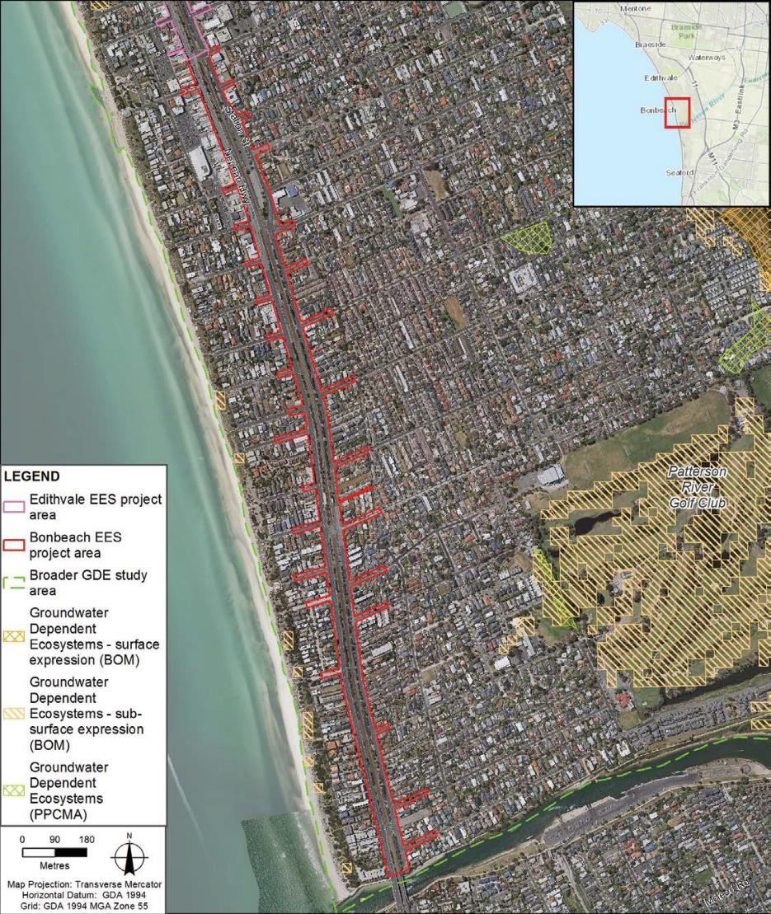

Methodology
The Edithvale-Seaford Wetlands were the priority for consideration in the impact assessment, given the significance of its Ramsar listing and its proximity to the project sites.
To understand the potential for ecologically significant GDEs to be impacted by project induced changes to groundwater, the following areas were considered as part of the ecological assessment:
- the hydrological regimes within identified GDEs and their dependency on, and relationship to, groundwater
- the nature and extent of regional groundwater impact
- the consequence of any change in the relationship between the GDEs and groundwater, and the subsequent impact this may have on the ecological values they support.
Edithvale Wetland and Seaford Wetland form two discrete wetland systems which are physically distinct
and are separated by the Patterson River (Technical Report A Groundwater), but are both incorporated within the same Ramsar site listing. As such, the Seaford Wetland would not be impacted by the Edithvale and Bonbeach level crossing removals, and the focus of this assessment is therefore on the Edithvale Wetland section of the Edithvale-Seaford Wetlands.
For other GDEs within the study area, the potential to support state and nationally significant ecological values was also considered as part of the impact assessment.
Ecological investigations that were undertaken concurrently with the groundwater and surface water modelling to inform the assessment of potential consequences of groundwater and/or surface water change on the ecological values of GDEs within the study area included:
- A review of key literature pertaining to GDEs in the study area, with particular reference to the Edithvale-Seaford Wetlands Ramsar site management plan and ecological character description (including the 2017 addendum) and a report on the natural values of the Kingston Foreshore Reserve.
- Aerial photographic interpretation to map the key habitat features that are likely to be preferred by significant wildlife at the Edithvale Wetland (mud flats, reed beds and open water).
- Bathymetric survey to establish a detailed depth profile of each of the cells of the wetland and allow a theoretical water volume of each cell to be determined. This was undertaken in July 2017 using a remote-controlled boat that uses sonar to measure water depth (as shown in Figure 6.3).
- Aquatic fauna survey to identify the diversity, abundance and distribution of invertebrates as a food source for priority wading birds and the presence and diversity of fish (including searches for the nationally significant Dwarf Galaxias).
- Analysis of BirdLife Australia data from bird surveys since 1987 to determine the types of species, their abundance and the period of occupancy of the key GDEs in the study area. Analysis focused on Edithvale Wetland and the key species of Sharp-tailed Sandpiper, Curlew Sandpiper, Australasian Bittern and Latham’s Snipe.
- Assessment of the likelihood of occurrence of threatened and/or migratory species within the study area. Habitat requirements were compared to existing conditions of the study area and a precautionary approach taken to their likelihood of occurrence.
- Vegetation assessments were undertaken at Edithvale Wetland in July 2017 to understand the current extent of vegetation and the condition of the vegetation. The vegetation assessment included mapping native vegetation and conducting vegetation quality assessments of native vegetation patches by applying the DELWP habitat hectare assessment method.
- Climate data (dating from 1950) was obtained from the Bureau of Meteorology (SILO data at station 86210 Bonbeach Carrum) to gain an understanding of whether seasonal variation in the abundance and diversity of key bird species at the Edithvale Wetland is influenced by rainfall and temperature.

Figure 6.3 The boat used to collect bathymetry data in the Wetlands
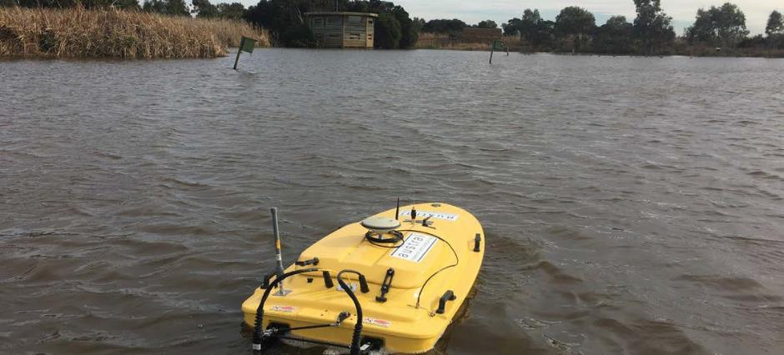

Edithvale-Seaford Wetlands
    - Existing conditions
The Edithvale-Seaford Wetlands are located approximately 30 kilometres south east of Melbourne.
The wetlands are regionally and internationally significant, providing habitat for a diversity of threatened and/or migratory birds.
The Edithvale-Seaford Wetlands are remnant of what was once the Carrum Carrum Swamp, a shallow freshwater swamp that was largely drained in the late nineteenth century to reclaim land for agriculture and housing. In 1974 the area was protected by the then Dandenong Valley Authority due to the potential for the wetlands’ capacity to process floodwaters in the area.
The Edithvale-Seaford Wetlands are used for conservation, recreation and education purposes and provide open space that is highly valued by the community. The Edithvale-Seaford Wetland Education Centre was established at Edithvale Wetland in recognition of its ecological value. The Education Centre is managed by Melbourne Water and is highly utilised, offering tailored education programs for students of all levels.
A bird hide was established at Edithvale for members of the public and researchers to observe wildlife within the Edithvale-Seaford Wetlands.
The Edithvale-Seaford Wetland was listed as a wetland of international importance under the Ramsar Convention in August 2001. For a wetland to be listed under the Ramsar Convention it must satisfy one or more of the criteria for identifying wetlands of international importance. The Ramsar criteria related to the Edithvale-Seaford Wetlands are outlined in Attachment III Matters of National Environmental Significance.
In addition to the Ramsar listing, the Edithvale-Seaford Wetlands are also recognised as:
- a wetland of national importance in the Directory of Important Wetlands in Australia
- a Matter of National Environmental Significance (MNES) under the Environmental Protection and Biodiversity Conservation Act 1999 (EPBC Act) by virtue of the Ramsar listing
- a site recognised to be internationally important for shorebird conservation in the East Asian Australasian Flyway (EAAF)
- part of the Carrum Wetland Key Biodiversity Area program led by BirdLife Australia.
- a site of State and International Treaty Zoological Significance in the south east of Melbourne and Mornington Peninsula (identified by DSE in 2004)
- identified as a high value site of biodiversity significance by Melbourne Water
- an area of environmental significance subject to an Environmental Significance Overlay under the Kingston Planning Scheme.

What are Ramsar wetlands?

A Ramsar wetland is a wetland that has been designated under Article 2 of the Ramsar Convention, or which has been declared
by the Federal Environment Minister to be a Ramsar wetland under the EPBC Act.
The Ramsar Convention encourages the designation of sites containing representative, rare or unique wetlands, or wetlands that are important for conserving biological diversity.

Once designated, these sites are added to the Convention's List of Wetlands of International Importance and become known as Ramsar sites.
In designating a wetland as a Ramsar site, countries agree to establish and oversee a management framework aimed at conserving the wetland and ensuring its wise use. Wise use under the Convention is broadly defined as maintaining the ecological character of a wetland.
For further information on Ramsar wetlands visit www.environment.gov.au.

Figure 6.4 Edithvale Wetland viewed from the bird hide
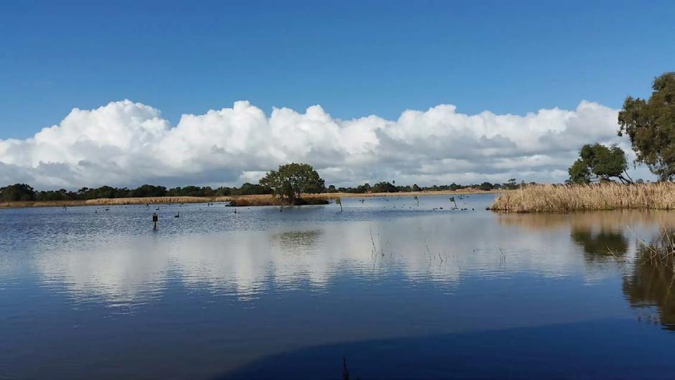

    - Impact assessment
The groundwater and surface water assessments undertaken for the EES have demonstrated that changes to the hydrological regime at the Edithvale-Seaford Wetlands are not predicted.
In particular, groundwater mounding is not modelled to occur closer than 1,000 metres away from the Edithvale Wetland section of the Ramsar site. As a result, there is negligible risk of an impact on the Edithvale-Seaford Wetlands from the projects. Chapter 5 Modelling the water environment provides detail on this finding.
In light of this, a separate attachment (Attachment III Matters of National Environmental Significance) is provided that discusses the wetlands and their importance as a Matter of National Environmental Significance and the impact and risk assessment that has been undertaken in relation to the wetlands.
Attachment III Matters of National Environmental Significance also responds to Section 4.2 of the Scoping Requirements, which requires an assessment of the ecological character of the Edithvale Wetland and any potential impacts of the projects.
For ease of reference, the findings of the risk assessment for the Edithvale-Seaford Wetlands are presented below:

Construction
No risks were identified during the construction phase of the Edithvale and Bonbeach level crossing removal projects in relation to the Edithvale Wetland and GDEs, given the significant distance between the level crossing sites and the wetlands. Refer to Technical Report B Ecology: Wetlands and Groundwater Dependent Ecosystems for further information.

Operation
The initial and residual risks identified for the operation phase of the Edithvale and Bonbeach level crossing removal projects in relation to the Edithvale Wetland and GDEs are outlined in Table 6.2.

Table 6.2 Edithvale Wetland risks – operation

Risk ID | Risk name | Risk pathway | Initial EPR | Initial risk | Final EPR | Residual risk
EG72 | Edithvale- Seaford Wetland Ramsar Site (Edithvale) | Groundwater mounding resulting in altered  hydrological regime and/or water quality leading  to a change in ecological character (habitat and/or  food availability) that exceeds the limit of acceptable change for critical components, processes and  systems to the extent that the Edithvale-  Seaford Wetlands no longer meet criteria for listing as a Ramsar site. | EPR GW1 –  Rail trench design | Negligible | EPR GW1 –  Rail trench design  EPR GW2 –  Groundwater performance outcomes  EPR GW3 –  Groundwater Management and Monitoring Plan  EPR FF8 – GDE  Monitoring and Mitigation Plan (Edithvale Wetland) | Negligible
EG73 | Listed migratory and threatened species | Groundwater mounding leading to an altered hydrological regime and resulting in change in habitat (wet grassland  / mudflats) at Edithvale Wetland to the extent that the site no longer regularly supports listed migratory and threatened bird species. Species  include Sharp-tailed Sandpiper Latham's Snipe, Australian Bittern and  Curlew Sandpiper. | EPR GW1 –  Rail trench design | Negligible | EPR GW1 –  Rail trench design  EPR GW2 –  Groundwater performance outcomes  EPR GW3 –  Groundwater Management and Monitoring Plan  EPR FF8 – GDE  Monitoring and Mitigation Plan (Edithvale Wetland) | Negligible

6.12 Edithvale and Bonbeach Environment Effects Statement | Edithvale-Seaford Wetlands and groundwater dependent ecosystems

Risk ID | Risk name | Risk pathway | Initial EPR | Initial risk | Final EPR | Residual risk
EG74 | Native vegetation (Edithvale) | Groundwater mounding resulting in altered  hydrological regime and/or water quality resulting in loss of native vegetation (patches and scattered trees) within Edithvale Wetland leading  to a reduction in the extent of native  vegetation in Victoria. | EPR GW1 –  Rail trench design | Negligible | EPR GW1 –  Rail trench design  EPR GW2 –  Groundwater performance outcomes  EPR GW3 –  Groundwater Management and Monitoring Plan  EPR FF8 – GDE  Monitoring and Mitigation Plan (Edithvale Wetland) | Negligible
EG75 | Exacerbate sea level rise (Edithvale) | Groundwater mounding resulting in altered hydrology exacerbates  or accelerates predicted effects of sea level rise (climate change) resulting in a loss of habitat and  change in ecological character of Edithvale Wetland resulting in failure to meet the Limits of Acceptable Change (LAC) for critical components, processes and services (CPS) and/or Ramsar listing criteria. | EPR GW1 –  Rail trench design | Negligible | EPR GW1 –  Rail trench design  EPR GW2 –  Groundwater performance outcomes | Negligible
EG76 | Threatening process – wetland loss (Edithvale) | Loss of Edithvale Wetland resulting in the exacerbation of a threatening process listed under the FFG Act. | EPR GW1 –  Rail trench design | Negligible | EPR GW1 –  Rail trench design  EPR GW2 –  Groundwater performance outcomes | Negligible

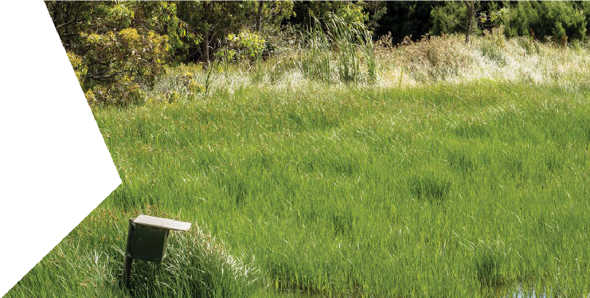Management approach
The EPRs developed for the project recognise the significance of the Edithvale-Seaford Wetlands
as a critically important environmental asset. In recognition of the importance of this asset, and despite the negligible risk that the project is considered to pose to this asset, a management approach has been developed and would be implemented.
A Groundwater Management and Monitoring Plan (EPR reference GW3) would be developed prior to commencement of construction. The Groundwater Management and Monitoring Plan would include:
- detailed monitoring parameters including timing and location of groundwater monitoring bores
- duration of the monitoring program
- clear trigger levels for changes in groundwater level and quality that would require mitigation plans to be developed and implemented.
A Groundwater Dependent Ecosystem Monitoring and Mitigation Plan for the Edithvale-Seaford Wetlands would be developed in consultation with Melbourne Water (EPR reference FF8). The Plan would only be implemented if the trigger levels for changes to groundwater level and quality that are detailed in the Groundwater Management and Monitoring Plan are met.
This plan would include:
- monitoring of groundwater and surface water level and quality at representative and strategic locations within and around the Edithvale Wetland
- the frequency and duration of monitoring if required
- monitoring of surface water quality at representative and strategic locations within the wetlands to differentiate temporal trends from long term changes to groundwater if required
- criteria (levels and quality) for groundwater and surface water change in and around the Edithvale Wetland to allow for the determination of whether a change in groundwater levels and/or quality is attributable to the projects
- response measures to implement in the event groundwater and surface water change criteria are met, such as:
- a process for ecological assessment developed by a suitably qualified ecologist to assess changes in aquatic and terrestrial fauna and flora, and consider whether these can be attributable to groundwater or surface water changes
- criteria for determining whether a change in the extent or condition of the wetlands is attributable to the projects
- contingency measures that would be implemented to mitigate potential impacts attributable to the projects
- include the frequency and duration of monitoring.

Wannarkladdin Wetlands

Existing conditions
Wannarkladdin Wetlands are ecologically similar to Edithvale Wetland, however they are not listed
as a Matter of National Environmental Significance (MNES). They are dominated by Tall Marsh Ecological Vegetation Classes (EVC) (refer Figure 6.5) and support a number of wetland cells which range from deep pools surrounded by dense reed beds (Wannarkladdin West, refer Figure 6.6) to shallow open water and bare soil or mud (Wannarkladdin East, refer Figure 6.7). The Wannarkladdin Wetlands provide a mosaic of permanent and semi-permanent habitat for a number of waterbirds and shorebirds (in low abundance).

Vegetation and habitat
Three EVCs are recorded in the Wannarkladdin Wetlands:
  - Tall Marsh (EVC 821) – fringes the waterbodies and covers extensive areas throughout the Wannarkladdin Wetlands.
  - Brackish Wetland (EVC 656) – appears as unvegetated open water/bare soil/mud (EVC 990) for approximately six months of the year.
  - Brackish Aquatic Herbland (EVC 537) – occurs in semi-permanent to seasonal wetlands and is dominated by aquatic herbs.

Ecological Vegetation Class (EVC)

In Victoria, patches of remnant vegetation are classified by an Ecological Vegetation Class (EVC) which are based on the general ecological characteristics and underlying geology of the vegetation.
Remnant vegetation includes patches both
of native vegetation and scattered indigenous trees. The removal of remnant vegetation

is controlled through the application of the Permitted clearing of native vegetation Biodiversity Assessment Guidelines an
incorporated document under the Planning and Environment Act 1987. Refer to Attachment III Matters of National Environmental Significance for further information.

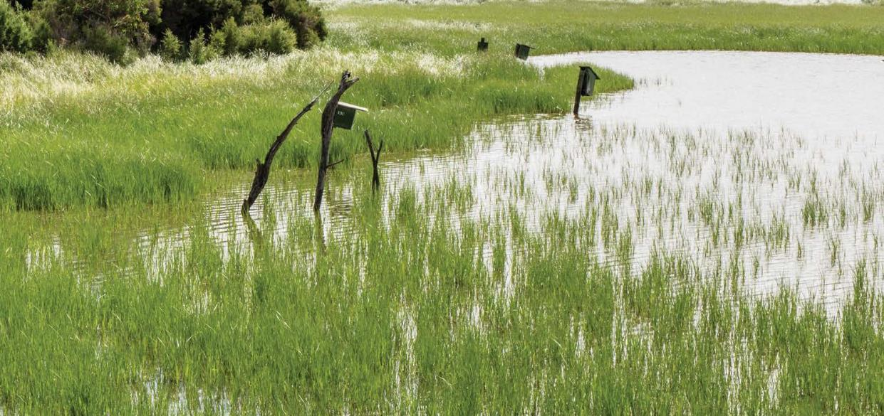

Figure 6.5 Tall Marsh and mown non-native areas – Wannarkladdin Wetlands north (June 2017)
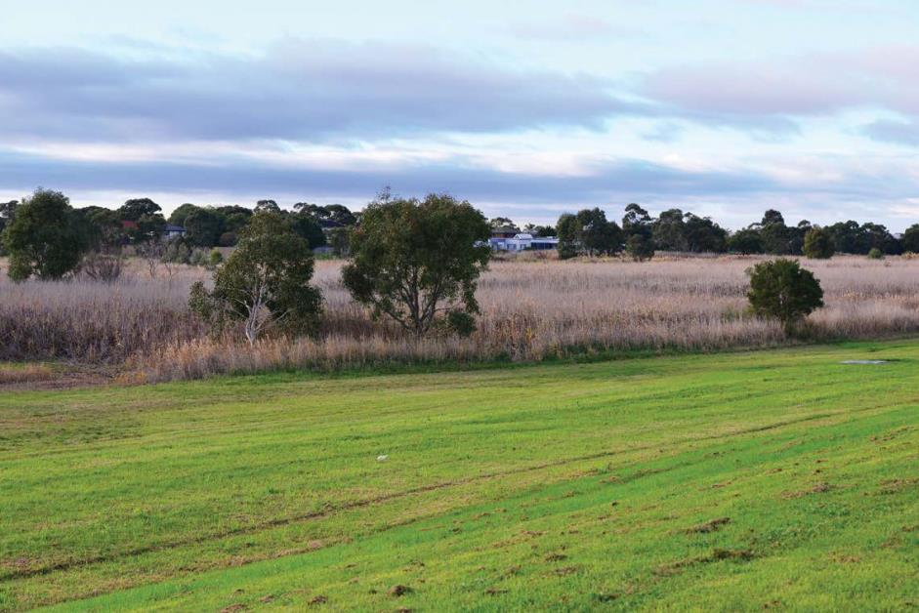

Figure 6.6 Deeper pool – Wannarkladdin Wetlands west (June 2017)
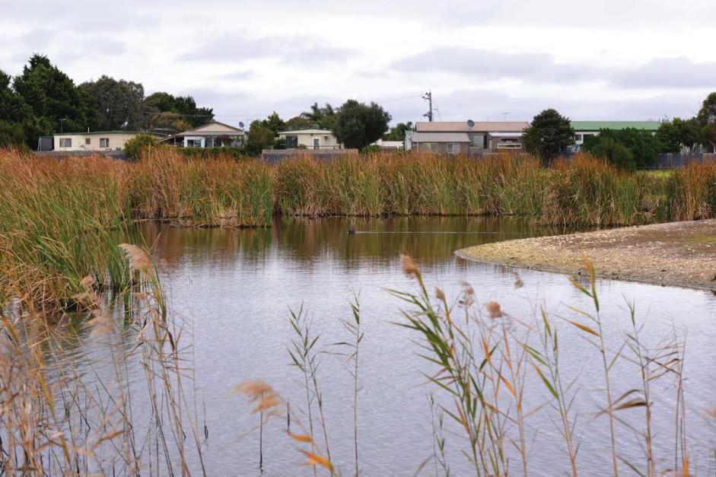

Figure 6.7 Semi-permanent wetland – Wannarkladdin Wetlands east (June 2017)
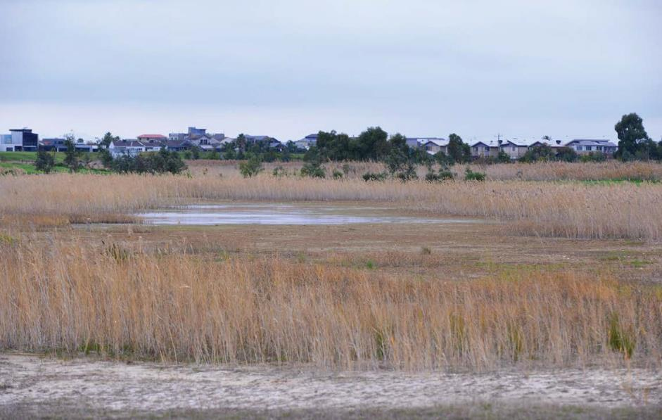

Threatened and/or migratory birds
BirdLife Australia has been monitoring birds (and other animals on an incidental basis) at the Wannarkladdin Wetlands since 2013. Based on analysis of BirdLife Australia data,
What is a threatened species?
‘Threatened species’ refers to those species that are considered ‘threatened’ in Victoria or Australia.
This includes species that are listed as:
- ‘threatened’ under the Flora and Fauna Guarantee Act 1988;
- ‘vulnerable’, ‘endangered’ or ‘critically endangered’ on the Victorian Rare or Threatened species advisory lists; or
- ‘vulnerable’, ‘endangered’ or ‘critically endangered’ under the Environment Protection and Biodiversity Conservation Act 1999.
Wannarkladdin Wetlands is known to provide habitat for 10 threatened and/or migratory birds:
  - Australasian Shoveler
  - Blue-billed Duck
  - Caspian Tern
  - Great Egret
  - Hardhead
  - Intermediate Egret
  - Latham’s Snipe
  - Little Egret
  - Musk Duck
  - Sharp-tailed Sandpiper.
All species were recorded in low abundance and habitat appears more important for threatened duck species than migratory shorebirds. Latham’s Snipe is the only exception to this.

Threatened plants
River Swamp Wallaby-grass and Swamp Everlasting (both listed under the EPBC Act), Pale Swamp Everlasting (vulnerable in Victoria) and Lacey River Buttercup (rare in Victoria) have a moderate likelihood of occurring at Wannarkladdin Wetlands. However, like Edithvale Wetland, the growth of both indigenous and exotic graminoid (herbaceous, grass-like) plants is the biggest limiting factor for the persistence of threatened plant species. In particular, the prolific growth of Common Reed, Narrow-leaf Cumbungi and Broad-leaf Cumbungi is likely encouraged by stormwater inflows which carry sediments and nutrients from the surrounding residential developments. Access to the wetlands is unrestricted, and the site is within close proximity to residential subdivisions, which is likely to exacerbate weed spread.

Impact assessment

Construction
An assessment of risks and impacts to groundwater posed by the projects was undertaken in accordance with the method described in Chapter 4 Assessment framework. No risks were identified during the construction phase of the Edithvale and Bonbeach level crossing removal projects, in relation to the Wannarkladdin Wetlands and GDEs, given the significant distance between the level crossing sites and the wetlands. Refer to Technical Report B Ecology: Wetlands and Groundwater Dependent Ecosystems.

Operation
The initial and residual risks identified for the operation phase of the Edithvale and Bonbeach level crossing removal projects in relation to the Edithvale Wetland and GDEs are outlined in Table 6.3.

Table 6.3 Wannarkladdin Wetlands risks – operation

Risk ID | Risk name | Risk pathway | Initial EPR | Initial risk | Final EPR | Residual risk
EG80 | Wannarkladdin Wetland (Bonbeach) | Groundwater mounding resulting  in altered hydrological regime and/or  water quality resulting in loss  of native vegetation and/or fauna habitat associated with Wannarkladdin Wetland | EPR GW1 –  Rail trench design | Negligible | EPR GW1 –  Rail trench design  EPR GW2 –  Groundwater performance outcomes  EPR GW3 –  Groundwater Management and Monitoring Plan | Negligible
EG82 | Threatening process – wetland loss (Bonbeach) | Loss of Edithvale Wetland and/or Wannarkladdin Wetland, resulting in the exacerbation of a threatening process listed under the FFG Act. | EPR GW1 –  Rail trench design | Negligible | EPR GW1 –  Rail trench design  EPR GW2 –  Groundwater performance outcomes | Negligible

No change to water levels is predicted to occur at Wannarkladdin Wetlands (refer to Chapter 5 Modelling the water environment) with groundwater mounding not expected to extend closer than 1,500 metres toward Wannarkladdin Wetlands.
In the highly unlikely event that there was an increase in groundwater level as a result of the projects, related impacts are unlikely to be significant in the context of existing risks which are already exerting pressure on the wetland’s ecological values. While Wannarkladdin Wetlands is considered to be a high quality GDE on the basis that it provides habitat for threatened and/or migratory birds, it is not specifically managed for the purposes of conservation.
Access to the wetlands by the public, as well as domestic animals is unregulated and no fencing exists to exclude pest animals. Impacts to surface water quality (through stormwater runoff), weed spread and predation and disturbance by domestic and/or pest fauna all pose a greater risk to the wetlands than that posed by the level crossing removal projects. The risk of altered hydrological regime and/or changes to groundwater quality resulting in loss of native vegetation and/or fauna habitat associated with Wannarkladdin Wetland is considered to be negligible.

Aspendale to Carrum Foreshore Reserve

Existing conditions
The Aspendale to Carrum Foreshore Reserve is a largely continuous and linear strip of vegetation which is identified as a key natural resource area by the Kingston City Council (that is, an area that contains remnant indigenous vegetation).
The importance of the foreshore as an environmental asset is recognised in Section 21.08 of the Kingston Planning Scheme, which aims to protect the foreshore for future generations and, where possible, restore natural ecosystems and minimise adverse environmental impacts. The establishment of a ‘friends group’ to help manage and revegetate the reserve at Bonbeach highlights the importance of this area for the local community.
One Coast Banksia in the foreshore reserve near the end of The Glade, Bonbeach is listed as a significant tree under Schedule 3 of the Environmental Significance Overlay of the Kingston Planning Scheme.

Vegetation and habitat
The reserve is characterised by three EVCs:
  - Coast Banksia Woodland (EVC 2) – this EVC is patchily distributed along the foreshore reserve, typically near the eastern edge adjacent to the residential area. Few large Banksias persist
in the foreshore reserve (refer Figure 6.8).
  - Coastal Dune Scrub (EVC 160) – this EVC forms a semi-continuous linear strip of vegetation which is primarily located on the top of and towards the back of the dune (refer Figure 6.9).
  - Coastal Dune Grassland (EVC 879) – this EVC also forms a semi-continuous linear strip, primarily along the foredune (refer Figure 6.10).
The vegetation within the foreshore reserve is considered to be of moderate to high quality and is more intact around Bonbeach than it is around Edithvale. Coast Tea-tree is the dominant species within the reserve and its ability to flourish in this dynamic landscape had resulted in a number of the more sensitive understorey species being out-competed. Recent targeted weed control and revegetation work has significantly increased the species diversity and hence the quality of this vegetation.
The foreshore vegetation provides habitat for a range of non-threatened fauna species and forms a wildlife corridor through the landscape, particularly for birds. The reserve does not support any biodiversity values that are protected as a MNES under the EPBC Act.
The remnant vegetation in the foreshore reserve is likely to be accessing groundwater (as discussed in Technical Report B Ecology: Wetlands and Groundwater Dependent Ecosystems). The extent to which the vegetation is dependent on groundwater for survival is unknown, but it is likely that the vegetation within this GDE also utilises rainfall to meet its water requirements. The potential rooting depths of the dominant plants within the foreshore reserve vegetation range from up to 15 metres for Coast Banksia and up to 2.5 metres for Hairy Spinifex, but are likely to be influenced by existing groundwater levels and possibly other factors such as substrate permeability and groundwater quality. Figure 6.11 illustrates the respective root depth capabilities of these plants.

Figure 6.8 Coast Banksia Woodland in the coastal reserve at Bonbeach
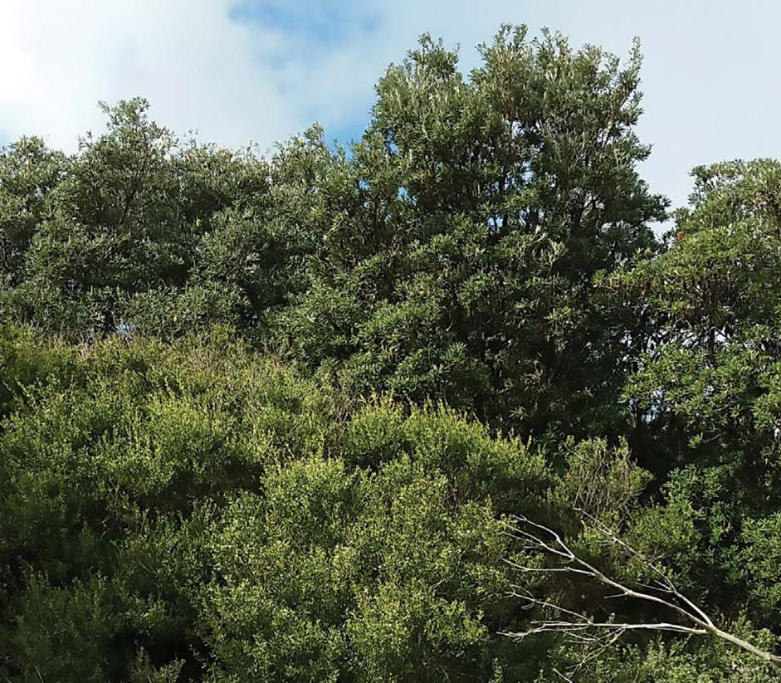

Figure 6.9 Coast Dune Scrub in the foreshore reserve at Bonbeach
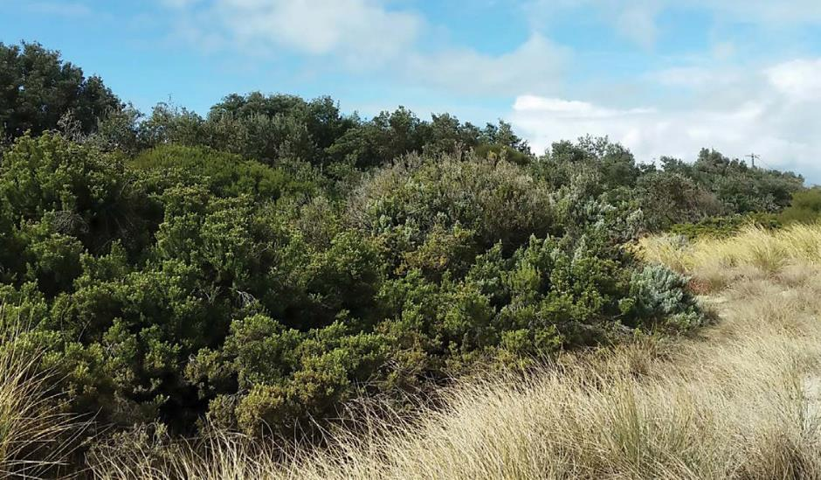

Figure 6.10 Coastal Dune Grassland
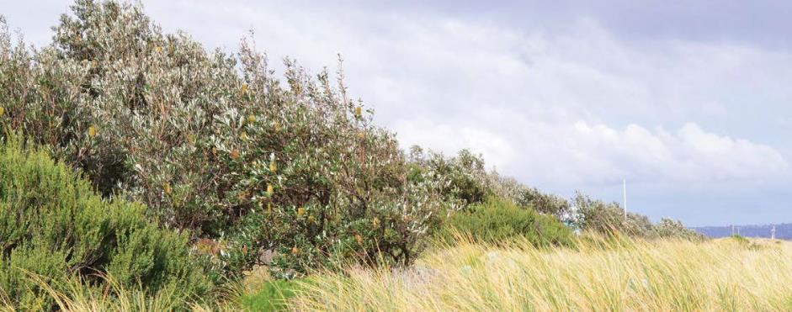

Figure 6.11 Indicative root depth capability of foreshore coastal vegetation relative to existing groundwater levels

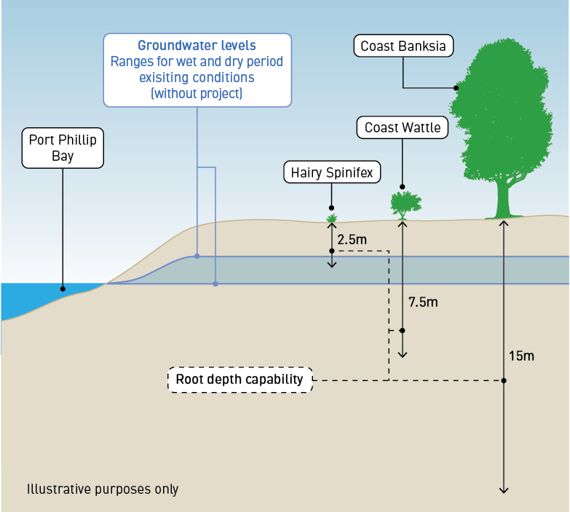

Threatened and/or migratory animals
The habitat of the foreshore reserve is considered unlikely to support threatened species given its proximity to residential areas and its history of disturbance. Some highly mobile species may occur on a rare and occasional basis.

Threatened plants
The foreshore reserve is not known to contain any threatened plants nor are any threatened species considered to have a moderate or above likelihood of occurrence.

Impact assessment

Construction
No risks were identified during the construction phase of the Edithvale and Bonbeach level crossing removal projects, in relation to the Aspendale to Carrum Foreshore Reserve and GDEs. This is due to the significant distance between the level crossing sites and the reserve. Refer to Technical Report B Ecology: Wetlands and Groundwater Dependent Ecosystems.

Operation
The initial and residual risks identified for the operation phase of the Edithvale and Bonbeach level crossing removal projects, in relation to the Edithvale Wetland and GDEs are outlined in Table 6.4.

Table 6.4 Aspendale to Carrum Foreshore Reserve risks – operation

Risk ID | Risk name | Risk pathway | Initial EPR | Initial risk | Final EPR | Residual risk
Edithvale
EG77 | Coastal reserve  – native vegetation (Edithvale) | Groundwater drawdown resulting in the loss of  native vegetation and fauna habitat along the coastal reserve leading to a reduction in the extent of native  vegetation in Victoria and increased  risk of erosion of the foreshore. | EPR GW1 –  Rail trench design  EPR FF7  – GDE  Monitoring and Mitigation Plan (Foreshore Native Vegetation) | Minor | EPR GW1 – Rail  trench design  EPR GW2 –  Groundwater performance outcomes  EPR GW3 –  Groundwater Management and Monitoring Plan  EPR FF7 – GDE  Monitoring and Mitigation Plan (Foreshore Native Vegetation) | Negligible
EG78 | Threatening process  – habitat fragmentation (Edithvale) | Fragmentation of the narrow habitat corridor of the foreshore reserve, resulting in the exacerbation  of a threatening process listed under the FFG Act. | EPR GW1 –  Rail trench design  EPR FF7  – GDE  Monitoring and Mitigation Plan (Foreshore Native Vegetation) | Negligible | EPR GW1 – Rail  trench design  EPR GW2 –  Groundwater performance outcomes  EPR GW3 –  Groundwater Management and Monitoring Plan  EPR FF7 – GDE  Monitoring and Mitigation Plan (Foreshore Native Vegetation) | Negligible

Risk ID | Risk name | Risk pathway | Initial EPR | Initial risk | Final EPR | Residual risk
Bonbeach
EG83 | Coastal reserve  – native vegetation (Bonbeach) | Groundwater drawdown resulting in the loss of  native vegetation and fauna habitat along the coastal reserve leading to a reduction in the extent of native  vegetation in Victoria and increased risk of erosion of the foreshore. | EPR GW1 –  Rail trench design  EPR FF7  – GDE  Monitoring and Mitigation Plan (Foreshore Native Vegetation) | Minor | EPR GW1 – Rail  trench design  EPR GW2 –  Groundwater performance outcomes  EPR GW3 –  Groundwater Management and Monitoring Plan  EPR FF7 – GDE  Monitoring and Mitigation Plan (Foreshore Native Vegetation)  EPR CL5 –  Groundwater Acidification and Contamination Mitigation Plan | Minor
EG84 | Threatening process  – habitat fragmentation (Bonbeach) | Fragmentation of the narrow habitat corridor of the foreshore reserve, resulting in the exacerbation of a threatening process listed under the FFG Act. | EPR GW1 –  Rail trench design  EPR FF7  – GDE  Monitoring and Mitigation Plan (Foreshore Native Vegetation) | Negligible | EPR GW1 – Rail  trench design  EPR GW2 –  Groundwater performance outcomes  EPR GW3 –  Groundwater Management and Monitoring Plan  EPR FF7 – GDE  Monitoring and Mitigation Plan (Foreshore Native Vegetation) | Negligible

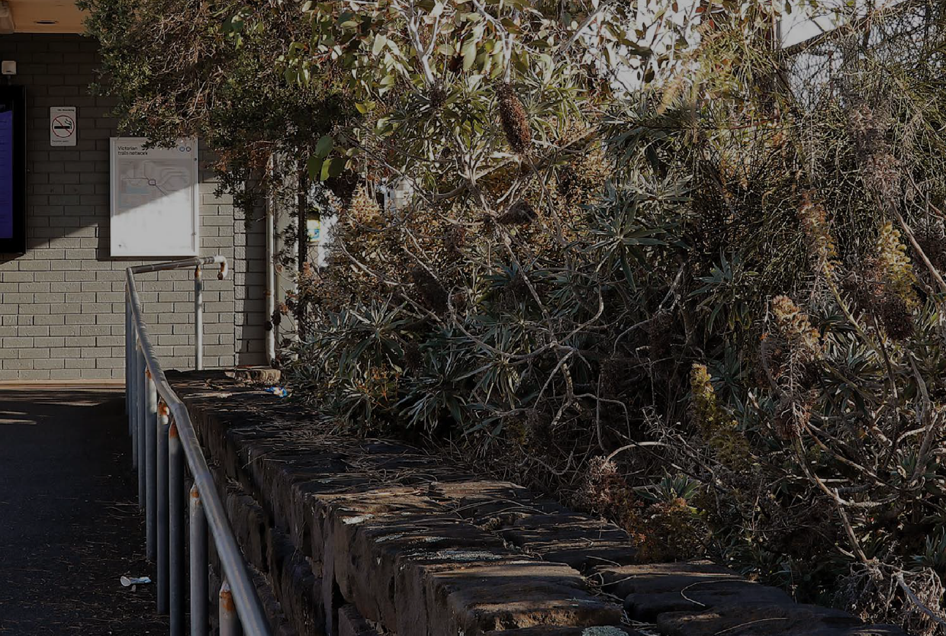
Loss of remnant vegetation of the foreshore reserve (risk EG77 and risk EG83)
Loss of vegetation could occur if groundwater drawdown below the Aspendale to Carrum Foreshore Reserve leads to an increase in seawater intrusion, activation of coastal acid sulfate soils or results in the water table dropping beyond the reach of plant roots.

Seawater intrusion
As described in Chapter 5 Modelling the water environment, changes to the salinity of groundwater can occur due to changes in the behaviour of the saltwater – freshwater interface as a result of onshore activities. An increase in groundwater salinity could affect vegetation if the salt content of the groundwater that the plants are accessing increases to a level that the plants cannot tolerate.
The project would potentially increase groundwater salinity, with groundwater quality generally remaining within the range that is suitable for potable use (refer to Technical Report A Groundwater). Chapter 5 Modelling the water environment provides data on the predicted change in salinity. Given that the foreshore vegetation is salt-tolerant, it is considered likely that the majority of the species that comprise the coastal dune vegetation will tolerate or adapt successfully to the potential increase in salinity.

Acid sulfate soils
Activation of coastal acid sulfate soils could occur through exposure of areas of potential coastal acid sulfate soils to oxygen. Coastal acid sulfate soils contain higher concentrations of iron sulfides or the products of sulfide oxidisation, which are natural and not a concern when left undisturbed. When disturbed or exposed, the sulfides come into contact with oxygen, break down and generate sulfuric acid. This means that a decline in groundwater level in these sediments could have the potential to result in acidification of the soils which in turn can lead to acidification of groundwater. This could render the water and/or soil unsuitable for the persistence of native plants leading to a loss of native vegetation. Refer to Chapter 7 Acid sulfate soils and contamination for further information. Acidification of groundwater could affect vegetation if the acidity of the groundwater that the vegetation is using rises to a level that vegetation cannot tolerate.

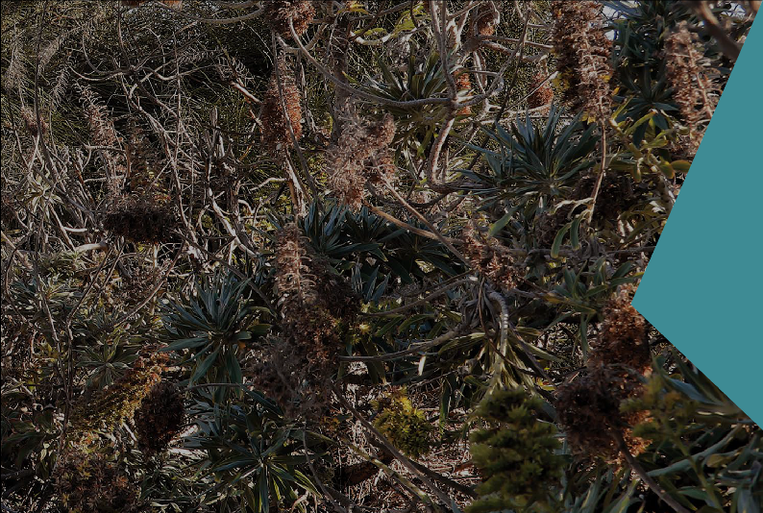Chapter 7 Acid sulfate soils and contamination identifies some small pockets of potentially acid sulfate soils at Bonbeach that could be activated as a result of the Bonbeach project. No areas of potential acid sulfate soils are expected to be activated at Edithvale.
Although the areas of potential acid sulfate soils likely to be affected by the Bonbeach project are relatively small, and any acidification could reduce or dissipate by the time it migrates to the foreshore vegetation, it is not possible to completely rule out acidification occurring at the foreshore vegetation.
Therefore, the EPRs for the projects include a monitoring and management approach that addresses this potential impact. The management approach is outlined below.

Access to groundwater
Lowering of the water table beyond the reach of plant roots could result in a decline in health or loss of native plants within the foreshore reserve. The likelihood of this occurring is dependent on
a number of factors, which influence the capacity of the plants to tolerate and/or adapt to the change, the magnitude of the change, and the timing and duration of change.
The design of the level crossing removal project has sought to minimise changes to groundwater levels (EPR reference GW1 and GW2). The potential for impacts at Edithvale are negligible as a result of the implementation of the project and EPRs. The project would achieve the outcomes required by EPR_GW2 (that the projects do not result in a significant impact on GDEs) through the addition of an engineering solution, which would improve the throughflow of groundwater around the trench. See Chapter 5 Modelling the water environment for a discussion of the proposed engineering solution at Edithvale.
Therefore, the maximum groundwater change (year 5 in the model described in Chapter 5 Modelling the water environment) in relation to the foreshore reserve at Edithvale ranges from 0.1 metres to 0.2 metres of drawdown (groundwater level decrease) as shown in Figure 6.12, and covers an area of 1.5 hectares. There is no groundwater change (drawdown) predicted within the foreshore reserve at Edithvale during a dry year (year 12 in the model) as shown in Figure 6.13.

Figure 6.12 Groundwater change (drawdown) predicted at Edithvale (during a wet year – year 5)
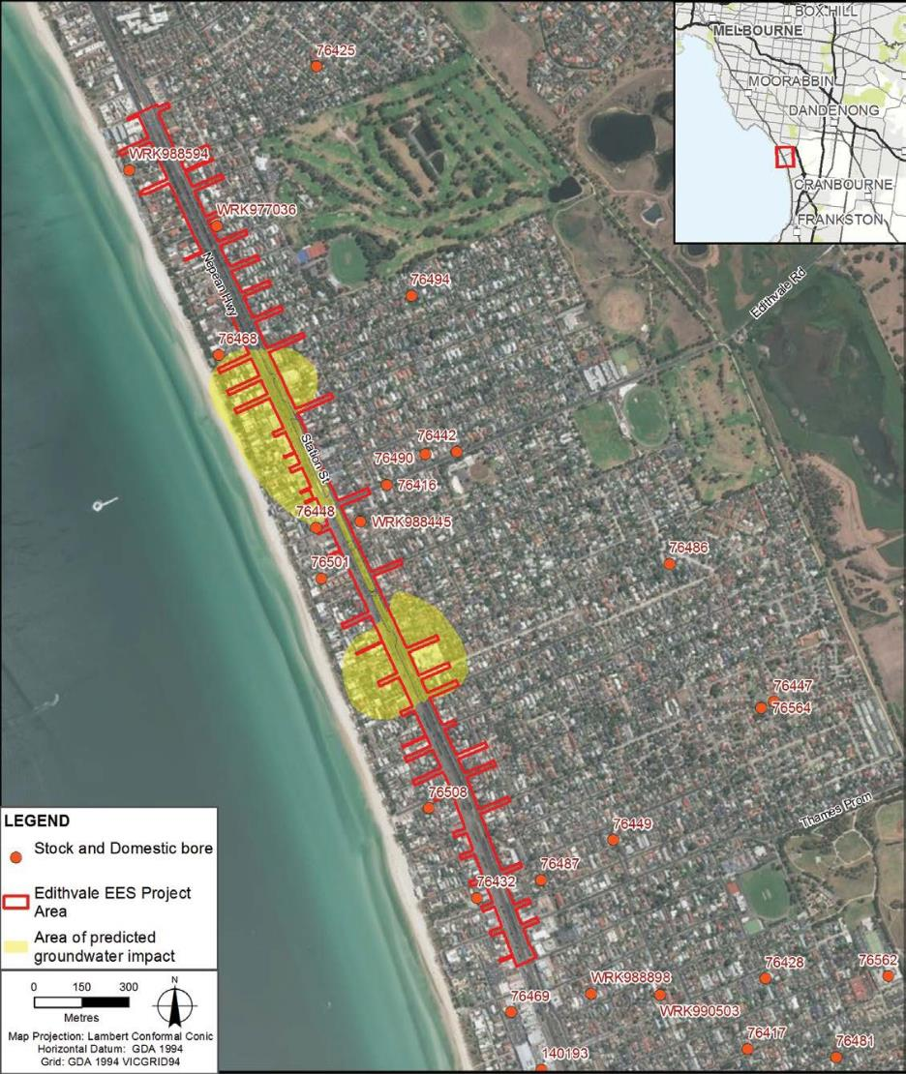

Figure 6.13 Groundwater change (drawdown) predicted at Edithvale (during a dry year – year 12)
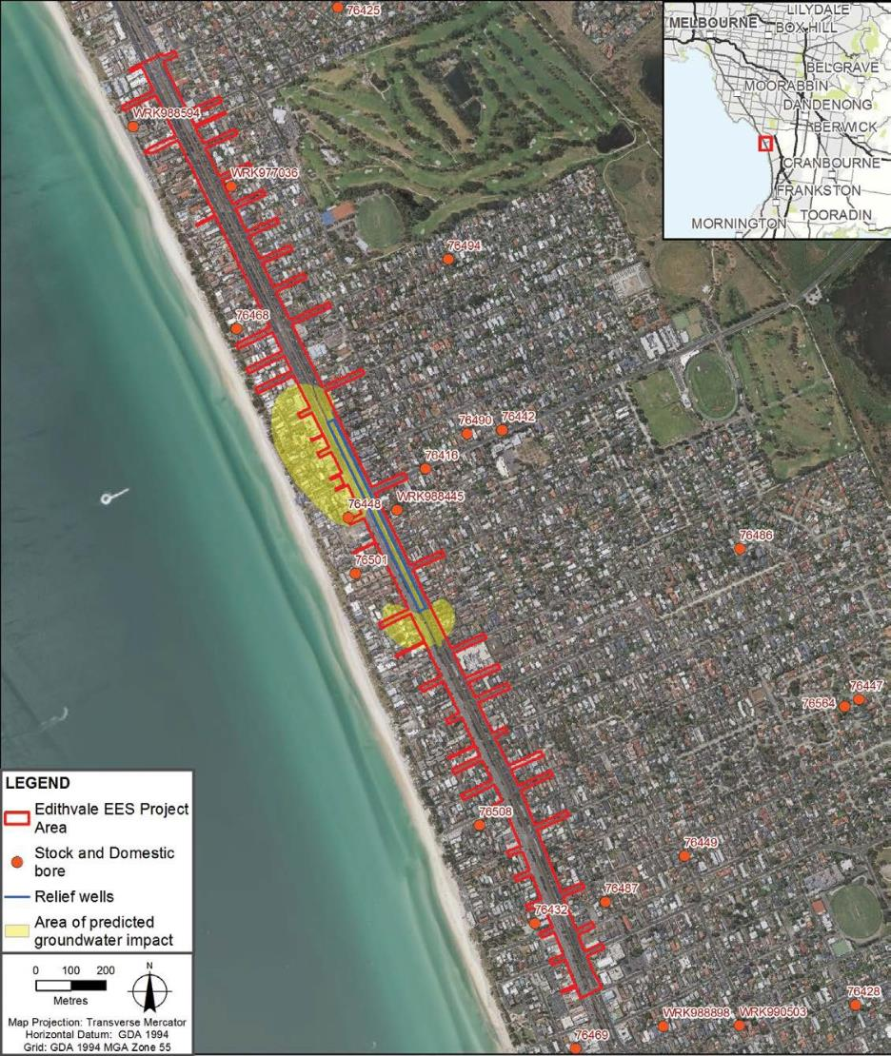

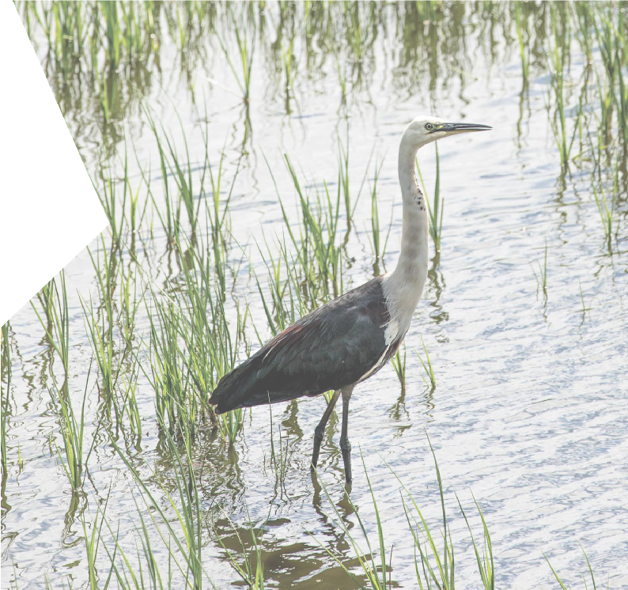The potential for impacts at Bonbeach are considered to be minor. The proximity of this site to the Patterson River means the direction of groundwater flow at the site of the level crossing removal is to the south west, as opposed to Edithvale which experiences a perpendicular groundwater flow path. This has the effect of reducing the volume of groundwater impeded by the pile walls, thus reducing the potential for groundwater drawdown at the Bonbeach site. At Bonbeach, an engineering solution is not required to achieve the performance outcomes (EPR reference GW2).
Therefore, the maximum groundwater change (year 5 in the model described in Chapter 5 Modelling the water environment) in relation to the foreshore reserve at Bonbeach arranges from 0.1 metres to 0.4 metres of drawdown (groundwater level decrease), as shown in Figure 6.14 (left hand side), and covers an area of 2.1 hectares. The predicted groundwater level change within the foreshore reserve at Bonbeach during a dry year ranges from 0.1 metres to 0.2 metres of drawdown (groundwater level decrease) as shown
in Figure 6.14 (right hand side).

Figure 6.14 Groundwater change (drawdown) predicted at Bonbeach
Left – during a wet year (Year 5) Right – during a dry year (Year 12)
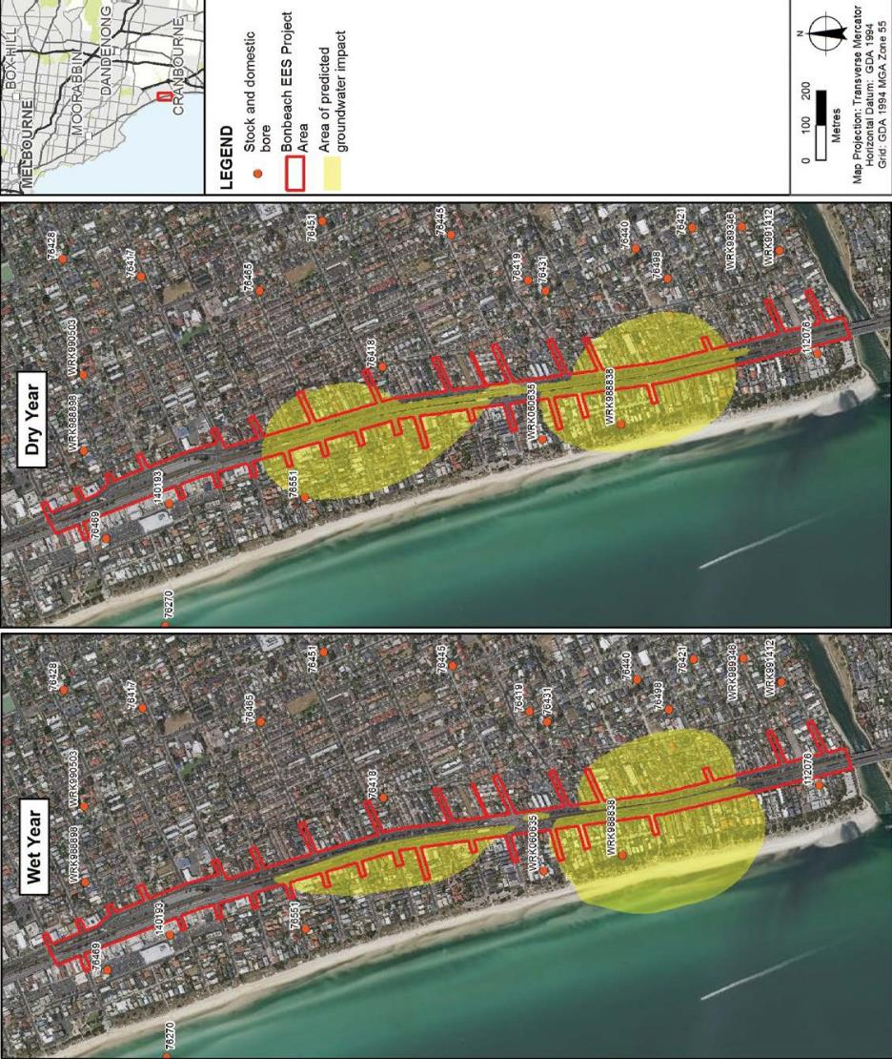

Any detrimental impact to the native vegetation of the foreshore reserve is likely to be dependent on the current reliance of the vegetation on groundwater as well as the likely duration and timing of project induced changes to groundwater that may eventuate. Groundwater data indicates that groundwater levels have fluctuated by up to two metres over the last 20 years, and during this period, plants within the foreshore reserve have persisted despite these existing natural variations. While the predicted changes in groundwater levels as a result of the level crossing removal project are within the range of natural variation (Figure 6.15), it is not possible to predict the cumulative impact of both the natural variation and the project-related drawdown on the coastal vegetation. However, the risk of impact has been assessed as minor at Bonbeach, and negligible at Edithvale, as the ability of the vegetation to tolerate the natural groundwater fluctuations demonstrates the inherent resilience of this vegetation.

Figure 6.15 Indicative root depth capability of foreshore coastal vegetation relative to predicted groundwater levels

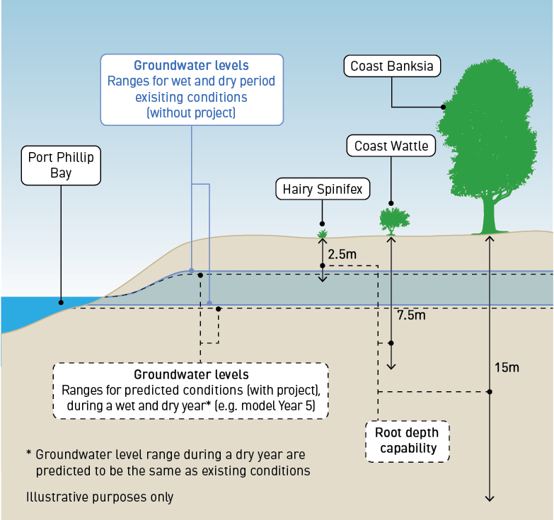

In addition, a literature review presented in the Technical Report B Wetlands and Groundwater Dependent Ecosystems refers to studies that have been undertaken in relation to sandy substrates and/or coastal environments which report that roots of plants in coastal environments can reach depths that exceed
10 metres and that roots have been recorded at depths of up to 15 metres and root to shoot ratios of 5:1 for plants less than 1.5 metres tall.
Groundwater levels within the coastal dune portion of the study area are likely to be highly dynamic, owing to the higher permeability of the Quaternary Aquifer along the coastal dune, and significant rainfall recharge response along the coastal dune (refer to Technical Report A Groundwater).
The dominant shrub species in the foreshore vegetation (Coast Tea-tree and Coast Wattle) were over one metre tall and the only tree species observed (Coast Banksia) grew up to 12 metres tall. Applying the 1:5 height to root ratio as detailed earlier, roots from these species could be reasonably expected to achieve depths of at least 5 metres below the base of the plant.

The existing groundwater depth under the foreshore reserve is predicted to range from 1.4 to 3.5 metres at Edithvale and from 1.6 to 3.3 metres at Bonbeach (refer to Technical Report A Groundwater). These ranges were based on predictions obtained from the numerical groundwater model, from the period 1997 to 2017.
Based on the ratio of plant height to root depth, some or all of the plant species within the coastal reserve may still be capable of accessing groundwater should the modelled drawdown be realised.

Management approach
Given the low risk to foreshore vegetation as a result of increased groundwater salinity, acidification of groundwater or reduced access to groundwater, the following management approach is proposed for the projects. A Groundwater Management and Monitoring Plan (EPR reference GW3) would be developed prior to commencement of construction.
The Groundwater Management and Monitoring Plan would include:
- detailed monitoring parameters including timing, location of monitoring bores
- duration of the monitoring program
- clear trigger levels for changes in groundwater level and quality that require mitigation plans to be implemented.
A Groundwater Dependent Ecosystem Monitoring and Mitigation Plan for the foreshore native vegetation would be developed in consultation with the land manager (EPR reference FF7). The mitigation plan would only be implemented if the trigger levels for changes to groundwater level and quality detailed in the Groundwater Management and Monitoring Plan were met.
The Groundwater Dependent Ecosystem Monitoring and Mitigation Plan would:
- identify areas of coastal vegetation potentially impacted by a change to groundwater quality and/or levels as a result of the projects
- include a process to monitor groundwater to confirm any changes to groundwater quality and/or levels that could result in a loss of coastal native vegetation
- include a process for monitoring coastal native vegetation developed by a suitably qualified ecologist
- include criteria for determining whether a change in the extent or condition of coastal native vegetation is attributable to the projects
- include contingency measures to mitigate potential impacts attributable to the projects
- include the frequency and duration of monitoring.
The monitoring program would inform whether changes in the condition and/or extent of vegetation were occurring and what, if any, contingency measures should be implemented to mitigate impacts.

Habitat fragmentation (risk EG78 and risk EG84)
Any loss of vegetation within the foreshore reserve as a result of groundwater drawdown would disrupt the narrow corridor of habitat which extends along the foreshore reserve. This would result in the exacerbation of a threatening process – habitat fragmentation – which is listed under the FFG Act. However, fragmentation is rated as a negligible risk at both Edithvale and Bonbeach, on the basis of the narrow nature of the corridor and the landscape context of the corridor in an urbanised, modified environment.
The Groundwater Dependent Ecosystem Monitoring and Mitigation Plan outlined above (EPR reference FF7) would inform whether changes in the condition and/or extent of vegetation were occurring and what, if any, contingency measures should be implemented to mitigate impacts.

Other GDEs within the study area

Existing conditions
Other GDEs modelled to occur within the study area include:
- Edithvale Common – a recreation reserve adjacent to Edithvale Wetland, which includes Memorial Oval, walking tracks and open space with areas of revegetation (refer Figure 6.16).
- Patterson River – an artificial waterway with the southern bank primarily consisting of rocks or concrete retaining walls and the northern bank consisting of rocks in proximity to the Nepean Highway, and patches of native vegetation further upstream where the bank becomes less artificial in appearance.
- Centre Main Drain – a large, man-made linear drainage channel commencing at Mordialloc Creek and terminating at an outfall on the Patterson River and comprising an open swale/retention basin along with a pipe underground. The invert elevation of Centre Main Drain is lower than shallow groundwater, indicating that Centre Main Drain likely receives seasonal groundwater discharges.
- Golf courses (Rossdale Golf Club, Chelsea Golf Club and Patterson River Golf Club) – typically characterised by mown grass fairways, manicured greens, waterbodies, sand bunkers and areas of planted trees and shrubs.
- Chelsea Bicentennial Park – a large recreation reserve adjacent to Wannarkladdin Wetlands dominated by large expanses of manicured, exotic grassland and some planted native trees. The reserve also incorporates Beazley Reserve (sporting oval) and the Chelsea Heights Community Centre.
- Residential areas – including residential streets and back yards. Residential streets typically contain semi-mature and mature planted native trees above manicured lawn nature strips. Vegetation within residential lots is far more variable with some lots containing large ornamental gardens while others are dominated by hardstand areas.
Other GDEs identified within the study area are not particularly significant individually, although their collective contribution may be valuable at a landscape scale. For instance, Bicentennial Park and Centre Main Drain form a network of habitats and/or open space linking Wannarkladdin Wetland and Edithvale Wetland.
A number of the residential lots within the study area are covered by Schedule 3 to the Environmental Significance Overlay under the Kingston Planning Scheme, which identifies significant exotic, native and indigenous trees.

Figure 6.16 Edithvale Common
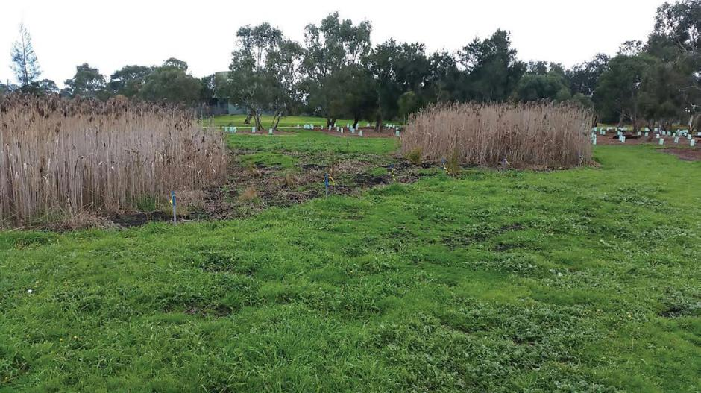

Vegetation and habitat
There were no patches of native vegetation observed within these ‘other GDEs’ where access was available.
Any native vegetation that may occur in inaccessible areas such as golf courses and private residences is likely to be limited in extent and quality given its urban setting.
The study area beyond Edithvale Wetland and Wannarkladdin Wetlands is characterised by a mix of recreation reserves, streets with planted trees above manicured lawn nature strips, and residential lots with ornamental gardens and hardstand areas. While individually of limited habitat value, the sum of these GDEs may be valuable at a landscape scale. Collectively, the canopy provided by trees throughout the residential areas (in gardens and along nature strips) represents an extensive area of foraging and resting habitat particularly for birds and possums.

Threatened and/or migratory animals
Edithvale Common, Patterson River, some of the local golf courses and Chelsea Bicentennial Park all contain a small number of records of threatened animal species. Their use as habitat by such species is likely to be due to their proximity to Edithvale Wetland and Wannarkladdin Wetlands, rather than the habitat they provide individually and in isolation of the wetland complex.

Threatened plants
No threatened plants are considered likely to occur within these areas.

Impact assessment

Construction
No risks were identified for the construction phase of the Edithvale and Bonbeach level crossing removals in relation to the other GDEs within the study area. Refer to Technical Report B Ecology: Wetlands and Groundwater Dependent Ecosystems.

Operation
The initial and residual risks identified for the operation phase of the Edithvale and Bonbeach level crossing removal projects in relation to the other GDEs within the study area are outlined in Table 6.5.

Table 6.5 Other GDEs within the study area risks – operation

Risk ID | Risk name | Risk pathway | Initial EPR | Initial risk | Final EPR | Residual risk
EG79 | Other vegetation / fauna habitat (Edithvale) | Groundwater change leading to altered hydrological regime and/or changes in water quality resulting in  the loss of undocumented remnant vegetation and/ or planted vegetation and  habitat outside of high value GDEs (i.e on residential properties) to the east (inland) of the rail corridor. | EPR GW1 –  Rail trench design | Negligible | EPR GW1 – Rail  trench design  EPR GW2 –  Groundwater performance outcomes | Negligible
EG85 | Other vegetation / fauna habitat (Bonbeach) | Groundwater change leading to altered hydrological regime and/or changes in water quality resulting in  the loss of undocumented remnant vegetation and/ or planted vegetation and  habitat outside of high value GDEs (i.e on residential properties) to the east (inland) of the rail corridor. | EPR GW1 –  Rail trench design | Negligible | EPR GW1 – Rail  trench design  EPR GW2 –  Groundwater performance outcomes | Negligible

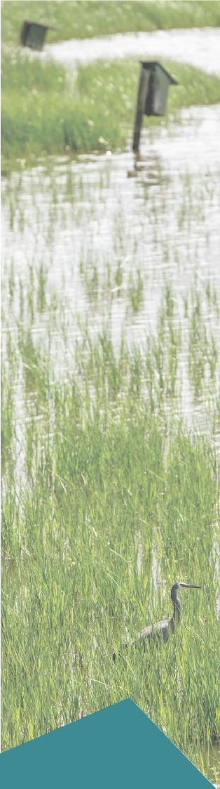

Groundwater mounding (risk EG79)
Groundwater mounding could result in the loss of vegetation and habitat in the residential areas east
of the rail corridor through saturation of the root zones.
The risk of this occurring is greatest in proximity to the project areas as this is where groundwater
mounding (increase in groundwater level) is predicted to be most pronounced.
No remnant vegetation was identified in the area modelled to be affected by groundwater mounding, however it is possible that remnant trees such as large old Coast Banksia and eucalypts are on some residential lots scattered throughout the suburbs. Collectively the canopy provided by trees throughout the residential areas (in gardens and along nature strips) represents
an extensive area of foraging and resting habitat particularly for birds and possums.
Impacts on an ecological level are not predicted to occur. The level crossing removal projects have been designed to minimise changes to groundwater levels (EPR reference GW1 and GW2) and therefore the projects would result in a negligible risk to other GDEs in the study area. No further mitigation is required.

Groundwater drawdown (risk EG85)
Groundwater drawdown (decrease in groundwater level) could result in the loss of vegetation in residential areas between the foreshore reserve and rail corridor through a lowering of the water table beyond the
reach of roots, an increase in saline intrusion and/or activation of coastal acid sulfate soils. The risk of this occurring is greatest in close proximity to the project areas as this is where groundwater drawdown
is predicted to be most pronounced.
No remnant vegetation is identified in the area of predicted drawdown, however it is possible that a small number of remnant trees such as large old Coast Banksia (Figure 6.8) and eucalypts exist on some residential lots. Collectively the canopy provided by trees throughout the residential areas (in gardens and along nature strips) represents foraging and resting habitat for local non-threatened fauna species, particularly birds and possums.
Like the foreshore reserve, the degree of vegetation dependence on groundwater and the potential extent and likelihood of impacts are difficult to determine. However, the risk of losing scattered trees and fauna habitat in this area is considered to be negligible given the highly urbanised environment within the area of potential groundwater drawdown.
The unavoidable loss of other vegetation and habitat that may occur as a result of groundwater drawdown is considered to constitute a negligible risk, given the
context of the projects in a modified, urban environment. No further mitigation is required.

Conclusion

A number of potential GDEs were identified to occur within the Edithvale and Bonbeach level crossing removals study area.
These included two high value GDEs:
- Edithvale Wetland section of the Edithvale-Seaford Wetlands Ramsar site – The wetland supports remnant vegetation and a diversity of habitat for a range of plant and animals. It provides potential habitat for significant plant species and is known to support a high diversity of significant birds including shorebirds listed under international agreements for migratory birds and wetland-dependent birds listed under the EPBC Act.
- Wannarkladdin Wetlands – These wetlands are ecologically similar to Edithvale Wetland, although not of national significance. The Wannarkladdin Wetlands provide habitat for a number of waterbirds and shorebirds and are part of a nationally significant complex of wetlands (which includes the Edithvale-Seaford Wetlands).
Regional numerical groundwater modelling presented in Technical Report A Groundwater indicated that groundwater mounding was not predicted to extend to the Edithvale Wetland (refer to Chapter 5 Modelling the water environment). As discussed in Appendix III Matters of National Environmental Significance (Edithvale-Seaford Wetlands), impacts on the habitat of Edithvale Wetland are therefore not expected as a result of the level crossing removal projects. As such, the capacity of the site to meet the Ramsar listing criteria would not be compromised by the level crossing removal projects.
Similarly, no impacts are expected at Wannarkladdin Wetlands and no changes to wetland function or character are anticipated as a result of the level crossing removal at Bonbeach. Despite this, a Groundwater Management and Monitoring Plan would be developed to monitor and manage predicted and potential impacts to groundwater following construction of the pile walls. A Groundwater Dependent Ecosystem Monitoring and Mitigation Plan for Edithvale Wetland would be developed in consultation with the land manager and the Commonwealth Department of the Environment and Energy. The mitigation plan would only be implemented in the unlikely event that trigger levels for changes to groundwater level and quality detailed in the Groundwater Management and Monitoring Plan were realised.
The Aspendale to Carrum Foreshore Reserve is identified by the Kingston City Council as a key natural resource area. The reserve contains remnant indigenous vegetation, which supports a diverse range of plants and comprises
a corridor of vegetation that is likely to facilitate the movement of fauna through the local area. The groundwater modelling predicted that groundwater drawdown could occur under the Aspendale to Carrum Foreshore Reserve. This could result in an increase in seawater intrusion, potential acidification of groundwater accessed by the foreshore vegetation and a lowering of the water table beyond the reach of plant roots.
The design of the level crossing removal project has sought to minimise changes to groundwater levels (EPR reference GW1 and GW2). There is a minor residual risk that groundwater drawdown could affect vegetation within the Aspendale to Carrum Foreshore Reserve at Bonbeach. The potential for impacts on the foreshore vegetation at Edithvale are considered to be negligible due to the smaller area likely to be affected, the lower magnitude of drawdown and the engineering solution that has been considered. A management approach is proposed in the EPRs for the projects to mitigate potential impact on vegetation within the Aspendale to Carrum Foreshore Reserve and ensure impacts are not significant.
Other GDEs identified within the study area are not ecologically significant individually, although their collective contribution may be valuable at a landscape scale. Groundwater mounding could result in the loss of vegetation and habitat east of the rail corridor through saturation of the root zones. Groundwater drawdown could also result in the loss of vegetation and habitat west of the rail corridor through a lowering of the water table beyond the reach of roots, which could result in increased risk of seawater intrusion and/or activation of coastal acid sulfate soils. However, the loss of other vegetation and habitat in the study area that may occur as a result of groundwater mounding or drawdown is considered to represent a negligible risk given the context of the projects in a modified, urban environment.

This page has intentionally been left blank

