
  - Suburban Rail Loop Authority

Annual Report 2024-2025

Acknowledgment of Country
Suburban Rail Loop Authority acknowledges the Traditional Owners of the land, sky and waters across Victoria and pays respect to their Elders past and present.
We proudly recognise the strength and enduring connection to Country as the world's longest living culture and the profound wisdom, resilience and contributions of First Peoples and their communities. We are committed to the ongoing journey of reconciliation by embedding self-determined Aboriginal ways of knowing and doing across the lifespan of the Suburban Rail Loop project.
Language used in this report
Suburban Rail Loop Authority recognises the diversity of Aboriginal and Torres Strait Islander peoples, their communities and cultures. References to ‘First Peoples’ or ‘Aboriginal Peoples’ in this Report are inclusive of all Aboriginal and Torres Strait Islander peoples in Victoria. The language reflects the plurality and diversity of Aboriginal communities.
Authorised and published by the Victorian Government
Suburban Rail Loop Authority
Level 21, 222 Exhibition Street, Melbourne, VIC 3000
Telephone: 1800 105 105
October 2025
ISSN 2653-598X (Online)
Unless indicated otherwise, this work is made available under the terms of the Creative Commons Attribution 3.0 Australia Licence. To view a copy of this licence, visit the Creative Commons website.
It is a condition of the Creative Commons Attribution 3.0 Licence that you must give credit to the original author, who is the State of Victoria.
Accessibility
An accessible version of this document will be made available on the Suburban Rail Loop Authority’s section of the Big Build website.
You can also contact the Suburban Rail Loop Authority call centre by phone (1800 105 105) or email (contact@srla.vic.gov.au) to request the document in an accessible format.
Contents
Board Chair foreword 6
Chief Executive Officer foreword 7
1. Overview 8
Suburban Rail Loop: More homes, more opportunities 8
Suburban Rail Loop – an orbital rail line for Melbourne 10
Suburban Rail Loop Authority 10
Suburban Rail Loop Authority’s vision, purpose and objectives 10
Suburban Rail Loop Authority’s values and cultural pillars 12
Key achievements 12
Construction full steam ahead 13
Achieving procurement milestones 14
Embedding best practice – amplifying health and safety 14
Consultation and community insights shaping plans for future neighbourhoods 14
Sustainability at the forefront 15
People and opportunities 16
Suburban Rail Loop East major milestones 18
Governance 18
Minister 18
Suburban Rail Loop Authority Board 18
Board committees 19
Information provided to the Minister and Treasurer 20
Suburban Rail Loop Authority Leadership Team and divisional structure 20
Suburban Rail Loop Authority structure 23
People and workplace 23
Public sector values and employment principles 24
People Strategy 24
Employment programs 24
Learning and development 24
Workforce inclusion 25
Wellbeing 28
Suburban Rail Loop Authority workforce information 29
Health and safety 32
Health and safety of Suburban Rail Loop Authority’s people 32
Embedding health and safety in project delivery 32
Rail safety 33
2. Disclosures 34
Local Jobs First 34
Local Jobs First – Strategic projects 34
Tunnels North – Terra Verde 34
Local Jobs First – Standard projects 34
Social procurement 35
Disclosure of consultancy expenditure 36
Disclosure of major contracts 36
Emergency procurement 36
Disclosure of procurement complaints 37
Disclosure of grants and transfer payments 37
Government advertising expenditure 37
Review and study expenses 37
Information and communication technology expenditure 38
Environmental performance 38
Performance against output performance measures 40
Freedom of Information 41
Freedom of Information statistics 41
Lodging Freedom of Information requests 42
Compliance with the Building Act 1993 42
Competitive Neutrality Policy 42
Compliance with the Public Interest Disclosure Act 2012 42
Reporting procedures 43
Further information 43
Compliance with the Carers Recognition Act 2012 43
Compliance with the Disability Act 2006 44
Additional information available on request 44
Attestation for financial management compliance with Ministerial Standing Direction 5.1.4 45
3. Financial Statements 46
Contents 46
Declaration in the Financial Statements 48
Independent Auditor’s Report 49
Comprehensive operating statement 51
Balance sheet 52
Cash flow statement 53
Statement of changes in equity 54
1. About this report 55
2. Funding delivery of our services 56
2.1 Grant income 56
2.2 Rental revenue 56
3. The cost of delivering services 57
3.1 Employee benefits 57
3.2 Operating expenses 59
4. Key assets available to support service delivery 61
4.1 Property, plant and equipment (including right of ose) 61
5. Other assets and liabilities 64
5.1 Receivables 64
5.2 Payables 64
5.3 Prepayments 65
5.4 Other provisions 66
6. Financing our operations 67
6.1 Borrowings 67
6.2 Cash flow information and balances 68
6.3 Commitments for expenditure 69
7. Risks, contingencies and valuation judgements 71
7.1 Financial instruments specific disclosures 71
7.2 Contingent assets and contingent liabilities 74
7.3 Fair value determination 75
8. Other disclosures 78
8.1 Ex-gratia expenses 78
8.2 Other economic flows included in net result 78
8.3 Responsible persons 79
8.4 Remuneration of executives 80
8.5 Related parties 80
8.6 Remuneration of auditors 83
8.7 Subsequent events 84
8.8 Other accounting policies 84
8.9 Australian Accounting Standards issued that are not yet effective 84
8.10 Style conventions 85
4. Disclosure Index 86
Statutory Disclosure and Financial Reporting Direction requirements 86
Report of operations 86
Financial Statements 87
Legislation 88

Board Chair foreword
Suburban Rail Loop (SRL) is a transformative infrastructure project that will change the way people live, work and move across Melbourne. As Australia’s largest housing project, Suburban Rail Loop will also boost housing choices for more Victorians, in places people want to live – close to work, study, family and friends.
Melbourne continues to be among the world’s most liveable cities, and Victoria continues to be an attractive destination for people to live, work, study and play. As Australia’s fastest growing capital, Melbourne’s population is expected to reach nearly nine million by the middle of the century. Suburban Rail Loop will provide essential transport solutions, reducing congestion across our city and suburbs, unlocking opportunities above and around the new Suburban Rail Loop East stations and enhancing productivity.
As an integrated rail and housing project, Suburban Rail Loop is ensuring more people have more options to live in affordable, high-quality homes close to transport, healthcare, education and local services, as well as parks and open spaces. Suburban Rail Loop is the catalyst for more local jobs, commercial, creative and innovation opportunities in vibrant precincts that cater to growing communities.
Major construction is underway. With Suburban Rail Loop East’s north and south tunnels contracts awarded, our contract partners are preparing for tunnel boring machines to arrive at the end of the year, ahead of tunnelling starting in 2026.
Three bidders have been shortlisted for the two contracts to build the six underground stations. We’ve also identified the preferred bidder for the Linewide package – to build the trains, install power, tracks and signalling, and to operate and maintain the network over a 15-year term. Careful and thoughtful planning for the neighbourhoods around the new stations is well advanced, underpinned by input from local residents, businesses, councils, Traditional Owners and stakeholders.
Through extensive consultation, these ideas are shaping the future for their communities. With trains taking passengers in 2035, Suburban Rail Loop is an essential part of a carefully considered Victorian Government strategy to manage the state’s growth by harnessing the opportunities across middle Melbourne. Building 70,000 new homes around the Suburban Rail Loop East stations will create much needed housing options for singles and couples, families and downsizers, students and essential workers – on the doorstep of world class public transport, schools and universities, healthcare and jobs.
Suburban Rail Loop is the step change we need to help us grow – and to grow well. This annual report demonstrates the progress achieved, and with a clear delivery pathway ahead for this state-shaping project.
Responsible Body’s declaration
In accordance with the Financial Management Act 1994, I am pleased to present Suburban Rail Loop Authority's Annual Report for the period 1 July 2024 to 30 June 2025.
The Honourable James Merlino
Board Chair, Suburban Rail Loop Authority

Chief Executive Officer foreword
The responsibility to deliver transport infrastructure and more homes that support thriving communities has never been greater. As a once in a generation project, Suburban Rail Loop represents one of the most significant investments in our state’s future. After years of meticulous planning, ground investigations and early works, Suburban Rail Loop East is now firmly in the delivery phase.
Major construction of the rail infrastructure is advancing at pace, along with the structure planning for the six new station precincts. We are working to ensure the best possible value for Victorian taxpayers as we deliver this city shaping project. Suburban Rail Loop East alone is expected to create up to 8,000 direct jobs, and more than 3,000 people are already working on this project. Construction is progressing at every Suburban Rail Loop East station site, between Cheltenham and Box Hill, and at the stabling facility in Heatherton. Approximately 11 million hours have been worked on the project so far, with crews now preparing the launch sites for tunnel boring machines and moving critical underground services for excavation of the new stations and twin tunnels.
Like any growing city, Melbourne needs more housing in the right places, supported by world-class public transport. As a fully integrated project, Suburban Rail Loop is uniquely placed to simultaneously deliver both transport infrastructure and housing. With trains running in 2035, Victorians will have more transport options.
Suburban Rail Loop will ease congestion on our roads and deliver substantial travel time savings for people across the city and state, with faster and easier journeys.
As a long-term strategic infrastructure project, Suburban Rail Loop will also alleviate the pressure of urban sprawl in the outer suburbs while slowly reshaping middle Melbourne’s growth and catalysing investment in Melbourne’s middle ring.
And as Australia’s largest housing project, Suburban Rail Loop will also bring more homes to the areas around the new stations, with a plan for 70,000 additional new homes in the areas around the six new Suburban Rail Loop East stations.
Alongside other transport infrastructure projects and strategies to boost housing, Suburban Rail Loop will support the city’s connectivity, productivity and liveability for decades to come. Planning for future neighbourhoods is taking shape with community feedback at the heart of decision making and placemaking. The six final Suburban Rail Loop East precinct visions were released at the end of 2024, and our proposed draft structure plans and planning scheme amendments were publicly released in March 2025. We’re now carefully analysing more than 800 submissions from the community and stakeholders ahead of the plans and amendments being finalised in 2026 – while achieving value for the Victorian taxpayer.
We are committed to the efficient delivery of Suburban Rail Loop East and to realising the ambitious transport and housing benefits – on time and on budget. By working with the market for several years to structure the major contracts, we have enabled the industry to help craft the procurement strategy with a variety of contract models and have successfully achieved every key procurement milestone to date.
Our two tunnelling contractors are gearing up for the delivery of tunnel boring machines, with tunnelling to begin in 2026. Three world-leading bidders with international and local experience are shortlisted to build the six underground stations. We have identified a global consortium as the preferred bidder for the Linewide package – to build the fleet of trains and signalling, and to operate the network. That contract will be awarded by the end of the year, with significant enduring opportunities for local jobs and industry.
I’m proud to deliver this annual report. While it reflects our substantial achievements on work sites and procurement over the past year, our focus is already on our next set of milestones as we continue to work in partnership with the community, our contractors and industry, local government and other stakeholders to deliver Suburban Rail Loop.
Frankie Carroll
Chief Executive Officer, Suburban Rail Loop Authority

1. Overview

Suburban Rail Loop: More homes, more opportunities
Victoria is growing. By the 2050s, Melbourne will be home to about nine million people – a global city the size of London today. We need a public transport system and new housing options to meet this challenge.
As Australia’s largest transport and housing project, Suburban Rail Loop is a once-in-a-generation opportunity to shape the future connectivity, productivity and liveability of Melbourne and Victoria.
Suburban Rail Loop will connect communities and is creating thousands of jobs during construction. The 90-kilometre orbital rail line will link every major metro rail line from the Frankston line to the Werribee line, via Melbourne Airport, connecting people and homes to jobs, education, medical care and retail across Melbourne’s suburbs.
Three transport super hubs at Clayton, Broadmeadows and Sunshine will connect regional services to Suburban Rail Loop, so passengers outside Melbourne will not have to travel through the Central Business District to get where they need to go.
Suburban Rail Loop is much more than a rail line. Beyond the better connections, Suburban Rail Loop will deliver more homes where they’re needed – on the doorstep of world class public transport, education and health services – and more opportunities. Suburban Rail Loop East alone will support the delivery of around 70,000 more homes in the areas around the six new stations.
Suburban Rail Loop will recalibrate Melbourne’s growth in the decades ahead, easing the pressure on our outer suburbs to accommodate a growing population and reshaping Melbourne into a ‘city of centres’. In doing so, Suburban Rail Loop will deliver on the vision in a Plan for Victoria, a long- term plan to ensure Melbourne and Victoria are inclusive, liveable and sustainable.
Suburban Rail Loop Authority will help deliver the urban planning, housing, amenities, open space and active transport links in the areas around the stations – supporting these communities to grow and thrive as the new rail line is delivered.
Suburban Rail Loop’s rail infrastructure will be delivered in stages:
- Suburban Rail Loop East – Cheltenham to Box Hill, with 26 kilometres of twin tunnels, six new underground stations and structure planning in the broader areas around each station. Major construction is now underway and trains will be running in 2035.
- Suburban Rail Loop North – Box Hill to Melbourne Airport, with seven stations and train services enabling direct access to the airport as well as faster travel times. The Broadmeadows transport super hub is located within this stage, which is set to be completed by 2053.
- Melbourne Airport Rail – Sunshine to Melbourne Airport, being delivered by the Victorian Infrastructure Delivery Authority.
- Suburban Rail Loop West – Sunshine to Werribee, connects to the transport super hub at Sunshine and is supported by other key infrastructure being delivered in the west. Suburban Rail Loop West will be subject to further investigation, planning and development.
Suburban Rail Loop will:
- Deliver up to 15 new stations and transform Melbourne’s public transport network.
- Provide a ‘turn-up-and-go’ metro-style rail service with a fleet of high-tech trains, powered by 100 per cent renewable energy.
- Increase housing choice and the availability of affordable homes in the established areas around the new Suburban Rail Loop stations.
- Deliver rail connections to Melbourne Airport and Australia’s largest universities.
- Integrate existing Melbourne Metropolitan Rail Network, road, tram, bus and active transport networks.
- Deliver on Plan for Victoria (the refreshed Plan Melbourne) objectives to create more homes in well-connected, well-serviced locations – while enhancing Melbourne’s productivity and liveability.
- Establish cross suburb connections for fast and convenient travel between major employment, health, education and activity centres outside Melbourne’s Central Business District.
- Deliver new transport super hubs at Clayton and Broadmeadows and link to the super hub at Sunshine. These super hubs will connect regional passengers to the new orbital rail line.
- Ease congestion on Melbourne’s roads, by taking 600,000 cars off the road every day.
- Unlock new placemaking possibilities in the broader areas around new Suburban Rail Loop stations through a range of initiatives, including new and improved walking and cycling links, open and public space, and opportunities for more businesses to locate near the new train stations.
- Boost the economic and employment potential of: Melbourne’s Employment and Innovation Areas at Monash, La Trobe, Sunshine and Werribee; Metropolitan Activity Centres (MACs) such as Box Hill and Broadmeadows; Health and/or Education Precincts (HEPs) at Clayton, Burwood and Heidelberg; and activity centres such as Cheltenham, Glen Waverley and Reservoir.
- Generate thousands of local job opportunities, support women into construction and help train the next generation of skilled workers. Construction of Suburban Rail Loop will support up to 24,000 jobs across the Victorian economy.

Suburban Rail Loop – an orbital rail line for Melbourne
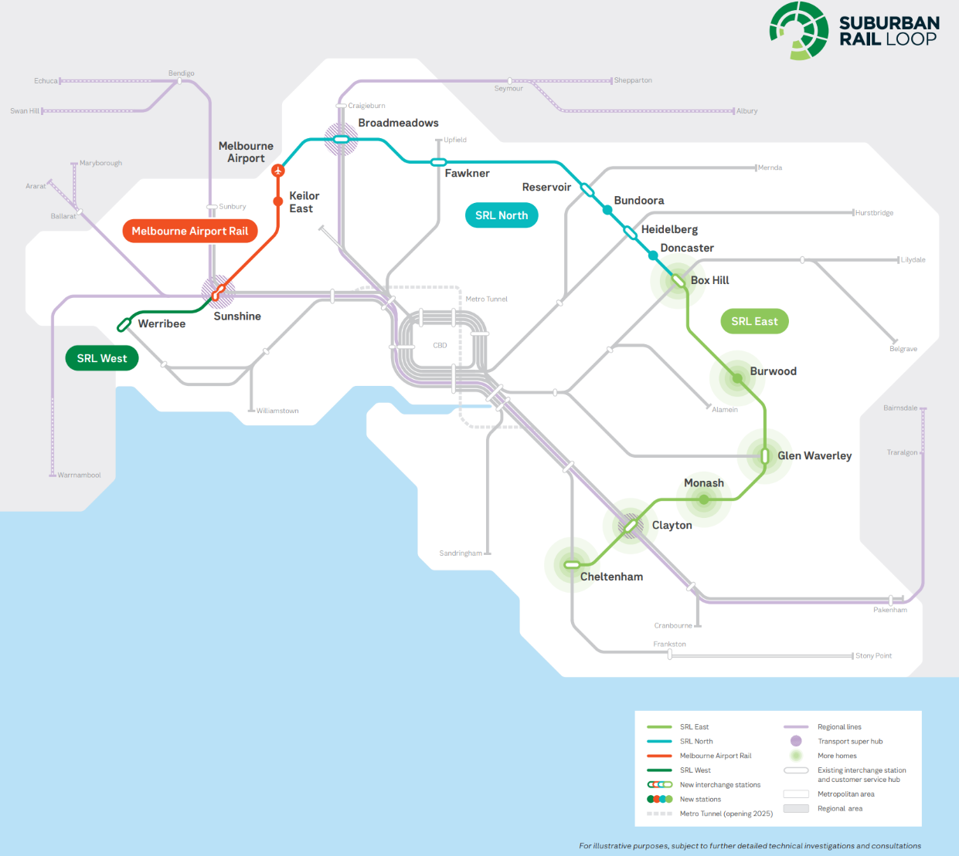

Suburban Rail Loop Authority
Suburban Rail Loop Authority is established under the Suburban Rail Loop Act 2021 (SRL Act). The Suburban Rail Loop Act outlines the functions, powers and governance arrangements of the authority.
The primary objective of Suburban Rail Loop Authority is to plan and deliver the Suburban Rail Loop program. Suburban Rail Loop Authority is governed by a board of directors that sets the authority’s strategic direction and priorities.
While an independent statutory authority, Suburban Rail Loop Authority contributes to the Victorian Government’s Department of Transport and Planning (DTP) initiatives and its vision: ‘We create thriving places and connected communities.’ Suburban Rail Loop Authority also contributes to the Victorian Government’s transport portfolio purpose statement of ‘Ensuring Victoria’s transport network and land use is safe, sustainable and integrated.’

Suburban Rail Loop Authority’s vision, purpose and objectives

Suburban Rail Loop Authority vision
A thriving global city, ready for the future.

Suburban Rail Loop Authority purpose
We connect people and communities to enhance liveability and create opportunity.
Suburban Rail Loop Authority’s vision and purpose guide the current and future stages of the Suburban Rail Loop program. They are based on the sentiment that it is not only about program delivery, but ensuring Suburban Rail Loop, as a transformational multi-generational program, plays an active role in shaping and connecting communities and contributing to Victoria’s long-term future liveability.
Underpinning the vision and purpose statements are three benefits Suburban Rail Loop will realise:
- Increasing productivity by facilitating greater employment, activity and investment in strategic areas within and around Suburban Rail Loop precincts and outside the inner Melbourne city.
- Improving transport connectivity between key employment, health, education and retail destinations across Melbourne’s middle suburbs and providing better access to opportunities for regional Victorians.
- Improving liveability through better connectivity in Suburban Rail Loop precincts.

Suburban Rail Loop Authority’s four-year focus
Suburban Rail Loop Authority’s objectives over the period 2025-29 centre on four strategic pillars:
- Community is at the heart of how we plan and deliver exceptional transport and precinct outcomes.
- Partners: Driving a program of collaboration for delivery.
- Culture and Capability: A team committed to the future, where people learn through doing and lead by actions.
- Create: An innovative organisation focussed on transformational legacies and sustainable outcomes.
Key activities over the coming period include:
- Completing the procurement of all major contracts for Suburban Rail Loop East Main Works: line-wide signalling, trains operation and maintenance; and station construction.
- Concluding Early Works across the Suburban Rail Loop East corridor and progressing major construction, including launching tunnel boring machines (TBMs) and starting station construction from 2026.
- Finalising Suburban Rail Loop East precinct structure plans and changes to planning rules, including continuing the important conversations with local communities, stakeholders and councils regarding the broader areas around the new Suburban Rail Loop stations.

Suburban Rail Loop Authority’s legislative objectives
Suburban Rail Loop Authority’s objectives, as defined under the Suburban Rail Loop Act, include:
- undertaking development consistent with the Transport Integration Act 2010 (TIA) and planning objectives of the Planning and Environment Act 1987
- integrating a new orbital rail line with existing and planned public transport and road networks in the state
- facilitating sustainable population growth, urban renewal and improved liveability
- encouraging land development and the facilitation of timely and coordinated delivery of non-transport infrastructure, transport infrastructure, services, and residential and commercial development
- improving connectivity throughout Melbourne by enhancing orbital public transport movements in relation to the new orbital rail loop
- increasing productivity by facilitating greater employment, activity and investment throughout Victoria
- enhancing regional Victorians' access to Melbourne’s health, education and employment centres by connecting regional rail lines to the new orbital rail loop at major interchange stations
- enhancing opportunities for the Victorian community, Victorian businesses and the state to capture value created by the development of precincts, non-transport infrastructure, transport infrastructure and other investments in relation to Suburban Rail Loop.

Suburban Rail Loop Authority’s values and cultural pillars
Suburban Rail Loop Authority staff uphold the seven Victorian Public Sector values:
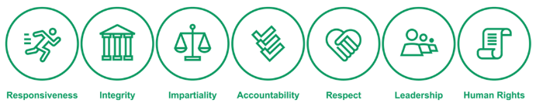
In addition, Suburban Rail Loop Authority is committed to four cultural pillars:

These pillars reinforce that it is not just about what Suburban Rail Loop Authority does, but how Suburban Rail Loop Authority staff work together within the organisation and with the community and other stakeholders that is important.
Suburban Rail Loop Authority’s aim is to remain high performing and agile in delivering the Suburban Rail Loop program – every step of the way.

Key achievements
In 2025, Suburban Rail Loop Authority has reached a pivotal milestone: transitioning from planning and procurement into an intensive delivery phase. With significant progress made on the ground with Initial and Early Works, major construction works are now full steam ahead across the Suburban Rail Loop East alignment. Reflecting that Suburban Rail Loop Authority is delivering Australia’s biggest housing project, our urban planning program has also scaled up to ensure the new Suburban Rail Loop stations and surrounding precincts will attract investment and enable the delivery of high-quality homes – in sustainable neighbourhoods that demonstrate density done well.
Close to 12 million hours have been clocked-up and more than 3,000 people are now working on the project. We have progressed structure planning for neighbourhoods around the six new Suburban Rail Loop East stations. Throughout an extensive consultation process, we have engaged with residents, businesses, traders, stakeholders, local councils and First Peoples. We are taking on board their insights, priorities and feedback as precinct planning and placemaking takes shape.
We are committed to the efficient delivery of Suburban Rail Loop East and to realising its ambitious transport and housing benefits – on time and on budget. In preparing for the next and future stages of the project, we are continuing to enhance our productivity and efficiency by leveraging digital delivery and artificial intelligence, while evolving our operating model to ensure the right capabilities and skills are in place for effective and coordinated delivery of the project.
Burwood site progress works, April 2025
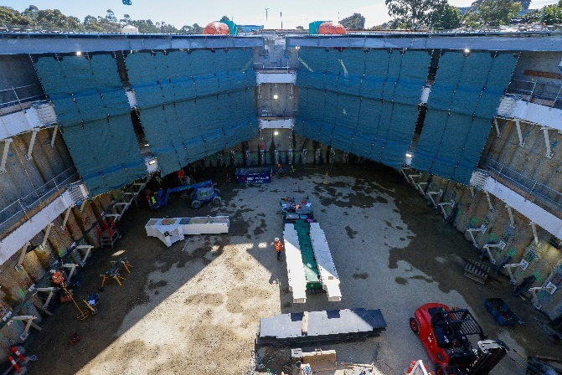

Construction full steam ahead
Suburban Rail Loop East’s major construction works kicked off in 2025 with works to build the massive launch sites for the tunnel boring machines that are set to arrive on site later this year. Tunnelling is scheduled to start in early 2026, along with construction of the stabling facility in Heatherton.
Crews have been busy excavating launch sites for the tunnel boring machines in Burwood and Clarinda, as well as a tunnel access structure in Heatherton. In an Australian-first, the tunnel boring machines will have a ‘flying launch’, which will allow tunnelling to begin while the tunnel boring machine continues to be built from behind, requiring a smaller launch area. And, in a world-first, an all-women tunnel boring machine crew has been recruited to help build the twin tunnels of Suburban Rail Loop East.
Initial and Early Works activities – including site establishment, utility works, relocation of underground services and ground improvements – have continued throughout the year. Crews have been busy building the temporary bridging structure along Whitehorse Road in Box Hill to keep traffic moving during construction of the station underneath. Road widening and realignment works are gathering pace in Glen Waverley and Monash. Works have also commenced to build an emergency support facility in Mount Waverley, and network and power support facilities at in Clarinda, Burwood, Heatherton and Monash. These facilities will play a crucial role in supporting the safe and reliable operation of Suburban Rail Loop.
In Clayton, Main Works commenced on the underground connection to the existing station, in preparation for the excavation of the new Suburban Rail Loop station.
Once complete, Suburban Rail Loop Clayton will become a transport super hub, connecting the Cranbourne/Pakenham and Gippsland lines to Suburban Rail Loop – giving people in regional Victoria better access to jobs, Australia’s largest universities and healthcare. This improved access was underlined by the Suburban Rail Loop Travel Time Savings report, launched in June 2025 and showing how people right across Melbourne and Victoria will have faster, easier journeys when Suburban Rail Loop East opens in 2035. For example:
- Cheltenham to Monash will take just 10 minutes, compared with about 30 minutes driving.
- A family from Dandenong needing to get to Box Hill will cut their public transport journey by 30 minutes.
- A student from Cranbourne travelling to Deakin University will save 27 minutes on public transport and 24 minutes compared with driving (shown below).
Extract from the Suburban Rail Loop Travel Time Savings report, June 2025
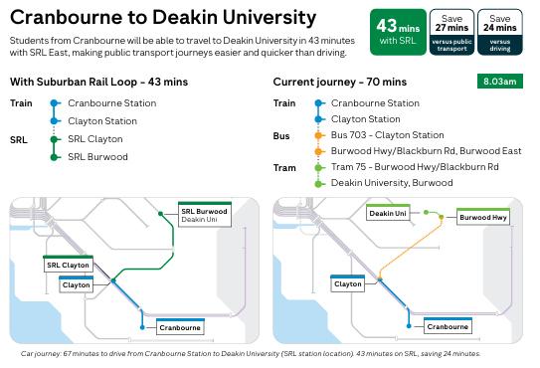

Achieving procurement milestones
Suburban Rail Loop Authority has worked closely with the market for several years to structure its major contracts to optimise competition and deliverability – incorporating industry feedback to achieve the best outcomes on costs and delivery risks. This important engagement with industry has helped underpin the Suburban Rail Loop East package and procurement strategy, using a variety of contract models – a strategy that has seen the project successfully achieve every key procurement milestone to date.
Initial and Early Works teams, led by Laing O’Rourke, have forged ahead with their activities on site, with a staged handover to our tunnelling partners, Suburban Connect and Terra Verde, which have ramped up their operations. We have also shortlisted world-leading consortia to bid for the two contracts to build the six new underground stations. Those contracts will be awarded over the next two years.
And, a global consortium, Transitlinx, has been identified as the preferred bidder for the Suburban Rail Loop East Linewide contract to build the high-tech trains, fit out the tunnels, install platform screen doors and operate the network for 15 years.

Embedding best practice – amplifying health and safety
With the project shifting gears from planning to delivery, the Health and Safety (H&S) Strategy was revised ahead of a re-launch in mid-2025. Building on the success of the existing strategy and lessons learned so far, the new strategy focusses on leadership, knowledge capability and safety of our precincts, railway and civic infrastructure – during the project delivery stage and after project completion.
Suburban Rail Loop Authority is the first Victorian Government agency to achieve rail accreditation from the Office of the National Rail Safety regulator. This accreditation enables the construction of the rail line and its supporting assets to get underway.
Continuing to strengthen our safety culture and capacity is among Suburban Rail Loop Authority’s highest priorities. To support this, Suburban Rail Loop Authority has held its first ever Health and Safety focussed summit to foster cross-organisational engagement, with workshops on tunnelling, risk controls, underground safety, environmental impact, injury prevention and workplace wellbeing.

Consultation and community insights shaping plans for future neighbourhoods
As Australia’s largest housing project, Suburban Rail Loop will support the delivery of 70,000 additional homes over time. The careful planning work, underpinned by good urban design and community consultation, has continued this year to ensure areas around the new Suburban Rail Loop East stations will be ready to meet the needs of our growing populations. At the end of 2024, we released the final visions for the Suburban Rail Loop East precincts. In March-April 2025, six draft structure and implementation plans, six draft planning scheme amendments (supported by six background reports and 60 technical studies) were released.
The draft structure plans outline how the visions for each neighbourhood will be realised, and where future development and investment is needed. The plans also look at key projects – from open space and community facilities to enhanced intersections to help people move around the station precinct. We have also proposed planning changes to help realise the ambition of Suburban Rail Loop by amending the built form, upgrading open spaces, and increasing setbacks and access to natural light.
A comprehensive program of community engagement and consultation has been undertaken throughout the public exhibition phase. The draft plans have been published online and made available in hard copy at local council offices and libraries, supported by webinars, community information sessions, pop-ups, workshops with local councils, and roundtables with strategic stakeholder organisations. Consultation opportunities have also been promoted via advertising, social media and media channels. More than 800 submissions have been received, with 23,000 visitors to the Engage Victoria page, and the plans have been downloaded more than 11,000 times.
This formal engagement builds on a wider conversation we have been having with communities and other stakeholders, over several years, to map out the priorities, visions and directions for these neighbourhoods – with more than 10,000 responses.
Public hearings by the Suburban Rail Loop East Standing Advisory Committee are now underway, with structure plans expected to be finalised in 2026. Planning scheme amendments will be approved and gazetted in 2026.
Box Hill Lunar New Year Festival – January 2025
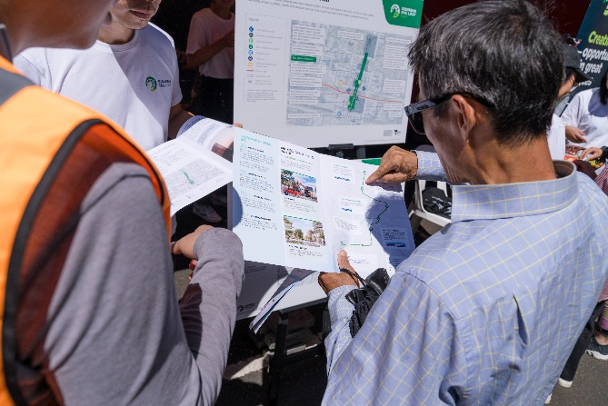
Suburban Rail Loop Authority has also taken significant steps to deepen its community and stakeholder engagement, including with the launch of a culturally and linguistically diverse steering committee. This is a first for a major project in Victoria and is aimed at improving conversations and collaboration with the diverse communities along the Suburban Rail Loop East rail alignment. Our online engagement with communities has also grown substantially, with a 31 per cent rise in website visits (to nearly 600,000) and a 24 per cent increase in social media followers.

Sustainability at the forefront
To meet the high standards set in our Environment Effects Statement, sustainability is at the forefront of project design, planning and delivery of both the rail infrastructure and station precinct structure planning. Suburban Rail Loop Authority and our contract partners are on track to deliver on key sustainability objectives and targets, including carbon emissions, energy, water, waste and materials. Our sustainability team has supported contract partners on site with Environmental Protection Regulation implementation and compliance, while providing critical advice to procurement teams evaluating proposals for Stations and Linewide contracts.
Suburban Rail Loop Authority Is committed to the Victorian Government’s Recycled First Policy, which ensures that as much recycled and reused material as possible is used on the project. We have a target of diverting more than 95 per cent of construction and demolition waste from landfill, and we are making progress towards our target of planting 4,000 trees. Hundreds of native trees have been planted along Gardiners Creek in Burwood and Blackburn Creek in Box Hill, creating new habitats for local insects, birds and wildlife, and improving the trails where locals ride, walk and run. A new community space created in Clayton, with a playground and recreation space, has been landscaped with new native trees.
Suburban Rail Loop Authority’s annual sustainability report was published mid-2025, demonstrating progress and innovation – from recycled crumb rubber barriers to solar-powered ecosites for temporary offices on site, recycled concrete hardstands for ground reinforcement, and electric vehicles for construction crews charged with renewable energy.
As part of Suburban Rail Loop Authority’s commitment to support local biodiversity in its precincts, professional beekeeping service Bees Melbourne has been engaged to carefully relocate more than 10,000 bees to an apiary in Pakenham after the discovery of several bee colonies during construction works in Monash.
Our Tunnels South contractor is trialling pedestrian and delineation barriers made from recycled tyres – a Victorian first
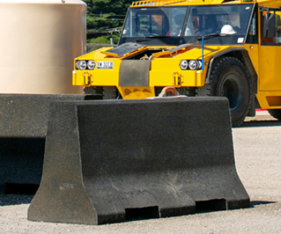

People and opportunities
As a multi-decade project, Suburban Rail Loop has the opportunity to create foundational change that will encourage greater diversity, expand the talent pool and boost productivity across our nation’s construction and infrastructure sectors. With more than 3,000 people already working on the project and thousands more jobs in the pipeline, Suburban Rail Loop Authority is committed to leaving an enduring legacy of skilled workers who can deliver the infrastructure for the next generation.
The Suburban Rail Loop Authority Graduate Program is going from strength to strength, with 14 new recruits from diverse backgrounds in the 2025 intake, and five recruits from the 2023 cohort moving into permanent roles, further developing their skills and taking on new responsibilities. The 2026 recruitment campaign, launched mid-year, attracted well over 1,000 applicants.
Suburban Rail Loop Authority graduate cohort 2025 – induction
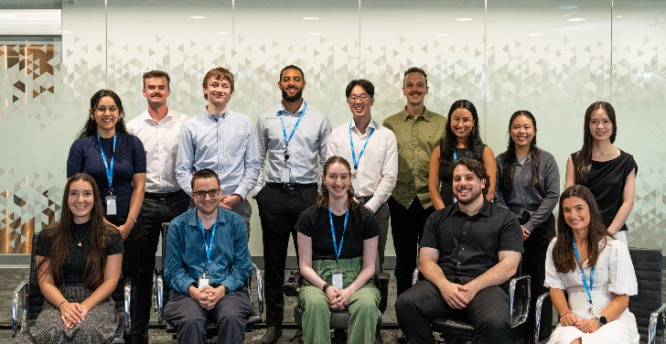
The 2024 recruitment campaign for the all-women tunnel boring machine crew attracted almost 900 applicants. Training is now underway for the crew, led by Isolde Piet, who was the world’s first female tunnel boring pilot. Tunnelling contractors are identifying other job opportunities on the project or with supply chain partners for suitable applicants not selected for the crew.
In line with Victoria’s Local Jobs First Policy, each of the three awarded major works contractors are on track to meet their commitment to exceed the 10 per cent target for hours worked by apprentices, trainees and cadets. And both of Suburban Rail Loop Authority’s tunnels contractors are fulfilling Victoria’s Building Equality Policy requirement for 40 per cent of these hours to be worked by women.
In partnership with RMIT University’s Engineering Higher Apprenticeships program, engineering students are gaining valuable on-the-job experience by working part-time on Tunnels South while they complete their studies. It is expected they will work a combined 48,000 hours on the project across the five years. Similar partnerships are also being established with Melbourne Polytechnic, Holmesglen TAFE, CareerTrackers and CareerSeekers.
Suburban Rail Loop Authority is off to a strong start in delivering social impact. Across Suburban Rail Loop East, at least 2.5 per cent of hours will be worked by Victorian Aboriginal people, and more than two per cent by Victorian priority jobseekers, including people with disability, long-term unemployed people and young people. Women are expected to work three per cent of trade roles, seven per cent of non-trade construction award covered roles, and 35 per cent of managerial, supervisory and specialist roles.
Examples of the project generating social value include the provision of civil construction works by Wamarra and office workwear and onsite personal protection equipment by A2B Consumables – both Aboriginal-owned and managed businesses that have expanded operations through Victoria’s Big Build. Several social enterprises, including Djookian, Cleanforce, OC Connections and Waverley Enterprises, have also been awarded contracts on the project – and, in turn, are providing employment opportunities for priority jobseekers.

Suburban Rail Loop East major milestones
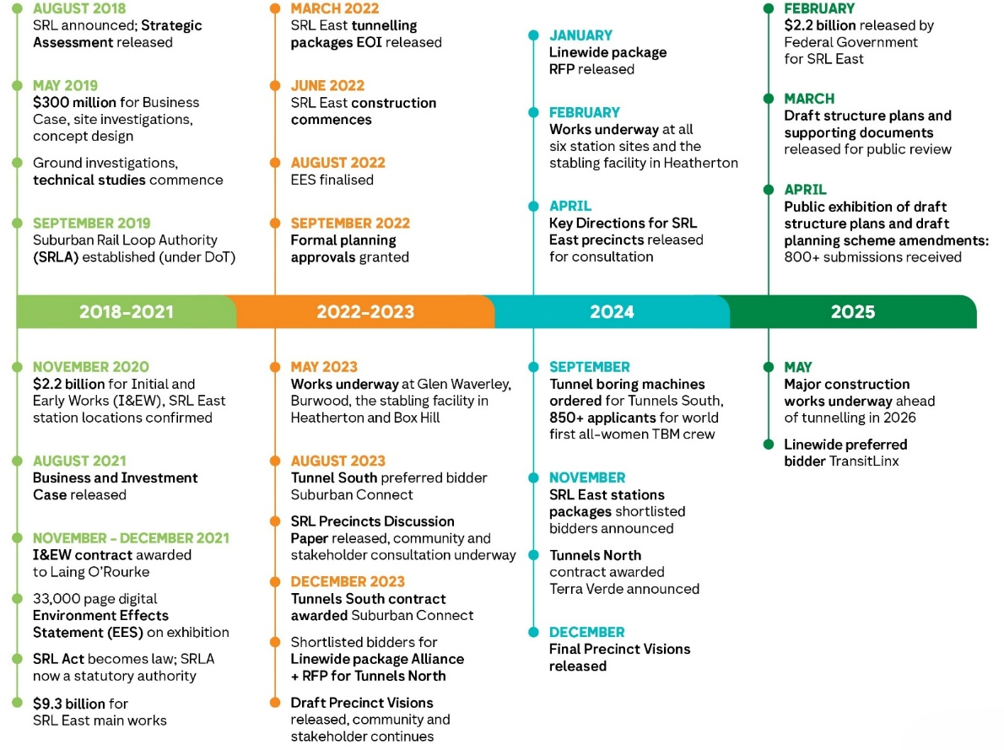

Governance

Minister
Honourable Harriet Shing, Member of Parliament, Minister for the Suburban Rail Loop.

Suburban Rail Loop Authority Board
Suburban Rail Loop Authority’s governing Board is responsible for the management and affairs of Suburban Rail Loop Authority, in particular:
- setting Suburban Rail Loop Authority’s strategic direction and priorities within the context of the Suburban Rail Loop Act and government policy
- ensuring Suburban Rail Loop Authority fulfils its objectives and functions effectively
- ensuring Suburban Rail Loop Authority complies with the Suburban Rail Loop Act and the regulatory framework within which it operates.
As at 30 June 2025, the Suburban Rail Loop Authority Board comprised four Directors:
- Honourable James Merlino (Chair)
- Ms Christine Wyatt (Deputy Chair)
- Mr Paul Barker
- Ms Sally Freeman.
The Board ensures the Victorian Government is informed of all significant matters regarding Suburban Rail Loop Authority. The Chief Executive Officer (CEO) is invited to attend each Board meeting.
The Suburban Rail Loop Authority Board held 15 meetings between 1 July 2024 and 30 June 2025, with attendance as follows:
Board Director | Eligible to attend | Attended
James Merlino | 15 | 15
Christine Wyatt | 15 | 14
Paul Barker | 15 | 15
Megan Bourke-O’Neil (refer note 1) | 2 | 2
Sally Freeman | 15 | 13
James MacKenzie (refer note 2) | 6 | 4
Notes:
- Directorship concluded 31 August 2024.
- Directorship concluded 30 November 2024.
Information about Directors’ remuneration is disclosed in the Financial Statements.

Board committees
Three committees operated during the reporting year:
- Audit and Finance Committee (refer note 1)
  - Paul Barker (Chair)
  - Sally Freeman
  - James Merlino
- Remuneration and People Committee
  - Christine Wyatt (Chair)
  - Sally Freeman
  - James Merlino
- Risk and Integrity Committee
  - Sally Freeman (Chair)
  - Paul Barker
  - James Merlino
  - Christine Wyatt
Notes:
- The Audit and Finance Committee undertakes reviews and makes recommendations to assist the Board to fulfil its responsibilities in relation to Suburban Rail Loop Authority’s financial management, performance and sustainability obligations. This includes considering financial risk management and the independence and performance of the internal audit function.

Information provided to the Minister and Treasurer
Reports are provided to, and as required and determined by, the Minister and Treasurer. Reporting includes information:
- regarding financial and delivery performance
- to support the Minister to meet Parliamentary responsibilities in respect of the exercise of Suburban Rail Loop Authority functions
- to inform the Minister regarding risk management activities in accordance with the Public Administration Act 2004.
Each annual report is provided to the Minister in accordance with the Suburban Rail Loop Act and Part 7 of the Financial Management Act 1994.

Suburban Rail Loop Authority Leadership Team and divisional structure
The Board is supported by the Executive Leadership Team (ELT), led by the Chief Executive Officer. The Chief Executive Officer is responsible for the day-to-day management of Suburban Rail Loop Authority in accordance with the general policies, strategic direction and priorities determined by the Board.
The Chief Executive Officer also holds the position of Accountable Officer under the Financial Management Act 1994 and is responsible for the relevant accountability and reporting obligations of Suburban Rail Loop Authority.
Executive Leadership Team members lead Suburban Rail Loop Authority divisions to achieve the organisation’s strategic and project outcomes. As at 30 June 2025, Suburban Rail Loop Authority had the following divisions:

Rail and Infrastructure Delivery
Responsible for implementing innovative and effective design and delivery solutions to help realise program objectives and benefits.
- Health and Safety establishes robust governance frameworks, manages risks and drives compliance with standards across rail operations, project delivery and organisational processes.
- Quality Assurance provides oversight to help ensure works are effectively delivered, managed and reviewed in accordance with Suburban Rail Loop Authority’s Integrated Management System (AIMS) requirements and standards.
- Engineering and Assurance provides oversight and expertise in technical design, digital engineering, information management, and structural and mechanical engineering.
- Initial and Early Works focusses on site preparation, including utilities relocation, setting up site accommodations for contractors and executing pre-demolition and demolition works.
- Tunnels and Civils oversee the installation and launch of tunnel boring machines for Suburban Rail Loop East’s 26km twin tunnel.
- Stations oversees delivery of the six Suburban Rail Loop East station boxes.
- Linewide and Operations oversees linewide delivery, including signalling, operations and maintenance (O&M) contracts and handover to operators.
- Technical and Commercial Interface provides management and coordination across work packages.
- Project Controls monitors and reports on cost, schedule and risk and administers the change management process.
- Rail Operations establishes requirements for the operator, serves as the internal client team and manages the day-to-day operations of assets contracted to Rail Train Operators (RTO).

Land, Planning, Environment and Sustainability
Leads the delivery of planning and environmental approvals; development of structure plans; and land access and transactions. The division helps ensure the Suburban Rail Loop program delivers positive environmental and community outcomes, while driving industry-leading sustainability opportunities. Activities led by the division include:
- land investigations, approvals and assembly
- precinct planning, including delivery of structure plans and planning scheme amendments for the six Suburban Rail Loop East precincts
- planning approvals, strategy and support for Rail and Infrastructure Delivery
- embedding quality urban design outcomes in infrastructure design and precincts
- environment and sustainability policy, procedures and management
- supporting Suburban Rail Loop Authority’s delivery partners to manage the impact on communities and the environment during construction and operation
- integrated transport planning
- spatial analysis and technical solutions
- coordinating Suburban Rail Loop Authority’s functions as a referral authority for applications under the Specific Controls Overlay Schedules 14 and 15 to protect project infrastructure
- coordinating Suburban Rail Loop Authority’s functions as a planning authority.

Strategic Communications and Engagement
Focussed on stakeholder engagement and consultation as well as communications activities to raise awareness and understanding of Suburban Rail Loop, the division develops and implements strategies to help Suburban Rail Loop Authority engage with local communities, stakeholders, government and the media.
The division manages Suburban Rail Loop Authority’s communication channels and its community relationships, including consultation, public information materials, as well as digital and in-person engagement and events. It also manages industry relationships and partnerships.
The division aims to nurture partnerships, build community awareness of the project, its delivery impacts and its benefits, and support and enhance the development and delivery of all elements of Suburban Rail Loop by capturing and incorporating stakeholder feedback into Suburban Rail Loop Authority’s transport and precinct plans.

Commercial
Provides comprehensive commercial and contractual leadership to support the successful procurement and delivery of Suburban Rail Loop East. The division shapes and implements procurement strategies that align with project objectives, advises on market engagement, and ensures all tender processes are fair, transparent and compliant.
The division is involved throughout the entire project lifecycle, from early planning and tender development, through bidder evaluation and contract negotiation, to contract award and ongoing contract management. It ensures that contracts are commercially sound, clearly structured, and aligned with the project's and the organisation's broader needs. It manages commercial risk, drives value for money and supports effective contractor performance. This includes resolving issues, managing change and overseeing compliance with contractual obligations.
The division also serves as a critical link between legal, technical and delivery teams, ensuring that commercial thinking is embedded in decision-making at every stage.

Strategy and Policy
Identifies strategic policy opportunities to leverage the Suburban Rail Loop program for long-term benefit and to help meet Suburban Rail Loop’s strategic objectives, as well as monitoring initiatives and legacy outcomes. Strategy and Policy also leads for Suburban Rail Loop Authority on long-term precinct-wide property development opportunities and strategies, which includes value creation and capture.
The division is focussed on:
- Delivering economic and social strategies to realise the productivity and liveability outcomes identified in the Suburban Rail Loop Business and Investment Case. This includes a strong focus on economic strategies that centre on precinct job creation and investment, as well as implementing an evidence-based and cohesive approach to economic development across Suburban Rail Loop East, including tracking benefits.
- Identifying, developing, implementing and monitoring initiatives and contractual requirements that connect new and underrepresented Victorian workers and social benefit suppliers to project opportunities, including monitoring government requirements under the Victorian Government’s Social Procurement Framework, Building Equality Policy and Major Projects Skills Guarantee.
- Creating and implementing long-term precinct-wide property development opportunities and strategies. Strategy and Policy partners with internal and external stakeholders to integrate property development opportunities with rail infrastructure and broader precinct objectives.

Chief Operating Officer
Responsible for people, cabinet and ministerial, internal audit, strategic planning and performance, legal and procurement advice and services to support decision-making and project delivery.
Responsibilities include:
- supporting the needs of Suburban Rail Loop Authority staff, managing related policies and procedures and helping to ensure Suburban Rail Loop Authority has the capability and capacity for effective project delivery
- supporting Suburban Rail Loop Authority's key decisions and approvals, coordinating and preparing materials for Suburban Rail Loop Authority/Suburban Rail Loop governance, and briefing and correspondence for Suburban Rail Loop Authority’s Chief Executive Officer, Minister and Victorian Government’s Department of Transport and Planning
- supporting work packages on legal matters including procurement, land assembly, structure planning, delivery, insurance, disputes and safety and accreditation
- providing the Executive and Board with unbiased and objective evaluations of Suburban Rail Loop Authority’s risk management, control and governance processes through effective internal audit
- general legal queries, freedom of information, privacy and governance oversight at Suburban Rail Loop Authority
- managing Suburban Rail Loop Authority's approach to integrity, probity, assurance and compliance
- providing guidance and support for all goods and services procurements, including framework/procedure development and implementation, sourcing advice/support and contract management support
- overseeing Suburban Rail Loop Authority’s technical service contracts
- leading for Suburban Rail Loop Authority on enterprise and corporate risk management
- delivering Suburban Rail Loop Authority’s annual corporate plan, including tracking progress, and annual report.

Office of the Chief Financial Officer
Responsible for providing financial, administrative and information technology advice, guidance and support to Suburban Rail Loop Authority. Activities include:
- budget management, planning, monitoring and reporting
- preparing the statutory annual financial statements for the annual report
- embedding internal control procedures and systems into Suburban Rail Loop Authority’s financial management activities
- asset management
- providing business services for facilities, fleet and mail
- delivering and enabling fit for purpose technology experiences across information and cyber security, data and analytics, and technology operational support
- company secretarial services to the Suburban Rail Loop Authority board and its subcommittees.

Suburban Rail Loop Authority structure
As at 30 June 2025.
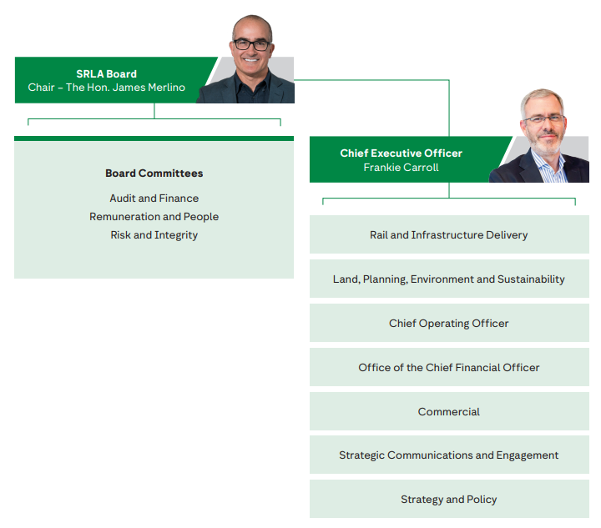

People and workplace
Over the year, Suburban Rail Loop Authority continued to develop and enable our people to deliver Suburban Rail Loop – while fostering an environment of diversity and inclusion. Into 2025-26, Suburban Rail Loop Authority will continue to review its future workforce needs as the organisation’s focus moves from planning and procurement to major delivery.

Public sector values and employment principles
Suburban Rail Loop Authority is pursuing initiatives to foster the highest standard of integrity and conduct, building leadership capability and supporting staff to create and maintain a workplace that demonstrates respect, trust and openness. Over 2024-25, Suburban Rail Loop Authority progressed initiatives and activities to underline and further its commitment to the Victorian Public Sector values and the employment principles set out in the Public Administration Act 2004.

People Strategy
The Suburban Rail Loop Authority People Strategy 2021-25 is our commitment to invest in Suburban Rail Loop Authority’s people, underpinned by five focus areas: workforce capability; employee wellbeing; building a high-performing environment; future-focussed leadership; and embedding a growth culture while embracing inclusion.
Suburban Rail Loop Authority undertook work to update the strategy over 2024-25. The refreshed strategy support ways of working and structures needed for major project delivery.

Employment programs
The size, scope and duration of the Suburban Rail Loop program provides for a wide range of career and development opportunities – and Suburban Rail Loop Authority’s workforce planning is identifying future needs and programs to attract, develop and retain the people and skills required to deliver Suburban Rail Loop Authority East.
Suburban Rail Loop Authority provides early career opportunities through internships and its established Graduate Program. The program gives graduates the opportunity to contribute to a city shaping project, gain valuable experience and exposure, and take their first – and all important – steps on a career pathway in the industry.
Suburban Rail Loop Authority partners with Victorian Government departments, Big Build projects and delivery partners to showcase the career opportunities across Victoria’s transport and infrastructure projects. Throughout 2024-25, Suburban Rail Loop Authority attended high school engagement programs and university careers events, job skills expos, and trade and technology fairs. Through these events, Suburban Rail Loop Authority connected with a diverse cohort of future workers to highlight the variety of career pathways available at Suburban Rail Loop Authority.
Melbourne STEM Women Careers Event
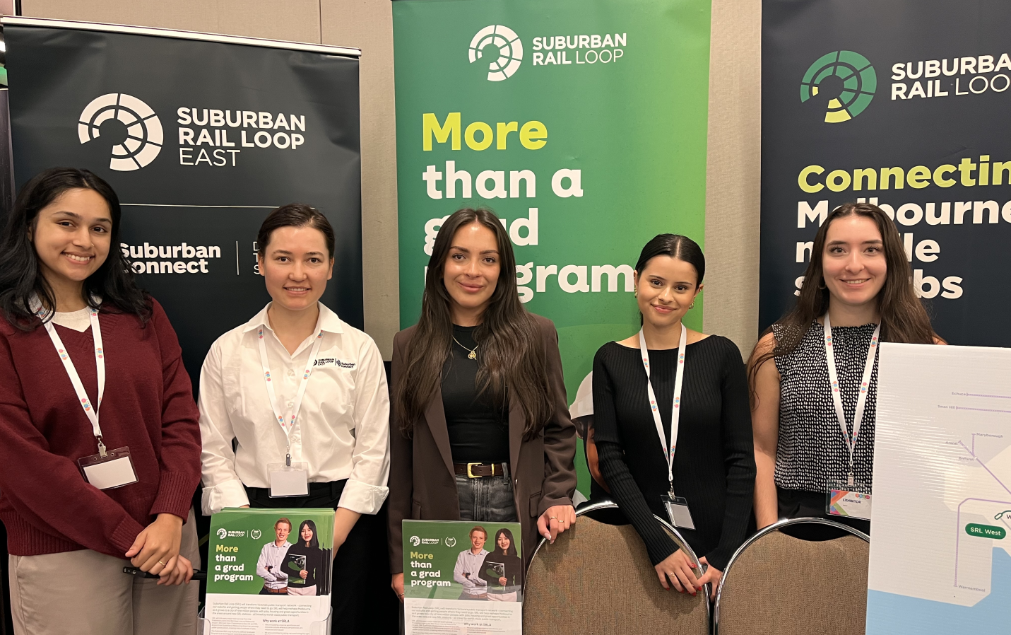

Learning and development
Suburban Rail Loop Authority is dedicated to fostering a culture of continuous growth, equipping our people with the skills and knowledge to excel. In 2024-25, we advanced our commitment to professional excellence through targeted initiatives aligned with organisational and individual needs, leveraging the VicGov People platform to enhance performance and learning across the organisation.

Performance development planning
Through individualised Performance Development Plans (PDPs), Suburban Rail Loop Authority empowers its employees to set clear goals aligned with organisational priorities. These plans are supported by structured in-year and end-of-year progress review and feedback, as well as discussions about professional development.

Development opportunities
Staff have access to a range of internal and external opportunities to support the development of skills and career progression. In 2024-25, Suburban Rail Loop Authority joined LinkedIn Learning giving staff access to its library of over 20,000 courses.
Suburban Rail Loop Authority’s Learning and Development Week ran in August 2024.

Leadership development
Suburban Rail Loop Authority is committed to building future-focussed leaders to support its people and project delivery. In 2025, Suburban Rail Loop Authority launched a new series of People and Senior Leader Forums, which provide a platform for staff to connect, share experiences and strengthen their skills. Other initiatives in the past 12-months include the introduction of an executive coaching program for senior leaders and development of a People Leader Essentials training guide.

Workforce inclusion
Suburban Rail Loop Authority is committed to encouraging, enabling and embracing an inclusive and diverse workforce that reflects the communities Suburban Rail Loop Authority serves.
Suburban Rail Loop Authority invests in programs and strategies to raise awareness and celebrate difference, and places a priority on ensuring there is a safe and inclusive workplace for the following groups:

First Peoples
In 2024-25, Suburban Rail Loop Authority strengthened its engagement, consultation and collaboration with First Peoples communities and Traditional Owners to ensure cultural respect and inclusivity within the organisation.
To attract current and future Aboriginal talent, Suburban Rail Loop Authority’ Skill Builder Program provides work experience opportunities for First Peoples university students while the Graduate Program has dedicated roles for First Peoples.
To promote everyone’s responsibility for Aboriginal inclusion and cultural safety, Suburban Rail Loop Authority established Balak Wartakangatj, meaning ‘people together’ in Dja Dja Wurrung language.
Dixon Patten’s ‘Remembering Country’
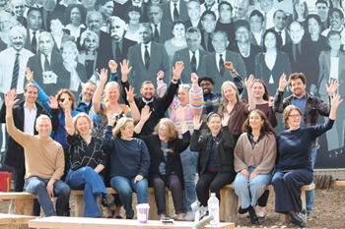
Balak Wartakangatj is Suburban Rail Loop Authority’s first employee network group to promote and champion self-determination, cultural safety and Aboriginal inclusion. In 2024-25, the group developed an Initiatives Plan with a focus on ensuring Suburban Rail Loop Authority staff are more confident engaging Aboriginal stakeholders and bringing Aboriginal perspectives into their work – helping ensure Suburban Rail Loop East’s benefits, which will be realised on Wurundjeri and Bunurong Country, are maximised.
In 2025, Suburban Rail Loop Authority staff celebrated Reconciliation Week, with the emphasis on moving forward together. The week commenced with an internal event that unveiled our Suburban Rail Loop Authority-commissioned Aboriginal artwork ‘Remembering Country’ by Dixon Patten and included ‘yarning’ sessions for staff on Acknowledging Traditional Owners, sharing personal stories and explaining Aboriginal cultures.
Suburban Rail Loop Authority’s Balak Wartakangati


People with disability
Suburban Rail Loop Authority continues to support accessibility and inclusivity for staff living with disability. Suburban Rail Loop Authority’s office at 222 Exhibition Street, Melbourne is accessible and benefits from recommendations by a working group ensure it met the needs of staff with disability.
Suburban Rail Loop Authority has embedded dedicated opportunities within its Graduate Program for people living with disability.
Suburban Rail Loop Authority’s membership with the Australian Disability Network continues to inform best practice, strengthen our understanding of disability, increase awareness of workplace adjustments and other initiatives to support the needs and expectations of people living with disability.

Women and Suburban Rail Loop Authority’s Gender Equality Action Plan
Suburban Rail Loop Authority submitted its first progress report against the seven gender equality indicators to the Commission for Gender Equality in February 2024. Suburban Rail Loop Authority continues to implement its Gender Equality Action Plan and support transport sector commitments under the Women in Transport program. Highlights include:
- supporting 28 Suburban Rail Loop Authority mentors and mentees to participate in the Women in Transport Mentoring Program
- sponsoring eight women to attend the Women in STEMM Leadership Summit
- awarding three scholarships as part of the Women in Transport Leadership Development Scholarship Program, which will help these women undertake postgraduate studies to advance their career in transport
- establishing a Gender Impact Assessment Think Tank to share knowledge and insights into how to conduct Gender Impact Assessments
- commencing consultation to develop a new Gender Equality Action Plan 2026-30.
In 2024-25, Suburban Rail Loop Authority also participated in community engagement and campaigns to promote women in transport. This included attendance at Melbourne STEM Graduate Careers event, Melbourne Uni Graduate Careers Fair, Deakin University Careers Fair, Box Hill Careers Expo, RMIT Careers Fair and Monash Speed X 2024.

Culturally and Linguistically Diverse (CALD) staff
Suburban Rail Loop Authority is home to a diverse mix of cultures, faiths and languages, with staff speaking more than 20 languages.
Suburban Rail Loop Authority acknowledges the unique barriers that are sometimes encountered by people in the Culturally and Linguistically Diverse community, and aims to reduce and remove these barriers to ensure Culturally and Linguistically Diverse communities can fully and equally participate in the workforce, access all occupations, and feel empowered irrespective of their race, religion, cultural or linguistic backgrounds.
During the 2025 Suburban Rail Loop Authority Health and Wellbeing Expo, a cultural food sharing experience was hosted by the Wellbeing and Inclusion team to celebrate the diversity of the Suburban Rail Loop Authority community. Employees were invited to bring a dish reflecting their place of birth, ancestry or a country they felt connected to, creating a link to each other through food.
Suburban Rail Loop Authority’s cultural celebration lunch
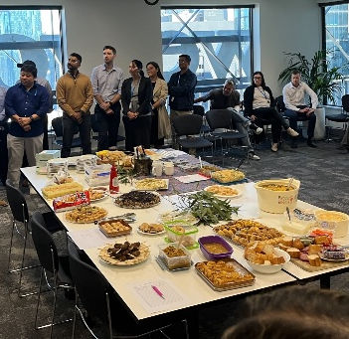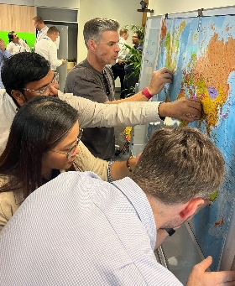
Suburban Rail Loop Authority encourages and supports staff to participate in the Victorian Government’s Department of Transport and Planning Culturally and Linguistically Diverse network and whole of government Culturally and Linguistically Diverse groups through the innovation network.
Suburban Rail Loop Authority continues to leverage its membership with Diversity Council Australia to increase its Culturally and Linguistically Diverse awareness and support for employees from diverse backgrounds.

LGBTIQA+
Suburban Rail Loop Authority aims to provide a workplace that is fully inclusive for our LGBTIQA+ workforce. This includes creating a culture where LGBTIQA+ people feel safe to identify and bring their whole selves to work.
To support Suburban Rail Loop Authority’s people to better understand the LGBTIQA+ community, a range of training opportunities were offered to staff through Suburban Rail Loop Authority’s Pride in Diversity membership.
‘Empowering Allies’ sessions were delivered to equip staff with the knowledge and skills to be champions for LGBTIQA+ colleagues.
A 'Foundations of LGBTIQA+ Inclusion' eLearning module, created by Pride in Diversity, was promoted to all staff as an avenue to build awareness and inclusion.
In 2025, Suburban Rail Loop Authority partnered with BentTransport, Victorian Government’s Department of Transport and Planning’s LGBTIQA+ Pride working group, to take part in Midsumma Festival Carnival and the Pride March. These events were a great opportunity to show support for and engage with the LGBTIQA+ community.

Wellbeing
Suburban Rail Loop Authority is focussed on building an organisation that promotes and protects employee wellbeing through initiatives that increase wellbeing awareness, build capability and create engagement – supporting everybody to be their best at work.
Suburban Rail Loop Authority wellbeing support for employees includes:

Peer Supporters
Peer Supporters provide informal, confidential support to employees by using an active listening, clarification and referral model.

Mental Health First Aid Officers and Mental Health First Aid training
Suburban Rail Loop Authority’s accredited Mental Health First Aid Officers (MHFAOs) support employees who are experiencing mental health challenges. As at 30 June 2025, 23 staff had been appointed Mental Health First Aid Officers.

Wellbeing Champion Network
Suburban Rail Loop Authority’s Wellbeing Champion Network consists of Peer Supporters and Mental Health First Officers and promotes positive mental health and wellbeing.

Employee Assistance Program (EAP)
Suburban Rail Loop Authority’s Employee Assistance Program, facilitated by one of Australia’s leading mental health providers, provides confidential support services to all Suburban Rail Loop Authority employees and their immediate family members. This includes a dedicated Manager Support Program.
As part of a partnership program with Victorian Government’s Department of Transport and Planning, Suburban Rail Loop Authority has engaged Aboriginal business Girraway Ganyi to provide culturally safe and inclusive employee assistance services.

Suburban Rail Loop Authority workforce information

Suburban Rail Loop Authority workforce statistics as at June 2025
Category | All employees Number | All employees Full Time Equivalent | Ongoing Full time | Ongoing Part time | Ongoing Full Time Equivalent | Fixed term & casual Number | Fixed term & casual Full Time Equivalent
Gender – Woman | 284 | 277.3 | 161 | 20 | 176.3 | 103 | 101.0
Gender – Man | 397 | 396.1 | 174 | 4 | 177.3 | 219 | 218.8
Gender – Self-described | 0 | 0 | 0 | 0 | 0 | 0 | 0
Age 15-24 | 20 | 20.0 | 3 | 0 | 3.0 | 17 | 17.0
Age 25-34 | 152 | 151.0 | 84 | 2 | 85.4 | 66 | 65.6
Age 35-44 | 288 | 282.2 | 131 | 20 | 146.7 | 137 | 135.6
Age 45-54 | 161 | 160.3 | 88 | 1 | 88.6 | 72 | 71.6
Age 55-64 | 54 | 53.9 | 25 | 1 | 25.9 | 28 | 28.0
Age 65+ | 6 | 6.0 | 4 | 0 | 4.0 | 2 | 2.0
Classification VPS 1 | 0 | 0 | 0 | 0 | 0 | 0 | 0
Classification VPS 2 | 0 | 0 | 0 | 0 | 0 | 0 | 0
Classification VPS 3 | 36 | 36.0 | 5 | 0 | 5.0 | 31 | 31.0
Classification VPS 4 | 78 | 77.1 | 51 | 5 | 55.1 | 22 | 22.0
Classification VPS 5 | 114 | 113.0 | 78 | 4 | 81.0 | 32 | 32.0
Classification VPS 6 | 228 | 224.2 | 131 | 12 | 140.0 | 85 | 84.2
Classification PS | 5 | 5.0 | 4 | 0 | 4.0 | 1 | 1.0
Classification STS | 134 | 132.7 | 66 | 3 | 68.5 | 65 | 64.3
Classification Executive | 86 | 85.4 | 0 | 0 | 0 | 86 | 85.4
Total employees | 681 | 673.4 | 335 | 24 | 353.6 | 322 | 319.8
Notes:
- FTE means full-time equivalent.
- STS refers to Senior Technical Specialist.
- PS refers to Principal Scientist.
- All figures reflect employment levels during the last full pay period of the financial year.
- External contractors/consultants and temporary employees employed by employment agencies are, in line with guidance for Victorian Government annual reports, excluded from the above employment data.
- Also in line with guidance, Executive Officers are treated as ongoing employees except where employed for discrete projects.
- Across 2024-25, Suburban Rail Loop Authority recruited prudently for the workforce necessary to deliver Suburban Rail Loop. Recruitment is programmed to reflect delivery timelines, including the progress of Initial and Early Works, the start of Main Works in 2026 and to enable the community consultation on and planning for the neighbourhoods around each Suburban Rail Loop East station.

Suburban Rail Loop Authority workforce statistics as at June 2024
Category | All employees Number | All employees Full Time Equivalent | Ongoing Full time | Ongoing Part time | Ongoing Full Time Equivalent | Fixed term & casual Number | Fixed term & casual Full Time Equivalent
Gender – Woman | 268 | 262.7 | 132 | 12 | 141.1 | 124 | 121.6
Gender – Man | 382 | 380.7 | 174 | 6 | 178.9 | 202 | 201.8
Gender – Self-described | 0 | 0 | 0 | 0 | 0 | 0 | 0
Age 15-24 | 18 | 18.0 | 1 | 0 | 1.0 | 17 | 17.0
Age 25-34 | 164 | 163.0 | 67 | 2 | 68.4 | 95 | 94.6
Age 35-44 | 262 | 257.8 | 123 | 10 | 130.7 | 129 | 127.1
Age 45-54 | 152 | 151.1 | 85 | 4 | 88.4 | 63 | 62.7
Age 55-64 | 49 | 48.5 | 28 | 2 | 29.5 | 19 | 19.0
Age 65+ | 5 | 5.0 | 2 | 0 | 2.0 | 3 | 3.0
Classification VPS 1 | 0 | 0 | 0 | 0 | 0 | 0 | 0
Classification VPS 2 | 0 | 0 | 0 | 0 | 0 | 0 | 0
Classification VPS 3 | 38 | 38.0 | 6 | 0 | 6.0 | 32 | 32.0
Classification VPS 4 | 75 | 73.8 | 34 | 4 | 37.2 | 37 | 36.6
Classification VPS 5 | 112 | 111.0 | 59 | 2 | 60.6 | 51 | 50.4
Classification VPS 6 | 203 | 200.1 | 79 | 6 | 83.3 | 118 | 116.8
Classification PS | 6 | 6.0 | 5 | 0 | 5.0 | 1 | 1.0
Classification STS | 127 | 126.3 | 38 | 2 | 39.7 | 87 | 86.6
Classification Executive | 89 | 88.2 | 85 | 4 | 88.2 | 0 | 0
Total employees | 650 | 643.4 | 306 | 18 | 320.0 | 326 | 323.4

Senior Executive Service data
An Executive Officer (EO) is defined as a person employed as an executive under Part 3 of the Public Administration Act 2004 or a person to whom the Victorian Government’s Policy on Executive Remuneration in Public Entities applies. The definition of an Executive Officer does not include a statutory office holder or an Accountable Officer.
All figures in the tables below reflect employment levels at the last full pay period in June 2025.

Total number of executives by gender
Classification | All | Man | Woman | Self-described
Chief Executive Officer | 1 | 1 | 0 | 0
SES3 | 6 | 4 | 2 | 0
SES2 | 61 | 54 | 7 | 0
SES1 | 18 | 14 | 4 | 0
Total | 86 | 73 | 13 | 0

Reconciliation of executive numbers
Executive Classification | 2025 | 2024
Executives | 100 | 102
Add Accountable Officer (Chief Executive Officer) | 1 | 1
Less leave without pay | 0 | 0
Less separations | (15) | (14)
Less other | 0 | 0
Total executives | 86 | 89
Notes:
- Figures do not include staff on higher duties in vacant SES positions.
- 'Other' captures executive movements to non-executive roles.

Annualised total salary for senior employees by classification
Range | Executive | STS | PS
<$160,000 | 0 | 0 | 0
$160,000 – $179,000 | 0 | 0 | 0
$180,000 – $199,999 | 0 | 15 | 0
$200,000 - $219,000 | 3 | 42 | 1
$220,000 - $239,000 | 3 | 27 | 1
$240,000 - $259,999 | 12 | 50 | 3
$260,000 - $279,000 | 9 | 0 | 0
$280,000 - $299,999 | 15 | 0 | 0
$300,000 – $319,999 | 7 | 0 | 0
$320,000 – $339,999 | 5 | 0 | 0
$340,000 – $359,999 | 5 | 0 | 0
$360,000 – $379,999 | 12 | 0 | 0
$380,000 – $399,999 | 3 | 0 | 0
$400,000 – $419,999 | 0 | 0 | 0
$420,000 – $439,999 | 2 | 0 | 0
$440,000 – $459,999 | 1 | 0 | 0
$460,000 – $479,999 | 3 | 0 | 0
$480,000 – $499,999 | 2 | 0 | 0
>$500,000 | 4 | 0 | 0
Total | 86 | 134 | 5
Notes:
- The salaries reported above are the full time equivalent total remuneration less superannuation.
- There was a total of 12 senior employees employed on a part-time basis as at 30 June 2025: 4 SES and 8 STS. The part-time fractions ranged from 0.79 to 0.95 FTE.

Health and safety
A top priority for Suburban Rail Loop Authority is ensuring the safe delivery of Victoria’s biggest infrastructure project. Suburban Rail Loop Authority’s Health and Safety Strategy commits Suburban Rail Loop Authority to strive to achieve unrivalled Health and Safety performance and outcomes by actively safeguarding and enhancing the wellbeing of our people, our industries and the communities we work in.

Health and safety of Suburban Rail Loop Authority’s people
In 2024-25, there were no recordable injuries to Suburban Rail Loop Authority’s employees. The All Injury Frequency Rate (AIFR) for Suburban Rail Loop Authority employees remained low at 2.97 injuries per million hours worked.
Key Health and Safety initiatives undertaken over 2024-25 included:
- Development of the new Health and Safety Strategy 2025-2029 - continuing Suburban Rail Loop Authority’s focus on unrivalled Health and Safety.
- Psychosocial training delivered.
- Virtual Site Walks 2.0, with additional 3D modelling visualisation.
- Simulated Active Client Training at the Master Builders Association of Victoria.
- Partnered with the Victoria Infrastructure Delivery Authority (VIDA) to launch the Major Infrastructure Safety Hub (MISH) within Suburban Rail Loop Authority. Major Infrastructure Safety Hub is supporting the sharing of industry safety insights, research and lessons learnt.
- 98 per cent of staff completed Health and Safety induction training.

Embedding health and safety in project delivery
In 2024-25, Suburban Rail Loop Authority continued its role as an Active Client through proactive engagement with our industry partners.
Eight recordable injuries to Suburban Rail Loop East’s industry partners’ workforce were recorded and the all injury frequency rate remained low at 10.7 injuries per million hours worked.
Key Health and Safety initiatives undertaken over 2024-25 included:
- Awarded Suburban Rail Loop East work package contracts included Safety Lead Indicators relating to Suburban Rail Loop Authority’s Health and Safety strategic pillars (Safety Leadership, Culture, Risk, Governance and Capability, and driving higher order solutions that are based on engineering and technology).
- Independent Safety Audits were completed across all works packages in delivery, with results indicating good application of client relations in safety management practices.
- Suburban Rail Loop Authority’s assurance program included 224 ‘Health and Safety site diaries’ and 139 ‘critical risk inspections’.
- Suburban Rail Loop Authority’s senior leaders participated in 37 ‘senior leader walks’ to maintain awareness and understanding of Suburban Rail Loop Authority’s contractors’ works and activities.
- Development of a Finals Campaign safety initiative with Laing O’Rourke to support the safe completion of remaining Initial and Early Works activities.

Rail safety
In December 2024, the Orange Book – which provides the code of practice for Victorian Traction Industry Electrical Safety Rules – was updated to allow for a 25 kV AC traction power configuration to be compliant under Victorian electrical legislation.
This update was as a result of safety analysis undertaken by Suburban Rail Loop Authority, in consultation with Energy Safe Victoria and the Victorian Railway and Tramway Electrical Safety Committee.

Health and safety metrics for Suburban Rail Loop Authority employees
Indicator | 2024-25 | 2023-24 | 2022-23
Assurance and governance activities (refer note 1) | 426 | 363 | 111
High potential incidents | 0 | 0 | 0
Suburban Rail Loop Authority (employer) Regulatory Notices (refer note 2) | 0 | 0 | 0
Incidence rate (VPS) (refer note 3) | 3.11 | 1.33 | 1.1.1
Lost time injury frequency rate (LTIFR) | 0 | 0 | 0
Total recordable injury frequency rate (TRIFR) (refer note 4) | 0 | 0 | 0
Average cost per worker compensation claim | $15,591 | $14,669  (refer note 5) | N/A
Notes:
- ‘Assurance and governance activities’ capture the number of ‘critical risk inspections’ and ‘office and site inspections’ conducted during the reporting period. Please note that in 2024-25, ‘Health and Safety walks’ have been combined with ‘assurance and governance’ into a single category ’Suburban Rail Loop Authority Assurance and Governance activities’.
- ‘Regulatory notices’ are notices issued to Suburban Rail Loop Authority by WorkSafe or ONRSR.
- ‘Incidence rate’ is calculated as: (number of incidents [divided by] number of full-time equivalents) [multiplied by] 100 full-time equivalents. Note ‘incidents’ exclude COVID-19 cases, environmental and ‘report only’ consequence types. Further, the methodology for calculating this indicator has been revised, with full-time equivalents rather than hours worked now the denominator (as per relevant guidance). The increase in the incidence rate for 2024-25 was due to Suburban Rail Loop Authority running several initiatives, such as launching an online incident notification form, raising safety awareness and fostering a more mature incident reporting culture within the organisation.
- ‘Total recordable injury frequency rate’ is calculated as: (number of recordable injuries [divided by] number of hours of works) [multiplied by] 1,000,000 hours. In 2024-25, there were no recorded injuries.
- Two WorkCover claims were registered in 2023-24 but determined in 2024-25. This figure was therefore not available to be included in the 2023-24 annual report.

2. Disclosures

Local Jobs First
The Local Jobs First (LJF) policy supports Victorian businesses and workers by ensuring small and medium size enterprises are given a full and fair opportunity to compete for both large and small government contracts. This helps create job opportunities, including for apprentices, trainees and cadets.
The Local Jobs First policy comprises the Victorian Industry Participation Policy (VIPP) and the Major Projects Skills Guarantee (MPSG). Victorian Government bodies are required to apply the Local Jobs First policy in all projects valued at $3 million or more in metropolitan Melbourne or state-wide projects, and $1 million or more for projects in regional Victoria.
Victoria’s Major Projects Skills Guarantee requires construction projects to commit to a minimum of 10 per cent of total estimated labour hours to be worked by registered Victorian apprentices, trainees and cadets.

Local Jobs First – Strategic projects
For projects valued at over $50 million, known as Strategic Projects, the Victorian Industry Participation Policy requires bidders to commit to a level of local content that meets or exceeds the minimum level set by the Minister for Industry.
The Major Projects Skills Guarantee applies to all construction projects valued at $20 million or more.
One Local Jobs First – Strategic project commenced in the reporting year (below); no such projects were completed.

Tunnels North – Terra Verde
The Tunnels North contract was awarded to Terra Verde in November 2024, valued at approximately $1.7 billion. The project is based in metropolitan Melbourne and is subject to both the Victorian Industry Participation Policy and the Major Projects Skills Guarantee. The commitments made are:
- 92.05 per cent local content for the entire scope of works, excluding tunnel boring machines (minimum commitment 92 per cent)
- 91.40 per cent local content for steel products (minimum commitment 90 per cent)
- Major Projects Skills Guarantee total labour hours of 179,534 to be created for apprentices, trainees and cadets
- Major Projects Skills Guarantee total labour hours of 91,072 total labour hours to be retained for apprentices, trainees and cadets
- Major Projects Skills Guarantee total estimated labour hours of 11 per cent to be performed by apprentices, trainees and cadets, representing a commitment to exceed the requirement by one percentage point
- 471 small to medium sized businesses engaged, captured in the Terra Verde Local Industry Development Plan.

Local Jobs First – Standard projects
During 2024-25, Suburban Rail Loop Authority commenced three new Local Jobs First – Standard projects with contract values totalling $11.80 million.
The commitments made are:
- Victorian jobs created: 10,950 hours
- Victorian jobs retained: 16,498 hours
- Australian and New Zealand (ANZ) jobs retained: 4,160 hours
- small to medium sized businesses engaged: 13
During 2024-25, Suburban Rail Loop Authority completed two Local Jobs First – Standard projects. The value of the two contracts was $11.6m.
The commitments made were:
- Victorian cadet jobs created: 3,012 hours
- Victorian cadet jobs retained: 5,020 hours
- Victorian jobs created: 8,563 hours
- Victorian jobs retained: 60,067 hours
- Australian and New Zealand cadet jobs created: 460 hours
- Australian and New Zealand jobs created: 263 hours
- Australian and New Zealand jobs retained: 835 hours
- small to medium sized businesses engaged: 23.
The following outputs were achieved:
- Victorian cadet jobs created: 900 hours
- Victorian cadet jobs retained: 2,350 hours
- Victorian jobs created: 900 hours
- Victorian jobs retained: 35,116 hours
- Australian and New Zealand jobs retained: 320 hours
- small to medium sized businesses engaged: 5.
Note: expenditure under these two contracts was materially less than initially envisaged. The lower volume of work required to complete the projects impacted Local Jobs First outputs.

Social procurement
Suburban Rail Loop Authority’s Social Procurement Strategy 2023-25 prioritised the following objectives from Victoria’s Social Procurement Framework:
- opportunities for Victorian Aboriginal people
- opportunities for Victorians with disability
- opportunities for Victorian priority jobseekers
- women’s equality and safety
- environmentally sustainable outputs
- implementation of the Victorian Government’s Climate Change Policy Objectives.
During 2024-25, Suburban Rail Loop Authority continued to work with its work package delivery partners – Laing O’Rourke, Suburban Connect and Terra Verde – to provide supplier and employment opportunities that generate social value, including:
- Engaging Aboriginal businesses as suppliers of civil construction works, temporary power and sustainable workwear and industrial personal protective equipment.
- Engaging social enterprises to supply goods and services including gardening, maintenance, office cleaning, sanitary products and labour hire, all while providing employment for priority jobseekers, including people with disability, apprentices and trainees.
- Recruiting for the world’s first all-women tunnel boring machine crew. Of the almost 900 expressions of interest, more than 100 were from women new to construction and tunnelling.
- Providing industry entry pathways to a diverse group of cadets and trainees as part a 10-day Tools of the Trade program at the Victorian Tunnelling Centre, hosted by Suburban Connect.
Suburban Rail Loop Authority’s Suburban Rail Loop East delivery partners are meeting or exceeding targets for:
- employing Victorians who have been underrepresented in the industry, with 509,506 hours worked by women, 84,320 hours by Aboriginal People living in Victoria and 302,179 hours worked by Victorian Priority Jobseekers
- expenditure with certified Victorian Social Benefit Suppliers, with procurement from 46 certified Aboriginal-owned and managed businesses, 27 social enterprises and one Australian Disability Enterprise on the project.
Note data is up to the end of June 2025.

Disclosure of consultancy expenditure
In the context of annual reporting, a consultant is defined as a specific category of contractor: primarily engaged to perform a discrete task to facilitate decision-making through the delivery of expert analysis and advice or the creation of written reports or other intellectual outputs.
Details of consultancy engagements in the period 1 July 2024 to 30 June 2025 valued at $10,000 (excluding GST) or higher can be found on Suburban Rail Loop Authority’s website.
For the period 1 July 2024 to 30 June 2025, there were no consultancy engagements valued at less than $10,000 (excluding GST).

Disclosure of major contracts
In line with Victorian Government Purchasing Board directives and guidelines, Suburban Rail Loop Authority has disclosed all contracts exceeding a value of $10 million (including GST) awarded in the year ending 30 June 2025.
Details of these contracts are available at Victorian Government Buying for Victoria Tenders website.
Contractual details have not been disclosed where disclosure is exempt under the Freedom of Information Act 1982 (FOI Act) and/or government guidelines.

Emergency procurement
During 2024-25, Suburban Rail Loop Authority did not start or conclude any emergency procurements.

Disclosure of procurement complaints
Under the Governance Policy of the Victorian Government Purchasing Board (VGPB), Suburban Rail Loop Authority must disclose any formal complaints relating to the procurement of goods and services received through its procurement complaints management system.
Suburban Rail Loop Authority did not receive any formal procurement complaints in 2024-25.

Disclosure of grants and transfer payments
In 2024-25, Suburban Rail Loop Authority did not issue any new grants or transfer payments.
Two financial claims, totalling $55,568 (excluding GST), were paid in relation to grants offered in November 2022.
Recipient | Payment
Clayton Football and Netball Club | $5,568
Cheltenham Football Club Incorporated | $50,000
Suburban Rail Loop Authority’s website provides a description of the purpose and nature of Community Project Fund grants.

Government advertising expenditure
In 2024-25, there were no government advertising campaigns with a total media spend of $100,000 or greater (excluding GST).

Review and study expenses
During 2024-25, one piece of work constituting a review or study was ongoing:
Review and study expenses  Name of the review | Reason for review/study | Terms of reference/ scope | Anticipated outcomes | Estimated cost for the year (excluding. GST) | Final cost if completed (incl previous years) (excluding GST) | Publicly available and URL
Independent Environmental Auditor (IEA) – Audits | To audit compliance with the Suburban Rail Loop East Environmental Management Framework (EMF) | Compliance checks of each Suburban Rail Loop East Environmental Performance Requirement | - Consideration of compliance by contractors and Suburban Rail Loop Authority with the Environmental Management Framework.  - Identification of any non-conformances.  - Identification of any areas for improvement. | $489,097 (see note below) | Ongoing | Independent Environmental Auditor Findings Summary Reports - Victoria’s Big Build
Notes:
- Cost for monthly and quarterly audits and six-monthly summary.

Information and communication technology expenditure
Suburban Rail Loop Authority had total Information and Communication Technology (ICT) expenditure of $28.4 million for the reporting period.
Business as usual Information and Communication Technology expenditure | Non-business as usual Information and Communication Technology expenditure (A+B) | Operational expenditure (A) | Capital expenditure (B)
$17.5 million | $10.9 million | $6.3 million | $4.6 million

Environmental performance
For the purposes of reporting against Financial Reporting Direction 24, Suburban Rail Loop Authority is a tier 3B organisation.
Suburban Rail Loop Authority’s office space is managed by the Department of Government Services (DGS), which provided the office-based electricity and gas usage data below. Suburban Rail Loop Authority’s fleet is managed by VicFleet, which provided the vehicle and petrol consumption data.
Suburban Rail Loop Authority is committed to minimising its environmental footprint and works collaboratively with Department of Government Services and VicFleet to enhance environmental performance.
Electricity production and consumption
Reference | Indicator | Unit | 2024-25 | 2023-24
EL1.1 | Electricity purchased directly through an electricity retailer | Megawatt hours (MWh) | 612 | 490
EL1.2 | Electricity directly purchased | MWh | 387 | 439
EL1 | Total electricity consumption (EL1.1 + EL1.2) | MWh | 1,000 | 929
EL2 | On-site electricity generated | MWh | 0 | 0
EL3 | On-site installed generation capacity | Megawatts (MW) | 0 | 0
EL4 | Total electricity offsets | MWh | 0 | 0
Stationary fuel use
Reference | Indicator | Unit | 2024-25 | 2023-24
F1 | Total fuels used in buildings and machinery  Natural gas | Megajoules (MJ) | 845,970 | 547,268
F2 | Total emissions from stationary fuel consumption  Natural gas | Tonnes CO₂-e | 43.593 | 28.201
Transport vehicle types and emissions
Total energy used in transportation within the entity:
Reference | Indicator | Unit | 2024-25 | 2023-24
TI | Petrol – unleaded/premium | MJ | 893,100 | 730,013
TI | Petrol – E10 | MJ | 0 | 0
TI | Diesel | MJ | 331,594 | 304,183
Number and proportion of vehicles in the organisational boundary (number and percentage):
Reference | Indicator | Unit | 2024-25 | 2023-24
T2 | Petrol – unleaded | Number/% | 28/70% | 20/71%
T2 | Diesel | Number/% | 7/17.5% | 5/18%
T2 | Hybrid | Number/% | 5/12.5% | 1/4%
T2 | Natural gas | Number/% | 0 | 2/7%
Total greenhouse gas emissions from vehicle fleet:
Reference | Indicator | Unit | 2024-25 | 2023-24
T3 | Petrol – unleaded (including E10, premium) | Tonnes CO₂-e | 60.391 | 49.364
T3 | Diesel | Tonnes CO₂-e | 23.348 | 21.418
T3 | Hybrid (unleaded) | Tonnes CO₂-e | 0 | 0
T3 | Natural gas (unleaded) | Tonnes CO₂-e | 0 | 0
Total energy use
Reference | Indicator | Unit | 2024-25 | 2023-24
E1 | Total energy usage from fuels (F1 + T1) | MJ | 2,065,683 | 1,581,465
E2 | Total energy usage from electricity (EL1) | MJ | 3,598,894 | 3,343,722
E3.1 | Total energy usage renewable | MJ | 665,076 | 633,970
E3.2 | Total energy usage non-renewable | MJ | 4,999,501 | 4,291,217
E3 | Total energy usage (E1 + E2) | MJ | 5,664,576 | 4,925,187
E4 | Total energy usage normalised by area | MJ/m² | 301 | 533
Sustainable buildings and infrastructure
Reference | 2024-25 output | 2023-24 output
B1 and B2 | Suburban Rail Loop Authority does not own its office accommodation, rather it is leased and managed by Department of Government Services through the Shared Services Provider. | Suburban Rail Loop Authority does not own its office accommodation, rather it is leased and managed by Department of Government Services through the Shared Services Provider.
B3 | Suburban Rail Loop Authority’s leased office accommodation has a National Australian Built Environmental Rating System rating of 5.5 stars. | Suburban Rail Loop Authority’s leased office accommodation has a National Australian Built Environmental Rating System rating of 4.5 – 5 stars.
B4 | This indicator relates to the environmental performance ratings of newly completed non-office buildings, infrastructure projects and/or upgrades with a value of over $1 million. It does not, at this time, apply to Suburban Rail Loop Authority. | This indicator relates to the environmental performance ratings of newly completed non-office buildings, infrastructure projects and/or upgrades with a value of over $1 million. It does not, at this time, apply to Suburban Rail Loop Authority.
Greenhouse gas emissions
Reference | Indicator | Unit | 2024-25 | 2023-24
G1 | Total scope one (direct) greenhouse gas emissions | Tonnes CO₂-e, CH4, N20, other and CO₂-e | 126.979 | 98.982
G2 | Total scope two (indirect electricity) greenhouse gas emissions | Tonnes CO₂-e | 660.109 | 609.694

Performance against output performance measures
Suburban Rail Loop Authority must report annually on expected and actual performance as part of Victorian Government’s Department of Transport and Planning’s Departmental Performance Statement in the State Budget papers.
The table below captures Suburban Rail Loop Authority’s performance measure, target, actuals and result. Commentary is included where there is a variance between the target and actual of greater than five per cent (which was not the case in 2024-25).
Transport Infrastructure output group – Suburban Rail Loop Authority performance measure
Performance measure | Unit | 2023-24 actual | 2024-25 target | 2024-25 actual | Performance variation (%) | Result
Suburban Rail Loop Initial and Early Works: Milestones delivered in accordance with agreed budget and timelines | Per cent | 100 | 100 | 100 | 0 | Target  was achieved
As well as the above performance measure, Suburban Rail Loop Authority reports on two capital projects, which were captured in Budget Paper Number 4 2025-26 as follows:
Budget Paper Number 4 – Capital projects delivered by Suburban Rail Loop Authority
Budget Paper 4 measures | Total estimated investment ($’000) | Estimated expenditure to 30 June 2025 ($’000) | Estimated expenditure  2025-26 ($’000) | Remaining expenditure ($’000) | Estimated completion date
Suburban Rail Loop East – Development, Initial and Early Works (metropolitan various) | 2,371,618 | 1,820,427 | 278,476 | 272,715 | Quarter 3  2025-26
Suburban Rail Loop East – Main Works (metropolitan various) | To be confirmed | To be confirmed | To be confirmed | To be confirmed | To be confirmed
The Suburban Rail Loop East is expected to cost between $30.000 billion – $34.500 billion and is targeting delivery by 2035. The expected cost includes $3.610 billion (GST exclusive) for the Tunnels South contract from Cheltenham to Glen Waverley, and $1.710 billion (GST exclusive) for the Tunnels North contract between Glen Waverley and Box Hill. Contract award for the Linewide package to deliver, operate and maintain trains and systems for Suburban Rail Loop East is expected in 2025. The TEI, estimated expenditure and estimated completion date will be disclosed following the procurement of the remaining main works packages. The TEI includes $2.200 billion of Commonwealth Government funding for land acquisition and early works.

Freedom of Information
The Freedom of Information Act gives members of the public the right to apply for access to documents held by Victorian Government departments and agencies, including Suburban Rail Loop Authority. Agencies are required to make a decision within 30 calendar days, subject to any allowable extensions under the Freedom of Information Act.
If an applicant is not satisfied by a decision made by Suburban Rail Loop Authority, under section 49A of the Freedom of Information Act they have the right to seek a review by the Office of the Victorian Information Commissioner (OVIC) within 28 days of receiving a decision letter.

Freedom of Information statistics
Suburban Rail Loop Authority received 16 Freedom of Information requests in the reporting period:
Request | Number
Freedom of Information requests from Members of Parliament | 15
Freedom of Information requests from media | 0
Freedom of Information requests other | 1
Total | 16
Of these, two were transferred to Suburban Rail Loop Authority from Victorian Government’s Department of Transport and Planning.
Suburban Rail Loop Authority finalised decisions / resolved six Freedom of Information requests. None of those decisions have been referred to Office of the Victorian Information Commissioner for review.
Suburban Rail Loop Authority was processing 12 active requests as at 30 June 2025.
A Victorian Civil and Administrative Tribunal decision was made in respect of one Freedom of Information request received in the 2021-22 reporting period. One Freedom of Information request received in the 2022-23 reporting period progressed to Victorian Civil and Administrative Tribunal during 2024-25. One Victorian Civil and Administrative Tribunal matter from the 2022-23 period remained ongoing as at 30 June 2025.

Lodging Freedom of Information requests
Freedom of Information requests should be lodged online at the Freedom of Information website.
A request must be:
- made in writing and clearly identify which documents are sought
- be accompanied by the application fee, which can be paid by credit card via the Freedom of Information Portal (or evidence supporting waiver of the application fee).
Any general enquiries regarding Freedom of Information arrangements can be directed to the Freedom of Information Officer (FOI@srla.vic.gov.au) or via the Suburban Rail Loop Authority contact centre (1800 105 105).

Compliance with the Building Act 1993
The buildings occupied and controlled by Suburban Rail Loop Authority comply with the building and maintenance requirements of the Building Act 1993. Suburban Rail Loop Authority monitors all works undertaken in relation to those buildings (including demolition) to ensure compliance with relevant requirements. In advance of demolition, Suburban Rail Loop Authority arranges routine inspections and maintenance while they remain occupied in order to keep the buildings in good repair and maintain building safety features in accordance with Building Act 1993 requirements.

Competitive Neutrality Policy
Competitive neutrality requires government businesses to ensure that where services compete, or potentially compete, with the private sector, any advantage arising solely from their government ownership is removed if it is not in the public interest. Government businesses are required to cost and price these services as if they were privately owned. Competitive neutrality policy supports fair competition between public and private businesses and provides government businesses with a tool to enhance decisions on resource allocation. This policy does not override other policy objectives of government and focuses on efficiency in the provision of service.
The Competitive Neutrality Policy did not apply to Suburban Rail Loop Authority in 2024-25 as Suburban Rail Loop Authority did not provide services that compete with the private sector.

Compliance with the Public Interest Disclosure Act 2012
The Public Interest Disclosures Act 2012 (PID Act) encourages and assists people in making disclosures of improper conduct by public officers and public bodies. The Public Interest Disclosures Act 2012 provides protection to people who make disclosures in accordance with the Public Interest Disclosures Act 2012 and establishes a system for disclosed matters to be investigated and rectifying action be taken.
Suburban Rail Loop Authority does not tolerate improper conduct by its employees, contractors or consultants, nor reprisals against those who come forward to disclose such conduct.
Suburban Rail Loop Authority is committed to ensuring transparency and accountability in its administrative and management practices and supports the making of disclosures that reveal corrupt conduct, conduct involving substantial mismanagement of public resources, or conduct involving a substantial risk to public Health and Safety or the environment.
Suburban Rail Loop Authority will take all reasonable steps to protect people who make such disclosures from any detrimental action in reprisal for making the disclosure. It will also afford natural justice to the person or persons who are the subject of the disclosure, to the extent it is legally possible.

Reporting procedures
As an independent statutory authority, Suburban Rail Loop Authority is unable to receive or notify public interest disclosures under the Public Interest Disclosures Act 2012. Any disclosures of improper conduct or detrimental action by Suburban Rail Loop Authority or any of its employees must be made directly to:
The Independent Broad-based Anti-corruption Commission (IBAC)
Level 1, North Tower, 459 Collins Street
Melbourne, VIC 3000
1300 735 135 | info@ibac.vic.gov.au
The Independent Broad-based Anti-corruption Commission Website
The Victorian Ombudsman
Level 2, 570 Bourke Street
Melbourne, VIC 3000
03 9613 6222
The Victorian Ombudsman Website
Integrity Oversight Victoria (formerly The Victorian Inspectorate)
PO Box 617, Collins Street West
Melbourne, VIC 8007
03 8614 3232
Integrity Oversight Victoria Website

Further information
For further information about public interest disclosures, visit the Independent Broad-based Anti-corruption Commission website.

Compliance with the Carers Recognition Act 2012
Suburban Rail Loop Authority has taken practical measures to comply with its obligations under the Carers Recognition Act 2012. Suburban Rail Loop Authority also ensures its policies, such as flexible working arrangements and hybrid work design and guidance material, are inclusive of carers.
Measures include:
- incorporating an opportunity for all employees to engage in discussions about workplace flexibility during their regular performance check-ins with their manager
- providing every employee with a laptop/tablet device
- a commitment to flexibility in the workplace and a variety of flexible working options to support staff
- parental leave
- providing new starters with information about hybrid work as part of their induction.

Compliance with the Disability Act 2006
The Disability Act 2006 reaffirms and strengthens the rights of people with disability and recognises this requires support across the government sector and within the community.
Suburban Rail Loop Authority has taken steps to ensure policies, practices and the workplace value the rights of people living with disability, including:
- Maintaining office facilities with wheelchair accessibility.
- Offering Mental Health First Aider training to all employees and embedding a Peer Support Program to equip staff to provide support to others who experience mental health issues in the workplace.
- Compulsory training that emphasises human rights and provides a refresher on anti-discrimination legislation and employer obligations.
- Providing access to online inclusion programs covering diversity topics including disability.
- Facilitating reasonable adjustments and equipment to support people in the workplace.
- Engaging the Australian Disability Network to review Suburban Rail Loop Authority policies to address any unintended barriers for people living with disability in recruitment and across the employee lifecycle.
- Consulting with staff with disability to embed employee voice into the implementation of the actions from the recruitment review.
Suburban Rail Loop Authority is committed to removing barriers and creating a supportive and enabling workplace culture for people living with disability, mental health issues and other long-term health conditions – and for their carers. In developing the next iteration of the People Strategy, Suburban Rail Loop Authority will identify actions that support disability-related objectives, including design of environments and spaces, recruitment and promotion and training and education across the organisation.

Additional information available on request
In compliance with the requirements of the Standing Directions of the Minister for Finance, details in respect of the items listed below have been retained by Suburban Rail Loop Authority and are available on request, subject to the provisions of the Freedom of Information Act. To request any of this additional information, please submit a Freedom of Information request.
- Statement that declarations of pecuniary interests have been duly completed by all relevant officers of Suburban Rail Loop Authority.
- Details of shares held by a senior officer as nominee or held beneficially in a statutory authority or subsidiary.
- Details of publications produced by Suburban Rail Loop Authority about Suburban Rail Loop Authority, and how these can be obtained
- Details of changes in prices, fees, charges, rates and levies charged by Suburban Rail Loop Authority.
- Details of any major external reviews carried out on Suburban Rail Loop Authority.
- Details of major research and development activities undertaken by Suburban Rail Loop Authority.
- Details of overseas visits undertaken including a summary of the objectives and outcomes of each visit.
- Details of major promotional, public relations and marketing activities undertaken by Suburban Rail Loop Authority to develop community awareness of Suburban Rail Loop Authority and its services.
- Details of assessments and measures undertaken to improve the occupational Health and Safety of employees [covered in this Annual Report].
- General statement on industrial relations within the entity and details of time lost through industrial accidents and disputes.
- List of major committees sponsored by Suburban Rail Loop Authority, the purposes of each committee and the extent to which the purposes have been achieved.
- Details of all consultancies and contractors.
Requests should be lodged online at the Freedom of Information website.
A request must be:
- made in writing and clearly identify which documents are sought.
- be accompanied by the application fee, which can be paid by credit card via the Freedom of Information Portal (or evidence supporting waiver of the application fee).

Attestation for financial management compliance with Ministerial Standing Direction 5.1.4
Suburban Rail Loop Authority is required to comply with the Standing Directions of the Financial Management Act 1994, which set the standard for financial management by Victorian Government agencies. Suburban Rail Loop Authority undertakes an annual review of its performance against these Directions, reviewed by a formal internal audit program.
I, James Merlino, on behalf of the Responsible Body, certify that Suburban Rail Loop Authority has no Material Compliance Deficiencies with respect to the applicable Standing Directions under the Financial Management Act 1994 and Instructions.
The Honourable James Merlino
Chair, Suburban Rail Loop Authority

3. Financial Statements

Contents
Contents | Page Number
Declaration in the Financial Statements | 48
VAGO Audit Report | 49
Financial Report | N/A
Comprehensive operating statement | 51
Balance sheet | 52
Cash flow statement | 54
Statement of changes in equity | 48
Notes to the Financial Statements | N/A
1. About this report | 55
2. Funding delivery of our services | 56
2.1 Grant income | 56
2.2 Rental revenue | 56
3. The cost of delivering services | 57
3.1 Employee benefits | 57
3.1.1 Employee benefits in the comprehensive operating statement | 57
3.1.2 Employee benefits in the balance sheet | 58
3.2 Operating expenses | 59
3.2.1 Other operating expenses | 60
4. Key assets available to support service delivery | 61
4.1 Property, plant and equipment | 61
4.1.1 Reconciliation of movements in carrying amount of property, plant and equipment | 63
5. Other assets and liabilities | 64
5.1 Receivables | 64
5.2 Payables | 64
5.2.1 Maturity analysis of contractual payables | 65
5.3 Prepayments | 65
5.4 Other provisions | 66
5.4.1 Reconciliation of movement in other provisions | 66
6. Financing our operations | 67
6.1 Borrowings | 67
6.2 Cash flow information and balances | 68
6.2.1 Reconciliation of net result for the period to net cash flows from operating activities | 69
6.3 Commitments for expenditure | 69
7. Risks, contingencies and valuation judgements | 71
7.1 Financial instruments specific disclosures | 71
7.1.1 Financial risk management objectives and policies | 72
7.2 Contingent assets and contingent liabilities | 74
7.3 Fair value determination | 75
7.3.1 Fair value determination: non-financial physical assets | 76
8. Other disclosures | 78
8.1 Ex-gratia expenses | 78
8.2 Other economic flows included in net result | 78
8.3 Responsible persons | 79
8.4 Remuneration of executives | 80
8.5 Related parties | 80
8.6 Remuneration of auditors | 83
8.7 Subsequent events | 84
8.8 Other accounting policies | 84
8.9 Australian Accounting Standards issued that are not yet effective | 84
8.10 Style conventions | 85

Declaration in the Financial Statements
The attached Financial Statements for Suburban Rail Loop Authority have been prepared in accordance with Direction 5.2 of the Standing Directions of the Minister of Finance under the Financial Management Act 1994, applicable Financial Reporting Directions, Australian Accounting Standards including Interpretations, and other mandatory professional reporting requirements.
We further state that, in our opinion, the information set out in the comprehensive operating statement, balance sheet, statement of changes in equity, cash flow statement and accompanying notes, presents fairly the financial transactions during the year ended 30 June 2025 and financial position of Suburban Rail Loop Authority as at 30 June 2025.
At the time of signing, we are not aware of any circumstance which would render any particulars included in the Financial Statements to be misleading or inaccurate.
We authorise the attached Financial Statements for issue on 15 September 2025.

The Hon. James Merlino
Board Chair
Melbourne
15 September 2025
Frankie Carroll
Chief Executive Officer
Melbourne
15 September 2025
Christopher M Storey
Chief Financial Officer
Melbourne
15 September 2025

Independent Auditor’s Report
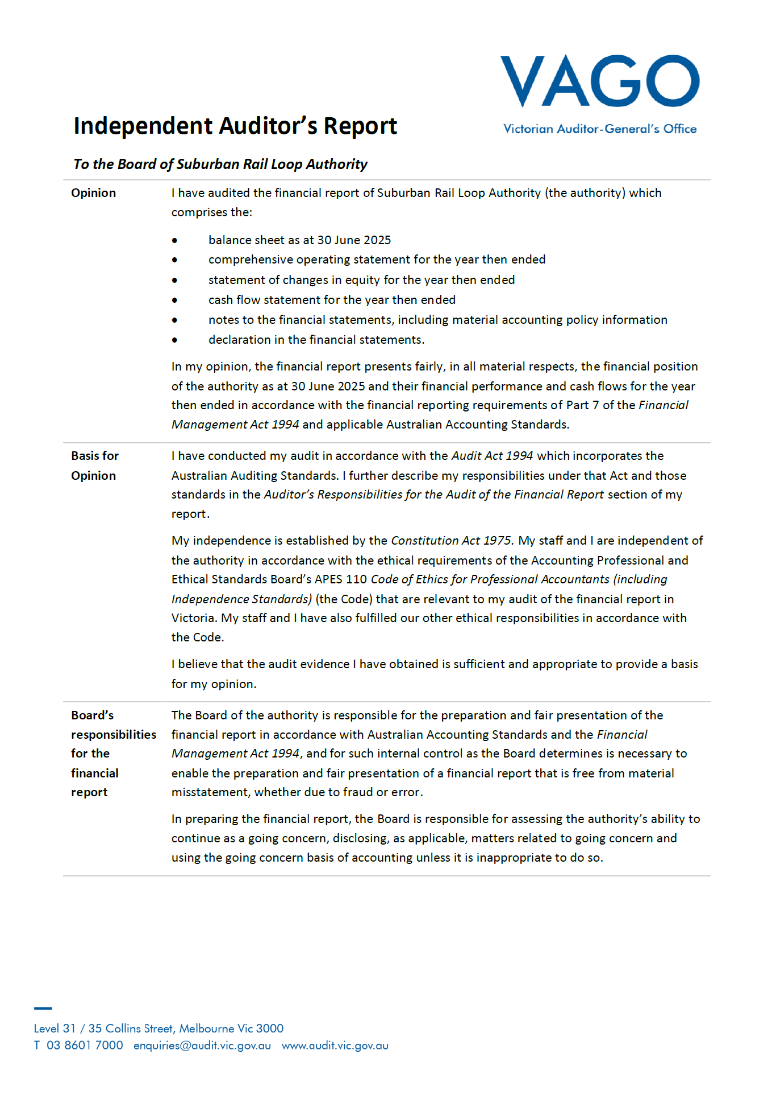
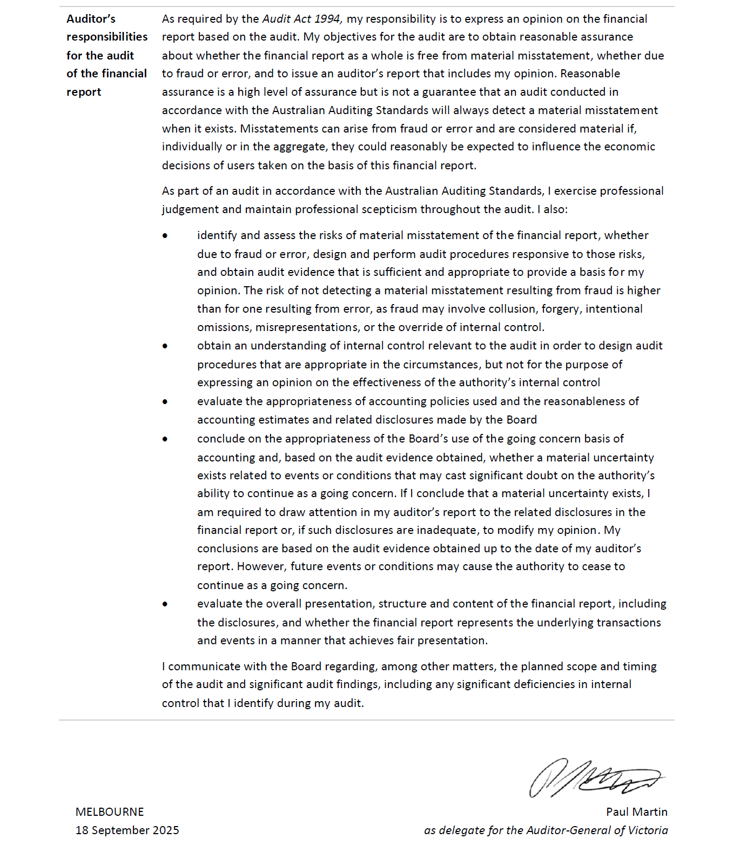

Comprehensive operating statement
For the financial year ended 30 June 2025
Item | Notes | 2025  ($ thousand) | 2024  ($ thousand)
Revenue and income from transactions | N/A | N/A | N/A
Grant income | 2.1 | 110,603 |  | 125,227
Interest income | N/A | 2,610 |  | 2,155
Rental revenue | 2.2 | 4,968 |  | 3,977
Total revenue and income from transactions | N/A | 118,181 |  | 131,359
Expenses from transactions | N/A | N/A | N/A
Employee benefits | 3.1.1 | 55,081 | 57,949
Supplies and services | 3.2 | 34,990 | 46,881
IT and telecommunications expenses | 3.2 | 7,975 | 9,142
Shared support services | 3.2 | 1,946 | 4,007
Office accommodation | 3.2 | 5,211 | 3,834
Grant expenses | 3.2 | 149 | 1,653
Other operating expenses | 3.2.1 | 12,713 | 7,269
Depreciation and amortisation | N/A | 224 | 221
Total expenses from transactions | N/A | 118,289 | 130,956
Net profit / (loss) from transactions | N/A | (108) | 403
Other economic flows included in net result | N/A | N/A | N/A
Net gain/(loss) on disposal of non-current assets | 8.2 | 32 | 3
Net gain/(loss) arising from revaluation of leave provisions | 8.2 | 3,268 | (3,387)
Total other economic flows included in net result | N/A | 3,300 | (3,384)
Net profit / (loss) | N/A | 3,192 | (2,981)
Other economic flows - other comprehensive income | N/A | N/A | N/A
Changes in physical asset revaluation surplus | N/A | 13,619 | 0
Comprehensive result | N/A | 16,811 | (2,981)
The above comprehensive operating statement should be read in conjunction with the accompanying notes.

Balance sheet
As at 30 June 2025
Item | Notes | 2025  ($ thousand) | 2024  ($ thousand)
Assets | N/A | N/A | N/A
Financial assets | N/A | N/A | N/A
Cash and deposits | 6.2 | 21,169 | 153,987
Receivables | 5.1 | 173,018 | 120,236
Total financial assets | N/A | 194,187 | 274,223
Non-financial assets | N/A | N/A | N/A
Property, plant and equipment | 4.1 | 615,633 | 515,836
Construction in progress | 4.1 | 3,551,609 | 1,784,053
Prepayments | 5.3 | 446,818 | 255,013
Total non-financial assets | N/A | 4,614,060 | 2,554,902
Total assets | N/A | 4,808,247 | 2,829,125
Liabilities | N/A | N/A | N/A
Payables | 5.2 | 168,517 | 121,495
Employee-related provisions | 3.1.2 | 24,453 | 22,980
Borrowings | 6.1 | 2,641 | 1,057
Other provisions | 5.4 | 56,540 | 57,439
Total liabilities | N/A | 252,151 | 202,971
Net assets | N/A | 4,556,096 | 2,626,154
Equity | N/A | N/A | N/A
Contributed capital from Victorian government | N/A | 4,542,280 | 2,629,149
Physical asset revaluation surplus | N/A | 13,619 | 0
Accumulated surplus/(deficit) | N/A | 197 | (2,995)
Total equity | N/A | 4,556,096 | 2,626,154
The above balance sheet should be read in conjunction with the accompanying notes.

Cash flow statement
For the financial year ended 30 June 2025
Item | Notes | 2025  ($ thousand) | 2024  ($ thousand)
Cash flows from operating activities | N/A | N/A | N/A
Receipts | N/A | N/A | N/A
Receipts from government | N/A | 115,560 | 123,048
Interest received | N/A | 2,610 | 2,155
Goods and Services Tax received from the Australian Taxation Office | N/A | 165,712 | 83,244
Total receipts | N/A | 283,882 | 208,447
Payments | N/A | N/A | N/A
Payments to suppliers | N/A | (253,051) | (154,866)
Payments to employees | N/A | (49,658) | (51,443)
Interest and other costs of finance paid | N/A | (146) | (436)
Total payments | N/A | (302,855) | (206,745)
Net cash flows (used in)/from operating activities | 6.2.1 | (18,973) | 1,702
Cash flows from investing activities | N/A | N/A | N/A
Proceeds from sale of non-financial assets | N/A | 154 | 43
(Purchase) of non-financial assets | N/A | (1,990,271) | (1,593,142)
(Purchase) of plant and equipment | N/A | (671) | (547)
Net cash flows used in investing activities | N/A | (1,990,788) | (1,593,646)
Cash flows from financing activities | N/A | N/A | N/A
Contributed capital from Victorian Government | N/A | 1,875,359 | 1,731,566
Principal portion of lease liabilities | N/A | 1,584 | 309
Net cash flows from financing activities | N/A | 1,876,943 | 1,731,875
Net (decrease)/increase in cash and cash equivalents | N/A | (132,818) | 139,931
Cash and cash equivalents at the beginning of the financial year | N/A | 153,987 | 14,056
Cash and cash equivalents at the end of the financial year | 6.2 | 21,169 | 153,987
The above cash flow statement should be read in conjunction with the accompanying notes.

Statement of changes in equity
For the financial year ended 30 June 2025
Item | Notes | Contributed capital  ($ thousand) | Physical asset revaluation surplus  ($ thousand) | Accumulated surplus/(deficit)  ($ thousand) | Total equity  ($ thousand)
Balance at 1 July 2023 | N/A | 934,646 | 0 | (14) | 934,632
Capital contributions by Victorian government | N/A | 1,694,503 | 0 | 0 | 1,694,503
Net result for the year | N/A | 0 | 0 | (2,981) | (2,981)
Balance at 30 June 2024 | N/A | 2,629,149 | 0 | (2,995) | 2,626,154
Balance at 1 July 2024 | N/A | 2,629,149 | 0 | (2,995) | 2,626,154
Capital contributions by Victorian government | N/A | 1,913,131 | 0 | 0 | 1,913,131
Changes in physical asset revaluation surplus | N/A | 0 | 13,619 | 0 | 13,619
Net result for the year | N/A | 0 | 0 | 3,192 | 3,192
Balance at 30 June 2025 | N/A | 4,542,280 | 13,619 | 197 | 4,556,096
The above statement of changes in equity should be read in conjunction with the accompanying notes.

About this report
The Suburban Rail Loop Authority (SRLA) is a statutory authority of the State of Victoria, established under the Suburban Rail Loop Act 2021 (SRL Act).
Its principal address is:
Suburban Rail Loop Authority
Level 21, 222 Exhibition Street
Melbourne VIC 3000
A description of the nature of its operations and its principal activities is included in the Report of Operations, which does not form part of these Financial Statements.
Basis of preparation
These Financial Statements are in Australian dollars and the historical cost convention is used unless a different measurement basis is specifically disclosed in the note associated with the item measured on a different basis.
The accrual basis of accounting has been applied in preparing these Financial Statements, whereby assets, liabilities, equity, income, and expenses are recognised in the reporting period to which they relate, regardless of when cash is received or paid.
These Financial Statements have been prepared on a going concern basis, which assumes the continuity of normal business activities, in particular over the next 12 months from the financial statements release date. The ability of Suburban Rail Loop Authority to pay its current and future contractual obligations is dependent on the Department of Transport and Planning (DTP) providing adequate cash flow. To this extent, a Letter of Support has been provided by Victorian Government’s Department of Transport and Planning dated 30 June 2025 covering the period until 30 September 2026.
Judgements, estimates, and assumptions are required to be made about financial information being presented. The significant judgements made in the preparation of these Financial Statements are disclosed in the notes where amounts affected by those judgements are disclosed. Estimates and associated assumptions are based on professional judgements derived from historical experience and various other factors that are believed to be reasonable under the circumstances. Actual results may differ from these estimates.
Revisions to accounting estimates are recognised in the period in which the estimate is revised and in future periods that are affected by the revision. Judgements and assumptions made by management in applying Australian Accounting Standards (AASs) that have significant effects on the Financial Statements and estimates are disclosed in the notes.
All amounts in the Financial Statements have been rounded to the nearest $1,000 unless otherwise stated. Figures in the Financial Statements may not equate due to rounding.
Compliance information
These general-purpose Financial Statements (Tier 1) have been prepared in accordance with the Financial Management Act 1994 (FMA) and applicable Australian Accounting Standards, which include Interpretations, issued by the Australian Accounting Standards Board (AASB). In particular, they are presented in a manner consistent with the requirements of AASB 1049 Whole of Government and General Government Sector Financial Reporting.
Where appropriate, those Australian Accounting Standards paragraphs applicable to not-for-profit entities have been applied. Accounting policies selected and applied in these Financial Statements ensure that the resulting financial information satisfies the concepts of relevance and reliability, thereby ensuring that the substance of the underlying transactions or other events is reported. Suburban Rail Loop Authority has elected to change its accounting policy for the cost base of land assets. This change was made to reflect only the land value as determined by the initial Valuer General Victoria valuation in the land asset class. Refer to Note 4.1.1.

Funding delivery of our services
Introduction
The primary purpose of Suburban Rail Loop Authority is to plan and deliver the Suburban Rail Loop program, in line with its objectives under the Suburban Rail Loop Act.
Structure
2.1 Grant income
2.2 Rental revenue

Grant income
Item | 2025  ($ thousand) | 2024  ($ thousand)
Income recognised as income of not-for-profit entities | N/A | N/A
Current grants from Department of Transport and Planning | 110,603 | 125,227
Total grant income | 110,603 | 125,227
Grants recognised under AASB 1058
Suburban Rail Loop Authority has made the judgement that the grant income included in the table above under AASB 1058 Income of Not-for-Profit Entities has been earned under arrangements that are either not enforceable and/or linked to sufficiently specific performance obligations.
Income from grants without any sufficiently specific performance obligations, or that are not enforceable, is recognised when Suburban Rail Loop Authority has an unconditional right to receive cash.
Grant income included in the table above relates to Suburban Rail Loop Authority’s operations and are not capital in nature.
Income from grants to support the construction of the Suburban Rail Loop project is recognised progressively as the asset is constructed. This aligns with Suburban Rail Loop Authority’s obligation to construct the asset. The progressive costs incurred is used to recognise income because this most closely reflects the construction progress as costs are incurred as the works are done. This grant income is capital in nature and is recognised as Contributed capital from government.

Rental revenue
Item | 2025  ($ thousand) | 2024  ($ thousand)
Rental revenue | 4,968 | 3,977
Total rental revenue | 4,968 | 3,977

Rental revenue recognised under AASB 15
Rental revenue is transactions that Suburban Rail Loop Authority has determined to be classified as revenue from contracts with customers in accordance with AASB 15 Revenue from Contracts with Customers.
Revenue is measured based on the consideration specified in the contract with the customer. Suburban Rail Loop Authority recognises revenue when the performance obligations are satisfied, i.e. on a straight-line basis over the period of their continued occupation agreement.
Rental revenue is related to properties that are primarily held to support the construction of the Suburban Rail Loop project. Therefore, the leasing of parts of these properties is incidental. Accordingly, these properties are reported as Property, plant and equipment, refer to Note 4.1.

The cost of delivering services
Introduction
This section provides an account of the expenses incurred by Suburban Rail Loop Authority in delivering services. In Section 2, the funds that enable the provision of services were disclosed and in this note the costs associated with provision of services are recorded.
Structure
3.1 Employee benefits
3.2 Operating expenses

Employee benefits

Employee benefits in the comprehensive operating statement
Item | Notes | 2025  ($ thousand) | 2024  ($ thousand)
Superannuation expense | N/A | 4,880 | 4,710
Termination benefits | N/A | 1,435 | 2,190
Salaries, wages, annual leave and long service leave | N/A | 48,766 | 51,049
Total employee benefits | N/A | 55,081 | 57,949
Employee benefits expenses include all costs related to employment, including wages and salaries, fringe benefit tax, leave entitlements, termination payments, superannuation and WorkCover premiums.
The amount recognised in the comprehensive operating statement in relation to superannuation is employer contributions for members of both defined benefit and defined contribution superannuation plans that are paid or payable during the reporting period. Suburban Rail Loop Authority does not recognise any defined benefit liabilities because it has no legal or constructive obligation to pay future benefits relating to its employees. Instead, the Department of Treasury and Finance (DTF) discloses in its annual financial statements the net defined benefit cost related to the members of these plans as an administered liability (on behalf of the state as the sponsoring employer).

Employee benefits in the balance sheet
Item | 2025  ($ thousand) | 2024  ($ thousand)
Current provisions | N/A | N/A
Annual leave | N/A | N/A
Unconditional and expected to be settled within 12 months | 4,777 | 3,868
Unconditional and expected to be settled after 12 months | 4,772 | 5,380
Long service leave | N/A | N/A
Unconditional and expected to be settled within 12 months | 220 | 75
Unconditional and expected to be settled after 12 months | 3,307 | 3,778
Provisions for on-costs | N/A | N/A
Unconditional and expected to be settled within 12 months | 981 | 744
Unconditional and expected to be settled after 12 months | 1,613 | 1,758
Total current provisions | 15,670 | 15,603
Non-current provisions | N/A | N/A
Long Service leave | 7,289 | 6,163
On-costs | 1,494 | 1,214
Total non-current provisions | 8,783 | 7,377
Total provisions for employee benefits | 24,453 | 22,980
Provision is made for benefits accruing to employees in respect of wages and salaries, annual leave and long service leave (LSL) for services rendered to the reporting date and recorded as an expense during the period the services are delivered. All leave entitlements have been transferred for employees who have rights under continuous services from the Victorian Public Service and are reflected within the balances above.
Reconciliation of movement in provisions for on-costs
Item | 2025  ($ thousand) | 2024  ($ thousand)
Opening balance | 3,716 | 2,027
Additional provisions recognised | 737 | 1,049
Additions due to transfer in | 277 | 111
Unwind of discount and effect of changes in the discount rates | (557) | 556
Reductions due to transfer out | (85) | (27)
Closing balance | 4,088 | 3,716
Current | 2,594 | 2,502
Non-current | 1,494 | 1,214
Total | 4,088 | 3,716
Wages and salaries, annual leave and sick leave: Liabilities for wages and salaries (including non-monetary benefits, annual leave and on-costs) are recognised as part of the employee benefit provision as current liabilities, as Suburban Rail Loop Authority does not have an unconditional right to defer settlements of these liabilities.
The liability for salaries and wages are recognised in the balance sheet at remuneration rates, which are current at the reporting date. As Suburban Rail Loop Authority expects the liabilities to be wholly settled within 12 months of reporting date, they are measured at undiscounted amounts.
The annual leave liability is classified as a current liability and measured at the undiscounted amount expected to be paid, as Suburban Rail Loop Authority does not have an unconditional right to defer settlement of the liability for at least 12 months after the end of the reporting period.
No provision has been made for sick leave as all sick leave is non-vesting and it is not considered probable that the average sick leave taken in the future will be greater than the benefits accrued in the future. As sick leave is non-vesting, an expense is recognised in the comprehensive operating statement as it is taken.
Employment on-costs such as payroll tax, workers compensation and superannuation are not employee benefits. They are disclosed separately as a component of the provision for employee benefits when the employment to which they relate has occurred.
Unconditional Long Service Leave is disclosed as a current liability even where Suburban Rail Loop Authority does not expect to settle the liability within 12 months because it will not have the unconditional right to defer the settlement of the entitlement should an employee take leave within 12 months.
The components of this current Long Service Leave liability are measured at:
- undiscounted value – if Suburban Rail Loop Authority expects to wholly settle within 12 months, or
- present value – if Suburban Rail Loop Authority does not expect to wholly settle within 12 months.
Conditional Long Service Leave is disclosed as a non-current liability. There is a conditional right to defer the settlement of the entitlement until the employee has completed the requisite years of service. This non-current Long Service Leave is measured at present value.
Any gain or loss following revaluation of the present value of non-current Long Service Leave liability is recognised as a transaction, except to the extent that a gain or loss arises due to changes in bond interest rates for which it is then recognised as an ‘other economic flows’ in the net result.

Operating expenses
Item | Notes | 2025  ($ thousand) | 2024  ($ thousand)
Supplies and services | N/A | 34,990 | 46,881
Information Technology and telecommunications expenses | N/A | 7,975 | 9,142
Shared support services | N/A | 1,946 | 4,007
Office accommodation | N/A | 5,211 | 3,834
Grant expenses | N/A | 149 | 1,653
Other operating expenses | 3.2.1 | 12,713 | 7,269
Total | N/A | 62,984 | 72,786
Operating expenses are recognised as an expense in the reporting period in which they are incurred.
Supplies and services expenses include mainly contractual payments for professional services to support Suburban Rail Loop Authority’s operations and project delivery.
IT and telecommunication costs include expenditure for desktop charges, provision and maintenance of system applications.
Victorian Government’s Department of Transport and Planning continues to provide shared support services such as financial and human resources systems, payroll support services and IT systems to Suburban Rail Loop Authority.
Office accommodation lease arrangements are deemed as short-term leases under AASB 16 Leases. Suburban Rail Loop Authority has elected to account for short-term leases using the practical expedients. Instead of recognising a right-of-use asset and lease liability, the payments in relation to these are recognised as an expense in comprehensive operating statement on a straight-line basis over the lease term.
The reported Grant expenses were incurred under the Community Projects Fund, supporting community projects along the Suburban Rail Loop East corridor that enhance community connectedness, meet community needs and enhance community cohesion.

Other operating expenses
Item | 2025  ($ thousand) | 2024  ($ thousand)
Information Technology portable and attractive assets | 273 | 1,092
Training and recruitment | 1,058 | 1,693
Legal fees | 6,796 | 1,095
Internal audit costs | 418 | 476
Travel and accommodation | 224 | 130
Other communications | 590 | 692
Insurance expense | 312 | 247
Property management services | 1,812 | 520
Vehicle and equipment | 163 | 89
Other administrative expenses | 1,067 | 1,235
Total | 12,713 | 7,269
Other operating expenses are recognised as an expense in the reporting period in which they are incurred. They generally represent the day-to-day running costs incurred in normal operations.

Key assets available to support service delivery
Introduction
Suburban Rail Loop Authority controls land and plant, equipment and vehicles that are utilised in fulfilling its objectives and conducting its activities. They represent the resources that have been entrusted to Suburban Rail Loop Authority for delivery of services.
Structure
4.1 Property, plant and equipment

Property, plant and equipment (including right of ose)
Item | Gross carrying amount  2025  ($ thousand) | Gross carrying amount  2024  ($ thousand)  ($ thousand) | Accumulated depreciation  2025  ($ thousand) | Accumulated depreciation  2024  ($ thousand) | Net carrying amount  2025  ($ thousand) | Net carrying amount  2024  ($ thousand)
Land at fair value | 612,525 | 514,658 | 0 | 0 | 612,525 | 514,658
Buildings (including right of use assets) at fair value | 1,846 | 0 | (160) | 0 | 1,686 | 0
Plant, equipment and vehicles (including right of use assets) at fair value | 2,169 | 1,687 | (747) | (509) | 1,422 | 1,178
Sub-total property, plant and equipment | 616,540 | 516,345 | (907) | (509) | 615,633 | 515,836
Construction in progress at cost | 3,551,609 | 1,784,053 | 0 | 0 | 3,551,609 | 1,784,053
Total property, plant and equipment | 4,168,149 | 2,300,398 | (907) | (509) | 4,167,242 | 2,299,889

Non-financial assets excluding right of use assets

Initial recognition
At the initial commencement of a construction project, assets are reported as Construction in Progress until the project reaches commercial acceptance and is available and ready for use. Construction in Progress is presented separately under Property, plant and equipment and is measured initially at cost, which includes costs of all materials used in construction, direct labour on the project and an appropriate proportion of variable and fixed overheads that are directly attributable to the design, pre-construction and construction of Suburban Rail Loop East.
Land assets are measured initially at cost, representing the land value assessed by the Valuer-General’s at acquisition date, and are subsequently revalued at fair value.
Other non-financial physical assets are measured initially at cost and subsequently revalued at fair value less accumulated depreciation.
Where an asset is acquired for no or nominal cost, the cost is its fair value at the date of acquisition.

Subsequent measurement
Construction in Progress continues to be measured at cost until the project reaches commercial acceptance and is available and ready for use, upon which they are capitalised and transferred to the appropriate asset classes. Construction in Progress does not include accumulated depreciation and impairment.
Items of non-financial physical assets are subsequently measured at fair value less accumulated depreciation, except for land assets which are subsequently measured at fair value. Fair value is determined with regard to the asset’s highest and best use – considering legal or physical restrictions imposed on the asset, public announcements or commitments made in relation to the intended use of the asset – and is summarised below by asset category.
Non-specialised land is valued using the market approach, whereby assets are compared to recent comparable sales and allowing for size, topography, location and other relevant factors specific to the asset being valued. Specialised land is also valued using the market approach, adjusted for the community service obligation to reflect the specialised nature of the land being valued.
Fair value for Buildings, plant and equipment is determined using the current replacement cost method.
Refer to Note 7.3.2 for additional information on fair value determination of Property, plant and equipment.

Depreciation
Plant, equipment and vehicles and other non-financial physical assets that have finite useful lives are depreciated.
Depreciation is calculated on a straight-line basis, at rates that allocate the asset’s value, less any estimated residual value, over its estimated useful life. Assets’ residual values and useful lives are reviewed, and adjusted if appropriate, at each balance sheet date. Actual useful lives for the different asset classes are included in the table below.
Asset class | Useful Life
Buildings (including leased assets) | 5 to 10 years
Plant, equipment and vehicles (including leased assets) | 3 to 5 years
Land assets are considered to have an indefinite life and are not depreciated. Depreciation is not recognised because its service potential has not, in any material sense, been consumed during the reporting period.

Impairment
Non-financial assets, including items of Property, plant and equipment, are tested for impairment whenever there is an indication that the asset may be impaired. The recoverable amount of primarily non-cash-generating assets of not-for-profit entities, which are typically specialised in nature and held for continuing use of their service capacity, is expected to be materially the same as fair value determined under AASB 13 Fair Value Measurement, with the consequence that AASB 136 does not apply to such assets that are regularly revalued.

Classification of land and building assets
In preparing these Financial Statements, significant judgments were made in classifying building assets. During the current and prior financial years, Suburban Rail Loop Authority acquired assets specifically to facilitate the construction of rail development projects, rather than for the purpose of holding property assets.
As of 30 June 2025, all building assets were assessed to determine their intended use. For compulsory acquisitions, a direct nexus was established between the buildings acquired and their deployment in approved and active rail development projects. Based on this assessment, these building assets were appropriately classified and recorded under Construction in Progress (CIP), where they contribute directly to the cost base of the asset under construction. For properties acquired under the Voluntary Purchase Scheme, building assets are recorded separately under Buildings.
All land assets acquired for these projects are recorded as their own asset category under Land.
These classification and judgments are based on a combination of professional judgment, historical experience and assumptions considered reasonable under the circumstances.

Reconciliation of movements in carrying amount of property, plant and equipment (including right of use)
Year ended 30 June 2025
Item | Land  ($ thousand) | Buildings  ($ thousand) | Plant, equipment and vehicles  ($ thousand) | Construction  in progress  ($ thousand) | Total  ($ thousand)
Opening balance | 514,658 | 0 | 1,178 | 1,784,053 | 2,299,889
Additions | 102,068 | 1,846 | 671 | 1,749,736 | 1,854,321
Depreciation expense | 0 | (160) | (305) | 0 | (465)
Revaluations | 13,619 | 0 | 0 | 0 | 13,619
Disposals | 0 | 0 | (122) | 0 | (122)
Transfer between asset classes  (refer note a) | (17,820) | 0 | 0 | 17,820 | 0
Closing balance | 612,525 | 1,686 | 1,422 | 3,551,609 | 4,167,242
Year ended 30 June 2024
Item | Land  ($ thousand) | Buildings  ($ thousand) | Plant, equipment and vehicles  ($ thousand) | Construction  in progress  ($ thousand) | Total  ($ thousand)
Opening balance | 65,247 | 0 | 892 | 938,511 | 1,004,650
Additions | 387,510 | 0 | 547 | 907,443 | 1,295,500
Depreciation expense | 0 | 0 | (221) | 0 | (221)
Disposals | 0 | 0 | (40) | 0 | (40)
Transfer between asset classes | 61,901 | 0 | 0 | (61,901) | 0
Closing balance | 514,658 | 0 | 1,178 | 1,784,053 | 2,299,889
(a) The accounting treatment of costs directly attributable to land acquisitions was reviewed and it was determined that the land asset class should reflect only the land value as determined by the initial Valuer General Victoria valuation, and any additional directly attributable costs related to land acquisition should be recognised as Construction in Progress. This is a change in accounting policy and accordingly, all relevant costs previously included in the land asset balance as at 1 July 2024 have been transferred to Construction in Progress during the financial year.

Other assets and liabilities
Introduction
This section sets out those assets and liabilities that arose from Suburban Rail Loop Authority’s operations.
Structure
5.1 Receivables
5.2 Payables
5.3 Prepayments
5.4 Other provisions

Receivables
Item | 2025  ($ thousand) | 2024  ($ thousand)
Contractual | N/A | N/A
Receivables - Department of Transport and Planning | 144,900 | 110,275
Other receivables | 7,843 | 4,376
Total contractual receivables | 152,743 | 114,651
Statutory | N/A | N/A
GST input tax credit recoverable from the Australian Taxation Office | 20,275 | 5,585
Total statutory receivables | 20,275 | 5,585
Total receivables | 173,018 | 120,236
Contractual receivables are classified as financial instruments and categorised as financial assets at amortised cost. They are initially recognised at fair value plus any directly attributable transaction costs.
Statutory receivables do not arise from contracts and are recognised and measured similarly to contractual receivables (except for impairment) but are not classified as financial instruments for disclosure purposes.
All receivables are classified as current.

Payables
Item | 2025  ($ thousand) | 2024  ($ thousand)
Contractual | N/A | N/A
Supplies and services | 7,205 | 16,208
Capital works | 160,568 | 104,541
Total contractual payables | 167,773 | 120,749
Statutory | N/A | N/A
Fringe Benefits Tax payable | 60 | 27
Payroll Tax payable | 684 | 719
Total statutory payables | 744 | 746
Total payables | 168,517 | 121,495
Contractual payables are classified as financial instruments and measured at amortised cost. Accounts payable represents liabilities for goods and services provided to Suburban Rail Loop Authority prior to the end of the financial year that are unpaid. Payables for capital works represent liabilities for goods and services already provided to Suburban Rail Loop Authority prior to the end of the financial year that are yet to be invoiced.
Statutory payables are classified and measured similarly to contractual payables but are not classified as financial instruments and not included in the category of financial liabilities at amortised cost, because they do not arise from a contract.
All payables are classified as current.

Maturity analysis of contractual payables
2025
Item | Maturity date  Carrying amount  ($ thousand) | Maturity date  Nominal Amount  ($ thousand) | Maturity date  Less than 1 month  ($ thousand) | Maturity date  1-3 months  ($ thousand) | Maturity date  3-12 months  ($ thousand)
Supplies and services | 7,205 | 7,205 | 6,695 | 510 | 0
Capital works | 160,568 | 160,568 | 140,618 | 19,342 | 608
Total | 167,773 | 167,773 | 147,313 | 19,852 | 608
2024
Item | Maturity date  Carrying amount  ($ thousand) | Maturity date  Nominal Amount  ($ thousand) | Maturity date  Less than 1 month  ($ thousand) | Maturity date  1-3 months  ($ thousand) | Maturity date  3-12 months  ($ thousand)
Supplies and services | 16,208 | 16,208 | 13,684 | 2,524 | 0
Capital works | 104,541 | 104,541 | 77,067 | 27,166 | 308
Total | 120,749 | 120,749 | 90,751 | 29,690 | 308
Payables for supplies and services have an average credit period of 30 days. No interest is charged on late payments.

Prepayments
Item | 2025  ($ thousand) | 2024  ($ thousand)
Current | N/A | N/A
Prepayments | 147,901 | 68,098
Non-current | N/A | N/A
Prepayments | 298,917 | 186,915
Total prepayments | 446,818 | 255,013
Prepayments represent payments in advance of receipt of goods or services, or the payments made for services covering a term extending beyond that financial accounting period. The amount comprising prepayments as at 30 June 2025 includes construction risk insurance payments and payment for key plant and equipment under the Tunnels South and Tunnels North contracts. Prepayments are amortised on a straight-line basis over the service term or when the funds are returned to Suburban Rail Loop Authority.

Other provisions
Item | 2025  ($ thousand) | 2024  ($ thousand)
Current | N/A | N/A
Acquisition of land and buildings | 26,205 | 32,362
Other provisions | 30,335 | 25,077
Total other provisions | 56,540 | 57,439
Other provisions are recognised when Suburban Rail Loop Authority has a present obligation, the future sacrifice of economic benefits is probable, and the amount of the provision can be measured reliably. The amount recognised as a provision is the best estimate of the consideration required to settle the present obligation at reporting date, taking into account the risks and uncertainties surrounding the obligation.
The property value and other additional costs are recognised as property acquisition liabilities in circumstances where Suburban Rail Loop Authority has issued a notice of compulsory acquisition or has taken possession of a property for the purpose of commencing construction and final compensation amount has not been agreed at the reporting date.
Other provisions relate to future payments to unsuccessful bidders of Suburban Rail Loop East construction contracts.

Reconciliation of movement in other provisions
Year ended 30 June 2025
Item | Acquisition of land and buildings  ($ thousand) | Other provisions  ($ thousand) | Total  ($ thousand)
Opening balance | 32,362 | 25,077 | 57,439
Additional provisions recognised | 26,205 | 30,335 | 56,540
Reduction arising from payments/other sacrifices of future economic benefits | (32,362) | (25,077) | (57,439)
Closing balance | 26,205 | 30,335 | 56,540
Year ended 30 June 2024
Item | Acquisition of land and buildings  ($ thousand) | Other provisions  ($ thousand) | Total  ($ thousand)
Opening balance | 96,421 | 70,000 | 166,421
Additional provisions recognised | 32,362 | 25,077 | 57,439
Reduction arising from payments/other sacrifices of future economic benefits | (96,421) | (70,000) | (166,421)
Closing balance | 32,362 | 25,077 | 57,439

Financing our operations
Introduction
This section provides information on the sources of finance utilised by Suburban Rail Loop Authority during its operations, along with interest expenses (the cost of leases) and other information related to financing activities of Suburban Rail Loop Authority.
This section includes disclosures of balances that are financial instruments (such as cash balances).
Structure
6.1 Borrowings
6.2 Cash flow information and balances
6.3 Commitments for expenditure

Borrowings
Item | Notes | 2025  ($ thousand) | 2024  ($ thousand)
Current | N/A | N/A | N/A
Lease liabilities | N/A | 784 | 312
Non-current | N/A | N/A | N/A
Lease liabilities | N/A | 1,857 | 745
Total borrowings | N/A | 2,641 | 1,057
Borrowings refer to interest bearing liabilities mainly raised from lease liabilities.
Borrowings are classified as financial instruments. The measurement basis depends on whether Suburban Rail Loop Authority has categorised its interest-bearing liabilities as either financial liabilities designated at fair value through net result, or financial liabilities at amortised cost. The classification depends on the nature and purpose of the interest-bearing liabilities. Suburban Rail Loop Authority determines the classification of its interest-bearing liabilities at initial recognition.

Suburban Rail Loop Authority leasing activities
Suburban Rail Loop Authority leases motor vehicles through Department of Government Services for operational needs with lease term of three years or 60,000 kilometres, whichever occurs first.
Suburban Rail Loop Authority also leases a parcel of land located at 275-315 Kingston Road, Clarinda through Charter Hall Real Estate with a lease term of five years.

Leases at significantly below-market terms and conditions
Suburban Rail Loop Authority has a peppercorn lease arrangement with Development Victoria for 36 Gillard Street, Burwood and 37 Cumming Street, Burwood for a term expiring on the date which is the earlier of: the first day of passenger services of Suburban Rail Loop East; the date the lease is terminated by agreement between the parties; or 31 December 2035.
The terms of the lease agreement provide for nominal payments of $1 as annual rent to the lessor upon demand.

Recognition and measurement of leases as a lessee

Lease liability – initial measurement
The lease liability is initially measured at the present value of the lease payments unpaid at the commencement date, discounted using the interest rate implicit in the lease if that rate is readily determinable or Suburban Rail Loop Authority’s incremental borrowing rate.
Lease payments included in the measurement of the lease liability comprise the following:
- fixed payments (including in-substance fixed payments) less any lease incentive receivable
- variable payments based on an index or rate, initially measured using the index or rate as at the commencement date
- amounts expected to be payable under a residual value guarantee
- payments arising from purchase and termination options reasonably certain to be exercised.
Suburban Rail Loop Authority elected to initially measure the recognition of the Right of Use (RoU) asset arising from leases that are significantly below market terms and conditions at cost, as per the temporary relief given to Not-For-Profit entities. Therefore, the Right of Use asset is not recognised in Suburban Rail Loop Authority financial statements due to the significantly below market payments. The corresponding liability of the Right of Use arrangement is not recognised as per above.

Lease liability – subsequent measurement
Subsequent to initial measurement, the liability will be reduced for payments made and increased for interest. It is remeasured to reflect any reassessment or modification, or if there are changes in-substance fixed payments.
When the lease liability is remeasured, the corresponding adjustment is reflected in the Right of Use asset, or profit and loss if the Right of Use asset is already reduced to zero.

Cash flow information and balances
Cash and deposits comprise cash at bank.
Item | 2025  ($ thousand) | 2024  ($ thousand)
Total cash and deposits disclosed in the balance sheet | 21,169 | 153,987
Balance as per cash flow statement | 21,169 | 153,987

Reconciliation of net result for the period to net cash flows from operating activities
For the purpose of the cash flow statement, cash includes cash at bank. Cash at the end of the financial year as shown in the cash flow statement is reconciled to the related items in the balance sheet as follows:
Item | 2025  ($ thousand) | 2024  ($ thousand)
Net profit / (loss) for the period | 3,192 | (2,981)
Non-cash movements | N/A | N/A
Depreciation and amortisation of non-current assets | 224 | 221
(Gain)/loss on sale or disposal of non-current assets | (32) | (3)
Other non-cash movements | (3,268) | 3,387
Movements in assets and liabilities | N/A | N/A
(Increase)/decrease in receivables | (15,010) | (7,440)
(Increase)/decrease in prepayments | 73 | 411
Increase/(decrease) in payables | (8,893) | 2,034
Increase/(decrease) in provisions | 4,741 | 6,073
Net cash flows (used in)/from operating activities | (18,973) | 1,702

Commitments for expenditure
Commitments for future expenditure include operating and capital commitments arising from contracts. These contracts are recorded at their nominal value and are inclusive of GST. These future expenditures cease to be disclosed as commitments once the related liabilities are recognised in the balance sheet.
2025
Nominal amounts | Less than 1 year  ($ thousand) | 1 year - 5 years  ($ thousand) | Total  ($ thousand)
Capital expenditure commitments | 1,935,378 | 3,538,110 | 5,473,488
Other commitments | 4,747 | 0 | 4,747
Total commitments (inclusive of GST) | 1,940,125 | 3,538,110 | 5,478,235
Less GST recoverable | (176,375) | (321,646) | (498,021)
Total commitments (exclusive of GST) | 1,763,750 | 3,216,464 | 4,980,214
2024
Nominal amounts | Less than 1 year  ($ thousand) | 1 year - 5 years  ($ thousand) | Total  ($ thousand)
Capital expenditure commitments | 641,489 | 3,517,017 | 4,158,506
Other commitments | 10,208 | 3,388 | 13,596
Total commitments (inclusive of GST) | 651,697 | 3,520,405 | 4,172,102
Less GST recoverable | (59,245) | (320,037) | (379,282)
Total commitments (exclusive of GST) | 592,452 | 3,200,368 | 3,792,820
Capital expenditure commitments include contracts mainly for capital projects relating to the Suburban Rail Loop program. These include the contractual construction costs of delivering the Tunnels South and Tunnels North tunnelling package, as part of the Suburban Rail Loop East. These non-cancellable contracts for commitments were signed prior to the balance date and have established a legal and binding obligation on Suburban Rail Loop Authority to make future payments.
The Tunnels South tunnelling package includes design and construction of two 16km tunnels between Cheltenham and Glen Waverley. The Tunnels North tunnelling package includes design and construction of two 10km tunnels between Glen Waverley and Box Hill. Both packages will also create cross passages between the tunnels, support structures for the tunnel entrances, access shafts and boxes for train stations.

Risks, contingencies and valuation judgements
Introduction
Suburban Rail Loop Authority is exposed to risk from its activities and outside factors. In addition, it is often necessary to make judgements and estimates associated with recognition and measurement of items in the financial statements.
This section sets out financial instrument specific information (including exposures to financial risks) as well as those items that are contingent in nature or require a higher level of judgement to be applied, which for Suburban Rail Loop Authority related mainly to fair value determination.
Structure
7.1 Financial instruments specific disclosures
7.2 Contingent assets and contingent liabilities
7.3 Fair value determination

Financial instruments specific disclosures
Financial instruments arise out of contractual agreements that give rise to a financial asset of one entity and a financial liability or equity instrument of another entity. Due to the nature of Suburban Rail Loop Authority’s activities, certain financial assets and financial liabilities arise under statutory obligation rather than a contract. Such financial assets and financial liabilities do not meet the definition of financial instruments in AASB 132 Financial Instruments: Presentation.
Where relevant, for note disclosure purposes, a distinction is made between those financial assets and financial liabilities that meet the definition of financial instruments in accordance with AASB 132 and those that do not.

Financial assets at amortised cost
Financial assets are measured at amortised cost if both the following criteria are met, and the assets are only designated as fair value through net result:
- the assets are held by Suburban Rail Loop Authority to collect the contractual cash flows
- the assets’ contractual terms give rise to cash flows that are solely payments of principal and interests.
These assets are initially recognised at fair value plus any directly attributable transaction costs and subsequently measured at amortised cost using the effective interest method less any impairment.
Suburban Rail Loop Authority recognises cash and deposits (Note 6.2), and contractual receivables (Note 5.1) in this category.
Receivables are financial instrument assets with fixed and determinable payments that are not quoted on an active market. These assets are initially recognised at fair value plus any directly attributable transaction costs. Subsequent to initial measurement, receivables are measured at amortised cost using the effective interest method (and for assets, less any impairment).

Financial liabilities at amortised cost
Financial instrument liabilities are initially recognised on the date they are originated. They are initially measured at fair value plus any directly attributable transaction costs. Subsequent to initial recognition, these financial instruments are measured at amortised cost with any difference between the initial recognised amount and the redemption value being recognised in profit and loss over the period of the interest-bearing liability, using the effective interest rate method.
Suburban Rail Loop Authority recognises contractual payables (Note 5.2) and borrowings (Note 6.1) in this category.
Suburban Rail Loop Authority currently holds a range of financial instruments that are recorded in the financial statements at their carrying amounts which approximate to fair value, either due to their short-term nature or with the expectation that they will be paid in full by the end of the 2025-2026 reporting period.

Financial risk management objectives and policies
Suburban Rail Loop Authority does not enter or trade financial instruments, including derivative financial instruments, for speculative purposes.
Suburban Rail Loop Authority’s principal financial instruments comprise:
- cash and deposits
- receivables (excluding statutory receivables)
- payables (excluding statutory payables)
- borrowings (including lease liabilities).
Details of material accounting policy information and methods adopted, including the criteria for recognition, the basis of measurement and the basis on which income and expenses are recognised, with respect to each class of financial asset and financial liability are disclosed throughout the notes to these financial statements.
The main purpose in holding financial instruments is to prudentially manage Suburban Rail Loop Authority’s financial risks within the government’s policy parameters.
Suburban Rail Loop Authority uses different methods to measure and manage the different risks to which it is exposed.

Financial instruments: Credit risk
Credit risk arises from the contractual financial assets of Suburban Rail Loop Authority, which comprise cash and deposits and non-statutory receivables. Suburban Rail Loop Authority’s exposure to credit risk arises from the potential default of the counter party on their contractual obligations resulting in financial loss to Suburban Rail Loop Authority. Credit risk is measured at fair value and is monitored on a regular basis.
Credit risk associated with Suburban Rail Loop Authority’s contractual financial assets is minimal because the main debtor is the Victorian Government. In addition, Suburban Rail Loop Authority does not engage in hedging for its contractual financial assets and mainly obtains contractual financial assets that are on fixed interest, except for cash and deposits, which are mainly cash at bank.
Except as otherwise detailed in the following table, the carrying amount of contractual financial assets recorded in the Financial Statements, net of any allowances for losses, represents Suburban Rail Loop Authority’s maximum exposure to credit risk without taking account of the value of any collateral obtained.
There has been no material change to Suburban Rail Loop Authority’s credit risk profile between 1 July 2024 and 30 June 2025.
Credit quality of financial assets
2025
Item | Financial institution  (AA- credit rating)  ($ thousand) | Victorian Government  (AA credit rating)  ($ thousand) | Total  ($ thousand)
Financial assets | N/A | N/A | N/A
Cash and deposits | 21,169 | 0 | 21,169
Receivables (with no impairment loss recognised) | 0 | 152,743 | 152,743
Total contractual financial assets | 21,169 | 152,743 | 173,912
2024
Item | Financial institution  (AA- credit rating)  ($ thousand) | Victorian Government  (AA credit rating)  ($ thousand) | Total  ($ thousand)
Financial assets | N/A | N/A | N/A
Cash and deposits | 153,987 | 0 | 153,987
Receivables (with no impairment loss recognised) | 0 | 114,651 | 114,651
Total contractual financial assets | 153,987 | 114,651 | 268,638

Contractual receivables at amortised cost
Suburban Rail Loop Authority applies AASB 9’s simplified approach for all contractual receivables to measure expected credit losses using a lifetime expected loss allowance based on the assumptions about risk of default and expected loss rates. Suburban Rail Loop Authority has grouped contractual receivables on shared credit risk characteristics and days past due and selected the expected credit loss rate based on Suburban Rail Loop Authority’s past history, existing market conditions, as well as forward-looking estimates at the end of the financial year.
On this basis, Suburban Rail Loop Authority has determined that its loss allowance at the end of the financial year is nil.

Financial instruments: Liquidity risk
Liquidity risk is the risk that Suburban Rail Loop Authority would be unable to meet its financial obligations as and when they fall due. Suburban Rail Loop Authority operates under the government fair payments policy of settling financial obligations within 30 days and in the event of a dispute, making payments within 30 days from the date of resolution.
The ability of Suburban Rail Loop Authority to pay its current and future contractual obligations is dependent on Victorian Government’s Department of Transport and Planning providing adequate cash flow. The Letter of Support provided by Victorian Government’s Department of Transport and Planning dated 30 June 2025 covering the period until 30 September 2026 reduces Suburban Rail Loop Authority’s exposure to liquidity risk.
Suburban Rail Loop Authority’s exposure to liquidity risk is deemed insignificant based on current assessment of risk. Maximum exposure to liquidity risk is the carrying amounts of financial liabilities as disclosed in the balance sheet.

Financial instruments: Interest rate risk
Suburban Rail Loop Authority does not hold any interest-bearing financial instruments that are measured at fair value and therefore has no exposure to fair value interest rate risk.

Foreign currency risk
All foreign currency transactions during the financial year are brought to account using the exchange rate in effect at the date of the transaction. Foreign monetary items existing at the end of the reporting period are translated at the closing rate at the date of the end of the reporting period.

Contingent assets and contingent liabilities
Contingent assets and contingent liabilities are not recognised in the balance sheet but are disclosed and, if quantifiable, measured at nominal value.

Contingent assets
Contingent assets are possible assets that arise from past events, whose existence will be confirmed only by the occurrence or non-occurrence of one or more uncertain future events not wholly within the control of the entity.
These are classified as either quantifiable, where the potential economic benefit is known, or non-quantifiable.
Suburban Rail Loop Authority have no contingent assets as at 30 June 2025.

Contingent liabilities
Contingent liabilities are:
- possible obligations that arise from past events, whose existence will be confirmed only by the occurrence or non-occurrence of one or more uncertain future events not wholly within the control of the entity
- present obligations that arise from past events but are not recognised because:
  - it is not probable that an outflow of resources embodying economic benefits will be required to settle the obligations, or
  - the amount of the obligations cannot be measured with sufficient reliability.
These are classified as either quantifiable or non-quantifiable.
Arising from Suburban Rail Loop Authority’s contracts with private partners for the construction of the Suburban Rail Loop project:
- there are contractual claims made in the ordinary course of business that are currently being assessed, either in its existence or in the quantum of the claim
- there are future payments that are dependent on the private partners exceeding certain key performance indicators. A reliable estimate of any payments to be made is not known until the date of practical completion.
Suburban Rail Loop Authority’s potential exposure from this mechanism is unknown at the time of this report.
Suburban Rail Loop Authority also has a number of compulsory property acquisition claims which have been referred for determination where the parties disagree on the total compensation payable relating to the acquisition. While these negotiations are continuing, Suburban Rail Loop Authority estimates the current contingent liability for these claims to be $11.2 million.

Fair value determination
This section sets out information on how Suburban Rail Loop Authority has determined fair value for financial reporting purposes. Fair value is the price that would be received to sell an asset or paid to transfer a liability in an orderly transaction between market participants at the measurement date.
The following assets and liabilities are carried at fair value:
- land and building assets
- plant, equipment and vehicles.
In addition, the fair values of other assets and liabilities that are carried at amortised cost also need to be determined for disclosure purposes.
Suburban Rail Loop Authority determines the policies and procedures for determining fair values for both financial and non-financial assets and liabilities as required.

Fair value hierarchy
In determining fair values, a number of inputs are used. To increase consistency and comparability in the Financial Statements, these inputs are categorised into three levels, also known as the fair value hierarchy. The levels are as follows:
- Level 1 – quoted (unadjusted) market prices in active markets for identical assets or liabilities
- Level 2 – valuation techniques for which the lowest level input that is significant to the fair value measurement is directly or indirectly observable
- Level 3 – valuation techniques for which the lowest level input that is significant to the fair value measurement is unobservable.
Suburban Rail Loop Authority determines whether transfers have occurred between levels in the hierarchy by reassessing categorisation (based on the lowest level input that is significant to the fair value measurement as a whole) at the end of each reporting period.
The Valuer General Victoria (VGV) is Suburban Rail Loop Authority’s independent valuation agency and Suburban Rail Loop Authority will engage them to monitor changes in the fair value of relevant assets and liabilities, through relevant data sources, to determine revaluations when it is required.

How this section is structured
For those assets and liabilities for which fair values are determined, the following disclosures are provided:
- carrying amount and the fair value (which would be the same for those assets measured at fair value)
- which level of the fair value hierarchy was used to determine the fair value
- in respect of those assets and liabilities subject to fair value determination using Level 3 inputs:
  - a reconciliation of the movements in fair values from the beginning of the year to the end
  - details of significant unobservable inputs used in the fair value determination.

Fair value determination: non-financial physical assets
2025
Item | Carrying amount as at 30 June 2025  ($ thousand) | Fair value measurement at end of reporting period using:  Level 1  (see note a)  ($ thousand) | Fair value measurement at end of reporting period using:  Level 2  (see note a)  ($ thousand) | Fair value measurement at end of reporting period using: Level 3  (see note a)  ($ thousand)
Land | 612,525 | 0 | 557,581 | 54,944
Buildings | 1,686 | 0 | 1,686 | 0
Plant, equipment and vehicles | 1,422 | 0 | 1,422 | 0
Total | 615,633 | 0 | 560,689 | 54,944
2024
Item | Restated carrying amount as at 30 June 2024  (see note b)  ($ thousand) | Fair value measurement at end of reporting period using:  Level 1  (see note a)  ($ thousand) | Fair value measurement at end of reporting period using:  Level 2  (see note a)  ($ thousand) | Fair value measurement at end of reporting period using: Level 3  (see note a)  ($ thousand)
Land | 496,838 | 0 | 496,838 | 0
Buildings | 0 | 0 | 0 | 0
Plant, equipment and vehicles | 1,178 | 0 | 1,178 | 0
Total | 498,016 | 0 | 498,016 | 0
(a) Classified in accordance with the fair value hierarchy.
(b) The balance at 30 June 2024 was restated due to a change in accounting policy on the cost base of land assets. Refer to Note 4.1.1.
There has been no transfer between levels during the period.

Land
An independent valuation of land and buildings was performed by Valuer General Victoria to determine fair value using the market approach. Valuation of the assets was determined by considering the market to arrive at a fair value assessment, whereby assets are compared to recent comparable sales and allowing for size, topography, location and other relevant factors specific to the asset being valued. The effective date of the valuation was 30 June 2025.
The majority of Suburban Rail Loop Authority’s land assets are non-specialised, which are valued using the market approach. Specialised land is also valued using the market approach, adjusted for the community service obligation (CSO) to reflect the specialised nature of the land being valued.
The community service obligation adjustment reflects the valuer's assessment of the impact of restrictions associated with an asset to the extent that is also equally applicable to market participants. This approach is in light of the highest and best use consideration required for fair value measurement and considers the use of the asset that is physically possible, legally permissible, and financially feasible. As adjustments of community service obligation are considered as significant unobservable inputs, specialised land would be classified as Level 3 assets.

Property, plant and equipment (excluding land)
Property, plant and equipment is held at fair value. When property, plant and equipment is specialised in use, such that it is rarely sold other than as part of a going concern, fair value is determined using the current replacement cost method.
There were no changes in valuation techniques throughout the period to 30 June 2025.
For all assets measured at fair value, the current use is considered the highest and best use.

Accounting for fair value movements
Revaluation increases or decreases arise from differences between an asset’s carrying value and its fair value.
Revaluation increases and decreases relating to individual assets in a class of property, plant and equipment are offset against other assets in that class but are not offset against assets in different classes. An asset revaluation surplus is not transferred to accumulated funds on the de-recognition of the related asset.
Revaluation increments are credited directly to revaluation reserves, except to the extent that an increment reverses a revaluation decrement in respect of that class of asset previously recognised as an expense, in which case the increment is recognised immediately as revenue.
Revaluation decrements are recognised immediately as an expense, except to the extent that a credit balance exists in revaluation reserves applicable to the same class of assets, in which case the decrement is debited directly to revaluation reserves.

Amendment to AASB 13 Fair Value Measurement
AASB 2022-10 Amendments to Australian Accounting Standards – Fair Value Measurement of Non-Financial Assets of Not-for-Profit Public Sector Entities amended AASB 13 by adding Appendix F Australian implementation guidance for not-for-profit public sector entities. Appendix F explains and illustrates the application of the principles in AASB 13 on developing unobservable inputs and the application of the cost approach. FRD 103 permits Victorian public sector entities to apply Appendix F of AASB 13 in their next scheduled formal asset revaluation or interim revaluation (whichever is earlier).
While the amended AASB 13 provides clarifications on how to measure fair value of non-financial assets of not-for-profit public sector entities not held primarily for their ability to generate net cash inflows, judgements still need to be exercised when applying the requirements of the amended standard in Suburban Rail Loop Authority’s valuation process.
The following key judgements are made by Suburban Rail Loop Authority in the scheduled valuation effective 30 June 2025.
- Current use of Suburban Rail Loop Authority’s non-financial assets is the highest and best use by default, unless a government decision mandates alternative use.
In accordance with FRD 103, Suburban Rail Loop Authority applied AASB 2022-10, including Appendix F of AASB 13 and the requirements of FRD 103 prospectively as part of the current scheduled formal revaluation process. As Suburban Rail Loop Authority’s existing accounting and valuation practices are mostly in alignment with the guidance included in the Amendment, there was no material impact to the financial statements.

Other disclosures
Introduction
This section includes additional material disclosures required by accounting standards or otherwise, for the understanding of these Financial Statements.
Structure
8.1 Ex-gratia expenses
8.2 Other economic flows included in net result
8.3 Responsible persons
8.4 Remuneration of executives
8.5 Related parties
8.6 Remuneration of auditors
8.7 Subsequent events
8.8 Other accounting policies
8.9 Australian Accounting Standards issued that are not yet effective
8.10 Style conventions

Ex-gratia expenses
There were no ex-gratia expenses to report in the financial year and prior reporting period.

Other economic flows included in net result
Other economic flows are changes in the volume or value of an asset or liability that do not result from transactions. Other gains/(losses) from other economic flows include the gains or losses from:
- the disposal of non-current assets
- the revaluation of the present value of leave provisions due to changes in the bond rates, wage inflation rates and on-cost rates
- the revaluation of the present value of the long service leave liability due to changes in the model used to discount the liability, including the discounting of all entitlements expected to be paid after twelve months, the use of an average retention rate and the assumed payment patterns.
Item | 2025  ($ thousand) | 2024  ($ thousand)
Net gain/(loss) on disposal of non-current assets | N/A | N/A
Proceeds from disposal of assets | 154 | 43
Written down value (WDV) of assets disposed | (122) | (40)
Net gain/(loss) on disposal of non-current assets | 32 | 3
Other gains/(losses) from other economic flows | N/A | N/A
Net gain/(loss) arising from revaluation of leave provisions | 3,268 | (893)
Net gain/(loss) arising from transition of long service leave model | 0 | (2,494)
Other gains/(losses) from other economic flows | 3,268 | (3,387)
Total other gains/(losses) from other economic flows | 3,300 | (3,384)

Responsible persons
In accordance with the Ministerial Directions issued by the Minister of Finance under the FMA, the following disclosures are made regarding responsible persons for the reporting period. The names of each person who held positions of Ministers, Accountable Officers and members of the Board for the period 1 July 2024 to 30 June 2025 are as follows:
Minister
Honourable Harriet Shing, Member of Parliament, Minister for the Suburban Rail Loop (from 19 December 2024)
Honourable Danny Pearson, Member of Parliament, Minister for the Suburban Rail Loop (until 18 December 2024)
Board Directors
James Merlino (Chair)
Christine Wyatt (Deputy Chair)
Paul Barker
Megan Bourke-O’Neil (until 31 August 2024)
Sally Freeman
James MacKenzie AO (until 30 November 2024)
Chief Executive Officer and Accountable Officer
Frankie Carroll

Remuneration
Remuneration received or receivable by the Accountable Officer in connection with the management of Suburban Rail Loop Authority during the reporting period was in the range: $900,000 - $909,999 (2023-24: $870,000 - $879,999).
The number of responsible persons excluding the Accountable Officer and Minister, and their remuneration during the reporting period, is shown in the table below.
Remuneration Bands | 2025 | 2024
$0 - $9,999 | 1 | 1
$20,000 - $29,999 | 1 | 0
$50,000 - $59,999 | 0 | 1
$60,000 - $69,999 | 2 | 3
$70,000 - $79,999 | 1 | 1
$150,000 - $159,999 | 0 | 1
$160,000 - $169,999 | 1 | 0
Total number of responsible persons | 6 | 7
Total remuneration ($ thousand) | 399 | 496
The compensation detailed in the table above excludes the salaries and benefits the Portfolio Minister receives. The Minister’s remuneration and allowances is set by the Parliamentary Salaries and Superannuation Act 1968 and is reported within the State’s Annual Financial Report.

Remuneration of executives
The number of executive officers, other than Ministers and accountable officers, and their total remuneration during the reporting period are shown in the table below. Total annualised employee equivalent provides a measure of fulltime equivalent executive officers over the reporting period.
Remuneration comprises employee benefits in all forms of consideration paid, payable or provided by Suburban Rail Loop Authority, or on behalf of Suburban Rail Loop Authority, in exchange for services rendered, and is disclosed in the following categories:
- Short-term employee benefits include amounts such as wages, salaries, annual leave or sick leave that are usually paid or payable on a regular basis, as well as non-monetary benefits such as allowances and free or subsidised goods or services.
- Post-employment benefits include pensions and other retirement benefits paid or payable on a discrete basis when employment has ceased.
- Other long-term benefits include long service leave, other long service benefits or deferred compensation.
- Termination benefits include termination of employment payments, such as severance packages.
Item | 2025  ($ thousand) | 2024  ($ thousand)
Remuneration of executive officers | N/A | N/A
Short term employee benefits | 28,874 | 28,831
Post-employment benefits | 2,432 | 2,374
Other long-term benefits | 673 | 719
Termination benefits | 672 | 1,027
Total remuneration | 32,651 | 32,951
Total number of executives | 100 | 102
Total annualised employee equivalent (AEE) (refer note a) | 83.6 | 88.8
(a) AEE is based on the time fraction worked over the reporting period.

Related parties
Suburban Rail Loop Authority is a wholly owned and controlled entity of the State of Victoria.
Related parties of Suburban Rail Loop Authority include:
- all key management personnel (KMP) and their close family members and personal business interests, including controlled entities, joint ventures and entities they have significant influence over
- all Cabinet Ministers and their close family members
- all departments and public sector entities that are controlled and consolidated into the whole of state consolidated financial statements.
All related party transactions have been entered into on an arm’s length basis.

Key management personnel
Key management personnel of Suburban Rail Loop Authority include the responsible persons (see Note 8.3 Responsible persons) and senior executive service officers who report directly to the Accountable Officer.
The following table shows Suburban Rail Loop Authority’s key management personnel:
Name | Position/s identified as key management personnel | Period
The Honourable Harriet Shing Member of Parliament | Minister for Suburban Rail Loop | 19 December 2024 to 30 June 2025
The Honourable Danny Pearson Member of Parliament | Minister for Suburban Rail Loop | 1 July 2024 to 18 December 2024
James Merlino | Board Chair | 1 July 2024 to 30 June 2025
Christine Wyatt | Board Deputy Chair | 1 July 2024 to 30 June 2025
James MacKenzie AO | Board Member | 1 July 2024 to 30 November 2024
Paul Barker | Board Member | 1 July 2024 to 30 June 2025
Sally Freeman | Board Member | 1 July 2024 to 30 June 2025
Megan Bourke-O’Neil | Board Member | 1 July 2024 to 31 August 2024
Megan Bourke-O’Neil (continued) | Chief Operating Officer | 2 September 2024 to 30 June 2025
Megan Bourke-O’Neil (continued) | Acting Executive General Manager, Strategic Communications and Engagement | 21 June 2025 to 30 June 2025
Frankie Carroll | Chief Executive Officer | 1 July 2024 to 30 June 2025
James Tonkin | Executive General Manager, Strategic Communications and Engagement | 1 July 2024 to 30 June 2025
Lissa van Camp | Executive General Manager, Land, Planning, Environment and Sustainability | 1 July 2024 to 30 June 2025
Naomi Kelly | Executive General Manager, Commercial & Legal | 1 July 2024 to 30 August 2024
Naomi Kelly  (continued) | Joint Acting Executive General Manager, Rail Infrastructure and Delivery | 1 July 2024 to 31 July 2024
Sashi Balaraman | Executive General Manager, Strategy and Policy | 1 July 2024 to 30 June 2025
Christopher M Storey | Chief Financial Officer | 1 July 2024 to 30 June 2025
Christopher M Storey (continued) | Joint Acting Chief People Officer | 1 July 2024 to 1 September 2024
Christopher M Storey (continued) | Joint Acting Executive General Manager, Rail and Infrastructure Delivery | 1 July 2024 to 31 July 2024
Matthew Martyn-Jones | Joint Acting Chief People Officer | 1 July 2024 to 1 September 2024
Neil Scales | Joint Acting Executive General Manager, Rail and Infrastructure Delivery | 1 July 2024 to 23 May 2025
Lisa Maksimovic | Acting Executive General Manager, Strategic Communications and Engagement | 28 February 2025 to 20 June 2025
Alison Karmelich | Acting Executive General Manager, Strategic Communications and Engagement | 2 December 2024 to 31 January 2025
Joe Alderuccio | Joint Acting Executive General Manager, Rail and Infrastructure Delivery | 1 August 2024 to 23 May 2025
Stephen Troughton | Executive General Manager, Rail and Infrastructure Delivery | 26 May 2025 to 30 June 2025
Key management personnel are those persons having authority and responsibility for planning, directing and controlling the activities of Suburban Rail Loop Authority, directly or indirectly, including any director (whether executive or otherwise) of Suburban Rail Loop Authority.
During the year, independent contractors were engaged to provide short-term executive support services of the Chief People Officer and Executive General Manager, Rail and Infrastructure Delivery. Therefore, they have been disclosed as key management personnel of the authority.
None of the independent contractors have financial delegation or the ability to bind the organisation to future commitments. During the period that the roles are vacant, the authority and responsibility for the role of Chief People Officer was delegated to the Chief Financial Officer, with the substantive reporting line being through to the Chief Executive Officer. The authority and responsibility for the role of Executive General Manager, Rail and Infrastructure Delivery was delegated to the Program Director, Integrated Delivery.
At the date of this report, the Executive General Manager, Rail and Infrastructure Delivery position has been filled. The authority and responsibility for decision-making for the role of Chief People Officer has been transferred to the Chief Operating Officer.
There were no related party transactions with key management personnel to report in the financial year and prior reporting period.

Remuneration of key management personnel
The compensation detailed below excludes the salaries and benefits the Portfolio Minister receives. The Minister’s remuneration and allowances are set by the Parliamentary Salaries and Superannuation Act 1968 and are reported within the State’s Annual Financial Report.
Item | 2025  ($ thousand) | 2024  ($ thousand)
Compensation of key management personnel | N/A | N/A
Short term employee benefits | 5,514 | 5,266
Post-employment benefits | 284 | 301
Other long-term benefits | 93 | 109
Termination benefits | 190 | 463
Total key management personnel compensation | 6,081 | 6,139
Total remuneration paid to key management personnel employed as a contractor during the reporting period through an external service provider has been reported under short-term employee benefits.
Significant transactions with government-related entities
Suburban Rail Loop Authority transacts with other State Government Departments and agencies through transactions such as grants in line with budgeted allocations. These notes provide further detail of counterparty and amount. Grant income disclosed in Note 2.1 Grant income and the corresponding receivable in Note 5.1 Receivables is from Victorian Government’s Department of Transport and Planning. Note 5.2 Payables identifies the balances with other state government departments.
During the year, Suburban Rail Loop Authority had the following government-related party transactions:
Income and receivable transactions over $100,000 with Government related entities
2025  Related party | Nature of transaction | Income  ($ thousand) | Receivables  ($ thousand)
Department of Transport and Planning | Provision of grant income | 110,603 | 144,900

Expenditure and payables transactions over $100,000 with government related entities
2025  Related party | Nature of transaction | Expenditure  ($ thousand) | Payables  ($ thousand)
Cenitex | IT desktop and system implementation support services | 757 | 139
Department of Energy, Environment and Climate Action | Project development and delivery support services for Rail and Infrastructure | 179 | 168
Department of Government Services | Office accommodation and other support services | 12,576 | 907
Department of Premier and Cabinet | Efficiency review consulting services | 535 | 0
Department of Transport and Planning | Shared service support in both corporate and projects | 16,291 | 1,828
Department of Treasury and Finance | Project support services | 265 | 0
EPA Victoria | Project services for Rail and Infrastructure | 295 | 0
Melbourne Water Corporation | Project services for Rail and Infrastructure | 379 | 27
Victorian Government Solicitors Office | Facilitation of land acquisition, including the purchase of land | 146,895 | 11,005
Victorian Managed Insurance Authority | Insurance arrangements | 143,004 | 618

Remuneration of auditors
Item | 2025  ($ thousand) | 2024  ($ thousand)
Victorian Auditor-General's Office Audit of the Financial Statements | 270 | 150
Total remuneration of auditors | 270 | 150

Subsequent events
Suburban Rail Loop Authority’s policy in connection with recognising subsequent events – that is, for events that occur between the end of the reporting period and the date when the financial statements are authorised for issue – is as follows:
- adjustments are made to amounts recognised in the financial statements where those events provide information about conditions that existed at the reporting date, and/or
- disclosure is made where the events relate to conditions that arose after the end of the reporting period that are considered to be of material interest.
No significant events have occurred since the end of the reporting period.

Other accounting policies

Contributed capital from government
Contributed capital was provided by the Victorian government during the financial year ended 30 June 2025, to fund the majority of capital investments. Capital contributions from the statement of changes in equity are reflective of capital investment.
Consistent with the requirements of AASB 1004 Contributions, contributions by owners (that is, contributed capital and its repayment) are treated as equity transactions and, therefore, do not form part of the income and expenses of Suburban Rail Loop Authority.
Additions to net assets that have been designated as contributions by owners are recognised as contributed capital. Other transfers that are in the nature of contributions to or distributions by owners have also been designated as contributions by owners.
Transfers of net assets arising from administrative restructurings are treated as distributions to or contributions by owners. Transfers of net liabilities arising from administrative restructurings are treated as distributions to owners.

Accounting for the Goods and Services Tax (GST)
Income, expenses and assets are recognised net of the amount of GST, except that:
- the amount of GST incurred by Suburban Rail Loop Authority as a purchaser that is not recoverable from the Australian Taxation Office is recognised as part of an asset’s cost of acquisition or as part of an item of expense
- receivables and payables are stated with the amount of GST included.
Cash flows are included in the statement of cash flows on a gross basis. However, the GST components of cash flows arising from investing and financing activities which is recoverable from, or payable to, the Australian Taxation Office are classified as operating cash flows.

Australian Accounting Standards issued that are not yet effective
Certain new and revised accounting standards have been issued but are not effective for the 2024-25 reporting period. These accounting standards have not been applied to Suburban Rail Loop Authority's Financial Statements. Suburban Rail Loop Authority is reviewing its existing policies and assessing the potential implications of these accounting standards, which include:
AASB 2024-2 Amendments to Australian Accounting Standards – Classification and Measurement of Financial Instruments
AASB 2024-2 amends AASB 7 Financial Instruments: Disclosures and AASB 9 Financial Instruments
AASB 2024-2 amends requirements relating to:
- settling financial liabilities using an electronic payment system
- assessing contractual cash flow characteristics of financial assets with environmental, social and corporate governance (ESG) and similar features
- disclosure requirements for investments in equity instruments designated at fair value through other comprehensive income and financial instruments with contingent features that do not relate directly to basic lending risks and costs.
This amendment applies to annual reporting periods beginning on or after 1 January 2026.
Suburban Rail Loop Authority does not expect the impact to be material to the financial statements.
AASB 18 Presentation and Disclosure of Financial Statements
AASB 18 replaces AASB 101 Presentation of Financial Statements to improve how entities communicate in their financial statements, with a particular focus on information about financial performance in the statement of profit or loss.
The key presentation and disclosure requirements established by AASB 18 is the presentation of newly defined subtotals in the statement of profit or loss.
AASB 18 applies to annual reporting periods beginning on or after 1 January 2027 for for-profit entities and applies to annual reporting periods beginning on or after 1 January 2028 for not-for-profit entities. The delayed date of one year will allow the AASB to consult with stakeholders and consider potential modifications for application by not-for-profit public sector entities.
Suburban Rail Loop Authority does not expect the impact to be material to the financial statements.
Other amendments to Accounting Standards
A number of other standards and amendments have also been issued that apply to future reporting periods, however, they are not expected to have any significant impact on the financial statements in the period of initial application.

Style conventions
Figures in the tables and in the text have been rounded. Discrepancies in tables between totals and sums of components reflect rounding. Percentage variations in all tables are based on the underlying unrounded amounts.
The notation used in the tables is as follows:
0 zero, or rounded to zero
(xxx) negative numbers
200x year period
200x-0x year period
The financial statements and notes are presented based on the illustration for a statutory authority in the 2024-2025 Model Report for Victorian Government Departments. The presentation of other disclosures is generally consistent with the other disclosures made in earlier publications of Suburban Rail Loop Authority’s annual reports.

4. Disclosure Index
Suburban Rail Loop Authority’s Annual Report is prepared in accordance with relevant Victorian legislation and pronouncements. This index signposts Suburban Rail Loop Authority’s compliance with Standing Direction (SD) requirements, Financial Reporting Directions (FRDs) and legislation.

Statutory Disclosure and Financial Reporting Direction requirements

Report of operations

Charter and purpose
SD/FRD | Requirement | Page
FRD 22 | Manner of establishment and the relevant Ministers | 10, 18
FRD 22 | Purpose, functions, powers and duties | 10, 20
FRD 22 | Key initiatives and projects | 12

Management and structure
SD/FRD | Requirement | Page
FRD 22 | Organisational structure | 23

Financial and other information
SD/FRD | Requirement | Page
FRD 10 | Disclosure index | 86
FRD 12 | Disclosure of major contracts | 36
FRD 15 | Executive disclosures | 30
FRD 22 | Employment and conduct principles | 23
FRD 22 | Occupational health and safety policy | 32
FRD 22 | Subsequent events | 84
FRD 22 | Application and operation of Freedom of Information Act 1982 | 41
FRD 22 | Compliance with building and maintenance provisions of Building Act 1993 | 42
FRD 22 | Statement on Competitive Neutrality Policy | 42
FRD 22 | Application and operation of the Public Interest Disclosures Act 2012 | 42
FRD 22 | Application and operation of the Carers Recognition Act 2012 | 43
FRD 22 | Application and operation of the Disability Act 2006 | 44
FRD 22 | Details of consultancies over $10,000 | 36
FRD 22 | Details of consultancies under $10,000 | 36
FRD 22 | Disclosure of emergency procurement | 36
FRD 22 | Disclosure of procurement complaints | 37
FRD 22 | Disclosure of government advertising expenditure | 37
FRD 22 | Disclosure of grants and transfer payments | 37
FRD 22 | Disclosure of review and study expenses | 37
FRD 22 | Disclosure of Information and Communication Technology expenditure | 38
FRD 22 | Statement of availability of other information | 44
FRD 24 | Reporting of environmental performance | 38
FRD 25 | Local Jobs First | 34
FRD 29 | Workforce data disclosures | 29
SD 5.2 | Specific requirements under Standing Direction 5.2 | Throughout

Compliance attestation and declaration
SD/FRD | Requirement | Page
SD 5.1.4 | Attestation for compliance with Ministerial Standing Direction | 45
SD 5.2.3 | Declaration in report of operations | 6

Financial Statements

Declaration
SD/FRD | Requirement | Page
SD 5.2.2 | Declaration in financial statements | 48

Other requirements under Standing Directions 5.2
SD/FRD | Requirement | Page
SD 5.2.1(a) | Compliance with Australian accounting standards and other authoritative pronouncements | 55
SD 5.2.1(a) | Compliance with Standing Directions | 45
SD 5.2.1(b) | Compliance with Model Financial Report | 85

Other disclosures as required by FRDs in notes to the financial statements
SD/FRD | Requirement | Page
FRD 21 | Disclosures of Responsible Persons, Executive Officers and other Personnel (Contractors with Significant Management Responsibilities) in the Financial Report | 79
FRD 110 | Cash Flow Statements | 53
FRD 114 | Financial Instruments – general government entities and public non-financial corporations | 71
Note:
Only FRDs applicable to Suburban Rail Loop Authority are listed in the disclosure index.

Legislation
Legislation | Page
Suburban Rail Loop Act 2021: requirement to include Statement of Corporate Intent | 8-12, 18, 48
Suburban Rail Loop Act 2021: other matters | Throughout
Freedom of Information Act 1982 | 41
Building Act 1993 | 42
Public Interest Disclosures Act 2012 | 42
Carers Recognition Act 2012 | 43
Disability Act 2006 | 44
Local Jobs Act 2003 | 34
Financial Management Act 1994 | Throughout

https://creativecommons.org/licenses/by/3.0/au/
https://bigbuild.vic.gov.au/news/suburban-rail-loop/faster-easier-journeys-with-srl-east
https://bigbuild.vic.gov.au/library/suburban-rail-loop/reports/srla-sustainability-reports
http://www.bigbuild.vic.gov.au/projects/suburban-rail-loop
http://www.tenders.vic.gov.au
https://bigbuild.vic.gov.au/projects/suburban-rail-loop/community/community-fund/round-1-recipients
https://bigbuild.vic.gov.au/library/suburban-rail-loop/reports/iea-findings-summary-reports
Tier 3b organisations are: ‘Public sector entities with individual estimated emissions between 0.1% and 1% (these thresholds are chosen in order to meet overall materiality requirements) of whole of Victorian Government emissions, or who have significant capital works programs.’
https://online.foi.vic.gov.au/
https://www.ibac.vic.gov.au/
https://www.ombudsman.vic.gov.au/
www.integrityoversight.vic.gov.au
ibac.vic.gov.au
https://online.foi.vic.gov.au

