27 July 2021 WES2107.03

Widening the West Gate Freeway: Newport Rail Bridge to Williamstown Road
Between now and the end of October, the West Gate Tunnel Project team will be completing more work on and close to the West Gate Freeway between the Newport Rail Bridge and Williamstown Road.
If the works will be particularly disruptive, we will get in touch with affected households before they begin.
Traffic disruptions will be updated on social media and the Big Build website, and sent out via our weekly traffic email alert.

 | Impact | Date
 | Occasional noisy nightworks (9pm to 5am).  The project team will be in touch directly with impacted households. | 1 August - 31 October, but particularly throughout August
 | Increased truck movements in the area | 1 August - 31 October
 | Occasional night-time lighting on the West Gate Freeway | 1 August - 31 October
 | Occasional West Gate Freeway lane closures | 1 August - 31 October
 | Road closures on Williamstown Road under the West Gate Freeway | Nightly, 9pm to 5am  Visit the Big Build website for the latest dates and times.
 | Closure of the connection between The Avenue and Fogarty Avenue underneath the West Gate Freeway.  Access to Footscray Hockey Club and Yarraville Glory Soccer Club is maintained via Fogarty Avenue. | Various times between August and early 2022.  Visit the Big Build website for the latest dates and times.

LEARN MORE
To learn more about the impacts, or any of the construction activities mentioned below, please don’t hesitate to give the team a call on 1800 105 105 or email us on info@wgta.vic.gov.au.

Installation of new noise walls

Ongoing until end of September 2021
We’re continuing to install new noise walls alongside the West Gate Freeway – mainly between Steel and Vernier Streets. We will be using cranes to install large concrete and acrylic panels. We will be doing these works at night so that we can close a lane on the freeway for the crane and keep traffic moving at the same time.
We’ll be in touch if works are going to be particularly disruptive.

Building the new Hyde Street ramps at Williamstown Road
Nightly closures from 9pm to 5am
There will be ongoing nightly closures (9pm to 5am) of Williamstown Road under the West Gate Freeway. This is needed as we continue to build the two Hyde Street ramps that will go over Williamstown Road, creating new connections for trucks into and out of the local industrial area.
To date we have completed the structures that sit beneath the ground and built some of the columns that the ramps will sit on. The next set of activities will include installation of support structures for the new ramps and pouring concrete to make the new lanes.
For the latest updates, dates of closures and detour route information visit: bigbuild.vic.gov.au/disruptions.

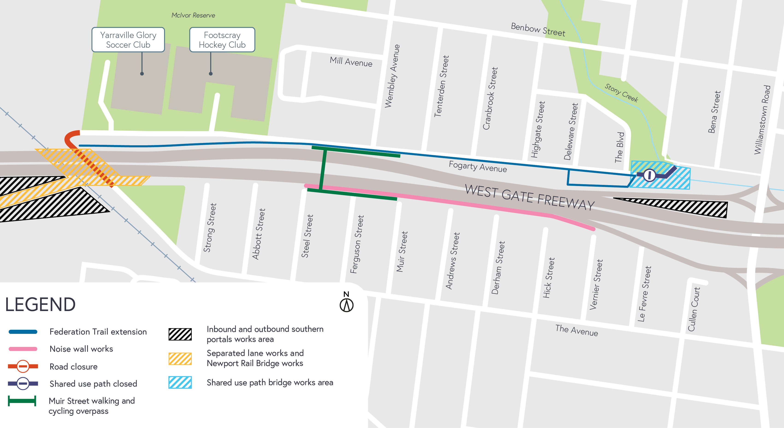
Newport Rail Bridge and The Avenue

Ongoing until early 2022
We will be closing The Avenue underneath the West Gate Freeway to carry out important freeway widening works. Works include demolishing the outer edge of one of the bridges using high pressure water, installing barriers and beams on the new bridges, and installing noise wall posts and acrylic panels on the new bridges that sit above The Avenue.
For all these works we will need to close the connection between The Avenue and Fogarty Avenue – this is so we don’t have paint or debris falling on road users or pedestrians.
We will be working day and night near The Avenue throughout these works to get them as quickly as possible. This includes using high pressure water to remove concrete at night throughout August.
For the latest traffic updates, dates of closures and detour route information visit: bigbuild.vic.gov.au/disruptions.

Federation Trail walking and cycling path extension

Ongoing until early 2022
We continue to work on the extension of Federation Trail alongside Fogarty Avenue, as well as the new walking and cycling bridge that will go over the Williamstown Road citybound exit ramp.
These works will include excavating dirt and pouring concrete for the new path, as well as building the structures to support the bridge that will go over the Williamstown Road citybound exit ramp.
If you want to ‘ride through’ this section – check out the video here:

Update on the Muir Street walking and cycling overpass
The stairs at Steel Street, Spotswood and Fogarty Avenue, Yarraville are expected to open in early 2022 once access to the stairs have been completed.
You may have also seen corflutes being installed along the residential side of the overpass ramps. This is part of our temporary solution for the noise being created during high winds.
These corflutes are in place while we work to identify and
install an appropriate permanent solution.

If you want to see how this new overpass was constructed, check out the video here:

Update on the Southern Inbound and Outbound Tunnels Portals

Ongoing until 2022
Works will continue at the Southern Inbound and Outbound portals, which includes installing concrete segments, concrete pours, excavation works and soil removal.

More detail on what you can expect during the works:
- Construction vehicles moving in and out of the area including excavators, cranes, rollers and water and concrete trucks. The main access to the sites will be from the West Gate Freeway, with additional access on designated truck routes.
- Construction noise, including intermittent short-term noise at night, from machinery such as cranes and high pressure water to demolish the old bridge over Newport Rail.
- Vibration may be experienced when we demolish the old bridge over Newport Rail and lay new surfaces.
- Water-spray trucks and road sweepers used in the local streets around our worksites, keeping local roads clear during construction.
- Lighting will be angled away from homes whenever possible when we’re working at night.
- Freeway lane closures and road closures will be required. Signed detours will be in place and traffic
updates available at bigbuild.vic.gov.au/disruptions.

Thank you
We appreciate our work can be disruptive and thank you for your understanding. Works may be rescheduled in the event of unexpected impacts.
For updates or questions, please call 1800 105 105,
email us at info@wgta.vic.gov.au or visit westgatetunnelproject.vic.gov.au

westgatetunnelproject.vic.gov.au info@wgta.vic.gov.au
1800 105 105
West Gate Tunnel Project Info Centre Corner of Somerville Rd and Whitehall St Yarraville VIC 3013
Follow us on social media Please contact us if you would like this
information in an accessible format.

Translation service – For languages other than English, please call 13 14 50.

Authorised by the Victorian Government, 1 Treasury Place, Melbourne

