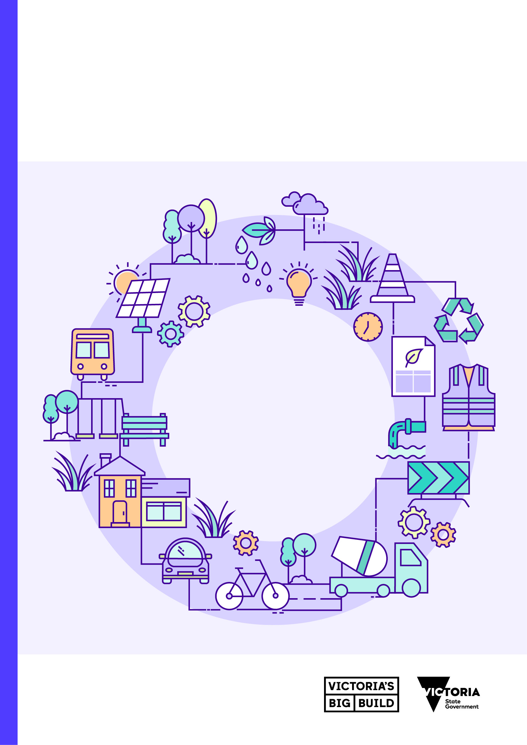
2024 Annual Sustainability Report
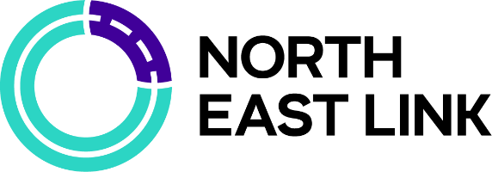

Contents
Acknowledgement of Country 3
Introduction 4
About this report 4
2024 project overview 6
What we’re building 7
Our sustainability targets 8
Materiality 9
UN Sustainable Development Goals 9
Leadership 11
Performance snapshot 11
Case Study: Australian-first PAS 2080 Accreditation 13
Case Study: Sustainability Strategy 14
Resource efficiency 15
Performance snapshot 15
Case Study: Trialling Calcined Clay as a Sustainable Concrete Alternative 18
Case Study: Digital Carbon Tracking 19
Urban Ecosystems 20
Performance snapshot 20
Case Study: Log Retention & Seed Collection 22
Communities 23
Performance snapshot 23
Case Study: Constructing Her Pathway 25
Case Study: Kicking Goals in Trades program 26
Economic Opportunities 27
Performance snapshot 27
Case Study: Yurringa Energy 28
Case Study: Creating Inclusive Work Environments 29
Case Study: Developing Socially Sustainable Canteens 30
Climate Change 31
Performance snapshot 31
Case Study: Electric Piling Rig 33
Glossary 34
Terms used in this report 34
Appendix 36
About IS Ratings 36

Acknowledgement of Country
We at the North East Link Program acknowledge the Wurundjeri people as the traditional Owners of the land on which the program stands, and respectfully recognise Elders past, present and emerging.
We also acknowledge the Traditional Custodians of lands across Australia where we conduct business, their Elders, Ancestors, cultures and heritage.
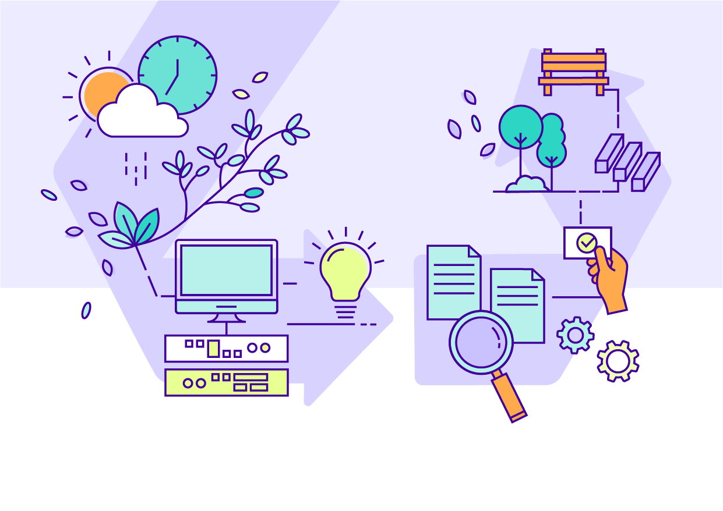

Introduction

About this report
Each year, the North East Link Program reports on our sustainability performance. Our commitment to public reporting drives accountability and transparency of sustainability outcomes across our program and supply chain.
This report covers the calendar year 1 January 2024 to 31 December 2024. Subsequent reports will be released annually for each calendar year. It enables us to present our progress each year and, in future reports, compare performance over time.
This report covers any package of works which has been in delivery for more than six months in 2024. The status of sustainability performance presented in this report is cumulative and accurate as of December 2024. We aim to achieve
all listed construction targets by the end of construction in 2028.
Early works status was independently verified by the Infrastructure Sustainability Council during 2023 and concluded
in 2024.
The status of the North East Link Tunnels (Tunnels) is based on Spark Consortium sustainability reporting.
The status for the M80 Ring Road Completion (M80RRC) and the Eastern Freeway Upgrade Burke to Tram (EBTA)
was based upon reporting from the M80 Ring Road Alliance and Eastern Freeway Burke to Tram Alliance.
All reporting was submitted in January 2024.
Data is based on monitored or estimated construction and operational impacts. Estimates are calculated using the
latest design or construction planning information.
Internal controls have been established to ensure the accuracy of information gathered, such as internal audits.
The content and quality of this report has been independently reviewed against the below principles of the Global Reporting Initiative, an international standard for sustainability reporting:
- Accuracy
- Balance
- Clarity
- Comparability
- Completeness
- Sustainability context
- Timeliness
- Verifiability.

Infrastructure Sustainability (IS) Rating
The IS Rating Scheme is a comprehensive system to assess the sustainability performance of infrastructure. Throughout this report we identify the IS Rating credits and levels which we will use to independently verify our performance against our sustainability targets. Refer to the Appendix for more information. Visit www.iscouncil.org to learn more.

United Nations (UN) Sustainable Development Goals
Throughout this report, we refer to North East Link’s contributions to the UN Sustainable Development Goals, a set
of global goals that frame our collective sustainability challenges and opportunities. See page 9 for further detail.
Visit sdgs.un.org to learn more.
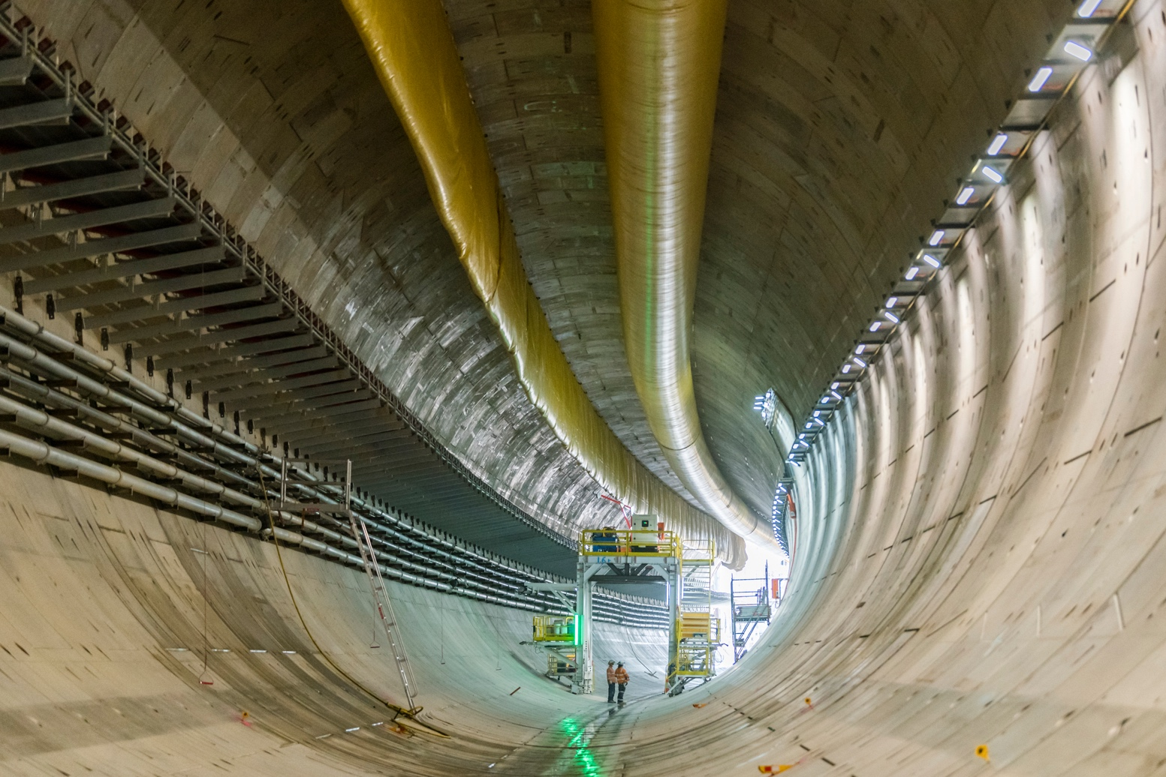

2024 project overview
We’ve set ambitious targets and benchmarks with our construction
partners and progress is well underway.
2024 saw us announcing the preferred bidders for the last two packages of work that make up the North East Link
Program – Hoddle Street to Burke Road, and Tram Road to Springvale Road, which make up the Eastern Freeway Upgrade along with Burke Road to Tram Road.
In August and September we launched our tunnel boring machines (TBMs), both of which made great progress over the fourth quarter, and will continue through 2025.
We reached 1 million hours worked by apprentices, trainees and cadets, signifying a huge milestone in achieving our goals
of providing economic opportunities for priority jobseekers.
We also signed a contract with Indigenous energy retailer Yurringa Energy to provide renewable power on the North East Link Tunnels, including powering the TBMs.
We’ve continued to support community sports in impacted areas, and in 2024 we opened two new facilities – Powerful Owl Park in Bulleen, and the Monash Tennis Centre – in order to keep sports clubs thriving while we deliver the biggest ever investment in Melbourne’s north east.
While the deadline for our ambitious sustainability targets is set for the end of construction in 2028, we have already delivered some great sustainability outcomes and we’re excited to continue sharing how we’re tracking.

What we’re building
We're delivering three major road projects to change the way people
move around Melbourne's north east by road, bus and bike.
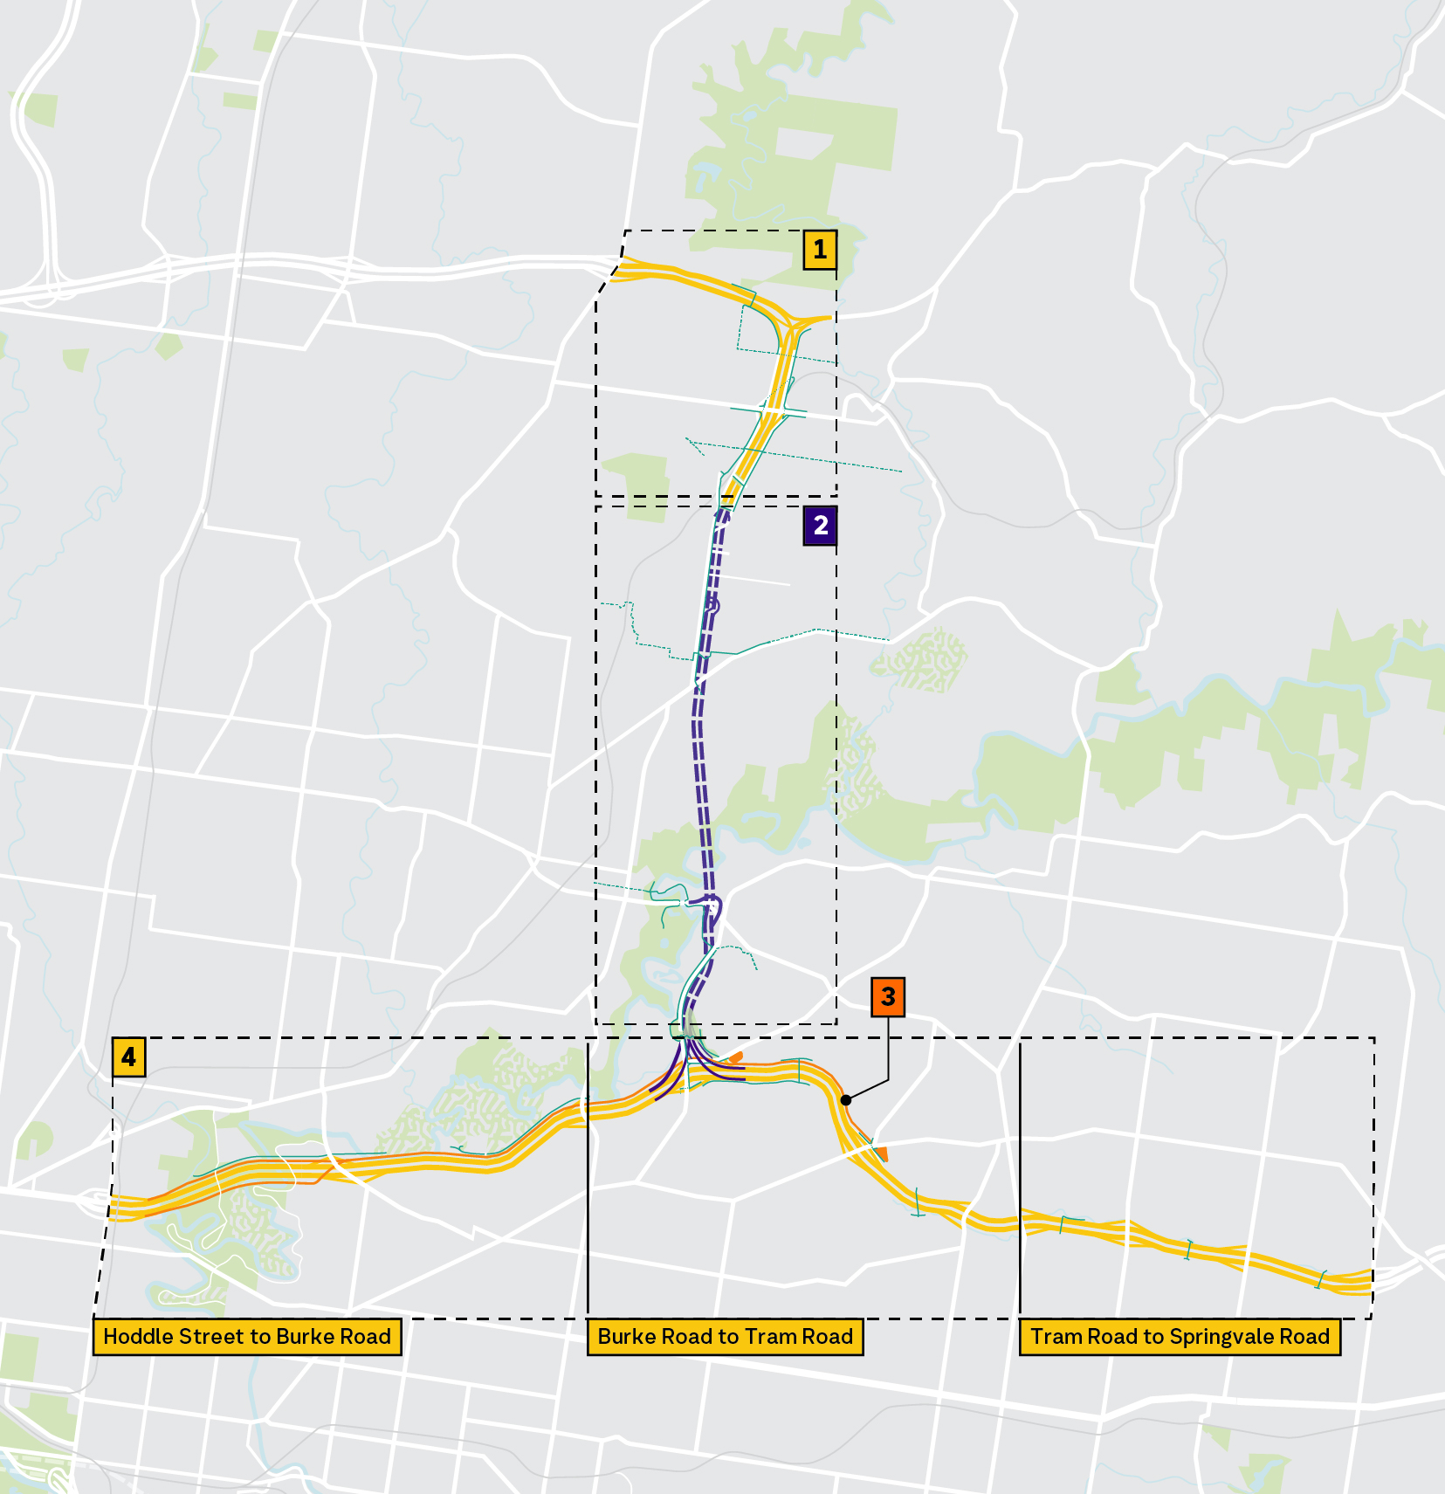
Victoria’s longest road tunnels will complete the missing link in Melbourne’s freeway network. We’ll also complete
the M80 Ring Road in Greensborough, and upgrade the Eastern Freeway. As part of all of this, we'll also deliver
Melbourne's first dedicated busway and create more than 34km of walking and cycling paths.

Big Build M80 Ring Road Completion

M80 Ring Road Alliance
Delivering new lanes, up-to-date technology, two landscaped bridges
in Watsonia and new train station parking. Construction 2024–2028.

North East Link Tunnels

Spark Consortium
Delivering Victoria’s longest twin
road tunnels, 15,000 trucks off
local roads each day and travel
times slashed by up to 35 minutes. Construction 2022–2028.

Big Build Eastern Busway
Delivering Melbourne's first dedicated busway, a new Bulleen Park & Ride,
and upgraded Doncaster Park & Ride. Construction 2024–2028.

Big Build Eastern
Freeway Upgrades

Hoddle to Burke Alliance,
Burke to Tram Road Alliance,
and Tram to Springvale Alliance
A major overhaul of the Eastern Freeway with new express lanes to slash travel times, new noise walls,
and new walking and cycling links. Construction 2024–2028.

Our sustainability targets
This report presents the status of North East Link Program’s performance against our sustainability objectives and targets in 2024. We set our ambitious
targets back in 2019 based on input from stakeholders and the community,
as well as technical sustainability assessments.

Key milestones in developing our Sustainability Objectives and Targets

2017–2018
Community feedback surveys on North East Link priorities and objectives.

December 2018
Sustainability workshop with councils and state government agencies.

March 2019
Sustainability workshop with community environment groups.

April 2019
Technical assessments of greenhouse gas footprint and
renewable energy options.

April–June 2019
NEL Environment Effects Statement on public exhibition.
This included our Sustainability Approach which details our
local, regional, and global sustainability context.

July 2019
Published sustainability objectives and targets on NEL website.

2019–2021
Incorporated sustainability targets into delivery partner contracts.

December 2021
Published 2021 Sustainability Snapshot.

July 2022
Sustainability targets briefing with Wurundjeri Woi-Wurrung
Aboriginal Cultural Heritage Corporation (the Wurundjeri).

June 2023
Published 2022 Annual Sustainability Report.

June 2024
Published 2023 Annual Sustainability Report.

2025 – We are here
Published 2024 Annual Sustainability Report.

2028 – North East Link opens

Materiality
These themes and objectives were established based on a materiality assessment conducted between 2018 to 2019.
This assessment brought together a review of the policy drivers, analysis of sustainability risks and opportunities, and community engagement feedback. Sector specific policies and instruments addressed included the UN Sustainable Development Goals, the Intergovernmental Panel on Climate Change’s Fifth Assessment Report and the Victorian Climate Change Act 2017 among others. The outcomes from these workshops set the six sustainability themes that form the foundation on which we set our sustainability targets – leadership, resource efficiency, urban ecosystems, communities, economic opportunities, and climate change.
This report shows the progress the project has made to date on these targets as well as case studies of some successful and unsuccessful initiatives.
The content and quality of this 2024 report, and the materiality assessment, have been independently reviewed against the principles of the Global Reporting Initiative, an international standard for sustainability reporting.

UN Sustainable Development Goals
Our targets seek to both minimise our negative impacts and maximise
our positive impacts as we procure, design, build and operate the
North East Link Program.
This diagram demonstrates how our targets address both positive and negative impacts and maps these against the
UN Sustainable Development Goals (SDGs). The performance snapshots on the following pages show how North East Link Program has sought to maximise our positive contributions and minimise our negative contributions to our key sustainability issues and the UN SDGs in accordance with the diagram.
Our aim is to work with our construction partners to exceed the ambitious sustainability targets across the design, construction and operation of the North East Link Program. Refer to the performance snapshots for more information
about our targets.

Maximise positive contribution

SUPPLY CHAIN


9: Industry, innovation
and infrastructure
THEME: Leadership
TARGET: Implement Initiatives
for sharing sustainability
knowledge gained from
the program.

SUPPLY CHAIN


10: Reduced inequalities
THEME: Economic opportunities
TARGET: Implement a social
and sustainable procurement
strategy that delivers on relevant legislative and policy frameworks, including Victoria’s Social Procurement Framework.

DESIGN


11: Sustainable cities
and communities
THEME: Communities
TARGET: Create a dedicated
Busway and provide accessible
and amenable Park & Ride
facilities connected to
shared use paths.

CONSTRUCTION
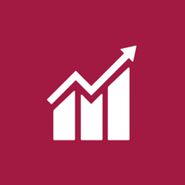

8: Decent work and
economic growth
THEME: Economic opportunities
TARGET: Implement a social and sustainable procurement strategy that delivers on relevant legislative and policy frameworks, including Victoria’s Social Procurement Framework.

CONSTRUCTION


11: Sustainable cities
and communities
THEME: Communities
TARGET: Implement initiatives that generate positive social and/or environmental outcomes and
enhance community wellbeing.

OPERATIONS


3: Good health and well-being
THEME: Communities
TARGET: Achieve at least a
10% increase (or greater) in
cyclist numbers travelling the
North East Link corridor after
3 years of operation.

Minimise negative contribution

SUPPLY CHAIN


12: Responsible consumption
and production
THEME: Resource efficiency
TARGET: Maximise use of reclaimed asphalt pavement and other
recycled materials in the program.

SUPPLY CHAIN


13: Climate action
THEME: Climate change
TARGET: Achieve a minimum
15% reduction in materials
lifecycle impacts.

SUPPLY CHAIN


6: Clean water and sanitation
THEME: Resource efficiency
TARGET: Maximise harvest and reuse of rainwater, stormwater, wastewater, groundwater and tunnel inflow water.

CONSTRUCTION

12: Responsible consumption
and production
THEME: Resource efficiency
TARGET: Achieve landfill diversion
rates of at least 90% by volume
of inert and non-hazardous
construction waste and 60%
by volume of office waste.

OPERATIONS


15: Life on land
THEME: Urban ecosystems
TARGET: Achieve a net gain
in canopy cover by 2045.

OPERATIONS

13: Climate action
THEME: Climate change
TARGET: Achieve net zero
emissions in the operation and maintenance of North East Link.



Leadership
Achieve excellent environmental, social and economic outcomes across
all phases of North East Link Program.

Performance snapshot


UNSDG 9: Industry, Innovation and Infrastructure

Seek opportunities to share knowledge and collaborate with stakeholders and industry peers
Target | Package | 2022 | 2023 | 2024
Implement innovative and pioneering initiatives in sustainable design, process or advocacy considered  a first in Victoria and/or Australia  IS v1.2 Inn-1 (Early Works)  IS v2.1 Inn-1 | Early Works |  Well Progressed | Well Progressed |  Complete
 | Tunnels |  Well Progressed | Well Progressed | Well Progressed
 | M80RRC |  N/A | N/A |  Well Progressed
 | EBTA |  N/A | N/A |  Well Progressed
Implement initiatives for sharing sustainability knowledge gained  from the program  IS v1.2 Man-6 Level 2 (Early Works)  IS v2.1 Lea-3 Level 2 | Early Works | Well Progressed | Well Progressed | Complete
 | Tunnels | Well Progressed | Well Progressed | Well Progressed
 | M80RRC | N/A | N/A | Well Progressed
 | EBTA | N/A | N/A | Well Progressed

Use sustainability rating schemes to set benchmarks and track and report performance
Target | Package | 2022 | 2023 | 2024
Achieve a minimum of 50 points  for the Program Rating under the  IS Rating tool v2.1 and 74 Points under IS v1.2 for Early Works | Early Works | Well Progressed | Well Progressed | Complete  82.8 Points
 | Tunnels | Well Progressed | Well Progressed | Well Progressed
 | M80RRC | N/A | N/A | Well Progressed
 | EBTA | N/A | N/A | Well Progressed
Achieve a minimum five-star  Green Star rating for the  Motorway Control Centre | Early Works |  N/A | N/A | N/A
 | Tunnels | Well Progressed | Well Progressed | Well Progressed
 | M80RRC | N/A | N/A | N/A
 | EBTA | N/A | N/A | N/A
Publicly report sustainability performance on an annual basis | Early Works | Complete | Complete | Well Progressed
 | Tunnels |  Complete | Complete | Well Progressed
 | M80RRC | N/A | N/A | Well Progressed
 | EBTA | N/A | N/A | Well Progressed

Case Study:
Australian-first PAS 2080 Accreditation
The North East Link Tunnels is the first project in Australia to achieve
PAS 2080 accreditation, setting a new benchmark for carbon management
in the Australian construction industry.
Target | Package | Current Phase | Status
Implement innovative and pioneering initiatives in sustainable design, process or advocacy considered a first in Victoria and/or Australia  (IS v1.2 or IS v2.1 Innovation Inn-1 credit) | North East Link Tunnels | Construction | Complete
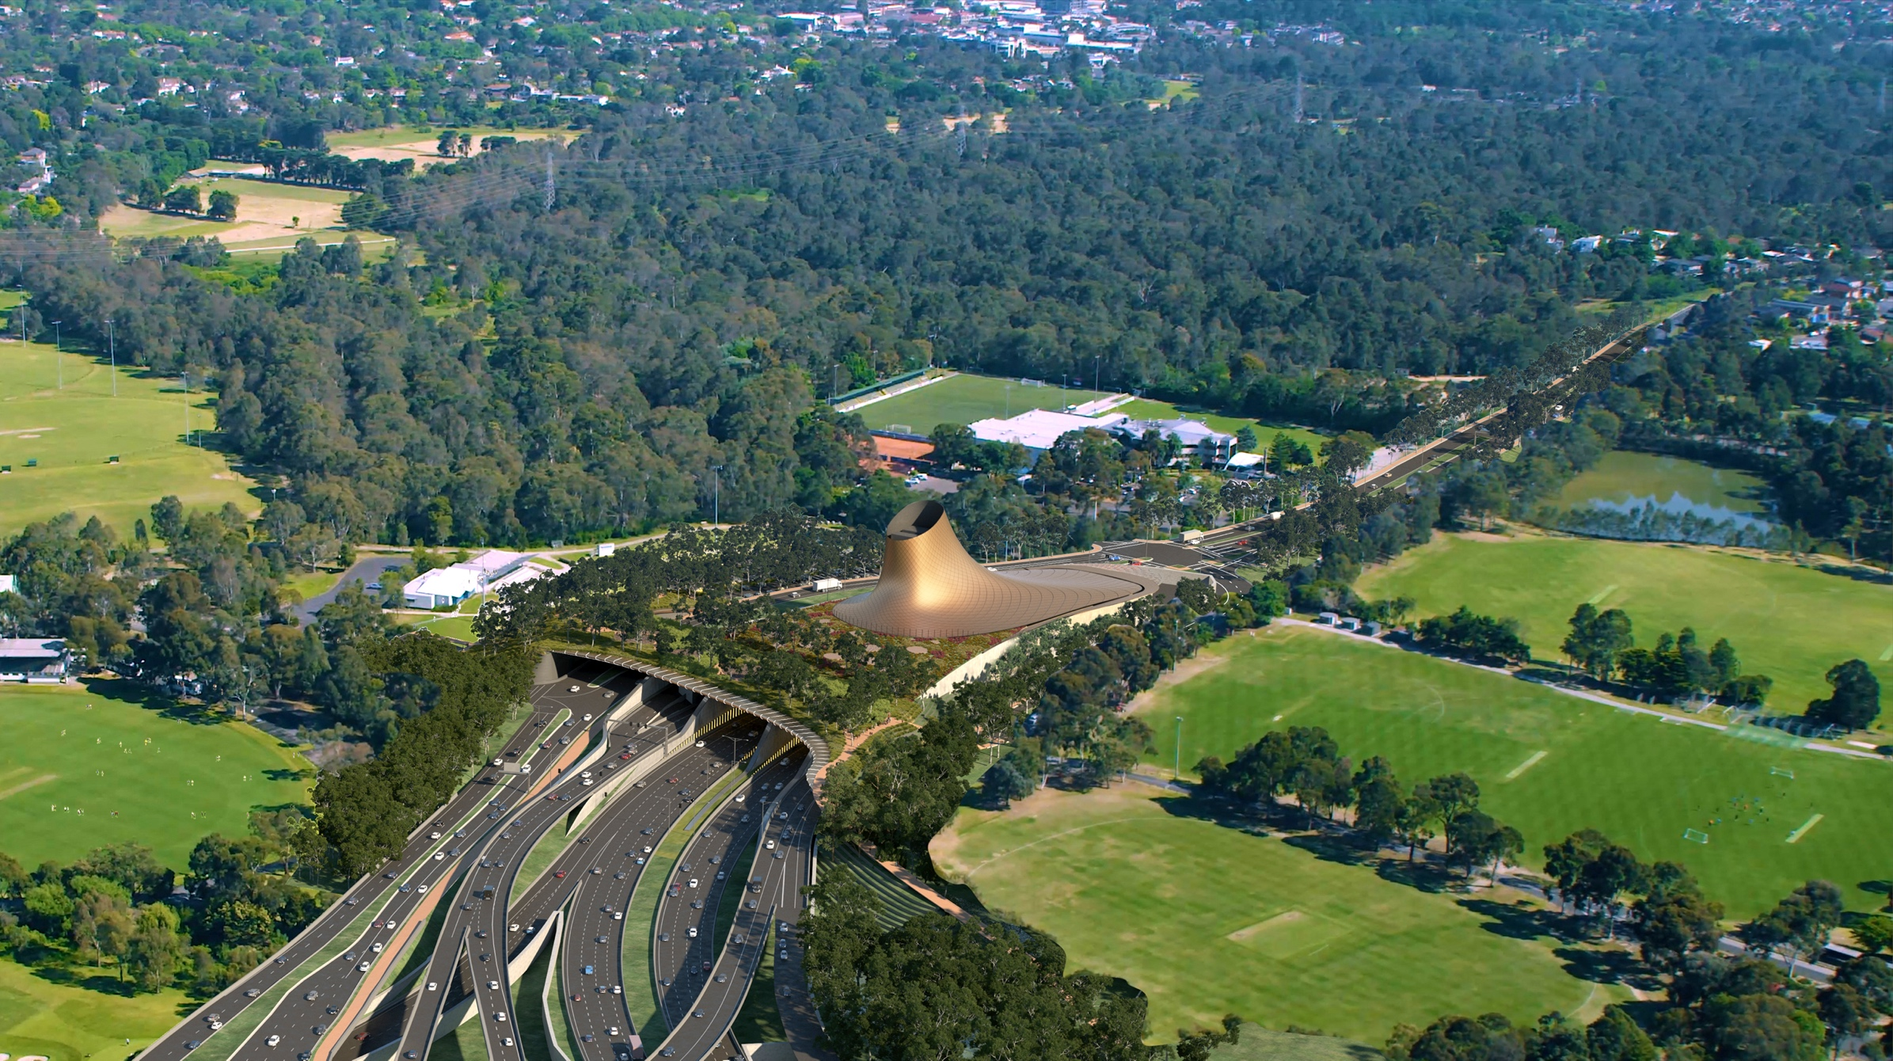
PAS 2080 is the global gold standard for carbon management in infrastructure since its release by The British Standards Institution (BSI) in 2016. It has seen extensive use in projects in the UK and Europe, which have shown benefits beyond emissions reduction. It also helps organisations streamline processes, enhance accountability, and make informed decisions that support long-term sustainability.
Achieving this accreditation required an in-depth gap analysis, which allowed us to identify and address key areas of alignment with PAS 2080. Using this data, we evaluated our carbon management system against the requirements
of the accreditation.
The North East Link Tunnels carbon management process seeks to mirror successful international efforts by fostering an effective decarbonisation culture across project functions. Several initiatives have been designed to support these efforts:
- Carbon literacy training for all project levels
- Targeted upskilling for specific functions
- The “Carbon Crusader Award” – a recognition program to celebrate contributions to our carbon reduction goals.
Collectively, these initiatives mean that carbon considerations can carry equal weight to more traditional values,
such as cost and program considerations, in the decision-making process.
This achievement demonstrates our commitment to sustainability and positions the Project as a leader in the future of
low-carbon infrastructure development.

Case Study:
Sustainability Strategy
The team on the Eastern Freeway Upgrades – Burke to Tram has established
a comprehensive sustainability strategy, drawing on the experience of the alliance partners – Laing O’Rourke, Symal, WSP, and Arcadis.
Target | Package | Current Phase | Status
Seek opportunities to share knowledge  and collaborate with stakeholders and  industry peers | Eastern Freeway Upgrade – Burke to Tram | Construction | Ongoing
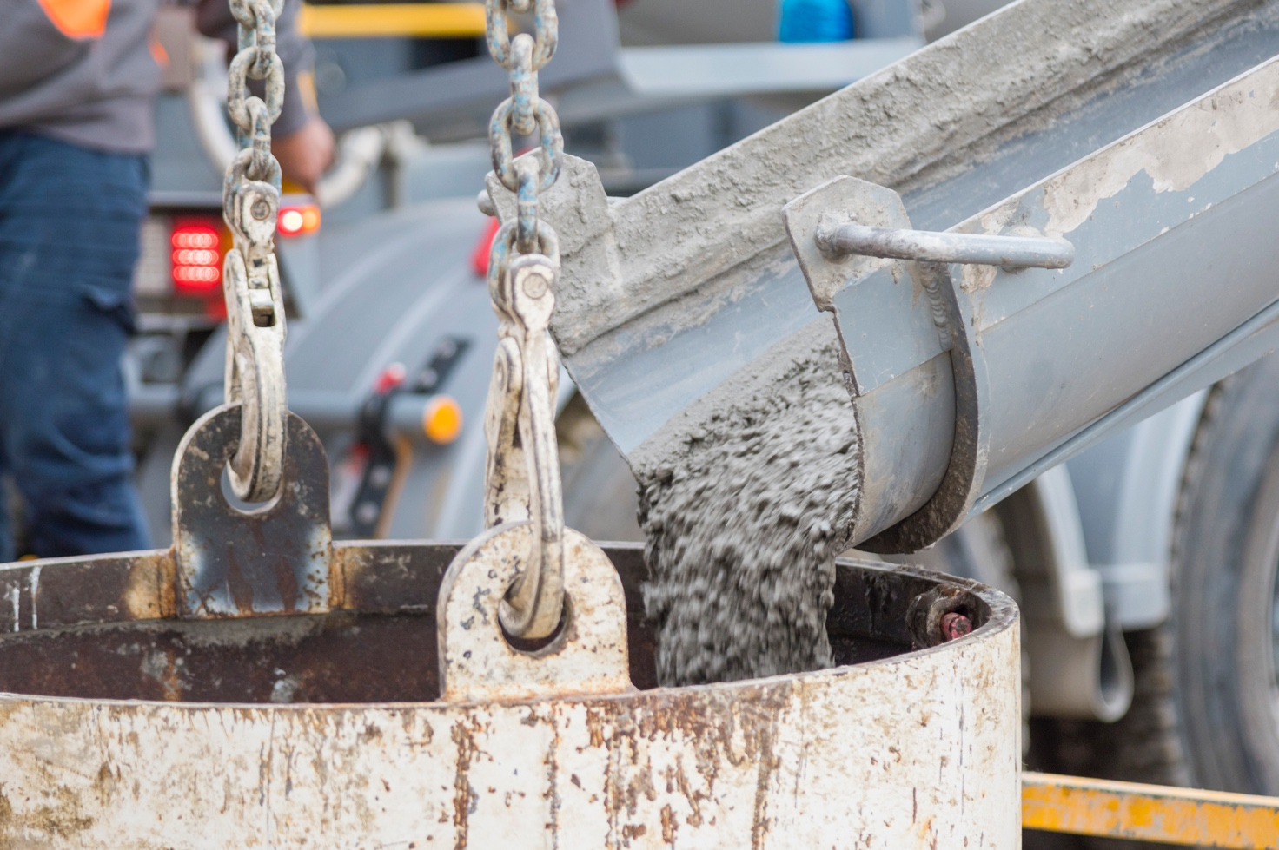
This strategy is based on three core sustainability pillars that align with Project requirements. These pillars are Decarbonisation, Resource Efficiency, and Legacy. A key aspect of this governance approach is aligning delivery partner and client targets to guarantee that the strategy meets the expectations of all stakeholders. In doing so, it aims to foster commitment and drive exceptional sustainability outcomes such as:

Decarbonisation
- Reducing scope 2 emissions by purchasing 100% GreenPower for electricity across the construction phase. This initiative is expected to reduce over 400 tonne of embodied carbon emissions (CO2-e) during the projects construction phase.
- Investing in solar-powered light towers – with 10 currently installed, with more planned – each saving approximately 135 kg CO2-e per week.

Resource efficiency
- Replacing 70% of the Portland cement in 4,000 cubic metres of piling mix with recycled materials. Portland cements has approximately 1 tonne of embodied carbon per 1 tonne of cement, equating to approximately a 1,000-tonne reduction of carbon emissions compared to using 100% Portland cement.

Legacy
- Donating numerous felled timber logs to local stakeholders, including 387 trees to Treasuring Our Trees – a not for profit organisation that uses fallen or felled trees to create community projects – and to YMCA Rebuild to provide employment and support the reintegration of ex-criminals into the workforce. Development and use of recycled plastic noise walls.
By aligning the expectations of the Bourke to Tram alliance and the North East Link Tunnel teams, we are fostering a commitment to driving exceptional sustainability outcomes, integrating sustainability into every aspect of the project
using a data-driven approach with live data reported by the team and the supply chain.
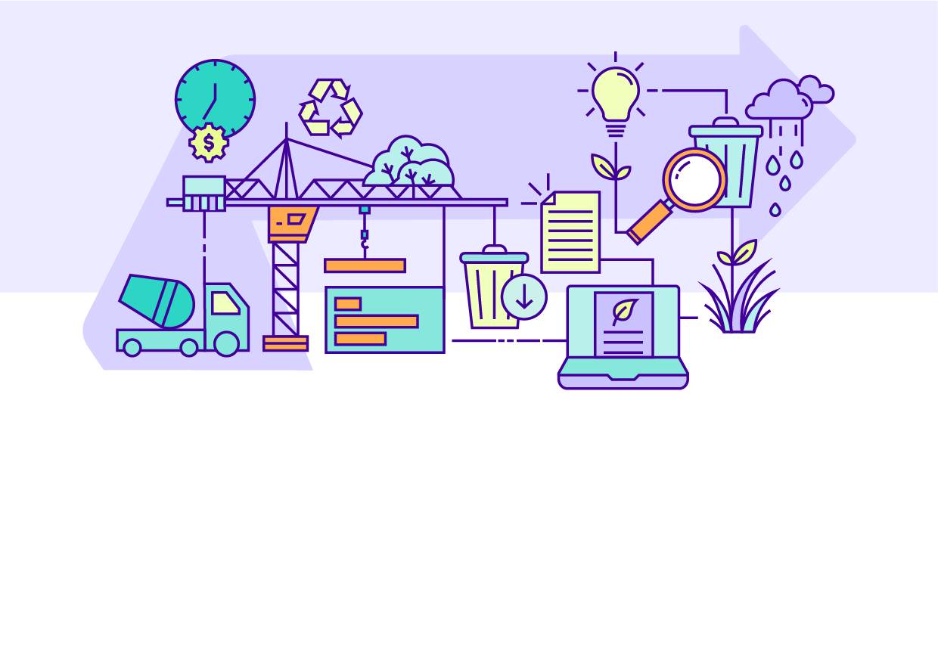

Resource efficiency
Embedding energy, water, material and waste reduction initiatives
into the design, construction and operation of the program.

Performance snapshot
  UNSDG 6: Clean water and sanitation |   UNSDG 12: Responsible consumption and production

Reduce the use and the lifecycle impacts of all materials like concrete and steel
Target | Package | 2022 | 2023 | 2024
Develop a Resource Efficiency Strategy and Action Plan.  IS v2.1 Rso-1 Level 2 | Early Works | N/A | N/A | N/A
 | Tunnels | Well Progressed | Well Progressed | Well Progressed
 | M80RRC | N/A | N/A | Well Progressed
 | EBTA | N/A | N/A | Well Progressed
Achieve a minimum 15% reduction  in materials lifecycle impacts (measured by the materials lifecycle calculator) below the base case.  IS v1.2 Mat-1 Level 1.3 (Early Works)  IS v2.1 Rso-6 Level 1  ¹ Early Works target 5%. | Early Works | Well Progressed 5.3%¹ | Well Progressed 5.7%¹ | Complete  5.7%¹
 | Tunnels |  Progressing  12% | Well Progressed  33.5% | Well Progressed  32.14%
 | M80RRC | N/A | N/A | Well Progressed 28%
 | EBTA | N/A | N/A | Well Progressed 15%
Reduce the amount of Portland Cement content in concrete  across the program by a minimum  of 30% (against Green Building Council of Australia reference  mix design levels). | Early Works | Well Progressed  36% | Well Progressed  30% | Complete  30%
 | Tunnels | Well Progressed  40% | Well Progressed  48% | Well Progressed  56.06%
 | M80RRC | N/A | N/A | Well Progressed  32%
 | EBTA | N/A | N/A | Well Progressed  40%
Maximise use of reclaimed asphalt pavement and other recycled materials in the program. | Early Works | Well Progressed  4.5% | Well Progressed  4.2% | Complete  4.5%
 | Tunnels | Well Progressed 27% Asphalt  38% Other | Well Progressed 13% Asphalt  29% Other | Well Progressed 23.16% Asphalt  19.48% Other
 | M80RRC | N/A | N/A | Well Progressed  31% Asphalt  35% Other
 | EBTA | N/A | N/A | Well Progressed  12% Asphalt  45% Other
Maximise local steel by volume sourced from fabricators or contractors who are accredited suppliers for the Environment Sustainability Charter of  Australian Steel Institute or  similar international association. | Early Works | Well Progressed  7.8% | Well Progressed  9.2% | Complete  9.2%
 | Tunnels | Well Progressed  50% | Well Progressed  83% | Well Progressed  89.27%
 | M80RRC | N/A | N/A | Well Progressed  40%
 | EBTA | N/A | N/A | Well Progressed 60%
Implement a sustainable procurement policy to ensure that major materials have environmental labels or are from sustainable  supply chains. | Early Works | Well Progressed | Well Progressed | Complete
 | Tunnels | Well Progressed | Well Progressed | Well Progressed  46.9%
 | M80RRC | N/A | N/A | Well Progressed  30%
 | EBTA | N/A | N/A | Well Progressed  30%

Reduce water use and maximise the use of alternatives to potable water
Target | Package | 2022 | 2023 | 2024
Maximise harvest and reuse  of rainwater, stormwater,  wastewater, groundwater  and tunnel inflow water. | Early Works | Well Progressed 6.1% | Well Progressed 19% | Complete  19.7%
 | Tunnels | In Progress  12% | Well Progressed  29% | Well Progressed  36%
 | M80RRC | N/A | N/A | Well Progressed  10%
 | EBTA | N/A | N/A | Well Progressed  1.8% (target 1.5%)
Develop Integrated Water Management projects to  supply construction and  post-construction uses. | Early Works | N/A | N/A | N/A
 | Tunnels | In Progress | Well Progressed | Well Progressed
 | M80RRC | N/A | N/A | Well Progressed
 | EBTA | N/A | N/A | Well Progressed
Develop a water usage and sourcing strategy that includes potable and non-potable water needs, volumes and sources that would be used and generated during construction and operation. Identify opportunities to reduce water use and maximise reuse. | Early Works | N/A | N/A | N/A
 | Tunnels | In Progress | Well Progressed | Well Progressed
 | M80RRC | N/A | N/A | Well Progressed
 | EBTA | N/A | N/A | Well Progressed

Reduce waste and maximise the sustainable reuse of excavated material
Target | Package | 2022 | 2023 | 2024
Implement initiatives to reduce  spoil quantities and maximise  the beneficial reuse of uncontaminated spoil. | Early Works | Well Progressed  97.4% | Well Progressed  100% | Complete  100%
 | Tunnels | Well Progressed 94% | Well Progressed 97% | Well Progressed  99.49%
 | M80RRC | N/A | N/A | Well Progressed  100%
 | EBTA | N/A | N/A | Well Progressed  98%
Maximise waste diverted from landfill and achieve landfill diversion rates of at least 90% by volume  of inert and non-hazardous construction waste. | Early Works |  In Progress  81.3% | Well Progressed  92% | Complete  95%
 | Tunnels | Well Progressed  98% | Well Progressed  98% | Well Progressed  97.9%
 | M80RRC | N/A | N/A | Well Progressed  100%
 | EBTA | N/A | N/A | Well Progressed  99%
Maximise waste diverted from landfill and achieve landfill  diversion rates of at least 60%  by volume of office waste. | Early Works | Well Progressed  63.7% | Well Progressed  80% | Complete  80%
 | Tunnels | In Progress  32% | In Progress  27% | In Progress  48.13%
 | M80RRC | N/A | N/A | Well Progressed  65%
 | EBTA | N/A | N/A |  In Progress  30%

Case Study:
Trialling Calcined Clay as a Sustainable Concrete Alternative
In collaboration with the University of Melbourne and Building 4.0 CRC –
an industry-led research initiative co-funded by the Australian Government –
we undertook a feasibility study looking into using excavated clay material in full scale concrete applications as a viable replacement for cement and sand.
Target | Package | Current Phase | Status
Implement innovative and pioneering initiatives in sustainable design, process or advocacy considered a first in Victoria  and/or Australia | M80 Ring Road Completion  North East Link Tunnels | Construction | Ongoing
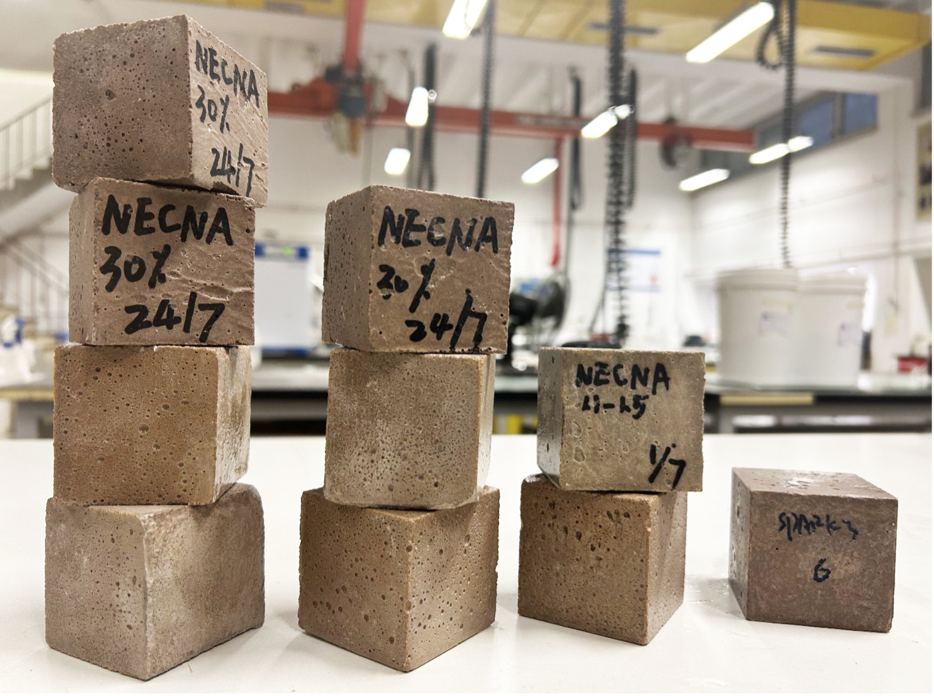
Demand for cement continues to increase, while the availability of alternative, low-carbon materials used in concrete like fly ash – a byproduct from coal power plants, most of which will be closing by 2040 – and slag – primarily sourced from overseas – are diminishing.
This makes it essential to find a supplementary cementitious material (SCM) that is eco-friendly, locally sourced, and abundant.
Calcined clay was identified as being a viable option for testing, because:
- it required less energy than cement clinker production – calcined clay is heated to 650°C for 1 hour, compared with cement clinker production at 1450°C for 2 hours
- compared with cement clinker production, which releases CO² through the chemical decomposition of limestone, the clay calcination process does not release CO² as a by-product.
- it promotes the circular economy by finding uses for excavated spoil and transforming it into high-value products
- it uses locally sourced Victorian clay instead of slag and fly ash, which are often imported from overseas or other states.
While a Life Cycle Assessment is still required to confirm the carbon footprint from using calcined clay, it appears to exhibit
a carbon factor similar to or lower than that of slag – only 17% of the emissions output from cement production.
The team has also found that the selection criteria for clay can be expanded, as most clays have demonstrated excellent performance in binary and triple-blend systems and meet the necessary standards.
A future field trial, with a triple blend containing a high content of calcined clay will provide valuable insights and help accelerate industry progress.

Case Study:
Digital Carbon Tracking
As part of our commitment to reducing carbon emissions, the Eastern Freeway Upgrades: Burke to Tram had an ambitious digital strategy to develop a whole of project model and incorporate carbon impacts into this model.
Target | Package | Current Phase | Status
Reduce the use and the lifecycle impacts of all materials, like concrete, asphalt and steel | Eastern Freeway Upgrade – Burke to Tram | Construction | Ongoing
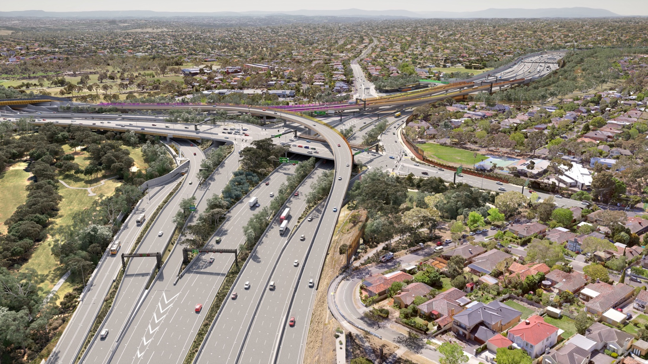
Reducing carbon emissions when building new infrastructure is key for achieving sustainable infrastructure. Embodied carbon represents the most significant source of carbon on the project. Embodied carbon refers to the greenhouse gas emissions associated with the production (the extraction, transport and manufacturing) stages of a product's life, which makes up approximately two thirds of the total carbon on the North East Link Program.
Embodied carbon reductions generally come from two key initiatives:
- Reducing the quantity of materials used through design optimisation
- Using lower embodied carbon materials e.g. reduced Portland cement content in concrete.
Our model captures all project building components, which is then investigated to extract material quantities and calculate embodied carbon.
The model and process were developed in collaboration between the Digital team, the BIM modellers, and the Sustainability team, with information accessible in a digital dashboard.
The dashboard displays the carbon tracking for individual design packages at design gates, as well as the overall project carbon tracking. This means that the whole project team can access carbon tracking information on both a holistic
and per package basis, providing transparency and engagement around carbon intense materials and where savings
can be achieved.
This results in increased accountability and ownership of the carbon impact of parts of the project and reduces the time spent calculating embodied carbon emissions by 85%.
Using this strategy, the Eastern Freeway – Burke to Tram package has reduced embodied carbon emissions associated with design efficiencies by more than 11% – the equivalent of more than 32,000 tonne of embodied carbon emissions.
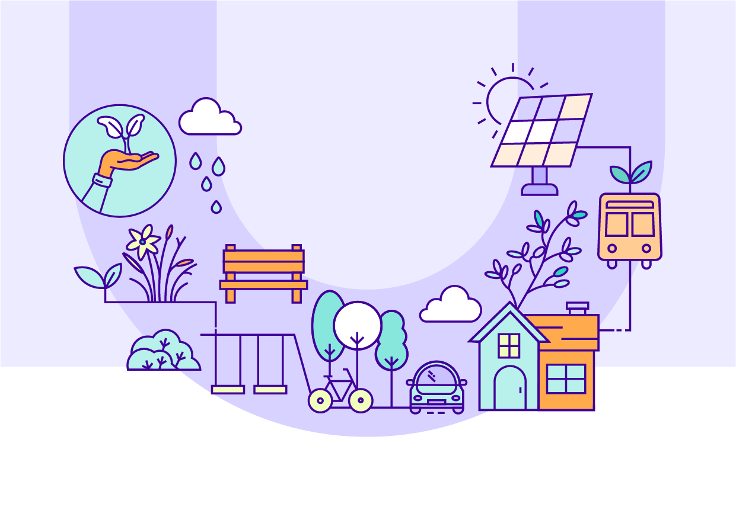

Urban Ecosystems
Protecting and seeking opportunities to enhance natural environments.

Performance snapshot


UNSDG 15:
Life on Land

Protect and enhance biodiversity and habitat links
Target | Package | 2022 | 2023 | 2024
Reduce impacts to ecological communities by minimising the removal of native vegetation, fauna habitat and mature old trees. | Early Works | Well Progressed | Well Progressed | Complete
 | Tunnels | Well Progressed | Well Progressed | Well Progressed
 | M80RRC | N/A | N/A | Well Progressed
 | EBTA | N/A | N/A | Well Progressed
Protect and enhance existing habitats, habitat connectivity and ecosystem function, where possible. | Early Works | Well Progressed | Well Progressed | Complete
 | Tunnels | Well Progressed | Well Progressed | Well Progressed
 | M80RRC | N/A | N/A | Well Progressed
 | EBTA | N/A | N/A | Well Progressed
Seek opportunities to create  new habitats and habitat links  in consultation with local environmental and  community groups. | Early Works | N/A | N/A | N/A
 | Tunnels | In Progress | Well Progressed | Well Progressed
 | M80RRC | N/A | N/A | Well Progressed
 | EBTA | N/A | N/A | Well Progressed
Apply best practice retention, responsible storage and reinstatement of topsoil to support growing conditions for local species. | Early Works | Well Progressed | Well Progressed | Complete
 | Tunnels | In Progress | In Progress | In Progress
 | M80RRC | N/A | N/A |  In Progress
 | EBTA | N/A | N/A | In Progress
Develop a Green Infrastructure  Plan and incorporate  Green infrastructure. | Early Works | N/A | N/A | N/A
 | Tunnels | Well Progressed | Well Progressed | Well Progressed
 | M80RRC | N/A | N/A | N/A
 | EBTA | N/A | N/A | N/A

Seek opportunities to improve stormwater quality and contribute to improvements
in waterway environments
Target | Package | 2022 | 2023 | 2024
Identify opportunities to improve water quality and contribute to improved connectivity and enhancement of waterways. | Early Works | N/A | N/A | Complete
 | Tunnels | Well Progressed | Well Progressed | Well Progressed
 | M80RRC | N/A | N/A | Well Progressed
 | EBTA | N/A | N/A | Well Progressed

Contribute to local urban forest outcomes
Target | Package | 2022 | 2023 | 2024
Contribute to urban forest outcomes by replacing lost canopy and achieving a net gain in canopy  cover by 2045. | Early Works | Well Progressed | Well Progressed | Complete
 | Tunnels | Well Progressed | Well Progressed | Well Progressed
 | M80RRC | N/A | N/A | Well Progressed
 | EBTA | N/A | N/A | Well Progressed
Prioritise the retention and protection of existing vegetation. | Early Works | Well Progressed | Well Progressed | Complete
 | Tunnels | Well Progressed | Well Progressed | Well Progressed
 | M80RRC | N/A | N/A | Well Progressed
 | EBTA | N/A | N/A | Well Progressed
Undertake new plantings early to optimise growth. | Early Works | Well Progressed | Well Progressed | Complete
 | Tunnels | In Progress | In Progress | In Progress
 | M80RRC | N/A | N/A | In Progress
 | EBTA | N/A | N/A | In Progress
Use indigenous species of local provenance where appropriate. | Early Works | Well Progressed | Well Progressed | Complete
 | Tunnels | Well Progressed | Well Progressed | Well Progressed
 | M80RRC | N/A | N/A | Well Progressed
 | EBTA | N/A | N/A | Well Progressed
Replanting to occur within the project boundary wherever possible. | Early Works | Well Progressed | Well Progressed | Complete
 | Tunnels | In Progress | In Progress | In Progress
 | M80RRC | N/A | N/A | In Progress
 | EBTA | N/A | N/A | In Progress

Case Study:
Log Retention & Seed Collection
The North East Link Program has encouraged and supported reuse opportunities for logs in the permanent design of the Project, enhancing
urban ecosystems by providing habitats.
Target | Project | Current Phase | Status
Protect and enhance biodiversity and habitat links | Eastern Freeway Upgrade – Burke to Tram | Construction | Ongoing
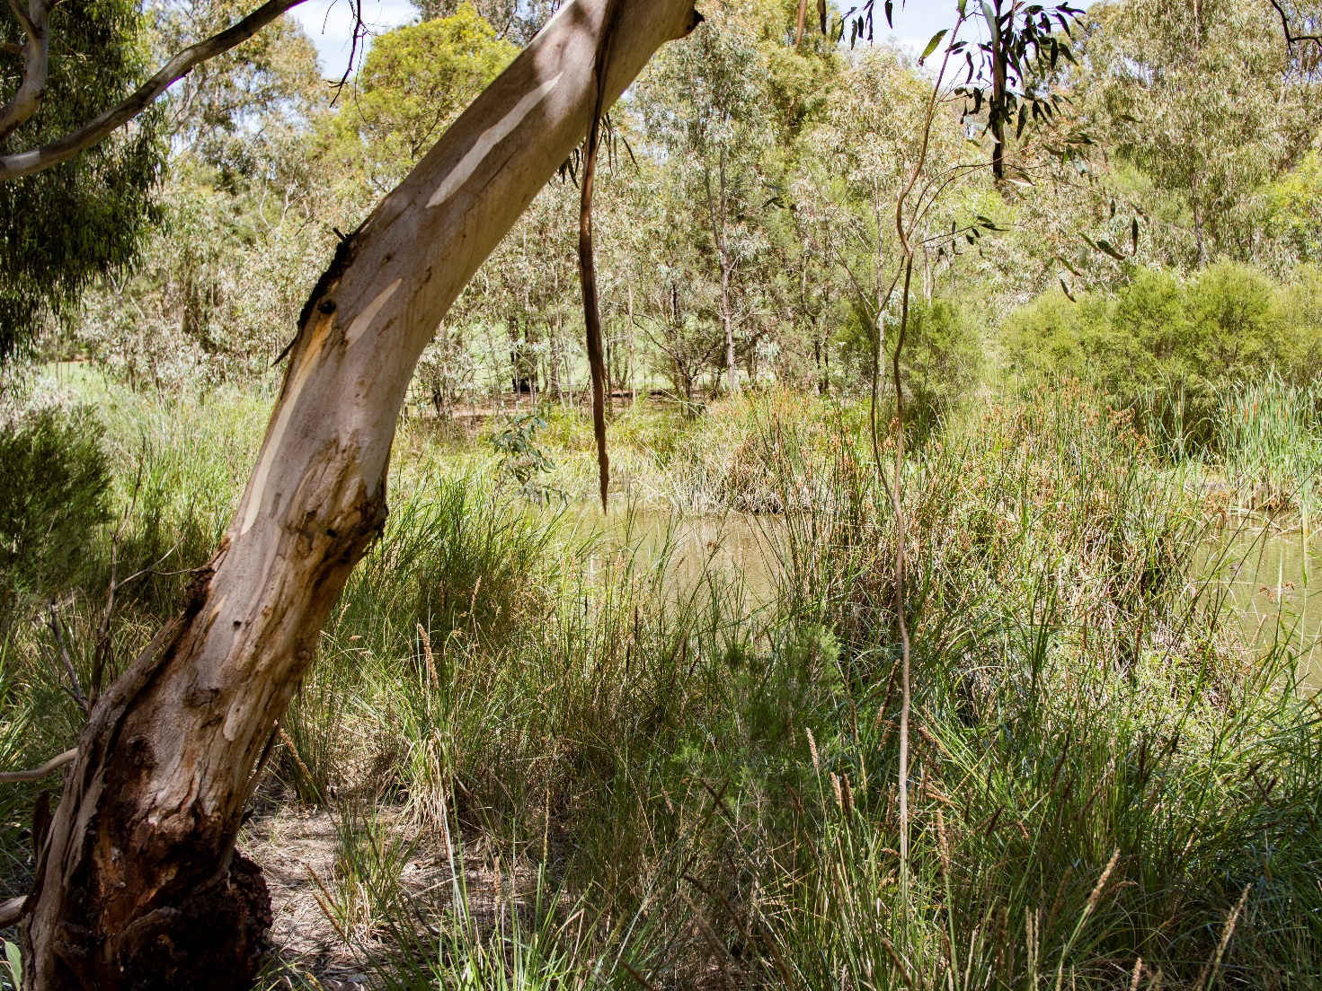
So far, the team on the Eastern Freeway Upgrade – Burke to Tram have installed more than 30 nest boxes across the project, providing safe spaces for birds – especially migrant birds who return to habitats for nesting – to lay their eggs.
We have also identified reuse opportunities for felled tree logs in the permanent design of the project. Over 500 felled trees have been stockpiled to be used throughout the landscaping of the project as horizontal habitat logs on the ground, while an additional 70 felled trees have been identified due to their diameter, branch formation, and tree hollows, as ideal for use as vertical habitat for native fauna.
Over 750 logs from the project have been repurposed through donations to various community groups and organisations.
50 logs have been provided to Melbourne Zoo as environmental enrichment for their elephant herd. Logs have been used to create seating for the Mourning Day dawn service and timber from the project area has been donated to primary schools for making fence posts, seating, planter boxes, and more.
The Environmental team has also commenced a program to collect, store and propagate the seeds of native plants in the project area, including the seeds of the critically endangered Studley Park Gums.
These initiatives will help support the planting of indigenous species of local provenance on the Project.


Communities
Making a positive contribution to social, cultural and community health
and wellbeing.

Performance snapshot
UNSDG 3: Good Health and  Well-Being | UNSDG 11: Sustainable Cities  and Communities

Enhance open space, active transport opportunities and community facilities
Target | Package | 2022 | 2023 | 2024
Implement initiatives that generate positive social and/or environmental outcomes and enhance community wellbeing.  IS v1.2 Hea-1 Level 2 (Early Works)  IS v2.1 Leg-1 Level 2 | Early Works | Well Progressed | Well Progressed | Complete
 | Tunnels | Well Progressed | Well Progressed | Well Progressed
 | M80RRC | N/A | N/A | Well Progressed
 | EBTA | N/A | N/A | Well Progressed
Achieve at least a 10% increase  (or greater) in cyclist numbers travelling the North East Link corridor after 3 years of operation. | Early Works | N/A | N/A | N/A
 | Tunnels | Well Progressed | Well Progressed | Well Progressed
 | M80RRC | N/A | N/A | Well Progressed
 | EBTA | N/A | N/A | Well Progressed
Increase the number of homes within 500m of a connected  shared use path. | Early Works | N/A | N/A | N/A
 | Tunnels | In Progress | Well Progressed | Well Progressed
 | M80RRC | N/A | N/A | Well Progressed
 | EBTA | N/A | N/A | Well Progressed
Create a dedicated Busway and provide accessible and amenable Park & Ride facilities connected to shared use paths, as guided by the Urban Design Strategy. | Early Works | Well Progressed | Well Progressed | Complete
 | Tunnels | Well Progressed | Well Progressed | Well Progressed
 | M80RRC | N/A | N/A | N/A
 | EBTA | N/A | N/A | Well Progressed
Seek opportunities to improve bus priority measures and facilities across the North East Link corridor. | Early Works | Well Progressed | Well Progressed | Complete
 | Tunnels | Well Progressed | Well Progressed | Well Progressed
 | M80RRC | N/A | N/A | N/A
 | EBTA | N/A | N/A | Well Progressed
Achieve a high level of improvement in recreational facility standards when compared with pre-North  East Link facilities. | Early Works | Well Progressed | Well Progressed | Complete
 | Tunnels | Well Progressed | Well Progressed | Well Progressed
 | M80RRC | N/A | N/A | Well Progressed
 | EBTA | N/A | N/A | N/A

Respect and promote cultural and historical heritage values
Target | Package | 2022 | 2023 | 2024
Demonstrate a design philosophy and approach that recognises, protects and promotes Indigenous cultural heritage values and celebrates and interprets places  and objects of historical  heritage importance. | Early Works | Well Progressed | Well Progressed | Complete
 | Tunnels | Well Progressed | Well Progressed | Well Progressed
 | M80RRC | N/A | N/A | Well Progressed
 | EBTA | N/A | N/A | Well Progressed
Seek opportunities to represent Wurundjeri people’s knowledge, insights and Connections to Country via a meaningful, authentic and collaborative process. | Early Works | Well Progressed | Well Progressed | Complete
 | Tunnels | Well Progressed | Well Progressed | Well Progressed
 | M80RRC | N/A | N/A | Well Progressed
 | EBTA | N/A | N/A | Well Progressed

Case Study:
Constructing Her Pathway
From 24 to 27 June, our delivery partners hosted the Constructing Her Pathway Program. This initiative to influence and empower female year 10 students, break gender biases, and highlight the opportunities and careers offered by the construction industry.
Target | Project | Current Phase | Status
Facilitating opportunities for economic development, provide a skilled local workforce and promote diversity and inclusion | North East Link Tunnels | Construction | Complete
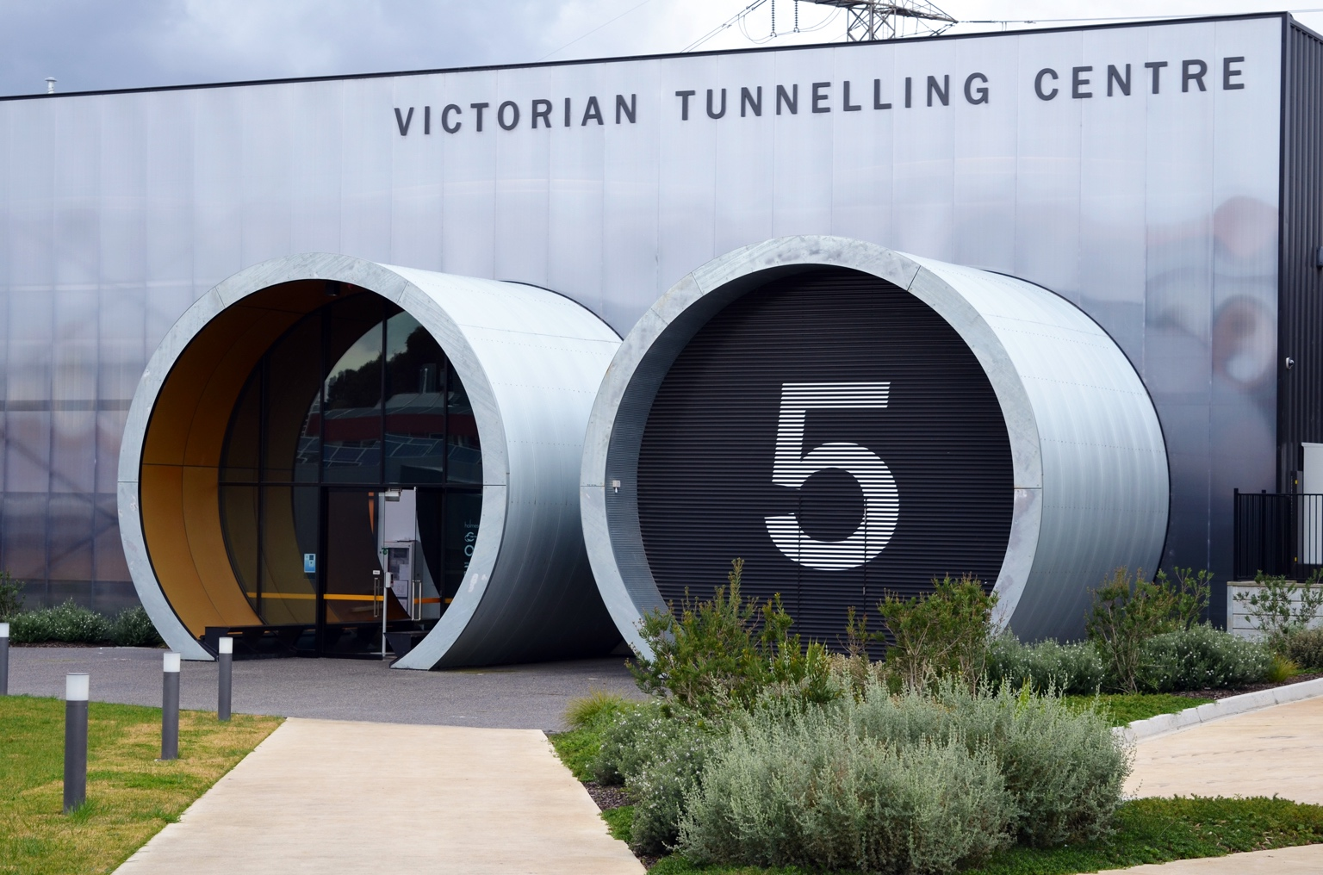
The program aims for maximum impact by exposing the students to the industry at a time when they are starting to make decisions about their futures, and to inspire them to make informed decisions to pursue challenging and rewarding careers.
More than 20 team members were involved in delivering the program, during which 11 students had the opportunity to:
- learn about the project and its benefits to the community
- visit the Manningham site and learn about career opportunities that construction offers
- visit the Victorian Tunnelling Centre – Holmesglen Institute and learn about safety and TAFE career pathways
- enhance their employability skills
- meet our Delivery Partner’s Managing Director
- learn about the different career pathways within the industry, learning from experts in HR, Communications, Engineering, and Business, among others.
Half of the attendees reported that they are now open to considering a career in construction. The other half reported that the program gave them great insight into the construction industry.

Case Study:
Kicking Goals in Trades program
We’re taking steps to inspire young women and non-binary people to explore careers in construction through industry trade apprenticeships.
Target | Project | Current Phase | Status
Facilitating opportunities for economic development, provide a skilled local workforce and promote diversity and inclusion | Eastern Freeway Upgrade – Burke to Tram | Construction | Ongoing
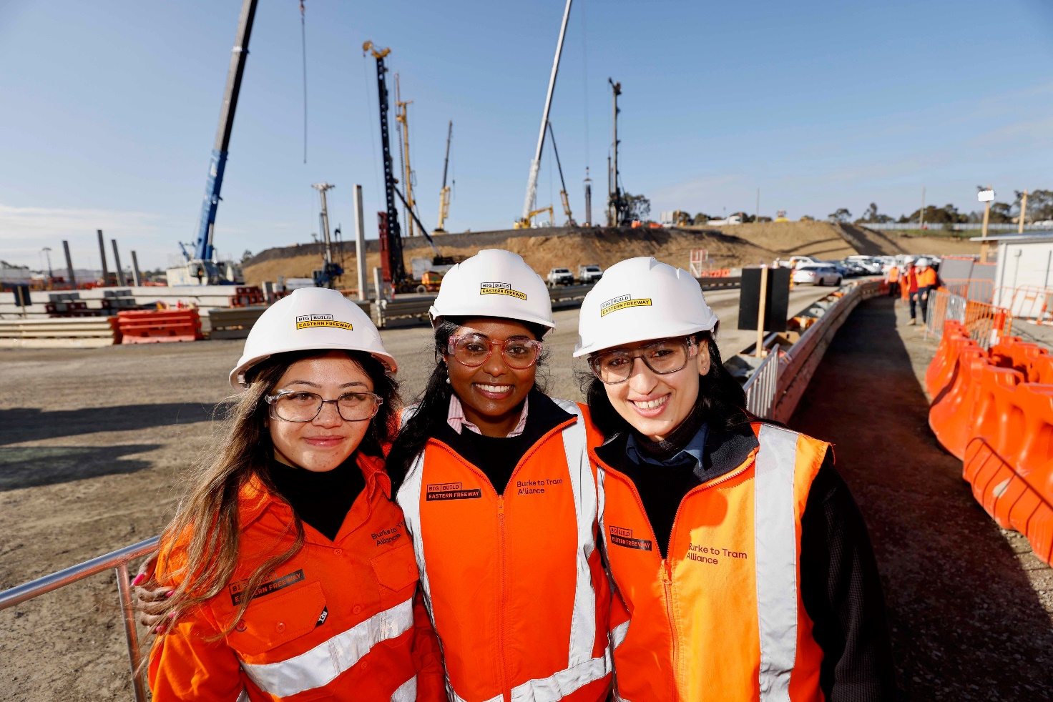
The Kicking Goals in Trades program is a joint initiative between the Burke to Tram Alliance, the North Melbourne Football Club, Tradeswomen Australia Group and Empowered Women in Trade, with the goal of creating a positive contribution to social, cultural and community health and wellbeing.
As part of the program, representatives from NELP visited Canterbury Girls School and Siena College in Camberwell, engaging over 250 students during the two-day program. Students learnt about the Eastern Freeway – Burke to Tram project and attended a presentation which introduced them to the road infrastructure industry and the different careers within construction, through both trade and university pathways.
The students then got to practice their skills using hand and power tools, building planter boxes for the school to keep.
For one group, we were able to bring North Melbourne Football Club AFLW player Libby Birch, providing positive
role-modelling, and helping with constructing the planter boxes.
The programs received extremely positive feedback from both students and teachers.
Kicking Goals in Trades forms part of our commitment to fostering connections with the communities we work in and creating positive long-term outcomes.


Economic Opportunities
Facilitating opportunities for economic development, provide a skilled
local workforce and promote diversity and inclusion.

Performance snapshot
  UNSDG 8: Decent Work and Economic Growth |   UNSDG 10:  Reduced  Inequalities

Achieve social value and sustainability outcomes through procurement
Target | Package | 2022 | 2023 | 2024
Implement a social and sustainable procurement strategy that delivers on relevant legislative and policy frameworks, including Victoria’s Social Procurement Framework. | Early Works | Well Progressed | Well Progressed | Complete
 | Tunnels | Well Progressed | Well Progressed | Well Progressed
 | M80RRC | N/A | N/A | Well Progressed
 | EBTA | N/A | N/A | Well Progressed

Promote sustainability within industry
Target | Package | 2022 | 2023 | 2024
Require relevant contractors and suppliers to adopt and implement recognised and accredited sustainability training for staff. | Early Works | N/A | N/A | N/A
 | Tunnels | Well Progressed | Well Progressed | Well Progressed
 | M80RRC | N/A | N/A | Well Progressed
 | EBTA | N/A | N/A | Well Progressed
Promote sustainability awareness among staff and contractors. | Early Works | Well Progressed | Well Progressed | Complete
 | Tunnels | Well Progressed | Well Progressed | Well Progressed
 | M80RRC | N/A | N/A | Well Progressed
 | EBTA | N/A | N/A | Well Progressed

Case Study:
Yurringa Energy
We have partnered with Yurringa Energy to facilitate the establishment
of the first Indigenous energy retail company.
Target | Package | Current Phase | Status
Achieve social value and sustainability outcomes through procurement | North East Link Tunnels | Construction | Ongoing
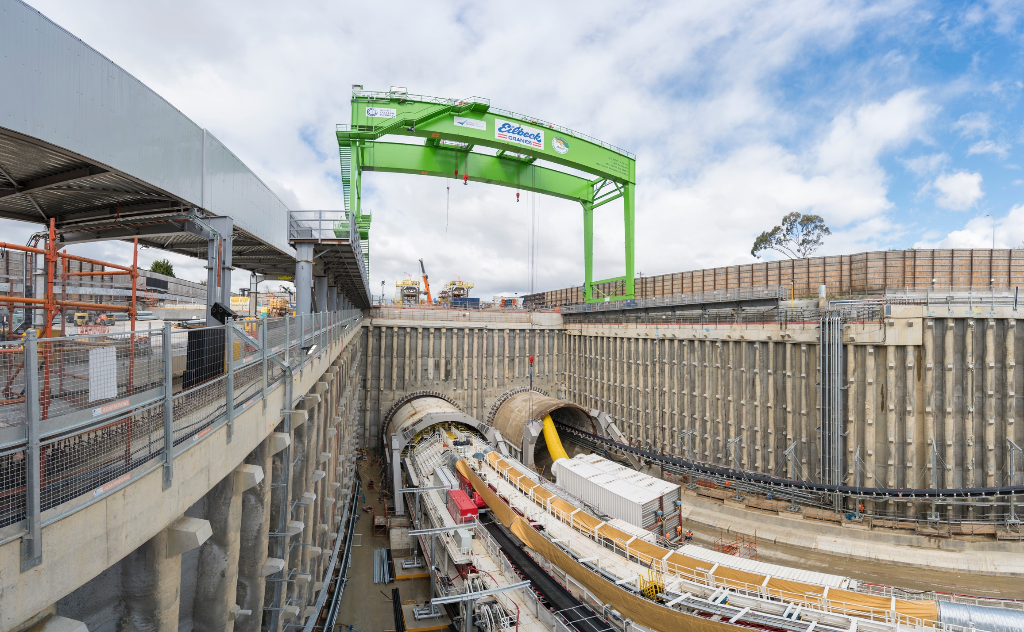
The contract is the first for Yurringa Energy, which will supply 137.5 GWh of renewable electricity to power the Tunnel Boring Machines and NELP’s construction sites – equivalent to the energy generated by over 91,000 solar panels in a year.
Yurringa Energy provides sustainable energy retail solutions while honouring Indigenous values, culture and traditions.
The business prioritises hiring Indigenous employees and contractors, and provides training and development opportunities to support their career growth.
This was achieved through a unique tender process, which reached beyond current industry best practice. Tenderers
were asked to provide their capabilities for Indigenous inclusion, female participation, traineeships and cadets, and social spend. This reflects the Project’s ambition to leverage its influence and purchasing power to positively influence the
broader energy market.
After a robust Cost Benefit Analysis, supported by economists, Yurringa Energy was deemed to have provided a bid which delivered excellent social and economic outcomes, including greater economic inclusion for First Nations peoples, and demonstrated the improved productivity generated by diversified organisations.

Case Study:
Creating Inclusive Work Environments
The M80 Ring Road Completion team has helped transform the lives of
over 90 individuals in the local community through a socially minded employment strategy.
Target | Package | Current Phase | Status
Achieve social value and sustainability outcomes through procurement | M80 Ring Road Completion | Construction | Ongoing
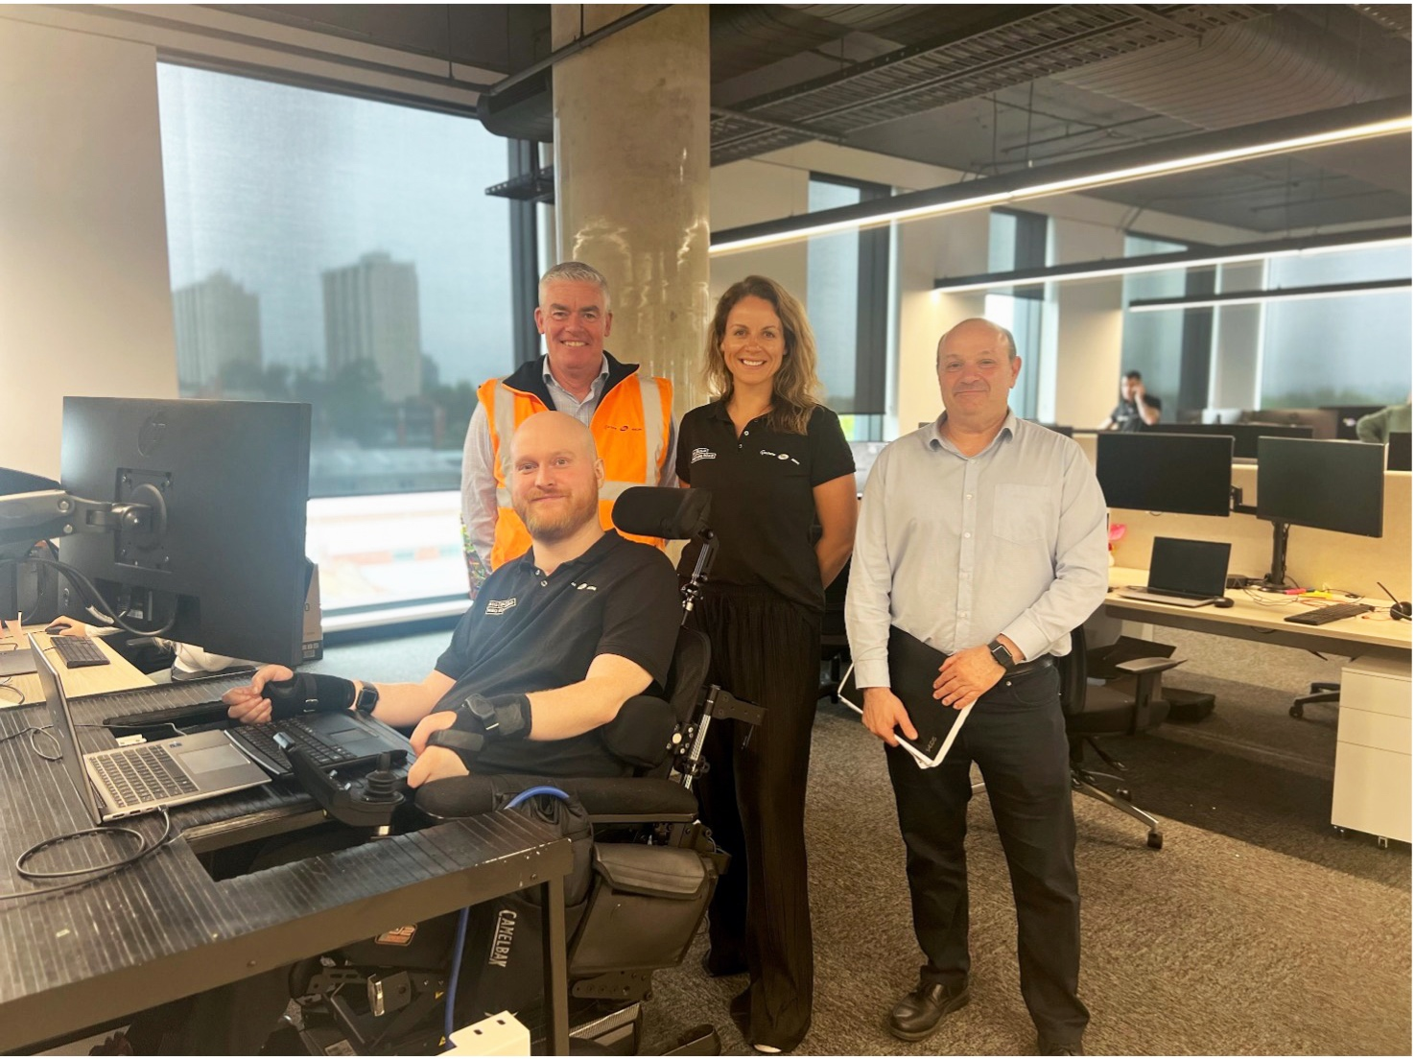
By forming strong, ongoing relationships with organisations that provide support to people facing barriers to gainful employment, the team has been able to offer employment to a diverse range of priority job seekers.
People supported through work on the project range from former refugees and asylum seekers, young offenders through
a pre-employment program in collaboration with Parkville Detention Centre, neurodivergent individuals and people living with a disability who historically experience employment barriers due to necessary extra workplace adjustments, such as facilitating support animals.
Among the individuals is Justin, who faced significant challenges, including societal stigma and barriers to education and employment, after an accident left him quadriplegic at 14. Justin’s journey to finding employment began when he sought help from MatchWorks, the project’s strategic social employment partner.
Through meaningful collaboration with Justin and MatchWorks, simple solutions to some of these barriers to employment were discovered – a custom table to facilitate his electric wheelchair and a specialised keyboard. Six months into his role, Justin has begun studying for a Certificate III in Business Administration. He has increased his work hours and constantly improves his database management and project work competency.
The impact of this collaboration extends beyond the workplace. The independence and confidence he developed means Justin can now leave home independently without the assistance of a support person. These kinds of employment opportunities highlight the importance of a supportive, inclusive work environment that fosters growth, independence,
and empowerment.

Case Study:
Developing Socially Sustainable Canteens
The team working on the M80 Ring Road Completion have developed canteens at three of our work sites that enhance employment pathways
for individuals from disadvantaged backgrounds.
Target | Package | Current Phase | Status
Achieve social value and sustainability outcomes through procurement | M80 Ring Road Completion | Construction | Ongoing
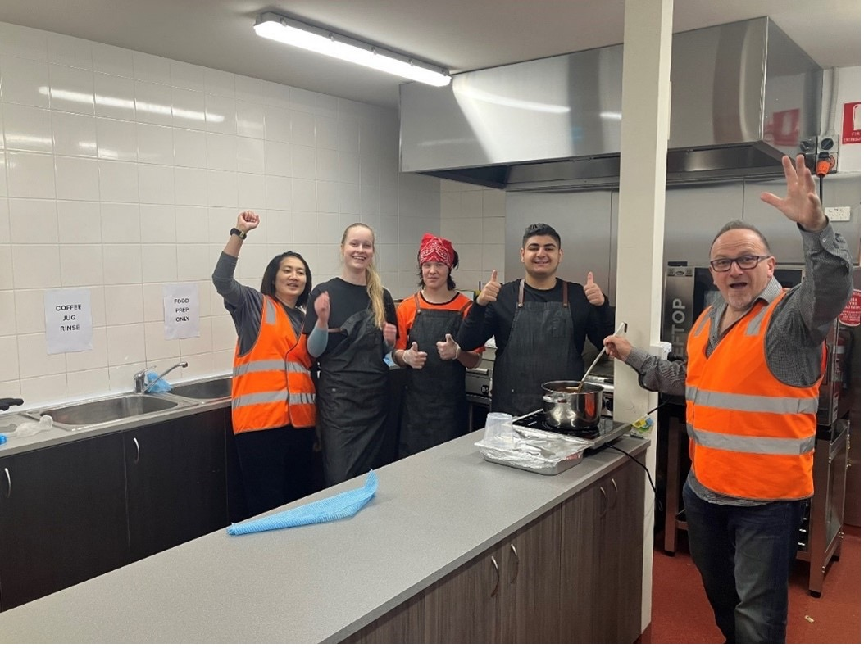

Many young people, particularly those from disadvantaged backgrounds or transitioning from custody, face significant barriers to employment. A lack of work experience, limited access to training, and difficulty in securing sustainable job opportunities often combine to result in long-term unemployment.

To help address these challenges, we’ve partnered with Parkville College, and social enterprise Social Engine, to provide job training, relevant work experience, and transition pathways into long-term employment through the canteens at the AK Lines, Gabonia, and Bundoora site offices.

Currently, six participants are employed in canteen roles on these project sites, with an additional 22 individuals expected to be hired as full-scale operations expand.

As part of the contract, Social Engine sources supplies for the canteens from local vendors. This approach not only bolsters economic growth but also strengthens community engagement.

By integrating employment pathways, facility enhancements, and community engagement, this initiative creates meaningful job opportunities while leaving a lasting, positive legacy for the community.
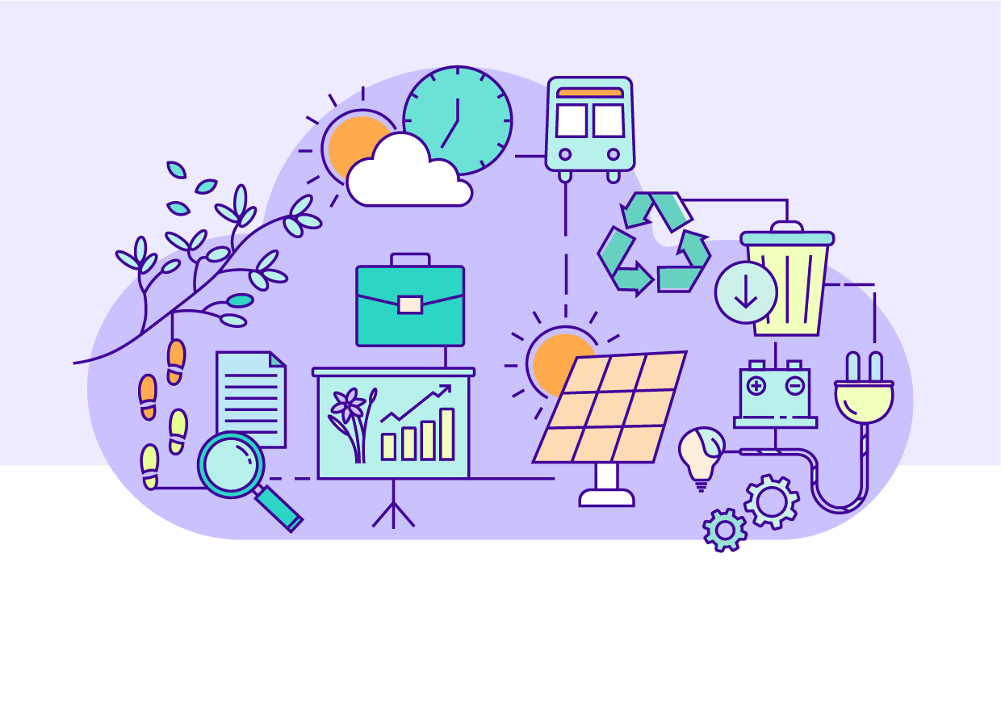

Climate Change
Playing a part in Victoria achieving its emission reduction targets while preparing for the challenges presented by climate change.

Performance snapshot


UNSDG 13:
Climate Action

Reduce carbon emissions during construction and operation
Target | Package | 2022 | 2023 | 2024
Analyse and implement all feasible opportunities to reduce energy  use and greenhouse gas emissions from construction and operation  of North East Link. | Early Works | Well Progressed | Well Progressed | Complete
 | Tunnels | Well Progressed | Well Progressed | Well Progressed
 | M80RRC | N/A | N/A | Well Progressed
 | EBTA | N/A | N/A | Well Progressed
Achieve at least a 30% reduction  in carbon emissions from the construction of North East Link against an ISC verified base case calculated in accordance with  their independent standards.  IS v1.2 Ene-1 Level 3 (Early Works)  IS v2.1 Ene-1 Level 3  ¹ Modeling 50% complete at the  time of reporting. | Early Works | Well Progressed  36% | Well Progressed  32% | Complete  25% reduction
 | Tunnels | Well Progressed  54% | Well Progressed  81% | Well Progressed 92.2% reduction
 | M80RRC | N/A | N/A | In Progress¹  32% reduction
 | EBTA | N/A | N/A | Well Progressed  30% reduction
Use at least 50% of renewable energy for electricity used to construct North East Link.  IS v1.2 Ene-2 Level 1.5 (Early Works)  IS v2.1 Ene-2 Level 1.5 | Early Works | Well Progressed  60% | Well Progressed  73% | Complete  73%
 | Tunnels | Well Progressed  100% | Well Progressed  100% | Well Progressed  100%
 | M80RRC | N/A | N/A | Well Progressed  100%
 | EBTA | N/A | N/A | Well Progressed  100%
Achieve net zero emissions in the operation and maintenance of  North East Link. | Early Works | N/A | N/A | N/A
 | Tunnels | Well Progressed | Well Progressed | Well Progressed
 | M80RRC | N/A | N/A | Well Progressed
 | EBTA | N/A | N/A | Well Progressed

Design to be resilient to a changing climate
Target | Package | 2022 | 2023 | 2024
Implement a Climate Resilience plan which addresses high and extreme climate change risks. | Early Works | Well Progressed | Well Progressed | Complete
 | Tunnels | Well Progressed | Well Progressed | Well Progressed
 | M80RRC | N/A | N/A | Well Progressed
 | EBTA | N/A | N/A | Well Progressed

Case Study:
Electric Piling Rig
The M80 Ring Road completion team has purchased one of only three electric piling rigs in the world. Utilising the new rig required a period of training and regulatory engagement, but it is now being used – alongside more traditional,
diesel-powered equipment – to bore around 25% of the approximately
4,500 piles required by October 2027.
Target | Package | Current Phase | Status
Reduce carbon emissions during construction and operation | M80 Ring Road Completion | Construction | Ongoing
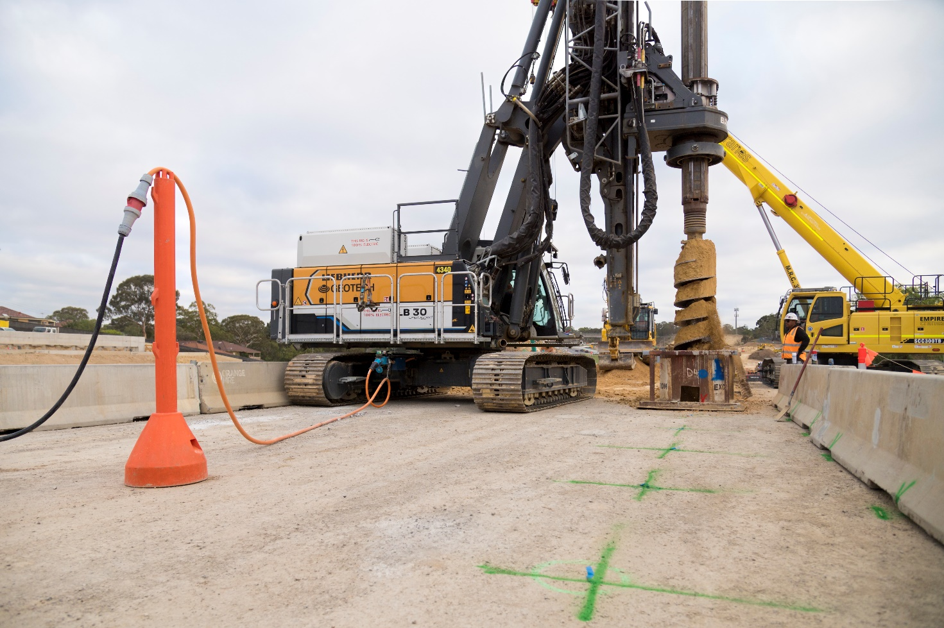
The operation of the rig is equal if not superior to its diesel counterpart, with elimination of tailpipe emissions, air quality improvements and a significant reduction in noise.
By utilising a hydrogen generator to charge the piling rig’s batteries, the team has delivered an Australian-first innovation. The initiative demonstrates options for power flexibility on projects where grid electricity may be difficult to access, whilst contributing to the development of hydrogen supply chains.
Using the electric piling rig improves the project’s impact on the environment by:
- significantly decreasing noise generated by piling works
- avoiding approximately 572t of scope 1 (direct) and scope 3 (indirect) carbon emissions
- reducing the risk to the health and safety of workers on-site, and to communities in the area
- positively impacting future construction projects through lessons learnt on the implementation of electric plant and equipment in construction.
Deploying the electric piling rig has demonstrated how new, sustainable technology can be introduced to the working environment of an infrastructure construction project. Trials such as these deliver valuable insights for future projects providing a template for broader and faster implementation.


Glossary

Terms used in this report

Carbon footprint
The greenhouse gas emissions impact associated with a product or activity.

Embodied carbon
The greenhouse gas emissions impact associated with all activities involved in the production of a finished material (e.g. activities include: raw material extraction, transport to manufacturing facilities, manufacturing).

Fabricators
A skilled tradesperson who creates value-added products from semi-finished or raw materials, such as the creation of custom steel products from coils or bars of steel.

Green Star Rating
A comprehensive system to assess the sustainability performance of buildings. Visit gbca.org.au to learn more.

Inert and non-hazardous construction waste
Materials resulting from construction and demolition activities, including concrete, bricks, paper, plastics, glass, metal, timber, asphalt, and used, rejected or unwanted tyres.

Infrastructure Sustainability (IS) Rating
A comprehensive system to assess the sustainability performance of infrastructure. Visit www.iscouncil.org to learn more.

Mass timber
An engineered timber product that can replace the steel or concrete structural components of buildings.

Non-potable water
Lower quality water suitable for purposes other than domestic consumption (see potable water), such as toilet flushing
or dust suppression.

Potable water
High quality water that is suitable, safe, and approved for domestic consumption as set and regulated by national health
and water quality standards. This is the standard supplied by water utilities which is sometimes called town water or reticulated water.

Reinstatement
To restore a material to its original state and/or former location.

Shared use path
A pathway that can be used for both walking and cycling.

Sustainable Development Goals
A set of global goals that frame our collective sustainability challenges and opportunities. Visit sdgs.un.org to learn more.

Topsoil
The uppermost layer of soil, distinguished from other layers of soil for its rich nutrient content and high levels of
organic matter.

Tunnel boring machine
A machine that excavates soil and rock. TBMs are being used to dig the tunnels for North East Link.

Tunnel inflow water
Groundwater which naturally flows into tunnels as a result of surrounding aquifer systems.

Wurundjeri Woi-wurrung Cultural Heritage Aboriginal Corporation
Visit www.wurundjeri.com.au to learn more.


Appendix

About IS Ratings

Leadership
IS Rating version | IS Rating credit | Intent of the credit | IS Rating level | Performance requirement
v1.2 | Inn-1 | Rewards pioneering initiatives in sustainable design, process or advocacy. | N/A | N/A
v2.1 | Inn-1 | Rewards innovative initiatives and outcomes in delivering sustainable infrastructure. | N/A | N/A
v1.2 | Man-6 | Rewards sustainability knowledge sharing initiatives. | Level 2 | One example of sustainability knowledge shared within the project One example of sustainability knowledge shared beyond project boundary One example of sustainability knowledge shared from outside the project onto the project.
v2.1 | Lea-3 | Rewards new or updated knowledge on issues and outcomes important to infrastructure sustainability shared between projects and more widely within industry. | Level 2 | Two examples of sustainability knowledge shared beyond the project boundary, resulting in competency improvement or specific action Two examples of sustainability knowledge shared from outside the project and has been utilised on the project Two examples of sustainability knowledge shared beyond the project boundary  to the wider industry.

Resource Efficiency
IS Rating version | IS Rating credit | Intent of the credit | IS Rating level | Performance requirement
v2.1 | Rso-1 | Rewards the identification, implementation and management of resource efficiency expectations for each phase of the infrastructure life cycle and the achievement of positive circular economy outcomes. | Level 2 | A Resource Efficiency Strategy and Resource Efficiency Action Plan have been developed Resource efficiency opportunities have been identified and assessed for feasibility Performance targets for circular economy outcomes have been reviewed with external stakeholders and proactively communicated to the market.
v1.2 | Mat-1 | Rewards design and practice that reduces lifecycle environmental impacts of materials. | Level 1.3 | Monitor and model materials life cycle impacts across the infrastructure lifecycle Monitoring and modelling demonstrate a 5% reduction in materials life cycle impacts compared to a base case footprint.
v2.1 | Rso-6 | Rewards the design and construction of the project in ways that reduce the environmental impacts of materials across the life cycle  of the infrastructure asset. | Level-1 | Monitor and model of materials life cycle impacts across the infrastructure life cycle Monitoring and modelling demonstrates a 15% reduction in materials life cycle impacts compared to a base case footprint.

Communities
IS Rating version | IS Rating credit | Intent of the credit | IS Rating level | Performance requirement
v1.2 | Hea-1 | To reward a positive contribution to community health  and wellbeing. | Level-2 | Measures to positively contribute to community health and wellbeing for three priority issues has been identified and implemented Monitoring of community health and wellbeing indicators related to the priority issues is undertaken at appropriate intervals during construction of the asset.
v2.1 | Leg-1 | To reward the  delivery of initiatives that contribute pronounced and  long-lasting societal  or environmental outcomes outside  of the project scope already addressed  by IS credits. | Level 2 | Initiatives have been implemented to contribute positively to society or the environment for three priority issues  or opportunities Monitoring has been established to demonstrate the success of the legacy initiatives.

Climate Change
IS Rating version | IS Rating credit | Intent of the credit | IS Rating level | Performance requirement
v1.2 | Ene-1 | To reward monitoring and minimising of energy use and GHG emissions across the infrastructure lifecycle. | Level 3 | Monitor and model energy use and greenhouse gas emissions across the infrastructure life cycle Monitoring and modelling demonstrates a 30% reduction in greenhouse gas emissions compared to a base case footprint.
v2.1 | Ene-1 | To reward the reduction of energy use and carbon emissions across the infrastructure life cycle and drive towards net zero carbon. | Level 3 | Monitor and model energy use and carbon emissions for capital and operational carbon Energy and  carbon emissions reduction opportunities have been investigated across the infrastructure life cycle and included in design and construction planning Monitoring and modelling demonstrates a 30% reduction in energy use and carbon emissions for capital and operational carbon compared to a base case footprint.
v1.2 | Ene-2 | To reward investigation of, and use of, renewable energy. | Level 1.5 | Opportunities for use of renewable energy are fully investigated Achieve  a 20% substitution of energy from renewable sources.
v2.1 | Ene-2 | To drive towards net zero carbon by increasing the development and use of renewable energy. | Level 1.5 | Achieve a 50% substitution of  capital and operational non-renewable energy use.

