EES Assessment Framework and Approach

Introduction
An assessment framework was developed for the EES to ensure consistency in approach was achieved throughout the EES and across the specialist assessments undertaken to evaluate and refine the proposed Melbourne Metro.
This chapter describes the assessment framework that has been applied to evaluating the environmental effects of Melbourne Metro, refining the project and preparing the EES. The framework has been applied to the assessment of potential risks and impacts, the development of recommended Environmental Performance Requirements to minimise adverse impacts and the evaluation of the overall potential impacts of Melbourne Metro, both positive and negative.
An overview of the environmental risk assessment process and its relationship to the impact assessment is also presented in this chapter.

Draft EES Evaluation Objectives and Assessment Framework
The assessment framework applied in evaluating the effects of Melbourne Metro and preparing this EES consists of the elements listed below. The relationship between these elements is illustrated in Figure ‎4-1:
- MMRA Project Objectives
- Draft EES evaluation objectives
- Project specific criteria (where appropriate)
- Relevant legislation, policy and guidelines
- Specialist risk assessment and impact assessment
- Recommended Environmental Performance Requirements.
The Melbourne Metro Project Objectives are a key input into the EES evaluation framework. These Project Objectives are listed in Section 1.1.3 of this EES. The Project Objectives have guided MMRA's approach to the development of the concept design for Melbourne Metro and would continue to inform its approach to the project's detailed design and construction.
While the Project Objectives are not focused on environmental performance, they do address the transport and social issues that are identified in the Scoping Requirements and aim to achieve transport, social and economic benefits. Section 2.6 (Chapter 2 Project Rationale and Benefits) provides a summary of how the proposed Melbourne Metro would meet the Project Objectives.
The draft EES evaluation objectives presented in Table 1 of the Scoping Requirements are also summarised in Table ‎4–1 below. The draft evaluation objectives provide a framework to guide an integrated assessment of the environmental effects of Melbourne Metro. The Scoping Requirements define the scope of the EES and set out in detail the specific matters to be investigated and documented in the EES.
The MMRA Project Objectives, the draft evaluation objectives and relevant legislation, policy and guidelines have informed the development of project-specific criteria, for areas of investigation where standards do not exist.
A systems and risk-based approach was adopted for the specialist studies to identify potential impact pathways, undertake an integrated risk assessment across all specialist disciplines and assess the potential impacts of Melbourne Metro. Through the specialist impacts assessments, recommended Environmental Performance Requirements have been developed to manage impacts to acceptable levels. The approach to specialist assessments is further described in Sections ‎4.5 and ‎4.6.
Figure ‎4-1 EES Assessment Framework
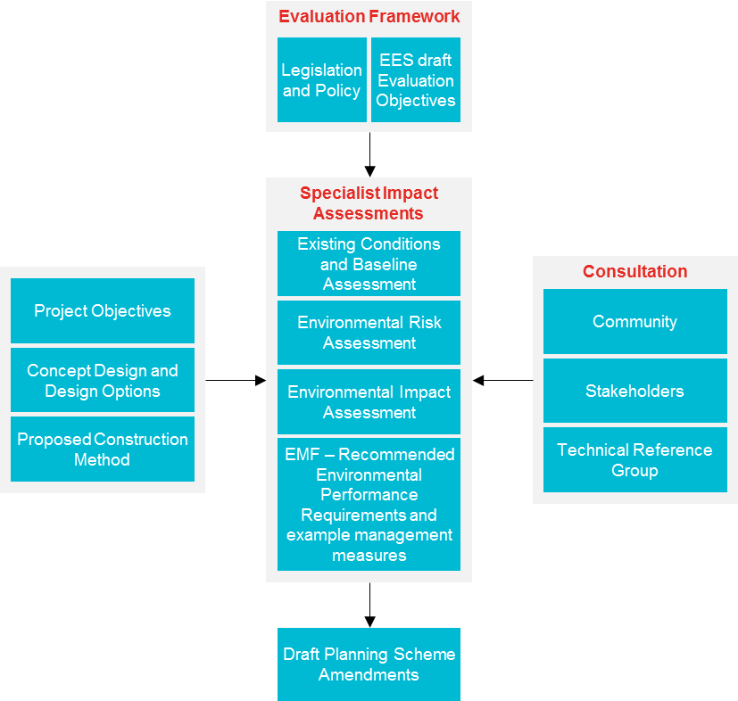

Relevant Legislation and Policies
Legislation, policies and guidelines relevant to Melbourne Metro are outlined in Table ‎4–1 and presented against the relevant draft evaluation objectives. The table describes how key legislation, policies and guidelines relate to the project and any implications for the approvals required for Melbourne Metro to proceed.
Table ‎4–1 Relevant legislation, policy strategies
Draft EES evaluation objective | Relevant legislation | Key policies and strategies | Further information
Transport connectivity  – To enable a significant increase in the capacity of the metropolitan rail network and provide multimodal connections, while adequately managing effects of the works on the broader transport network, both during and after the construction of the project | The Transport Integration Act 2010 establishes a framework for an integrated and sustainable transport system. Transport agencies and interface agencies listed under the Act must have regard to its objectives and principles when exercising their powers and performing their functions.  Section 19 of the Act requires a commitment to sustainability through the use of the precautionary principle, which means that if there are threats of serious or irreversible environmental damage, the lack of full scientific certainty should not be used as a reason for postponing measures to prevent environmental degradation.  The Act provides a basis for assessing the consistency of Melbourne Metro with transport system objectives relating to:  - Social and economic inclusion  - Economic prosperity  - Environmental sustainability  - Integration of transport and land use  - Efficiency, coordination and reliability  - Safety, health and wellbeing.  The triple bottom line approach contained in the Act has been adopted in the assessment framework that has been used for the Melbourne Metro options assessment.  No approval is required under the Act. | Plan Melbourne identifies the previously proposed Melbourne Rail Link project. This document is being refreshed and is due for release in 2016. The Plan Melbourne Refresh Discussion Paper identifies Melbourne Metro as a priority transport project that 'includes new stations to generate land use and interchange opportunities, particularly around Arden and Parkville’.  PTV’s Network Development Plan – Metropolitan Rail identifies Melbourne Metro as a key project to address congestion, respond to patronage demand increases, improve reliability, enhance accessibility and improve the city’s productivity. | Chapter 5 Project Development  Chapter 8 Transport  Technical Appendix D Transport
 | The Road Management Act 2004 provides the statutory framework for VicRoads and local government to manage the Victorian road network. Consent may be required under the Act for works on, in or under any road.
Built environment  – To protect and enhance the character, form and function of the public realm and buildings within and adjacent to the project alignment, and particularly in the vicinity of project surface structures, having regard to the existing and evolving urban context | The Planning and Environment Act 1987 provides the framework for the use, development and protection of land in Victoria. | Policies and strategies that have been considered in design and delivery of Melbourne Metro include:  - Clause 15 of the Victoria Planning Provisions: Built Environment and Heritage of the State Planning Policy Framework) of all planning schemes provides the basis for achieving high quality urban design  - Metropolitan Planning Strategy: Plan Melbourne (currently being revised)  - Urban Design Charter for Victoria (Victorian Government, 2009)  - Creating Places for People: an Urban Design Protocol for Australian Cities (Infrastructure Australia, 2011)  - Good Design + Transport (Office of the Victorian Government Architect, 2014).  Melbourne Metro responds to the principles of the Urban Design Charter for Victoria and associated strategies through the Urban Design Strategy for Melbourne Metro | Chapter 6 Project Description  Chapter 9 Land Use and Planning  Chapter 14 Historical Cultural Heritage  Chapter 16 Landscape and Visual  Technical Appendix E Land Use and Planning  Technical Appendix J Historical Cultural Heritage  Technical Appendix L Landscape and Visual  Technical Appendix M Urban Design Strategy
Social, community, land use and business  – To manage the effects on the social fabric of the community in the area of the project, including with regard to land use changes, community cohesion, business functionality and access to services and facilities, especially during the construction phase | The Transport Integration Act 2010 states that the transport system should provide for the effective integration of transport and land use and facilitate access to social and economic opportunities.  MMRA and the Secretary to DEDJTR should have regard to the decision making principles set out in the Act, including integration of transport and land use, and social and economic inclusion. This EES presents an integrated assessment of these matters.  The social impact assessment prepared for the EES gives consideration to the principles of triple bottom line assessment in the Transport Integration Act 2010. | Melbourne Metro would need to contribute to achieving the relevant structure and precinct plans of the Cities of Melbourne, Port Phillip and Stonnington, such as the Arden-Macaulay Structure Plan 2012 in the planning amendment process. | Chapter 8 Transport  Chapter 9 Land Use and Planning  Chapter 10 Social and Community  Chapter 11 Business  Technical Appendix D Transport  Technical Appendix E Land Use and Planning  Technical Appendix F Social and Community  Technical Appendix G Business
 | The Planning and Environment Act 1987 regulates the use and development of land in Victoria. The Act authorises the preparation, approval and adoption of planning schemes and planning scheme amendments by planning authorities.  Planning scheme amendments to the Melbourne, Port Phillip, Stonnington and Maribyrnong Planning Schemes would be required under the Planning and Environment Act 1987 for Melbourne Metro.  The social impact assessment prepared for the EES gives consideration to the objectives of the Planning and Environment Act 1987, which include giving ‘explicit consideration’ to social effects when making decisions about the use and development of land. | The Melbourne, Port Phillip, Stonnington and Maribyrnong Planning Schemes (in particular the State and Local Planning Policy Frameworks) are relevant for Melbourne Metro.  The four planning schemes contain objectives, policies and particular provisions for the use, development and protection of land. Consideration will be given to the relevant planning schemes (including any reference documents and potential amendments to these schemes) when seeking planning approval for Melbourne Metro.
 | Under the Major Transport Projects Facilitation Act 2009, once the Project Area for Melbourne Metro is designated, the project authority has the power to compulsorily acquire land within this area. The Act requires the acquisition of property to be conducted in accordance with the provisions of the Land Acquisition and Compensation Act 1986.
Amenity  – To minimise adverse air quality, noise or vibration effects on the amenity of nearby residents and local communities, as far as practicable, especially during the construction phase | The Environment Protection Act 1970 provides a legal framework to protect the environment in Victoria, (including in relation to groundwater, surface water, land and air) and provides for the preparation of State Environment Protection Policies (SEPPs). | Melbourne Metro would be required to comply with specific criteria derived from relevant policies and guidelines dealing with amenity and environmental impacts.  Noise control guidelines relevant to Melbourne Metro include:  - SEPP (Control of Noise from Commerce, Industry and Trade) No. N-1, which provides maximum acceptable noise levels for the Melbourne metropolitan area  - EPA Noise Control Guidelines (Publication 1254), which provides a framework for the management of construction noise  - EPA Environmental Guidelines for Major Construction Sites (Publication 480)  - Victorian Passenger Rail Infrastructure Noise Policy (Victorian Government, 2013). | Chapter 10 Social and Community  Chapter 13 Noise and Vibration  Technical Appendix F Social and Community  Technical Appendix I Noise and Vibration
 |  | Air quality guidelines relevant to Melbourne Metro include:  - National Environment Protection (Ambient Air Quality) Measure (NEPM) (National Environmental Protection Council, 2003)  - Ground level impacts of air emissions (during construction and operation) would need to comply with standards in the NEPM for six primary air pollutants: carbon monoxide, nitrogen dioxide, ozone, sulphur dioxide, lead and particles (as PM10)  - SEPP (Air Quality Management) No. S240 2001, incorporating the Protocol for Environmental Management (PEM): Mining and Extractive Industries  - Ground level impacts of air emissions (during construction and operation) would need to comply with the standards and objectives provided in SEPP (AQM) No. S240 2001, incorporating the PEM: Mining and Extractive Industries.  - EPA Environmental Guidelines for Major Construction Sites (Publication 480). | Chapter 12 Air Quality  Technical Appendix H Air Quality
 |  | The primary vibration guideline relevant to Melbourne Metro is DIN 4150-3 Structural Vibration Part 3: Effects of vibration on structures (DIN 4150), which provides guideline targets for construction vibration with respect to damage to buildings.
Cultural heritage  – To avoid or minimise adverse effects on Aboriginal and historical cultural heritage values | The Heritage Act 1995 regulates the protection and conservation of places and objects of heritage significance listed on the Victorian Heritage Register. It also provides for the protection or recording of all historical archaeological sites and relics, including those listed in the Victorian Heritage Inventory.  Planning schemes prepared under the Planning and Environment Act 1987 contain Heritage Overlays that include sites and places of heritage significance, and where planning approval is required for any demolition, buildings and works. The proposed planning scheme amendments would address sites in Heritage Overlays.  The proposed planning scheme amendments would manage sites in Heritage Overlays. Where a site is listed on the Victorian Heritage Register and is in a Heritage Overlay, the requirements of the Heritage Act 1995 overrides the requirements of the planning scheme. Where required, approvals and other consents would be sought from Heritage Victoria.  Where a site is listed on the Victorian Heritage Register or Victorian Heritage Inventory, an approval would generally be required to carry out works or undertake activities (unless specifically exempted). | Australia ICOMOS Charter for the Conservation of Places of Cultural Significance (Burra Charter) 2013 defines the basic principles and procedures to be followed in conserving Australian heritage places. | Chapter 15 Aboriginal Cultural Heritage  Technical Appendix K Aboriginal Cultural Heritage  Chapter 14 Historical Cultural Heritage  Technical Appendix J Historical Cultural Heritage
 | The Aboriginal Heritage Act 2006 requires a CHMP to be prepared for any project requiring an EES. The Act’s regulations set standards for the preparation of CHMPs. As Melbourne Metro requires an EES, a CHMP must be prepared.
 | The EPBC Act regulates the protection of places listed on the Commonwealth Heritage and National Heritage List as well as Commonwealth land. No approval is required for Melbourne Metro under the EPBC Act, as long as it is undertaken in the particular manner set out in the Commonwealth Government’s referral decision of 22 September 2015 (see Section 1.6 in Chapter 1).
Land stability  – To avoid or minimise adverse effects on land stability that might arise directly or indirectly from project works | Key objectives of the Planning and Environment Act 1987 relate to the need to provide for the sustainable use of land, the protection of natural and man-made resources, securing of a safe working, living and recreational environment and protection of public utilities and other facilities.  Geotechnical investigations have been undertaken to ensure that direct and indirect ground movements from the construction and operation of Melbourne Metro would not adversely impact structures, infrastructure and amenity in the following categories:  - Rail and tram services and furniture  - Existing buildings, including significant heritage structures  - Existing road pavement  - Existing underground services. | n/a | Chapter 19 Ground Movement and Land Stability  Technical Appendix P Ground Movement and Land Stability
Landscape, visual and recreational values  – To avoid or minimise adverse effects on landscape, visual amenity and recreational values as far as practicable | The Planning and Environment Act 1987 provides the framework for the use, development and protection of land in Victoria.  Planning scheme amendments are required for Melbourne Metro. These amendments would include a requirement to comply with the project's Urban Design Strategy. | Relevant clauses of the State Planning Policy Framework of the four planning schemes are:  - Clause 12: Environment and Landscape Values  - Clause 15: Built Environment and Heritage  - Clause 18: Transport.  Relevant clauses highlight the need to protect areas of landscape value, particularly where these contribute to character and identity, and to ensure that a new land use proposal responds to its landscape context and protects areas with significant aesthetic value. Development must also minimise disruption of residential communities and their amenity and protect the city's overall urban structure.  The Municipal Strategic Statement and Local Planning Policy of each planning scheme is also relevant. | Chapter 10 Social and Community  Chapter 16 Landscape and Visual  Technical Appendix F Social and Community  Technical Appendix L Landscape and Visual  Technical Appendix M Urban Design Strategy
Hydrology, water quality and waste management  – To protect waterways and waterway function and surface water and groundwater quality in accordance with statutory objectives, to identify and prevent potential adverse environmental effects resulting from the disturbance of contaminated or acid-forming material and to manage excavation spoil and other waste in accordance with relevant best practice principles | The Environment Protection Act 1970 provides a legal framework to protect the environment in Victoria, and provides for the preparation of State Environment Protection Policies (SEPPs). | Melbourne Metro would be required to comply with specific criteria derived from relevant policies and guidelines dealing with the protection and use of water resources, including:  - SEPP (Waters of Victoria), which provides a framework for the protection of water resources and associated beneficial uses throughout Victoria  - SEPP (Groundwaters of Victoria), which provides a framework for protecting groundwater resources and associated beneficial uses throughout Victoria. | Chapter 17 Surface Water  Chapter 18 Groundwater  Technical Appendix N Surface Water  Technical Appendix O Groundwater
The Water Act 1989 provides for management of the State’s water resources. Within the proposed project boundary, Melbourne Water is responsible for managing surface water and Southern Rural Water for managing groundwater.
The Maribyrnong River, Moonee Ponds Creek and Yarra River are designated waterways under the Water Act 1989. As such, permits would be required from Melbourne Water for works within or over these waterways.
A licence for groundwater dewatering and recharge would need to be issued by Southern Rural Water under the Water Act 1989.
Planning Schemes manage the presence and movement of surface water and overland flows via Land Subject to Inundation, Special Building and Floodway Overlays.
Land Subject to Inundation and Special Building Overlays exist within the proposed project boundary, potentially triggering the need for planning approval to be granted prior to commencement of works. This would be addressed through the proposed planning scheme amendments for Melbourne Metro.
 | The waste management hierarchy is one of eleven principles of environment protection contained in the Environment Protection Act 1970. The hierarchy is a decision-making framework promoting the avoidance of waste as the most preferred option and disposal as the least. The waste management hierarchy would be considered in all Melbourne Metro activities that generate waste, including avoiding or minimising generation of waste material; and appropriate reuse/recycling where this is not practicable. | Melbourne Metro would be required to comply with specific criteria derived from relevant policies and guidelines dealing with the management of contaminated land and waste, including:  - SEPP (Prevention and Management of Contamination of Land) 2002 (amended 26 September 2013), known as the ‘Land SEPP’, provides a framework to protect land and its associated beneficial uses in Victoria  - The SEPP requires occupiers of land to ensure that land is managed to prevent contamination and that disposal or reuse of any material off-site is undertaken in accordance with legislative requirements and procedures approved by the EPA  - Industrial Waste Management Policies (IWMPs) prepared under the Environment Protection Act 1970. In particular, the IWMP (Waste Acid Sulfate Soils) 1999 outlines a framework and specific requirements for the management of acid sulfate soils.  - EPA works approvals and licenses may be required for the movement and disposal of spoil, depending on the waste classification and proposed spoil management approach.  - Off-site disposal of waste acid sulfate soils may only occur at premises licensed to take that type of waste or at premises where an EPA-approved EMP is in place. | Chapter 20 Contaminated Land and Spoil Management  Technical Appendix Q Contaminated Land and Spoil Management
Biodiversity  – To avoid or minimise adverse effects on native terrestrial and aquatic flora and fauna, in the context of the project’s components and urban setting | The Flora and Fauna Guarantee Act 1988 provides a framework for biodiversity conservation in Victoria. Threatened species and communities of flora and fauna, as well as threatening processes, are listed under this Act. No FFG Act-listed flora or fauna are likely to be present within the proposed project boundary, other than habitat for the Flying Fox and possibly the Powerful Owl. | Approval to remove, destroy, or lop native vegetation (with specific exemptions) in Victoria is generally required under Clause 52.17 (Native Vegetation) of the Victoria Planning Provisions. Planning approval may be required if there are any impacts on Exceptional Trees located along Grattan Street within the Parkville station precinct under the provisions of the Environmental Significance Overlay. This would be addressed through the proposed Planning Scheme Amendment.  Protection, relocation and removal of trees required for the project would be undertaken in accordance with:  - City of Melbourne’s Urban Forest Strategy and Tree Retention and Removal Policy 2012  - City of Port Phillip’s Greening Port Phillip. An Urban Forest Approach 2010  - City of Stonnington’s General Local Law 2008 (No.1)  - Memorandum of Understanding for Native Vegetation Offsets (Victorian Government), 2010. | Chapter 21 Biodiversity  Technical Appendix R Arboriculture (1)  Technical Appendix S Arboriculture (2)  Technical Appendix T Terrestrial Flora and Fauna  Technical Appendix U Aquatic Flora and Fauna and River Health
 | Planning schemes require planning approval to remove, destroy or lop native vegetation (with some exceptions). The removal of any native vegetation required by Melbourne Metro would be subject to the requirements of the Permitted Clearing of Native Vegetation – Biodiversity Assessment Guidelines.
 | The EPBC Act states that ‘controlled’ actions (actions that are likely to have a significant impact on a Matter of National Environmental Significance) are subject to a stringent assessment and approval process. No approval is required for Melbourne Metro under the EPBC Act, as long as it is undertaken in the particular manner set out in the Commonwealth Government’s referral decision of 22 September 2015 (see Section 1.6 in Chapter 1).

Approach to EES Specialist Studies
Specialist studies were undertaken to address every item covered in the draft EES evaluation objectives. Baseline studies were completed to identify relevant standards and/or specific criteria, and to identify the assets and values present within the proposed project boundary that would be affected by the project.
A risk assessment was used to identify high risk activities and to focus the impact assessment on those activities that presented the most significant risks and impacts to the assets and values identified. In a number of instances where initial risks were found to be ‘low’ or ‘very low’, those risks were nevertheless investigated to test the risk assessment findings and satisfy the Scoping Requirements. The risk assessment consequence ratings were informed by specific consequence criteria developed for each specialist study. The approach to the risk assessment is described further in Section ‎4.5.
The specialist studies then evaluated the impact of the identified risks by considering the significance of the asset or value impacted, management measures that could be put in place to reduce the risks, the ability of the asset or value to recover and the significance of the impact. The impact assessments drew conclusions about the net effect (with mitigation) of the activity, considering the relevant draft EES evaluation objectives.
Importantly, an environmental risk is different from an environmental impact. Risk is a function of the likelihood of an adverse event occurring and the consequence of the event, whereas, impact relates to the outcome of an action in relation to values of a resource or sensitivity of a receptor. Benefits are considered in impact assessment but not in risk assessment. An impact assessment must be informed by a risk assessment so that the level of action to manage an impact relates to the likelihood of an adverse impact occurring.
A performance based approach is being adopted for the delivery of Melbourne Metro. Therefore, the management measures that are the basis of the Environmental Management Framework outlined in this EES are expressed as recommended Environmental Performance Requirements. Rather than specify the management measure to be undertaken to minimise the impact, the outcome that must be achieved is identified in the Environmental Management Framework. The Environmental Performance Requirements would also manage the potential impacts of any changes to the Concept Design within the proposed project boundary, which may be required during the next stage of detailed design and delivery.
Where required, the Environmental Performance Requirements are precinct-specific and require compliance with relevant legislation, policies and guidelines.

Environmental Risk Assessment
The objective of the environmental risk assessment was to identify key social, environmental, transport and business risks associated with construction and operation of Melbourne Metro and to identify possible management and mitigation measures to reduce these risks, which would inform the development of recommended Environmental Performance Requirements.
A summary of the risk assessment process, and its relationship with the impact assessment process, is provided in Figure ‎4-2. The process was based upon AS/NZS IS0 31000:2009: Risk Management.
A copy of the Environmental Risk Assessment Report (Risk Register) is provided in Technical Appendix B.
Figure ‎4-2 Risk and impact assessment process
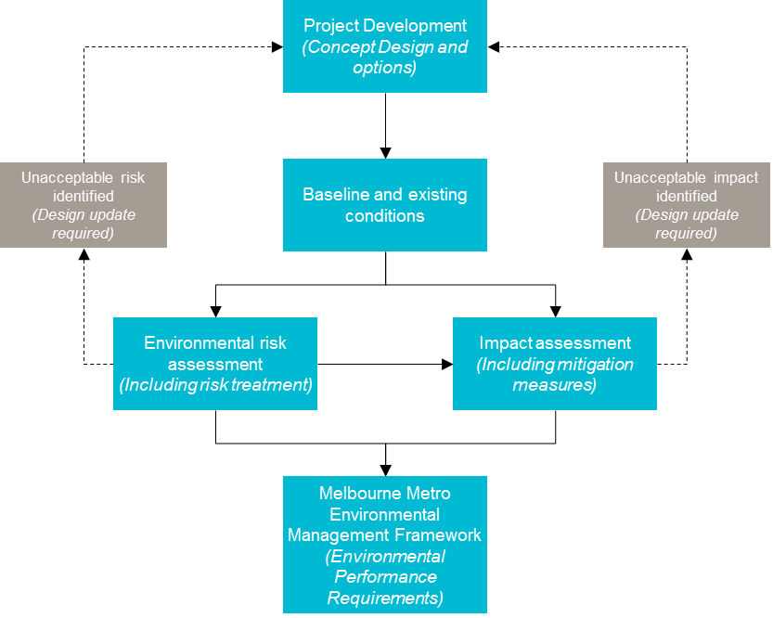

Approach to Environmental Risk Assessment
A Concept Design was developed for Melbourne Metro that contained vertical and horizontal alignment details, station layouts and proposed construction methods. The Concept Design formed the basis for impact assessments and environmental risk assessment and is presented in Chapter 6 Project Description.
As a first step in the environmental risk assessment, specialists reviewed the Concept Design and identified potential interactions or events in their particular disciplines.
Each of the events identified was then allocated a consequence and likelihood category, based on the descriptions in Table ‎4–2 and Table ‎4–3. Specific consequence categories were developed by each specialist using the framework provided in Table ‎4–2 as a guide and taking into account existing conditions in the project area.
An initial risk rating was then assigned to each event, applying the risk assessment matrix shown in Table ‎4–4 and based on the elements and measures outlined in the Concept Design. The risk matrix reflects the fact that risk is a function of the consequence of an event, if it occurs, and the likelihood of the event occurring.
The consequence criteria in the risk assessment matrix extend across a scale of magnitude from ‘negligible’ to ‘severe’, reflecting the size of the impact, the spatial area affected and the expected recovery time of the environmental system(s) affected. Where a minimal impact was indicated over a local area only and with a recovery time within the range of normal variability, the consequence of the event was considered to be ‘minor’ (towards the ‘negligible’ end of the scale). Conversely, a ‘major’ consequence describes scenarios involving a very high magnitude event, affecting a very large area or requiring many years to recover.
The likelihood criteria in the risk assessment matrix relate to the likelihood or probability or chance of a risk event occurring over a particular period of time. The longer the time-scale, the greater the likelihood of a particular risk event occurring. The likelihood criteria in the risk assessment matrix range across a scale from ‘almost certain’ where ‘the event is almost certain to occur one or more times a year’ to ‘rare’ where ‘the event is unlikely to occur but may occur in exceptional circumstances.’
After each risk was assigned a rating, the specialists conducting the risk assessments participated in a series of multi-disciplinary workshops to consider any events that were identified as having a very high, high or medium initial risk. The workshops ensured the risks were contextualised to the project, being evaluated consistently across the disciplines and that risks resulting from interactions between study disciplines were considered and delineated.

Additional management and mitigation measures were identified and each relevant risk rating was re-evaluated to identify the residual risk from Melbourne Metro. The residual risk reflects the likelihood and consequence of the risk following the implementation of the Environmental Performance Requirements.
The risk assessment was reviewed progressively during the specialist impact assessment phase to reflect the findings of investigations undertaken and to finalise proposed mitigation measures to inform the residual risks. The risk assessment also informed the development of the Environmental Management Framework, which provides the framework for implementing the mitigation measures to achieve compliance with regulatory requirements, government policy and strategy throughout the life of Melbourne Metro.
The finalised risk assessment is presented in a report appended to the EES (see Technical Appendix B), which includes the complete Melbourne Metro Risk Register. Extracts from the register are included in each of the impact assessment chapters.
Table ‎4–2 Consequence framework
Level | Qualitative description of biophysical/environmental consequence | Qualitative description of socio-economic consequence
Negligible | No detectable change in a local environmental setting | No detectable impact on economic, cultural, recreational, aesthetic or social values
Minor | Short-term, reversible changes, within natural variability range, in a local environmental setting | Short-term, localised impact on economic, cultural, recreational, aesthetic or social values
Moderate | Long-term but limited changes to local environmental setting that are able to be managed | Significant and/or long-term change in quality of economic, cultural, recreational, aesthetic or social values in local setting. Limited impacts at regional level
Major | Long-term, significant changes resulting in risks to human health and/or the environment beyond the local environmental setting | Significant, long-term change in quality of economic, cultural, recreational, aesthetic or social values at local, regional and State levels. Limited impacts at national level
Severe | Irreversible, significant changes resulting in widespread risks to human health and/or the environment at a regional scale or broader | Significant, permanent impact on regional economy and/or irreversible changes to cultural, recreational, aesthetic or social values at regional, State and national levels

Table ‎4–3 Definition of likelihood
Level | Description
Rare | The event is very unlikely to occur but may occur in exceptional circumstances
Unlikely | The event may occur under unusual circumstances but is not expected
Possible | The event may occur once within a five year timeframe
Likely | The event is likely to occur several times within a five year timeframe
Almost Certain | The event is almost certain to occur one or more times a year

Table ‎4–4 Risk assessment matrix
 |  | Consequence ratings
 |  | Negligible | Minor | Moderate | Major | Severe
Likelihood rating | Rare | Very Low | Very Low | Low | Medium | Medium
 | Unlikely | Very Low | Low | Low | Medium | High
 | Possible | Low | Low | Medium | High | High
 | Likely | Low | Medium | Medium | High | Very High
 | Almost Certain | Low | Medium | High | Very High | Very High

Scope of Specialist Studies
The specialist studies conducted for the EES considered the risks and impacts associated with the construction and operation phases of the proposed Melbourne Metro at both the precinct (local) level and wider regional level, and recommended Environmental Performance Requirements to manage and mitigate impacts. Where appropriate, the studies also identified potential benefits from Melbourne Metro. Table ‎4–5 summarises the scope of each study.
A number of specialist studies were peer reviewed. The review considered the assumptions, methodology, assessment criteria and scope applied in the report. The peer reviews also addressed whether there were any additional matters which should be considered as part of the impact assessment in order to address the EES Scoping Requirements and whether there are any gaps or matters where they disagreed with this assessment. The final peer review reports are appended to each of the reports. The studies that have been peer reviewed are outlined in Table ‎4–5.
Table ‎4–5 Scope of EES specialist studies
EES Technical Appendix | Study | Scope
Appendix D | Transport | Impacts on transport connectivity – including the impacts of additional trucks and construction traffic, closure of local roads, permanent changes to the road and public transport networks, and disruption to tram and bus services and walking and cycling routes.  This study was peer reviewed
Appendix E | Land Use and Planning | Impacts on land use and the built form in the vicinity of Melbourne Metro – including impacts from the temporary occupation and permanent acquisition of property and public open space, amenity impacts on land uses during construction and longer term impacts on built form as a result of the acquisition and demolition of buildings. This includes an assessment of Future Development Loading above and around the proposed tunnel, stations and portals.  This study was peer reviewed
Appendix F | Social and Community | Impacts on the social fabric of the community in the vicinity of Melbourne Metro – including impacts on private residential property owners and occupiers, social infrastructure, valued places and community accessibility, values, safety and amenity  This study was peer reviewed.
Appendix G | Business | Impacts on individual businesses and local economies – including impacts from commercial property acquisition and disruption to businesses during construction. Also assesses longer term productivity and employment impacts on the broader Melbourne economy from the operation of Melbourne Metro.  This study was peer reviewed.
Appendix H | Air Quality | Impacts on local and regional air quality – including impacts from dust and odorous emissions during construction and impacts from exhaust emissions during the operation of Melbourne Metro.  This study was peer reviewed.
Appendix I | Noise and Vibration | Impacts on people, buildings, structures and utilities from the generation of noise and vibration during construction and operation of Melbourne Metro – including airborne and ground-borne noise, and vibration from tunnelling.  This study was peer reviewed.
Appendix J | Historical Cultural Heritage | Impacts on heritage buildings, values and landscapes – including impacts from vibration and ground settlement during construction and visual impacts from permanent structures.
Appendix K | Aboriginal Cultural Heritage | Impacts on Aboriginal cultural heritage – including potential disturbance of Aboriginal places and disturbance or removal of Aboriginal cultural heritage material.
Appendix L | Landscape and Visual | Impacts on local landscapes, sensitive land uses and sightlines – including impacts on trees, parks, community facilities, events, iconic views and the character, form and function of public buildings.
Appendix M | Urban Design Strategy | Presents the Urban Design Strategy for Melbourne Metro – including high level urban design principles to be adopted across the project.
Appendix N | Surface Water | Impacts on surface water flows and flooding – including impacts on major waterways and overland drainage flows, the effects of runoff from permanent Melbourne Metro structures and potential consequences of flooding on Melbourne Metro stations and tunnels.
Appendix O | Groundwater | Impacts on groundwater quantity and quality – including issues associated with encountering contaminated groundwater, impacts from dewatering during construction and ways to protect groundwater.  This study was peer reviewed.
Appendix P | Ground Movement and Land Stability | Impacts on buildings, civil infrastructure and utilities from ground movement as a result of construction activities – including potential ground settlement impacts associated with tunnel excavation, station construction and retaining structures.  This study was peer reviewed.
Appendix Q | Contaminated Land and Spoil Management | Impacts from disturbing contaminated soil, rock and groundwater – including the potential to encounter acid-forming material. Also assesses the amount of spoil generated in each precinct and the management, removal and disposal of spoil and waste.
Appendix R | Arboriculture (1) | Impacts to trees within all precincts other than the City of Stonnington (Precinct 8) – including removal and replacement of trees, and re-establishment of tree cover
Appendix S | Arboriculture (2) | Impacts to trees within the City of Stonnington (Precinct 8) – including removal and replacement of trees, and re-establishment of tree cover
Appendix T | Terrestrial Flora and Fauna | Impacts to biodiversity (threatened terrestrial flora and fauna and remnant vegetation) during construction and operation of Melbourne Metro
Appendix U | Aquatic Ecology and River Health | Impacts to biodiversity (aquatic flora and fauna, water quality and river health) during construction and operation of Melbourne Metro.
Appendix V | Greenhouse Gas | Assessment of emissions of greenhouse gases during the construction of Melbourne Metro – including the project’s contribution to improving Melbourne’s future GHG inventory.
Appendix W | Sustainability Principles and Approach | Documents MMRA's approach to applying sustainability principles through the delivery of Melbourne Metro – including MMRA Sustainability Performance Requirements and self-assessment using ISCA and Green Star rating tools

