25/11/2019 EAS19NOV.003

Works reminder: Railway Place Reserve site establishment and works

To build the new shared use path along Dynon Road, the West Gate Tunnel Project will start works to establishment our construction site in Railway Place Reserve from December 2019.

The shared use path will provide a new dedicated bridge that will ensure a safe path separate to vehicles for pedestrians and cyclists to travel along Dynon Road to North Melbourne.

Site establishment and works – Stage one
December 2019 – February 2020

The first stage of site establishment and works will be adjacent to and in the Railway Place reserve area. Works will include:
- Fencing works
- Closure of skate park area
- Worksite shed installation
- Pedestrian detour through the park
- Cycle detour via Dryburgh St
- Closure of bus stop at Dynon Road Bridge
- Identification of existing services
- Piling preparations and piling works.

Ongoing works
From February 2020, stage two of these works will be established in the remaining park area. Works for this area will include:

- Fencing
- Vegetation removal
- Changes to the pedestrian detour
- Piling preparations and piling works
- Shared use path bridge installation.
Once stage one and two of works are complete, the area will remain occupied for the works required to upgrade Dynon Road. More information will be provided closer to the works date.
Once construction is completed, the park and skate area will be completely reinstated.

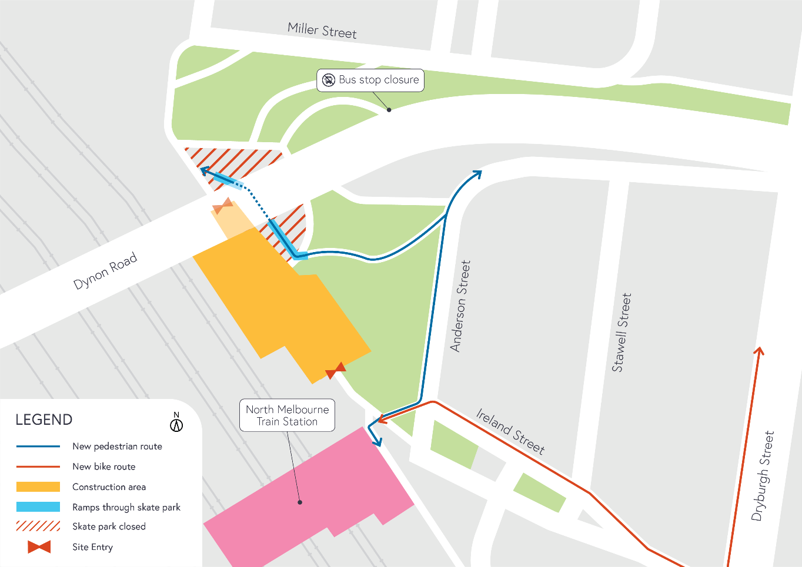
Figure 1 – Site establishment – Stage 1 from December 2019

What to expect during construction
- Works will be completed both during the day and at night time.
- We will notify you if there are any significant changes to the timing of our works.
- Traffic management will be in place to manage changed conditions including temporary access changes
- Signage will be in place to guide road users and cyclists of any changes.
- Dust will be managed on-site.
- Piling works can create increased levels of noise and may also cause some vibration. Assessments have been conducted, which indicate the noise levels are expected to remain within permissible levels as documented in the project’s Environmental Performance Requirements.

We thank you for your patience during these works.

