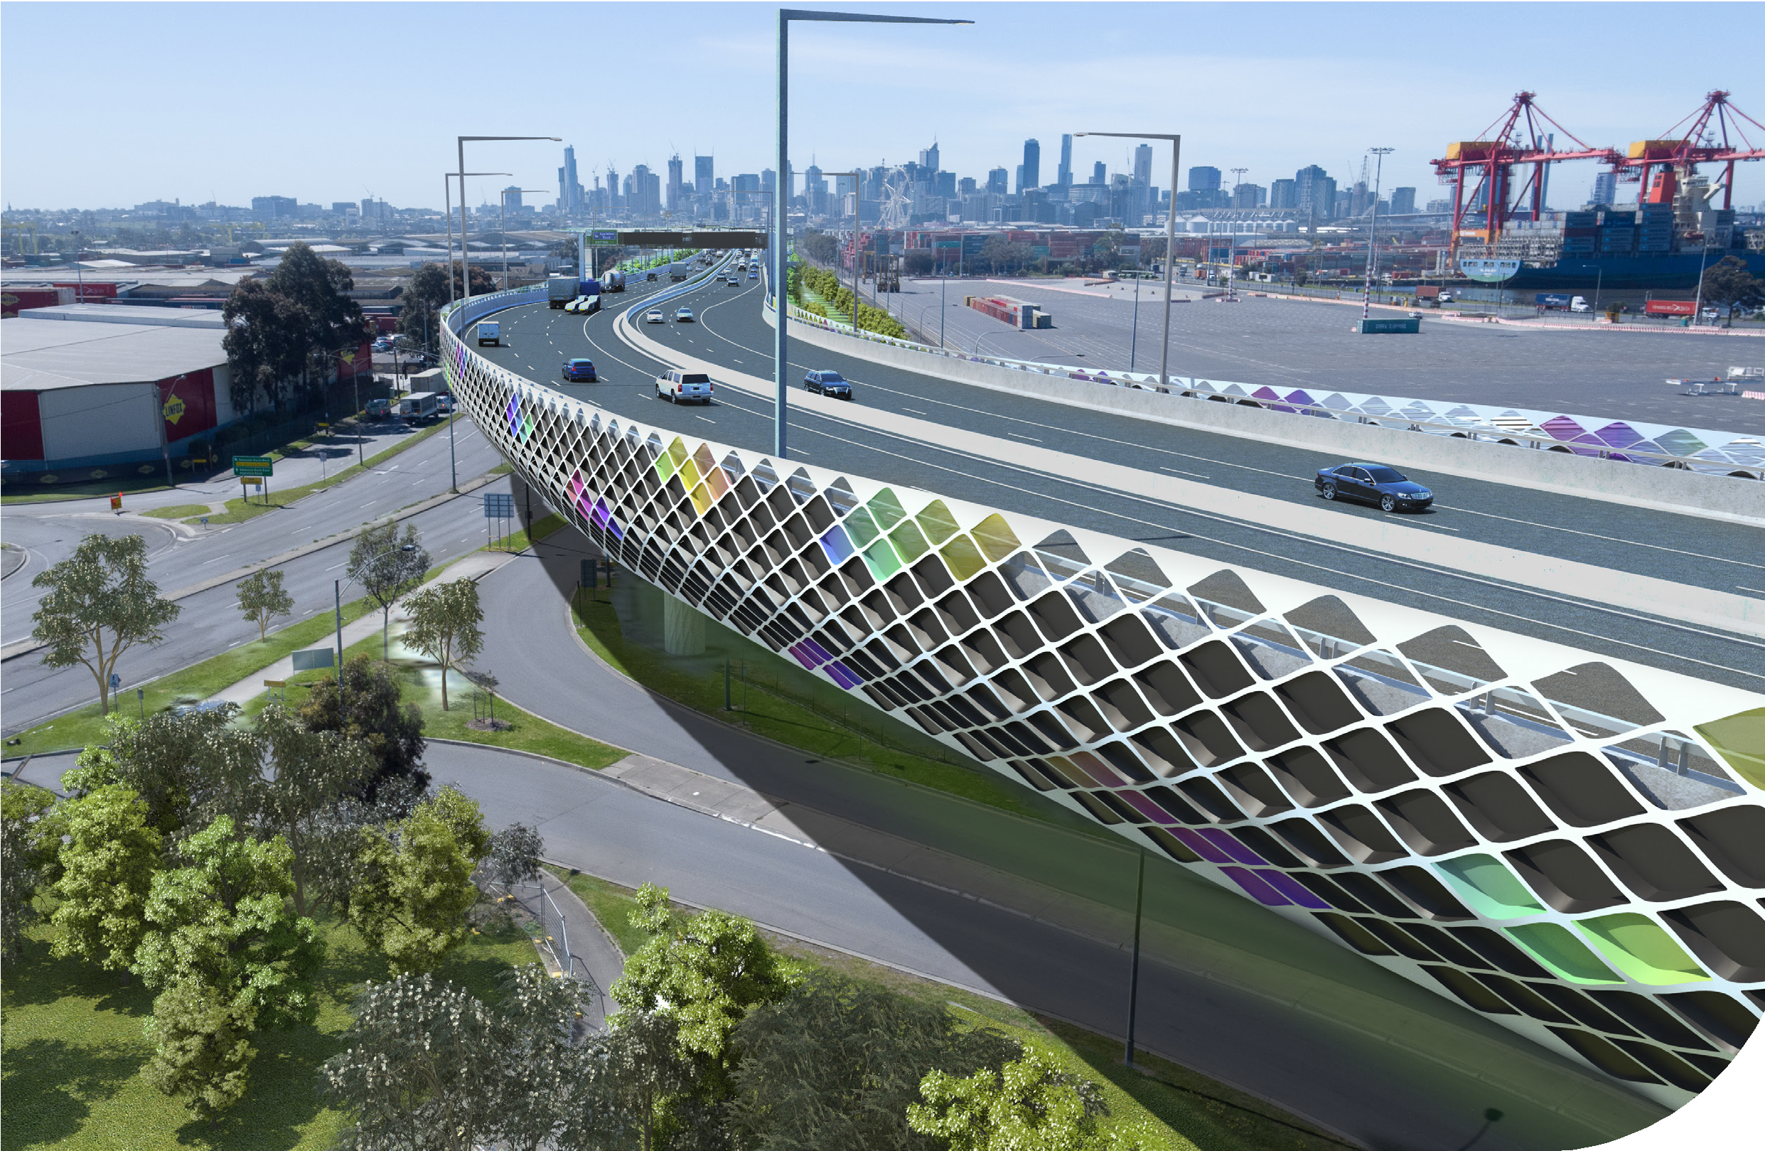

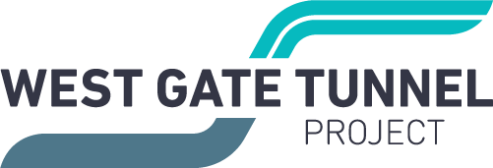

COMMUNITY UPDATE

Ready to launch

ISSUE #15
DECEMBER 2019

As part of the West Gate Tunnel Project we are building an elevated roadway above Footscray Road that will connect the West Gate Tunnel to the port, CityLink, Dynon Road and
Wurundjeri Way.
It will be built using a launching gantry, a specialist elevated road building machine that will build 2.5 kilometres of elevated road.
We are in the process of building the launching gantry in the middle of
Footscray Road which will be 12 metres tall, 12 metres wide, 114 metres long
and weighs more than 1000 tonnes when assembled.
It is made up of two steel trusses placed side by side on top of support legs that move the trusses forward as the gantry lifts and connects sections of the elevated road.
The machine will start at the city end of Footscray Road and work its way west building the outbound elevated road first. It will then change direction and head back east toward the city.
This will take around two years to complete.
It’s compact enough to work safely next to traffic, which means we can keep drivers and cyclists moving along Footscray Road.

Fast facts
weeks to transport the
8

60
gantry to Melbourne from Italy on a ship
containers needed to transport the gantry
1,600
concrete precast segments will make the elevated road
238
piers and 90 spans to support the elevated road

SIGN UP FOR PROJECT UPDATES
westgatetunnelproject.vic.gov.au


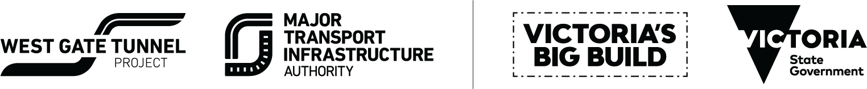

Authorised and published by the Victorian Government, 1 Treasury Place, Melbourne

SUMMER CONSTRUCTION WORKS

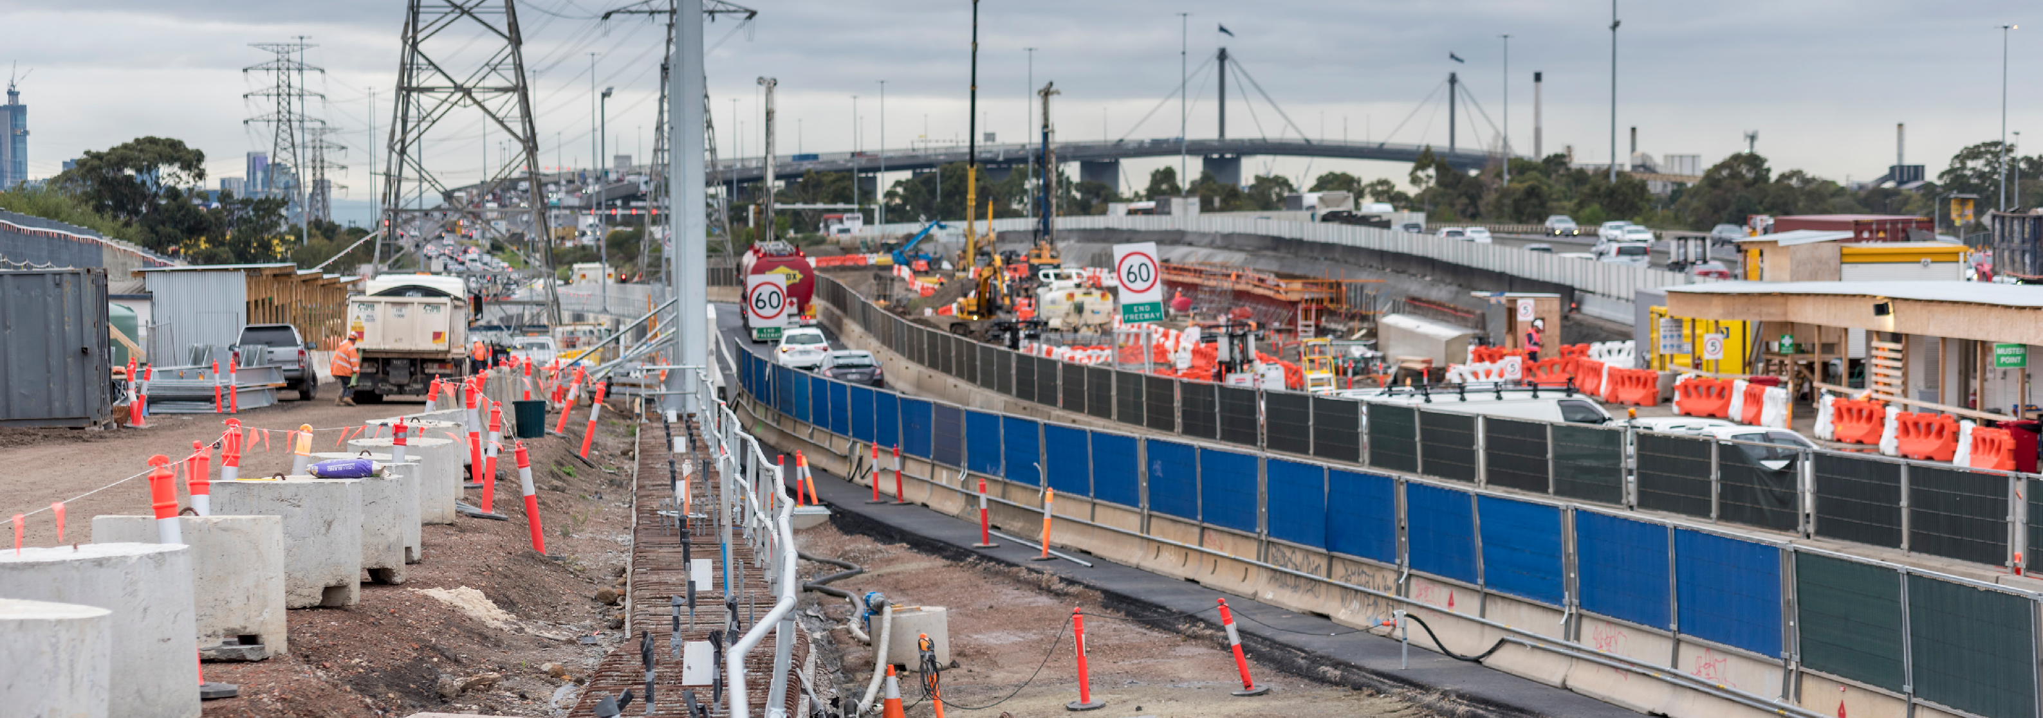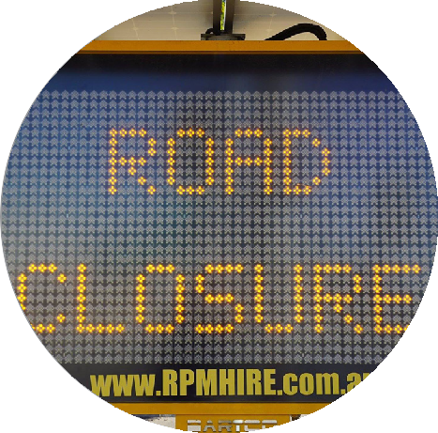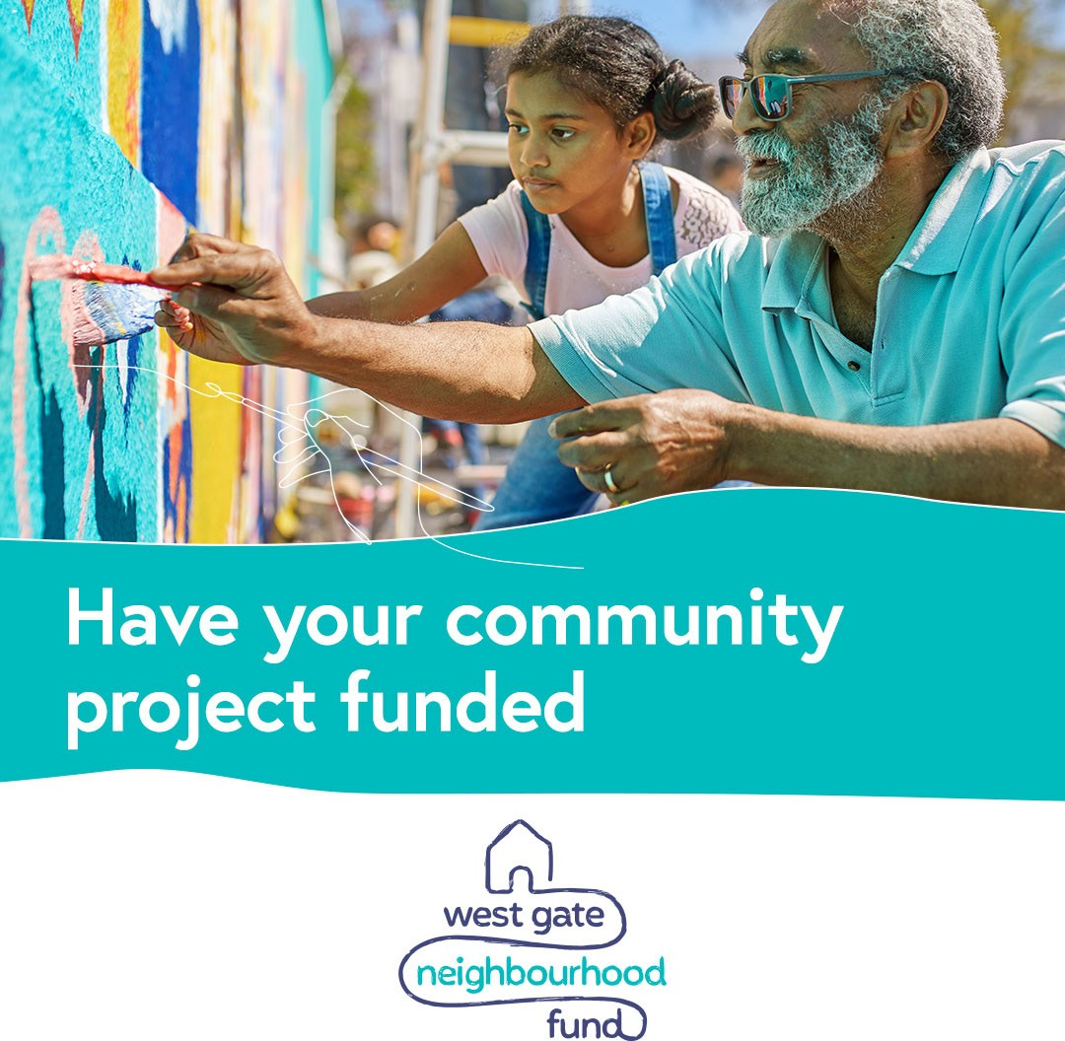

Summer construction works across Melbourne’s road network will deliver major infrastructure upgrades in Melbourne’s western suburbs.
We are taking advantage of the quieter time on Melbourne’s roads to carry out vital works.
Road users in the area can expect road works all throughout the west with ongoing works planned as part of the West Gate Tunnel Project, Western Roads Upgrade and maintenance on the West Gate Bridge.
Works on the West Gate Tunnel Project will include demolishing and moving bridge piers at the M80 interchange to make room for the extra lanes on the West Gate Freeway, and building new, permanent entry and exit ramps at Grieve Parade and Millers Road.

Heads up!

Works are also scheduled on the Metro Tunnel and Level Crossing Removal projects.

Check bigbuild.vic.gov.au for info on travel disruptions to the public transport network.

Starting from early January 2020 through to mid-February 2020, ramps will be closed between Geelong Road and the Princes Freeway outbound, the Western Ring Road and West Gate Freeway inbound and the outbound Millers Road exit and entry ramps.
Detours will be in place and some delays are expected so drivers are encouraged to plan ahead and allow extra travel time.

If you are travelling around the state during the Christmas and New Year period, plan ahead by visiting bigbuild.vic.gov.au

Plan ahead during road works

Investing in the west

Applications are now open for partnerships under the $10 million West Gate Neighbourhood Fund.
The fund is a grants and partnerships program for communities located in Maribyrnong and Hobsons Bay local government areas designed to support these inner west communities prioritising those who are most affected by construction, ensuring project benefits to the local community start now.
Both the grants and partnerships streams will provide funding towards community initiatives – both big and small.
Grants of up to $100,000 will be available for community groups and organisations for one off projects that bring communities together, temporary installations or events or improvements to community, sporting and recreation facilities or the environment.
The partnerships stream will jointly fund bigger projects that
deliver a lasting benefit for the community.

Partnership projects above $100,000 will be considered – co-funded initiatives are encouraged.
For more information or to make an application for partnerships, visit westgatetunnelproject.vic.gov.au/ neighbourhoodfund
Grants will be open early 2020.

West Gate Freeway widening works

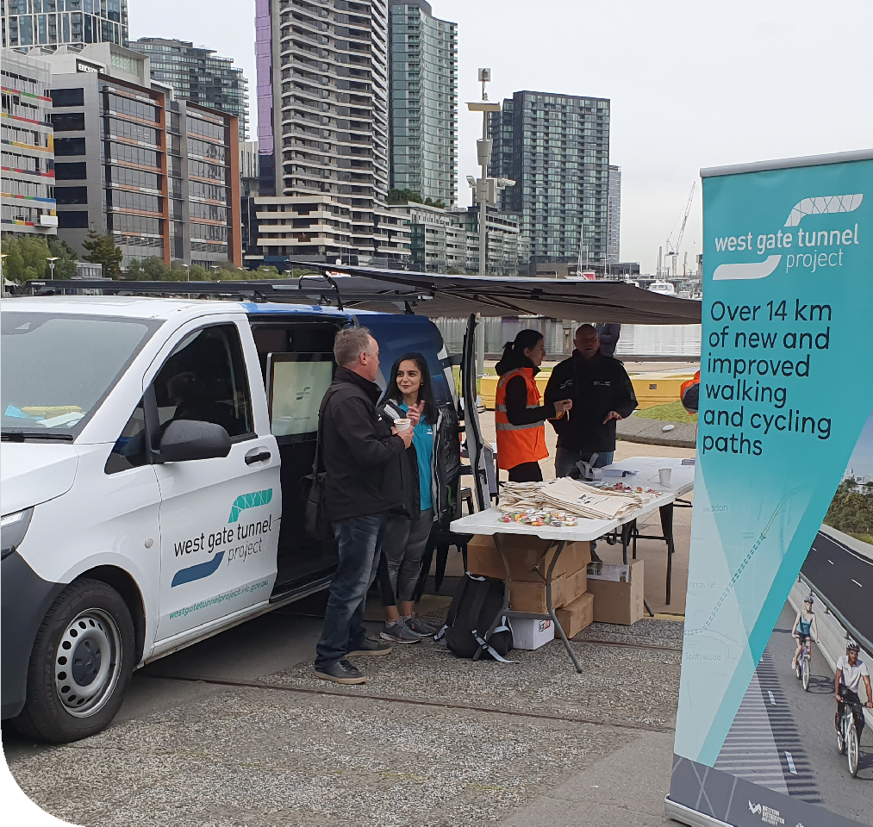Our Mobile Info Hub and team talking to the community

Tis the season, drive with care
The West Gate Tunnel Project would like to wish you all a happy and safe festive season. Drive with care throughout the
summer period and remember to allow extra travel time when you are out and about.
We thank you for all your patience throughout the year as we work to build your alternative to the West Gate Bridge.

Looking for something to do during the school holidays?
Come visit our Info Centre and take a virtual reality ride along the new 2.5 kilometre veloway, or check out our interactive 3D model of the project.
For Info Centre Christmas and New Year opening times visit westgatetunnelproject. vic. gov.au/contact/information-centre
2019 – A year in review

West Gate Freeway
- Relocated utilities ready for freeway widening
- Replaced some old 220kV electricity towers with new monopoles
- Began installing new noise walls
- Began building the new pedestrian bridges at Rosala Avenue and Muir Street
- Built new retaining walls at the Millers Road interchange

Tunnels
- Completed diverting 600 metres of the North Yarra Main Sewer and reopened Whitehall Street after a year long closure
- TBMs Bella and Vida arrived
- Completed building the launch site for TBMs Bella and Vida
- Finished building the big shed that will house our rock and soil

Port to City
  - Moved an existing walking and cycling path and shifted traffic to set up a construction site down the middle of Footscray Road
  - Began piling on Footscray Road and in the Maribyrnong River to build the bridge to link the West Gate Tunnel with the port, city and CityLink
  - Elevated road builder arrived and began being assembled onsite

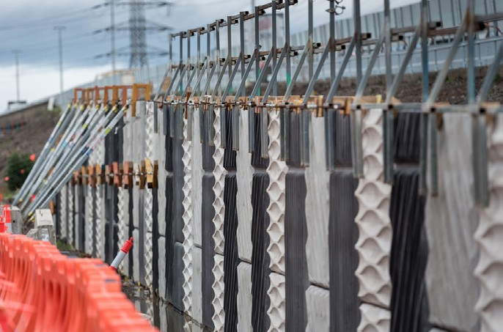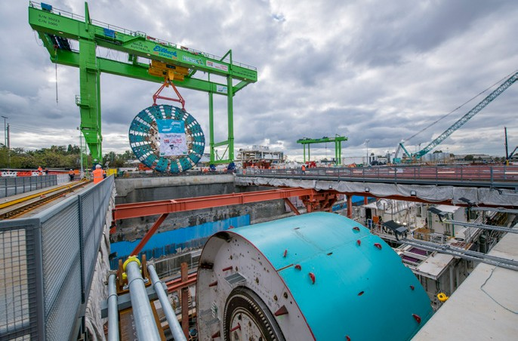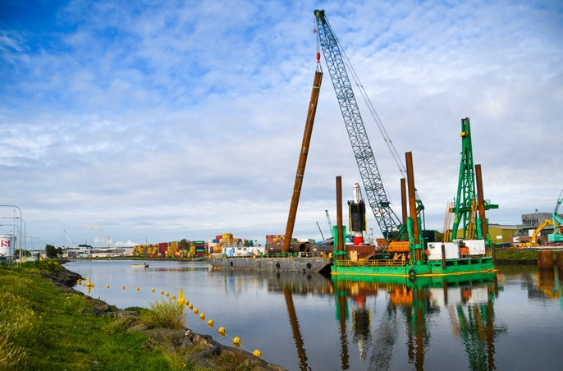

CONTACT US
info@wgta.vic.gov.au 1800 105 105
West Gate Tunnel Project Info Centre Corner of Somerville Rd and Whitehall St Yarraville VIC 3013

Follow us on social media
Translation service – For languages other than English, please call 13 14 50.
Please contact us if you would like this information in an accessible format.
If you need assistance because of a hearing or speech impairment, please visit relayservice.gov.au

