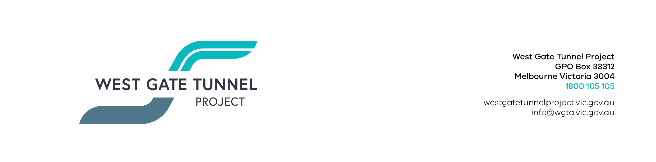
EAS19JUN.001

16 July 2019

Works Notification: Dynon Road
Works around Dynon Road as part of the West Gate Tunnel Project are starting shortly, notably with the new shared user path and the Dryburgh Street intersection upgrade. This notification provides a summary of upcoming works.

Site Establishment

Late-July to December

To enable upcoming construction in the Dynon Road and E/F-Gate areas, we will be establishing two work sites (see map below), which will include the following activities:
- Fencing works;
- Crib shed installation;
- Vegetation removal within work areas; and
- Identification of existing services.
These activities will be done during the day between 7am-5pm Monday to Saturday.

Dynon Road shared user path and bridges

Ongoing from late-July

Works to construct the new shared user path and bridges over Moonee Ponds Creek and the rail yard will be starting in late July. This works will include:
- Creating an access path to the rail corridor site from the Capital City Trail shared user path;
- Piling preparation within the rail corridor; and
- Weekend piling works during in August to build the bridge piers.
Please see map overleaf for area locations. Works within the rail corridor will mostly be undertaken at night to minimise impact to train services. More information regarding the weekend rail occupation works will be advised closer to the day. There may be some noise associated with this work.

Dryburgh Street intersection upgrade

August to early-September

We will be upgrading the Dryburgh Street intersection. These works will include:

- Removal of traffic islands on Dryburgh Street;
- Traffic signalisation works; and
- Construction of a new turning lane.
- Vegetation removal and site set up;
These works are planned to be delivered at night to minimise disruption to Dynon Road. More information will be provided to the local community closer to the works start date.

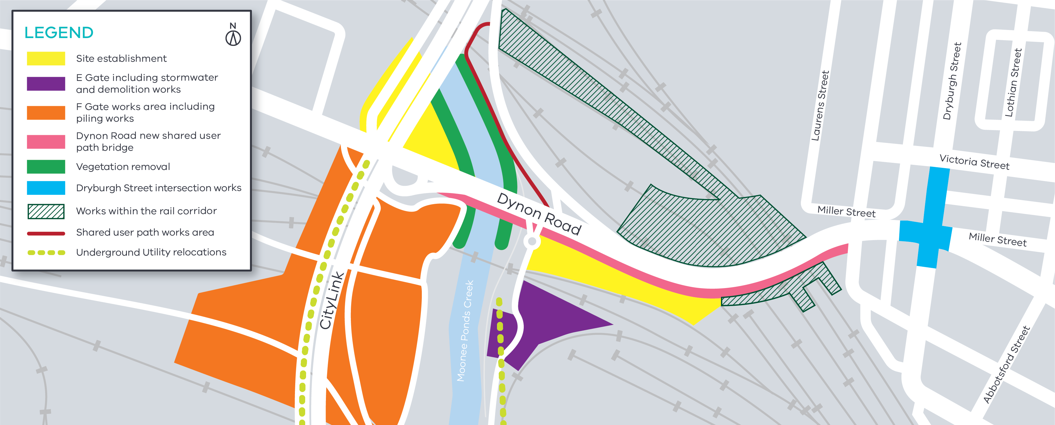
Figure 1: Dynon Road works

Utilities works
The relocation works for the 66KV underground cable
through the South Dynon rail yard, in the F-Gate and F-Gate areas will be ongoing for the next 6 months.
Storm water drainage works will also be undertaken in E Gate form August. This may require some temporary impacts to the shared user path.
Traffic Control will be in place to assist users.

F-Gate works
Piling works required to construct the foundations for the piers that will support the bridges to be constructed in F-Gate will be ongoing throughout this quarter (see map above).
Piling activity includes a combination of driven, bored and sheet piling, pile cap preparation, pile break back, excavation and pier erection.
Also taking place will be some investigations and drilling into the existing CityLink structure
(July to December), at the connection points for our ramp which will go over CityLink and connect to the West Gate Tunnel).

Piling preparation and piling works
Piling has commenced at various locations in this area and will continue through the next quarter, including the delivery of piling equipment and piling rigs to site.
Piles will be constructed using a combination of driven, bored and sheet piling (where required to protect open excavation areas).

GPO Box 4509, Melbourne Victoria 3001

Interpreter service: 13 14 50

If you are deaf, or have a hearing or speech impairment, contact us through the National Relay Service.
For more information, visit: www.relayservice.gov.au.

What to expect during construction
  - Works completed both during the day and at night time.
  - We will notify you if there are any significant changes to the timing of our works.
  - Traffic management will be in place to manage changed conditions including temporary access changes to
car parking spaces and signage to guide road users and cyclists.
  - Dust will be managed on site.
  - Piling works can create increased levels of noise and may also cause some vibration, however assessments have been conducted, which indicate the noise levels are expected to remain within permissible levels as documented in the project’s Environmental Performance Requirements.

We thank you for your patience during these works.

Contact us
Please contact us if you have any questions or feedback about these works.
westgatetunnelproject.vic.gov.au info@wgta.vic.gov.au
1800 105 105
facebook.com/westgatetunnelproject
@westgatetunnel
West Gate Tunnel Project

