Chapter 16
Landscape and visual

Chapter 16

Landscape and visual

This chapter provides an assessment of impacts to landscape, landscape values and visual amenity, associated with the construction and operation of North East Link. This chapter is based on the impact assessment presented in Technical report H – Landscape and visual.
North East Link would pass through three landscape character areas (Yarra River Valley, Koonung Creek Valley and Ridgeline) each with different characteristics and varying levels of sensitivity. Proposed visual components of North East Link include noise walls, flood walls, tunnel portals, ventilation structures, viaducts and overpasses. These components have the potential to result in temporary or permanent changes to the existing landscape within the above character areas.
What are landscape values?
Landscape values are defined as “The relative value that is attached to different landscapes by society. A landscape may be valued by different stakeholders for a whole variety of reasons” (Guidelines for Landscape & Visual Impact Assessment - Third Edition, Landscape Institute and Institute of Environmental Management & Assessment (2013)).
And as “those landscape characteristics that the community considers are significant for reasons such as their aesthetic (predominantly visual), social, environmental and heritage values” (Visual Landscape Planning in Western Australia, Western Australian Planning Commissions (2007)).

The EES scoping requirements set out the following evaluation objective:
- Landscape, visual and recreational values – to minimise adverse effects on landscape values, visual amenity, recreational and open space values and to maximise the enhancement of these values where opportunities exist.
To assess the potential effects of the project on the landscape and visual environment, a landscape and visual impact assessment was undertaken. This included a landscape values assessment, which informed the development of the landscape character areas, identifying a zone of theoretical visibility, viewpoint analysis, and an assessment of potential shading and light spill impacts.
Other aspects closely related to the landscape and visual impact evaluation objective include land use planning, arboriculture and social. These are addressed in the following chapters and technical reports:
- Chapter 13 - Land use planning and Technical report E – Land use planning
- Chapter 15 - Arboriculture and Technical report G – Arboriculture
- Chapter 17 - Social and Technical report I – Social.
How does this impact assessment relate to the Urban Design Strategy?
The landscape and visual design impact assessment (LVIA) and EES Attachment II – Urban Design Strategy have been prepared simultaneously, informing and responding to each other.
The LVIA informed the development of the Urban Design Strategy through the landscape values assessment, evident in the consistent use of the landscape character areas. It is noted that the Urban Design Strategy uses the term 'design character areas' as they are used to drive the design intent and to inform future design. The LVIA uses the 'landscape character areas' term to illustrate the existing conditions. The LVIA also identifies key visual impacts for the Urban Design Strategy to address in their performance requirements.
The Urban Design Strategy has informed the LVIA as it contains performance requirements, outcomes and benchmarks for the project design. This informs the integrated design approach of the constructed project elements including the siting, location, scale, landscape and aesthetic of the project. It can also increase the ability of the project to integrate with the surrounding landscape character and visual environment, including revegetation and screening, including during construction.
The performance requirements for the project design, as defined in the Urban Design Strategy, have been considered in the preparation of the LVIA.

Method
Informed by the risk assessment described in Chapter 4 – EES assessment framework, the key steps taken to assess landscape and visual impacts are described below.

Desktop analysis
To provide a framework for the landscape and visual impact assessment, a study area for the landscape and visual assessment was established as shown in Figure 16-3. The study area extent was determined using the parameters of human vision, which is basically what a person can see. The central field of view in human vision is approximately 10° (15° while sitting). An object which takes up less than 5 per cent of this 10° cone of view may be discernible. However, it is noted this calculation does not account for intervening topography, vegetation or built form and is therefore a conservative study area boundary. The field of human vision is show in Figure 16-1.
Figure 16-1 Parameters of human vision definition

The calculation for the study area is based on the assumed height of constructed elements defined in the reference project. This involved estimation of the height of built form elements where ventilation structures have been defined as 40 metres, noise walls at 10 metres for the portions of the project that are at grade and viaduct structures at 18 metres. These are conservative maximum heights. Similar calculations were applied to other built form elements as appropriate. These are conservative maximum heights. Similar calculations were applied to other built form elements as appropriate.
What are the tunnel ventilation structures?
Two tunnel ventilation structures are proposed as part of the reference project and are located in the vicinity of each tunnel portal. Each ventilation structure would include a ventilation outlet, ventilation building and an electrical substation. The ventilation outlets would be approximately 40 metres high above the local surface level.
For further detail on the size and scale of the ventilation structures and associated infrastructure, see Section 4.5 of Technical report H - Landscape and visual.
All structures would be designed in accordance with Environment Protection Authority (EPA) Victoria requirements and the urban design principles, objectives, guidelines and detailed requirements for North East Link. Refer to EES Attachment II – Urban Design Strategy.

Within the study area, differing zones of visual influence were determined based upon the distance of the viewer to the largest visual component of the project.
Baseline data relating to the landscape and visual study area was reviewed to provide a profile of the existing landscape and visual environment. This included a desktop review of relevant planning provisions, land uses, geology, vegetation types, soils, topography and heritage and cultural values.
What is the ‘zone of visual influence’?

The zone of visual influence defines the differing zones of visual impact based upon the distance of the viewer to the largest visual component of the project within the study area.
For example, if the viewer is 2.1 kilometres away from the project, the visual impact would be less than if the viewer is 210 metres away. This is because the apparent height and scale of the noise walls or other visible components changes as a person moves nearer or farther away.
If the project element is approximately 18 metres in height, at 2.1 kilometres the project would take up approximately 0.5° of the vertical field of view. As shown in the diagram below, this has been determined as the point from which there is a negligible visual impact. From 210 metres away, the same project component would take up 5° of the vertical field of view and the visual impact would be assessed as dominant.
For the purposes of assessing the effect of distance, intervening bands are also defined. This is shown in Figure 16-2, which illustrates the diminution of visual influence based on distance.
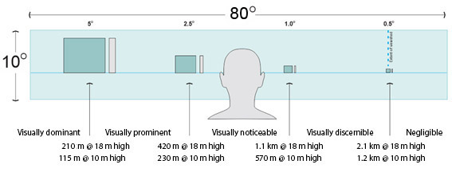
Figure 16-2 Diminution of visual influence based on distance

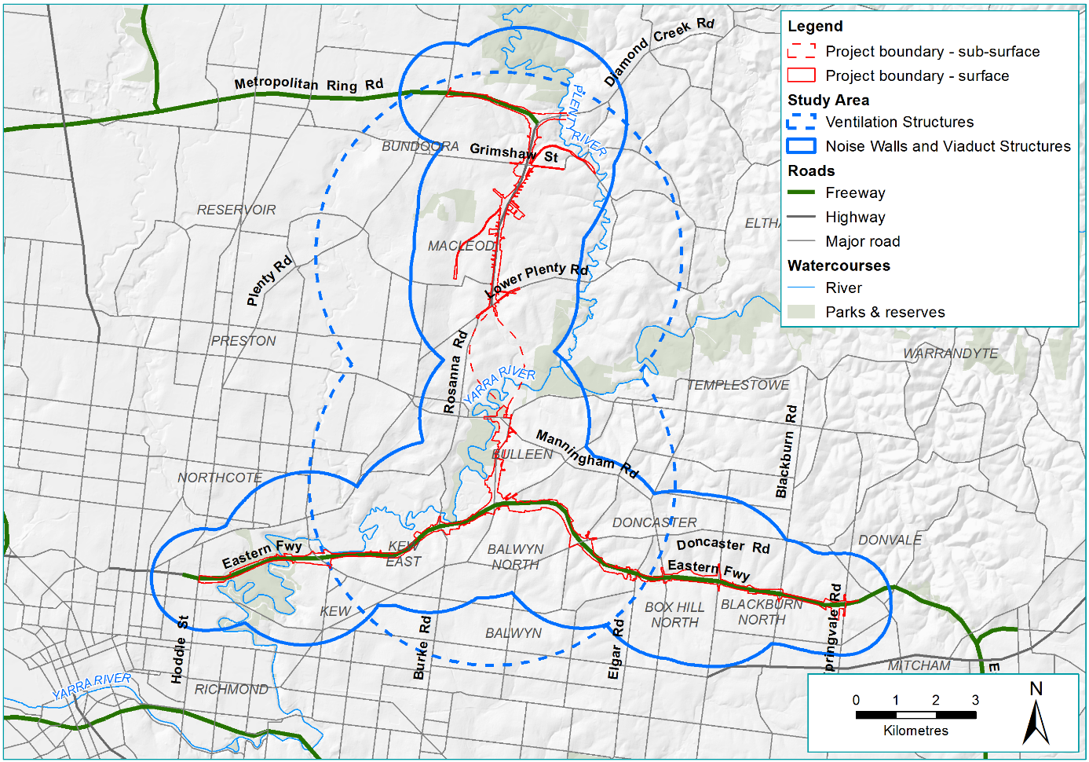
Figure 16-3 Landscape and visual impact assessment study area

Site investigations and consultation

The desktop analysis and a zone of theoretical visibility were used to determine appropriate locations for site investigations.
Representatives of Banyule, Boroondara, Manningham, Whitehorse, Yarra and Nillumbik councils were also consulted. This included engagement through workshops to inform development of the project’s Urban Design Strategy. For further detail on stakeholder consultation relating to urban design, refer to Chapter 7 – Urban design.
What is the ‘zone of theoretical visibility’?
A zone of theoretical visibility is the area from which the project could be visible (without taking into account existing buildings and vegetation that may screen views). This is determined using Geographical Information Systems (GIS) software and elevation data within a Digital Terrain Model.
This involved estimation of the height of built form elements where ventilation structures have been defined as 30 metres (75 per cent of the design height), noise walls at 50 per cent of the design height for all new walls, and viaduct structures at 10 metres (55 per cent of the design height). These are conservative maximum heights.
This tool assists in determining locations for site investigations.

The site investigations and stakeholder consultations helped to identify landscape values, views, built form and vegetation and set the regional landscape context for the study area. This informed the development of the three landscape character areas, described in more detail in Section 16.2.

Impact assessment and management

As described in Chapter 4 – EES assessment framework, a risk assessment was undertaken to prioritise the impact assessment.
The potential landscape and visual impacts of the project during its construction and operation were assessed through a viewpoint assessment for viewpoints in the public domain and private domain. This approach assesses the scale and location of the project in the existing landscape. This involved the following activities:
- Councils were consulted and invited to provide viewpoints as part of the initial consultation, and feedback from community consultation sessions was taken into consideration.
What are the risk categories?
Risk levels were categorised as very low, low, medium, high or very high. When an impact is a known consequence of the project, the rating is indicated as ‘planned’.
The results of the initial risk assessment were used to prioritise the focus of the impact assessments.

- A number of viewpoints were identified to reflect the various types of viewers and landscapes located throughout the study area.
- The impacts during construction and operation were assessed separately. The scale used to rate the visual impact of the project from publicly accessible and private domain viewpoints is presented in Table 16-1. The ratings were determined giving consideration to:
  - The visibility of the infrastructure
  - The distance of the viewer
  - The landscape and viewer sensitivity
  - The number of viewers.
- Photomontages were produced for a number of viewpoints that reflect the various impacts throughout the study area are generally representative of views in that immediate area and cover off on key project elements. Some example photomontages are included in this chapter to represent the assessment. For further detail on all the photomontages and illustrative sections, see Section 3.5.4 of Technical report H – Landscape and visual.
What is landscape sensitivity?
Landscape sensitivity can be defined as ‘the extent to which the landscape can absorb change of a particular type and scale without unacceptable adverse impacts on its character’.
While change is part of any landscape, human induced changes are considered significantly different to the natural processes that occur in a landscape.
Generally the greater the extent of prior modifications, the lesser its sensitivity to change.
The assessment of landscape and visual impacts is therefore informed by the assessment of landscape sensitivity, described in Section 16.2.

- In assessing the impacts due to vegetation removal and re-establishment, growth rates for proposed landscaping have been assumed as one metre per year based on best practice plant installation methods. These methods such as selection of healthy plant stock, soil preparation (deep ripping, rotary hoe and harrow), best practice planting and allowance for a 12-month maintenance period including watering.
The landscape and visual impact assessment also considered the potential for overshadowing from new structures and noise walls and light spill due to the introduction of new lighting. The potential overshadowing impacts are discussed in further detail in Chapter 13 – Land use planning and Technical report E – Land use planning.
Table 16-1 Scale of visual impact
Rating | Description
Nil | There would be no perceptible visual change.
Positive | There would be a visual change that improves or is beneficial for the outlook or view.
Negligible | There would be a minute level of effect that is barely discernible over ordinary day-to-day effects. The assessment of a ‘negligible’ level of visual impact is usually based on distance. That is, the project elements would either be at such a distance that, when visible in good weather, these elements would be a minute element in the view within a modified landscape or they would be predominantly screened by intervening topography and vegetation.
Low | There would be visual impacts that are noticeable but that would not cause any significant adverse impacts. The assessment of a ‘low’ level of visual impact would be derived if the rating of any one of four criteria, that is visibility, distance, viewer numbers and landscape sensitivity, is assessed as low. Therefore, the project in a landscape which is modified, and which already contains many buildings or other similar built form may be rated as a low level of visual impact. Similarly, if the distance from which it is viewed means that its scale is similar to other elements in the landscape it would also be assessed as a low level of visual impact.
Medium | The assessment of a ‘medium’ visual impact will depend upon all four-assessment criteria being assessed as higher than ‘low’ and when significant effects may be able to be mitigated or remedied.
High or adverse effect | There would be extensive adverse effects that cannot be avoided, remedied or mitigated. The assessment of a ‘high or unacceptable adverse effect’ from a publicly accessible viewpoint requires the assessment of all four factors to be high. For example, a highly sensitive landscape, viewed by many people, with the project in close proximity and largely visible would lead to an assessment of an adverse effect.

In response to the impact assessment, Environmental Performance Requirements (EPRs) were developed to set the required environmental outcomes for North East Link. The residual risk ratings and the assessment of impacts presented in this chapter assume implementation of the EPRs. Refer to Chapter 27 – Environmental management framework for the full list of EPRs.

Existing conditions
This section summarises the existing landscape and visual conditions of the study area.
Geology, topography and waterways, vegetation coverage and land use were identified through a desktop assessment, a review of council planning policies and site investigations, which led to the establishment of the three identified landscape character areas. These landscape character areas also underpin the project’s Urban Design Strategy and have been developed for both documents. These are illustrated in Figure 16-4, and described in the sections below.
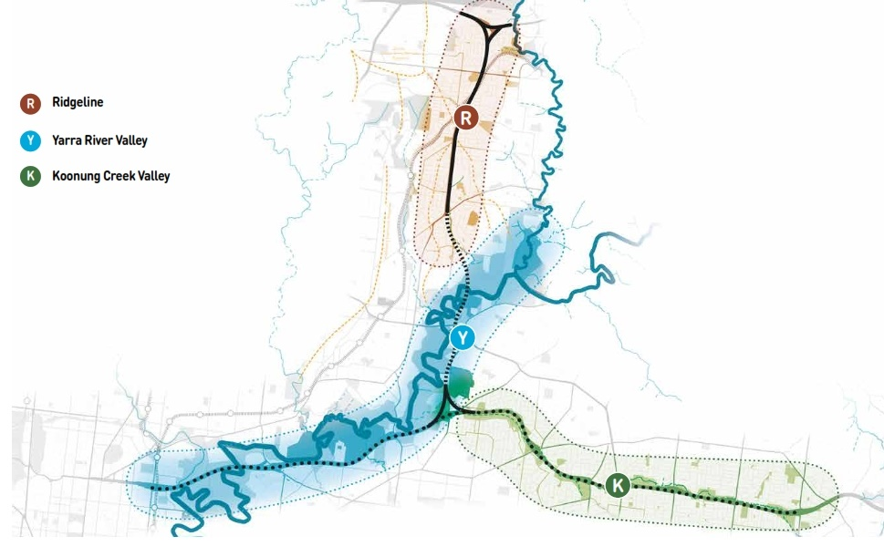
Figure 16-4 Landscape character areas

Ridgeline
The Ridgeline landscape character area dominates the northern part of the study area around the M80 Ring Road (otherwise known as the Metropolitan Ring Road), Watsonia and Yallambie. It has a distinct suburban residential character set in an elevated topography with schools and aged care facilities. Long views are provided to and from treed ridgelines, with multiple ridgelines present throughout the character area. Vegetation is generally a mix of established native and exotic species on a Silurian siltstone geology. The M80 Ring Road runs east-west in the northern part of this character area, with a multi-lane freeway set amongst densely vegetated embankments screening the road corridor from surrounding residential area. Simpson Barracks is located along one of the key ridgelines within the character area and the dense established vegetation within the barracks provides visual relief from the surrounding urban environment.

Yarra River Valley
The Yarra River Valley character area is the largest of the three in the study area. It follows the river from Viewbank, through the Banyule Flats, Warringal Parklands, the Yarra River Parklands to Kew and Fairfield. This area consists of low-lying floodplains with high cultural heritage significance. The low-lying topography allow flat open areas for sporting fields which are scattered along the river corridor. This character area is open, vegetated and naturalistic in character. Vegetation is mostly floodplain riparian woodland on alluvial soils. The wide green valley corridor of the Yarra River is a distinct feature with residential areas adjoining either side, overlooking the vegetated corridor. Views range from short enclosed views, dictated by vegetation and topography to medium expansive views over open grassed areas. Borrowed views to and across the densely vegetated Yarra River corridor are a key feature of this character area. This character area is defined by the presence of culturally significant landscapes such as Bolin Bolin Billabong, Yarra Flats and the Heide Museum of Modern Art. Multiple golf courses and sports fields abut the Eastern Freeway and river’s edge throughout the character area.

Koonung Creek Valley
The Koonung Creek Valley landscape character area dominates the south-eastern part of the study area, defined by suburban residential areas, following the Koonung Creek east through Balwyn North, Doncaster, Blackburn North, Nunawading and Box Hill North. Koonung Creek is a small and highly modified tributary of the Yarra River that runs through a narrow upper valley. The Eastern Freeway follows the valley floor with suburban residential areas rising up out of the valley to the north and south. Passive linear open space follows the alignment of Koonung Creek with a focus on shared use. The open space alternates between the north and south side of the freeway corridor. Vegetation is established and dense and the vegetation along Koonung Creek and the Eastern Freeway provides a dense green corridor along the valley floor on alluvial and colluvial soils. Views to and across the dense vegetation are key features of this character area.

Landscape sensitivity
In the assessment of existing conditions, relevant council neighbourhood character policies were reviewed and several site visits undertaken to assess the landscape character areas described above and their sensitivity. While change is an integral part of any landscape, human-induced changes are considered significantly different to the natural processes that occur in a landscape. Sensitivity depends on a number of factors including location, the rarity of the landscape and the scenic qualities of a landscape. Sensitivity ratings for the landscapes character areas are summarised in Table 16-2.
Table 16-2 Landscape character areas and sensitivity
Landscape character area | Sensitivity
Ridgeline | Medium  The Ridgeline area is characterised by suburban residential areas and undulating topography. As this is an area with substantial obvious human-made modifications, while of a smaller scale, the landscape sensitivity is assessed as medium.
Yarra River Valley | High to medium  The landscape values of the Yarra River and intersecting creek and drain age areas are held in high regard, particularly those that appear ‘natural’ with fewer obvious signs of man-made alterations. These locations have a high degree of sensitivity.  The landscape sensitivity is rated as medium where the character area is heavily modified to create sporting facilities or where suburban residential occurs.
Koonung Creek Valley | High to medium  The Koonung Creek Valley is characterised by suburban residential areas. As this is an area with substantial obvious human modifications, while of a smaller scale than proposed in the project, the landscape sensitivity is assessed as medium.  The landscape sensitivity is greater where the character area is of a more natural setting along the open space adjoining the Koonung Creek. In these areas, the sensitivity is rated as high.

Construction impact assessment
This section summarises the landscape and visual impacts of North East Link’s construction.
Key landscape and visual impacts during the project’s construction have been assessed through the risk pathway described in Section 16.1.
The potential impacts associated with the risk pathway were informed by the assessment of a number of key viewpoints. The potential construction impacts to specific viewpoints are described in detail in Technical report H – Landscape and visual.
The construction impacts have been summarised and grouped into the relevant landscape character area below Table 16-3.
Table 16-3 Risk table - construction
Risk ID | Risk pathway | Risk rating
Risk LV01 | Construction laydown, works areas, materials storage and stockpiling causes adverse impacts to views experienced from within the Ridgeline, Yarra River Valley and Koonung Creek Valley landscape character areas. | Planned  (moderate consequence)

Ridgeline
The assessment of impacts to the Ridgeline landscape character area during construction has been informed by an assessment of viewpoints described in Section 16.4.1 and Section 16.4.2.
Construction impacts within the Ridgeline character area would consist of site compounds located within AK Lines Reserve, Gabonia Avenue Reserve, Winsor Reserve, Simpson Barracks and Borlase Reserve. There would be construction fencing along the boundary of the project works area. Viewers located directly adjacent to the construction compounds would have their views to open space interrupted. Due to the undulating topography within the Ridgeline character area viewers from streets and properties located further away, but elevated above the project area would have views into the construction compounds. These views would have been of vegetated parkland and now would be interrupted by views of machinery, storage sheds, spoil stockpiles, construction materials and access routes.
The proposed alternative TBM launch site (refer to Chapter 8 – Project description) would occur within the Ridgeline character area. This would add to the construction activity and visual clutter around Borlase Reserve and Simpson Barracks, with adjacent residences views interrupted by workshops, storage facilities and an acoustic shed for up to seven years.
The visual impact within the Ridgeline character area is rated as medium to high for the construction period due to the number of adjacent residences with long term views towards the construction activity.

Yarra River Valley
The assessment of impacts to the Yarra River Valley landscape character area during construction has been informed by an assessment of viewpoints described in Section 16.4.1 and Section 16.4.2.
Construction impacts within the Yarra River Valley character area would be associated with site compounds located at the drive-in site adjacent to Bulleen Road, the Manningham Road interchange, Marcellin College and Trinity Grammar School Sporting Complex, Bulleen Oval and Musca Street Reserve. There would be construction fencing along the boundary of the project works area. Viewers located directly adjacent to the construction compounds would have their views to open space interrupted. Due to the steep topography within the Yarra River Valley character area viewers from streets and properties located further away, but elevated above the project area would have views into the construction compounds. These views would have been of vegetated parkland and now would be interrupted by views of machinery, storage sheds, spoil stockpiles, construction materials and access routes.
The proposed alternative TBM retrieval site (refer to Chapter 8 – Project description) would occur within the Yarra River Valley character area. This would add to the construction activity and visual clutter around Banksia Park, with views from within the park and the adjacent Heidi Museum of Modern Art grounds interrupted by piling equipment, cranes and machinery for up to three years. The impact associated with this alternative TBM retrieval site would be temporary and the area returned to open space.
These areas may be occupied for up to seven years. The visual impact within the Yarra River Valley landscape character area is rated as medium during project construction due to the number of adjacent residences with views towards the construction activity.

Koonung Creek Valley
The assessment of impacts to the Koonung Creek Valley landscape character area during construction has been informed by an assessment of viewpoints described in Section 16.4.1 and Section 16.4.2.
Construction impacts within the Koonung Creek Valley landscape character area would be associated with site compounds, widening of the Eastern Freeway and noise wall construction. There would be seven construction compounds across the character area including the new park and ride facility in the vicinity of the Doncaster Road interchange with the Eastern Freeway.
The site compounds would be located within Koonung Creek Reserve, the Doncaster Park and Ride, Katrina Street Reserve, Elgar Park and the Eastern Freeway Linear Reserve. There would be construction fencing along the boundary of the project works area. Viewers located directly adjacent to the construction compounds would have their views to open space interrupted. Viewers from streets and properties located further away, but elevated above the project area would have views into the construction compounds. These views would have been of vegetated parkland and now would be interrupted by views of machinery, storage sheds, spoil stockpiles, construction materials and access routes.
These areas may be occupied for up to seven years and views would be impacted for the duration of this period. The visual impact within the Koonung Creek Valley landscape character area is rated as medium to high for the construction period.

Environmental Performance Requirements
Landscape and visual impacts during construction would be managed through the implementation of EPRs and measures identified in consultation with key stakeholders. This includes implementation of EPR LV1 which requires the design to be generally in accordance with the Urban Design Strategy. The project would also be required to design temporary works and landscaping to avoid or minimise landscape and visual impacts and to be generally in accordance with the Urban Design Strategy (EPR LV2). This would also include the implementation of measures to use temporary landscaping, features or structures (including viewing portals) during construction to soften and filter views to construction compounds, minimise adverse visual impact of project works and provide visual appeal during construction where appropriate. EPR LV3 requires the project to minimise construction lighting impacts to the extent practicable.

Operation impact assessment
This section summarises the landscape and visual impacts of North East Link’s operation.
The potential impacts during the project’s operation relating to the landscape and visual environment have been grouped into four main themes:
- Landscape and visual impacts at public viewpoints
- Landscape and visual impacts at private viewpoints
- Landscape and visual impacts due to overshadowing
- Landscape and visual impacts due to light spill.
The potential for impacts associated with these themes are discussed in the following sections.

Landscape and visual impacts: public viewpoints
Changes to the landscape due to permanent project infrastructure can adversely impact on views from within the three landscape character areas.
The risk pathways associated with these impacts are summarised in Table 16-4.
Table 16-4 Risk table – operation impacts to landscape character areas
Risk ID | Risk pathway | Risk rating
Risk LV02 | Elevated road structures, road infrastructure, noise walls, flood walls, throw screens, viaducts, pedestrian bridges, vegetation loss, ventilation structures and open cut causes adverse impacts to views experienced from within Ridgeline, Yarra River Valley and Koonung Creek Valley landscape character areas. | Planned (severe consequence)
Risk LV03 | Noise walls, loss of vegetation and roadside landscape treatment along the Eastern Freeway widening causes adverse impacts to the Eastern Freeway. | Planned  (severe consequence)
The potential impacts associated with each of the risk pathways above are discussed in the following sections.

Reference project
The reference project has been designed to reduce impacts on the existing landscape where possible, with articular consideration to:
- Minimising the construction footprint, with one of the key objectives of the project being to minimise impacts to private properties and open space where practicable.
- Locating project infrastructure to avoid, minimise or reduce impacts. The project generally follows existing arterial roads or freeway routes. Where North East Link diverts from existing roads through part of the Ridgeline and Yarra character area this section has been placed in twin tunnels to avoid large areas of residential and ecological significant areas.
- Reducing surface impacts through part of the Ridgeline with the use of a trench between Watsonia railway station and Blamey Road and incorporating land bridges that connect the existing landscape on either side.
- Micro-siting and design of project infrastructure, with the Urban Design Strategy providing guidance to avoid adverse landscape and visual impacts.
The project has three distinct appearances when viewed from locations outside the road corridor. These include:
- Above natural ground level (in a viaduct) with associated noise walls in some locations
- On grade, but with associated walls and screens
- In tunnel or trench.
For further detail on the reference project see Chapter 8 - Project description, and Section 4 of Technical report H - Landscape and visual.

Ridgeline
The Ridgeline landscape character area is located in the northern section of the study area from the M80 Ring Road to Lower Plenty Road. The existing landscapes within this character area generally have a medium level of sensitivity and the landscape and visual impact ranges from positive to high. Within this landscape character area, the M80 Ring Road and Greensborough Bypass would have high viewer numbers, the public reserves would have medium viewer numbers and the residential areas would have medium to low viewer numbers.
To assess the landscape and visual impacts in this character area, 24 viewpoints in the public domain were selected. Table 16-5 and Figure 16-5 identify the location of these viewpoints and the proposed change immediately after construction (year 0) and 10 years after construction (year 10). For further detail on specific visual and landscape impacts on each viewpoint, see Technical report H – Landscape and visual.
Key findings of this assessment were:
- In locations where new infrastructure would be located directly adjacent to a viewpoint, the landscape and visual impacts are expected to be medium to high. This is due to the close proximity of the views to the new elements and the limited space for landscaping, particularly evident in locations close to the Lower Plenty Road interchange and the M80 Ring Road interchange.
- In locations where new infrastructure would be located some distance from the viewpoint and where there is space available for landscaping, the impacts would be low to negligible.
- In locations adjacent to the proposed land bridges, the impacts are negligible to positive due to the improved landscape and visual amenity and provision of additional open space.
- The amount of open space that may be impacted in the Ridgeline landscape character area varies between construction to operation. During construction, this area is considered to have a significant impact on landscape character as the use of open spaces (such as AK Lines Reserve) would be impacted. However, this is not considered a significant visual impact as the majority of the open space impacted during construction would be returned to its original use during the project’s operation.
Overall, the proximity of new infrastructure and availability of space for landscaping would have the greatest influence on the visual impacts within the Ridgeline landscape character area. Furthermore, the landscape character of this area would not be significantly impacted for operation as the use of open spaces would be retained and vegetation buffers would largely maintain the visual amenity and landscape character.
To inform the impact assessment, photomontages or illustrative sections were prepared for some viewpoints to assess in greater detail the potential landscape and visual impacts at those specific points. Photomontages for three representative viewpoints from within the Ridgeline landscape character area are presented in the next few pages. Further detail, illustrative sections and more photomontages are provided in Technical report H – Landscape and visual.
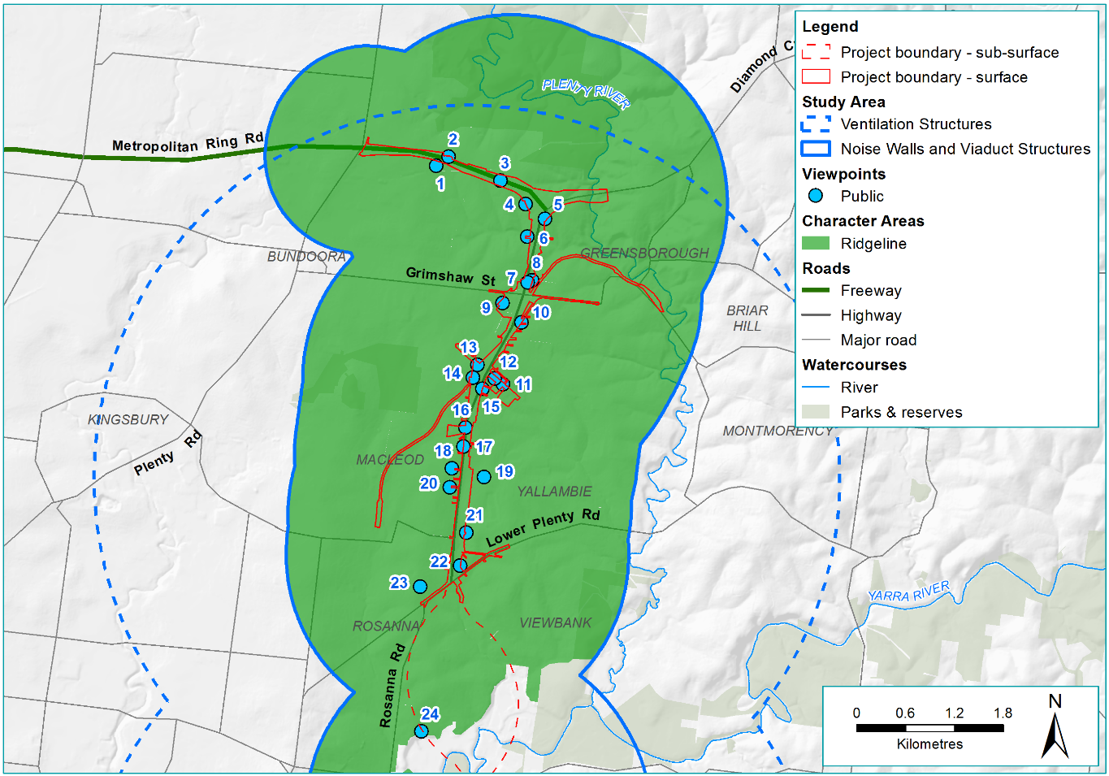
Figure 16-5 Ridgeline landscape character area and viewpoint map
Table 16-5 Ridgeline public viewpoint assessment
Viewpoint number and location | Proposed change | Potential impact year 0 | Potential impact year 10
VP1 - Healy Court, Bundoora | The current view looks north towards the M80 Ring Road. The view consists of established native trees on the embankment between property fence lines and the M80 Ring Road with single and double-storey houses in the foreground. This viewpoint is located approximately 70 m from noise wall on the south side of the M80 Ring Road. The existing vegetation and embankment would be removed. | Low – due to the visually dominant 10 m high noise wall, but viewer numbers would be low. | Low to negligible – landscaping would screen views of the noise wall.
VP2 - Killarney Ridge, Greensborough | The current view looks south-west from the northern side of the M80 Ring Road. The view consists of a 3 m high timber noise wall in the background, grassed and vegetated embankments in the middle ground and a chain mesh fence in foreground. This viewpoint is located approximately 5 m from the noise wall south of the M80 Ring Road. The existing vegetation within the road corridor and Killarny Ridge would be removed. | Medium – due to the visually dominant 7 m high noise wall, and viewer numbers would be medium. | Low – landscaping would screen views and the landscape setting would be similar to the existing landscape
VP3 - M80 Ring Road pedestrian overpass | The current view looks east towards the Dandenong Ranges in the background, established native trees in the middle ground and the M80 Ring Road in the foreground. This viewpoint is located approximately 120 m from the Greensborough Bypass interchange with viaducts and approximately 50 m from the proposed noise walls to the north (approximately 7 m high) and the south (approximately 8 m high) of the road corridor. The existing vegetated embankments within the road corridor would be removed. | Low – due to the new built elements added to the existing view including viaducts, noise walls and widened road corridor, but the viewer sensitivity would be low. | Low – landscaping would only occur on the northern embankment. Other elements would still be visually prominent.
VP4 - Gillingham Street, Watsonia North (image included below) | The current view looks north-west towards the M80 Rind Road and consists of a 2.5 m high timber noise wall in the background, with a vegetated embankment in the foreground. This viewpoint looks to the existing noise wall which would remain in the current position but would be increased to 7 m high. The existing vegetation and embankment would be removed. | Medium – due to the visually dominant 7 m noise wall, and viewer numbers would be medium. | Low to negligible – landscaping would screen the noise wall.
VP5 - Greensborough Bypass shared use path | The current view is located on the eastern side of the Greensborough Bypass and looks south-west. The view consists of established native trees in the background, a steep vegetated embankment filtering views to the Greensborough Bypass in the middle ground and a shared use path in the foreground. The proposed noise wall would be located approximately 3 m from the viewpoint. The existing vegetation would be removed on the roadside of the shared use path. | Medium – due to the visually dominant 8 m noise wall, but viewer numbers would be medium. | Medium to low –landscaping would screen the proposed noise wall but the landscape setting would be visually different from the existing landscape.
VP6 - Open space adjacent to Sellars St, Watsonia North | The current view looks east towards the Greensborough Bypass and consists of dense native vegetated embankments in the background and a concrete drain that forms the Yando Street underpass with shared use path in the foreground. The proposed noise wall would be located approximately 50 m from the viewpoint. The existing vegetation would be removed. | Medium – due to the visually dominant 10 m noise wall and viewer numbers would be medium. The open space in the foreground would be retained and afford additional landscape opportunities. | Low – landscaping would screen views and the landscape setting would be similar to the existing landscape.
VP7 - Greensborough Bypass north of Grimshaw Street intersection | The current view is located on the eastern side of Greensborough Bypass and looks south towards Grimshaw Street. The view consists of established native shrubs located either side of the road corridor on grassed embankments, three lanes of traffic in each direction with a grassed median. This viewpoint is located approximately 140 m from the proposed Grimshaw Street interchange and approximately 25 m from the proposed noise walls. The road corridor would be widened and the vegetation and embankments removed. | Low – due to the visually dominant 10 m high noise wall, but the viewer sensitivity of the driver is assessed as low. | Low – there would be no change from year 0.
VP8 - Hamlet Street and Saxon Court, Greensborough | The current view is located on the eastern side of Greensborough Bypass looking south towards Grimshaw Street. The view consists of established native vegetation and residential properties in the background, and shared use path and semi-mature street trees in the foreground. The proposed noise wall would be located approximately 20 m from the viewpoint. The existing vegetation would be removed. | Medium – due to the visually dominant 7 m high noise wall. | Medium – the 7 m high noise wall would be visually dominant and the landscaping would be low planting, so it would not provide any screening.
VP9 - AK Lines Reserve, south-west of Grimshaw Street and Greensborough Road (image included below) | The current view is located on the western side of Greensborough Bypass and looks north-east towards established native trees in the background, Greensborough Road, a grassed embankment in the middle ground and grassed oval in the foreground. The proposed noise wall would be located approximately 160 m from the viewpoint. The existing vegetation would be removed. | Medium – due to the visual prominence of the proposed 5 m high noise wall, this would be seen by the users of the reserve and there would be a significant visual change in the landscape. Viewer sensitivity would be rated as medium. | Medium to low – the landscaping would filter views to the proposed noise wall.
VP10 - Greensborough Road, north of Teresa Street | The current view looks north-west towards Greensborough Bypass and consists of established native trees and shrubs along the rail corridor in the background and the eastern side of Greensborough Road in the foreground. The proposed shared use overpass with switchback would be located approximately 15 m from the viewpoint with a noise wall behind. The existing vegetation would be removed. | Medium – the new 10 m high shared use overpass and proposed 7 m high noise wall would be visually dominant, and there would be significant visual change in the landscape. However, viewer numbers would be rated as medium. | Medium – there would be no change from year 0.
VP11 - Intersection of transmission line corridor and Frensham Road, Watsonia | The current view looks north-west towards the Greensborough Bypass. This view is of a 2.5 m high timber noise wall and large shrubs in the background, overhead transmission lines and towers in the middle ground and open space with shared use path and low scattered trees in the foreground. The proposed shared use overpass would be located approximately 125 m from the viewpoint. Two transmission towers would be relocated adjacent to the existing towers with a proposed noise wall behind. | High to medium – the proposed 10 m high shared use overpass, relocated transmission towers and proposed 8 m high noise wall would be visually prominent and there would be a significant visual change. | Medium – the landscaping would partially screen the noise walls and the shared use overpass, but the transmission towers would remain dominant elements in the landscape.
VP12 - Power line easement, Watsonia | The current view looks west towards Greensborough Bypass. The view consists of transmission towers in the background, dense native shrubs in the middle ground with a shared use running through an open grassed reserve in the foreground. There are scattered small deciduous trees and an existing timber fence to the south of the reserve. The proposed shared use overpass would be located approximately 17 m, the relocated transmission towers would be located approximately 85 m, and the noise wall would be located approximately 108 m from the viewpoint. The existing vegetation would be removed. | High to medium – the proposed 10 m high shared use overpass, relocated transmission towers and proposed 8 m high noise wall would be visually dominant. | Medium –landscaping would partially screen the noise walls, but the shared use overpass and transmission towers would remain dominant elements in the landscape.
VP13 - Watsonia railway station reserve | The current view looks south-east towards the Watsonia Station carpark and Greensborough Bypass. The view consists of large transmission towers in the background with a shared use bridge over the train line in the foreground surrounded by established vegetation The proposed shared use overpass would be located approximately 4 m from the viewpoint and the proposed noise wall approximately 110 m from the viewpoint. The transmission towers would be relocated behind the noise wall and there would be some vegetation loss in the foreground. | Medium to low – the proposed 5 m noise wall and shared use overpass would create additional built form but this would be balanced by the relocation of the transmission towers to the east. | Medium to low –there would be no change from year 0.
VP14 - Watsonia Road north of Watsonia Road / Lambourne Road | The current view looks north-east towards the Watsonia car park and Greensborough Bypass. The view is of established trees and residential properties in the background, transmission towers, overhead power lines and car park in the middle ground and a train line and steep bare earth embankment in the foreground. This viewpoint would be located approximately 45 m from the proposed multi-deck car park and approximately 135 m from the proposed shared use overpass. | Low – the proposed 7 m multi-deck car park would be visually dominant but would not be out of place in the existing visually cluttered landscape setting. | Low – there would be no change from year 0.
VP15 - Service Road, Watsonia | The current view is located on the eastern side of Greensborough Bypass and looks north-east towards established native shrubs in the background with a vegetated embankment on the west, and suburban residential properties on the east in the foreground. The proposed noise wall would be located approximately 15 m from the viewpoint adjacent to the Greensborough Bypass with a proposed shared use overpass located approximately 185 m from this viewpoint at the end of service road. The existing vegetation would be removed. | Medium – the proposed 6 m high noise wall and 10 m high shared use overpass would be visually dominant and there would be a significant visual change in the landscape. However, the viewer numbers would be medium. | Medium to low – landscaping would partially screen the lower half of the wall.
VP16 - Greensborough Road adjacent to Winsor Reserve | The current view is located on the western side of Greensborough Road looking north. The view is includes two lanes in each direction and suburban residential properties either side. This viewpoint would be located approximately 29 m from the proposed noise wall with the proposed shared use path in front. The existing properties on the east side of Greensborough Road would be removed. | Low – the proposed 4 m high noise wall would be visually dominant and there would be significant visual change in the landscape. However, the viewer sensitivity of the driver is assessed as low. | Negligible to positive – the landscape would screen the 4 m noise wall and the landscape setting would be improved.
VP17 - Greensborough Road, adjacent to Simpson Barracks, Macleod (image included below) | The current view is located on the western side of Greensborough Road, looking south towards established native trees in the background and the four lane Greensborough Road in the foreground adjacent to residential properties. The proposed anti-throw screen would be located approximately 24 m and the proposed ventilation structure would be located 355 m from the viewpoint. The ventilation outlet would be approximately 40 m high and the associated ventilation building would be approximately 8 m high. The existing vegetation would be removed. | Medium – the proposed 4 m anti-throw screen and 40 m ventilation outlet and 8 m high ventilation building would result in the removal of existing vegetation. This significant visual change is given a low rating due to the low sensitivity of road users. | Low to negligible – the landscaping would partially screen the anti-throw screen and filter views to the ventilation structure.
VP18 - Fairlie Avenue, Macleod | The current view looks east towards Greensborough Road and consists of established exotic and native trees in the background, a concrete and chain mesh fence with signage in the middle ground and Greensborough Road in the foreground. The existing vegetation would be removed from the roadside and partially within Simpson Barracks. | Low – the removal of existing vegetation would not be a significant visual change at this distance, and viewer numbers would be low. It is noted that from viewing locations closer to Simpson Barracks, the visual impact would be higher. | Negligible – the landscaping would have established and the landscape would be similar to the existing.
VP19 - Simpsons Barracks | The current view looks west towards Greensborough Road from the Simpson Barracks carpark. The view consists of established native trees on a grassed area sloping down in the background and a t intersection and overhead power lines in the foreground. The proposed ventilation structure would be approximately 160 m and the proposed substation would be approximately 192 m from the viewpoint. The ventilation outlet would be approximately 40 m high and the associated ventilation building would be approximately 8 m high. The existing vegetation and some of the grassed area in the background would be removed. | Medium – the 40 m ventilation outlet and the 8 m ventilation building would be the visually dominant element and would significantly alter the existing view, but viewer sensitivity would be medium. The existing vegetation in the foreground would screen the lower half of the ventilation outlet. | Medium – there would be no change from year 0.
VP20 - Strathallan Road, Macleod | Strathallan Road is a side street to the west of Greensborough Road. The current view looks east towards established native vegetation in the background, Greensborough Road in the middle ground and a residential street grassed nature strips in the foreground. The proposed road barrier and intersection would be located approximately 145 m from the viewpoint. Where the proposed intersection would be located, the existing vegetation would be removed. Landscaping is also proposed between the intersection and this viewpoint. | Low – the proposed intersection and road barriers (approximately 0.9 m high) would be visible at the end of the street, however, the existing vegetated ridgeline behind would remain unchanged and the sense of enclosure this provides would not be altered. | Low – there would be no change from year 0.
VP21 - Kay Court, Yallambie | Kay Court is located to the east of Greensborough Road. The current view looks west towards Greensborough Road, but consists of multistorey residential in the background, established native vegetation in the middle ground and residential with established street trees in the foreground. The proposed noise wall would be located approximately 80 m from the viewpoint with a proposed shared use path in front. It has been assumed that existing residential properties in the foreground and vegetation in the background would be removed. | Medium to low – the proposed 5 m noise wall would be visually dominant and there would be a significant visual change in the landscape. However, viewer numbers would be low. | Low – the landscaping would filter views of the noise wall.
VP22 - Borlase Street, Yallambie | The current view looks north-west towards Greensborough Road and consists of established native vegetation in the background with open grassed reserve in the foreground the proposed noise wall would be located approximately 14 m from the viewpoint. The existing vegetation would be removed. | High – the proposed 4 m noise wall would be visually dominant and there would be a significant visual change in the landscape and the open space would be removed. | Medium – the landscaping would partially screen the proposed noise wall, and the open space would not be replaced.
VP23 - Interlaken Parade, Rosanna | The current view looks north-east towards established trees in the background with suburban residential properties in the foreground. There would be some vegetation removal due to the proposed road corridor. | Low – there would be a minor visual change due to the removal of some vegetation. | Negligible – landscaping would be established and the landscape would be similar to the existing.
VP24 - Dalvey Street, Heidelberg | The current view looks south-east towards the Manningham Road and Bulleen Road interchange and consists of the Dandenong Ranges in the background, established vegetation and residential properties in the middle ground and densely vegetation suburban residential properties in the foreground. The proposed Manningham Road interchange with emergency smoke duct would be located approximately 1 km from the viewpoint. The proposed ventilation structure would be located approximately 2.5 km from the viewpoint. The ventilation outlet in this location would be 40 m high and the ventilation building approximately 15 m high. | Low – the proposed emergency smoke duct and ventilation outlet and associated ventilation building would be visually noticeable and there would be a visual change in the landscape. However, viewer numbers would be low. | Low – there would be no change from year 0.

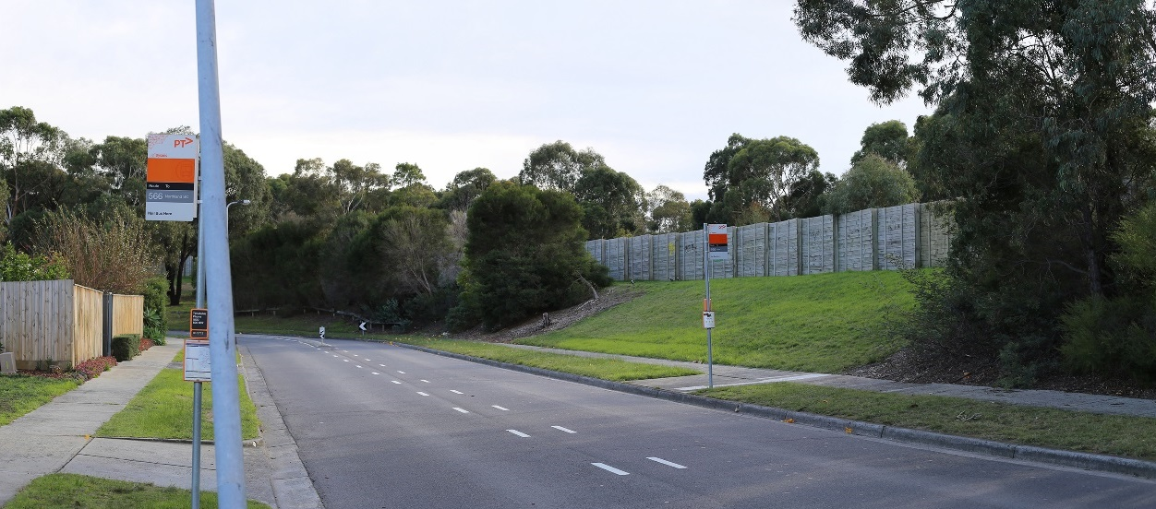
Figure 16-6 Viewpoint 4: Gillingham Street, Watsonia North - existing
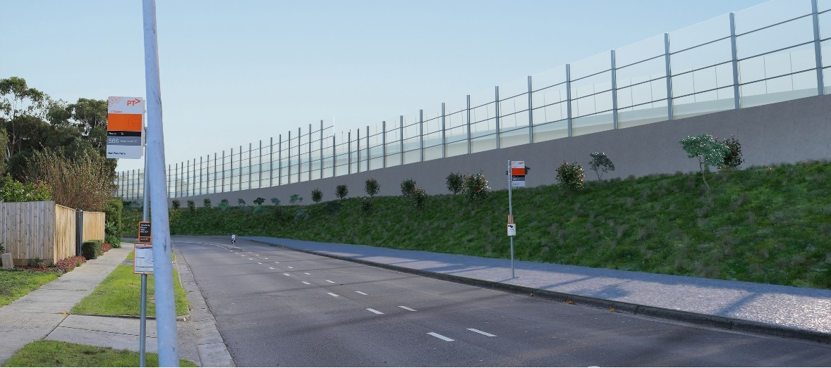
Figure 16-7 Viewpoint 4: Gillingham Street, Watsonia North - year 0 - noise wall visible – medium rating
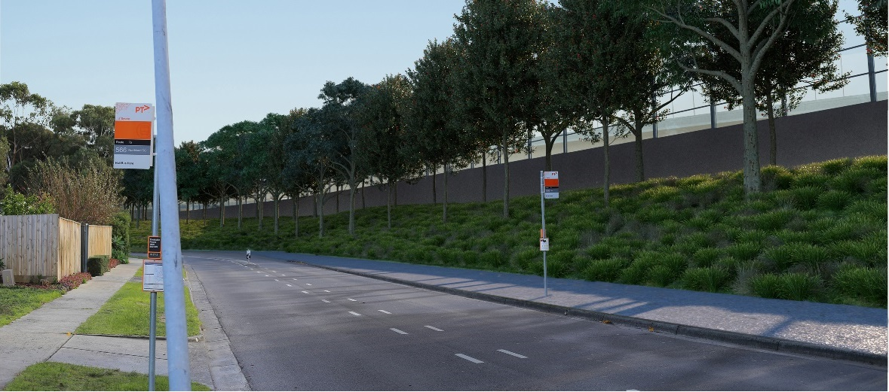
Figure 16-8 Viewpoint 4: Gillingham Street, Watsonia North - year 10 - vegetation screen - low to negligible rating
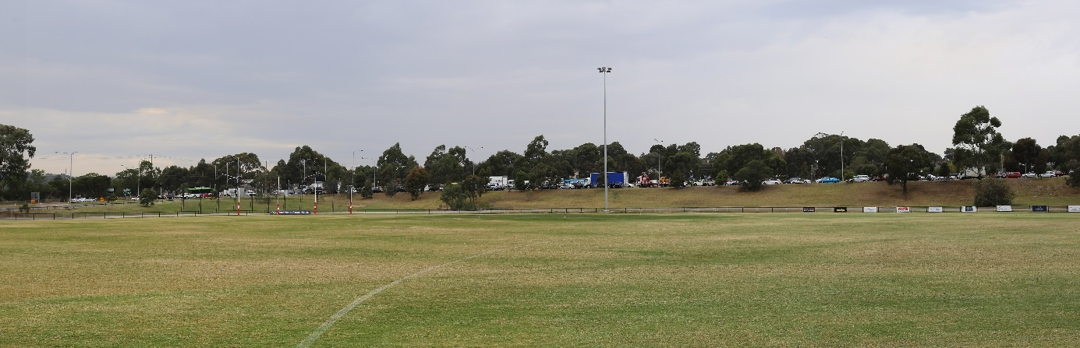
Figure 16-9 Viewpoint 9: AK Lines Reserve, Watsonia - existing
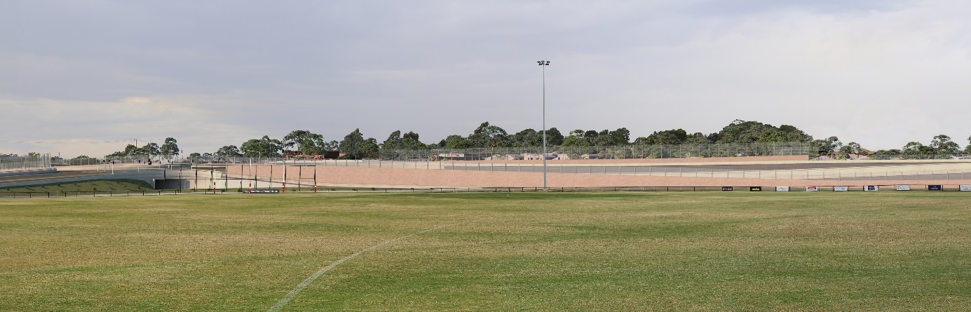
Figure 16-10 Viewpoint 9: AK Lines Reserve, Watsonia - year 0 - noise wall visible – medium rating
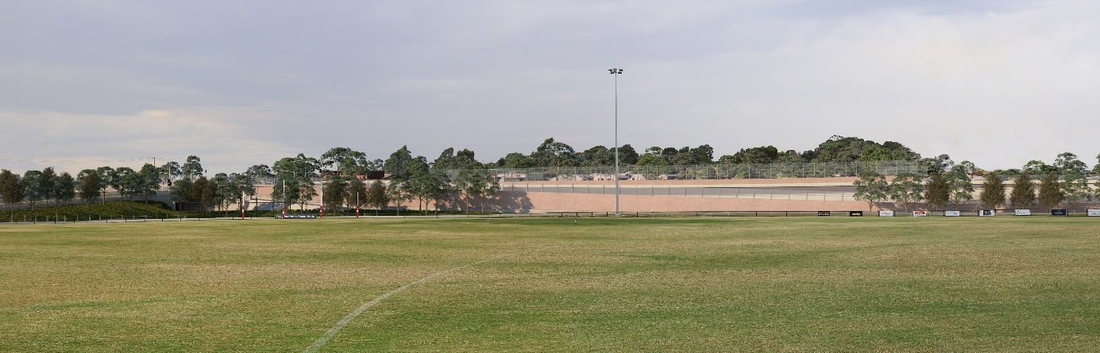
Figure 16-11 Viewpoint 9 - AK Lines Reserve, Watsonia - year 10 - vegetation screen – medium to low rating
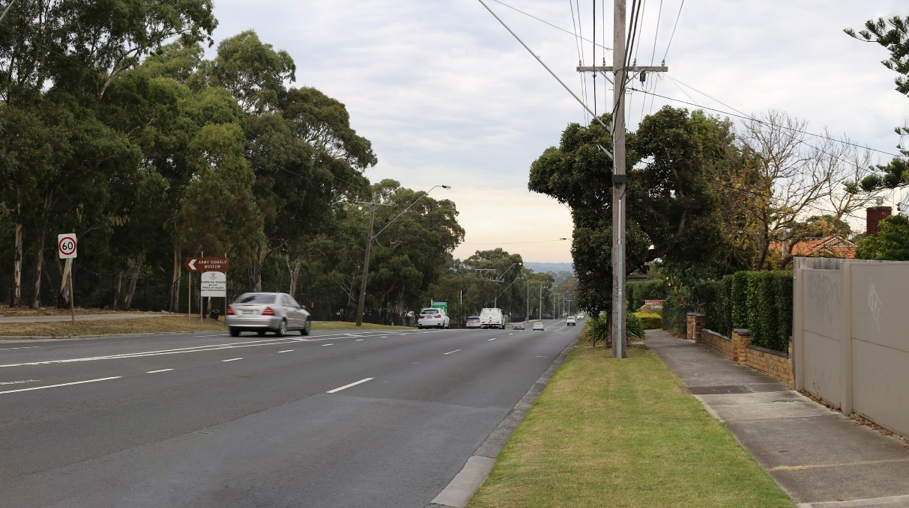
Figure 16-12 Viewpoint 17: Greensborough Road, Macleod (Simpsons Barracks) - existing
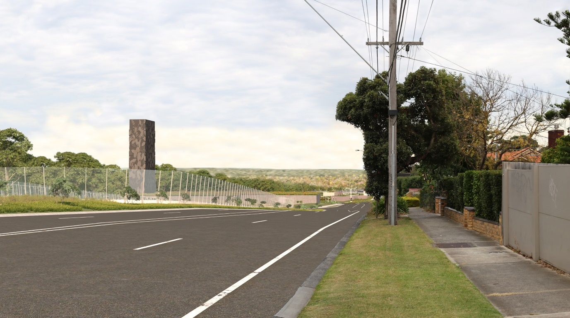
Figure 16-13 Viewpoint 17: Greensborough Road, Macleod - year 0 - ventilation structure visible - medium rating
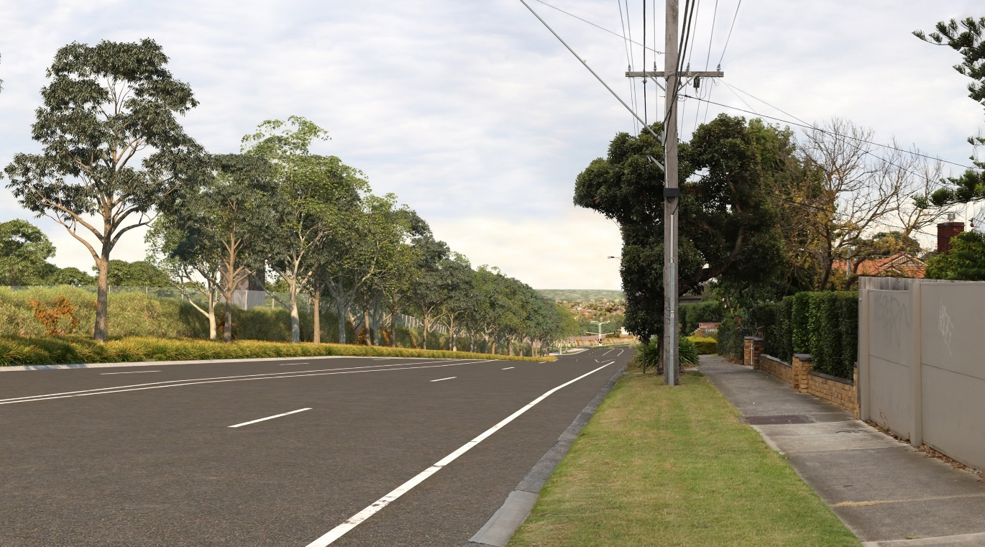
Figure 16-14 Viewpoint 17: Greensborough Road, Macleod - year 10 - vegetation screen - low to negligible rating

Yarra River Valley
The Yarra River Valley landscape character area is located in the southern section of the study area from Manningham interchange to Hoddle Street. The existing landscapes within this character area generally have a medium to high level of sensitivity and the landscape and visual impact ranges from negligible to high. Within the Yarra River Valley landscape character area the public reserves and sporting facilities have medium viewer numbers and the residential areas have medium to low viewer numbers.
To assess the landscape and visual impacts in this character area, 22 viewpoints in the public domain were selected. Figure 16-15 and Table 16-6 identify the location of these viewpoints and the proposed change as a result of the project immediately after construction (Year 0) and at 10 years after construction (year 10). For further detail on specific visual and landscape impacts for each viewpoint, see Technical report H – Landscape and visual.
Key findings of this assessment were:
- In locations where new infrastructure would be located directly adjacent to the viewpoint, the landscape and visual impacts would be medium to high. This is due to the close proximity of the views to the new elements, the limited space for landscaping and the isolation of existing open space. This includes sections of the Eastern Freeway where residences are already close to noise walls and this would be exacerbated by the project.
- In locations where new infrastructure would be located some distance from the viewpoint and where there is space available for landscaping, the impacts would be low to positive. This is evident in the impacts to the Yarra River, Bolin Bolin Billabong and Heide Museum of Modern Art due to the topography and existing mature vegetation that would screen the new infrastructure from view.
- The amount of open space that would be impacted in the Yarra River Valley landscape character area varies between construction to operation, but is considered to be significant. This is because the current use of some open spaces (such as Bulleen Park) would be permanently changed. However, this is not considered to be a significant visual impact as the majority of the open space impacted during construction would be returned for operation. Where open space could not be returned, vegetation buffers are expected to largely maintain the visual amenity and landscape character of the area. The area around the Manningham interchange (currently the Bulleen Industrial Precinct) and the former Bulleen Drive-in site would also provide new land use opportunities.
- The widening of the Eastern Freeway road corridor would impact the road users with the removal of vegetation, increased lanes and reduced space for landscaping. The Eastern Freeway upgrades would also greatly alter the existing freeway landscape character. Road users would have a low sensitivity to this type of change as they have a transient experience of the landscape and their primary focus is on driving. Although the freeway landscape character would be altered and the road users experience impacted, a key objective for the project is to minimise impacts on communities therefore the widening of the Eastern Freeway has been limited to protect the adjoining public open space which is valued by the community. In addition the project’s Urban Design Strategy outlines detailed requirements which would reduce the landscape and visual impacts on the Eastern Freeway road corridor. For further detail, see Attachment II - Urban Design Strategy.
- The Yarra River Valley landscape character area is valued for its natural landscape features such as the vegetated appearance, the Yarra River and the culturally significant landscapes such as Bolin Bolin Billabong, the Yarra River and the Heide Museum of Modern Art. Whilst overall the landscape character would not be impacted by the project, the introduction of the ventilation structure at the southern portal would introduce a new element into the natural, low-lying floodplain environment which is characterised by a treed outlook and currently devoid of large scale built form. The ventilation structure should be sensitively sited and could be designed to act as sculptural piece, or a recessive design that is intended to blend in with the surrounding landscape. The project would be unlikely to have an impact on the landscape value of the Yarra River Valley landscape character area as the attributes it is valued for such as established vegetation, the Yarra River and the associated character, and culturally significant landscapes would be either retained or enhanced.
Overall, the proximity of new infrastructure and availability of space for landscaping would have the greatest influence on the visual impacts of the Yarra River Valley landscape character area.
To inform the impact assessment, photomontages or illustrative sections were prepared for some viewpoints to assess in greater detail the potential landscape and visual impacts at those specific points. Photomontages for three representative viewpoints from within the Yarra River Valley landscape character area are presented in the next few pages. Further detail, illustrative sections and more photomontages are provided in Technical report H – Landscape and visual.
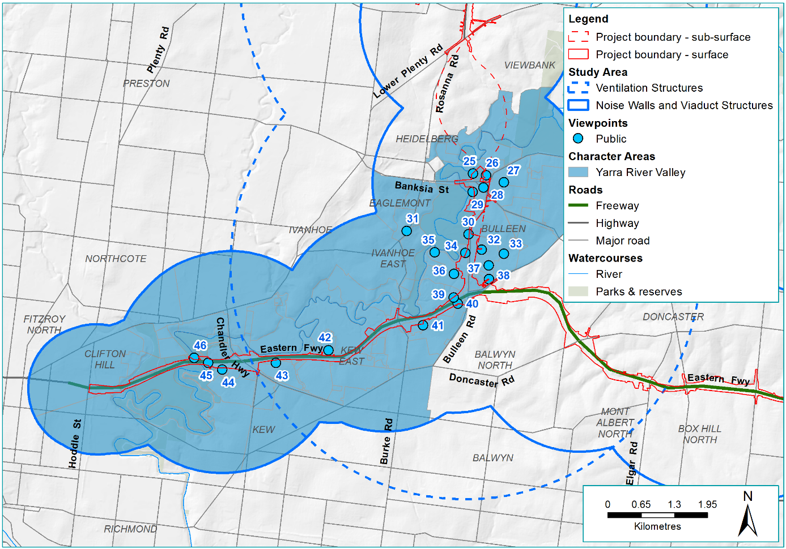
Figure 16-15 Yarra River Valley character area and viewpoint map
Table 16-6 Yarra River Valley public viewpoint assessment
Viewpoint number and location | Proposed change | Potential impact  year 0 | Potential impact year 10
VP25 - Banksia Park Bulleen | The current view looks south-east towards the industrial buildings along Banksia Street and the Ned Kelly sculpture in the background with established trees and a grassed open space in the foreground. The viewpoint is located approximately 245 m from the proposed substation, approximately 315 m from the proposed emergency smoke duct and approximately 145 m from the proposed shared use path. | Low to negligible – the built form would be removed and replaced by a substation and open space. This would be partially screened, as the existing vegetation within Banskia Park would be retained. There would be minor visual change to the landscape. | Low to negligible – there would no change from year 0.
VP26 - Heide Museum of Modern Art (image included below) | The current view looks south-west from Heide Museum of Modern Art towards Manningham Road. The view consists of established vegetation in the background with glimpses of buildings located in the industrial precinct below Banksia Road. The proposed substation and emergency smoke duct would be located approximately 150 m from this viewpoint. The existing industrial buildings would be removed. | Negligible – the industrial buildings and surrounding vegetation would be removed. The existing houses and dense vegetation would screen the proposed 9 m substation and the emergency smoke duct from view. | Negligible – there would be no change from year 0.
VP27 - Helene Street at intersection of England Street and Helene Street, Bulleen | The current view looks west towards Bulleen Road and consists of commercial buildings in the background with a residential tree lined street in the foreground. The viewpoint is located approximately 390 m from the proposed substation and approximately 530 m from the proposed emergency smoke duct. | Low – the proposed emergency smoke duct and proposed 9 m substation would be visually prominent and partially screened behind the existing vegetation and residential properties. The landscape setting would be similar to the existing. | Low – there would be no change from year 0.
VP28 - Manningham Road | The current view looks south towards a car yard and timber supplies store with grassed nature strips and scattered established trees in the background and a main road in the foreground. The viewpoint is located approximately 117 m from the proposed emergency smoke duct and approximately 4 m from the proposed shared use path. All built form and existing vegetation would be removed. | Negligible – while there would be a significant visual change to the landscape, this would be positive as the built form would be removed and replaced by open space. | Negligible – there would be no change from year 0.
VP29 - Yarra River embankment adjacent to Kim Close Reserve (image included below) | The current view looks north-east towards Manningham Road and consists of a large industrial building in the background with dense native vegetation and a walking trail in the foreground. The proposed flood walls would be located approximately 47 m from the viewpoint with a shared use path in front. The existing industrial buildings would be removed. | Medium – the proposed 9 m flood wall would be visually dominant, seen by pedestrians and cyclists and there would be a significant change in the landscape. The existing pedestrian access from the industrial area down to the Yarra River would be restricted by the presence of the proposed flood walls, but this would be compensated by the provision of a new shared use path connection from Banksia Street to Bulleen Road. There is an opportunity for open space in the area above the cut and cover on the eastern side of the flood wall. | Low – the landscaping would filter views to the flood wall.
VP30 - Bolin Bolin Billabong | The current view borders the western side of Bulleen Road looking south. The view consists of dense established native vegetation surrounding a walking trail. The proposed shared use path would require some vegetation removal and would be located approximately 9 m from the viewpoint and the proposed ventilation structure would be approximately 570 m from the viewpoint. The ventilation outlet would be approximately 40 m high and the associated ventilation building would be approximately 15 m high. | Negligible – the dense existing vegetation would screen the proposed 40 m ventilation outlet and associated 15 m ventilation building and the landscape setting would be similar to the existing. Minor vegetation loss would occur directly adjacent to the proposed shared use path, but existing foreground vegetation would filter this from view | Negligible – there would be no change from year 0.
VP31 - Outlook Drive, Eaglemont | The current view looks south-east towards Bulleen Road. This view consists of established vegetation and residential properties. The proposed ventilation structure would be located approximately 1.2 km from the viewpoint and 1.3 km from the proposed 4 m high noise walls. The ventilation outlet would be approximately 40 m high and the associated ventilation building would be approximately 15 m high. | Negligible –the existing landscape is characterised by built form scattered throughout existing vegetation in the distance. Part of the ventilation outlet would be visibly discernible above the existing vegetation in the distance although if the Urban Design Strategy objectives are fulfilled some viewers may see the ventilation outlet as a positive element in the landscape. The 4 m high noise walls would be visibly negligible from this distance. | Negligible – there would be no change from year 0.
VP32 – Trinity Grammar School Sporting Complex, Bulleen | The existing view looks west towards Bulleen Road and consists of established vegetation in the background with open grassed sports fields in the foreground to the left, and a water body surrounded by vegetation to the right. This viewpoint is located approximately 235 m from the proposed shared use path, and approximately 405 m from the proposed ventilation structure. The ventilation outlet would be approximately 40 m high and the associated ventilation building would be approximately 15 m high. The existing vegetation along Bulleen Road would be removed. Landscaping would be proposed between the shared use path and the sports fields. | High to medium – the proposed ventilation outlet would be visually dominant. The existing vegetation along Bulleen Road would be removed. Viewer numbers would be high and viewer sensitivity would be medium. | Medium to low –the landscaping between the shared use path and sports field would have established, and filter views to the lower half of the ventilation outlet.
VP33 - Barak Street, Bulleen | The current view looks west towards Trinity Grammar School Sporting Complete. The view consists of established native vegetation in the background, grassed sporting fields surrounded by scattered established trees in the middle ground with footpath and low mesh fence in the foreground. The proposed ventilation structure would be approximately 770 m from the viewpoint. The cut and cover tunnel works adjacent to Bulleen Road would result in the loss of some vegetation in the background. | Negligible – the existing vegetation would largely screen the proposed 40 m ventilation outlet, 15 m ventilation building and the landscape setting would be similar to the existing. | Negligible – the landscaping would screen the ventilation outlet and the landscape setting would be similar to the existing.
VP34 - Veneto Club, Bulleen | The current view looks south-east towards Bulleen Road and consists of established vegetation in the background, filtering views to Bulleen Road and Bullen Park sports fields, with the sealed car park in the foreground. The viewpoint is located approximately 50 m from the footpath adjacent to the proposed road corridor and approximately 200 m from the proposed ventilation structure. The ventilation outlet would be approximately 40 m high and the associated ventilation building would be approximately 15 m high. The existing vegetation and oval to the south would be removed. Landscaping would be proposed between this viewpoint and the road corridor. | High to medium – the proposed ventilation outlet and associated ventilation building would be visually dominant, seen by visitors of the Veneto Club and there would be significant visual change. | Medium to low –the landscaping would filter views to the proposed ventilation outlet.
VP35 - Bulleen Park playground | The current view looks south-east towards Bulleen Road. The view consists of a grassed sports fields and a playground with BBQ. The viewpoint is located approximately 645 m from the 4 m high proposed noise wall and approximately 630 m from the proposed ventilation structure. The ventilation outlet would be approximately 40 m high and the associated ventilation building would be approximately 15 m high. The existing dense vegetation would screen the lower half of the ventilation outlet and the proposed 4 m noise wall. | Low to negligible –the existing landscape is characterised by large light poles around the oval and tall high voltage towers behind this viewpoint. Part of the ventilation outlet and associated ventilation building would be visible above the existing vegetation in the middle distance. It would be perceived as being lower than the existing light poles and if the Urban Design Strategy objectives are fulfilled some viewers may see the ventilation outlet as a positive element in the landscape. | Low to negligible – there would be no change from year 0.
VP36 Carey Bulleen Sports Complex | The existing view looks east towards Bulleen Road and consists of established vegetation, tennis courts and Bulleen Road in the background with open grassed sports field in the foreground. This viewpoint is located approximately 210 m from the proposed 4 m high noise wall with proposed road corridor in front, and approximately 250 m from the proposed ventilation structure. The ventilation outlet would be approximately 40 m high and the associated ventilation building would be approximately 15 m high. The existing vegetation and tennis courts would be removed. Landscaping would be proposed between the proposed road corridor and existing oval. | High to medium – the proposed 4 m high noise wall and 40 m high ventilation outlet and associated 15 m ventilation building would be visually prominent. There would be a significant visual change in the landscape and a loss of open space. | Medium – the established landscaping would filter views to the proposed noise wall and the lower have of the ventilation outlet and there would be a visible loss of open space.
VP37 Marcellin College, Bulleen | The existing view looks west towards established vegetation in the background with open grassed sports fields in the foreground. This viewpoint is located approximately 390 m from the proposed shared use path, and approximately 445 m from the proposed ventilation structure, and associated 15 m high ventilation building. The ventilation outlet would be approximately 40 m high and the associated ventilation building would be approximately 15 m high. The existing vegetation along Bulleen Road would be removed. Landscaping would be proposed between the shared use path and sports fields. | Medium – the proposed ventilation outlet and associated ventilation building would be visually dominant and the existing vegetation along Bulleen Road would be removed. Viewer numbers would be high although viewer sensitivity would be medium. | Medium –the landscaping between the shared use path and sports field would have established and filter views to the lower half of the ventilation outlet.
VP38 - Sandra Street, Bulleen | The current view looks south-west towards the Boroondara Tennis Centre and consists of established native vegetation and tennis courts in the background, and a residential street with grassed nature strips, native trees and overhead power lines. The proposed viaduct with noise walls would be located approximately 290 m and the proposed busway interchange located approximately 280 m from the viewpoint. The tennis courts and some of the existing vegetation around Bulleen Road would be removed. The noise wall in this location would be 4 m high on top of the viaduct. | Low – the viaducts with noise walls would be partially screened by existing vegetation and there would be visual change in the landscape, but the vegetated ridgeline in the background would be retained and viewer numbers are low. | Low – there would be no change from year 0.
VP39 Freeway Public Golf Course north east | The existing view looks north-east on the northern boundary of the Eastern Freeway towards the Freeway Public Golf Course. The view consists of established vegetation along the edge of the hole with the open grassed areas, paths and sand bunkers of the sixth green in front. The view to the south is of a high chain mesh fence with established vegetation of the Eastern Freeway in the background. The light poles of the Eastern Freeway are visible in this location. The existing fence, vegetation to the south, sand bunker and part of the green would be removed with the proposed widening of the Eastern Freeway road corridor and addition of the Busway. The proposed viaduct at the Eastern Freeway interchange would be located approximately 115 m from the viewpoint. Landscape would be proposed between this viewpoint and the edge of the Busway. | High – the proposed interchange and viaducts would be visually dominant, the existing vegetation to the south and part of the hole would be removed, resulting in an obvious change to the landscape. | Medium to low – the proposed landscaping would have established and filter views towards the proposed interchange. The landscape setting would be similar to the existing.
VP40 - Columba Street, Balwyn North (image included below) | The current view looks north-east towards the Eastern Freeway and consists of residential properties in the background, the Eastern Freeway and established trees in the middle ground and a transparent 1.9 m noise wall in the foreground. The proposed noise wall at this location would be approximately 9 m high and the existing noise wall would be replaced with an approximately 6 m high noise wall. The viewpoint is located approximately 10 m from the proposed noise wall abutting the Eastern Freeway. There would be no room for landscape. | Medium – the new 9 m high noise wall would be higher than the existing noise wall, it would limit and enclose views beyond the wall, but viewer numbers would be medium. There would be no room for vegetation or landscaping. | Medium – there is no room for landscaping in this area, there would be no change from year 0.
VP41 - Musca Street Reserve, Balwyn North | The current view looks west along the Koonung Creek Trail on the southern side of the Eastern Freeway. The view consists of established native vegetation on a grassed embankment in the background with a shared use path and open grassed area. The proposed noise wall would be approximately 94 m from the viewpoint. The existing vegetation directly adjacent to the proposed noise wall would be removed. | Negligible – the proposed 5 m noise wall would be screened by the existing vegetation. The embankments and landscape setting would be the same as existing. | Negligible – there would be no change from year 0.
VP42 - Elm Grove, Kew East | The current view looks south towards the Eastern Freeway and consists of established vegetation with a 4 m high timber noise wall in the background and a residential street with grassed nature strips and established street trees in the foreground. The proposed noise wall would be located in the same location as the existing noise wall, approximately 119 m from the viewpoint. | Low – the proposed 8 m noise wall would be visually prominent but the landscape setting would be visually similar to the existing and viewer numbers would be low. | Low – there would be no change from year 0.
VP43 - Kellett Grove, Kew | The current view looks north towards the Eastern Freeway and consists of a 4.6 m timber noise wall with established native vegetation in the background. The proposed noise wall would be located in the same location as the existing noise wall, but some of the existing vegetation behind and in front of the noise wall would be removed, approximately 65 m from the viewpoint. | Low – the proposed 7 m noise wall would be visually dominant. There would be a visual change in the landscape due to the removal of some vegetation and viewer numbers would be low. | Negligible – the re-established landscaping would screen the noise wall and the landscape would be similar to the existing.
VP44 - Vaughan Crescent, Kew | The current view looks north-east towards the Eastern Freeway and consists of established vegetation in the background, a 2.5 m high timber fence in the middle ground with a residential street in the foreground with established trees and grassed nature strips. The proposed noise wall would be approximately 52 m from the viewpoint. | Low to negligible – the proposed 5 m high noise wall would be partially screened by the existing timber fence and the vegetation in Vaughan Crescent. | Low to negligible – the landscaping would partially screen the proposed noise wall and the landscape setting would be similar to the existing.
VP45 - Yarra Boulevard overpass | The current view looks east along the Eastern Freeway and consists of established vegetation and an overpass in the background with a multi-lane freeway road corridor in the foreground. The existing embankment either side would be reduced with the addition of the busway and noise walls which would be approximately 255 m from the viewpoint and the proposed noise wall would be located on top of the embankment approximately 155 m from the viewpoint. The existing vegetation along the top of the embankments and adjacent to the existing off-ramp would be removed. The proposed shared use path would be located along the top of the northern embankment. | Low – the proposed noise walls (approximately 5 m high on the southern embankment and 6 m high on the northern embankment) and viaduct with noise walls (approximately 4 m high) would be visually prominent but the road users have short-term transient views and low viewer sensitivity. | Low – there would be no change from year 0.
VP46 - River Circuit Trail (Yarra River) | The current view looks south towards the Eastern Freeway and consists of existing Eastern Freeway viaducts in the background with established native vegetation and a walking trail in the foreground. The proposed shared use bridge would be located approximately 40 m from the viewpoint. | Medium – the proposed 14 m high shared use bridge would be visually dominant, but not out of place with the existing landscape setting as there is already an existing viaduct in this landscape. | Medium – there would be no change from year 0.

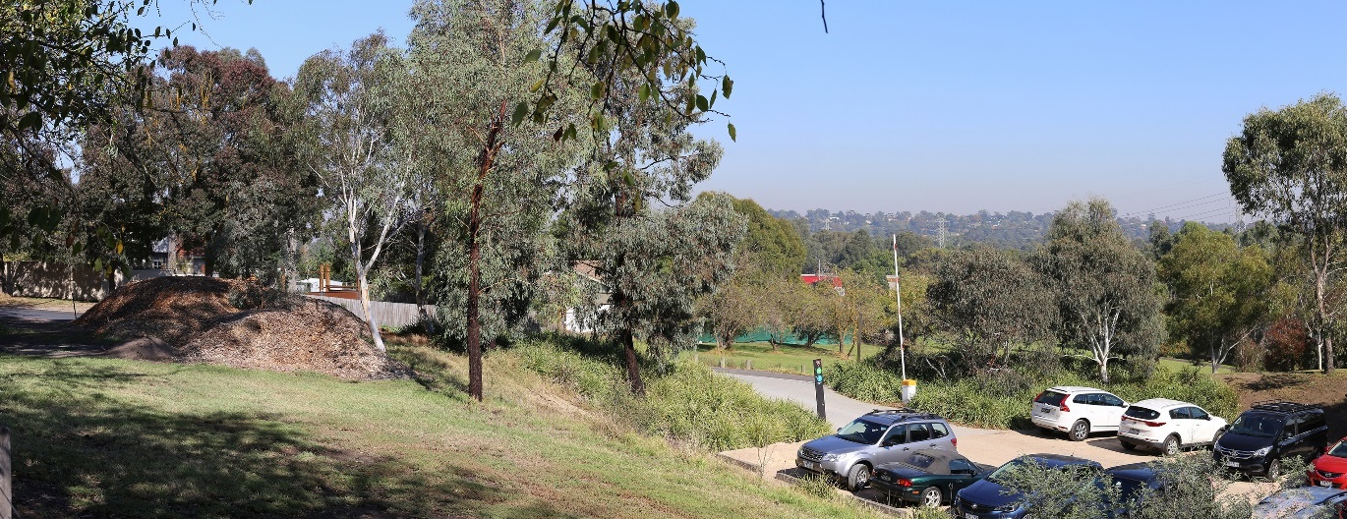
Figure 16-16 Viewpoint 26 - Heide Museum of Modern Art, Bulleen – existing
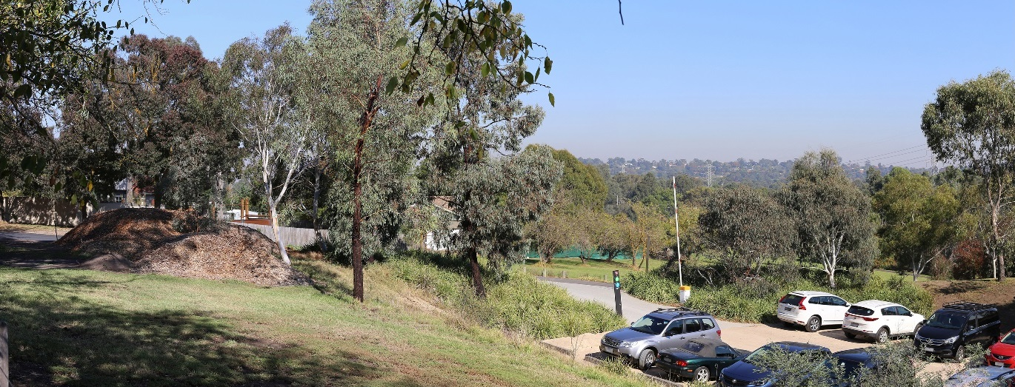
Figure 16-17 Viewpoint 26 - Heide Museum of Modern Art, Bulleen - year 0 - no impact – negligible rating
Figure 16-18 Viewpoint 26 - Heide Museum of Modern Art, Bulleen - year 0 - no impact – negligible rating
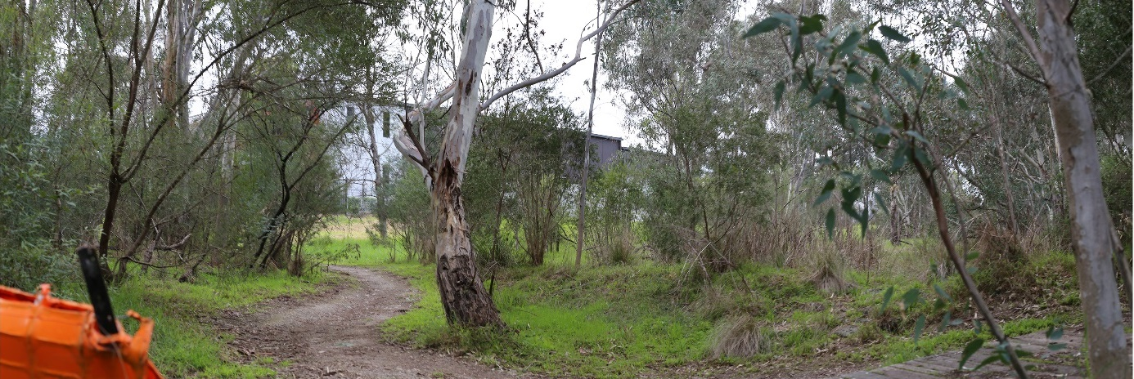
Figure 16-19 Viewpoint 29 - Yarra River, Bulleen – existing
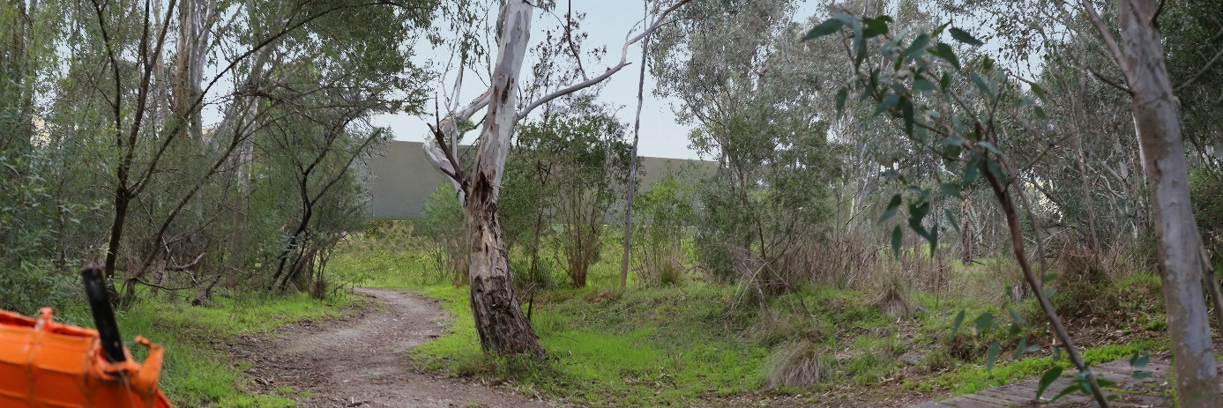
Figure 16-20 Viewpoint 29 - Yarra River, Bulleen - year 0 – flood wall visible – medium rating
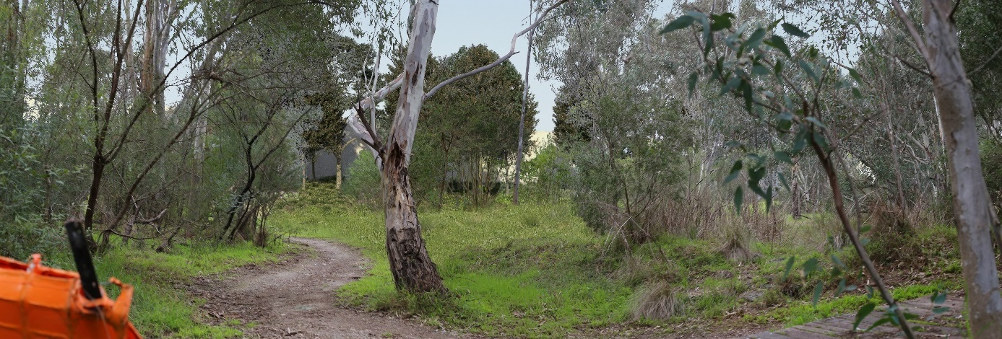
Figure 16-21 Viewpoint 29 - Yarra River, Bulleen - year 10 - vegetation screen – low rating
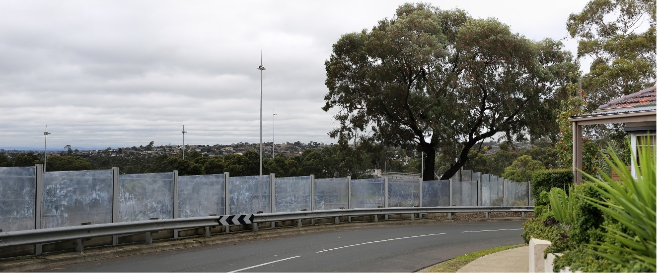
Figure 16-22 Viewpoint 40: Columba Street, Balwyn North - existing
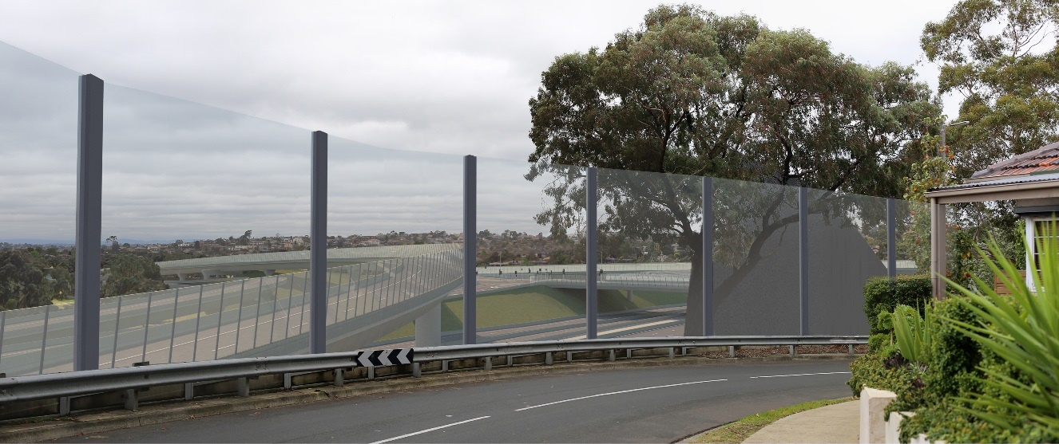
Figure 16-23 Viewpoint 40: Columba Street, Balwyn North - year 0: noise walls and viaducts visible - medium rating
Figure 16-24 Viewpoint 40: Columba Street, Balwyn North - year 10: noise walls and viaducts visible - medium rating

Koonung Creek Valley
The Koonung Creek Valley landscape character area comprises the Eastern Freeway (east of Bulleen Road) section of the project. The existing landscapes within this character area generally have a medium level of sensitivity and the landscape and visual impact ranges from negligible to high. In this landscape character area, the Eastern Freeway has high viewer numbers, the public reserves and Koonung Creek Trail have medium to high viewer numbers, and the residential areas have medium to low viewer numbers.
To assess the landscape and visual impacts in this character area, 23 viewpoints in the public domain were selected. Table 16-7 and Figure 16-25 identify the location of these viewpoints and the proposed change as a result of the project immediately after construction (year 0) and at 10 years after construction (year 10). For further detail on specific visual and landscape impacts on each viewpoint, see Technical report H – Landscape and visual.
Key findings of this assessment were:
- In this character area where noise walls would be new to the view or higher than the existing noise walls, the impact would be greatest. Over time, views to some of the noise walls would be filtered or screened by newly established vegetation where space allows.
- The amount of open space that may be impacted in the Koonung Creek Valley landscape character area varies between construction to operation, but is considered to be significant. This is because the use of some open spaces (such as Elgar Park and Koonung Creek Reserve) would be permanently changed. However, this is not considered to be a significant visual impact as the majority of the open space impacted during construction would be returned for operation. Where open space cannot be returned, vegetation buffers are expected to maintain the visual amenity and landscape character of the area, but the usability of these spaces would be impacted. This is discussed in more detail in Chapter 17 – Social.
- The widening of the Eastern Freeway road corridor would impact the road users with the removal of vegetation, increased lanes and reduced space for landscaping. The Eastern Freeway upgrades would also greatly alter the existing freeway landscape character. Road users would have a low sensitivity to this type of change as they have a transient experience of the landscape and their primary focus is on driving. Although the freeway landscape character would be altered and the road users experience impacted, a key objective for the project is to minimise impacts on communities therefore the widening of the Eastern Freeway has been limited to protect the adjoining public open space which is valued by the community. Although the freeway landscape character would be altered and the road users experience impacted, a key objective for the project is to minimise impacts on communities therefore the widening of the Eastern Freeway has been limited to protect the adjoining public open space which is valued by the community. In addition the project’s Urban Design Strategy outlines detailed requirements which would reduce the landscape and visual impacts on the Eastern Freeway road corridor. For further detail, see Attachment II - Urban Design Strategy.
- The Koonung Creek Valley landscape character area is valued for the linear open space associated with the Koonung Creek and the vegetated appearance of the general character area. The project would be unlikely to have an impact on the landscape value of the Koonung Creek Valley landscape character area as the characteristics it is valued for such as established vegetation and the linear open space would be either retained or enhanced.
Overall, the proximity of new infrastructure and availability of space for landscaping would have the greatest influence on the visual impacts of the Koonung Creek Valley landscape character area.
To inform the impact assessment, photomontages or illustrative sections were prepared for some viewpoints to assess in greater detail the potential landscape and visual impacts at those specific points. Photomontages for three representative viewpoints of the Koonung Creek Valley character area are presented in the next few pages. Further detail, illustrative sections and more photomontages are provided in Technical report H – Landscape and visual.
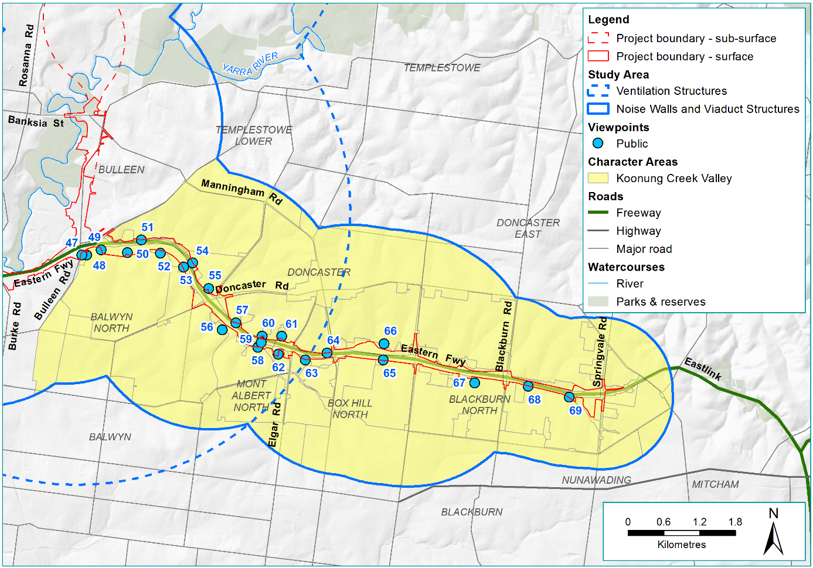
Figure 16-25 Koonung Creek Valley character area and viewpoint map
Table 16-7 Koonung Creek Valley public viewpoint assessment
Viewpoint number and location | Proposed change | Potential impact year 0 | Potential impact year 10
VP47 - Belle Vue Primary School | The existing view looks north towards the Eastern Freeway and consists of established vegetation in the background with a 2 m high timber wall, established vegetation and an open grassed area in front. The proposed noise wall would be located approximately 40 m from the viewpoint in this location. The existing vegetation and timber wall in the foreground would be removed. | High to medium – the existing vegetation would be removed and the proposed 8 m noise wall would be visually dominant, and there would be a change in the landscape. | Low – the landscaping would establish and filter views to the noise wall. The landscape would be similar to the existing.
VP48 - Highview Road, Balwyn North (image included below) | The current view looks north-west towards the Eastern Freeway and consists of established native and exotic trees in the background between the Eastern Freeway and 4 m high concrete noise wall, and Belle Vue Primary School and established native vegetation in the foreground. This viewpoint is located approximately 91 m from the proposed noise wall and approximately 116 m from the proposed shared use path. The existing vegetation directly adjacent to the noise wall would be removed. | Medium to low –the proposed 9 m high noise wall would dominate the view, although the landscape setting would be similar to what is existing. | Medium to low – there would be no change from year 0.
VP49 - Mountain View Road, Balwyn North | The current view looks north-east towards the Eastern Freeway and consists of scattered established native trees and grassed embankment in the background, a 4 m concrete noise wall in the middle ground and a grassed embankment in the foreground. This viewpoint is located approximately 49 m from the proposed shared use path, 53 m from the proposed noise wall and approximately 57 m from the proposed viaduct and viaduct with noise walls. The existing vegetation directly adjacent to the existing noise wall and the Eastern Freeway would be removed. | Medium – the establishing landscape would not screen the proposed 10 m high noise wall and the viaduct with a 4 m noise wall, would be dominant in the view, and the viewer sensitivity would be medium. Some established trees would remain in the foreground and filter views to the proposed noise wall and viaduct. | Low – the growth of existing trees and re-establishment of vegetation would improve the landscape setting and filter views.
VP50 - Koonung Creek Reserve (Larbert Avenue), Balwyn North (image included below) | The current view looks west along the Koonung Creek Reserve, south of the Eastern Freeway and consists of established native trees in the background with an open grassed reserve in the foreground. The proposed noise wall would be located approximately 65 m from the viewpoint with a proposed shared use path in front. The existing vegetation and open space to the north would be removed. | High to medium – the proposed 9 m high noise wall would be visually dominant, there would be significant visual change in the landscape and a loss of open space. | Medium – the landscaping would screen the proposed noise wall and the landscape would be similar to the existing, but there would be a visible loss of open space.
VP51 - Estelle Street, Bulleen (image included below) | The current view looks south-west towards the Eastern Freeway and consists of established native and exotic trees in the background, a 2 m timber noise wall in the middle ground and a grassed embankment, scattered native and exotic trees and shrubs and a shared use path in the foreground. This viewpoint is located approximately 15 m from the proposed noise wall on the north side of the Eastern Freeway. The existing vegetation between the existing shared use path and the Eastern Freeway would be removed and in some areas the noise wall would be directly adjacent to the existing shared use path | High – the new 10 m noise wall would dominate the view, the landscaping would be insignificant and the project would remove the existing open space adjacent to the shared use path. | Medium – landscaping is not possible in many locations between the shared use path and the noise wall. New planting would reduce the visual impact.
VP52 - Koonung Creek Reserve (Carron Street) | The current view looks north towards the Koonung Creek Reserve and consists of dense established native and exotic vegetation, and grassed areas on either side of the existing shared use paths. This viewpoint is located approximately 74 m from the proposed shared use overpass and approximately 145 m from the proposed noise wall abutting the Eastern Freeway. Some of the existing vegetation between this viewpoint and the proposed shared use overpass and noise wall would be removed. | Low – the removal of existing vegetation in the foreground would be minor, views of the 9m high noise wall and shared use overpass would be screened by retained vegetation. | Negligible – the establishment of the landscape would screen the shared use overpass and noise wall, potentially improving the existing view.
VP53 - Koonung Creek Reserve (Wandeen Street Playground) | The current view looks north-east towards the Eastern Freeway and consists of densely vegetated mounding in the background, grassed embankment in the middle ground and a shared use path in the foreground. This viewpoint is located approximately 63 m from the proposed noise wall abutting the Eastern Freeway. | High – the landscape would not have established and the 8 m high noise wall would dominate the view. The viewer numbers would be high and there would be a loss of open space. | Medium – the establishing landscape would partially screen the noise wall, but the open space would not be replaced.
VP54 - Outhwaite Avenue, Doncaster | The current view looks west towards the Eastern Freeway and consists of established native and exotic trees in the background, a 2 m high timber noise wall at the top of an embankment with scattered native and exotic trees and shrubs and a shared use path in the foreground. This viewpoint is located approximately 12 m from the proposed noise wall and 8 m from the proposed shared use path adjacent to the Eastern Freeway. The embankment and existing vegetation between the existing noise wall and Eastern Freeway would be removed | Low – the new 8 m noise wall would dominate the view although the viewer numbers would be low. | Low to negligible – the establishment of the vegetation would filter views.
VP55 - Paul Street, Doncaster | The current view looks south-west towards the Eastern Freeway and consists of established native and exotic trees in the background, a 3 m high timber noise wall at the top of a low vegetated embankment in the middle ground, and a shared use path in the foreground. An electricity substation is located to the north-east of this view and consists of secure fencing, brick buildings and transformers. This viewpoint is located approximately 67 m from the proposed noise wall adjacent to the Eastern Freeway. Established vegetation between the existing noise wall and Eastern Freeway would be removed | Low – the new 8 m noise wall would dominate the view although viewer numbers would be low. | Negligible – the establishment of vegetation between the noise wall and the shared use path would filter views to the wall and potentially improve the view.
VP56 - Sweyn Street, Balwyn North | The current view looks north-east towards the Eastern Freeway and consists of a mix of single and double-storey houses with established native and exotic trees on a ridgeline in the background, acrylic and concrete 7 m high noise walls in the middle ground, and Koonung Creek Trail, a shared use path and single and double-storey houses with established native and exotic trees in the foreground. This viewpoint is located approximately 140 m from the proposed 10 m high noise wall adjacent to the Eastern Freeway. Some established vegetation between the existing noise wall and the shared use path would be removed and Koonung Creek would be enclosed in a culvert at this location. | Low – the new 10 m noise wall would be similar to the existing view and existing vegetation would filter views of the noise wall and viewer numbers would be low. Landscaping is also proposed between this viewpoint and the proposed noise wall. | Negligible – the establishment of vegetation between the noise wall and the shared use path would further screen views of the noise wall and potentially improve the view.
VP57 - Massey Street, Doncaster | The current view looks west towards the Eastern Freeway and consists of the Koonung Creek Trail in the background, a 7.5 m high concrete noise wall in the middle ground and single and double-storey residential properties in the foreground. Dense and established native and exotic vegetation form the view between the noise wall and the shared use path. Some established vegetation would be removed for the project between the existing noise wall and the Eastern Freeway. | Negligible – the view would be similar to the existing view. | Negligible – there would be no change from year 0.
VP58 - Koonung Creek Wetlands, Mont Albert North | The current view looks north-east towards the Eastern Freeway is of a densely vegetated wetland and suspension bridge shared use overpass in the background, densely vegetated wetland in the middle ground and shared use path in the foreground. This viewpoint is located approximately 66 m from the proposed noise wall directly adjacent to the Eastern Freeway and 87 m from the proposed shared use overpass in the background of this view. All existing vegetation between the proposed noise wall and eastern freeway would be removed. | High – the new 9 m noise wall and replacement of the shared use overpass would remove large amounts of existing vegetation. The noise wall and 14 m high shared use overpass would dominate the view. | High – the establishment of the landscaping would filter and partially screen the noise wall and shared use overpass, but these elements would remain visually dominant and there would be reduced open space.
VP59 - Koonung Creek wetlands overpass along the Eastern Freeway, Doncaster | The current view looks east along the Eastern Freeway from the existing pedestrian overpass and consists of established vegetation and 6.5 m high concrete noise walls in the background and the Eastern Freeway road corridor with vegetated embankments in the foreground. The relocated shared use path overpass would be approximately 13 m from the viewpoint and the proposed noise wall would be approximately 35 m from the viewpoint. The existing vegetation would be removed to allow for the widened road corridor. | Low – the proposed 8 m high noise wall and widened road corridor would be visually dominant and there would be a significant change to the landscape. However, the viewers would have a low sensitivity to the proposed visual change. | Low – there is no room for revegetation due to the widening of the road, but the viewers would have a low sensitivity to the visual change.
VP60 - Corner of Stanton Street and Heyington Avenue, Doncaster | The current view looks south towards the Eastern Freeway and consists of dense and established vegetation and residential properties on a steep ridgeline in the background. A shared use overpass which crosses over the Eastern Freeway in the middle ground and connects Stanton Avenue Reserve in the foreground. This viewpoint is located approximately 45 m from the proposed shared use overpass and the barrier would be approximately 3 m high. | Negligible – the view would be similar to the existing view. | Negligible – there would be no change from year 0.
VP61 - Katrina Street Reserve, Doncaster | The current view looks south-west towards the Eastern Freeway and consists of a ridgeline with scattered established trees and residential properties in the background, a grassed reserve sloping down to the south in the middle ground, and a playground, basketball half court and shared use path in the foreground. There are no proposed changed to this viewpoint. | Negligible – the view would be similar to the existing view. | Negligible – there would be no change from year 0.
VP62 - Elgar Park, Mont Albert North | The current view looks north towards the Eastern Freeway from Elgar Park. The view consists of a vegetated embankment with established native trees and shrubs in the background, filtering views to the Eastern Freeway noise walls and residential beyond with a sunken grassed oval in the foreground and scattered established native trees. The proposed noise wall would be located approximately 120 m from the viewpoint. The existing vegetation and open space would be removed to the north of the proposed noise wall and Koonung Creek would be enclosed in a culvert at this location. Existing vegetation in front of the existing shared use path to the south of the noise wall would be retained. | Medium – the proposed 7 m high noise wall would be visually prominent and there would be a loss of open space. However, viewer numbers would be medium. The retained existing vegetation would filter views to the proposed noise wall. | Medium to low – the landscaping would establish and filter views to the proposed 7 m noise wall. The open space would not be replaced.
VP63 - Frank Sedgeman Reserve, Box Hill North | The current view looks north-east towards the Eastern Freeway and consists of dense established vegetation in the background, a noise wall and gravel shared use path separated by dense vegetation in the middle ground, and grassed embankments and Koonung Creek in the foreground. This viewpoint is located approximately 62 m from the proposed noise wall directly adjacent to the Eastern Freeway. All existing vegetation between the proposed noise wall and Eastern Freeway would be removed and some of the vegetation on front of the noise wall. | Medium – the new 5 m noise wall and widened road behind would result in the loss of existing vegetation and open space. The noise wall would dominate the view however viewer numbers would be medium and the existing retained vegetation would filter views to the noise wall. | Low – the establishment of the vegetation would filter views of the noise wall and would be similar to the existing view.
VP64 - Koonung Creek Trail, adjacent to Michael Close | The current view borders the northern edge of the Eastern Freeway looking east. The view consists of established native vegetation in the background with a narrow reserve and shared use path in the foreground. A 3 m high concrete and acrylic noise wall is located to the south of the shared use path and residential houses to the north. The proposed widening of the Eastern Freeway road corridor would see the removal of existing vegetation between the road and the noise wall. | Low to negligible – the removal of vegetation between the existing noise wall and road way would be a minor visual change and the landscape setting would be similar to the existing. | Low to negligible – there would be no change to year 0.
VP65 - Koonung Creek Trail, adjacent to Eram Road, Box Hill North | The current view borders the southern edge of the Eastern Freeway looking east. The view consists of established vegetation in the background with a shared use path in the foreground. A 3 m high concrete noise wall is located to the north of the shared use path and timber residential fence to the south. The proposed noise wall would be approximately 2 m closer to the viewpoint and finish in line with the existing residential side boundary. | Medium – the proposed 8 m high noise wall would be visually dominant, seen by the users of the shared use path and there would be a significant visual change. The viewer numbers in this location would be medium. | Medium – the landscaping would establish but due to limited space, this would only partially screen the noise wall.
VP66 - Koonung Creek Linear Park, Doncaster | The current view looks south towards the Eastern Freeway and consists of established vegetation and houses in the background, a 3.5 m high concrete noise wall in the middle ground and open space with overhead power lines, established vegetation and shared use path in the foreground. The proposed noise wall would be approximately 27 m closer to the viewpoint and only extend into part of the view. The Eastern Freeway road corridor would be widened, and the existing noise wall and adjacent vegetation would be removed. | Medium – the proposed 4 m high noise wall and Eastern Freeway road corridor would be visually prominent and there would be significant visual change in the landscape. There would be a loss of open space and viewer numbers would be medium. | Low – the landscaping would screen the proposed noise wall and freeway and the landscape setting would be similar to the existing, but the open space would not be replaced.
VP67 - Middlefield Drive and Koonung Road, Blackburn North | The current view looks north towards the Eastern Freeway and consists of established trees in the background (covering a 4 m high noise wall 120 m away from the viewpoint) and a residential street with established street trees and densely vegetated private gardens in the foreground. The proposed noise wall would be approximately 5 m closer compared to the current noise wall and some existing vegetation would be removed. | Low – the proposed 8 m noise wall would be visually dominant and there would be a visual change in the landscape. However, viewer numbers would be low. | Negligible – the landscaping would screen the noise wall and the landscape setting would be similar to the existing.
VP68 - Slater Avenue, Blackburn North | The current view looks north towards the Eastern Freeway and consists of a 5 m high concrete noise wall in the background with established native trees and shared use path in the foreground. The proposed widening of the eastern freeway road corridor would result in the removal of vegetation between the existing noise wall and the Eastern Freeway. | Negligible – the vegetation loss between the existing noise wall and the Eastern Freeway would be minor and the landscape setting would be similar to the existing as the existing noise wall would be retained. | Negligible – there would be no change from year 0.
VP69 - Eastern Freeway Linear Reserve, Nunawading | The current view looks north-west towards the Eastern Freeway and consists of a low noise wall in the background with established native vegetation bordering a gravel shared use path in the foreground. The proposed widening of the Eastern Freeway road corridor would result in the removal of vegetation behind the existing noise wall. | Negligible – the existing vegetation behind the noise wall would be removed and the landscape setting would be similar to the existing. | Negligible – there would be no change from year 0.

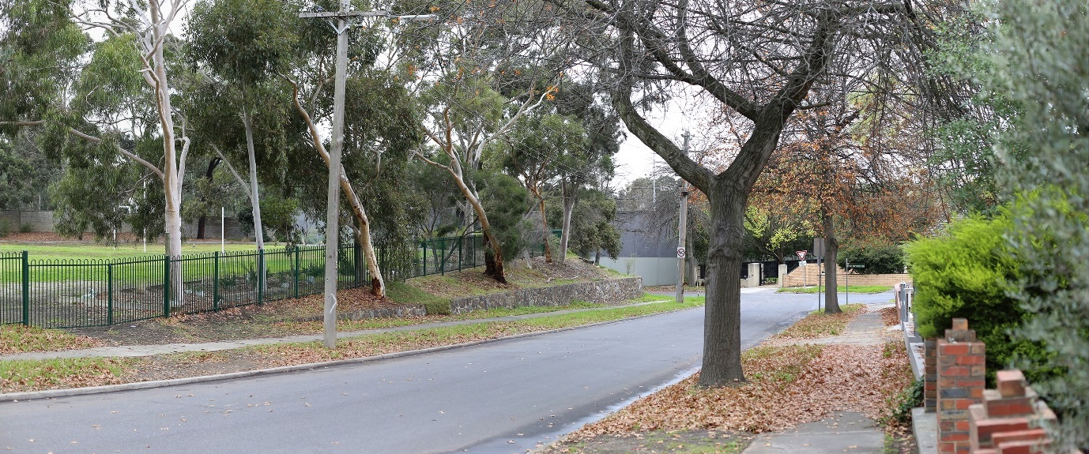
Figure 16-26 Viewpoint 48 - Highview Road, Balwyn North - existing
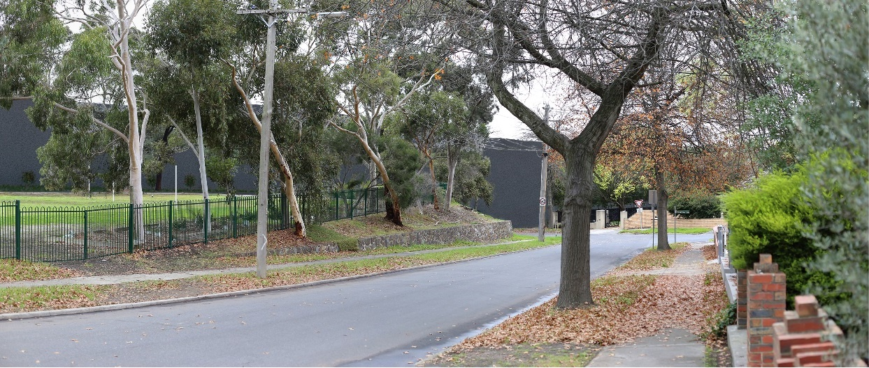
Figure 16-27 Viewpoint 48 – Highview Road, Balwyn North – year 0 – noise wall visible – medium to low rating
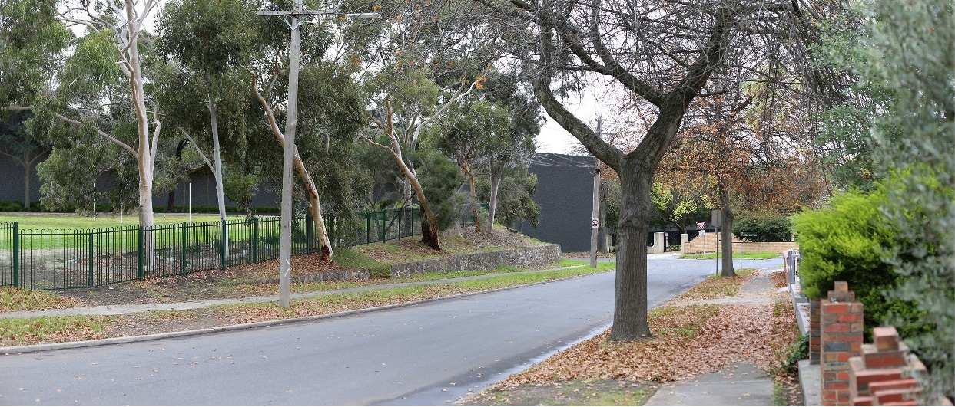
Figure 16-28 Viewpoint 48 - Highview Road, Balwyn North - year 10 – noise wall screened by vegetation – medium to low rating
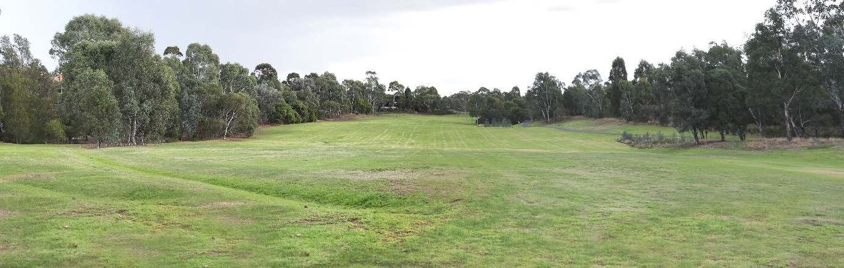
Figure 16-29 Viewpoint 50 - Koonung Creek Reserve, Balwyn North - existing
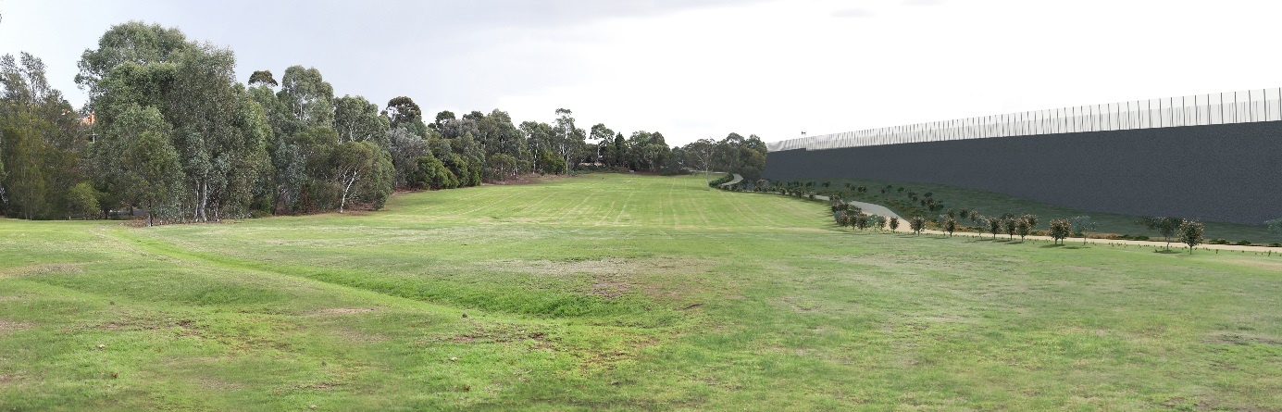
Figure 16-30 Viewpoint 50 - Koonung Creek Reserve, Balwyn North - year 0 - noise wall visible – high to medium rating
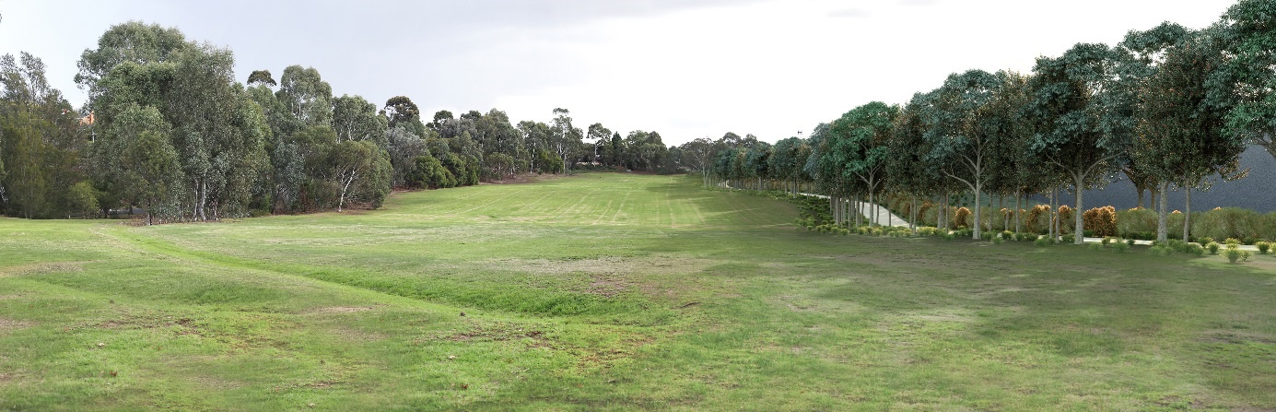
Figure 16-31 Viewpoint 50 - Koonung Creek Reserve, Balwyn North - year 10 - vegetation screen – medium rating
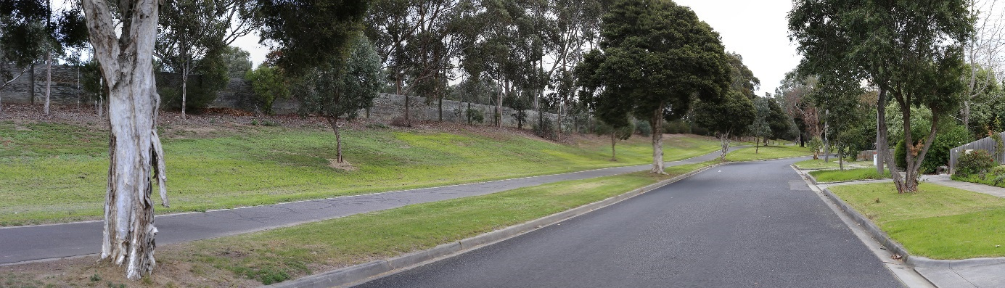
Figure 16-32 Viewpoint 51 - Estelle Street, Bulleen - existing
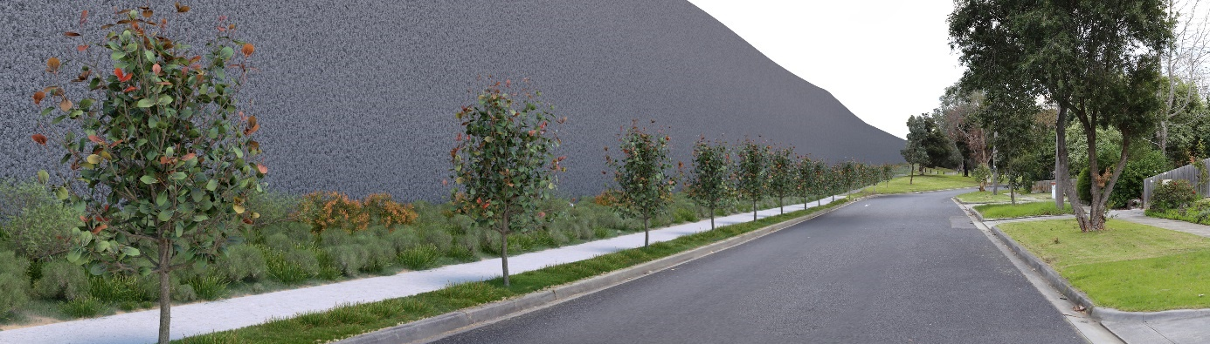
Figure 16-33 Viewpoint 51 - Estelle Street, Bulleen - year 0 – noise wall visible - high rating
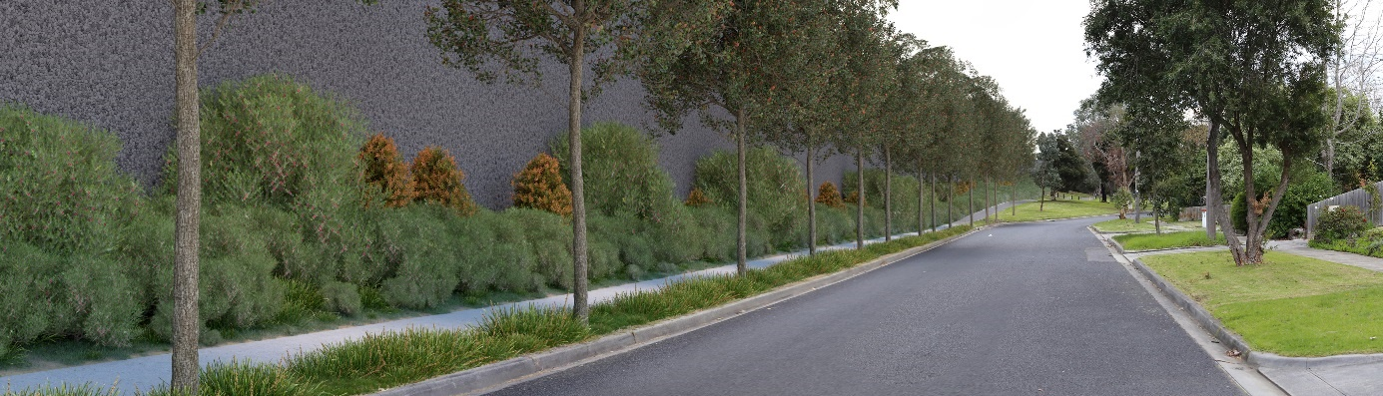
Figure 16-34 Viewpoint 51 - Estelle Street, Bulleen - year 10 – noise wall visible - high rating

Environmental Performance Requirements
Any future landscape and visual impacts would be further reduced through the implementation of the landscape and visual EPRs. EPR LV1 requires the design of permanent works to avoid or minimise landscape, visual and shading impacts, to the extent practicable.
This would need to be generally in accordance with the Urban Design Strategy which requires materials and colour palettes to be coordinated, with consideration to form, texture, colour and high quality finishes. Structures would also be required to be well designed, complement the surrounding area, and consider sensitive interfaces.

Landscape and visual impacts: private viewpoints
New or additional project infrastructure can cause changes to the views experienced from private domain.
The risk pathway associated with these impacts is summarised in Table 16-8.
Table 16-8 Risk table – operation impacts to private viewpoints
Risk ID | Risk pathway | Risk rating
Risk LV06 | Elevated road structures, road infrastructure, noise walls, throw screens, viaducts, pedestrian bridges, vegetation loss, ventilation structures and open cut causes adverse impacts to views experienced from within the private domain. | Planned  (severe consequence)
The potential impacts associated with the risk pathway above were informed by the assessment of a number of key viewpoints. To assess the landscape and visual impacts to private viewpoints, 12 viewpoints within the private domain have been selected to represent views of the project from residential properties. It should be noted that opportunities to access private viewpoints were limited.
Key findings of this assessment were:
- In locations where new infrastructure would be located directly adjacent to the property, the landscape and visual impacts would be medium to high. This is due to the close proximity of the views to the new elements and the limited space for landscaping. This includes residences along sections of the Eastern Freeway and the M80 Ring Road where properties that are already close to noise walls may lose mature vegetation between their back fence and the road. High-quality noise walls and over time, new landscape vegetation would be introduced, but there would still be a significant change in views for some residences.
- In locations where new infrastructure would be located some distance from the viewpoint and where there is space available for landscaping, the impacts would be low to positive. This is evident in residences in side streets off Greensborough Road where existing vegetation and topography screens the views to ventilation structures and noise walls.
Overall, the proximity of new infrastructure and availability of space for landscaping would have the greatest influence on the visual impacts at private properties. For further detail on the viewpoints assessed, see descriptions in Table 16-9 and mapped locations in Figure 16-35. The key impacts associated with each viewpoint have been highlighted in the table, noting that vegetation removal impacts are not directly highlighted unless they are the only impact.
To inform the impact assessment, photomontages were prepared for some private viewpoints to aid the assessment of potential landscape and visual impacts. Photomontages are presented in the next few pages. Further detail and more photomontages are provided in Technical report H – Landscape and visual.
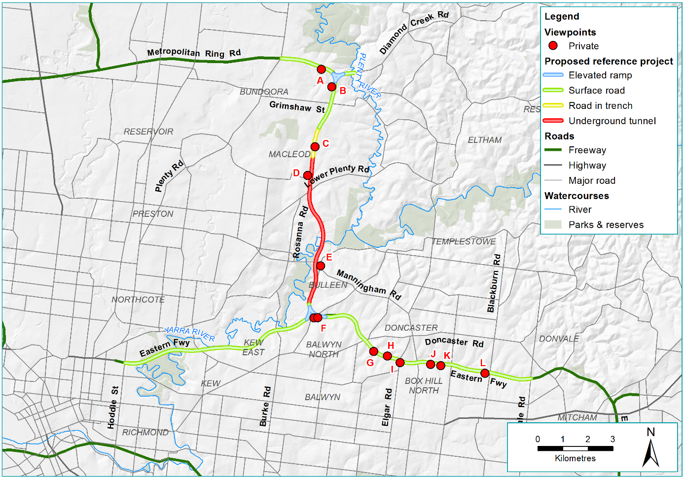
Figure 16-35 Private domain viewpoints
Table 16-9 Private domain viewpoint locations
Viewpoint No. and location | Proposed change | Potential impact year 0 | Potential impact year 3 | Potential impact year 10
VPA – Macorna Street Watsonia North | The current view looks north-east towards the M80 Ring Road and consists of established native trees on the embankment in the background (between property fence lines and the M80 Ring Road), with a wire fence line on the property boundary. The proposed noise wall would be located approximately 15 m from the viewpoint and the proposed shared use overpass would be 10 m. The existing vegetation and embankment would be removed. The existing chain mesh fence would be removed and replaced with a new timber fence. | High – the proposed 7 m noise wall and shared use overpass would be visually dominant and there would be a significant visual change. | High – the landscaping would still be establishing and the proposed 7 m noise wall and shared use overpass would remain visually dominant. | High to medium – the landscaping would partially screen views of the 7 m noise wall.
VPB – Sellars Street Watsonia North (included images below) | The current view looks north-east towards the Greensborough Bypass and consists of dense established native vegetation in the background, open grassed reserve in the middle ground and neighbouring residential roofs and native established trees in the foreground. The proposed noise wall would be located approximately 40 m from the viewpoint and the proposed shared use overpass would be 35 m. The existing vegetation in the grassed reserve would be removed and the reserve would be significantly reduced in size. | High – the proposed 10 m high noise wall and shared use overpass would be visually dominant and there would be a significant visual change in the landscape. | High to medium – the landscaping would be establishing and begin to screen the shared use overpass and noise wall, but they would remain dominant elements in the view. | Medium – the landscaping would partially screen the noise wall and shared use overpass.
VPC – Watson Street Macleod (included images below) | The current view looks north-west towards Greensborough Road and consists of established vegetation and roof in the background, timber residential fence in the middle ground with a large deciduous tree and picket fence and shed in the foreground. The proposed anti-throw screen would be located approximately 40 m from the viewpoint. The existing rear boundary fence would screen views to the proposed anti-throw screen. | Medium to low – the proposed 4 m anti-throw screen would replace the existing built form and vegetation, and there would be a visual change in the landscape, although the existing rear boundary fence would screen views to the proposed noise wall. | Low to negligible – the landscaping would begin to screen anti-throw screen. | Negligible to positive – the landscaping would screen the anti-throw screen and the landscape setting possibly improved.
VPD – Baptcare Strathalan, Upper Boronia Crescent, Macleod | The current view looks north-east towards Greensborough Road and consists of dense established native trees in the background and of single storey residential buildings with some exotic vegetation in the foreground. The proposed noise wall with a widened road corridor behind would be 95 m away. | Negligible – the existing vegetation and built form would filter views of the proposed 3 m noise wall and the landscape setting would be similar to the existing. | Negligible – there would be no change from year 0. | Negligible – there would be no change from year 0.
VPE – Bulleen Road, Bulleen (included images below) | The current view looks south-west towards the intersection of Manningham Road and Bulleen Road. The view consists of low rise commercial and light industrial buildings in the background, with a road intersection and power lines in the middle ground, and a brick property fence in the foreground. There are some native street trees and exotic landscaping within the property boundary. This viewpoint is located approximately 210 m from the proposed emergency smoke duct. All built form and existing vegetation within the commercial and light industrial activity centre would be removed. The existing vegetation within the residential property would filter views to the proposed emergency smoke duct. | Low – the built form would be removed and there would be views to the emergency smoke duct, there would be a significant change to the landscape. However, as the existing landscape sensitivity is rated as low due to it being highly modified, this impact is rated low. | Low – there would be no change from year 0. | Low – there would be no change from year 0.
VPF – Mountain View Road, Balwyn North | The current view looks north towards the Eastern Freeway and consists of a low timber fence to the front of the property with local road, shared use path and existing noise wall behind. Vegetation partially screens the existing concrete noise wall. The existing noise wall in this location is approximately 4 m high and existing vegetation with the road corridor is visible above the top of the noise wall. The proposed noise wall would be 5 m closer to the viewpoint in this location with a shared use path in front and a proposed viaduct with viaduct noise wall behind. The existing noise wall, path and vegetation would be removed. Landscaping would be between the path and existing road surface. | High – the proposed 10 m high noise wall and proposed 4 m high viaduct noise wall would be visually dominant and the existing vegetation would be removed. | High to medium – the proposed landscaping would partially filter views to the noise wall and viaduct behind which would continue to dominate the view. | High to medium – the proposed landscaping would only partially screen some sections of the proposed noise wall, which would be significantly higher and closer than the existing.
VPG – Jocelyn Avenue, Balwyn North | The current view looks north-east towards the Eastern Freeway and consists of the existing acrylic noise wall, with established vegetation and a timber fence in front. The existing noise wall in this location is approximately 7.2 m high. The proposed noise wall in this location would be approximately 14 m closer to the viewpoint. Some of the existing vegetation would be removed. | High – the proposed 10 m high noise wall would be visually dominant and some of the existing vegetation would be removed, opening up views. | High – the proposed landscaping would partially screen the proposed noise wall. | High – the landscape would screen the noise wall and the landscape setting would be similar to the existing.
VPH – Stanton Street, Doncaster | The current view looks south towards the Eastern Freeway and consists of a concrete noise wall with suspension bridge in the background and back garden with open grassed area and vegetation partially screening the existing 7 m high noise wall. The existing noise wall in this location would be retained. The existing suspension bridge behind would be removed. As a result of the project the view would be towards part of the proposed bridge visible above the top of the existing noise wall. | Low – the existing noise wall would be retained, the suspension bridge in the background would be replaced with a new bridge which would be partially visible above the top of the existing noise wall. | Low –there would be no change from year 0. | Low –there would be no change from year 0.
VPI – Presbyterian Theological College, Elgar Road, Box Hill North | The current view looks north towards the Eastern Freeway and consists of dense vegetation and a 3 to 4 m high concrete noise wall in the background with a low timber fence, car park and established trees and shrubs in the foreground. This viewpoint is located approximately 63 m from the existing noise wall. The proposed noise wall would be approximately 11 m closer to the viewpoint. Some of the existing vegetation behind the low timber fence would be removed. | High – the proposed 8 m high noise wall would be visually dominant and the existing vegetation removed. | Medium – the landscaping would establish and partially screen the lower half of the proposed noise wall. | Low to negligible – the landscaping would screen the noise wall and the landscape setting would be similar to the existing.
VPJ – Lyndhurst Crescent, Box Hill North | The current view looks north-east towards the Eastern Freeway and consists of established vegetation in the background. There are glimpsed views through the vegetation of the existing concrete noise wall. The property has a fence with a gate leading to the existing shared use path. The existing noise wall is approximately 5 m high. The existing noise wall would be retained to the west and the existing noise wall to the east would be replaced by a proposed 8 m high noise wall in the same location. Some of the existing vegetation would be removed for the construction of the proposed shared use overpass. The proposed shared use overpass would be located to the north-east of the rear of the property. The existing retained vegetation adjacent to the property boundary would filter views to the proposed shared use overpass and noise walls. | Medium to low – the removal of vegetation would open up views to the noise wall and the proposed shared use overpass, although the existing vegetation retained adjacent to the property boundary would filter views to the noise walls and shared use overpass. | Low to negligible – the landscaping would establish and screen the existing noise wall and proposed shared use overpass. | Low to negligible – the landscaping would establish and screen the existing noise wall and proposed shared use overpass.
VPK – Eram Road, Box Hill North | The current view looks north towards the Eastern Freeway and consists of established vegetation to the rear of the property adjacent to the shared use path. There are views through the vegetation to the existing concrete 3.5 m high noise wall. The proposed noise wall would be approximately 2 m closer to the viewpoint. The existing vegetation would be removed. A noise wall would run along the south side of the shared use path adjacent to the back fence of the residential properties. | High – the proposed 8 m high noise wall would be visually dominant and there would be significant visual change. | High – there would be no change from year 0. | High –there would be no change from year 0.
VPL – Douglas Street, Blackburn North | The current view looks north towards the existing concrete noise wall on the southern edge of the Eastern Freeway, with established vegetation behind and a timber fence with creepers in front. A shared use path and established vegetation are located between the back fence and the 4 m high noise wall. The proposed noise wall in this location would be approximately 3 m closer to the viewpoint. Some of the existing vegetation would be removed. | High – the proposed 8 m noise wall would be visually dominant and some of the existing vegetation removed, opening up views to the noise wall. | Medium – the proposed landscaping would partially screen the proposed noise wall. | Low to negligible – the landscaping would screen the noise wall and the landscape setting would be similar to the existing.

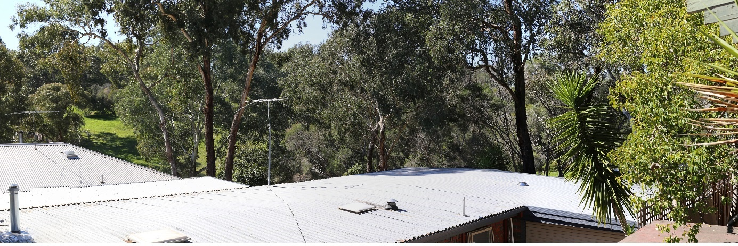
Figure 16-36 Viewpoint B - Sellars Street, Watsonia North – existing
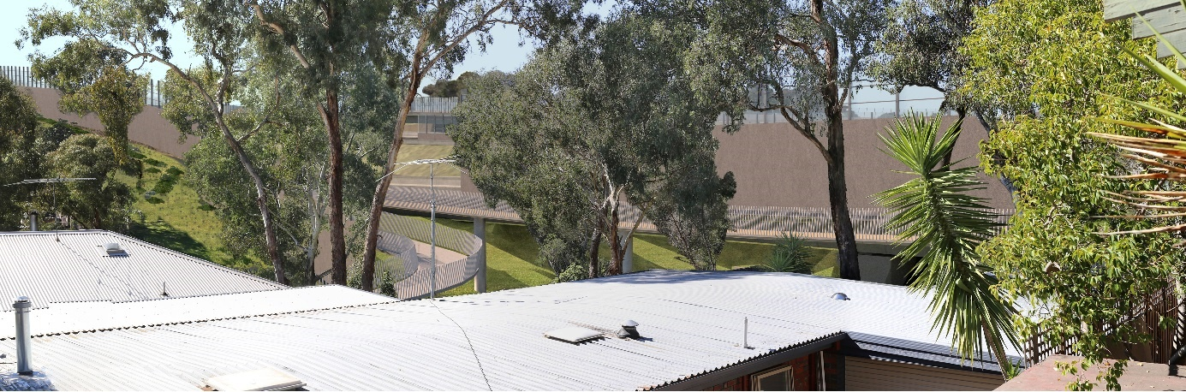
Figure 16-37 Viewpoint B - Sellars Street, Watsonia North – year 0 - views to noise wall - high rating
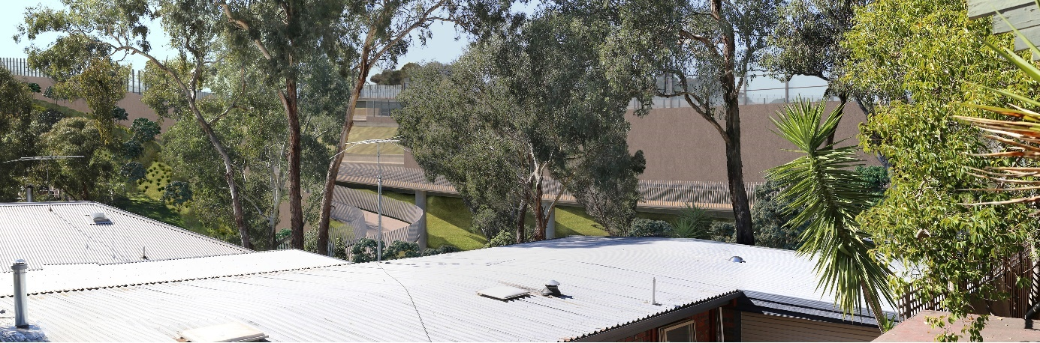
Figure 16-38 Viewpoint B - Sellars Street, Watsonia North - year 3 - views to shared use path screened – high to medium rating
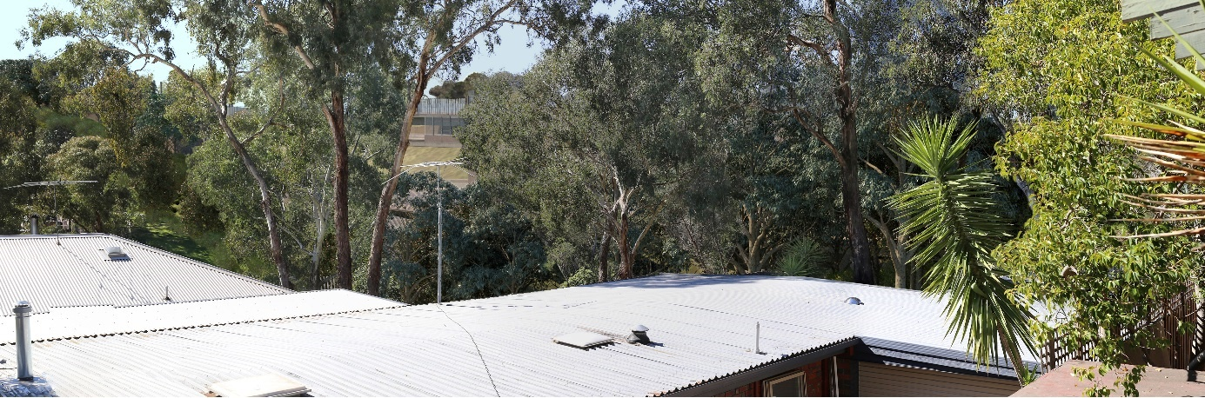
Figure 16-39 Viewpoint B - Sellars Street, Watsonia North – year 10 – views to shared use path and noise wall partially screened by landscaping - medium rating
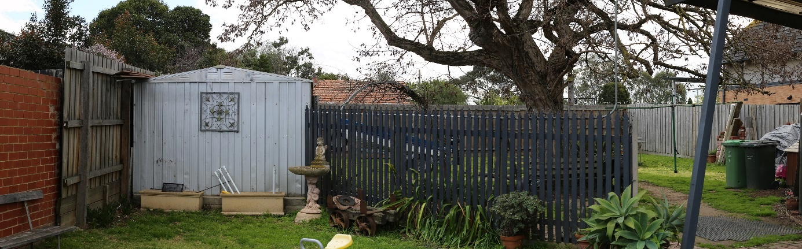
Figure 16-40 Viewpoint C - Watson Street, Macleod – existing
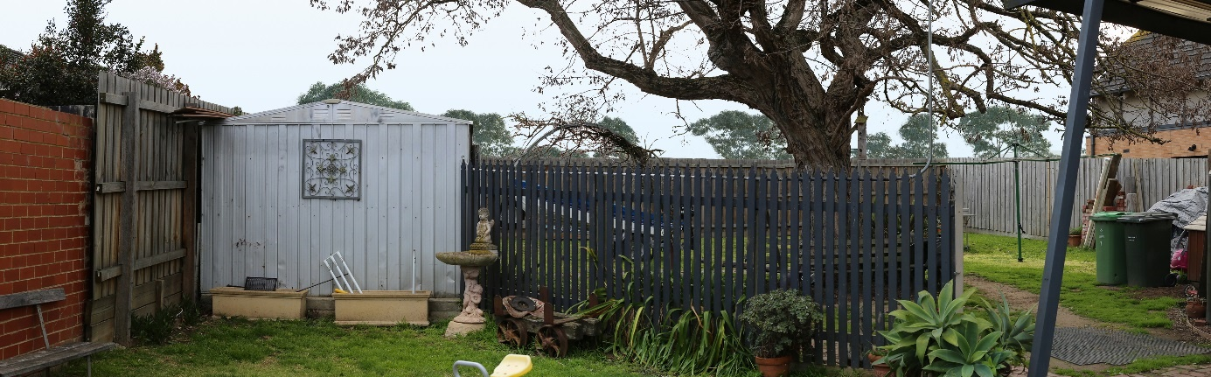
Figure 16-41 Viewpoint C - Watson Street, Macleod - year 0 - vegetation removal - medium to low rating
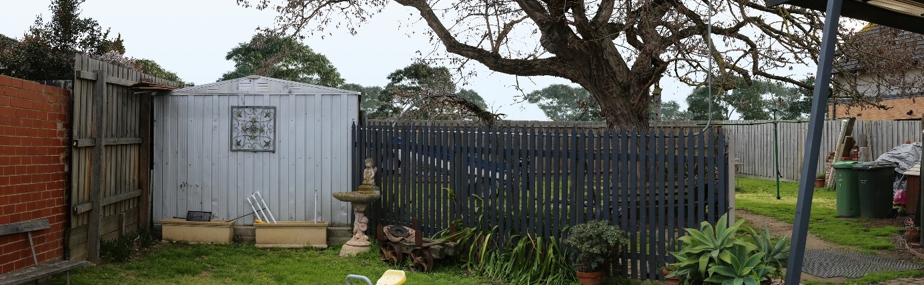
Figure 16-42 Viewpoint C - Watson Street, Macleod - year 3 - some vegetation regrowth and screening – low to negligible rating
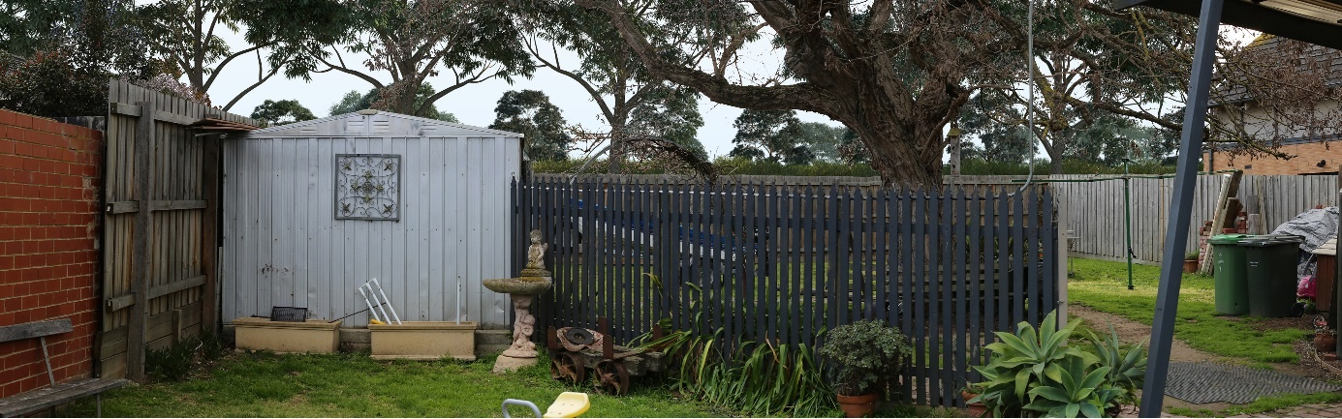
Figure 16-43 Viewpoint C - Watson Street, Macleod - year 10 - screening and improvement due to landscaping - negligible to positive rating
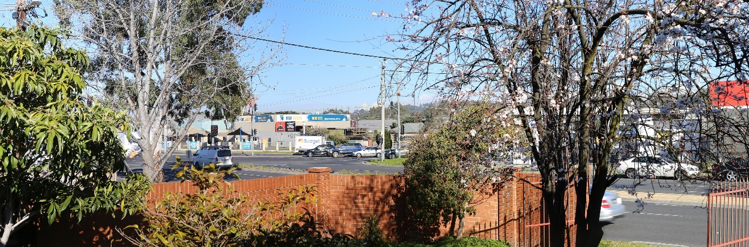
Figure 16-44 Viewpoint E - Bulleen Road, Bulleen – existing
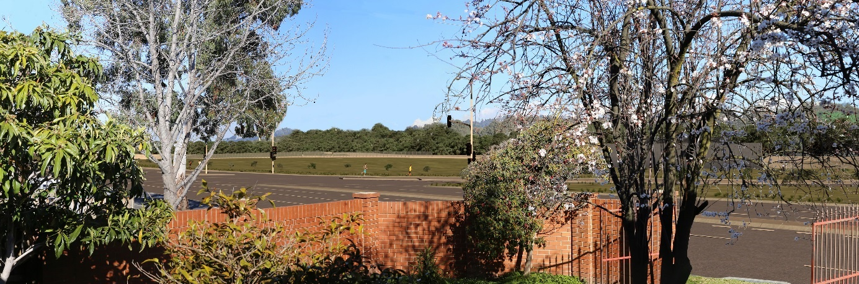
Figure 16-45 Viewpoint E - Bulleen Road, Bulleen - year 0 - views to emergency smoke duct - low rating
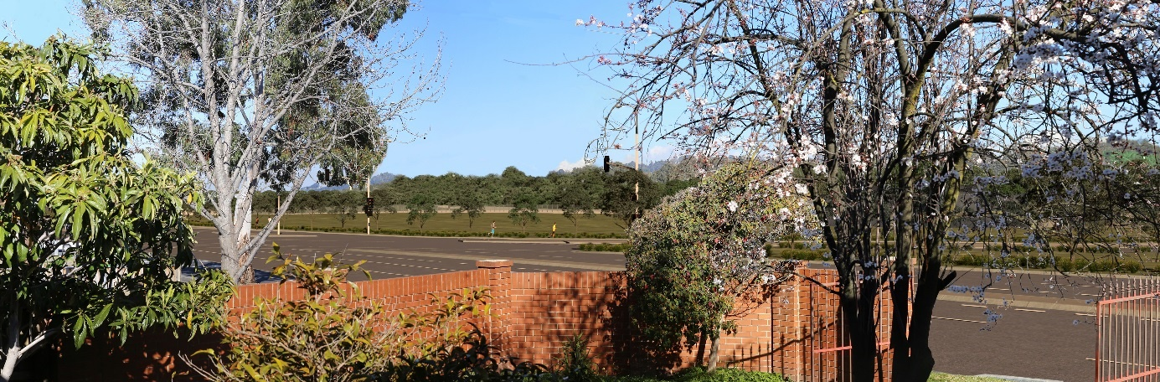
Figure 16-46 Viewpoint E - Bulleen Road, Bulleen - year 3 - views to ventilation structure – low rating
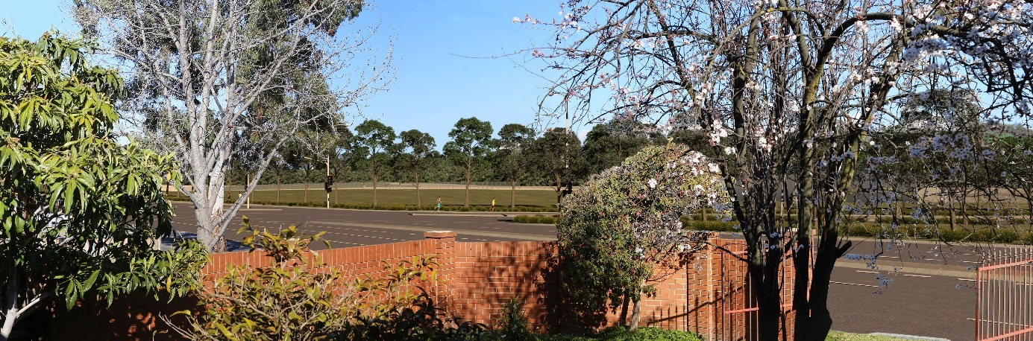
Figure 16-47 Viewpoint E - Bulleen Road, Bulleen - year 10 - views to emergency smoke duct partially screened - low rating

Environmental Performance Requirements
Any future landscape and visual impacts to private viewpoints would be reduced through the implementation of the landscape and visual EPRs. EPR LV1 requires the design of permanent works to avoid or minimise landscape, visual and shading impacts, to the extent practicable.
This would need to be generally in accordance with the Urban Design Strategy which requires materials and colour palettes to be coordinated, with consideration to form, texture, colour and high quality finishes. Structures would also be required to be well designed, complement the surrounding area, and consider sensitive interfaces.

Overshadowing
Project infrastructure can cause overshadowing which adversely impacts on people and places.
The risk pathway associated with these impacts is summarised in Table 16-10.
Table 16-10 Risk table - operation - overshadowing
Risk ID | Risk pathway | Risk rating
Risk LV04 | Shading caused by elevated structures and noise walls causes adverse impacts to residences, open space users, schools and other sensitive receptors. | Planned  (severe consequence)

The potential impacts associated with this risk pathway above have been considered for both the public and private domain, where there may be different impacts based on the sensitivity of the area.
For further detail on shading impacts, see Section 9 of Technical report H – Landscape and visual where impacts have been assessed where applicable on a viewpoint by viewpoint basis.

Public domain
The impact of overshadowing on the public domain varies across the project area according to context. For example, public parkland that retains significant areas of unshaded space but also has an increased area of shading may well provide users with choices as to where they sit or how they enjoy that open space. If increased shading is a result of planted vegetation designed to screen views to the noise walls, the increase in shading may be considered a positive outcome.
Areas within the public domain that have the potential for increased overshadowing include the Koonung Creek Wetlands reserve to the south of the Eastern Freeway, due to the increased height and proximity of the noise walls. For further detail on overshadowing impacts see Chapter 13 – Land use planning and Technical report E – Land use planning, where shading impacts have been identified where relevant for each viewpoint.

Private domain
The impact of overshadowing on residential viewpoints depends upon the extent and type of overshadowing. For example, it could be associated with project infrastructure such as noise walls or from vegetation.
Many residential properties abutting the Eastern Freeway are screened from the road by planted vegetation. This vegetation provides a pleasant outlook for residential courtyards and private open space. As a result, overshadowing from this vegetation may be perceived as a positive outcome. However, if the increased overshadowing is a result of noise walls, this would exacerbate a negative visual outcome.
Overshadowing is expected to occur in locations where noise walls and elevated structures would be constructed close to existing dwellings and directly abutting private open space. Areas within the private domain that have the potential for increased shading impacts would include residential properties south-west of the M80 Ring Road interchange and along the Greensborough Bypass and south of the Eastern Freeway, due to the increased height and proximity of noise walls. For further detail on overshadowing impacts on residential properties see Chapter 13 – Land use planning and Technical report E – Land use planning.

Environmental Performance Requirements
To mitigate potential visual impacts due to overshadowing from noise walls and elevated structures would be required to be minimised (EPR LP4). There are a number of ways the extent of overshadowing may be reduced through the design of the project, such as changing the location of the structures causing the overshadowing, reducing their height, or selecting materials to allow light through to areas of open space and solar panels.
The design would also need to be generally in accordance with the Urban Design Strategy (EPR LV1). This requires the design of permanent works to avoid or minimise landscape, visual and shading impacts, to the extent practicable. While it is noted that overshadowing does have the potential to affect the light availability required for vegetation growth, species selection during the project’s detailed design could mitigate the impact through the implementation of EPR LV1.

Light spill
Changes to the landscape due to permanent lighting infrastructure can cause adverse visual impacts.
The risk pathway associated with impacts to views within the private domain are summarised in Table 16-11.
Table 16-11 Risk table – operation – light spill
Risk ID | Risk pathway | Risk rating
Risk LV05 | Lighting infrastructure causing adverse impacts to views and increased light spill experienced from residential properties. | Planned  (severe consequence)
There is currently no lighting design for the project, however locations have been identified for future assessment where medium to high light spill impacts may potentially occur.
Locations containing new above ground infrastructure adjacent to residential properties or public areas have been identified for future assessment where an increase in street lighting is expected to be required for the project. Lighting design for major roads is quite sophisticated, with the systems designed to illuminate the road without spilling light unnecessarily into adjacent areas. As required by EPR LV4, locations containing new above ground infrastructure would need to be assessed against relevant standards including AS 4282-1997 Control of the obtrusive effects of outdoor lighting.

Environmental Performance Requirements
Any future impact would be reduced via implementation of EPR LV3 Lighting (construction) and EPR LV4 Lighting (operation). EPR LV3 would mitigate any residual impacts during the project’s construction by minimising light spill. EPR LV4 would mitigate light spill impacts during operation through the requirement to adhere to the AS 4282-1997 Control of the obtrusive effects of outdoor lighting and in accordance with the relevant standards.

Conclusion
This chapter has identified and assessed existing conditions, potential impacts and associated risks to landscape and visual amenity from North East Link.
Key findings of the assessment include:
- In locations where new infrastructure would be located in close proximity to properties, the impact during the project’s operation would be significant (medium to high). This is because there would be insufficient space for landscaping or vegetation to screen and filter the views towards the project. However, in locations where new infrastructure would be located at a distance from the viewpoint and where there is space available for landscaping, the impacts would be far less significant.
- Landscape and visual impacts would generally be similar during the project’s construction to its operation at year 0, but temporary construction fencing would be located around the works and be visually impermeable. The visual impact within the Ridgeline and Koonung Creek landscape character areas would be rated as medium to high, and Yarra River Valley as medium during construction due to the number of adjacent residences with temporary views towards the construction activity, particularly along the Eastern Freeway. However, these impacts would be temporary (up to seven years) in duration and intensity.
Where there are any further impacts on the landscape and visual environment, landscape treatments and the design response would be required to comply with the EPRs (described in full in Chapter 27 - Environmental management framework) and in accordance with the project’s Urban Design Strategy, which has focused on impacts identified in the LVIA. The EPRs include EPR LV1 which requires the design to be generally in guided by the Urban Design Strategy and EPR LV2, which requires the project to minimise landscape impacts during construction. These require the project to avoid or minimise landscape and visual impacts, overlooking and shading impacts in duration and intensity, and to maximise opportunities for enhancement of public amenity, open space and facilities and heritage places.
To address lighting impacts, EPR LV3 would mitigate any residual impacts during the project’s construction by minimising light spill during construction, and EPR LV4 would mitigate light spill impacts during its operation.
Based on the EES evaluation objective described at the beginning of this chapter, effects of the project and associated shading and light spill on public and private viewpoints have been assessed and EPRs identified to minimise or avoid impacts to the landscape and visual environment.

