Ground Movement and Land Stability

Overview
This chapter provides an assessment of the ground movement and land stability impacts of Melbourne Metro. The chapter is based on the impact assessment presented in Technical Appendix P Ground Movement and Land Stability. All relevant references are provided in Technical Appendix P.
Ground movement is an expected outcome on any tunnelling project. The draft EES evaluation objective to avoid or minimise adverse effects on land stability that might arise directly or indirectly from project works can be achieved practically through implementing engineering solutions that would minimise ground movements. Such solutions include:
- Adoption of suitable excavation equipment and construction methodologies that limit the potential for unacceptable ground movement
- Where required, improvement of the ground mass surrounding excavations to minimise ground movement and/or groundwater inflows to the Melbourne Metro works.
The extent of ground movement that could arise as a consequence of Melbourne Metro, and the resulting level of impact, would be determined by the complex interaction of a number of factors, including (but not limited to) the geological and hydrogeological conditions encountered along the route, the depth and alignment of the tunnels and associated structures, the construction methods adopted and the condition of buildings and infrastructure situated along the alignment.
Predominantly, the tunnels alignment is located within favourable geological units for ground stability, while meeting the key requirement to achieve safe design gradients for rail operations. However, as in any tunnelling project of this scale, there is the potential for ground movements to occur where excavations would be undertaken as part of Melbourne Metro works.
Ground movements may occur above and adjacent to Melbourne Metro works due to the following mechanisms:
- Underground excavation-induced ground movement
- Open cut excavation-induced ground movement
- Primary consolidation settlement of soft soils, primarily Coode Island Silt
- Slope instability.
Movements may occur in isolation or as a result of a combination of these mechanisms. Chapter 13 Noise and Vibration addresses the noise and vibration risks associated with the project.
Generally, Melbourne Metro underground excavations would be for tunnels, cross passages and station caverns. Open cut excavations would be for station boxes, portal structures and shafts.
Primary consolidation settlement may occur in softer soils due to groundwater drawdown (as a secondary effect of groundwater flowing into Melbourne Metro excavations) or the construction of new embankments (such as at the western portal). The zones of soft soil that are susceptible to consolidation settlement do not necessarily overlie the project alignment; rather, they are located within the potential influence zones of groundwater drawdown resulting from groundwater inflow into Melbourne Metro excavations. Once excavations are tanked (sealed), groundwater levels start recovering and the risk of primary consolidation settlement occurrence reduces substantially. However, the time for groundwater levels to recover may overlap with the project’s operational phase, meaning that consolidation settlement trigged during construction could continue into the operational phase.
Ground movement related to slope instability could occur where existing batters, such as those present at the eastern portal cutting, are altered or new retaining structures constructed as the existing rail lines are reconfigured to accommodate the Melbourne Metro tunnel entrance and realigned surface railway tracks.
Buildings, utilities and civil infrastructure – such as roads, tram lines, rail lines, bridges and pipes – would potentially be subjected to the effects of ground movement caused by excavation activities.
The extent of ground movement that might occur varies along the Melbourne Metro alignment. Factors that would influence the magnitude of ground movements and surface deformation profile include site-specific geological conditions, the depth of excavations, the excavation methods used and the type of ground support adopted.
Excavation-induced ground movements would only occur during the construction phase, but primary consolidation settlement could commence in the construction phase and continue into the operational phase for a number of years, as outlined above.
Ground movement impacts have been assessed against evaluation criteria established for buildings, infrastructure and utilities. These criteria are preliminary only and further discussion would be required with the respective asset owners and operators to determine appropriate acceptability criteria for various buildings and civil infrastructure.
The Potential Zone of Influence relating to ground movement has been defined by the estimated 5 mm excavation-induced ground surface settlement contours, together with areas potentially subject to primary consolidation settlement greater than 10 mm. The Potential Zones of Influence across the Melbourne Metro alignment are shown in Figure ‎19-1 to Figure ‎19-5.
Prior experience demonstrates that tunnelling projects have negligible impacts on structures outside these parameters. Structures and underground services within these parameters have been considered in the ground movement impact assessment conducted for the EES.
The ground movement assessment identified the possible mechanisms leading to ground movement, estimated the settlements that could occur and predicted the category of potential damage. The ground movement impact assessment reviewed the possible degree of damage to buildings and infrastructure that could be caused by the excavations associated with Melbourne Metro, taking into consideration the structure type, the current condition of the structure and the differential settlement across the structure.
Melbourne Metro’s construction would be undertaken in a manner that would minimise any damage to structures and assets as a result of ground movement. This would be achieved by applying well-tested engineering practices, including designing the tunnel and underground structures to limit ground movement to within appropriate acceptability criteria, adopting the proposed or equivalent construction methodologies and excavation support systems, and applying appropriate controls during TBM operation.
Other potential mitigation measures could include reducing tram and train operating speeds where settlement may potentially affect particular sections of the rail or tram networks during construction activities.
The recommended Environmental Performance Requirements specify the implementation of a ground movement plan for the construction and operation phases of Melbourne Metro. This plan would require consultation with landowners, utilities and other stakeholders to:
- Identify acceptable ground movement criteria for buildings, structures, trams, trains and pavement
- Identify specific mitigation measures to ensure these criteria are met
- Identify techniques for limiting settlement of buildings and protecting buildings from damage
- Identify additional measures to be adopted if acceptability criteria are not met (such as reinstatement of any property damage).
Detailed condition surveys of potentially affected structures would be conducted prior to construction commencing. These surveys would confirm that predicted ground movements would be acceptable or identify the need for further mitigation measures to ensure there would be no impacts worse than minor. A detailed database of pre-construction information would be maintained for each potentially affected structure.
In addition, real time monitoring programs would be implemented from the onset of construction to confirm the impact assessment and manage and document the implementation of any mitigation measures.
The impact assessment has indicated that, following the adoption of appropriate mitigation measures to meet the recommended Environmental Performance Requirements, which specify the outcome to be achieved, the potential for damage to property (including existing buildings, approved developments, civil infrastructure and utilities) from the construction and operation of Melbourne Metro would be negligible to minor, and within acceptable limits.

EES Objective
The EES Scoping Requirements set the following draft evaluation objective for the EES:
- Land stability – To avoid or minimise adverse effects on land stability that might arise directly or indirectly from project works.
A ground movement impact assessment was conducted to assess the potential impacts to categories of buildings and infrastructure. It did not deal with the specific impacts of settlement on individual structures, utilities and civil infrastructure. Detailed condition surveys of potentially affected structures would be conducted prior to construction commencing and the results reported in a database of as-built and pre-construction information.
The potential impacts of detailed design, construction schemes and construction methodology would be assessed further (using refined structural and geotechnical models) to confirm the consistency of assessment outputs with the preliminary assessments conducted to date.
However, the impact assessment conducted for the EES provides an assessment of the extent of likely impacts along the Melbourne Metro alignment and recommends Environmental Performance Requirements to ensure that any adverse effects on land stability are controlled within acceptable limits.

Legislation and Policy
There are no specific Commonwealth or Victorian laws and policies directly relating to ground movement. However, some laws and policies that apply to groundwater (including those relevant to dewatering and recharging through bores) are applicable to the assessment and mitigation of ground movement. These applicable laws and policies are outlined in Appendix P and include:
- Environment Protection Act 1970
- State Environment Protection Policy (Waters of Victoria)
- State Environment Protection Policy (Groundwaters of Victoria)
- EPA Guidelines for Major Construction Sites (Publication 480)
- Water Act 1989
- Water Industry Regulations 2006.
In addition, the objectives of the Planning and Environment Act 1987 require planning authorities to consider the environmental, economic and social effects of a proposed planning scheme amendment (including in respect of ground movement).
Additional legislation may be applicable to heritage structures.

Background

Geological Setting
Predominantly, the project alignment would traverse bedded and folded sedimentary rock, the Melbourne Formation, which forms the rock beneath much of Melbourne. The tunnels would be located within Melbourne Formation generally between the Arden station precinct and the Yarra River crossing. Layered soils of varying composition and consistency, interbedded with tongues of basalt, are encountered from the Maribyrnong River to the Moonee Ponds Creek valleys (western portal to Arden station precincts), as well as at the Yarra River crossing. A layer of generally very stiff sedimentary soil is found overlying the Melbourne Formation generally from Kings Domain to the eastern portal, and the tunnel passes through these materials along this eastern section of the project.
A Geological Context Summary Report is appended to Technical Appendix P.
It should be noted that ongoing and future geotechnical investigations undertaken for Melbourne Metro could result in refinement or alteration of the conceptual geological models produced in the EES.

Ground Movement Mechanisms
Predicted ground movements have been assessed to determine whether Melbourne Metro would potentially expose existing buildings and structures or existing underground assets to adverse impacts as a result of the following ground movement mechanisms:
- Underground excavation-induced ground movement – Underground excavations generally include the tunnels, cross passages and mined station caverns. Ground deformation around any underground void could propagate to surface level as ground is removed and support is installed. This surface expression is in the shape of a trough or wide ‘dish’, with sides that may be steep enough to induce tension in a surface structure such as a building
- Open cut excavation-induced ground movement – Vertical ground movement may occur as a result of the lateral deflection of retaining walls at the shafts, station boxes, decline structures and cut and cover tunnel sections
- Primary consolidation settlement – Consolidation settlement may occur in softer soils due to groundwater drawdown or new embankment loading in soft soils. Drawdown describes the lowering of the water table that may occur due to drainage or groundwater extraction. The zones along the alignment that are of particular interest in relation to potential consolidation settlement are:
  - Western portal up to and including Arden station
  - Yarra River crossing to Alexandra Gardens
  - South Melbourne areas in the Potential Zone of Influence of Domain station
The Potential Zones of Interest do not necessarily overlie the project alignment but are located within the Potential Zones of Influence of groundwater drawdown resulting from inflow to Melbourne Metro excavations.
However, it should be noted that as all structures would be tanked once completed, groundwater drawdown during Melbourne Metro’s operation phase would be insignificant. Consequently, primary consolidation settlement associated with this drawdown would be negligible.
- Slope instability – The existing rail cutting batters at the eastern portal would be extended or widened as the existing rails are reconfigured to accommodate the Melbourne Metro decline structure and realigned surface railway tracks. Retaining walls or soil reinforcement systems would be required at various locations to maintain batter stability.
Extension of the existing embankment at the western portal to accommodate the rail tie-in would require some excavation and alteration of the existing embankment. Temporary support or reinforcing systems would be required to maintain stability where excavations would be undertaken in the existing embankment.
Generally, ground movements from these mechanisms have been estimated separately. However, where the influences of these mechanisms overlap, the results have been combined when assessing their effects. Effects due to underground excavation-induced movement and lateral deflection of retaining walls have been combined where these structures interact, such as where a station entrance shaft is adjacent to a station cavern. Effects due to consolidation settlement have been combined and assessed with underground and open cut excavation movement on a site by site basis.
Ongoing ground movements that are not expected to be exacerbated by the proposed Melbourne Metro works include:
- Secondary compression – This type of settlement occurs both as a natural process as a result of to the consolidation which occurs due to the self-weight of the soil, as well as due to historical activities such as fill placement. This settlement is not expected to be exacerbated by Melbourne Metro activities or other environmental effects of Melbourne Metro
- Seasonal movements – Seasonal ground movement magnitudes vary according to geology type, groundwater level and soil moisture variations, temperature and the thickness, construction type and function of existing pavements. Similarly, existing structures may experience ongoing seasonal movements in response to seasonal ground movements as well as to other structure movements that might be attributed to natural foundation settlement, thermal effects and/or shrinkage.

Buildings, Infrastructure and Utilities
The Melbourne Metro alignment would pass beneath and adjacent to many different buildings, structures and utilities. While it is unlikely that any of these structures have been subject to the effects of large diameter tunnels (aside from those in the vicinity of the City Loop tunnels and possibly, some of the sewer mains), many would have already experienced some form of ground movement generated by other sources, such as previous adjacent excavations.
The manner in which a building or other structure responds to differences in ground movements depends upon its size, design and materials. A modern steel or reinforced concrete structure can be flexible, deflecting as the ground moves. In contrast, a masonry building, subject to similar displacements, could behave as a brittle structure and respond by cracking. The interaction between a structure and ground movement is also influenced by the foundation type. Deep foundations might support a structure from outside the zone of movement, isolating the structure from the adjacent surface level changes.
In the absence of structural or building-specific preliminary condition assessments, the impact assessments to date assumed that the current structural condition and serviceability of buildings and structures are sound. As noted in Section ‎19.2, further settlement assessments of all potentially affected structures, utilities and civil infrastructure would be undertaken during detailed design prior to construction.

Methodology
This section outlines the methodology adopted for the assessment of ground movement and the potential impacts on buildings and civil infrastructure above and adjacent to the Melbourne Metro works.
Detailed descriptions of the technical work undertaken to develop these assessments is provided in Technical Appendix P.

Study Area
The ground movement study area includes the western portal and eastern portal precincts, the full extent of the Melbourne Metro tunnels and the five station precincts.
As potential ground movements generated by changes in groundwater levels are determined in this assessment, a wider study area than the immediate vicinity of the tunnels, stations and portals was considered. The assessment of the primary consolidation settlement impacts is based on the groundwater assessments in Technical Appendix O Groundwater.
The vertical extent of the study area is based on the vertical alignment of the tunnels: up to 40 m below ground level.

Assessment Inputs
The ground movement impacts assessment involved two principal components:
- Estimation of ground movements and Potential Zone of Influence, as described in Section ‎19.5.3
- Identification of the position of buildings, structures and underground services within the Potential Zone of Influence and assessment of potential impacts of Melbourne Metro on a representative sample of existing structures in varying ground conditions as described in Section ‎19.5.4.

Potential Zone of Influence
Excavation-induced settlement (underground and open cut) at surface level is the result of settlement caused by the ground movement mechanisms summarised in Section ‎19.4.2 that has propagated from the actual excavation depths.
The Potential Zone of Influence relating to ground movement has been defined by:
- The 5 mm excavation-induced ground surface settlement contours
- The 10 mm consolidation settlement contours.
Experience from tunnelling projects over past decades has shown that structures subjected to smaller settlements than these have negligible or no effects from the movements.
Buildings, structures and underground services located between the contours defined above are considered within the Potential Zone of Influence.

Figure ‎19-1 Potential Zone of Influence relating to ground movement, Sheet 1 of 5
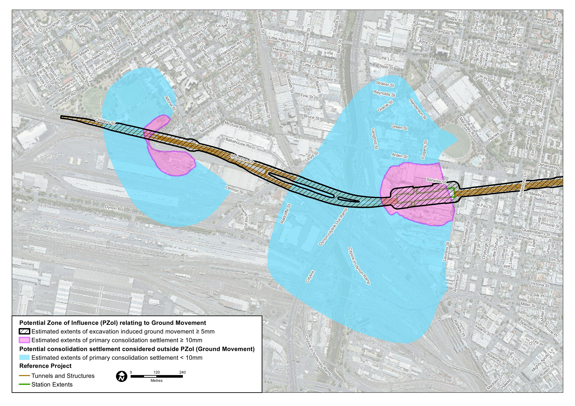
Figure ‎19-2 Potential Zone of Influence relating to ground movement, Sheet 2 of 5
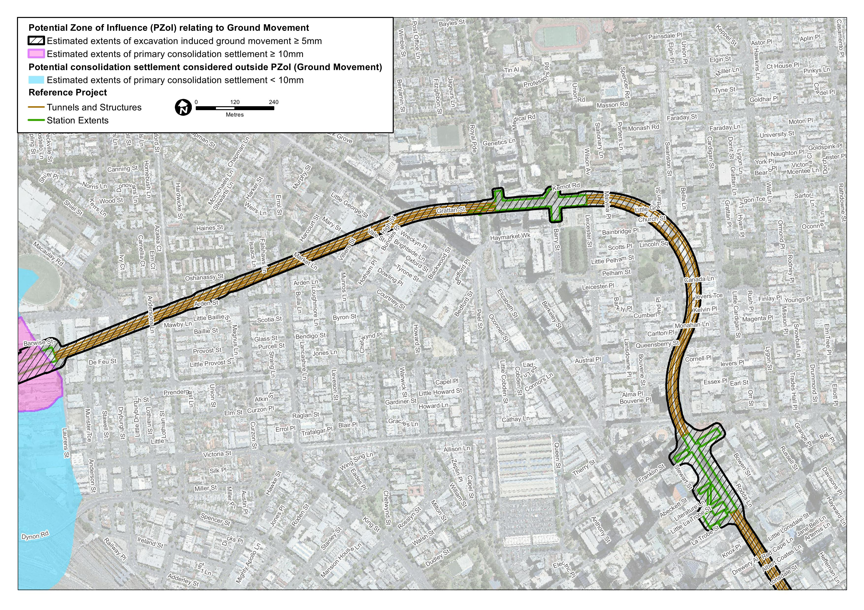
Figure ‎19-3 Potential Zone of Influence relating to ground movement, Sheet 3 of 5
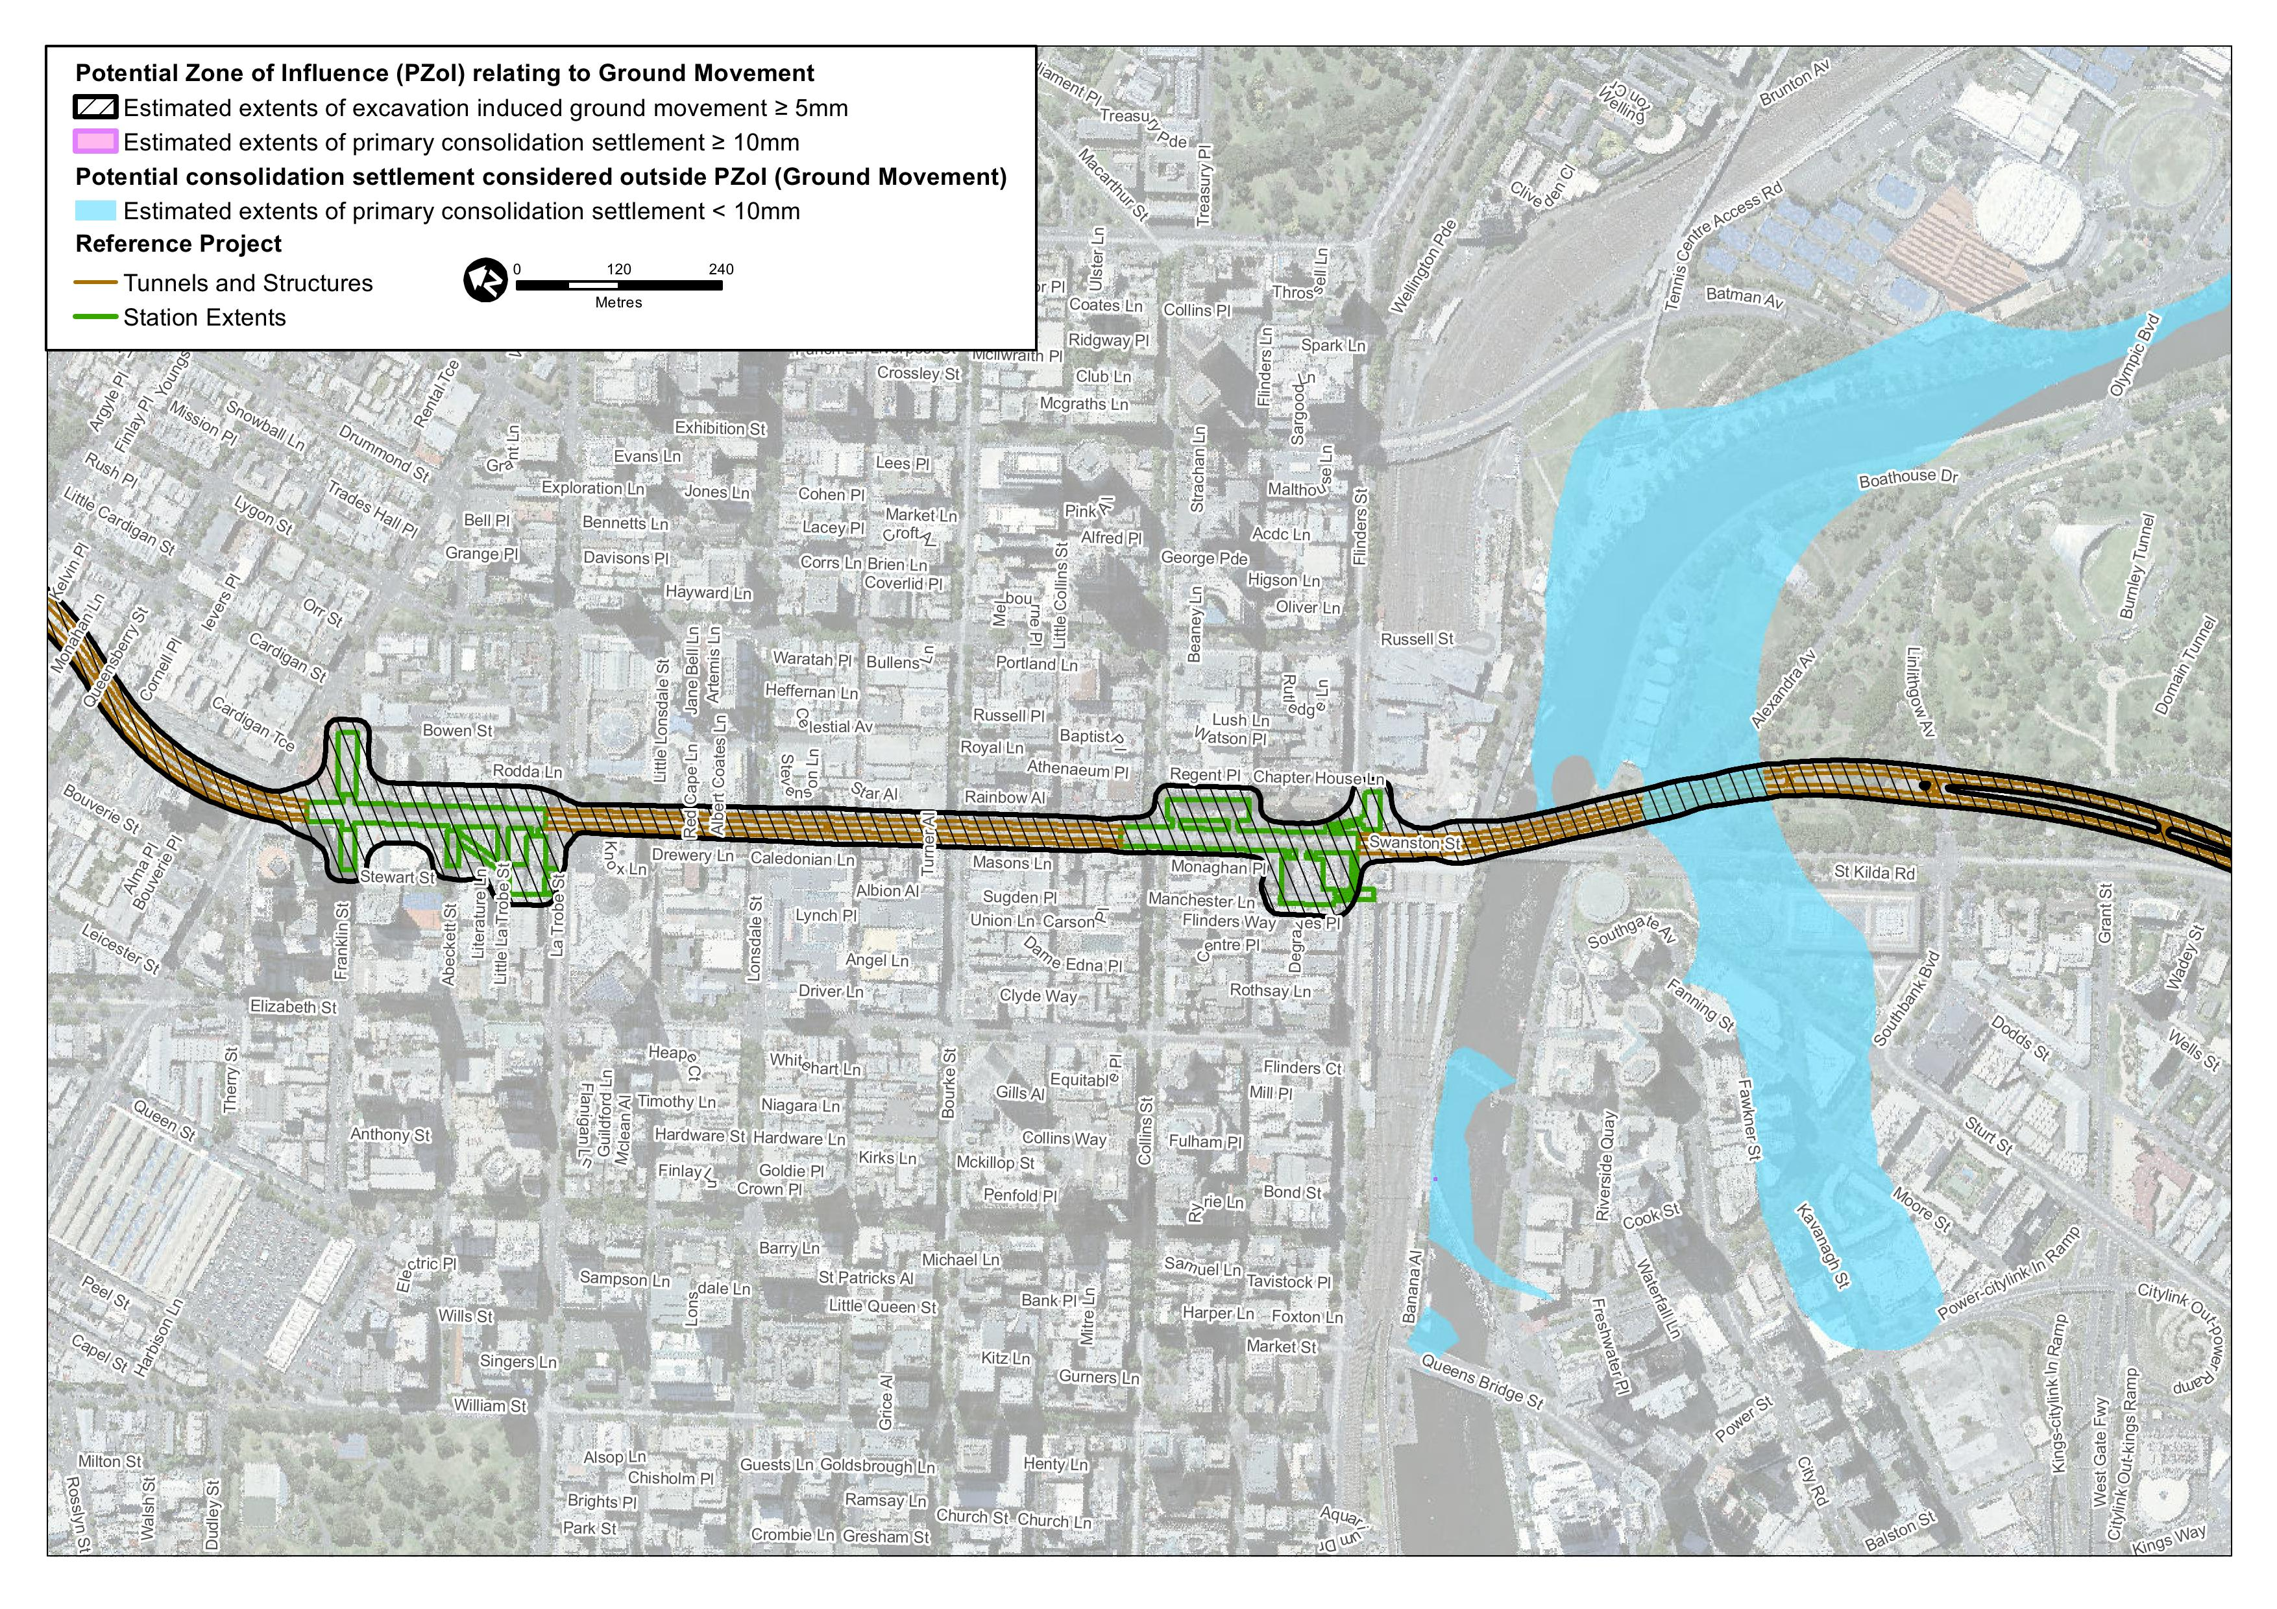
Figure ‎19-4 Potential Zone of Influence relating to ground movement, Sheet 4 of 5
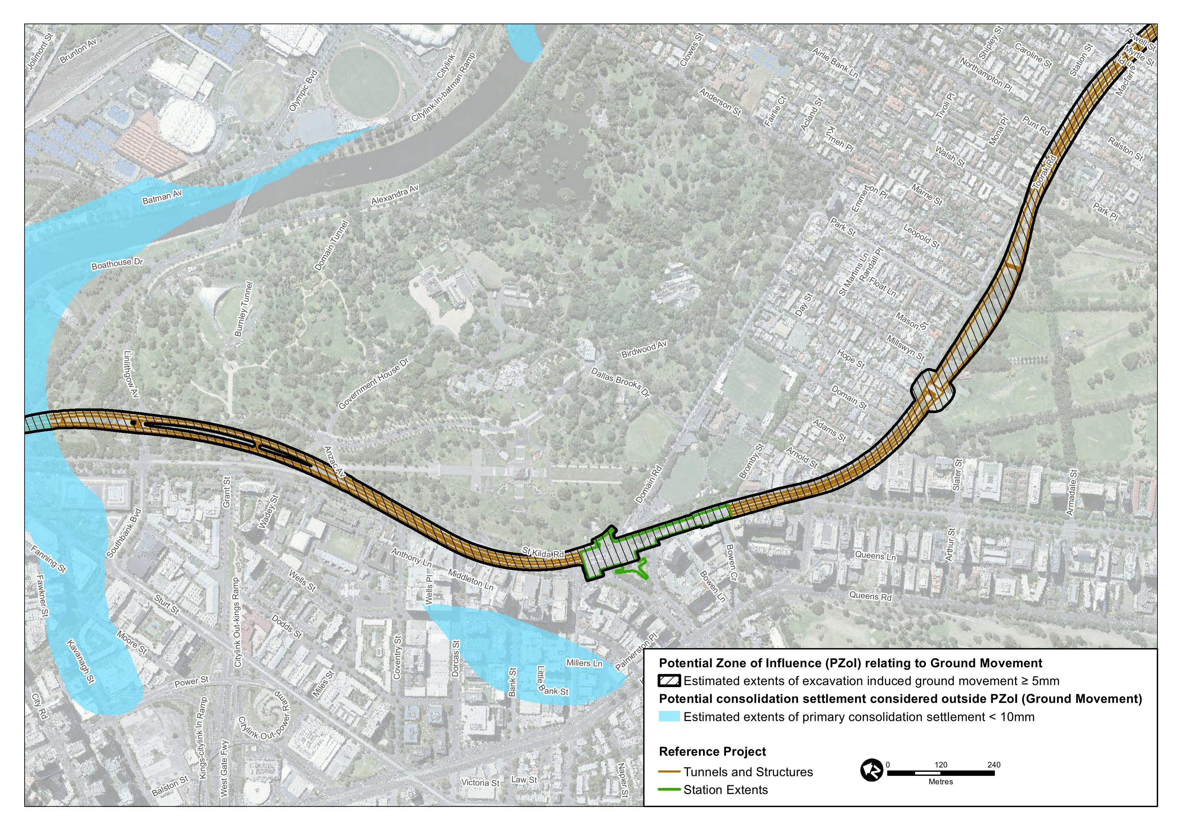
Figure ‎19-5 Potential Zone of Influence relating to ground movement, Sheet 5 of 5
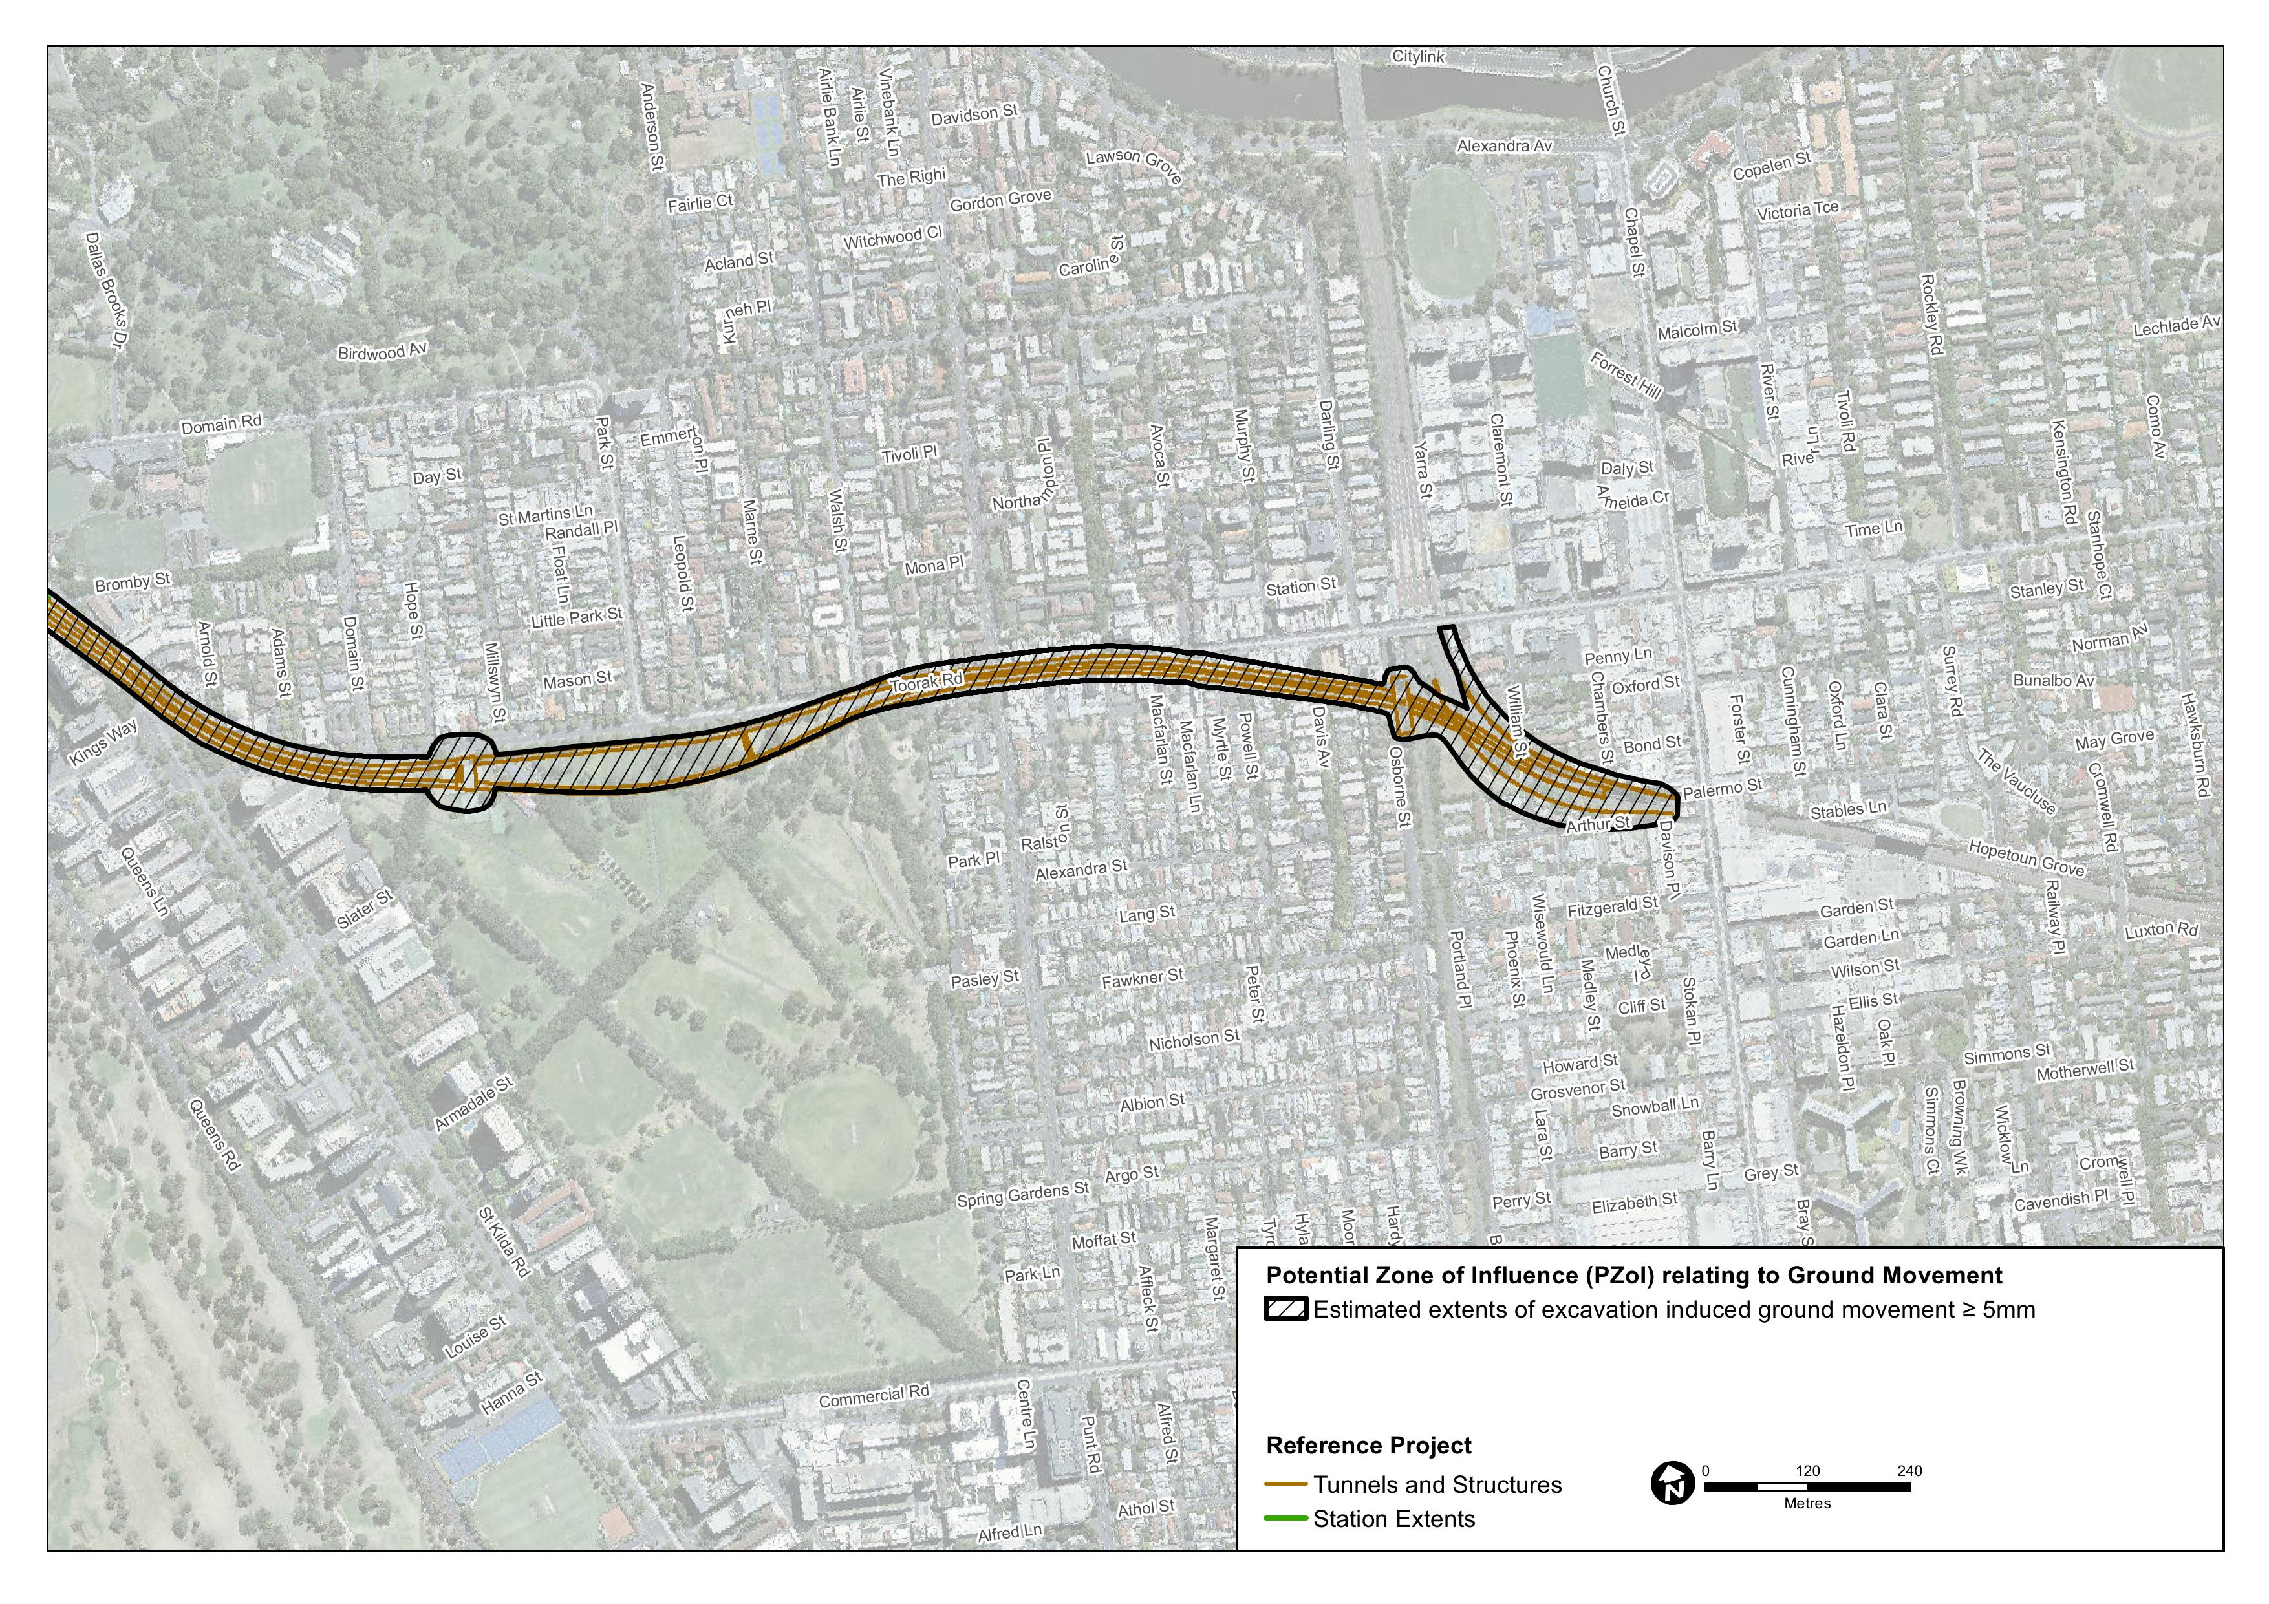

Levels of Assessment

Level 1 Assessment
A Level 1 Assessment is the process of identifying existing structures and civil infrastructure that are within the Potential Zone of Influence relating to ground movement. The influence of existing building foundations, existing structures or existing underground openings do not form part of the Level 1 or Level 2 assessment.

Level 2 Assessment
In a Level 2 Assessment, it is conservatively assumed that building and structure foundations behave flexibly and follow the estimated ground settlement profile.
In the assessment, a representative sample of different building types, utilities and key civil infrastructure were assessed that are founded in varying geological settings, have varying construction types and overlie or are situated close to project works with varying tunnel or underground structure arrangements.
The building assessment results were assessed against potential building damage classifications which correlate maximum tensile strain against typical degree of damage for buildings. This system is generally only applicable for buildings with relatively shallow foundations and is not strictly appropriate for assessment of structures with deep foundations or tall buildings. This method is likely to be conservative for this building type.
Assessment results for utilities and infrastructure were compared against preliminary impacts evaluation criteria, as discussed in Section 5.6 of Technical Appendix P.
Buildings, structures or utilities where potential impacts were considered acceptable (that is, negligible or minor) were not subject to further assessment at this stage of the project’s development.

Level 3 Assessment
Selected Level 3 Assessments were conducted for:
- Structures or utilities found to have potential for unacceptable damage (moderate or worse impacts), based on a Level 2 assessment
- Structures on shallow foundations and within a distance from an open excavation equal to the excavated depth of soils or extremely weathered rock or 50 per cent of the total excavation depth
- Structures with piled foundations
- Structures where protective measures might be required
- Tall buildings.
On completion of the Level 2 Assessments on the selected structures and utilities, the Level 3 Assessments comprised the following steps:
- Review as-built information for the existing structure (which was collated for the Level 2 Assessment)
- Collate or determine design inputs and engineering parameters from existing geotechnical interpretive reports and historical records
- Establish anticipated excavation and construction sequence based on the proposed structural scheme
- Undertake analyses based on numerical modelling which is used to represent a complex ground-structure interaction scenario
- Undertake independent calculations using empirical classical equations as a validation check, where appropriate
- Document potential impacts, required mitigations and/or further required work.

Risk Assessment
An Environmental Risk Assessment has been completed for impacts of Melbourne Metro in relation to ground movement and land stability. Further information about the risk assessment approach adopted for Melbourne Metro is included in Chapter 4 EES Assessment Framework and Approach.
Impact assessment must be informed by risk assessment so that the level of mitigation action relates to the likelihood of an adverse impact occurring.
High initial risk ratings were assigned to four ground movement risks. As a result of the impact assessment, project-specific Environmental Performance Requirements – combined with the proposed mitigation measures – have been recommended to reduce the identified impacts.
Achieving the recommended Environmental Performance Requirements and implementation of appropriate mitigation measures would be expected to reduce the residual risk ratings of all ground movement risks to medium, low or very low.
Ground movement and land stability risks associated with Melbourne Metro with a residual risk rating of medium or above are shown in Table ‎19-1. A full list of ground movement risks, showing the initial and residual risk rating of each risk, is provided in Technical Appendix B Environmental Risk Assessment Report and in the Technical Appendix P.
The recommended Environmental Performance Requirements are listed in Section ‎19.18.
Table ‎19-1 Ground movement risks
Impact pathway |  | Project phase | Precincts | Residual risk rating
Category | Potential event
Construction stage excavations cause ground movement | Damage to rail lines resulting in disruption of services | Construction | 2 – Western portal  1 – Tunnels (western portal to Arden station) | Medium
Construction stage excavations cause ground movement | Damage to tram lines resulting in disruption to services | Construction | 6 – CBD South station | Medium
Construction stage excavations cause ground movement | Damage to Telstra Tunnels resulting in disruption to key infrastructure | Construction | 6 – CBD South station | Medium
Tunnel construction encountering rock with greater rock mass strength than expected | May necessitate a change in construction methods in a zone of mixed geological conditions leading to increased ground movement or cause TBM to go off-line. Requirement to change construction method or repair/retool TBM could result in project delays | Construction | 1 – Tunnels (western portal to Arden station, Arden station to Parkville station, CBD South station to Domain station)  2 – Western portal  3 – Arden station | Medium
Ground heave as a result of excessive face pressure by the TBMs in shallow cover areas | Unacceptable ground movement | Construction | 1 – Tunnels (All)  2 – Western portal | Medium

The assessment has been based upon a review of the ground conditions and preliminary modelling that provides a conservative estimate of the potential settlement values, their distribution and their effects on structures and civil infrastructure. The risk register was developed with the geotechnical risks associated with geological variability in mind and the potential for excavations to encounter unforeseen/unexpected conditions. The levels of confidence in the current interpreted geological model are reflected in the current register. Ongoing geotechnical and hydrogeological investigations would allow refinement of the model and increase levels of confidence in those areas identified as having medium residual risk ratings, potentially reducing them to low.

Evaluation Criteria
The potential for damage to structures is dependent upon the structure type, the current condition of the structure and the differential settlement across the structure. The operational requirements and maintenance intervention levels of the asset owner must also be considered when developing appropriate acceptability criteria for the various structure and infrastructure types. Further discussion with the relevant asset owners and stakeholder(s) would be required to confirm appropriate acceptability criteria.
Table ‎19-2 below summarises the damage that would be associated with the potential impacts. The definitions of the damage levels and their relation to ground movements are provided in more detail in Technical Appendix P.
Table ‎19-2 Impacts Evaluation Criteria
Potential Impact | Description of potential damage
 | Buildings | Tram lines, rail lines, and road pavements | Existing Infrastructure | Utilities
Negligible | Aesthetic damage only comprising hairline cracks less than about 0.1 mm wide | Negligible effects, worse than superficial damage unlikely | Structure Specific | Negligible effects, worse than superficial damage unlikely
Minor | Aesthetic damage only comprising cracks that are easily treated during normal decoration. Recurrent cracks can be masked by suitable linings.  Cracks may be visible externally and some repointing may be required to ensure weather-tightness. Doors and windows may stick slightly. Typical crack widths up to 5 mm | Increased change of slope of the surface or rail, but effects remain negligible, with worse than superficial damage unlikely |  | Increased change of slope of rail lines but effects remain negligible effects, with worse than superficial damage unlikely
Moderate | Serviceability damage comprising cracks that require some opening up and can be patched by a mason. Repointing of external brickwork and possibly a small amount of brickwork to be replaced.  Doors and windows sticking. Service pipes may fracture. Weather-tightness often impaired. Typical crack widths are 5–15 mm or several >3 mm | Possible superficial damage, which is unlikely to have significant effect to the structure |  | Possible superficial damage, which is unlikely to have significant effect to the structure or function of the utility

Buildings
The classification of building strains was conducted in accordance with recognised criteria and guidelines. The relationship between Category of Damage and Limiting Tensile Strain (after Burland (1995) and Mair et al (1996)) and Classification of Visible Damage to Walls with Particular Reference to Ease of Repair of Plaster and Brickwork (Mair, Taylor and Burland, 1996) was adopted for the evaluation of potential impacts to buildings.
Taking into consideration the types of potential damage and a desired criterion of limiting any impacts to aesthetic damage only for Melbourne Metro, a negligible or minor level of consequence would be considered acceptable. However, it should be noted that the prediction of small settlements does not guarantee that no damage to buildings would occur. While damage would be unlikely, any damage sustained would be cosmetic in nature and readily repaired post-construction.

Existing Civil Infrastructure
At various locations along the Melbourne Metro alignment, ground movement induced by Melbourne Metro works may affect operating transport infrastructure (resulting in settlement under or adjacent to operating rail lines, tram lines and roads) or affect the structural integrity or serviceability of other major civil structures.
Preliminary consequence criteria were developed for the evaluation of potential ground movement impacts for the various structure types. The Hudson-Smith and Grinceri paper Ground Conditions and Building Protection for the New MetroRail City Project, Perth (2007) was adopted for the evaluation of potential impacts on road pavements and tram lines. The tensile strain categories typically applied to buildings were conservatively applied to the assessment of other infrastructure.

Existing Utilities
The Attewell and Yeates paper Soil Movements Induced by Tunnelling and their Effects on Pipelines and Structures (1986) forms the basis of the preliminary evaluation criteria adopted for utilities. The criteria proposed are accepted industry practices and have been adopted in comparable projects.

Impact Assessment
As noted in Section ‎19.2, the potential impacts of settlement on all structures, utilities and civil infrastructure have not been assessed. Preliminary assessments of potential impacts and mitigation measures were made for selected building types identified as a representative sample of buildings within the Potential Zone of Influence.
These preliminary assessments have established that:
- The likely impact on buildings outside the Potential Zone of Influence would be negligible
- The modelled impacts on the vast majority of buildings within the Potential Zone of Influence are negligible or minor and within acceptable limits
- In the relatively few instances where the initial modelled impacts are moderate, specific mitigation measures have been identified that would achieve acceptable outcomes.
The recommended Environmental Performance Requirements describe comprehensive monitoring and maintenance regimes to ensure that, should unacceptable impacts eventuate, they would be quickly identified and remedied.
Settlement assessments of all potentially affected structures, utilities and civil infrastructure would be undertaken during detailed design prior to construction and the results reported separately. The potential impacts of detailed design construction schemes and construction methodologies would be assessed using refined structural and geotechnical models to confirm the consistency of assessment outputs with the preliminary assessments conducted to date.
The results of the completed potential impact assessments – and the potential mitigation measures – are summarised in tabular form for each precinct in Sections ‎19.9 to ‎0. Victorian Heritage Register listed buildings are included in the tables, where relevant.

Estimated Impacts to Buildings
As described in Section ‎19.7, both slight and very slight damage classifications (Burland et al., 1977, Boscardin and Cording, 1989) are grouped as a potentially minor impact to buildings. Very slight damage may result in crack widths up to 1 mm thick and slight damage may result in cracks between 1 mm and 5 mm wide.

Measures to Limit Ground Movement
Potential for impacts to existing structures and infrastructure cannot be eliminated and would be managed through the adoption of measures to limit ground movement. Measures would be taken to limit ground movement around an excavation or its propagation to ground surface level. Ground improvement measures (pre-injection, jet grouting, etc) may be adopted at some locations to improve ground mass strength and resist local deformation. Additional mitigations for potential ground movement risks may also need to be incorporated in the final design and adopted construction method.
Measures that are inherent in the construction schemes for the Concept Design and alternative design options are incorporated into the completed impact assessments and are reflected in the initial ratings assigned to risks associated with the project. These measures are well-understood and are commonly implemented in tunnelling projects of this scale and complexity.
The assessment assumes that ground movements and associated potential impacts would be minimised by adopting sound engineering practices which would include engaging contractors with the appropriate levels of skill and experience, using the proposed or equivalent construction methodologies to those in the Concept Design and managing the excavation sequencing and appropriate controls on TBM operation. In addition, comprehensive ground movement and groundwater monitoring programs would be implemented from the onset of construction.

Construction Stage Controls
During Melbourne Metro’s construction stage, measures to manage the implementation of ground movement control and risk mitigation would be required to reduce or avoid the potential for adverse impacts of ground movement on buildings, civil infrastructure, utilities and parkland. These measures would include:
- Conducting condition surveys before construction commences of buildings (including heritage properties), structures, pavements and other significant features within the Potential Zone of Influence to establish baseline conditions. These surveys would confirm that predicted ground movements would be acceptable or identify the need for further mitigation measures to ensure there would be no impacts from the project worse than minor.
Timeline of ground movement occurrence
Excavation-induced ground movements typically occur in response to the actual excavation works, when the state of stress in the ground mass is altered.
Excavation-induced ground movements typically cease when underground excavation primary linings have been installed and open cut excavations have been completed and retention systems fully installed, at which time the altered state of stress in the ground mass has reached equilibrium around the new excavation.
Primary consolidation settlement is a secondary effect of groundwater inflow to excavations and the effects of the associated groundwater table drawdown would be measurable sometime after Melbourne Metro excavations commence. The highest groundwater drawdowns typically result from construction stage groundwater inflows to excavations.
Once excavations are tanked and inflows limited to acceptable levels, the potential for consolidation settlement reduces substantially. However, the subsequent recovery of groundwater levels does not result in a recovery of consolidation settlement that has already occurred.
Time for groundwater levels to recover may overlap with the project’s operational phase, so consolidation settlement triggered during the construction phase could continue into the operational phase.
The actual settlements would be compared to predicted settlements and further mitigating measures taken where adverse departures from predictions are noted.
Structures in poor condition could have higher susceptibility to adverse impacts from ground movements. The listed key civil infrastructure within each precinct would require a Level 3 assessment at the project’s detailed design stage, incorporating structural condition and as-built data or as-built survey information.
- Identifying the potential effects (if any) of settlement as a consequence of Melbourne Metro by reviewing the condition survey results in consultation with property owners, where appropriate
- Developing and implementing a ground movement and groundwater monitoring plan to detect ground movement and changes in groundwater levels. The plan would include trigger levels to ensure appropriate action is taken when the measured responses approach maximum allowable levels
- Groundwater management strategies, such as carrying out targeted pre-excavation grouting where necessary to limit construction stage groundwater inflows
- Implementing feasible and reasonable measures during construction to limit operational inflows to excavations
- Making provision for reinstatement works in the unlikely event of damage to structures resulting from project works
- Designing Melbourne Metro structures and utility connections to accommodate potential differential settlement that might occur between a zone undergoing consolidation settlement and the stiffer components of Melbourne Metro structures, founded in deeper strata
- Control of volume losses.
Monitoring would be used to check that the actual amounts and patterns of movement are similar to those predicted and not exceeding allowable limits and to identify whether reactive protective works are required.
The recommended Environmental Performance Requirements specify the establishment of a regime to ensure that these measures would be incorporated within the detailed design and construction phases of Melbourne Metro.

Precinct 1: Tunnels
For assessment purposes, the Melbourne Metro tunnels have been divided into six sectors with varying geological and topographical settings:
- Sector 1: Western portal to Arden station
- Sector 2: Arden station to Parkville station
- Sector 3: Parkville station to CBD North station
- Sector 4: CBD North station to CBD South station
- Sector 5: CBD South station to Domain station
- Sector 6: Domain station to the eastern portal.
Table ‎19-3 Tunnel sector 1: Western Portal to Arden station
Asset | Preliminary assessment findings | Potential mitigations
Buildings
Typical for the area | Negligible to minor | Impact Management: fine cracks could be treated during normal decoration.  Repointing may be required of external cracks to ensure weather-tightness
Civil infrastructure
Rail | Minor to moderate impact | Impact Management: monitor and re-tamp existing lines as required
Road | Negligible to minor impact | Additional injection wells if actual groundwater inflows exceed detailed design estimations
Utilities | Minor impact:  - Pylons near West Melbourne Terminal Station  - Electrical conduits – Moonee Ponds Creek crossing | Subject to confirmation at detailed design incorporating stakeholder acceptability criteria
 | Moderate impact:  - North Yarra Main Sewer | Condition survey of the sewer to determine extent of re-lining requirement.  Investigate potential requirement to re-line the sewer at detailed design stage
Lloyd Street bridges | Minor impact to abutment retaining walls on shallow foundations | Assess settlement impact on the bridge structures and implement any strengthening works required.  Conduct very close monitoring of ground movements as TBM excavations advance towards these bridges
Essendon Rail Flyover
West Melbourne Terminal Station (tower with raked pile foundations) | Minor impact  (Induced pile deformations, moments and shear forces all expected to be structurally acceptable) | Subject to confirmation at detailed design stage
CityLink Viaduct (pier with pile foundations)
Parkland and waterways
Moonee Ponds Creek and bike path | Negligible to minor impact | Impact Management: sites to be remediated on completion of works, if required

Table ‎19-4 Tunnel sector 2: Arden station to Parkville station
Asset | Preliminary assessment findings | Potential mitigations
Buildings
Typical for the area | Negligible to minor impact | Impact Management: fine cracks could be treated during normal decoration.  Repointing may be required of external cracks to ensure weather-tightness
Royal Women’s Hospital | Negligible damage is predicted for each piled structure, although serviceability damage to footpaths and road may occur | Impact Management: footpaths and road could require resurfacing on completion of Melbourne Metro works in this area
Victoria Comprehensive Cancer Centre
Existing Grattan Street bridge (piled foundations)
Existing Grattan Street tunnel | Minor – at junctions-tunnel connection to piled buildings  (Potential for serviceability cracking at interface of piled building and tunnel) | Impact Management: inspect post-construction and undertake minor repairs as required
Royal Women’s Hospital Service tunnel
Approved developments | Negligible to minor impact | Impact Management: fine cracks could be filled. Repointing may be required of external cracks to ensure weather-tightness
Civil infrastructure
Road | Negligible to minor impact | -
Tram lines | Negligible impact:  - Arden Street  - Abbotsford Street junction
Utilities | Negligible to minor impact:  - Sewers, drains and Grattan Street services tunnel

Table ‎19-5 Tunnel sector 3: Parkville station to CBD North station
Asset | Preliminary assessment findings | Potential mitigations
Buildings
Typical for the area (including tall buildings) | Negligible to minor impact | Impact Management: fine cracks could be filled. Repointing may be required of external cracks to ensure weather-tightness
Approved developments | Negligible to minor impact | Impact Management: fine cracks could be treated during normal decoration
Civil infrastructure
Road | Negligible impact | -
Tram lines | Negligible impact:  - Swanston Street and Lincoln Street junction  - Swanston Street and Queensberry Street junction | -
Utilities | Negligible to minor impact:  - Queensberry Street sewer, drainage and other services | -
Parkland and waterways
Lincoln Square Gardens | Outside Potential Zone of Influence

Table ‎19-6 Tunnel sector 4: CBD North station to CBD South station
Asset | Preliminary assessment findings | Potential Mitigations
Buildings
Typical for the area (including tall buildings) | Negligible to minor impact | Impact Management: fine cracks could be treated during normal decoration.  Repointing may be required of external cracks to ensure weather-tightness
Heritage buildings | Negligible to minor impact | Impact Management: fine cracks could be treated during normal decoration
Approved developments | Negligible to minor impact | Impact Management: fine cracks are easily treated during normal decoration
Civil infrastructure
Road | Negligible impact | -
Tram lines | Negligible impact:  - Swanston Street: City Baths to Princes Bridge, Bourke Street junction | -
Utilities- Telstra Tunnels: Lonsdale Street and Little Bourke Street | Moderate impact:  - Lonsdale, Little Bourke and Little Collins Street crossings | Further assessment would be required in the detailed design stage, including procurement of more detailed information on the as-constructed lining and a detailed inspection and assessment of the lining condition.  Following the condition survey, refinement of the modelling should be undertaken to account for the actual Telstra Tunnel and utility construction and condition. Subsequent to refinement of the modelling, a plan of protective measures (strengthening works) should be established in consultation with the stakeholder to reinforce the tunnels where there is the potential for unacceptable lining deformation or risk to tunnel or utility operation due to Melbourne Metro works

Table ‎19-7 Tunnel sector 5: CBD South station to Domain station
Asset | Preliminary assessment findings | Potential mitigations
Buildings
Typical | Negligible to minor impact | Impact Management: fine cracks could be treated during normal decoration
Civil infrastructure
Road | Moderate impact | Ground improvement in shallow tunnel section, comprehensive real time monitoring strategy
Rail | Negligible impact:  - Flinders Street Station lines | Impact Management: monitor and re-tamp existing lines as required
Trams lines | Negligible impact:  - St. Kilda Road | -
 | Moderate impact:  - St. Kilda Road (near Wadey Street and CityLink crossing) | Ground improvement in shallow tunnel sections  Comprehensive real time monitoring strategy
Utilities | Negligible impact | -
Existing CityLink tunnels | - Preliminary assessment results found the change in stress in the existing concrete lining caused by Melbourne Metro excavation would be within the strength capacity of the lining  - There is a risk of aesthetic cracking in the unreinforced secondary lining. As the linings are unreinforced, cracks would not pose any structural capacity or durability risk | Condition survey and monitoring of the CityLink tunnels prior to and during the excavation and construction of Melbourne Metro tunnels would be required. An appropriate management plan would be required that documents acceptable stakeholder criteria for potential cracking and a predetermined program for undertaking any potentially required minor repairs. After construction of Melbourne Metro tunnels is completed, the CityLink tunnels should be inspected and, if required, new cracks sealed during a regular maintenance closure.  Detailed assessment of impact on CityLink tunnels
Swanston Street Bridge (between Princes Bridge and Flinders Street) | Negligible to minor impact | -
Princes Bridge | Minor impact | Completion of current site investigation works  Strict control on TBM operation.  Further analysis at detailed design stage
Alexandra Avenue retaining walls | Minor impact | Strict control on TBM operation.  Further analysis at detailed design with the benefit of pre-construction settlement monitoring data
St. Kilda Road over-bridge | Negligible impact:  - Outside potential zone of influence relating to excavation induced settlement  - Estimated consolidation settlement <10mm  - Structure is piled | -
Parkland and waterways
North and south bank of Yarra River; Alexandra Gardens and bike path; Queen Victoria Gardens; Kings Domain | Negligible to minor impact | Impact Management: sites to be reinstated on completion of works if required
Tom’s Block (for over CityLink crossing option) | Moderate to severe impact | Impact Management: sites to be remediated on completion of works
Table ‎19-8 Tunnel sector 6: Domain station to Eastern Portal
Asset | Preliminary assessment findings | Potential Mitigations
Buildings
Typical for the area | Reinforced concrete tall buildings:  - Negligible to minor impact | Impact Management: fine cracks could be treated during normal decoration
 | Masonry and rendered brick residential buildings:  - Minor impact | Impact Management: cracks could be filled. Repointing may be required of external cracks to ensure weather-tightness
Heritage buildings | Negligible to minor impact | Impact Management: fine cracks are easily treated during normal decoration
Approved developments | Negligible to minor impact | Impact Management: fine cracks could be treated during normal decoration
Civil infrastructure
Road | Negligible impact | -
Tram lines | Negligible impact:  - Toorak Road and Marne Street junction to Toorak Road and Avoca Street junction | -
Utilities | Negligible to minor impact:  - Walsh Street water main and services on St Kilda Road and Toorak Road | -
Parkland and waterways
Fawkner Park – immediately adjacent to construction shaft | - Potential impacts on parklands are anticipated to be minor immediately surrounding the shaft construction site | Impact Management: sites to be reinstated on completion of Melbourne Metro works
Fawkner Park – elsewhere | - Negligible impact | Impact Management: sites to be reinstated on completion of works, if required

Alternative Design Options

Western Portal Alternative Design Option
Preliminary impact assessment results were comparable to the ground movement effects around the Concept Design portal location.

Under CityLink Crossing Alternative Design Option
For tunnel lining, preliminary impact assessment results were found to be equivalent to those for the over CityLink crossing option. The change in stress in the existing concrete lining caused by Melbourne Metro excavation would be within the strength capacity of the lining. There would be a risk of aesthetic cracking in the un-reinforced secondary lining. As the linings are un-reinforced, cracks would not pose any structural capacity or durability risk.
Condition survey and monitoring of the CityLink tunnels prior to and during the excavation and construction of Melbourne Metro tunnels would be required. An appropriate management plan would be required that documents acceptable stakeholder criteria for potential cracking and a pre-determined program for undertaking any potentially required minor repairs. After construction of Melbourne Metro tunnels is completed, the CityLink tunnels should be inspected and if required, new cracks sealed during a regular maintenance closure.

Fawkner Park Shaft Alternative Design Option
Preliminary impact assessment results were found to be equivalent to the Concept Design.

Precinct 2: Western Portal (Kensington)
There would be the potential for ground movement in this precinct associated with the cut and cover tunnel excavation and the construction of the decline structure and embankment.
Table ‎19-9 Ground movement assessment: Precinct 2
Asset | Preliminary assessment findings | Potential mitigations
Buildings
Typical | Negligible to minor impact | Impact Management: Fine cracks could be treated during normal decoration
Civil infrastructure
Road | Negligible to minor impact | -
Rail | Minor | Impact Management: Monitor and re-tamp existing lines as required
Utilities | Negligible to minor impact | -
Parkland and waterways
JJ Holland Park | Negligible impact | -

Precinct 3: Arden Station
There would be the potential for ground movement in this precinct from consolidation settlement associated with the cut and cover construction of the station and TBM launch and retrieval.
Table ‎19-10 Ground movement assessment: Precinct 3
Asset | Preliminary assessment findings | Potential mitigations
Buildings
Typical | Minor impact | Impact Management: Cracks could be filled. Repointing may be required of external cracks to ensure weather-tightness
Civil infrastructure
Road | Negligible impact | -
Utilities | Minor impact:  - Laurens Street sewer | -

Precinct 4: Parkville Station
There is the potential for ground movement in this precinct associated with the cut and cover construction of the station and the construction of the underground access between the new station and the western side of Grattan Street.
Table ‎19-11 Ground movement assessment: Precinct 4
Asset | Preliminary assessment findings | Potential mitigations
Buildings
Typical for the area (including tall buildings) | Minor impact | Impact Management: Cracks could be filled. Repointing may be required of external cracks to ensure weather-tightness
Basement car park | Minor impact | Impact Management: Cracks could be filled. Repointing may be required of external cracks to ensure weather-tightness
Heritage buildings | - Negligible impact  - Includes Main Entrance Gates, Vice Chancellor’s House and Gatekeeper’s Cottage, University of Melbourne | Impact Management: Fine cracks could be treated during normal decoration
Civil infrastructure
Road | Negligible to minor impact | -
Tram lines | Negligible to minor impact:  - Flemington Road and Grattan Street junction  - Royal Parade and Grattan Street junction | -
Utilities | Negligible to minor impact | -

Precinct 5: CBD North Station
There would be the potential for ground movement in this precinct associated with the excavations for the station cavern and entrances.
Table ‎19-12 Ground movement assessment: Precinct 5
Asset | Preliminary assessment findings | Potential mitigations
Buildings
Typical for the area (including tall buildings) | Steel and concrete buildings:  - Minor impact | Impact Management: Cracks could be filled. Repointing may be required of external cracks to ensure weather-tightness
 | Masonry buildings:  - Minor-moderate impact | Impact Management: Cracks could require some opening up and patching by a mason. Repointing of external brickwork and possibly a small amount of brickwork may need to be replaced
Heritage buildings | Negligible to minor impact:  - Includes City Baths, State Library, and Storey Hall (RMIT) | Impact Management: Fine cracks could be treated during normal decoration
Approved developments | Minor impact | Impact Management: Cracks could be filled. Repointing may be required of external cracks to ensure weather-tightness
Civil infrastructure
Road | Negligible to minor impact | -
City Loop | Minor impact.  There is a risk of serviceability cracking in the unreinforced secondary lining. | Further assessment of the City Loop tunnels would be required in the detailed design stage, including procurement of more detailed information on the as-constructed linings and a detailed inspection and assessment of the linings condition.  Following the condition survey, refinement of the modelling should be undertaken to account for the actual City Loop construction and condition. Subsequent to refinement of the modelling, a plan of monitoring and where required, protective measures (strengthening works) should be established in consultation with the stakeholders.
 |  | An appropriate management plan would be required that documents acceptable stakeholder criteria for potential cracking and a predetermined program for undertaking any potentially required minor repairs. After construction of Melbourne Metro is completed, the City Loop tunnels should be inspected and if required, new cracks sealed during a regular maintenance closure
Tram lines | Negligible to minor impact:  - Swanston Street and Victoria Street junction (north bound and west bound lines)  - Swanston Street and Victoria Street junction (north bound and west bound lines)  - Swanston Street – La Trobe Street junction | -
 | Moderate impact:  - Swanston Street – CBD North station cavern excavation | Comprehensive real time monitoring strategy
Utilities | Negligible to minor impact:  - City Baths electrical cables | -

Precinct 6: CBD South Station
There would be the potential for ground movement in this precinct associated with the excavations for the station cavern and entrances.
Table ‎19-13 Ground movement assessment: Precinct 6
Asset | Preliminary assessment findings | Potential mitigations
Buildings
Typical for the area (including tall buildings) | Minor impact | Impact Management: Cracks could be filled. Repointing may be required of external cracks to ensure weather-tightness
Heritage buildings | Negligible to minor impact:  - Includes Melbourne Town Hall, Manchester Unity Building, Nicholas Building, St Pauls Cathedral, Young and Jackson Hotel and Flinders Street Station Dome | Impact Management: Fine cracks could be treated during normal decoration
Approved developments | Negligible to minor impact | Impact Management: Fine cracks could be treated during normal decoration
Civil infrastructure
Road | Minor impact | Comprehensive real time monitoring strategy
Tram lines | Negligible impact:  - Swanston Street: Collins Street junction  - Swanston Street: Flinders Street junction | -
 | Moderate impact:  - Swanston Street – CBD South station cavern excavation | Comprehensive real time monitoring strategy
Utilities | Minor impact:  - Includes Melbourne Main Sewer | -
Telstra Tunnel – Lonsdale Street | Moderate impact | Further assessment is required in the detailed design stage, including procurement of more detailed information on the as-constructed tunnel lining and a detailed inspection and assessment of the lining condition.  Following the condition survey, refinement of the modelling should be undertaken to account for the actual Telstra Tunnel construction and condition. Subsequent to refinement of the modelling, a plan of protective measures (strengthening works) should be established in consultation with the stakeholders to reinforce the tunnels where potential for unacceptable lining deformation or risk to tunnel operation due to Melbourne Metro works is identified
Telstra Tunnel – Little Bourke Street
Telstra Tunnel – Little Collins Street to Flinders Street
525 mm Sewer

Precinct 7: Domain Station
There would be the potential for ground movement in this precinct associated with the cut and cover construction of the station. Consolidation settlement may also occur as a result of larger than expected groundwater inflows during the excavation of the station box. Based on the identified mitigation measures, the impact of the potential ground movement and consolidation settlement are anticipated to be negligible to minor.
Table ‎19-14 Ground movement assessment: Precinct 7
Asset | Preliminary assessment findings | Potential mitigations
Buildings
Typical for the area (including tall buildings) | Negligible to minor impact | Impact Management: Fine cracks could be treated during normal decoration
Heritage buildings | Negligible impact:  - Melbourne Grammar School | -
Civil infrastructure
Road | Minor impact | Comprehensive real time monitoring strategy
Tram lines | Negligible impact:  - Domain Station site to Toorak Road and St. Kilda Road junction | -
Utilities | South Yarra Main Sewer would be reconstructed at Domain station. Tie-in points to the existing brick lined sewer are outside the Potential Zone of Influence as defined by the 5mm ground movement contour | -
Parkland and waterways
Domain Parklands | Negligible impact | Impact Management: Ground surrounding immediate worksite to be reinstated on completion of works

Precinct 8: Eastern Portal (South Yarra)
There would be the potential for ground movement in this precinct associated with the cut and cover tunnel excavation, the construction of the emergency access shaft and the widening of the existing rail corridor and construction of retaining walls.
Table ‎19-15 Ground movement assessment: Precinct 8
Asset | Preliminary Assessment Findings | Potential mitigations
Buildings
Typical for the area | Negligible to minor impact | Impact Management: Fine cracks could be treated during normal decoration
Structure with mixed foundations | Moderate (building at close proximity to proposed works) | Detailed design stage assessment to incorporate as-built details, condition survey and final construction details. Protective works such as reinforcement of the ground mass beneath existing footings may be required
Heritage buildings | Minor impact:  - Franklyn House Flats | Impact Management: Cracks would be repaired. Repointing may be required of external cracks to ensure weather-tightness
Approved Developments | Negligible to minor impact | -
Civil Infrastructure
Road | Negligible to minor impact | -
Rail | Negligible to minor impact | Lines to be rebuilt as part of Melbourne Metro works. Monitor and re-tamp while operational
Trams | Negligible to minor impact | -
Utilities | Minor impact | -
Parkland and Waterways
The South Yarra Siding Reserve; Lovers Walk | Negligible to minor impact | Impact Management: Sites to be reinstated on completion of works

Precinct 9: Western Turnback (West Footscray)
No ground movement impacts are anticipated in Precinct 9 as no Melbourne Metro excavations are proposed in this precinct.

Environmental Performance Requirements
Table ‎19-16 shows the recommended Environmental Performance Requirements for Melbourne Metro in relation to ground movement. These requirements would apply across the project.
Appropriate ground movement limiting measures would be developed initially in the detailed design process and applied prior to or during the construction stage. Issues that would need careful consideration are tunnel volume loss, design of tunnel support and liners, and stability assessment of open excavation retention systems, as well as driven tunnel and groundwater modelling of any impact by the proposed Melbourne Metro works.
To minimise the risks associated with ground movement, it is important to adhere to good construction practices and ensure that effective monitoring and management approaches are implemented and reviewed from the onset of construction.
Additional geotechnical investigations are required for improved definition of the subsurface profile and materials along the alignment and hence, reduce the risk of encountering conditions not accounted for in the design. These measures would limit predicted damage to negligible or minor consequences, and hence damage would be easily repairable, if it occurred.
All structures and utilities within the Potential Zone of Influence with potential for adverse impacts would have a condition survey completed prior to construction. Condition surveys and other displacement monitoring would be used to monitor the effects of settlement, if any, from Melbourne Metro works. The actual settlements would be compared to predicted settlements. If the monitored results are on a trend that would take them beyond the design predictions, construction control measures would be applied or, if necessary, further mitigating measures would be taken.
The risk numbers listed in the final column of Table ‎19-16 align with the list of ground movement risks provided in Technical Appendix B Environmental Risk Assessment Report.

Table ‎19-16 Environmental Performance Requirements for Ground movement and land stability
Draft EES evaluation objective | Environmental Performance Requirements | Proposed mitigation measures | Precinct | Timing | Risk No.
Land Stability  – To avoid or minimise adverse effects on land stability that might arise directly or indirectly from project works | Develop and maintain geological and groundwater models (as per the Environmental Performance Requirements GW2) which:  - Use monitored ground movement and groundwater levels prior to construction to identify pre-existing movement  - Inform tunnel design and the construction techniques to be applied for the various geological and groundwater conditions  - Assess potential drawdown and identify trigger levels for implementing additional mitigation measures to minimise potential primary consolidation settlement  - Assess potential ground movement effects from excavation and identify trigger levels for implementing additional mitigation measures to minimise potential ground movement effects. | While not specifying required mitigation measures, the recommended Environmental Performance Requirements are framed to ensure appropriate mitigation and management measures would be adopted and implemented in the design and construction of Melbourne Metro.  Refer also to the potential impact management measures identified in the ground movement assessment tables provided for each precinct. | All | Design/ Construction | GM001 to GM025
 | Design and construct the permanent structures and temporary works to limit ground movements to within appropriate acceptability criteria (to be determined in consultation with relevant stakeholders) for vertical, horizontal, and angular deformation as appropriate for project activities during the construction and operational phase. |  | All | Design
 | Develop and implement a ground movement plan for construction and operational phases of the project that:  - Addresses the location of structures/assets which may be susceptible to damage by ground movement resulting from Melbourne Metro works  - Identifies appropriate ground movement impact acceptability criteria for buildings, utilities, trains, trams and pavement after consultation with the various stakeholders  - Identifies mitigation measures to ensure acceptability criteria can be met  - Identifies techniques for limiting settlement of buildings and protecting buildings from damage  - Addresses additional measures to be adopted if acceptability criteria are not met such as reinstatement of any property damage  - Addresses monitoring ground movement surrounding proposed Melbourne Metro works and at the location of various structures/assets to measure consistency with the predicted model.  - Consult with land and asset owners that could potentially be affected and where mitigation measures would be required. |  | All | Construction/ Operation
 | Conduct pre-construction condition surveys for the assets predicted to be affected by ground movement.  Develop and maintain a data base of as built and pre construction condition information for each potentially affected structure, specifically including:  - Identification of structures/assets which may be susceptible to damage resulting from ground movement resulting from Melbourne Metro works  - Results of condition surveys of structures, pavements, significant utilities and parklands to establish baseline conditions and potential vulnerabilities  - Records of consultation with landowners in relation to the condition surveys.  - Post construction stage condition surveys conducted, where required, to ascertain if any damage has been caused as a result of Melbourne Metro. |  | All | Construction
 | Adopt construction techniques for Melbourne Metro to limit ground movement to within appropriate acceptability criteria (to be determined in consultation with the relevant stakeholders). |  | All | Construction
 | For properties and assets affected by ground movement, undertake any required repair works |  | All | Construction
Refer also to the recommended Environmental Performance Requirements in relation to groundwater impacts. These requirements and proposed mitigation measures are provided in Chapter 18.

Conclusion
Without measures to limit ground movements and appropriate mitigations, ground movement resulting from Melbourne Metro works has the potential to impact unacceptably on existing buildings and infrastructure in the vicinity of the project. Most of these effects would occur during construction, but some longer term effects could extend beyond that period.
The impact assessment conducted for the EES has been based upon review of the ground conditions and modelling that provides a guide on the general settlement values, their distribution, and their effects on structures and underground services.
While the specific details of many buildings and other structures are not available, sufficient information is available to make an initial assessment of the likely impacts with a reasonable degree of confidence, particularly where the outcome of the assessment indicates negligible impact.
However, there are zones where the ground conditions or the proximity of the excavation could potentially lead to damage if not managed. For such cases, the assessment proposes mitigation measures that could be applied. Typically, these are standard tunnelling construction practices that have been included in the assessments of the impacts.
The impact assessment has demonstrated that the implementation of these measures would control ground movement impacts within acceptable limits. The recommended Environmental Performance Requirements would establish a regime to ensure that these measures would be incorporated within the detailed design, construction and operation phases of Melbourne Metro.
Accordingly, the Melbourne Metro works would meet the draft EES evaluation objective relating to the avoidance or minimisation of adverse effects on existing assets due to ground movements that might arise directly or indirectly from project works.

