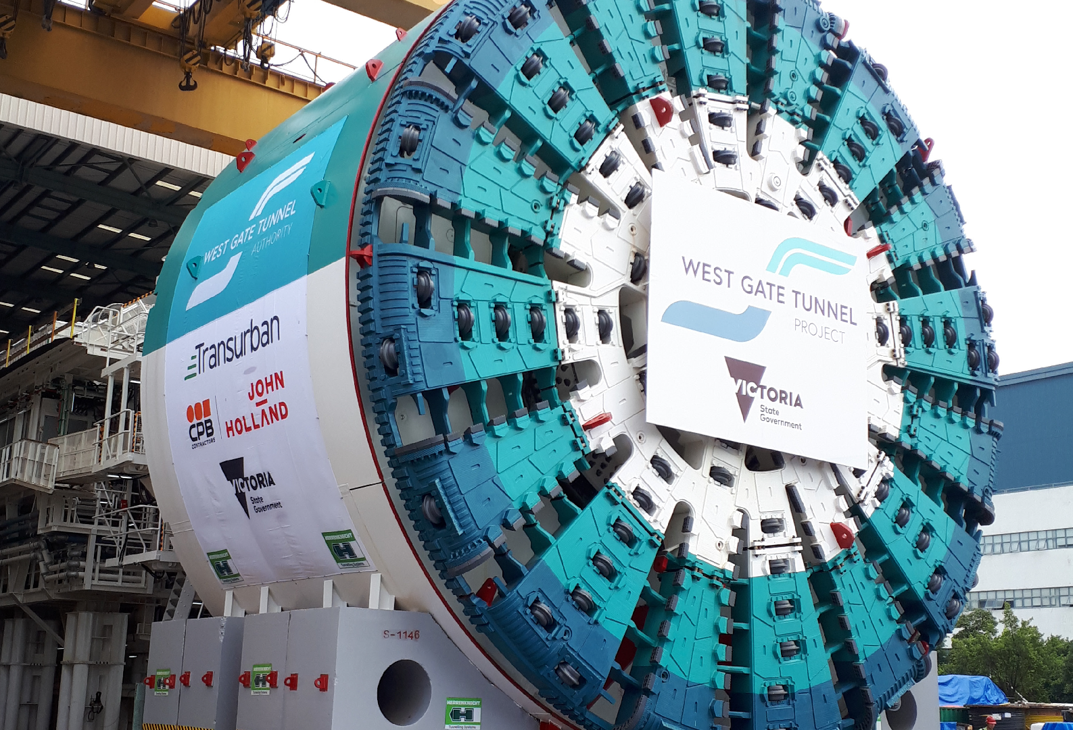





**January 2019**

**Welcome, Bella!**

**number of cutting**

**105 discs on the**

**cutter head**

**length of each TBM**

**90m**

**number of people**

**20 that will work on the TBM at any one time**

**diameter of each TBM,**

**or five storeys high**

**15.6m**

**each TBM will bore on average each day**

**9m**

**TBM Facts**

## Bella, the West Gate Tunnel Project’s first tunnel

boring machine (TBM), has arrived in Melbourne.

Bella is named after Bella Guerin, the first woman to graduate from a university in Australia in 1883.



Bella got her name following the state-wide competition to name our machines after ground- breaking women.

Bella left China in early December and arrived in Melbourne in early January,

before being transferred to the northern portal site where she will be launched. The second TBM is named Vida, after Vida Goldstein, a campaigner for women’s rights, who established the right for females to vote and stand for election. Vida will arrive in March.

The TBMs are built and tested in China before being disassembled and shipped to Melbourne.

The TBMs are so big, that transporting just one machine and all of its components requires nearly 100 truck loads.

When fully assembled, each TBM weighs 4,000 tonnes, or equivalent to the combined weight of 110 trams. The cutter head exerts a rotation force of 85,000 kilonewton per metre. This is about the same force produced by 140,000 V8 cars or the force needed to move 8,667 tonnes per second.

Visit **facebook/ westgatetunnelproject** to see a time lapse video of Bella being built.

**Do you live above the tunnel alignment?** We will be in touch with you before tunnelling starts to let you know what

to expect.

What a difference a year makes!

### It’s been a year since the first sod was turned on the West Gate Tunnel Project

**– check out what we’ve achieved in your area over the last 12 months.**

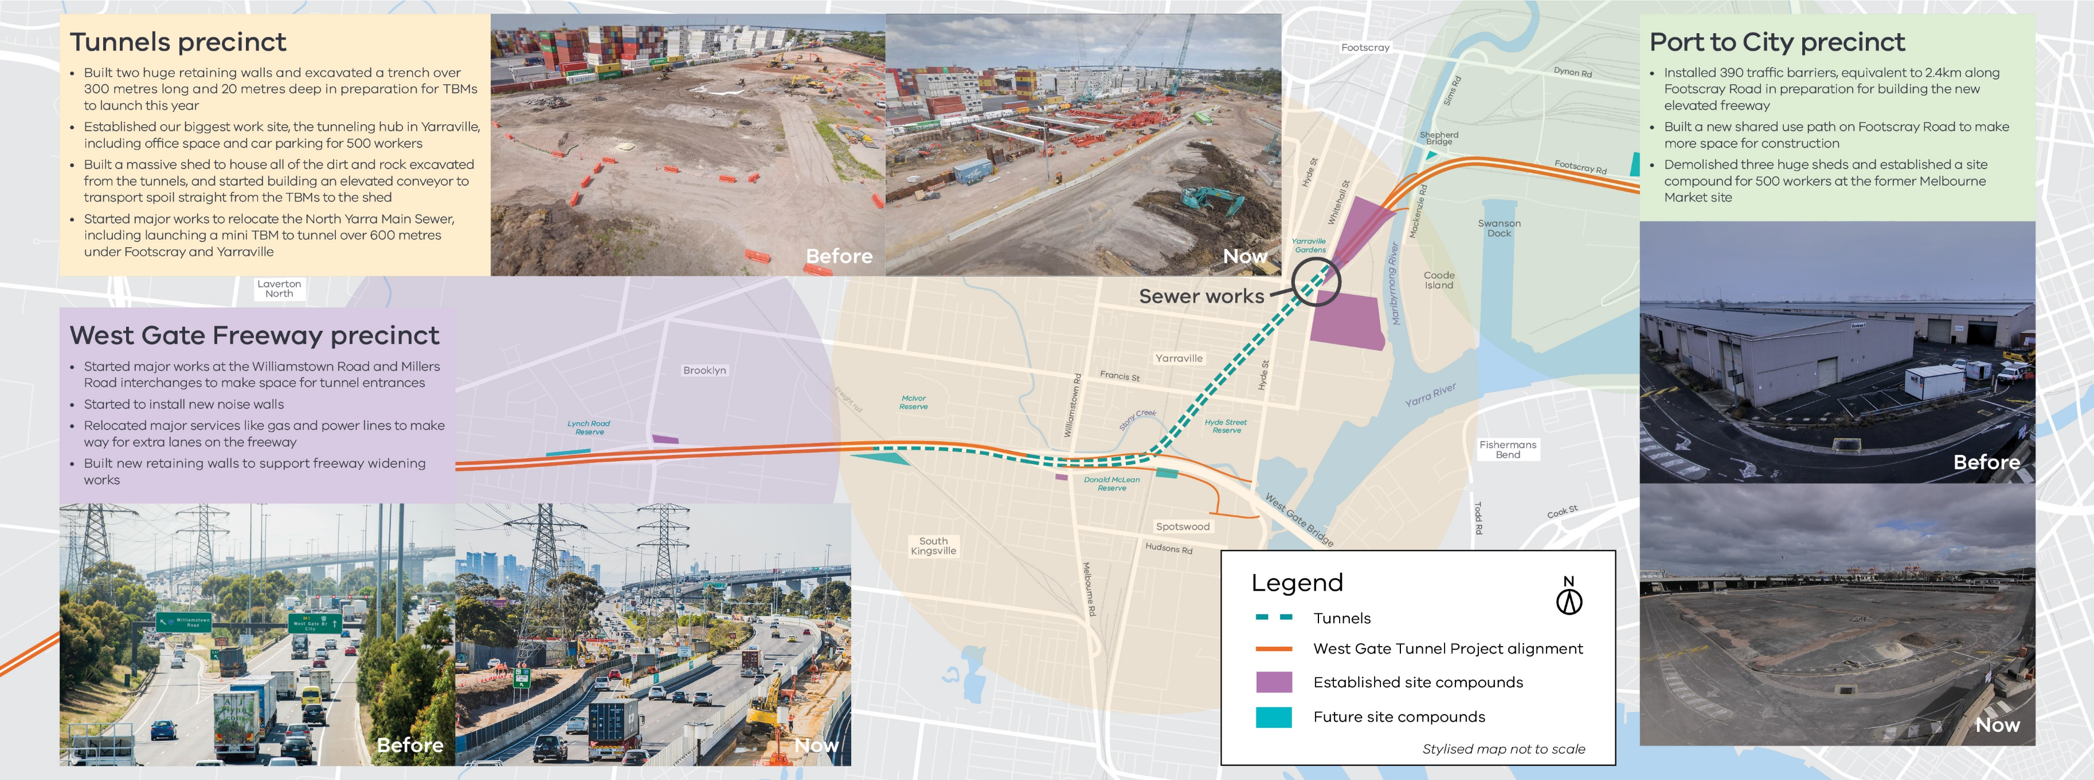

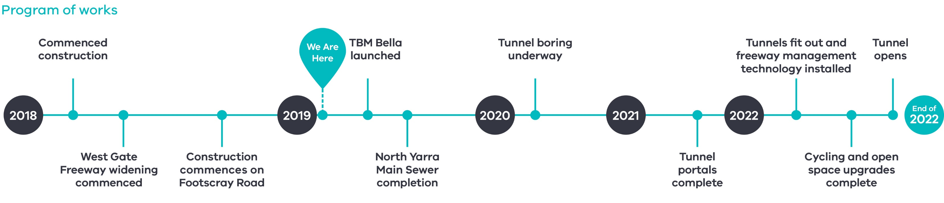

**Protecting birds and trees**

**Upcoming works in your area**

### January to May

The West Gate Tunnel Project team has been working with Wembley Primary School students to make new homes for birds that have been displaced by construction.

The project team visited the school with Habitat Management Systems (Victoria) and taught Year 1 students how to make nest boxes for the birds, and gave them some additional tips on caring for our wildlife.

In addition to creating new homes for birds, the project   
is also collecting seeds from trees along the West Gate Freeway to plant when construction has finished.

### West Gate Freeway

Continued freeway widening works, noise wall construction and service relocation activities

**Mobile Hub hits the road**

The West Gate Tunnel Mobile Hub is coming to a location near you! It’s just like our Info Centre in Yarraville, but it’s on wheels - perfect for getting out and about and speaking to the community at events and festivals.

The Mobile Hub has almost everything that you can see and experience at the Info Centre, including the interactive 3D model of the project corridor and virtual reality ride on the new 2.5 km veloway.

You can pick up fact sheets about different aspects of the project, view the latest project videos on a 43 inch flat screen and check out a project map to see what we’re building in your area.

The mobile hub will be at the Yarraville Festival on 17 February. Check out the project website for upcoming locations.

### Port to City

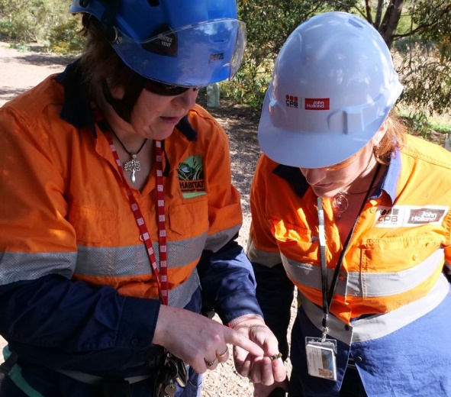

Works get underway to build the foundations for the elevated freeway above Footscray Road

**Tunnel Zone**

TBM Bella assembled at the northern portal and works continue to divert the North Yarra Main Sewer

**Contact us**

**Do you have a question about the project? If you need more information or would like to provide feedback, please get in touch.**

westgatetunnelproject.vic.gov.au [info@wgta.vic.gov.au](mailto:info@wgta.vic.gov.au)

1800 105 105

facebook.com/westgatetunnelproject @westgatetunnel

West Gate Tunnel Project

GPO Box 4509, Melbourne Victoria 3001

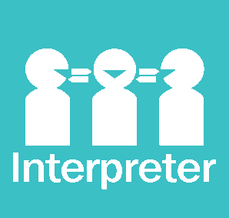 **Interpreter service: 13 14 50**

If you are deaf, or have a hearing or speech impairment, contact us through the National Relay Service.

For more information, visit: [www.relayservice.gov.au.](http://www.relayservice.gov.au/)