Reference: WES1808.01
5 October 2018
Works update – temporary disruptions

Construction has begun on Fogarty Avenue to safely relocate some existing power lines and install new drainage. As part of these works, Fogarty Avenue will be temporarily closed at the intersection of your street.
Temporary closure of Fogarty Avenue
9 October to 27 October 2018

- Fogarty Avenue will be closed between Wembley Avenue and the Footscray Hockey Club from 9 October to 27 October;
- driveway and footpath access will be maintained;
- a local detour will be in place during this time; and
- parking along sections of Fogarty Avenue will be unavailable during this time – please see the map below for location details.

What you could expect:
- an increase in construction vehicles within the area;
- an increase in construction noise from our machinery and trucks;
- water spray trucks to help manage dust and dirt and covered loads when dirt and rock when are being transported; and
- traffic changes will be required and signed detours will be in place – latest traffic updates are available at www.westgatetunnelproject.vic.gov.au/traveldisruptions.

These works will generally be carried out from Monday to Friday between 7am - 6pm and Saturdays between 7am - 3pm, however some night works may be required.

When works are scheduled out of hours and may have a direct impact on you, we will provide further information to you before works start.

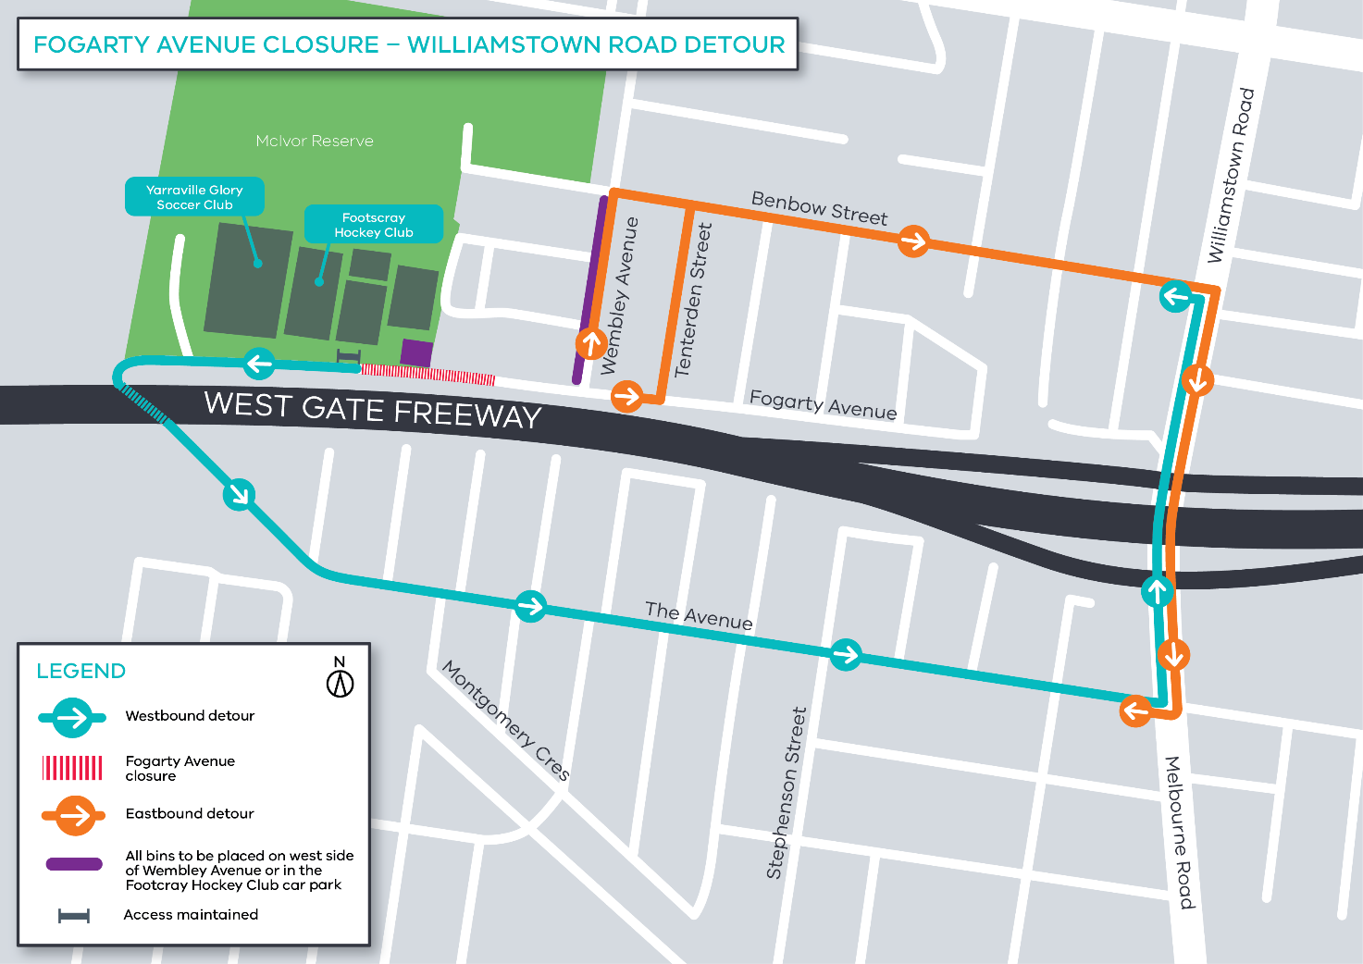

Please note that works may be rescheduled in the event of bad weather or other unavoidable circumstances.
For updates and more information about our works please visit westgatetunnel.vic.gov.au or contact us using the details below.

Contact us

Please contact us if you have any questions or feedback about these works.
westgatetunnelproject.vic.gov.au
westgatetunnelproject@wda.vic.gov.au
1800 105 105
facebook.com/westgatetunnelproject
@westgatetunnel
West Gate Tunnel Project
GPO Box 4509
Melbourne Victoria 3001
Interpreter service: 13 14 50

