Ref: EASNOV19.2

4 November 2019

WORKS NOTIFICATION: Power outage

South Dynon and E Gate 6.6kV Power outage – Sunday 17 November
Works are being undertaken by the West Gate Tunnel Project to relocate the 6.6kV power lines along the Moonee Ponds Creek, which distribute power to all tenants in E Gate and South Dynon. The relocation works require a full day power outage and this is planned to take place on Sunday 17 November.
Areas that will be impacted during these works include: E Gate, South Dynon and north of Dynon Road.

Rail operators impacted during these works include:

Yarra Trams and MTM Depots,

V/Line Maintenance, Bombardier,

V/Line Fuel Point / Wash, Gemco Maintenance,

VicTrack Operations,

V/Line Comms Centre,

V/Line Arrivals Centre and

MTM Rollingstock Depot.

Please see map below for location details.

What to expect:

Works will be completed during the day between 7am – 7pm

A power outage will be in place for E Gate, South Dynon and north of Dynon Road

Individual arrangements will be made with operators prior to the works commencing

Traffic management will be in place to manage changed conditions

We will notify you if there are any significant changes to the timing of our works

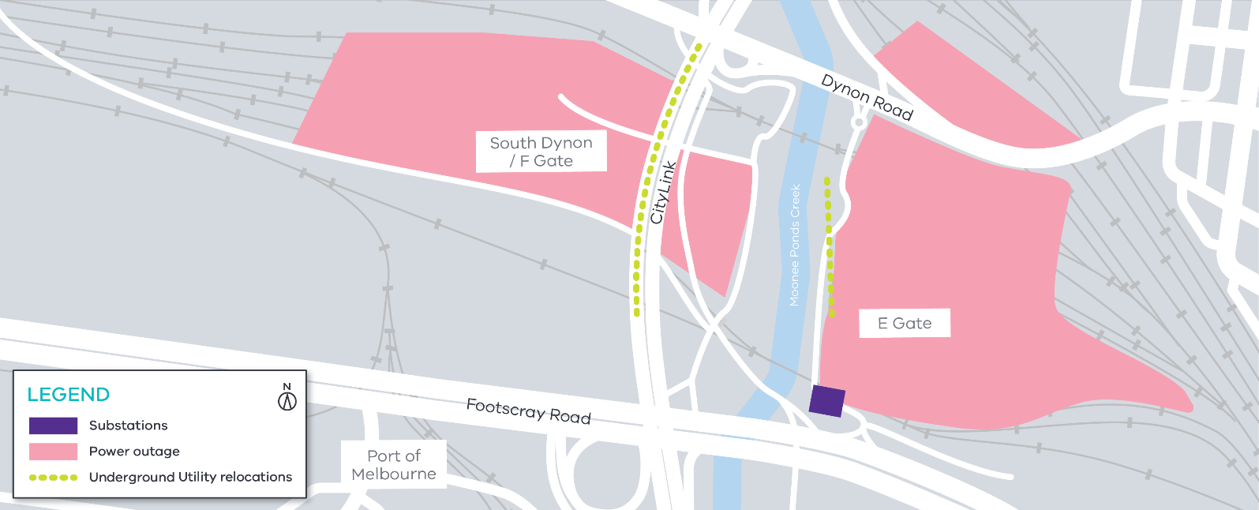

Please note that works may be rescheduled in the event of bad weather or other unavoidable circumstances.
We thank you for your patience during these works.

GPO Box 4509, Melbourne Victoria 3001

Interpreter service: 13 14 50

If you are deaf, or have a hearing or speech impairment,
contact us through the National Relay Service.
For more information, visit: www.relayservice.gov.au.

Contact us
Please contact us if you have any questions or feedback about these works.
westgatetunnelproject.vic.gov.au info@wgta.vic.gov.au
1800 105 105
facebook.com/westgatetunnelproject
@westgatetunnel
West Gate Tunnel Project

