Chapter 17
Social

Chapter 17

Social
This chapter provides an assessment of the social impacts associated with the construction and operation of North East Link. This chapter is based on the impact assessment presented in Technical report I – Social, which includes a list of references relevant to this chapter.

People and communities are at the heart of every infrastructure development. The features and qualities of the built environment influence the way that people use areas and identify with their communities. Property acquisition and works associated with the construction and operation of North East Link have the potential to have positive and negative social impacts through changes to amenity and character, the level of community cohesion and access and connectivity to places.
The EES scoping requirements set out the following evaluation objective for social and community:
- Social, business, land use and infrastructure – To manage effects of the project on land use and the social fabric of the community with regard to wellbeing, community cohesion, business functionality and access to goods, services and facilities.
What are social impacts?
According to 'Social Impact Assessment: Guidance for Assessing and Managing the Social Impacts of Projects' (Vanclay et al, 2015), social impacts include all the issues associated with a project that affect or concern people, whether directly or indirectly. Social impacts are changes to one or more of the following:
- People’s way of life
- People’s culture
- People’s community
- People’s political systems
- People’s environment
- People’s health and wellbeing
- People’s personal and property rights
- People’s fears and aspirations.

To assess the potential effects of the project on communities, a social impact assessment was undertaken.
This evaluation objective is also addressed by the assessment of land use, business functionality and accessibility, which are presented in:
- Chapter 9 – Traffic and transport and Technical report A – Traffic and transport
- Chapter 13 – Land use planning and Technical report E – Land use planning
- Chapter 14 and Technical report F – Business
- Chapter 18 and Technical report J – Human health.

Method

Informed by the risk assessment described in Chapter 4 – EES assessment framework, the social impact assessment involved the following key tasks:

Desktop analysis
A social study area was established to provide a framework for the social impact assessment. As the socio-economic impacts and benefits of large infrastructure developments are experienced beyond the immediate surroundings of the development, the social study area was defined as:
- The regional study area, including the Melbourne metropolitan region
- The local study area, including the municipalities and suburbs intersected by the project, as shown in Figure 17-1
- The project corridor, including the area directly under the project’s construction and operation footprint as shown in Figure 17-1.
What are the standards for social impact assessment?
The process for the social impact assessment was guided by international social impact assessment principles and methods as described by Vanclay (2003) and Vanclay et. al. (2015) and endorsed by the International Association for Impact Assessment (IAIA) and by other industry standards such as the Social Impact Assessment Position Statement by the Planning Institute of Australia (2010) and Environmental Impact Assessment Practice Note – Socio-economic assessment, New South Wales Roads and Maritime Services (2013).

For the assessment of community facilities, as a general guide, facilities within 100 metres of either side of the alignment were included in the social study area as they would be more likely to be potentially impacted by project activities. Some facilities beyond this area were also identified as potentially impacted by the project.
Baseline data relating to the social study area was reviewed to provide a profile of the current social environment. This included understanding existing demographic characteristics, community values and community infrastructure. In addition, relevant national, state and local legislation and policy was reviewed.
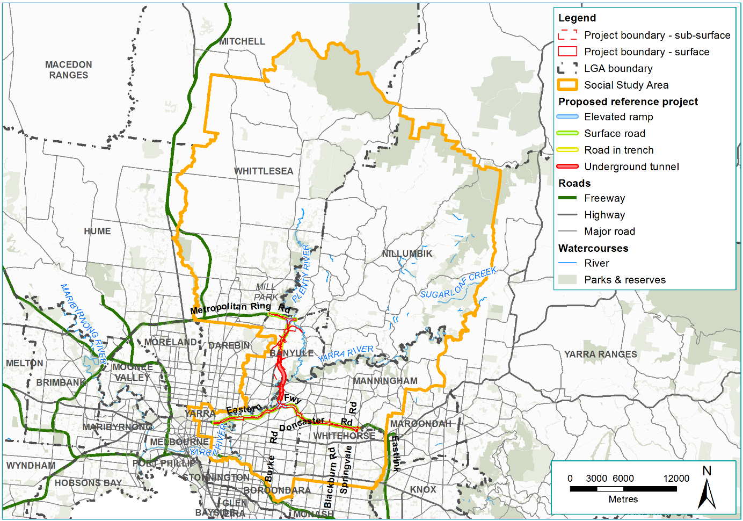
Figure 17-1 Social impact assessment local study area

Stakeholder consultation and community engagement
Extensive stakeholder consultation and community engagement activities were undertaken to inform the development of the social impact assessment. Specific activities undertaken by the social impact assessment team included:
- Meetings with representatives from Banyule, Boroondara, Manningham, Whitehorse and Yarra and Nillumbik local councils (six meetings in total) as well as with key community groups including resident action groups local to the study area (four meetings with four community groups). In addition to the meetings in 2018, NELP met with Whittlesea City Council, however given the minor nature of works in this local government area, discussions were limited to the extent of works at the M80 Ring Road (otherwise known as the Metropolitan Ring Road) and Plenty Road intersection.
- Meetings and online surveys with a sample of managers and users of community infrastructure facilities located in proximity to the project. Managers representing 52 community infrastructure facilities and representatives from 28 user groups were consulted directly by the social impact assessment team. Issues and concerns of other facilities managers and user groups were noted from the project-wide engagement activities being undertaken by the North East Link Project (NELP). Community infrastructure facilities consulted and the method of consultation are listed in Appendix C of Technical report I – Social.
- Five workshops with residents living in close proximity to the alignment. The locations of the workshops were based on identification of residential areas in proximity to the project. This was further refined by identifying clusters across the entire alignment to allow for an appropriate cross-section of community representation. A representative sample was used based on desktop demographic and geographic information. Letters were delivered to approximately 1,050 residents across the project area inviting people to register their interest in the workshops. The workshops were attended by 44 residents at Greensborough, Watsonia Macleod, Balwyn North, Bulleen and Rosanna.
Project-wide engagement activities undertaken by NELP, and attended by the social impact assessment team, also informed the social impact assessment. These included:
- Community drop-in sessions:
  - 12 information displays in mid to late 2017 – 2,300 people attended
  - 8 design update information sessions in April/May 2018 – 2,280 people attended
  - 14 design update information sessions in September/October 2018 – 3,715 people attended
- Small group forums in February to March 2018 covering 'Your environment', 'Urban design' and 'Cycling and walking', attended by 141 people.
- Community Liaison Group meetings, comprising 15 to 20 people including local residents, businesses, community groups, environmental groups, education institutions, Wurundjeri Woi-wurrung Cultural Heritage Aboriginal Corporation (WWCHAC), VicRoads and local councils.
For further detail on stakeholder and community consultation activities, including the number of attendees at workshops, see Section 5.4 of Technical report I – Social.

Impact assessment and management

As described in Chapter 4 – EES assessment framework, a risk assessment was undertaken to prioritise the impact assessment.
The potential social impacts of the project on residents, the general community and community facilities during construction and operation of the project were then assessed. For the purposes of this assessment the potential impacts have been categorised into four themes:
- Property acquisition and relocation (assessed as a part of the construction impact phase as this is when the impact would begin but may occur over the long term)
- Amenity and character
- Access and connectivity
- Function and viability of community infrastructure facilities.
As all social impacts were assessed qualitatively, the significance rating of the social impacts arising from the project is rated according to Table 17-1. The impact rating has been determined for residual impacts after the implementation of the Environmental Performance Requirements (EPRs).
What are the risk categories?
Risk levels were categorised as very low, low, medium, high or very high. When an impact is a known consequence of the project, the rating is indicated as ‘planned’.
The results of the initial risk assessment were used to prioritise the focus of the impact assessments.

Table 17-1 Social impact significance rating
Severity |  | Significance rating
Marginal change from the baseline conditions with no discernible effects to way of life/social values and a functional recovery occurs in several months |  | Negligible
Small change from the baseline conditions with easily negotiable effects to way of life/social values and a functional recovery is expected within 5 years |  | Minor
Noticeable change from the baseline conditions with not easily negotiable effects to way of life/social values and a functional recovery is expected within 5 years |  | Moderate
Substantial change from baseline conditions with noticeable with substantial effects to way of life/social values and a functional recovery is expected within 5 years |  | Major
Significant change to baseline conditions with irreversible and unreplaceable changes to way of live/social values and functional recovery is expected in 10 years, if at all. |  | Severe
In response to the impact assessment, Environmental Performance Requirements (EPRs) were developed to set the required environmental outcomes for North East Link. The residual risk ratings and the assessment of impacts presented in this chapter assume implementation of the EPRs. Refer to Chapter 27 – Environmental management framework for the full list of EPRs.

Existing conditions
The following section outlines the existing conditions of the North East Link study area that relate to social characteristics of the community.

Region overview
The social impact assessment has drawn on the Victorian Government’s metropolitan strategy, Plan Melbourne 2017–2050 to identify regionally relevant land use and infrastructure and the potential for regional impacts. According to Plan Melbourne, North East Link is located within land in the following metropolitan regions: Inner Metro Region, Inner South East Region, Northern Region and Eastern Region. These regions comprise the following municipalities:
- Inner Metro Region – Melbourne, Port Phillip, Yarra
- Inner South East Region – Stonnington, Bayside, Boroondara, Glen Eira
- Northern Region – Banyule, Whittlesea, Nillumbik, Hume, Moreland, Darebin, Mitchell (part)
- Eastern Region – Manningham, Whitehorse, Knox, Yarra Ranges, Maroondah, Monash.
As a whole, North East Link would be located within a well-established and urbanised area in the north-east of the Melbourne metropolitan region, characterised by residential areas, open spaces, commercial and industrial land uses.
In the north-east, the M80 Ring Road and Eastern Freeway are the major routes, although the arterial and major road network is also relied upon for access to key services and local centres. There is limited access to trams and rail services, particularly in the outer area. A number of key regional community infrastructure facilities and places of State and local significance are near the project. These facilities are considered important to the social regional context. These are described in Section 6.2.3 of Technical report I – Social.
The existing amenity and character of the communities directly adjoining the project along the M80 Ring Road, Greensborough Bypass, Greensborough Road and the Eastern Freeway is generally influenced by this road infrastructure, and have a typical suburban feel. Residents in these areas are generally exposed to high levels of traffic noise due to proximity to the existing freeways and highway. This is particularly noticeable in areas that do not have existing noise mitigation controls. As a result, the interface between dwellings and the adjacent freeways, highways and roads are highly valued by local residents and commonly includes parks, reserves, roadside mounds or acoustic noise walls, which often provide a buffer.
Consultation indicates there are common concerns among communities across the project area about existing traffic congestion along arterial roads that create barriers to community connectivity particularly during peak times. Residents raised concerns about existing road and pedestrian safety on these busy roads, particularly for school children. Residents confirmed that existing pedestrian crossings across these roads are important for connectivity and for access community facilities, services and public transport.

Northern region

Within the northern region, the municipalities of Banyule, Whittlesea and Nillumbik are characterised by communities with higher levels of car ownership and infrequent changes in residential address compared with Greater Melbourne. Banyule and Nillumbik are characterised by significant ageing populations and generally advantaged communities, while Whittlesea has a higher level of disadvantage (as defined by the Australian Bureau of Statistics’ (ABS) Index of Relative Socio-Economic Advantage and Disadvantage (IRSAD)). The area surrounding North East Link in Nillumbik and Whittlesea includes residential and open space areas and in Banyule consists of residential areas, the Watsonia Activity Centre and the Simpson Barracks site.
In comparison with Nillumbik, the City of Banyule contains a notable increase in the proportion of young children. While the City of Banyule is highly advantaged, there are areas of disadvantage clustered around the south-west. There are also pockets of moderate to high disadvantage within the suburbs of Watsonia and Greensborough.
What are vulnerable groups?
Vulnerable groups are those groups in a society that have an inability to withstand or adapt to change due to characteristics of the group.
These vulnerable populations have been determined at the local government area level and include:
- Socio-economic disadvantage as defined by the Australian Bureau of Statistics’ Index of Relative Socio-Economic Advantage and Disadvantage (IRSAD).
- Ageing populations
- Children
- Culturally and linguistically diverse (CALD) groups
- People who require assistance with daily tasks.

Social cohesion and trust indicators for Banyule and Nillumbik are relatively high according to the VicHealth Indicators Survey 2015. This is likely to allow for people to form more and stronger relationships with community members. Conversely, social cohesion and trust indicators for the City of Whittlesea are lower than the state average, indicating that a lower proportion of residents feel that people are willing to help each other or that they live in a close knit neighbourhood.

Shire of Nillumbik
Known broadly as the ‘green wedge Shire’, the Shire of Nillumbik is characterised by non-urban areas including reserves, national park, bushland and lifestyle and agricultural properties. Nillumbik’s natural and rural landscapes, along with rural townships and artist colonies, are recognised as important to the local community and to the wider metropolitan Melbourne region. Urban areas including Diamond Creek (which provides significant industrial land) and Eltham are the major activity centres, as well as Greensborough, which contains open space and recreational areas.

City of Banyule
The City of Banyule is bound by the Yarra River to the south and Darebin Creek to the west, both of which are associated with large and in some cases regionally significant open spaces. Banyule is part of the Melbourne Riverlands and Plenty Yarra Community Tourism Association tourist areas, which are valued for their natural landscapes and cultural heritage (Aboriginal and non-Indigenous). While Banyule contains large areas of open space and areas with significant heritage values, the municipality is largely characterised as a residential area. The character of residential areas and protecting this is important to the community.
Banyule contains a number of neighbourhood activity centres including Watsonia, as well as a number of major activity centres, including Greensborough, Heidelberg and Ivanhoe. In addition, Banyule hosts parts of the La Trobe National Employment and Innovation Cluster (NEIC) that includes the Heidelberg Major Activity Centre, several public and private hospitals, La Trobe University, Northern College of the Arts and Technology and Melbourne Polytechnic.

City of Whittlesea
More than 61 per cent of the City of Whittlesea is the Whittlesea Green Wedge, which supports agricultural activities, national parks and rural living. This includes parts of the Great Dividing Range and Kinglake National Park.
Urban areas to the south of the municipality include the Epping metropolitan activity centre and Plenty Valley activity centre. Epping includes a shopping centre, Northern Hospital, Melbourne Polytechnic – Epping Campus, business parks within the Cooper Street employment area and soccer stadium. Adjacent to North East Link, University Hill in the north of Bundoora contains the RMIT East Campus, a town centre, residential development, a retirement village, recreation parks and nature reserves.

Community infrastructure facilities
Community infrastructure facilities within the northern region in proximity of the project are described in Figure 17-2, Figure 17-3 and Figure 17-4.

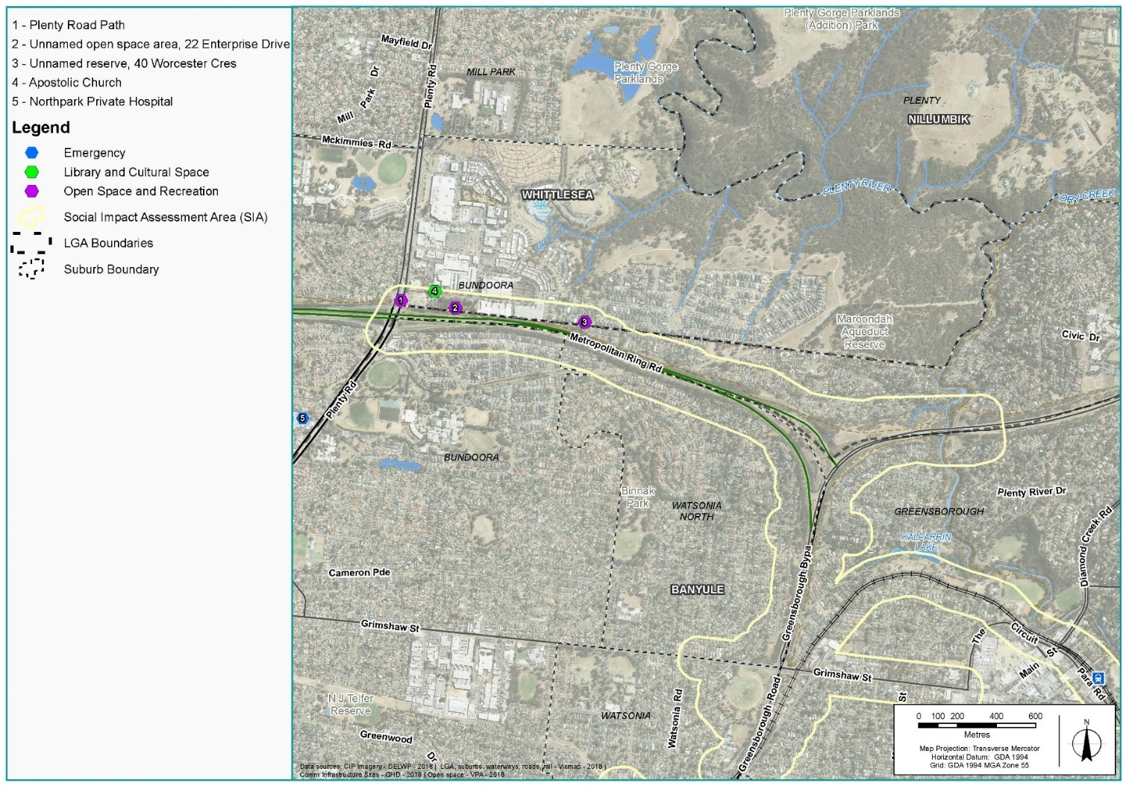
Figure 17-2 Community infrastructure facilities in Nillumbik

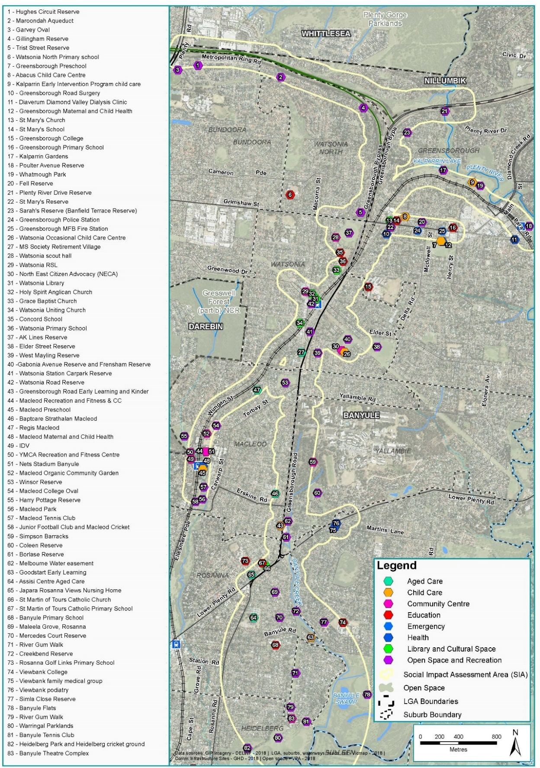
Figure 17-3 Community infrastructure facilities in Banyule (north)
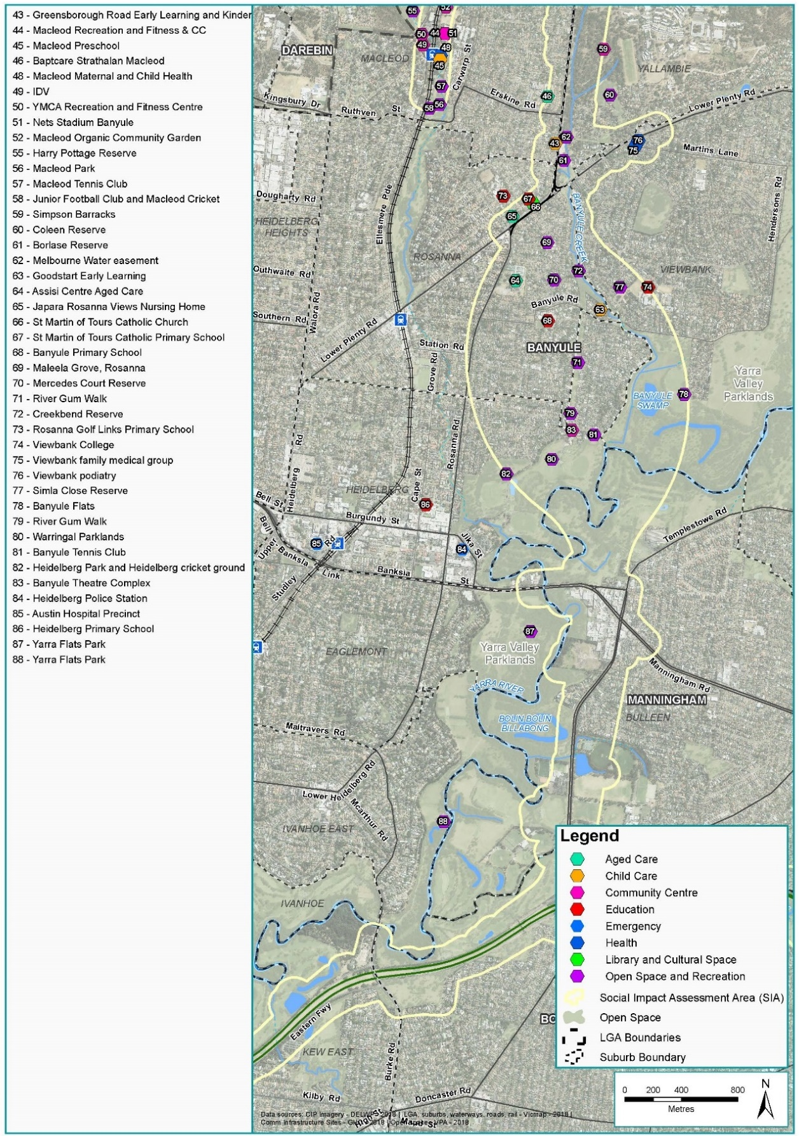
Figure 17-4 Community infrastructure facilities in Banyule (south)

Eastern region
In the eastern region, the municipalities of Manningham and Whitehorse are characterised by generally advantaged communities with significant ageing populations and higher levels of cultural diversity compared with Greater Melbourne. Both municipalities have pockets of disadvantage, including areas close to the Eastern Freeway, as defined by the ABS Index of Relative Socio-Economic Advantage and Disadvantage (IRSAD).
According to the VicHealth Indicators Survey 2015 Manningham and Whitehorse, residents have slightly higher levels of trust in others compared with the state average. These slightly higher proportions of longer residence in Manningham likely would allow for people to form more and stronger relationships with community members, which is generally recognised to increase social cohesion.

City of Manningham
The City of Manningham is bound by the Yarra River to the north and west, and Koonung Creek to the south. Manningham contains a network of activity centres, including a Principal Activity Centre in Doncaster Hill, a Major Activity Centre in East Doncaster, and nine Neighbourhood Activity Centres.
The area surrounding North East Link includes the Heide Museum of Modern Art, Bulleen Industrial Precinct and the residential area of Bulleen. Businesses within the Bulleen Industrial Precinct are well-established and there are strong social ties among business owners, employees and the local community. Consultation has found that businesses in the precinct are valued due to their long-standing relationships, and the diversity they offer in apprenticeship and traineeship pathways for the local and broader community. Consultation with Manningham City Council confirmed the importance of the Bulleen Industrial Precinct to the local economy.
Moving south towards the Eastern Freeway, the area is largely characterised by schools and recreational and open space areas. Bulleen Park incorporates significant sport and recreational facilities, playgrounds, picnic areas, walking trails and bushland reserves. The areas surrounding the Yarra River are also characterised by extensive vegetation and contain areas of biological significance. Consultations with residents revealed the importance of linear parks and open space close to the project boundary. Of significance is the Koonung Creek Trail, Yarra River and Estelle Street Linear Park for recreational walking and cycling. Bolin Bolin Billabong is part of a larger network of billabongs and swamps formed by the Yarra River and is of high significance to the Wurundjeri.
Residents in the City of Manningham rely more on cars and buses compared with Greater Melbourne, although traffic congestion in Manningham is an increasing concern, as highlighted during community consultations. There is considerable congestion on arterial roads, especially during peak hours. Traffic congestion and poor pedestrian connectivity were also noted as key issues for accessing some community facilities.

City of Whitehorse
The City of Whitehorse is bound by Warrigal Road to the west, Highbury Road to the south, Heatherdale Road to the east and Koonung Creek to the north. Whitehorse is known for its mix of quiet residential streets, lively activity centres and employment areas. It has large educational, medical, business and technology precincts and activity centres including the Box Hill Metropolitan Activity Centre and the MegaMile Activity Centre.
North East Link would traverse the northern edge of the municipality close to residential areas buffered by open space areas. The linear reserves along the waterways provide open space corridors. These include the Koonung Creek, Bushy Creek and Mullum Mullum Creek. The linear reserves are well used by the community for passive recreation including dog walking, picnicking and informal sport. People with disabilities from nearby day services also use the linear reserves as sections of the reserves have good accessibility. The Eastern Freeway linear park and sporting facilities at Elgar Park and Slater Reserve are also adjacent to the project area in Whitehorse. The Koonung Creek Trail is an established regional east-west walking and cycling link that connects many open spaces and facilities within Whitehorse, as well as a series of open spaces outside the area. Footbridges over the Eastern Freeway provide residents direct access to open spaces to the north, such as the Koonung Creek Linear Park and Boronia Grove Reserve.
The City of Whitehorse has higher levels of public transport use and lower levels of car ownership compared with Greater Melbourne. This is evident in several on-road bicycle lanes and off-road shared trails that provide for recreational walking and cycling, as well as commuter cycling trips. This is reinforced by a number of rail lines, tram lines and Smart Bus routes that facilitate a high level of connectivity.

Community infrastructure facilities
Community infrastructure facilities within the eastern region in proximity to the project are described in Figure 17-5 and Figure 17-6.

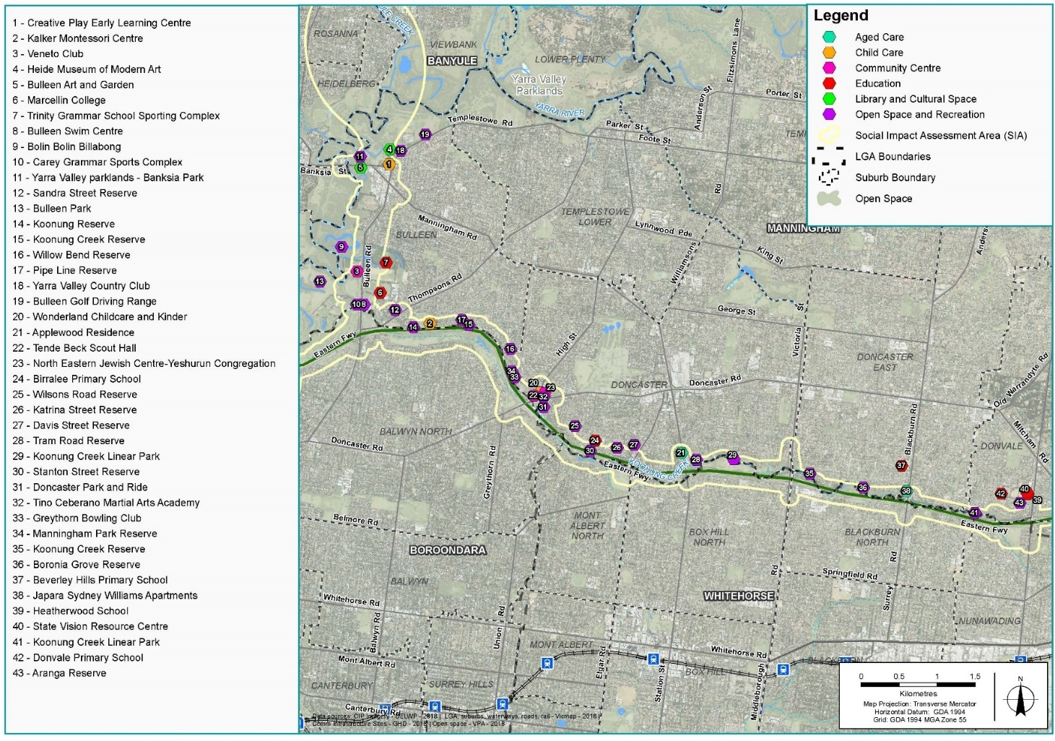
Figure 17-5 Community infrastructure facilities in Manningham
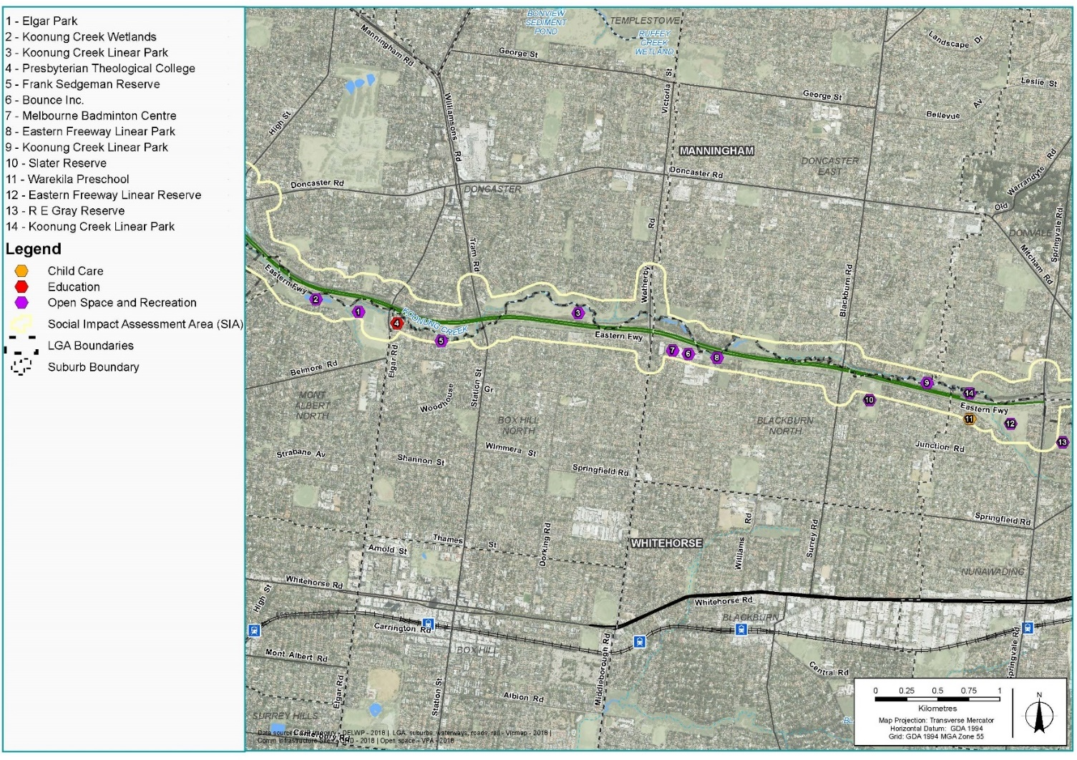
Figure 17-6 Community infrastructure facilities in Whitehorse

Inner region

Within the inner region, the municipalities of Boroondara and Yarra are characterised by generally advantaged communities with lower levels of car use and higher levels of walking and cycling compared with Greater Melbourne.
According to the VicHealth Indicators Survey 2015, fewer residents in Boroondara and Yarra felt that people in the community were willing to help each other, compared with the state average. This has implications for social cohesion and could be due to the high levels of residential migration. Almost half the population moves address every five years in Boroondara, and more than half the population moves every five years in Yarra.
The City of Boroondara is in the inner south-east and has a significant ageing population compared with the City of Yarra, which has a lower median age compared with Greater Melbourne. This is also evident in the higher proportions of people living alone, renting and living in state housing in the City of Yarra. There is also limited socio-economic disadvantage within Boroondara, particularly compared with the City of Yarra, which contains some pockets of disadvantage near Hoddle Street and in the south-west of the municipality (as defined by the ABS Index of Relative Socio-Economic Advantage and Disadvantage (IRSAD)).

City of Boroondara
The City of Boroondara is primarily residential and is bound by the Yarra River for much of the west and north. As a result, Boroondara is associated with significant landscape and open spaces, historical and Aboriginal cultural heritage as well as a distinct residential character. This includes a large number of open space and recreational areas, many of which are associated with the Yarra River, Koonung Creek and Gardiners Creek (which is distant from the project). There is also an extensive network of activity centres including Glenferrie, Camberwell Junction and Kew Junction, and a significant education sector containing the highest concentration of independent schools in Melbourne.
Boroondara is serviced by a number of train, tram and bus services and as a result has a higher level of public transport use compared with Greater Melbourne. However, concerns about congestion on the Eastern Freeway and Bulleen Road creating barriers to accessing the CBD and for diverting speeding traffic onto local roads and streets were raised as concerns in community consultations.

City of Yarra
The City of Yarra contains a number of cultural, open space and entertainment areas important to the local community and the wider central Melbourne community (such as the Royal Exhibition Building, Carlton Gardens, major activity centres, and employment/tourism areas). It should be noted these locations are quite distant from the project works.
The City of Yarra includes a large number of open space and recreational areas including Yarra Bend Park that are valued by the local community as well as across the broader metropolitan Melbourne. Sport and recreation play an important role for residents and visitors to make use of the open space and sporting facilities. This is complemented by the City of Yarra’s embedded cycling culture and well-established public transport network. North East Link would intersect the Main Yarra Trail and the Anniversary Trail, which are both highly utilised by recreational and commuting cyclists.

Community infrastructure facilities
Community infrastructure facilities in the eastern region in proximity to the project are shown in Figure 17-7 and Figure 17-8.

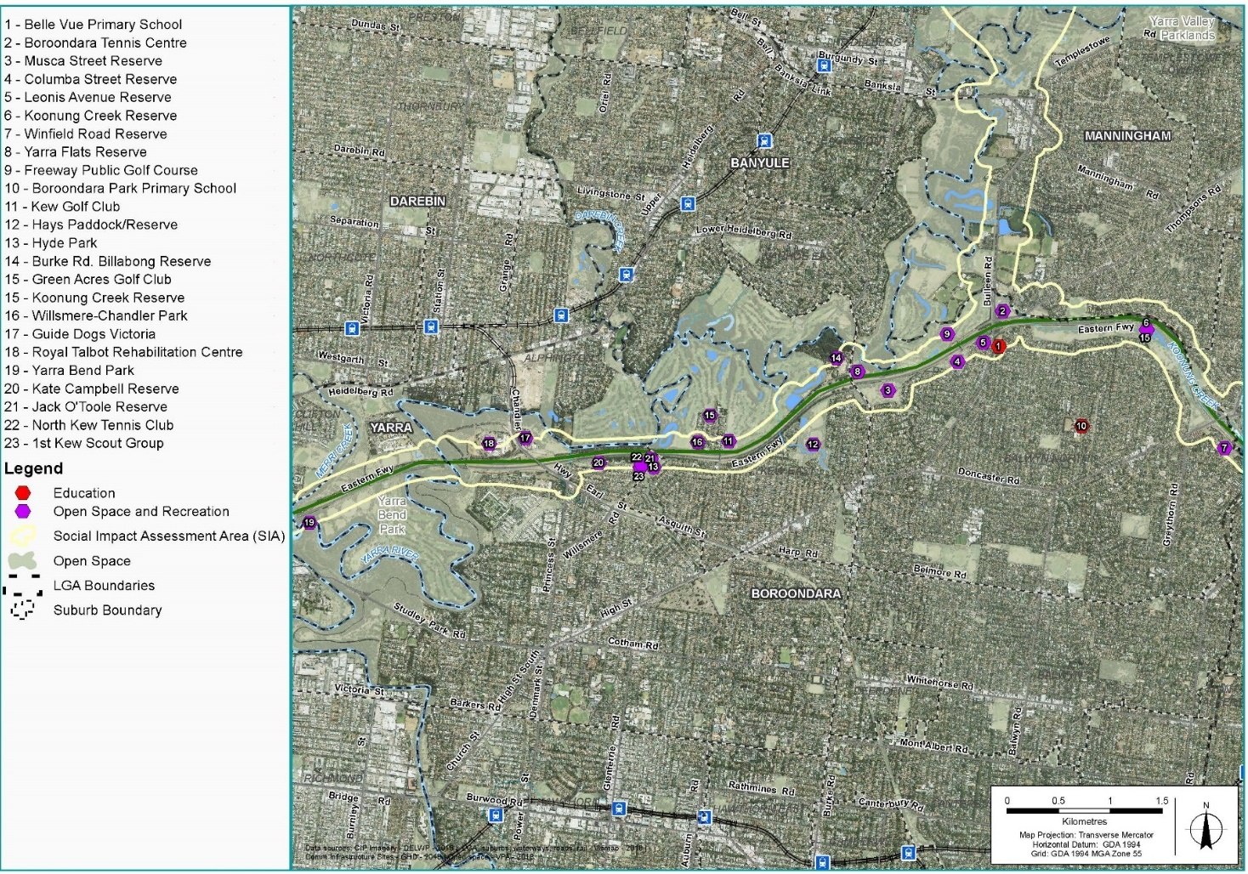
Figure 17-7 Community infrastructure facilities in Boroondara
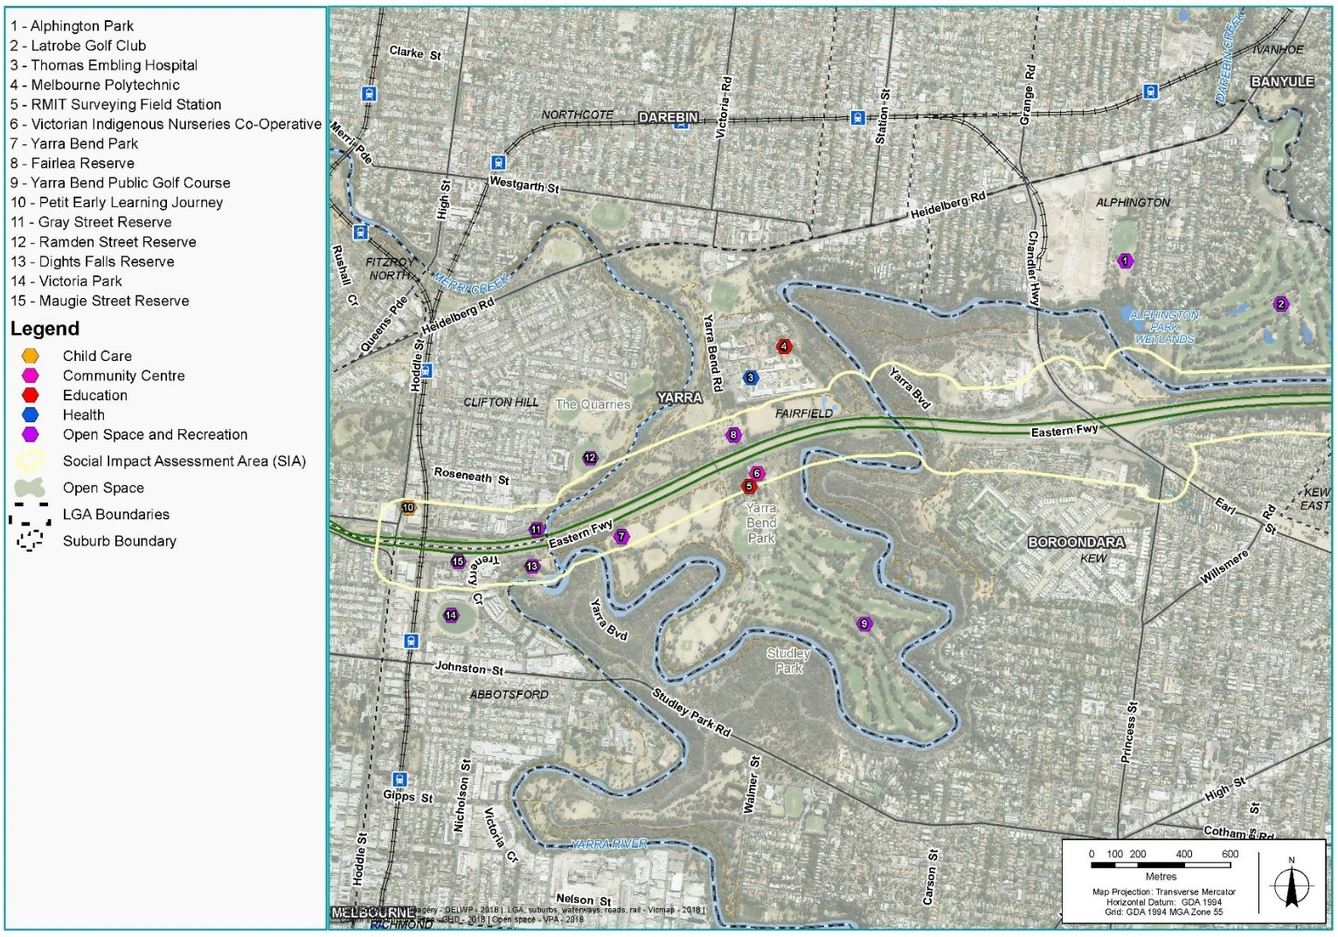
Figure 17-8 Community infrastructure facilities in Yarra

Construction impact assessment
This section discusses the potential construction impacts of North East Link that relate to social cohesion and communities.
The impacts identified for the construction of North East Link that relate to social and community are grouped according to four main themes:
- Property acquisition and relocation
- Amenity and character
- Access and connectivity
- Function and viability of community infrastructure facilities.
The potential for impacts associated with these main themes are discussed in the following sections.
The impact ratings described in the sections below have been determined based on residual impacts following the implementation of the EPRs.

Property acquisition
Residential, business and open space land would be permanently acquired for the construction and operation of North East Link. Property acquisition requirements have been assessed in the construction phase as this is when the risk would occur. The risk pathways associated with property acquisition are described in Table 17-2 and discussed below.
Table 17-2 Risk table – Construction – property acquisition
Risk ID | Risk pathway | Risk rating
Risk SO01 | Acquisition of residential properties leading to relocation of residents from existing place of residence and neighbourhood that may disrupt established social networks, and residents will have to re-establish and adapt to a different place of residence. | Medium
Risk SO02 | Acquisition of residential properties causes social isolation and increases vulnerability if people have to move out of the area due to unaffordability or unavailability of properties to buy within the same area. | Low
Risk SO11 | Acquisition of commercial properties increases unemployment in the local area, as some people may choose to quit their jobs as the commercial operations relocate to another area. | Medium
Risk SO12 | Acquisition of commercial properties leading to relocation of businesses or closure of businesses resulting in disruption or breakdown in the social networks created by the businesses owners and staff in the area. | Medium
Risk SO13 | Relocation of businesses resulting in diminished access to those goods and services for the surrounding community. | Low
This chapter discusses the acquisition requirements associated with the reference project and the potential social impacts of these acquisitions. This is considered to be a conservative approach as design refinements would occur in the detailed design process, with a view to ensuring an optimal environmental, economic and social outcome, including the potential for a smaller project footprint.

Residential property acquisition and relocation
The project would require the acquisition of up to 36 residential properties across the North East Link corridor. These properties would be located within the municipalities of Banyule and Manningham and more specifically in the suburbs of Macleod, Yallambie, Greensborough, Watsonia and Bulleen.
To assess the social impact of residential property acquisition, three key impacts have been assessed, including potential impacts to households and individuals, neighbourhoods and communities, and housing demand.
At a household level, the involuntary nature of residential property acquisition under the Land Acquisition and Compensation Act 1986 (Vic) and the Major Transport Projects Facilitation Act 2009 (Vic) and the subsequent relocation of residents is likely to result in lifestyle disruption, pose demands on individual and family time, and cause worry due to uncertainty. Generally people who have lived at the same residence for a long time would likely have stronger ties and attachment to the area (risk SO01). Banyule and Manningham have slightly lower levels of migration compared with Greater Melbourne, which indicates that residents would have stronger ties to the area (described in Section 17.2.2 and Section 17.2.3 above). However, initial consultation undertaken by NELP with residents who would be subject to acquisition has found that not all residents would seek to relocate within the same community or neighbourhood, indicating that for some residents, neighbourhood social ties could be replaced, or may not be important. These effects are also likely to cause stress and worry for some individuals; the potential for this to occur has been discussed and assessed in Chapter 18 – Human health. The severity of these effects would vary depending on the individuals and their circumstances; vulnerable households may experience these impacts at a higher level of intensity.
Vulnerable households would require additional long-term support to manage the logistical and emotional impacts associated with property acquisition. However, the baseline assessment identified low levels of vulnerability in the overall project areas subject to acquisition (risk SO02).
Relocation of households introduces the potential for reduced or loss of social ties at the neighbourhood and community level. This impact is more likely to occur in instances where several households from an area would be relocated due to residential property acquisition. Residential acquisition across the project would generally be required directly adjacent to the project along a linear corridor, although there are some areas where acquisition would occur in clusters within a neighbourhood. This is likely to occur in areas within the City of Banyule. The severity of these effects would vary depending on the individuals and their circumstances, where vulnerable households may experience these impacts at a higher level of intensity. However, the significance of this impact has been identified as minor in Banyule as the municipality has a high level of socio-economic advantage which indicates that some people are likely to have greater capacity to adapt to change.
Residential property acquisition and associated relocation for the project is unlikely to reduce supply and increase demand for similar housing in the area due to the length of the property acquisition process, which is likely to prevent an increase in demand at one point in time.

Commercial property acquisition and relocation
The project would require permanent land acquisition or temporary occupation of properties affecting 102 businesses. Potential impacts to businesses due to commercial property acquisition are assessed in Chapter 14 – Business, and the potential social impacts in relation of impacts to owners and employees and the surrounding general community are discussed below.
Business owners and employees would need time to work through the project’s compensation and negotiation process, and the relocation or future of the business, which would cause stress and worry for some individuals and would vary in intensity based on their particular circumstances. Depending on individual and business circumstances, the disruption impacts of commercial land acquisition on business owners and employees would range from minor to major. The potential for stress and worry impacts is discussed and assessed in Chapter 18 – Human health.
Business displacement would also reduce local employment opportunities (risk SO11). This could occur if employees choose not to continue to work with the business due to its relocation, or if the business closed due to the land acquisition. The loss of employment opportunities would mean an increase in people seeking work and potentially increase unemployment, especially for those who may be vulnerable to unemployment such as those close to retirement age or those with limited skill sets. For individuals, unemployment has the potential to reduce living standards by reducing income and social inclusion, challenging their personal identity and life satisfaction and ultimately adversely impacting their health and wellbeing.
Chapter 14 – Business estimated that approximately 80 jobs in Watsonia and Greensborough in the City of Banyule, and approximately 830 jobs in Bulleen in the City of Manningham, would be potentially impacted by the project. The potential social impact of displacement and loss of some employment opportunities is expected to be moderate to major in the City of Manningham, depending on where businesses relocate and the viability of other dependent businesses to continue operating. As noted in Chapter 14 – Business, many businesses within the Bulleen Industrial Precinct rely on appropriately zoned land (Industrial 1 Zone) and limited sites are available in Manningham and the immediate surrounding areas. However, the overall potential social impact is expected to be minor, noting that the project is only expected to require limited business displacement outside the Bulleen Industrial Precinct.
Displacement of businesses may mean that residents would have to find other service providers, which could be inconvenient and potentially add travel time to access services elsewhere (risk SO13). Businesses that would be affected generally include non-essential services such as industrial service type businesses, public and private sporting and recreational clubs and educational centres. Chapter 14 – Business notes this would likely impact on the convenience for usual customers, but unlikely to affect fewer regular customers as there are other businesses that provide similar services in the surrounding area accessible by car. Furthermore, as the community is relatively advantaged as defined under the ABS Socio-Economic Indexes for Areas (SEIFA index), people would likely have capacity to adapt to this change.
Many businesses at the Bulleen Industrial Precinct and businesses along the M80 Ring Road to northern portal area have been noted to have high levels of social cohesion (risk SO12). Community consultation also found that local businesses are valued by the community for their service, and also for the longevity of relationships between businesses and customers. Overall, the displacement of businesses would reduce social ties between businesses, their supply chain and their customer and employment base. The loss of social relationships for businesses and the surrounding community in Manningham and to a smaller extent in Banyule would be noticeable and experienced over time. For businesses in Manningham, it would be beneficial if businesses were able to relocate somewhere close to the Bulleen Industrial Precinct, so businesses would have similar locational advantages to their current location and local jobs would be maintained as well as business-to-business cooperation.

Environmental Performance Requirements
Impacts associated with residential and commercial property acquisition as informed by the risk pathways in Table 17-2 would be managed with the implementation of mitigation measures summarised below, in consultation with stakeholders and owners.
Key measures to mitigate impacts associated with residential property acquisition and temporary occupation include reducing disruption as far as practicable through a case management approach and understanding the relative vulnerability and special needs of landowners and occupants, and endeavouring to reach agreement on the terms for possession of the land. This applies to residences and community infrastructure facilities during the project’s design and construction (EPR SC1). The project would also be required to develop a Communications and Community Engagement Plan to engage the community and potentially affected stakeholders and communicate progress of construction activities and operation (EPR SC2). Following the implementation of mitigation measures, the overall social impact of residential property acquisition is expected to be minor to moderate. The social impact on vulnerable individuals or households and some long-term residents or households is expected to range from minor to major, depending on the circumstances of the particular household.
At the neighbourhood level, land acquisition is expected to have a minor social impact due to reduced or loss of social ties. However, the impact to vulnerable individuals at the neighbourhood level would range from minor to moderate, depending on personal circumstances.
The level of impact associated with commercial property acquisition, including local availability of employment, social cohesion and local services, would largely depend on the successful relocation of displaced businesses. The project would be required to undertake this through minimisation of disruption to businesses from permanent acquisition or temporary occupation to the extent practicable (EPR B2). The project would also be required to provide regular updates of the planning and design progress for the project and to work with Councils to identify alternative location options for displaced businesses (EPR B1). If businesses could relocate within the vicinity of their current location, the disruption to business relationships and displacement of local jobs could be minimised. Following the implementation of these mitigation measures, the social impacts on businesses and the surrounding community is expected to be minor as people would likely seek and gain employment elsewhere. However, within the City of Manningham, the social impact would be moderate to major due to the loss of available choices for local employment. Similarly, the displacement of employment for people who may be vulnerable would be major. Given the type of goods and services currently offered by potentially impacted businesses, and given the context of the broader region, the loss of access to services and goods is expected to have a minor social impact. Further detail and discussion of impacts to businesses are discussed more in Chapter 14 – Business.

Amenity and character
Noise, air and visual amenity allow residents to enjoy their surroundings and create a recognisable and distinctive community character. The project’s construction would change noise, air and visual amenity in the project area. The risk pathways associated with amenity and character are described in Table 17-3 and discussed below.
Table 17-3 Risk table – Construction – amenity and character
Risk ID | Risk pathway | Risk rating
Risk SO03 | Construction and location of infrastructure closer to private residential properties leading to changes to amenity and lifestyle. | Medium
Risk SO05 | Noise, air emissions and visual changes generated due to construction activities, construction traffic and redistribution of traffic, affect the amenity for the nearby residents and reduce the overall liveability and attractiveness of the area causing inconvenience, changes to lifestyle, disruption to daily life and activities. | Medium

This section assesses the potential social impacts on residents and the general community in proximity to the construction of the project due to changes to amenity and character. It is noted the degree to which residents would experience social impacts due to amenity changes would vary between individuals based on various factors. The assessment considers the social implications of other technical reports, including Technical report B – Air quality, Technical report C – Surface noise and vibration, Technical report D – Tunnel vibration, Technical report E – Land use planning, Technical report H – Landscape and visual, and Technical report J – Human health, as well as their corresponding chapters.

Combined impacts
During the project’s construction, some nearby residents may experience combined changes to visual, noise and air amenity. This would lead to cumulative social impacts, which may include feeling annoyed, inconvenienced and at a greater disadvantage than before the project started. They may experience a diminished sense of pride and contentment in the area where they live or work and may choose to spend less time at home or less time pursuing day-to-day activities in and around their homes.
Combined amenity impacts are likely to occur in residential areas adjacent to construction activities and construction compounds, including at AK Lines Reserve, Winsor Reserve, Borlase Reserve, Musca Street Reserve, Koonung Creek Linear Reserve, Katrina Street Reserve and Elgar Park.
However, different people would perceive amenity impacts differently. Vulnerable groups living close to construction activities would be more sensitive to change in amenity. These include older people, children, people with a disability or special needs, or people with medical conditions.

Visual amenity
Construction works that may have social implications due to visual change include the removal of existing vegetation, construction sites, construction screening and additional lighting, which have the potential to affect the amenity of nearby residences (risk SO05).
These works have implications for community perceptions of neighbourhood character and potentially community wellbeing due to a reduced level of engagement with nature and open spaces. These social impacts would be more pronounced where residents would be exposed to a change in character for an extended period of time (more than two years).
Construction works would also impact direct views from residences. This could impact people’s enjoyment of their properties, particularly their backyards or outdoor spaces, which could lead to changes in lifestyle (risk SO03). For example, the glow from night-time lighting for construction could lead to residents needing to close their curtains or blinds, which may reduce the flow of breeze especially during summer, resulting in a lifestyle change. There is potential for some people to be more sensitive to the glow, particularly vulnerable groups such as older people, children and people with medical conditions, which may affect sleep. The degree to which residents would experience these impacts would vary between individuals, but generally it is considered unlikely this would impact people’s ability to continue with their day-to-day activities and functionally and they would continue to use outdoor spaces and neighbourhoods. Impacts due to overshadowing during operation are described in Section 17.4.1 below and in Chapter 13 – Land use planning.

Noise amenity
Construction activities including truck movements, tunnelling, demolition and piling have the potential to increase noise levels, which could have social impacts (risk SO05). According to Chapter 11 – Surface noise and vibration, noise levels from construction equipment generally reduce with increased distance from the noise source. Residences and other receptors in the immediate vicinity of the construction activity would usually be more impacted than more distant receptors. As the distance between the residential properties and construction works increase, it is likely the noise would decrease and be less noticeable. However, perception and sensitivity to changes in noise levels varies from person to person. Construction activities and equipment are generally likely to move within the construction sites and along the linear project area, so the associated increase in noise levels is expected to be temporary and sporadic in frequency.
Increase in noticeable levels of daytime noise and night-time noise could potentially lead to residents temporarily spending less time outdoors in backyards or balconies, or closing windows while indoors, which may reduce the flow of breeze especially during summer. Increased noise also has the potential to disturb normal home activities and sleep, which may reduce people’s ability to enjoy their properties, participate in work and community activities, and affect personal and social relationships. This may lead to the risk of social isolation for some residents, particularly vulnerable groups such as people with a disability, older people and children. Vulnerable groups may also be more sensitive to more noise and may have less capacity to adapt to the change. An increase in noise levels can have health impacts, which are discussed in Chapter 18 – Human health.

Air quality amenity
Construction activities that have the potential to impact air quality, intermittent dust and odour include the removal, transport and disposal of spoil, and surface works including site clearing, operation of equipment and demolition activities. These impacts to air quality may reduce the amenity for residents living near these activities during the project’s construction, which may impact their ability to enjoy and use their properties (risk SO05).
According to Chapter 10 – Air quality, finer dust particles can disperse at greater distances from the source and have the potential for human health impacts if not adequately controlled. This may have significant implications for people who are more sensitive to dust impacts such as children, older people and people that need assistance with core activities. Any health implications of dust impacts are assessed in Chapter 18 – Human health. It is acknowledged that any health impacts due to air quality changes from the project would have social implications on people’s day-to-day lives.

Environmental Performance Requirements
Impacts associated with visual, noise and air quality amenity, as well as the combined amenity impacts, as informed by the risk pathways in Table 17-3, would be managed with the implementation of identified mitigation measures in consultation with stakeholders and owners.
To address specific sensitivities of residents to visual, noise and air quality amenity impacts during construction, the project would be required to develop a Communications and Community Engagement Plan (EPR SC2) and participate in the Community Liaison Group, established and managed by NELP (EPR SC3). This would enable engagement with residents before and during construction to inform them of project activities and provide a feedback mechanism for residents.
Key mitigation measures to address impacts to visual amenity have been identified in Technical report H – Landscape and visual. They include the requirement for temporary and construction works to be designed and carried out in general accordance with EES Attachment II – Urban Design Strategy and to minimise landscape impacts during construction (EPRs LV1 and LV2) which would minimise adverse visual impacts of the project works and provide visual appeal across the project. Further guidance to reduce visual impacts is included in EES Attachment II – Urban Design Strategy. The project would also be required to minimise construction light spillage to protect the amenity of adjacent neighbourhoods, parks, community facilities and any known significant native fauna habitat to the extent practicable (EPR LV3). Following the implementation of mitigation measures, the social impact of overall visual amenity change on nearby residents is expected to be negligible to minor. In the case of vulnerable groups who would be more sensitive to night-time glow, the social impacts are expected to be minor to moderate.
To address impacts to noise amenity, Technical report C – Surface noise and vibration and Technical report D – Tunnel vibration include requirements to manage and minimise construction noise and vibration impacts to sensitive receivers in accordance with applicable legislation and a Construction Noise and Vibration Management Plan (EPRs EMF2, NV3, NV4, NV8, NV9, NV10, NV11 and NV13). With the implementation of the mitigation measures, the social impact of overall noise amenity change on nearby residents and vulnerable groups is expected to be minor to moderate and social impacts on residents in the vicinity is expected to be negligible to minor.
Key mitigation measures to address impacts to air quality amenity have been identified in Technical report B – Air quality. They include requirements to minimise and monitor the impact of construction dust through tools such as a Construction Environmental Management Plan, Dust and Air Quality Management and Monitoring Plan and Spoil Management Plan inclusive of odour management (EPRs EMF2, AQ1, CL1 and CL3). The assessment also proposes additional controls to minimise dust emissions, such as site barriers and management of construction vehicles. Following the implementation of the mitigation measures, the social impact of overall air quality amenity change on nearby residents is expected to be minor, social impacts on residents in the vicinity is expected to be negligible and social impacts on vulnerable groups is expected to be minor to moderate.
With the implementation of the identified mitigation measures to address construction noise, air quality and visual impacts, the combined social impacts from changes in amenity of residents immediately adjacent to construction activities and residents in the vicinity are expected to be minor to moderate, and minor to major for vulnerable groups. This is because it is considered that most residents would generally adapt to the change during construction and be able to continue with their usual activities.

Access and connectivity
Connectivity refers to people’s ability to move through their community and access a range of places safely and conveniently. The risk pathways associated with access and connectivity during construction are described in Table 17-4 and discussed below.
Table 17-4 Risk table – Construction – access and connectivity
Risk ID | Risk pathway | Risk rating
Risk SO03 | Construction and location of infrastructure such as ramps near or surrounding residential communities leads to a sense of loss of connectivity and access to other areas. | Medium
Risk SO06 | Changes to traffic conditions during construction such as road, lane, or shared path closures and detours may cause safety concerns, disruption to access areas and properties, increase travel time, cause delays and inconvenience for road users. | Medium
Risk SO07 | Changes to traffic conditions during construction such as road, lane, or shared path closures and detours impacting on the vulnerable population such as the elderly, those that use mobility aid (wheelchairs) by reducing travel accessibility, causing isolation, deterioration of mental and physical health. | Medium
Risk SO10 | Disruption to and change in public transport services may lead to users having to change their travel routes and adapt to temporary relocation of bus stops and bus and train routes. | Medium
This section assesses the social impacts on residents and the general community due to access and connectivity changes during the project’s construction. It should be noted that details of changes to roads, traffic, shared use paths and public transport have been derived from the findings of Technical report A – Traffic and transport. Refer to that report and associated chapter for more information.

Roads and traffic impacts
Construction works would impact the road and traffic network surrounding North East Link over a likely period of seven years, with construction at different locations mobilising and demobilising throughout that time. This would be due to construction activities that generate additional truck traffic, require lane and road closures and create detours to facilitate public safety and safety of workers. More detail on indicative locations for access and connectivity changes is provided in Table 9.2 of Technical report I – Social. For road users, traffic changes due to construction activities would increase their travel time for daily commutes or usual trips during the project’s construction (risk SO06). Additional time spent travelling would likely reduce the time people spend with families and undertaking leisure and social activities.
The location of construction sites along some roads such as Greensborough Road, Bulleen Road and the Eastern Freeway would likely increase the perception of these roads as barriers to travel (risk SO03). This may deter people from making trips at certain times, particularly vulnerable groups such as older residents and people needing assistance who could then be deprived of social interactions (risk SO07). However, since these traffic changes would only occur during the construction phase and alternative routes and access would be available, it is unlikely this infrequent deterrence would lead to social isolation or impact community cohesion.

Shared use paths
To facilitate construction works, temporary relocation, diversions and potential closure of shared use paths would be required. For further detail on indicative locations for access and connectivity changes, see Table 9.3 in Technical report I – Social. These temporary disruptions would increase travel times for shared use path users such as commuters, active recreational users, students and people with mobility aids such as wheelchairs and electric scooters.
The area surrounding the project hosts a sizeable vulnerable population including elderly people and children, evident in the number of aged care homes and schools. As a result, even temporary disruption to shared use paths around these areas could cause the social isolation of vulnerable individuals who use the paths to make necessary trips to shops, medical centres and social activities (risk SO07). This is because routes could become unfamiliar and perceived to be unsafe. It is important to engage shared use path users to address any disruption that would occur during project’s construction.

Public transport
Public transport facilities along the project corridor including bus stops, bus routes, Watsonia railway station and the Hurstbridge rail line would be temporarily disrupted during the project’s construction (risk SO10). For more detail on indicative locations and duration of impacts, see Technical report A – Traffic and transport.
Temporary increased travel time would likely reduce the time people spend with families and undertaking leisure and social activities. Changes to public transportation can be confusing and stressful for people, especially vulnerable groups such as the elderly, children, people with disability and people with English language difficulties. To mitigate these impacts, alternative transport would need to be provided for disrupted rail services and public transport users engaged with before and during construction to communicate any changes to services. This would allow people to anticipate access changes and plan their journeys ahead. Signage would be provided where changes to park and ride facilities, bus stops and routes are proposed. Accessibility would be maintained so that people with mobility issues could continue to access bus stops.

Environmental Performance Requirements
Impacts associated with access and connectivity as informed by the risk pathways in Table 17-4 would be managed with the implementation of identified mitigation measures in consultation with stakeholders and owners.
Mitigation measures are drawn from Technical report A – Traffic and transport and Technical report I – Social. Transport Management Plans for the project would be required to minimise disruption to affected local land uses, traffic, car parking, public transport, pedestrian and bicycle movements, and existing public facilities during all stages of construction (EPR T2). As part of the Transport Management Plans, suitable measures would be developed in consultation with emergency services to ensure emergency service access is not impacted by project construction activities. A Traffic Management Liaison Group would also be established before works that started to identify any impacts on existing roads, paths or public transport infrastructure (EPR T3).
Residents, cyclists and vulnerable groups would be consulted before and during construction. This would occur through the Communications and Community Engagement Plan and the Community Liaison Group (EPRs SC2 and SC3). This would minimise impacts caused by any travel delays the project would cause by allowing residents to anticipate traffic changes and plan their journeys.
Based on the assessment of access and connectivity impacts above, the social impact assessment concludes that by implementing the mitigation measures, the social impacts on residents and the community of road traffic, shared use path and public transport changes is expected to be minor. Social impacts on vulnerable groups is expected to be minor to moderate.

Function and viability of community infrastructure facilities
Community infrastructure facilities serve an important function to meet social needs and enhance community wellbeing. The risk pathways associated with changes to the function and viability of community infrastructure are described in Table 17-5 and discussed below.
Table 17-5 Risk table – Construction – function and viability of community infrastructure facilities
Risk ID | Risk pathway | Risk rating
Risk SO08 | Full or partial land acquisition of sporting and recreational facilities reduces the function and viability of the facility and in turn reduces opportunities for an active lifestyle and impacts on social networks that people create through participation in sporting and recreational activities. | Low
Risk SO09 | Noise, air emissions and visual changes including overshadowing generated during construction reduces the overall amenity of community infrastructure facilities, leading to reduce enjoyment of the facility and impacting on the function and viability of the place. | Medium
Risk SO06 | Changes to traffic conditions during construction such as road, lane, or shared path closures and detours may cause safety concerns, disruption to access areas and properties, increase travel time, cause delays and inconvenience for road users. | Medium
Risk SO07 | Changes to traffic conditions during construction such as road, lane, or shared path closures and detours impacting on the vulnerable population such as the elderly, those that use mobility aid (wheelchairs) by reducing travel accessibility, causing isolation, deterioration of mental and physical health. | Medium
Risk SO10 | Disruption to and change in public transport services may lead to users having to change their travel routes and adapt to temporary relocation of bus stops and bus and train routes. | Medium

This section discusses potential impacts on the ability of facilities to continue providing community services due to permanent acquisition, changes to amenity and character, and changes in access and connectivity. For further detail on the impacts to each community facility, see Appendix E of Technical report I – Social. Community facilities identified within the project area have been categorised into open space and recreation, educational, emergency, aged care and community centres.

Open space and recreational facilities
The construction of North East Link would require land acquisition and temporary occupation of open space and recreational areas (risk SO08).
Recreational areas proposed to be impacted by temporary occupation and permanent acquisition are mainly clustered around the southern extent of Bulleen Road (Bulleen Park) and the area surrounding the Eastern Freeway. This includes the sports fields provided by Carey Grammar, Trinity Grammar School and Marcellin College, and other facilities including Bulleen Park, Bulleen Swim Centre, Boroondara Tennis Centre, the Veneto Club and the Freeway Public Golf Course. For further detail on temporary occupation and permanent acquisition impacts at these facilities, refer to Table 9-4 in Technical report I – Social.
A number of other facilities used for recreational sporting would also be impacted by full or partial temporary occupation including Gabonia Avenue Reserve, Winsor Reserve, AK lines Reserve and Elgar Park. Some of these recreational facilities are also used as a venue for other community events and functions. Despite these impacts, it is not anticipated the availability of sporting facilities and clubs would be reduced due to the project’s land acquisition requirements. This is due to the project’s commitment to work with local councils and Victorian government authorities to identify alternative local facilities for formal recreational users displaced from recreational facilities due to project works (EPR SC4). Further consultation has been undertaken with Sport and Recreation Victoria and state sporting associations to ensure that relevant sporting requirements are considered throughout this process.
Following consultation with the managers, operators and users of the facilities, it was noted that people generally travel a fair distance to use these facilities and the majority of users would continue to use the facilities at a new location, even if further away.
A number of public open spaces used for active or passive recreation would also be required for full or partial temporary occupation. This could reduce the immediate opportunities for community members to have an active lifestyle or interact with their neighbouring community. This may occur in areas near Borlase Reserve, Boronia Grove Reserve, Eastern Freeway Linear Reserve, Frensham SEC Reserve, Gray Street Reserve, Jack O'Toole Reserve, Koonung Creek Linear Park, Koonung Creek Reserve and Koonung Reserve. Partial areas within some affected open spaces would remain available during the project’s construction. This would allow for the continuation of the primary function of these open spaces, but with reduced overall availability. While inconvenience some people during construction, people would be able to adapt over time or find alternatives to access similar facilities. More detail on the amount of public open space proposed to be impacted during the project’s construction is provided in Section 9.4.2 of Technical report I – Social.
Impacts to community facilities during the project’s construction are also expected due to changes to noise (risk SO09). Construction activities are likely to generate noticeable noise levels, temporarily and intermittently, especially in areas directly adjacent to construction activities. This could temporarily and infrequently disturb active and passive recreational and sporting activities but only when the timing of high noise from construction activities coincided with these activities (risk SO09).
Impacts to community facilities changes to access and connectivity during construction would also occur. It is likely that traffic conditions would change along the road network near construction sites where a number of recreational and open space areas are located. Specifically, there would be increased truck movements along Bulleen Road and Manningham Road and the Eastern Freeway. These changed conditions may cause congestion and delays in accessing recreational facilities at Bulleen Park.
The temporary presence of construction activities, changes to traffic conditions to access open spaces and recreational facilities and the relocation of some sporting facilities further away from their existing location may deter some people from accessing these facilities and reduce their involvement, particularly elderly people who socialise at venues like the Veneto Club or volunteer at various impacted sports clubs. These changes have the potential to isolate vulnerable people. Impacts to vulnerable people’s ability to access facilities should be managed by engaging with facility operators and user groups.

Educational and child care facilities
While a significant number of educational and child care facilities are located near the project alignment, the potential impacts to these facilities are generally minimal. North East Link would require only a small strip section along the eastern boundary of Watsonia Primary School, which is unlikely to impact the school’s functionality (risk SO08). NELP has engaged with the school and the Department of Education and Training to discuss this acquisition. The project would also require partial temporary occupation of the sporting facilities at Marcellin College, Trinity Grammar School and Carey Grammar (discussed above).
Impacts to educational facilities due to changes in noise would also occur during the project’s construction (risk SO09). While most facilities are at a sufficient distance from construction, there are some exceptions where the facility is adjacent to North East Link and therefore likely to experience a change in the noise environment. These include Watsonia Primary School, Watsonia Occasional Child Care Centre, St Mary’s Parish Primary School, St Martin of Tours Catholic Primary School, Belle Vue Primary School, Greensborough Road Early Learning and Kinder, Macleod Preschool, Creative Play Early Learning Centre, Kalker Montessori Centre, and Wonderland Childcare and Kinder. These amenity changes have the potential to impact users and managers of these facilities, disturb concentration, people’s capacity to participate in work and to participate in learning activities. For childcare centres, these works may also impact daytime sleep for children. With the implementation of noise mitigation, monitoring and the Construction Environment Management Plan, where possible construction works around these facilities would be undertaken mainly outside operating hours. Due to the sensitivity of the facility users, each facility’s management would be consulted to seek input to the Construction Environment Management Plan and engagement would continue before and during construction. As a result, amenity changes would have a minimal impact on the overall functionality of the facilities.
Community facilities would also be impacted due to changes to access and connectivity during the project’s construction. It is likely that traffic conditions would change along the road network near construction sites where a number of educational facilities are located. These changes would temporarily increase travel times during school pick up and drop off times or may result in people using the shared use paths to make alternative arrangements to travel to schools and child care centres near the project. This may occur due to the project’s temporary occupation of Koonung Creek Reserve, which connects to Belle Vue Primary School. Similarly, the construction of North East Link may present a connectivity barrier, particularly for pedestrians and cyclists who need to cross roads to Marcellin College, St Mary’s Parish Primary School, St Martin of Tours Catholic Primary School and Greensborough Secondary College.
Traffic impacts across the area surrounding North East Link are expected to be managed with the implementation of various EPRs (see EPRs below and Chapter 9 – Transport for more detail). To provide safe crossings for students and young people while facilitating truck movements, the project would be required to install traffic signals at the intersections of Carey Grammar Sports Complex and Marcellin College access roads. As above for noise impacts, each facility’s management would be consulted to seek input to the Construction Environment Management Plan and engagement would continue before and during construction.

Emergency services
Emergency services across the project area would not be impacted by property acquisition, and are not expected to have significant amenity impacts or changes to access and connectivity (risk SO09). Thirteen emergency services have been identified within 500 metres of the project, including hospitals, medical centres and day surgeries, police stations, ambulance and fire stations. All facilities except the Greensborough Road Surgery, Thomas Embling Hospital and Royal Talbot Rehabilitation Centre are at a sufficient distance from the construction footprint of North East Link and so their functionality is not expected to be affected by amenity changes.
Where facilities may be potentially affected by noise, sufficient noise attenuation would be required (as described in Chapter 11 – Surface noise and vibration). Given the distance between the project boundary and facility buildings, and the natural noise attenuation present between the project and the facility, as well as the EPRs that would be implemented to manage noise levels (particularly EPR NV3, NV4 and SC2), it is unlikely that the functionality of the emergency facilities would be impacted due to project-related amenity changes. Although construction noise would be minimised, the vulnerability of the hospital’s population increases their sensitivity to noise level changes. Hospital management would be consulted early, particularly about the potential for exceedance periods in accordance with EPR SC2.
Where facilities may be impacted due to changes to the road network, suitable measures would be developed in consultation with emergency services and facilities so that access was not inhibited due to project activities.

Aged care facilities
Aged care facilities along the project alignment would not be impacted by property acquisition, but are likely to experience amenity impacts (risk SO09). Facilities near the project include Baptcare Strathallan, Regis Macleod, Assisi Centre Aged Care, Japara Rosanna Views Nursing Home, Applewood Retirement Village and the MS Respite Services. Given the residential nature of these facilities and vulnerabilities of their inhabitants, users of these facilities are likely to experience similar amenity impacts to residents living in close proximity to the project (as described in Section 17.3.2). The implementation of EPRs defined in Chapter 11 – Surface noise and vibration, construction noise and vibration impacts to sensitive receivers would be managed in accordance with applicable legislation and a Construction Noise and Vibration Management Plan. Early engagement with aged care facilities would be required to address particular project-related amenity issues.
Visual changes would include direct views of construction activities which may reduce people’s enjoyment of their properties and use of outdoor spaces. Construction activities would increase noise levels at aged care facilities close to the project. These facilities include the Japara Rosanna Views Nursing Home, Applewood Retirement Village and the MS Respite Services. These facilities may experience a noticeable increase in noise levels, which may impede people’s ability to sleep, relax or engage in conversation. It is also likely that some within this vulnerable group of users could be more sensitive to increases in noise levels and may have less capacity to adapt to changes in the noise environment.
Intermittent dust and odour would be generated by construction of the northern tunnel boring machine (TBM) launch site, which would temporarily reduce the amenity of residents living near these activities. This would occur near Baptcare Strathallan, and these works are likely to have a greater impact on the more vulnerable residents. Health impacts due to change in air quality are assessed in Chapter 18 – Human health.
Aged care facilities may also experience temporary changes to access and connectivity during construction, particularly around Watsonia and Rosanna. This may deter some elderly people from making some trips due to congestion and a reduced sense of road safety. This could reduce the ability of aged care residents to maintain social and community networks and conveniently access essential services. With the implementation of traffic management measures described above and in more detail in Chapter 9 – Traffic and transport, it is expected that access and connectivity to and from these facilities would be maintained, which would allow community members to continue travelling safely on roads.

Community halls, libraries, art and culture centres, and community centres
Construction activities would also increase noise levels, particularly for facilities close to construction sites. A number of facilities discussed in this section would be sensitive to changes in the noise environment, based on aspects of their function that value low noise levels, such as places of worship or because they cater to vulnerable groups. Increased noise may impede people’s ability to engage in conversation, listen to religious ceremonies or engage in contemplative practice. It is likely that some within this vulnerable group could be particularly sensitive to increases in noise levels and may have less capacity to adapt to changes in the noise environment.
The project’s construction would also include temporary delays and additional travel time along some roads. Users of facilities in Greensborough, Watsonia, Macleod and Rosanna may experience increased travel times due to increased traffic, lane and road closures and diversions on Greensborough Road and Lower Plenty Road. Similarly, facility users in Heidelberg and Bulleen are likely to experience increased travel times due to haulage activities along Bulleen Road and lane closures and diversions on Manningham Road and Bridge Street. It is notable these facilities are predominantly used on the weekends and in off-peak periods.
Construction works would require acquisition of Bulleen Art and Garden. Bulleen Art and Garden is a not for profit business with a nursery and gallery space for emerging local artists. As a result of acquisition, the business service and community function it provides, would cease. As a business, the business owners are likely to experience disruption and stress and worry due to the acquisition. Depending on if and where the business relocates, its displacement could result in potential loss of some local employment opportunities if employees choose not to continue to work with the business due to its relocation, or if the business closes as a result of land acquisition. The loss of employment opportunities would increase the labour pool seeking employment and potentially increase unemployment, especially for those who may be vulnerable to unemployment such as those close to retirement age or those with limited skill sets. The displacement of this business may inconvenience users of the facility, particularly because of the unique community activities it provides. The users wold have to find other facilities that may provide a similar function, if available, in the area.

Environmental Performance Requirements
Impacts associated with the function and viability of community facilities as informed by the risk pathways in Table 17-5 would be managed with the implementation of identified mitigation measures in consultation with stakeholders and owners.
To minimise impacts due to property acquisition and temporary occupation, the project would be designed to reduce disruption to community infrastructure facilities (EPR SC1). Through the Communications and Community Engagement Plan, the community, stakeholders and relevant local councils would be engaged and consulted with to communicate progress of construction activities and operation (EPR SC2).
Where recreational facilities would be displaced by the construction or operation of the project, the project would be required to work in collaboration with facility operators, local councils and relevant State authorities to identify relocation opportunities, where practicable.
The recreational facilities within Banyule, Manningham, Boroondara and Whitehorse Council that would be displaced by the reference project have been subject to a Sport and Recreation Options Assessment that has been prepared by North East Link Project. The Sport and Recreation Options Assessment (located in Appendix F of Technical report I – Social) has been prepared in consultation with each of the relevant Councils and provides further detail to supplement this social impact assessment report.
The Sport and Recreation Options Assessment documents the approach that has been adopted in consultation with facility operators, local councils and relevant State authorities to identify relocation opportunities. Solutions to address this include increasing the capacity at nearby sites to enable them to accommodate increased use for a temporary period. The objective of this work is to accommodate impacted facilities in alternative locations and where practicable, to maintain the continuity of the facilities. The options assessment represents the work that has been completed to date consistent with EPR SC4.
Through this process, NELP and the councils have held the common objectives of accommodating displaced facilities and maintaining the continuity of those recreational activities. The Sport and Recreation Options Assessment is however, preliminary in nature and does not present a definitive solution for each recreational facility or club. Further consultation and assessment of the feasibility of these options is required before this work is completed. Once preferred options have been selected, the implications for the recreational facilities and user groups would be further considered and NELP would work with these groups to reduce impacts as much as possible.
NELP has developed seven relocation options within the Bulleen Park Area. Principles and Evaluation Criteria have also been developed to enable an objective options assessment process. The development of both these options and the principles and criteria has included consultation and feedback from Council officers.
The project would also be required to maintain ongoing communication and engagement with community facilities. This would occur through early engagement with managers and residents of these facilities to identify and address particular access and connectivity issues and related potential social isolation issues, through the Community Liaison Group (EPR SC3). Maintaining access and connectivity is also addressed through mitigation measures identified in Chapter 9 – Transport, which would require Transport Management Plans that include suitable measures, developed in consultation with emergency services, to ensure emergency service access is not inhibited as a result of project construction activities. This would also include requirements to minimise impacts on local streets, community and commercial facilities (EPR T2).
To manage amenity impacts on community facilities, noise management, noise monitoring and a Construction Environment Management Plan would be required (EPRs EMF2, NV3, NV4, NV8, NV9, NV10 and NV11). This would ensure that, where possible, works around community facilities would be undertaken mainly outside their operating hours. With the implementation of these measures, these facilities are not expected to be exposed to exceedances in noise limits. More detail on noise-related impacts of the project is provided in Chapter 11 – Surface noise and vibration.
Based on the above, the social impact assessment provides the following impact ratings. Following the implementation of EPRs discussed above, the overall significance of potential social impacts on the functionality and viability of open spaces and recreational areas, and the functionality of community infrastructure facilities, is expected to be negligible to moderate. The overall significance of potential social impacts on the functionality and viability of educational facilities, child care centres and aged care centres is expected to be minor to moderate. This is with the exception of Watsonia Primary School, which may experience a moderate impact to its functionality due to the impacts associated with the cumulative effect of acquisition, changes in amenity and accessibility.
The social impacts on users and staff of aged care facilities are expected to be minor to major. The potential social impacts on the functionality of emergency facilities and services and community access to these facilities and services is expected to be minor. The significance of social impacts on the functionality of other community infrastructure facilities including community halls, libraries, art and culture centres and community centres is expected to be negligible to moderate, and minor to major for the users and staff. More detail on community facilities is provided in Appendix E of Technical report I – Social.

Operation impact assessment
This section discusses the potential impacts of North East Link’s operation that relate to social and community.
Identified impacts of the project’s operation that relate to social and community are grouped according to three main themes:
- Amenity and character
- Access and connectivity
- Function and viability of community infrastructure facilities.
The potential for impacts associated with these main themes are discussed in the following sections.
The impact ratings described in the sections below have been determined based on residual impacts following the implementation of the EPRs.

Amenity and character
The risk pathways associated with changes to amenity and character due to noise, air quality and visual impacts during the project’s operation are described in Table 17-6 and discussed below.
Table 17-6 Risk table – Operation – amenity and character
Risk ID | Risk pathway | Risk rating
Risk SO14 | Infrastructure such as ramps near or surrounding the residential communities causing severance of communities or residential areas, leading to a sense of isolation, increased sense of disadvantage and vulnerability. | Low
Risk SO15 | Changes to amenity (noise, air and visual including overshadowing) of nearby residents due to road infrastructure moving closer to homes, impacting lifestyle or increasing vulnerability. | Low

This section assesses the potential social impacts on residents and general community members in proximity to the operation of North East Link due to changes in amenity and character. It is noted the degree to which residents would experience these impacts would vary between individuals based on various factors. The assessment considers social implications discussed in other technical reports, including Technical report B – Air quality, Technical report C – Surface noise and vibration, Technical report D – Tunnel vibration, Technical report E – Land use planning and Technical report H – Landscape and visual, as well as their corresponding chapters.

Combined impacts
During the project’s operation, some residents within the project boundary may experience combined changes to visual, noise and air amenity. This would lead to cumulative social impacts, which may include feeling annoyed, inconvenienced and at a greater disadvantage than before the project opened. They may experience a diminished sense of pride and contentment in the area where they live or work and may choose to spend less time at home or less time pursuing day-to-day activities in and around their homes.
Generally, many residential areas along the M80 Ring Road between Plenty Road and Greensborough Bypass and some sections of the Eastern Freeway could benefit from new noise walls. Therefore, while most residents would experience visual change in their environment, traffic noise levels would reduce.

Visual amenity
North East Link would involve a number of changes to visual amenity for residential communities. This would largely be due to the presence of new permanent infrastructure including noise walls, viaducts, elevated road structures, shared use path overpasses and street lighting (risk SO15). The final built form would also include the permanent removal of some open spaces and vegetation, which currently offer visual amenity for nearby residents. Existing views of residents would change, with views of nearby new infrastructure, the loss of some open spaces, overshadowing from the noise walls and light spill.
As described in Chapter 14 – Landscape and visual, potential impacts to residential views during project operation are expected to be most significantly experienced in areas that do not currently have views of road infrastructure, and where there would be limited space for vegetative screening. This may permanently alter the character of the residential area and streetscape. Some residents may also lose existing views to open space due to permanent loss of this open space to accommodate the project. This is particularly evident for some residences facing Borlase Reserve as well as the open space adjacent to Sellars Street in Watsonia North and Koonung Creek Linear Park. These impacts would also be experienced at residences south of the M80 Ring Road and to the north of Grimshaw Street and east of Greensborough Road. More detail on visual impacts due reduced open space is provided in Chapter 14 – Landscape and visual. These potential impacts may mean that residents experience a reduced sense of pride in their properties, particularly outdoor spaces.
Some residential areas are also likely to experience overshadowing from noise walls and road infrastructure (risk SO15). Overshadowing would likely occur more prominently in areas where the noise walls are close to the property boundary and impacts would depend on the use of the section of the property experiencing overshadowing. Blocking direct sunlight in yards and through windows would diminish people’s use of the outdoor space, ability to maintain gardens and plants that need direct sunlight, and could alter the temperature regulation of the house, potentially increasing indoor heating use during winter. As described in Chapter 13 – Land use planning, overshadowing from project infrastructure would be minimised through detailed design, mitigating potential impacts associated with loss of sunlight.
Where there is increased permanent infrastructure near residences, potential light spill impacts, such as the glow from night-time lighting, could be visible from indoor and outdoor residential spaces (risk SO15). This is not expected to have a significant impact as most people close their blinds and curtains at night for comfort, privacy and security. To mitigate potential impacts, lighting designs would need to adhere to relevant standards, which would minimise light spill impacts to protect the amenity of adjacent neighbourhoods.
While the degree to which residents’ enjoyment would be impacted would vary, it is considered unlikely this would impact people’s ability to continue with their everyday lives. People tend to adjust to visual changes over time, particularly once vegetation matures and filters views of the infrastructure. The project’s design would also be required to be generally in accordance with EES Attachment II – Urban Design Strategy to minimise and mitigate visual impact. It is therefore unlikely that infrastructure such as ramps near or surrounding the residential communities would impact visual amenity to a point that it could cause severance of communities or residential areas, leading to a sense of isolation, increased sense of disadvantage and vulnerability (risk SO14).
More detail on locations where impacts to visual amenity are expected to occur during operation is provided in Section 10.2.1 of Technical Report I – Social.

Noise amenity
As a result of traffic diversion onto North East Link, the operation phase would result in reduced noticeable traffic-related noise on a number of local and arterial roads in the surrounding road network (risk SO15). Additional noise mitigation measures such as noise walls along the project’s alignment would also reduce traffic noise in residential areas near the project. This may contribute to quieter residential amenity and encourage residents to enjoy outdoor spaces. More detail about reduced traffic volumes is provided in Chapter 9 – Transport, and see Chapter 11 – Surface noise and vibration.
North East Link is predicted to generate a net-benefit across the study area in terms of operational noise. 2,300 properties would experience a noticeable reduction in road traffic noise due to North East Link’s proposed noise mitigation measures. Many other properties are predicted to experience reduced traffic noise during operation, due to the removal of vehicles, particularly heavy vehicles, off the regional road network and onto North East Link.
Despite these benefits, Chapter 11 – Surface noise and vibration indicates that some residential areas would experience increased surface noise due to predicted increased traffic volumes along some local roads not associated with the project around Blackburn North, Doncaster East and Doncaster. The maximum noise level increase is predicted to be minimal and would generally be unnoticeable.
In the long term, it is considered unlikely that day-to-day lifestyles of most people would be adversely impacted due to project-related noise level increases. Noise change is also gradual over time. While perception and sensitivity to changes in noise levels is subjective and varies from person to person, vulnerable groups may be more sensitive to slight increase in noise levels and may have less capacity to adapt to the change. Health impacts caused by operational noise are discussed in the Chapter 18 – Human health.

Air quality amenity
According to Chapter 10 – Air quality, improved air quality is predicted for the 2026 and 2036 scenarios along many roads due to decreased traffic (risk SO15). These roads include those currently used by the community to travel between the M80 Ring Road and the Eastern Freeway, including Lower Plenty Road and Rosanna Road. More detail on the locations of roads predicted to have a decrease in traffic is provided in Section 10.2.3 of Technical report I – Social.
Improved air quality due to reduced traffic is expected to enhance the air quality amenity of surrounding residential areas, and provide further opportunity for residents to spend time in outdoor spaces.
Minor increase in air emissions are predicted along some roads including the M80 Ring Road, Eastern Freeway and Middleborough Road. Maximum concentrations along each road are generally expected near intersections. Increased dust in some areas would reduce the amenity of residents, with more dust on indoor surfaces and roofs. However, dust increases are not likely to change people’s lifestyle or day-to-day activities. The health implications of increase in dust are assessed in Technical report J – Human health.

EPRs
Impacts associated with changes to visual, noise and air quality amenity and character during operation, as informed by the risk pathways in Table 17-6 would be managed with the implementation of identified mitigation measures in consultation with stakeholders and owners.
Landscape and visual impacts would need to be minimised during the design process to the extent practicable and to maximise opportunities to enhance public amenity, open space and facilities, in general accordance with EES Attachment II – Urban Design Strategy (EPR LV1). This would consider the design of infrastructure, interfaces for residential and business properties, and historic, cultural and natural values in consultation with relevant stakeholders. Impacts from overshadowing onto residential properties, community facilities, open spaces, waterways and valuable natural habitats due to noise walls and elevated structures would also need to be minimised (EPR LP4). Lighting designs would be required to adhere to relevant standards (EPR LV4) to minimise light spills to protect the amenity of adjacent neighbourhoods. Based on the impact assessment and proposed mitigation measures, the social impact associated with changes to visual amenity is expected to be minor to moderate, and minor in the long term.
To minimise noise amenity impacts during operation, mitigation measures would be implemented to verify compliance with noise and vibration requirements for traffic and tunnel ventilation system noise (EPRs NV1, NV2, NV6 and NV7). If the external traffic noise performance requirements were not met, remedial action would be taken. Based on the impact assessment and proposed mitigation measures, the social impact associated with changes to noise amenity is expected to be negligible to minor, and moderate for properties identified for further noise treatment.
While air quality changes during the project’s operation are not expected to have significant social impacts, the project would be required to meet relevant air quality requirements, and monitor ambient air quality, in-tunnel air quality and ventilation structure emissions in accordance with the relevant standards (EPRs AQ2, AQ3, AQ4 and AQ5). With the implementation of these measures, the social impact of increased dust at few locations on people’s day-to-day life is expected to be negligible.
Overall, the project would generate positive social impacts due to reduced traffic noise along the majority of the project boundary despite visual changes associated with new infrastructure. With the implementation of the identified mitigation measures, at some locations, the combined social impacts from changes in amenity of residents including vulnerable groups are expected to be moderate.

Access and connectivity
The risk pathways associated with changes to access and connectivity during operation are described in Table 17-7 and discussed below.
Table 17-7 Risk table – Operation – access and connectivity
Risk ID | Risk pathway | Risk rating
Risk SO16 | Increase in traffic on feeder roads or on roads designated for re-distribution of traffic can deteriorate amenity (noise and air quality) for nearby residents over a period of time, increasing their sense of disadvantage. | Medium
Risk SO17 | The grade separated shared path crossings can deter some vulnerable groups from making the journey, increasing their isolation and sense of disadvantage. | Low

This section assesses the social impacts on residents and the general community due to access and connectivity changes during operation. It should be noted that details of changes to roads, traffic, shared use paths and public transport have been derived from the findings of Technical report A – Traffic and transport. Refer to that report and its associated chapter for further detail.

Roads and traffic impacts
Traffic volumes would decrease on almost every road between the M80 Ring Road and the Eastern Freeway during operation. This is because medium and longer cross-city trips would divert to North East Link, resulting in faster travel times. Large decreases in traffic movements are predicted along Greensborough Road, the M80 Ring Road west of the Plenty Road interchange, roads between Plenty Road (both north and south of the freeway), Rosanna Road (and parallel routes of Rosanna Road), Manningham Road, roads serving the La Trobe precinct, Yarra River crossings and Main Road. Reduced travel times would benefit road users including cars, trucks, buses, trams, cyclists and pedestrians, allowing more time for people in the north-east to spend with their families and to undertake leisure and social activities. These benefits can help strengthen cohesion across communities.
Fewer trucks are predicted on arterial and local roads due to diversion to North East Link. Based on consultations for the social impact assessment, some residents and representatives of community facilities raised concern that Greensborough, Rosanna and Bulleen Roads act as real or perceived barriers between both sides of the road due to high levels of traffic and truck noise. During the consultations, concerns were raised about the safety of community members, particularly school children, who walk along these roads close to truck traffic. Less trucks along these roads may improve community perceptions of road and pedestrian safety and amenity, which may increase connectivity across these roads.. Road safety would also be improved along the Eastern Freeway, where the proposed managed motorway safety features such as ramp metering and overhead lane control would benefit the broader community.
Increased traffic volumes are predicted along some feeder routes and arterial roads during operation (risk SO16). These include the M80 Ring Road between Plenty Road and Greensborough Bypass, Grimshaw Street, Greensborough Bypass, Watsonia Road, Eastern Freeway between Bulleen Road and Doncaster Road, and arterial roads south of the Eastern Freeway. Truck volumes are also forecast to increase along feeder routes to North East Link. Residents living on Grimshaw Street, Watsonia Road and the arterial roads south of the Eastern Freeway mentioned above may experience slightly longer travel times due to this increased traffic along these roads. North East Link would also alter travel patterns and some access arrangements, which would require residents and commuters to take alternative routes within the local road network. This may increase daily travel times of these residents.
While these increased travel times may marginally reduce time available for leisure activities, it is unlikely to impact most people’s ability to continue with their day-to-day activities over the long term nor their ability to access various destinations. Given the broader community benefit provided by North East Link with overall faster travel times in the north-east, increased traffic along some of the feeder routes is not expected to affect the majority of residents and general community in the north-east.

Shared use paths
North East Link would include new shared use paths to complete missing pedestrian and cycling links along Greensborough Road and create a more direct shared use corridor between the city and north-eastern suburbs. This would increase pedestrian and cyclist connectivity, particularly for commuter cyclists who are expected to save time between Chandler Highway and Hoddle Street, and near Burke Road. The separation of cyclists from general traffic would reduce the likelihood of crashes with vehicles along the project area and enhance safety of cyclists. Increased access to shared use paths for residents living near North East Link may lead to more active lifestyles, encourage active travel and lead to more time and opportunity for people to spend with families and to undertake leisure and social activities.
Pedestrian bridges, land bridges and signalised crossings across a number of arterial roads such as at the Greensborough Bypass and Greensborough Road would improve east-west connectivity for the community. Community members who rely on pedestrian facilities are generally expected to benefit from these crossings and they may encourage more walking. Community consultation identified that the preference to use the shared use path bridges and land bridges by older people and people with disability may be reduced due to the increased distance to walk over and the land bridges. However, given the additional connections provided by the land bridges to the new shared use path along Greensborough Road, overall this is considered to improve pedestrian connectivity. Increased active travel would also provide greater passive surveillance along shared use paths and pedestrian facilities along the alignment, benefitting the broader community in the long term. It is highly likely that improved connectivity with the new shared use path network would increase opportunities for vulnerable people to travel.
In addition, consultation undertaken for the social impact assessment highlighted the current lack of pedestrian and cycling facilities around Bulleen Park. The proposed footpath along the western side of Bulleen Road between North East Link and Thompsons Road would provide a new walking connection between the Bulleen residential area and community facilities in Bulleen Park, including the Veneto Club and Carey Grammar School Sports Complex. This would improve the walking access of residents and users of these facilities. It would also improve connectivity across Bulleen Road and increase safety of pedestrians crossing Bulleen Road.

Public transport
As discussed above, improved traffic flow and faster travel times are anticipated in the north-east, as well as slightly faster travel times between Melbourne CBD and the north-east. This would benefit public transport users. This would particularly benefit community members who generally have a higher reliance on public transport services, such as children, older people, and people with disability.
The proposed Doncaster Busway would improve traffic flow and increase faster travel times and frequencies for bus users between Melbourne CBD and the eastern suburbs, such as The Pines Shopping Centre (Doncaster East), Warrandyte and Mitcham. This would positively impact community accessibility and connectivity along these routes, including connections to other public transport and active transport options along the corridor. This may lead to increased use of these other modes.

Environmental Performance Requirements
Impacts associated with changes to access and connectivity during operation as informed by the risk pathways in Table 17-7 would be managed with the implementation of identified mitigation measures in consultation with stakeholders and owners.
Road safety audits would be required, along with monitoring of traffic levels during operation (EPRs T4 and T5). The project would also be required to minimise adverse impacts on travel times for all transport modes (EPR T1). Where practicable, pedestrian movements, bicycle connectivity and shared use paths would be enhanced, as well as public transport facilities and services that cross or run parallel to North East Link.
Based on the assessment of access and connectivity impacts above and with the implementation of mitigation measures, the overall road traffic, shared use path and public transport improvements during operation, are expected to generate positive social impacts for residents and the community. In areas that would experience some increased traffic, the social impacts on motorists is expected to be negligible following the implementation of EPRs described above. The increase in end-to-end distance of grade separated crossings is expected to have a negligible to minor impact on some vulnerable groups including the elderly, children and people with disability.

Function and viability of community infrastructure facilities
The risk pathways associated with the function and viability of community infrastructure facilities during operation are described in Table 17-8 and discussed below
Table 17-8 Risk table – Operation – function and viability of community infrastructure facilities
Risk ID | Risk pathway | Risk rating
Risk SO18 | Noise, air emissions and visual changes including overshadowing generated during operation reduces the overall amenity of community infrastructure facilities, leading to reduce enjoyment of the facility and impacting on the function and viability of the place. | Low
This section provides a separate assessment of open spaces and recreational facilities, and an overall assessment for other facilities. More detail on the impacts to each community facility is provided in Appendix E of Technical report I – Social.

Open spaces and recreational areas
Open space and recreational facilities temporarily acquired for the construction of North East Link would be reinstated to provide a positive contribution to open space during operation, generally in accordance with EES Attachment II – Urban Design Strategy and in consultation with relevant councils and land owners.
During operation, land used for formal recreation that is not required for permanent infrastructure would generally be returned to its original use, however, permanent infrastructure would occupy a small area of AK Lines Reserve and Elgar Park. Some public open spaces would be required for permanent project infrastructure including Borlase Reserve, Watsonia Road Reserve, Watsonia Station Carpark Reserve, Koonung Creek Reserve, Koonung Reserve. For further detail on temporary occupation and permanent acquisition impacts, see Table 9-4 in Technical report I – Social. The open space permanently acquired at every other location would be minimal and would include strip acquisition along existing road infrastructure for the purpose of widening roads, in addition to small areas of open spaces acquired to establish shared use paths and trails. All functional space in these areas would return to passive and active recreational use. The establishment of shared use paths would increase the connectivity and active recreational values of some areas, which would allow for greater engagement in active lifestyles and provide spaces for engaging with others in the community. This would allow and encourage community participation in active and passive recreational activities and community networking, including for vulnerable groups.
The project’s permanent acquisition of open space and recreational areas across the entire project area would be 182,300 square metres, including the addition of new open space created through land bridges built over North East Link in Watsonia. They would create approximately 8,450 square metres of new open space, and provide north-south linear parkland between Wittman Reserve and Winsor Reserve. The area would provide informal parkland for recreation and active transport opportunities with a series of walking paths and a north-south cycling and walking route.
Visual amenity along the open spaces and recreational areas would be enhanced where possible along the project as described in Section 17.4.1 above and Chapter 16 – Landscape and visual. As discussed in Chapter 13 – Land use and planning, noise walls would cause some overshadowing of open space and recreational areas. The majority of these spaces and areas are established linear reserves and parks along the Eastern Freeway, the M80 Ring Road and Greensborough Bypass. These areas typically act as a green buffer between major road infrastructure and residential areas, and provide space for passive recreation and shared use paths. Many of these areas have existing noise walls with associated overshadowing. AK Lines Reserve, Bulleen Park and the Freeway Public Golf Course would also experience minor overshadowing along their boundaries with North East Link. Overshadowing is not expected to occur on active areas of these facilities, with the exception of a very small portion of the east of AK Lines Reserve. Technical report I – Social has assessed that increased shadowing is unlikely to impact on the usability and functionality of community facilities, because many of these spaces already experience some overshadowing. However, some users may be deterred to use the spaces due to the potential obstruction of the sun in winter.
Visual amenity may also be impacted where there is limited space for replanting. The loss of vegetation may make these areas less attractive to use as open space and may reduce shade provided. This is discussed in further detail in Chapter 16 – Landscape and visual. The potential human health impacts associated with this loss is discussed in Chapter 18 – Human health.
During operation, surface noise and vibration and air quality changes to open spaces and recreational areas would be positive in most cases in 2036. More detail on these positive impacts is provided in Chapter 11 – Surface noise and vibration and Chapter 10 – Air quality. Specifically, the establishment of noise walls along much of the project would reduce traffic noise at open space areas. However, increased dust at Bulleen Oval is predicted in 2036 due to the proximity to the tunnel ventilation structure. For further detail see Chapter 10 – Air quality.

All other community infrastructure facilities
Impacts on community facilities due to land acquisition would occur during construction, and is described in Section 17.3.4 above.
Changes to visual amenity during operation would generally include the changes to direct views due to new infrastructure including noise walls, viaducts, elevated road corridors, lighting, interchanges and overpasses. Various locations along the project area would have views of new noise walls, including open space reserves adjacent to the M80 Ring Road and the Eastern Freeway. In many cases these noise walls would replace existing noise walls, particularly within linear reserves along the Eastern Freeway. Once planted buffers grew to screen new noise walls, which would take a number of years, the visual change would be negligible on the functionality of community infrastructure facilities.
Aged care facility users adjacent to the project boundary would likely experience minimal visual impacts as landscape settings would be similar to the existing environment. It is expected that areas where re-established vegetation would mature and filter views of the infrastructure, residents would likely adjust to visual changes over a shorter period, compared with areas without revegetation. People are likely to continue to use their backyards and outdoor spaces over time.
A number of community facilities are also expected to have improved visual amenity including:
- Watsonia shopping precinct, where the transmission towers would be relocated out of view and vegetation within the car park and buffer planting would screen the noise wall
- Heide Museum of Modern Art, where there would be no overall impact as the view of commercial buildings would likely be replaced by a future land use of a similar scale.
Reduced noise and vibration is expected at a range of community infrastructure facilities. In particular, this would improve the value of facilities that host outdoor activities, including open space and recreational areas, schools and aged care facilities. Chapter 11 – Surface noise and vibration expects the majority of community infrastructure facilities would experience reduced traffic noise during operation. A small number would experience increases between 0.5 dBA to 2 dBA, which is not expected to cause noticeable change in noise or impact the functionality of these facilities. However, a number of community infrastructure facilities are expected to experience higher noise levels in 2036 due to increased traffic on non-project roads. These include St Mary’s Parish Primary School and Church, Belle Vue Primary School, Japara Sydney Williams Apartments, Heatherwood School and Presbyterian Theological College. More detail on specific impacts is provided in Technical report C – Surface noise and vibration.
Air quality amenity is predicted to improve under the 2026 and 2036 scenarios along many roads due to decreased traffic. As a result, this would be most beneficial to community facilities that engage in outdoor activities. This would improve the potential for these facilities to promote social cohesion over the longer term. However, air quality is expected to decrease in some areas including the M80 Ring Road, Eastern Freeway, Middleborough Road, Greensborough Bypass between Grimshaw Street and Lower Plenty Road and the Watsonia Road interchange. Similarly the tunnel ventilation structures would mean a small number of additional exceedances in dust for in the 2026 and 2036 scenarios. Several community infrastructure facilities are close to these areas, including a number that currently service vulnerable groups. However the minor increase in dust over a period of time is unlikely to affect the functionality of these facilities.
As described above, traffic flow and travel times would improve during operation, which would substantially improve accessibility of the range of community infrastructure facilities. This would help community facilities maintain users and their functionality, which would help facilitate social cohesion and the sustainability of key social services in the longer term.
However, increased traffic may be experienced along some feeder routes, as discussed in Section 17.4.2 above. This may annoy some community facility users but is unlikely to impact on people’s ability to continue to use or access these facilities. Similarly, the major improvements to the shared use path network would improve connectivity to and within several community infrastructure facilities. This has the potential to positively impact on community social cohesion as well as people’s sense of wellbeing and ability to engage in active and recreational lifestyles. A complete description of active transport infrastructure provided by the project is described in Chapter 8 – Project description.

Environmental Performance Requirements
Impacts associated with the function and viability of community facilities during operation, as informed by the risk pathways in Table 17 8, would be managed with the implementation of identified mitigation measures in consultation with stakeholders and owners.
To manage amenity impacts on community facilities, a detailed urban design and landscape response would be required to minimise landscape and visual impacts to the extent practicable, and to maximise opportunities to enhance public amenity (EPR LV1). It would also be a requirement to design the project to meet the required traffic noise level limits and air quality requirements, and to monitor traffic noise, ambient air quality, in-tunnel air quality and ventilation structure emissions during operation in accordance with the relevant standards (EPRs NV1, NV2, NV6, NV7, AQ2, AQ3, AQ4 and AQ5).
Following the implementation of EPRs discussed above, the overall significance of potential social impacts on the functionality and viability of community facilities during operation is expected to be negligible, with a number of benefits available to residents and the community due to reduced traffic noise and improved access and connectivity.

Conclusion
This chapter has identified and assessed existing conditions, impacts and associated risks to social cohesion and communities during the construction and operation of North East Link.
The overall intensity of social impacts would vary between individuals and communities depending on their circumstances and levels of socio-economic advantage and vulnerability.
The key findings of the assessment include:
- The permanent acquisition or temporary occupation of residential and commercial properties and open spaces and recreational areas would impact existing social ties and interactions
- Changes to amenity due to proposed changes to the visual landscape and increased noise levels during daytime and night time would impact people’s ability to go about their day-to-day lives
- The closure of lanes and roads and changes to public transport arrangements would increase community travel times, reducing time available for people to spend with families and to undertake leisure activities.
However, by applying the project EPRs (described in full in Chapter 27 – Environmental management framework), the impacts due to acquisition, temporary occupation, amenity and access changes would be minimised. This would be achieved through project requirements to reduce disruption to residences and community infrastructure facilities (EPR SC1) and to work with community infrastructure facilities and relevant stakeholders including Victorian Government agencies and local councils to identify recreation facility relocation opportunities (EPR SC4).
A Communications and Community Engagement Plan (EPR SC2) would be required to be prepared during the project’s construction and the project’s contractors would be required to participate in a Community Liaison Group managed by NELP. This would provide communities with ongoing opportunities to engage with the project and stay informed of design and construction activities (EPR SC3). A number of EPRs from a range of other disciplines as described in this chapter would also assist in managing and mitigating the social impacts of the project’s construction.
During operation, North East Link would likely generate social benefits for residents and communities in the nearby area and wider region (including vulnerable groups) with improved access, reduced travel times and improved amenity. Some negligible to minor social impacts due to amenity changes such as increased noise and dust might be experienced at some locations. EPRs identified in relevant technical reports that set objectives the project must meet would require the mitigation and monitoring of noise and air quality changes.
In response to the EES evaluation objective described at the beginning of this chapter, effects of the project on the social fabric of the surrounding community have been assessed and EPRs identified to minimise or avoid impacts to community lifestyle, wellbeing and cohesion.

