TUN1903.01

1 March 2019

WORKS UPDATE - WHITEHALL STREET CONSTRUCTION AREAS
It has been an exciting start to 2019 with the successful arrival of ‘Bella’, the Project’s first Tunnel Boring Machine (TBM), to the northern portal site in January. Over the next few months, works on all of our sites will ramp up as we launch Bella mid-year. This includes:
- Delivery of the precast concrete tunnel lining segments from Benalla and components for our second TBM, Vida, will start to arrive after Easter;
- Ongoing installation of devices to monitor ground movement, building movement, vibration and ground water levels along the tunnel alignment; and
- Pre-assembly of TBM components and preparing for the launch in the northern portal site.
01. North Yarra Main Sewer Diversion
Major works to divert the North Yarra Main Sewer will continue through March and April and we are tracking well for a mid-2019 completion. Here’s what to expect in the coming months:
- We will be connecting the new section of the sewer to the existing sewer at both Somerville Road and Youell Street;
- The team will be regularly accessing manholes along sewer alignment (Whitehall Street). It is expected that there will be some localised odour when the manhole is first opened that will dissipate quickly;
- Sewer reticulation reconnections will commence on Whitehall Street properties. This will involve the reconnection of properties’ sewer outlets into the new sewer alignment. It will require approximately 5 weeks of night works on Whitehall St commencing mid-March. Property owners will be directly engaged prior to these works commencing;
- We will also be decommissioning and backfilling the existing section of sewer;
- To complete this work we will need to make temporary changes to parking and traffic conditions. Please observe traffic management signage and traffic controllers at each location; and
- Pedestrian access or detour around these works will be maintained and works will continue 24 hours a day, seven days a week.

Check out what we’ve been up to

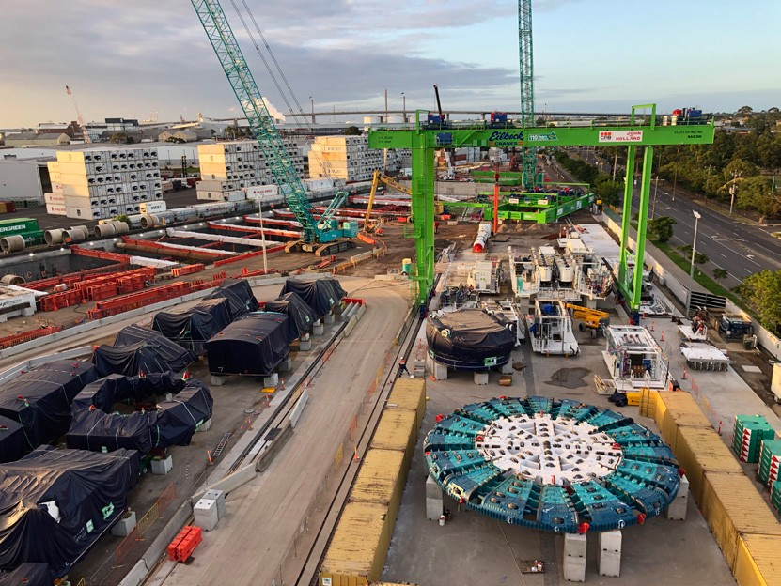
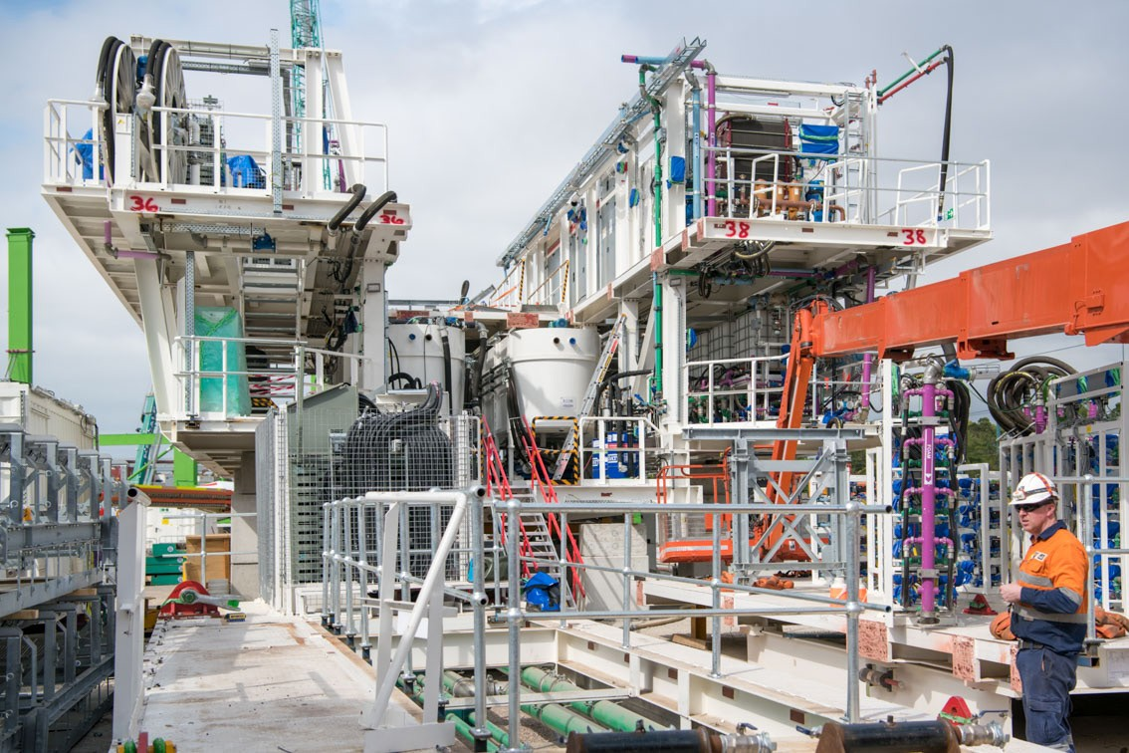
L-R: Birds eye view northern portal site and the first TBM gantry (tunnel building factory) awaiting assembly.

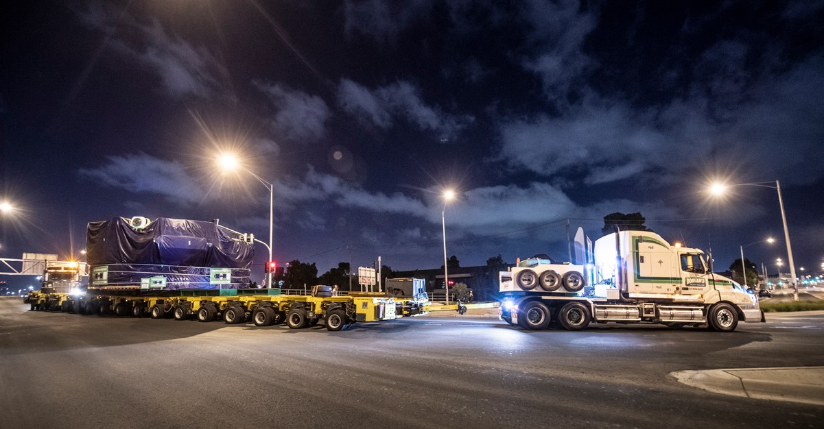
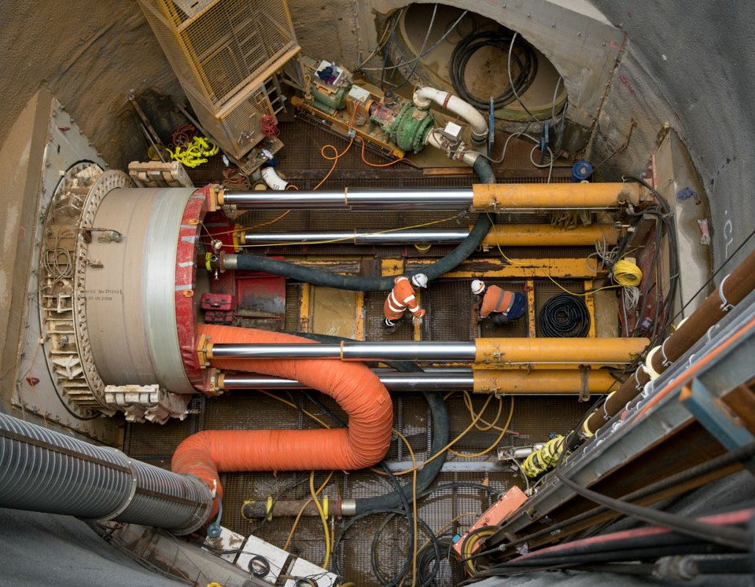
L-R: Parts of the TBM on route from the Port to the northern portal and North Yarra Main Sewer works in progress.

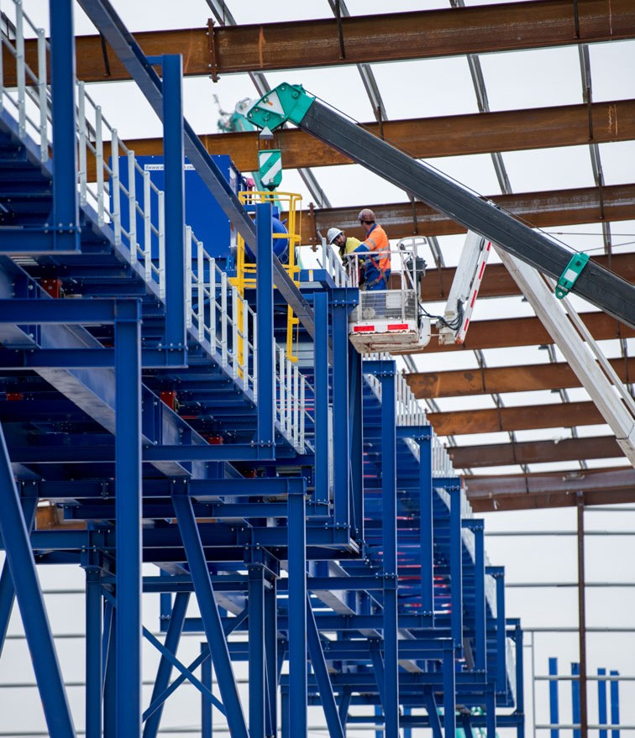
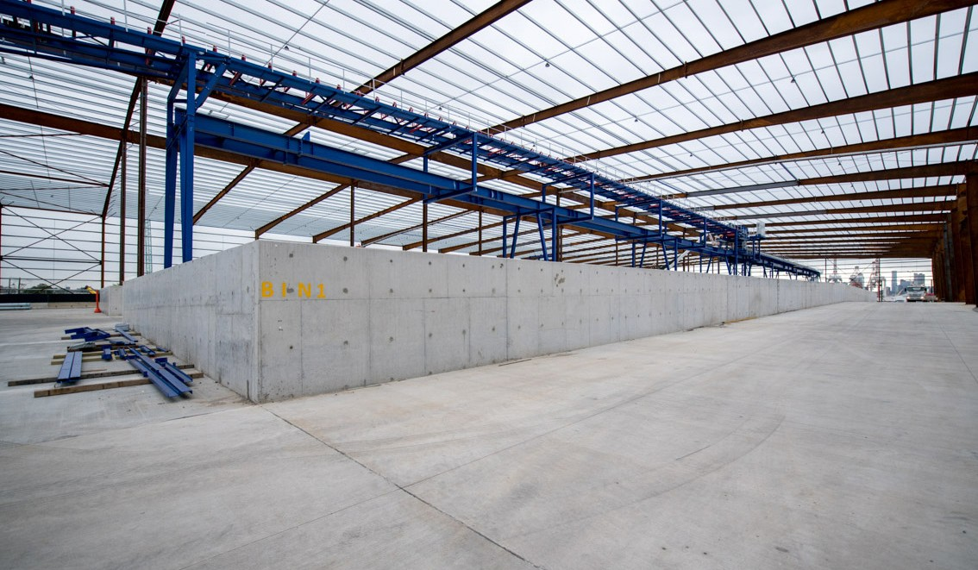
Spoil handling shed and conveyor taking shape on the site at 221 Whitehall Street.

02. Northern portal works
The northern portal site works are focused on getting our TBM’s Bella and Vida into the ground and on their way. The area will be busy over the next month as we:
- Complete the assembly of the 500 tonne gantry crane. The 500 tonne and 250 tonne cranes will be used to lift Bella and Vida into place within the launch shaft and once tunnelling starts, place the tunnel segments behind them; and
- Complete the final stages of excavation and then install the lining for the launch area.

03. Tunnelling Hub at 221 Whitehall Street
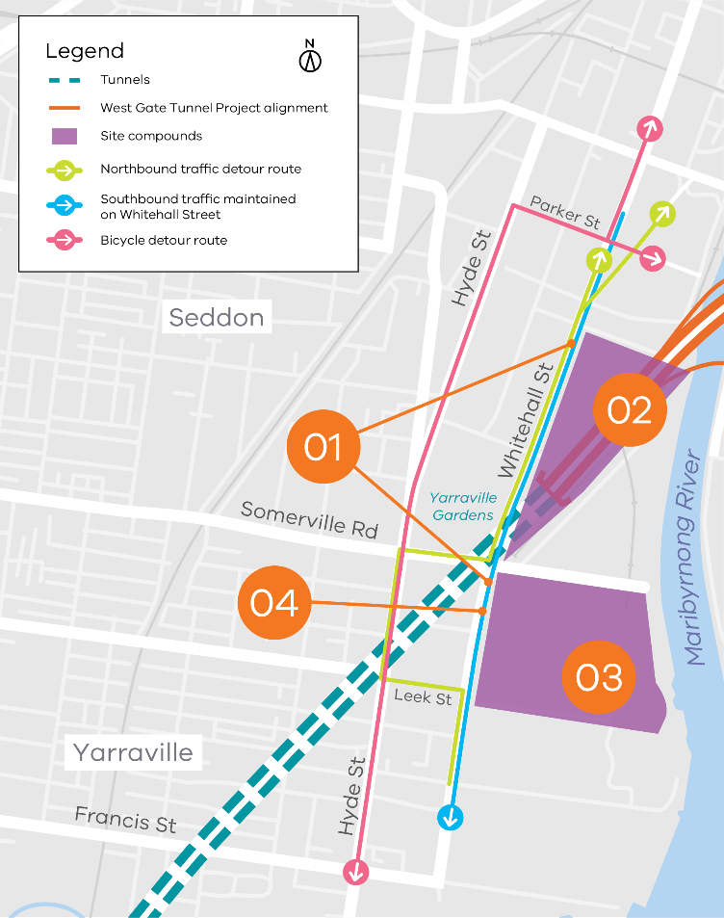
The big shed for spoil handling is almost ready and we’ve recently installed the footbridge over Somerville Road. In March we will:
- Install the external cladding to enclose the current steel frame and complete the shed; and
- Fit the covered conveyor that will carry the tunnel spoil into the shed over Somerville Road toward the end of March or early April.
04. New traffic signals on Whitehall Street
Through March and April, the team will commence the installation of the new set of traffic signals at 221 Whitehall Street.
These will assist project vehicle movements for the site once tunnelling begins and also help to maintain traffic flow on Whitehall Street in this area.
Temporary changes such as lane and road closures may be required at times and works will be both day and night.
Please observe traffic management signage and traffic controllers at each location.

Maribyrnong River Crossing
Works will be commencing this month in preparation for the new Maribyrnong River bridges. Utility relocations on Maribyrnong, Lyons, Whitehall and Youell Streets will continue through March and piling works will also get underway on Maribyrnong Street. We will be in touch with adjacent businesses and residents with more details.
Monitoring Instrumentation
From early March, we will commence works on groundwater recharge near the tunnel alignment. The recharge system is designed to manage existing groundwater levels around the tunnel during construction. Well development will include localised traffic and parking restrictions and directly impacted residents and business will be engaged individually.
Information about wells and/or extraction bores on properties is useful before we commence tunnelling so please contact us if you are aware of a well located on your property.

Just a couple of reminders:
Youell Street East – no stopping zone
Last year we advised that car parking on Youell Street between Whitehall Street and Maribyrnong Street, will be removed for the duration of the project to allow safe access to the sites. A section of parking was removed last year and the remaining 16 parking spaces will be removed in March.

Property Condition Surveys – tunnel alignment
If you have received a letter of invitation over the last 12 months to have a property condition survey completed for your property but have not yet actioned, please contact the project team to arrange. If you have already completed the survey or have an appointment booked, thanks for your assistance. Please note this is for only for properties in the tunnel alignment boundary. If you have any questions in regards to this, please contact us to discuss.
Please note that works are subject to change and may be rescheduled in the event of bad weather or updates to the construction schedule. For more information about the upcoming works and traffic changes, please contact us.
Contact us
Please contact us if you have any questions or feedback about these works.

westgatetunnelproject.vic.gov.au info@wgta.vic.gov.au
1800 105 105
facebook.com/westgatetunnelproject
@westgatetunnel
West Gate Tunnel Project GPO Box 4509
Melbourne Victoria 3001
Interpreter service: 13 14 50

