Transport

Overview
This chapter provides an assessment of the transport connectivity impacts associated with the construction and operation of Melbourne Metro. The chapter is based on the impact assessment presented in Technical Appendix D Transport. All relevant references are provided in Technical Appendix D.

Construction
The Melbourne Metro alignment traverses a dense, inner city transport network that includes motorways, major arterial roads, key local roads, residential streets, the core of the metropolitan rail network, tram routes including the city’s busiest tram corridor, high frequency and well-patronised bus routes, and major cycling trails and routes.
With most construction activities taking place beneath ground, the impacts of Melbourne Metro on traffic operations and transport connectivity would largely be confined to vehicle movements between key construction works sites along the alignment, primarily the stations and TBM launch/retrieval locations.
The main construction-related impacts would be:
- Truck movements associated with the construction of the proposed tunnels and stations, in particular for removing spoil and delivering materials and equipment. While truck movements would generally be planned to occur outside peak periods, they would add to existing local traffic and affect transport operations to a modest degree.
- The temporary closure of a number of major roads for extended periods, which would impact on local traffic patterns, bus and tram operations, and cycling and walking activities and would also include some re-routing of tram services.
- The presence of a large construction workforce. Workers would need to drive or be transported to and from their workplace, which could potentially have an impact on the local and wider road network at times.
Managing these impacts would be a crucial component in the delivery of Melbourne Metro. With the adoption of the proposed mitigation measures to meet the recommended Environmental Performance Requirements, potential impacts would be minimised. Proposed mitigation measures include implementation of detailed transport management plans that would include measures to direct traffic away from construction work sites to alternative routes and minimise truck movements during peak periods and through residential areas at night. The plans would also identify construction traffic routes for each precinct with the aim of moving this traffic away from local areas to the arterial road/motorway network as quickly as possible.

Road Transport
Following the implementation of the recommended Environmental Performance Requirements, many of the transport risks associated with the project have been assessed as medium or low. However, the closure of Grattan Street (in the Parkville station precinct) and the closure of Domain Road and the reduction of St Kilda Road to one lane of road traffic in each direction during construction (in the Domain station precinct) would have a significant impact on traffic operations within these precincts, with some impacts also likely across the wider network. While transport management plans would encourage traffic to divert around the works areas and use alternative routes, the limited options available in these areas mean that there is likely to be congestion and delays in both precincts during construction.
There would be moderate impacts from increased truck movements in the three precincts where the greatest volumes of spoil from excavation works would need to be transported away from the construction work sites: Precinct 1 - Tunnels (in relation to the potential Fawkner Park construction work site), Precinct 3 - Arden station and Precinct 7 - Domain station.
In some precincts, construction activities would result in the temporary loss of car parks.

Public Transport
Potentially, there would be increased congestion and reduced connectivity for public transport modes in the CBD North and CBD South station precincts, where construction activities and route adjustments could lead to some delays to tram services from time to time. Impacts on these services – and to bus and tram services in other precincts – would be minimised through the adoption of localised measures to manage impacts on specific services and to minimise disruption to train, tram and bus passengers during the construction period.
The closure of Grattan Street east of Royal Parade would require re-routing of the 401, 402, 403 and 505 bus services around the construction works site. As a result of these altered routes and increased traffic congestion through the precinct, bus travel times would be up to four minutes longer during peak periods.

Active Transport (Pedestrians and Cyclists)
Impacts on walking and cycling routes during construction would vary across the Melbourne Metro alignment. In the CBD North and South precincts, the very high levels of walking and cycling mean that construction activities would need to be carefully managed to minimise disruption to pedestrians and cyclists, especially during peak periods. In the Domain station precinct, the high volumes of bicycle traffic along St Kilda Road during weekdays mean that cyclists would be travelling on temporary facilities (such as temporary paths around the construction work sites) during the construction period due to road closures, construction activities and construction work sites.
In all precincts, suitable measures would be implemented to direct pedestrian and bicycle movements safely and effectively around works sites and maintain walking and cycling access.

Operation – Legacy Transport Network

Road Transport
The operation of Melbourne Metro would result in a small number of permanent changes to the road network, with the main changes being:
- Grattan Street reduced to one lane in each direction between Flemington Road and Leicester Street to provide for a bus lane in each direction (Precinct 4).
- Permanent closure of part of Franklin Street between Swanston Street and Bowen Street to provide for the new access to CBD North station (Precinct 5) (permanent closure has been assessed as representative of the worst case, though other options are being evaluated).
- A three-lane each-way configuration for St Kilda Road, including a parking lane that would be available as a Clearway during peak periods, between Domain Road and Toorak Road (Precinct 7).
There are no significant forecast changes in traffic volumes within these precincts, so impacts across the network would be minimal.
In some precincts, replacement car parking would be required to offset the permanent loss of car parks or as part of the reinstatement of closed roads
post-construction.
Following the adoption of the recommended Environmental Performance Requirements and proposed mitigation measures, including active and effective community information (such as the provision of advisory signs), diversion routes and replacement car parks, the risk of these permanent changes affecting transport connectivity has been assessed as low or very low.
Overall, the future road network when Melbourne Metro is operational would be suitable, safe and appropriate to service the needs of all precincts.

Public Transport
The project provides enhanced public transport along the busy Swanston Street tram corridor, enabling the relocation of tram services to the western part of the CBD to better service this growing part of central Melbourne.
No significant changes would be required to the bus network as a result of the operation of Melbourne Metro, other than changes to the frequency of the 401 bus service from North Melbourne to Parkville. However, PTV and MMRA may undertake further reviews of the bus network and bus services to align with Melbourne Metro operations.

Active Transport (Pedestrians and Cyclists)
Pedestrian volumes would increase significantly once Melbourne Metro commences operation, particularly around the new stations.
For example, during the busiest two hours of the AM peak, over 12,000 passenger entry/exits are predicted at the new Parkville station (Precinct 4) and more than 12,400 exits are predicted at the new Domain station (Precinct 7). There is predicted to be over 28,700 entry/exits at the CBD North station (Precinct 5) (including Melbourne Central station) during the two-hour AM peak period, compared to the 2012 Melbourne Central activity of around 16,000 entry/exits. There is predicted to be nearly 70,000 entry/exits at CBD South station (Precinct 6) (including Flinders Street Station) compared to the 2012 Flinders Street Station activity of around 33,000 entry/exits during the two-hour AM peak period.
All stations would be designed to accommodate higher levels of pedestrian activity safely and efficiently, and with a high degree of comfort and amenity. Improvements to pedestrian environments would include widened footpaths, redesigned streetscapes to encourage walking and new pedestrian crossings. In addition, new DDA-compliant tram superstops in Royal Parade and St Kilda Road would improve access to the new stations and adjacent neighbourhoods, particularly for passengers with reduced mobility.
Bicycle infrastructure proposed as part of Melbourne Metro would include new segregated on-road bicycle lanes and additional bicycle parking spaces at or nearby the new stations.

Rail Network Operational Enhancements
Melbourne Metro would lead to a major reconfiguration of Melbourne’s metropolitan rail network. The reconfiguration would allow for the independent operation of all lines and release substantial additional capacity on the existing inner city network by moving the Cranbourne/Pakenham and Sunbury Lines from the existing City Loop. This increased capacity would enable more people to travel in peak periods and deliver more reliable, more frequent and less crowded services.
These developments would open up opportunities to further improve transport connectivity across all precincts. To ensure effective integration and connectivity between transport modes, PTV is likely to review the existing tram and bus networks to realign routes and better coordinate services with the reconfigured metropolitan rail network.
The transport impact assessment conducted for the EES focuses on specific transport connectivity and traffic impacts within and surrounding each precinct and not on the broader implications of the rail network reconfiguration. The implications of the network reconfiguration for train and tram services are described in Chapter 2 Project Rationale and Benefits.

EES Objectives
The EES Scoping Requirements set the following draft evaluation objective for transport:
- Transport connectivity – To enable a significant increase in the capacity of the metropolitan rail network and provide multimodal connections, while adequately managing effects of the works on the broader transport network, both during and after the construction of the project.
In accordance with this objective, an assessment of the transport connectivity impacts associated with the construction and operation of Melbourne Metro was conducted for the EES.
Using the information provided by the assessment, Environmental Performance Requirements have been recommended to manage, avoid or reduce transport connectivity impacts associated with the project.

Legislation and Policy
As discussed in Chapter 4 EES Assessment Framework and Approach, Melbourne Metro would be designed, constructed and operated in accordance with Victorian legislation, policies and guidelines. The main laws and policies relevant to the project are set out in Table 8–1.
Table 8–1 Transport legislation and policy relevant to Melbourne Metro
Legislation | Policy/Guideline | Comment
State
Transport Integration Act 2010 |  | The Transport Integration Act 2010 establishes a framework for an integrated and sustainable transport system for Victoria and requires that all decisions affecting the transport system consider the principles and objectives set out in the Act.  The Act provides the basis for assessing the consistency of Melbourne Metro with transport system objectives relating to:  - Social and economic inclusion  - Economic prosperity  - Environmental sustainability  - Integration of transport and land use  - Efficiency, coordination and reliability  - Safety, health and wellbeing.  Transport planning decisions relating to Melbourne Metro must have regard to current and future impact on land use and include a triple bottom line assessment including costs, benefits and sustainability.  Section 63 requires that the department responsible for administering the Act undertakes integrated transport planning to guide the development of the transport network in Victoria. The Department is developing a network development strategy, which would align with both a refresh of Plan Melbourne (anticipated to be finalised in mid-2016) and the Regional Statement, to provide integrated guidance on land use and transport planning for Victoria.
Major Transport Projects Facilitation Act 2009 |  | Pursuant to the Premier's declaration (gazetted 4 September 2015), Melbourne Metro would utilise the Act’s suite of project delivery powers.  Melbourne Metro is a 'declared project' under the Act other than for Part 3 - Assessment and Approval of Major Transport Projects and Part 8 - Assessment Committees.  The Act provides project delivery powers regarding land assembly and project delivery. It is anticipated that when the planning approval for Melbourne Metro is gazetted, a Project Area would be declared under the Act for the project delivery powers.
Road Management Act 2004 |  | The Road Management Act 2004 provides the statutory framework for VicRoads and local councils to manage the Victorian road network and the coordination of road reserves for roadways, pathways, infrastructure and similar purposes.
 | Network Development Plan – Metropolitan Rail, December 2012 | The Network Development Plan, developed by PTV, sets out in detail how Melbourne's railway system is expected to evolve and grow over the short, medium and long-term. The plan sets out four sequential stages for the network's development, with the second stage being the introduction of a metro-style train system for Melbourne. This system, enabled by construction of a major cross-city rail tunnel, is identified as the best way to overcome the network's capacity constraints and enable later expansion of the network.
Local
 | Melbourne Transport Strategy 2012, City of Melbourne  Sustainable Transport Strategy 2014, City of Port Phillip  Sustainable Transport Policy 2013, City of Stonnington | These strategies aim to coordinate and integrate transport initiatives with strategic land use planning and policy, achieve more connected and liveable communities, support more sustainable travel choices and reduce car-based travel. Melbourne Metro would give consideration to these strategies.  A range of other local government strategies would also be considered, including local walking and cycling plans, car parking plans and precinct plans.

Methodology

Assessment Approach
The approach adopted for the transport impact assessment included:
- Undertaking desktop assessments to source and collate existing data and identify locations where additional transport data collection was required
- Reviewing and updating information about existing transport conditions (see Section 8.4.2) and conducting site inspections to confirm these conditions for all transport modes: road, rail, bus, tram and active transport (cycling and walking)
- Using transport models to assess the impacts of the construction of Melbourne Metro on transport operations in each precinct in 2021 (when construction activity is expected to be significant) against existing conditions
- Assessing anticipated traffic and transport conditions in 2031 (five years after Melbourne Metro would commence operations) against existing conditions and future conditions without Melbourne Metro, using transport models to determine the operational impacts of Melbourne Metro.
The analysis of each transport mode takes into consideration the anticipated growth in population, jobs and travel demand in the vicinity of Melbourne Metro. The analysis has adopted different approaches for each precinct and each mode, as the type of information available for each mode and location is different and the assessment needs to be tailored to the project needs and the available data. Details of the different approaches adopted are provided in Section 4 of Technical Appendix D.
The transport impact assessment at Technical Appendix D has been independently peer reviewed.

Baseline and Background Data
Data sources used in the transport impact assessment included:
- Public transport data provided by PTV
- Surface level pedestrian data sourced from the City of Melbourne
- Pedestrian counts undertaken in July 2015
- Road network configuration and road traffic data sourced from VicRoads and local councils (with additional counts arranged where data were not available)
- Cycling data sourced from the VicRoads, local councils and Bicycle Network Victoria (where available)
- Parking and access information sourced from the relevant authority
- Site inspections to confirm data collected from the various sources.

Transport Modelling
A number of modelling tools have been used to test and understand current and anticipated traffic conditions within each precinct. Different modelling tools have been applied at different locations, depending on the precinct’s complexity and the type of issues to be addressed. These tools include the State Government’s strategic transport model, Victorian Integrated Transport Model (VITM), and a number of micro-simulation, mesoscopic and hybrid traffic models.
The models have been tailored to assess impacts within each precinct for four scenarios:
- Base year models to reflect existing conditions
- Future conditions models to reflect conditions in year 2021 with and without Melbourne Metro construction activities
- Future conditions models to reflect the 2031 No Project Case – to understand the differences between existing conditions and conditions in 2031 if Melbourne Metro is not built
- Future conditions models to reflect the 2031 Concept Design – to understand the differences between conditions in 2031 if Melbourne Metro was not built and conditions in 2031 with Melbourne Metro operating.
Pedestrian modelling has also been undertaken to determine the changes in pedestrian activity in the vicinity of the stations where pedestrian demands are expected to be high including Precinct 4 - Parkville, Precinct 5 - CBD North, Precinct 6 - CBD South and Precinct 7 - Domain.
Further details of the modelling tools used and the approach taken to traffic modelling are provided in Section 4 of Technical Appendix D.
In addition, the transport modelling analysis outlined in the Technical Appendix D and associated appendices have been independently peer reviewed.

Existing Conditions
Existing transport network conditions across the Melbourne Metro alignment are summarised in the following sections. Conditions within each precinct are described in detail in Technical Appendix D Transport and discussed where relevant to Melbourne Metro’s construction and operation in Sections 8.8 to 8.16.

Public Transport
The Melbourne Metro alignment traverses a dense and well-patronised inner city public transport network.
The metropolitan rail network (including the City Loop underground rail lines) runs adjacent to the Melbourne Metro alignment at a number of places. Surface level stations are located at South Kensington (Precinct 2), North Melbourne (near Precinct 3), Flinders Street (Precinct 6), South Yarra (just outside Precinct 8) and West Footscray (Precinct 9). The underground Melbourne Central station is located in Precinct 5 adjacent to the proposed CBD North station.
Flinders Street and Melbourne Central stations are Melbourne’s busiest and third busiest stations by annual patronage.
The metropolitan tram network features in most precincts and includes SmartRoads tram priority routes, the Free Tram Zone (Precincts 5 and 6), a major tram interchange (in Precinct 7) and some of the most popular tram services in the city (such as those operating along Swanston Street, St Kilda Road and Royal Parade). Melbourne’s busiest tram corridor (the St Kilda Road – Swanston Street corridor) runs through Precincts 5, 6 and 7. Precinct 6 has the highest volume of tram routes serving the local area across the whole of Melbourne.
The metropolitan bus network operates in all precincts and includes SmartRoads priority bus routes, high frequency express services and lower frequency local services. Reflecting the 37 per cent increase in bus boardings across the network since 2002-03, some of the routes that intersect or are adjacent to the Melbourne Metro alignment (such as route 401 in Precinct 4 and near Precinct 3 and route 220 in Precinct 7) have recorded significant increases in patronage in recent years.

Road Network
The Melbourne Metro alignment traverses a dense inner city road network that comprises motorways, major arterial roads, key local roads and residential streets.
In some precincts (such as Precinct 2 - Western portal and Precinct 3 - Arden station), the network has few major roads and relatively low traffic volumes due to the industrial nature of the area. In other precincts (such as Precinct 4 - Parkville station and Precinct 7 - Domain station), large volumes of traffic use major roads such as Royal Parade and St Kilda Road across the day, with particularly heavy traffic flows at peak periods. Precincts 5 and 6 - CBD North and CBD South stations are located in the busiest parts of the central city, with large volumes of traffic moving along Victoria Street in the north and Flinders Street in the south.
In recent years, there has been a relatively small growth in Vehicle Kilometres Travelled (VKT) in the inner areas of metropolitan Melbourne, with most growth occurring on major arterial roads and motorways. In the CBD, traffic volumes have shown almost zero growth over the last 10 to 15 years.
Managing Melbourne’s roads
VicRoads manages Melbourne’s road network through a defined road hierarchy that includes:
- Preferred Traffic Routes – where traffic is encouraged to travel as a first priority and typically these are arterial roads
- Traffic Routes – where traffic is also encouraged to travel as a priority compared to other modes. Though not arterial roads, these routes have a strong traffic network connectivity function
- Routes where other road users are given priority as appropriate – such as Bus Priority Route, Tram Priority Route, Bicycle Priority Route and Pedestrian Priority Route.
Each municipality across Melbourne includes roads defined according to this structure, and roads are managed (by VicRoads or local Councils) to give effect to this policy.
Road Use Hierarchy Maps showing the priority modes operating on each road in the Cities of Melbourne, Port Phillip, Stonnington and Maribyrnong are included in Technical Appendix D.
SmartRoads is a plan for managing the many competing demands for arterial road space in Melbourne. The plan links transport decisions with land use planning and provides guiding principles for road use by transport mode, place of activity and time of day. For example, at peak periods, buses or trams are given priority on some roads. Other roads are assigned to provide cycling access to train stations or activity centres.

Active Transport

Cycling
Cycling is an increasingly popular travel mode in Melbourne, with more people choosing to commute to work by bicycle. Bicycle use in the inner and middle suburbs of Melbourne has increased significantly over the last decade. Peak bicycle travel periods across the busiest routes are on weekdays at around 9 am and 6 pm.
Across the Melbourne Metro alignment, most precincts have on-road and off-road bicycle routes of varying levels of amenity and legibility. Major cycle routes (including the Capital City Trail) and sections of the Principal Bicycle Network run through or adjacent to a number of precincts. In some places (notably Precinct 4 - Parkville station and Precinct 7 - Domain station), cycling is becoming a significant and growing transport mode. The CBD North and South station precincts include some of Melbourne’s most developed and utilised bicycle infrastructure. The CBD South station precinct is one of Melbourne’s busiest bicycle activity areas during weekday commuting peak hours.

Walking
Between 2001 and 2011, the number of people walking to work in Melbourne increased by 50 per cent, and walking now accounts for 3.4 per cent of all trips made to work. This does not include people who walk as part of their journeys to work, such as to/from a train station.
Pedestrian movements have increased significantly in the CBD and are predicted to grow further. Pedestrian volumes are particularly high in the CBD North and CBD South station precincts associated with the major attractions in those areas and the availability of Flinders Street Station and Melbourne Central station.

Risk Assessment
An Environmental Risk Assessment has been completed for the transport connectivity impacts of Melbourne Metro. Further information about the risk assessment approach adopted for Melbourne Metro is included in Chapter 4 EES Assessment Framework and Approach.
Impact assessment must be informed by risk assessment so that the level of proposed mitigation action relates to the likelihood of an adverse impact occurring.
The impact assessment focused on those risks that were assessed as having an initial risk level of medium or above. As a result of the impact assessment, project-specific Environmental Performance Requirements – combined with the implementation of identified mitigation measures to achieve the Environmental Performance Requirements (such as the preparation of detailed transport management plans) − have been recommended to reduce the identified impacts.
Effective implementation of these requirements would be expected to reduce the residual risk ratings of all potential events to medium, low or very low. This includes the impacts of permanent road changes.
Transport connectivity risks associated with Melbourne Metro with a residual risk rating of medium or above are shown in Table 8–2. A full list of transport connectivity risks, showing the initial and residual risk rating of each risk, is provided in Technical Appendix B Environmental Risk Assessment Report and in Technical Appendix D Transport.
The recommended Environmental Performance Requirements are listed in Section 8.17.
Table 8–2 Transport connectivity risks
Impact pathway |  | Project phase | Precincts | Residual risk rating
Activity | Potential event
Construction activities impeding traffic flow | Increased congestion and reduced connectivity for all transport modes within the vicinity of the project area at the western portal and diverted traffic impacts on local residents | Construction | 2 - Western Portal | Medium
Construction activities impeding traffic flow | Increased congestion and reduced connectivity for transport modes within the vicinity of Melbourne Metro | Construction | 5 - CBD North station  6 - CBD South station | Medium
Construction activities impeding traffic flow | Increased congestion and reduced connectivity for transport modes within the vicinity of Melbourne Metro as a result of road closures | Construction | 4 - Parkville station  7 - Domain station | Medium
Trucks removing tunnel spoil increase congestion levels in key parts of the network | Increased levels of heavy trucks on city streets across day and night would affect amenity and traffic operations, in all precincts where spoil is to be removed | Construction | 1 - Tunnels  3 - Arden station  7 - Domain station | Medium

Impact Assessment

Construction
The main transport impacts during Melbourne Metro’s construction would be associated with the additional traffic generated by construction activities, the temporary closure of local roads and changed traffic conditions. The assessment of transport impacts assumes that:
- Onsite parking for the Melbourne Metro workforce would be kept to a minimum, especially in the CBD
- Access through each construction work site would be maintained at all times for emergency vehicles
- Pedestrian and cycling connections would be maintained during construction wherever possible
- Access to businesses and residences near construction work sites would be maintained.

Additional Truck and Traffic Movements
Melbourne Metro would be expected to generate a large amount of spoil that would need to be removed from construction areas by truck and transported elsewhere for disposal (see Chapter 20 Contaminated Land and Spoil Management). Materials and equipment would also need to be delivered to construction work sites by truck. These activities would generate additional truck movements, increasing existing traffic activity in areas surrounding the construction work sites – potentially disrupting local traffic – and having amenity impacts on nearby residents and businesses.
The presence of a large onsite construction workforce (approximately 1,442 persons across the various construction work sites) would be likely to add to existing traffic activity and parking demand, potentially affecting the operation of the broader transport network on occasions.
While construction activity would occur mainly outside peak travel periods (and mainly during daytime in residential areas), there would be some impacts on the transport network’s operations at certain times.
Managing the impacts of additional construction-related traffic on local streets (and on the road network more broadly) is a crucial component of Melbourne Metro’s delivery. Detailed transport management plans would be implemented in each precinct to minimise the disruption to traffic caused by construction activities. These plans would include measures designed to:
- Manage transport movements around construction work sites during the construction period
- Minimise truck movements during peak periods to avoid adverse impacts on peak period traffic
- Divert traffic to alternative routes and/or encourage motorists to use alternative routes
- Minimise truck movements at night time to reduce adverse impacts on residents.
These plans would also identify construction traffic routes to direct this traffic away from local streets and to the arterial road/freeway network as quickly as possible. Indicative construction traffic routes have been proposed for each precinct and are provided in Technical Appendix D.

Road Closures
The closure of roads would have an impact on traffic patterns in five precincts:
- Precinct 2 - Western portal: the closure of Childers Street to enable the construction of the western portal would impact on local traffic patterns, particularly activity associated with the 50 Lloyd Street Business Estate, as well as pedestrian and bicycle movements through the area
- Precinct 3 - Arden station: as the Arden station site would be a major construction work site and a major tunnel spoil removal site, construction traffic would impact local transport operations for the duration of the works
- Precinct 4 - Parkville station: the closure of Grattan Street to the east of Royal Parade to enable the construction of Parkville station would impact local traffic patterns, bus and tram operations, and pedestrian and cycling connections for the duration of the closure
- Precinct 5 - CBD North station: the closure of Franklin Street to the east of Swanston Street to enable the construction of CBD North station would impact local traffic patterns, tram operations and pedestrian and bicycle routes, particularly during the early construction period
- Precinct 7 - Domain station: the closure of Domain Road (between St Kilda Road and Dallas Brooks Drive) and the reduction of St Kilda Road to a single lane of motor vehicle traffic in each direction (between Domain Road and Toorak Road) adjacent to the construction works would have a significant impact on traffic patterns, tram operations, and pedestrian and bicycle movements for the duration of the closures.
These impacts are described in greater detail within each precinct. Traffic management and travel demand management tools would be used to discourage traffic from travelling through these areas, with potential measures including:
- Publicising closures well ahead of the commencement of works and the closure of roads
- Identifying alternative routes around construction work sites
- Giving advance notice to local residents, businesses and motorists of the upcoming works and expected travel delays via media and roadside variable message signs
- Modifying traffic signal timings to prioritise preferred travel routes and optimise travel times
- Encouraging people to consider using non-car transport modes for all or part of their regular trips.
These measures would be developed in collaboration with PTV, VicRoads and the relevant local Councils.
More broadly, the combination and timing of these road closures could potentially result in a wider redistribution of traffic across the road network. In practice, some current users of these roads would adjust their travel patterns by using other transport modes or changing the time of their journeys.

Loss of Car Parking
In some precincts such as Precinct 2 - Western portal and Precinct 4 - Parkville station, construction activities would result in the temporary loss of car parks. The Melbourne Metro contractor’s CEMP would include measures to minimise the impact of the loss of car parking on local businesses.

Public Transport Impacts
Construction impacts on public transport operations vary across the Melbourne Metro alignment. In precincts where there are particularly high levels of public transport services and patronage (such as Precincts 4, 5, 6 and 7), the impacts are expected to be moderate, with some services being re-routed temporarily or disrupted for short periods of time. The most significant impacts would be the potential re-routing of route 401, 402, 403 and 505 bus services (Precinct 4) and the re-routing of the route 8 tram from Domain Road to Toorak Road West (Precinct 7). In precincts such as Precincts 2 and 3 the impacts would be minimal.
Impacts would be minimised by achieving the recommended Environmental Performance Requirements and implementing the proposed mitigation measures. These measures would include the adoption of localised measures to manage impacts on specific tram and bus services.

Active Transport Impacts
Impacts on walking and cycling routes and facilities would also vary across the Melbourne Metro alignment. In all precincts, suitable measures would be implemented as a result of the recommended Environmental Performance Requirements to direct pedestrian and bicycle movements safely and effectively around construction work sites and maintain walking and cycling access to train stations, bus stops and activity centres.

Operation – Legacy Transport Network

Changes to the Road Network
Melbourne Metro would result in a number of permanent changes to the road network. The main changes and their broader implications are summarised in Table 8-3 and discussed further within the relevant precincts. The risk of these changes adversely affecting network connectivity has been assessed as low.
Table 8–3 Changes to the road network as a result of Melbourne Metro
Location | Changes to road network | Network implications*
Precinct 4 - Parkville station | Grattan Street reduced to one lane in each direction between Flemington Road and Leicester Street.  Royal Parade, southbound, no right turn into Grattan Street. | Reduction in traffic volumes along Grattan Street, between Flemington Road and Swanston Street.  General reduction in traffic along the east-west route centred on Grattan Street and Wreckyn Street.  Some increase in east-west traffic along Victoria Street.  Some increase in north-south traffic along Swanston Street and Rathdowne Street to the north of Victoria Street.  No major increases on other roads in the area.
Precinct 5 - CBD North station | Permanent closure of Franklin Street east of Swanston Street. | No significant changes in traffic volumes.
Precinct 7 - Domain station | Reconfiguration of St Kilda Road between Domain Road and Toorak Road to optimise the thoroughfare for all modes of traffic. | Some reduction in traffic volumes in both directions along St Kilda Road in the AM and PM peak periods.  No major increases on other roads in the area.  Better bicycle facilities that would enhance safety and capacity on this bicycle priority route.
* These implications have been derived from traffic modelling of the road network changes, comparing conditions in 2031 with and without Melbourne Metro. The results of this modelling are provided in greater detail in Technical Appendix D Transport.

Replacement Car Parking
In some precincts, replacement car parking would be provided to offset the permanent loss of car parks or as part of the reinstatement of closed roads post-construction. The recommended Environmental Performance Requirements provide for reducing the permanent loss of parking and retaining or replacing loading zones to service the needs of existing businesses.

Public Transport

Rail Network
Melbourne Metro would lead to a major reconfiguration of the Melbourne metropolitan rail network. The reconfiguration would allow for the independent operation of all lines and support the transformation of the rail network into a metro style service with the capacity to move more people in peak periods and deliver more reliable, more frequent and less crowded services.
The implications of the rail network reconfiguration for train and tram services are described in Chapter 2 Project Rationale and Benefits.

Tram and Bus Network
The Melbourne Metro tunnels would facilitate changes to the tram network in the Melbourne CBD, as customers would be less reliant on the Swanston Street corridor for access between St Kilda Road, Parkville and the CBD − resulting in spare tram capacity along Swanston Street. This creates the opportunity to redistribute spare tram capacity towards the western end of CBD and provide direct connections from Melbourne Metro to the inner north and inner west tram routes to better match the supply of tram services with jobs growth and employment catchments.
No significant changes would be made to bus routes as a direct result of the operation of Melbourne Metro, other than a review of the frequency of routes 401 and 402 that are effectively replaced by the Melbourne Metro tunnels from Arden station to Parkville station. However, to maintain integration and connectivity between transport modes, PTV and MMRA would review the existing bus network to realign routes (where appropriate) and better coordinate services with the reconfigured rail network.

Active Transport
Pedestrian activity would increase significantly around the proposed new stations, with the largest increases expected around the two CBD stations and Domain station. Improvements to pedestrian environments would include widened footpaths, redesigned streetscapes to encourage walking and new pedestrian crossings.
The Urban Design Strategy developed for Melbourne Metro would ensure that stations are designed to accommodate high levels of pedestrian activity safely and efficiently, and with a high degree of comfort and amenity (see Chapter 16 Landscape and Visual).
New bicycle infrastructure would be provided as part of Melbourne Metro to improve connectivity with the reconfigured rail network, including segregated on-road bicycle lanes and bicycle parking spaces at the new stations. No significant changes would be made to the bicycle network as a result of the operation of Melbourne Metro.

Precinct 1: Tunnels

Construction
The main construction activities with the potential to impact transport connectivity in Precinct 1 are the tunnelling works, the construction of the emergency access shafts and the potential use of Fawkner Park as a major construction work site (if Fawkner Park is used as a TBM launch site along with Domain).
There are two TBM access and retrieval options for the southern sections of the tunnel works. The two southern TBM options are:
- Domain only
- Both Domain and Fawkner Park.
Discussion related to construction within the Domain precinct can be found in Section 8.14. The impacts associated with spoil extracted from the excavation of the tunnels are addressed in Precinct 3 - Arden station and Precinct 7 - Domain station.
The Concept Design proposes emergency access shafts at the north-east section of Fawkner Park, and in Queen Victoria Gardens adjacent to Linlithgow Avenue. Alternatives to the Concept Design that are considered in this EES include co-locating the emergency access shaft with a Fawkner Park TBM launch site instead of the north-east corner of the park, and locating an emergency access shaft at Tom’s Block instead of Queen Victoria Gardens.

Additional Truck and Traffic Movements
The anticipated working hours at the proposed Fawkner Park construction work site are 24-hour, 7-day operations for a period of up to 24 months. Based on the anticipated scale of spoil removal and materials delivery activities, it is expected that there would be an average of around 140 truck movements per day over that period travelling to/from the Fawkner Park construction work site (emergency access shaft and TBM launch site). If the TBM launch site is only at Domain, then the average truck movements to/from Fawkner Park would be around 20 per day over 18 months (emergency access shaft only).
The proposed Linlithgow Avenue emergency access shaft site (i.e. Queen Victoria Gardens) would generate around 20 truck movements per day over an 18 month period.
Proposed traffic routes for these construction work sites aim to provide the most direct routes to the arterial road and motorway networks for trucks and other construction traffic. For the potential Fawkner Park sites, the main access routes would be Kings Way, St Kilda Road, Toorak Road West and Punt Road. For the Queen Victoria Gardens site, the main access routes would be Linlithgow Avenue, Power Street, City Road, Batman Avenue, Swan Street and Alexandra Avenue.
All of these roads currently carry in excess of 10,000 vehicles per day, with some in excess of 30,000 vehicles per day. These proposed routes are shown in Figure 8-1 and Figure 8-2. More detailed maps and descriptions of the truck access routes are included in the Technical Appendix D.
Figure 8-1 Precinct 1 (Fawkner Park): Proposed construction vehicle access routes
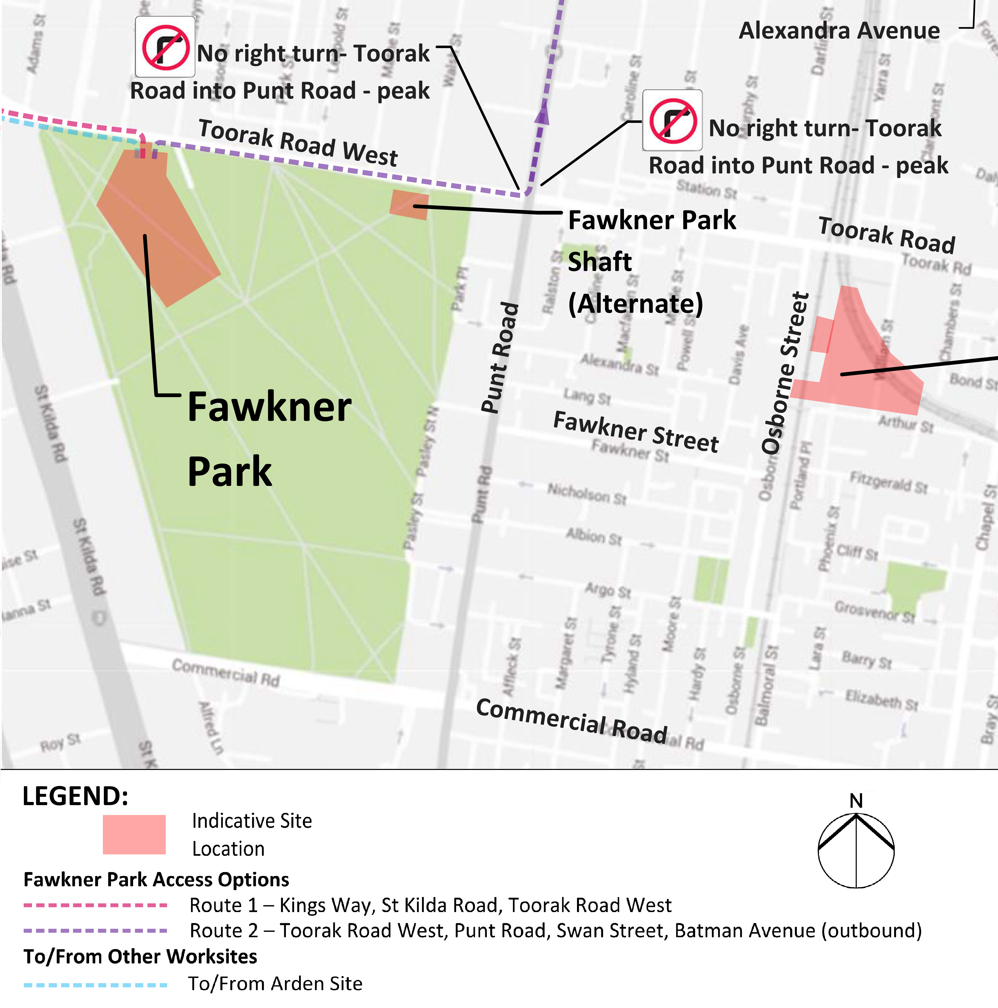
Figure 8-2 Precinct 1 (Linlithgow Avenue): Proposed construction vehicle access routes
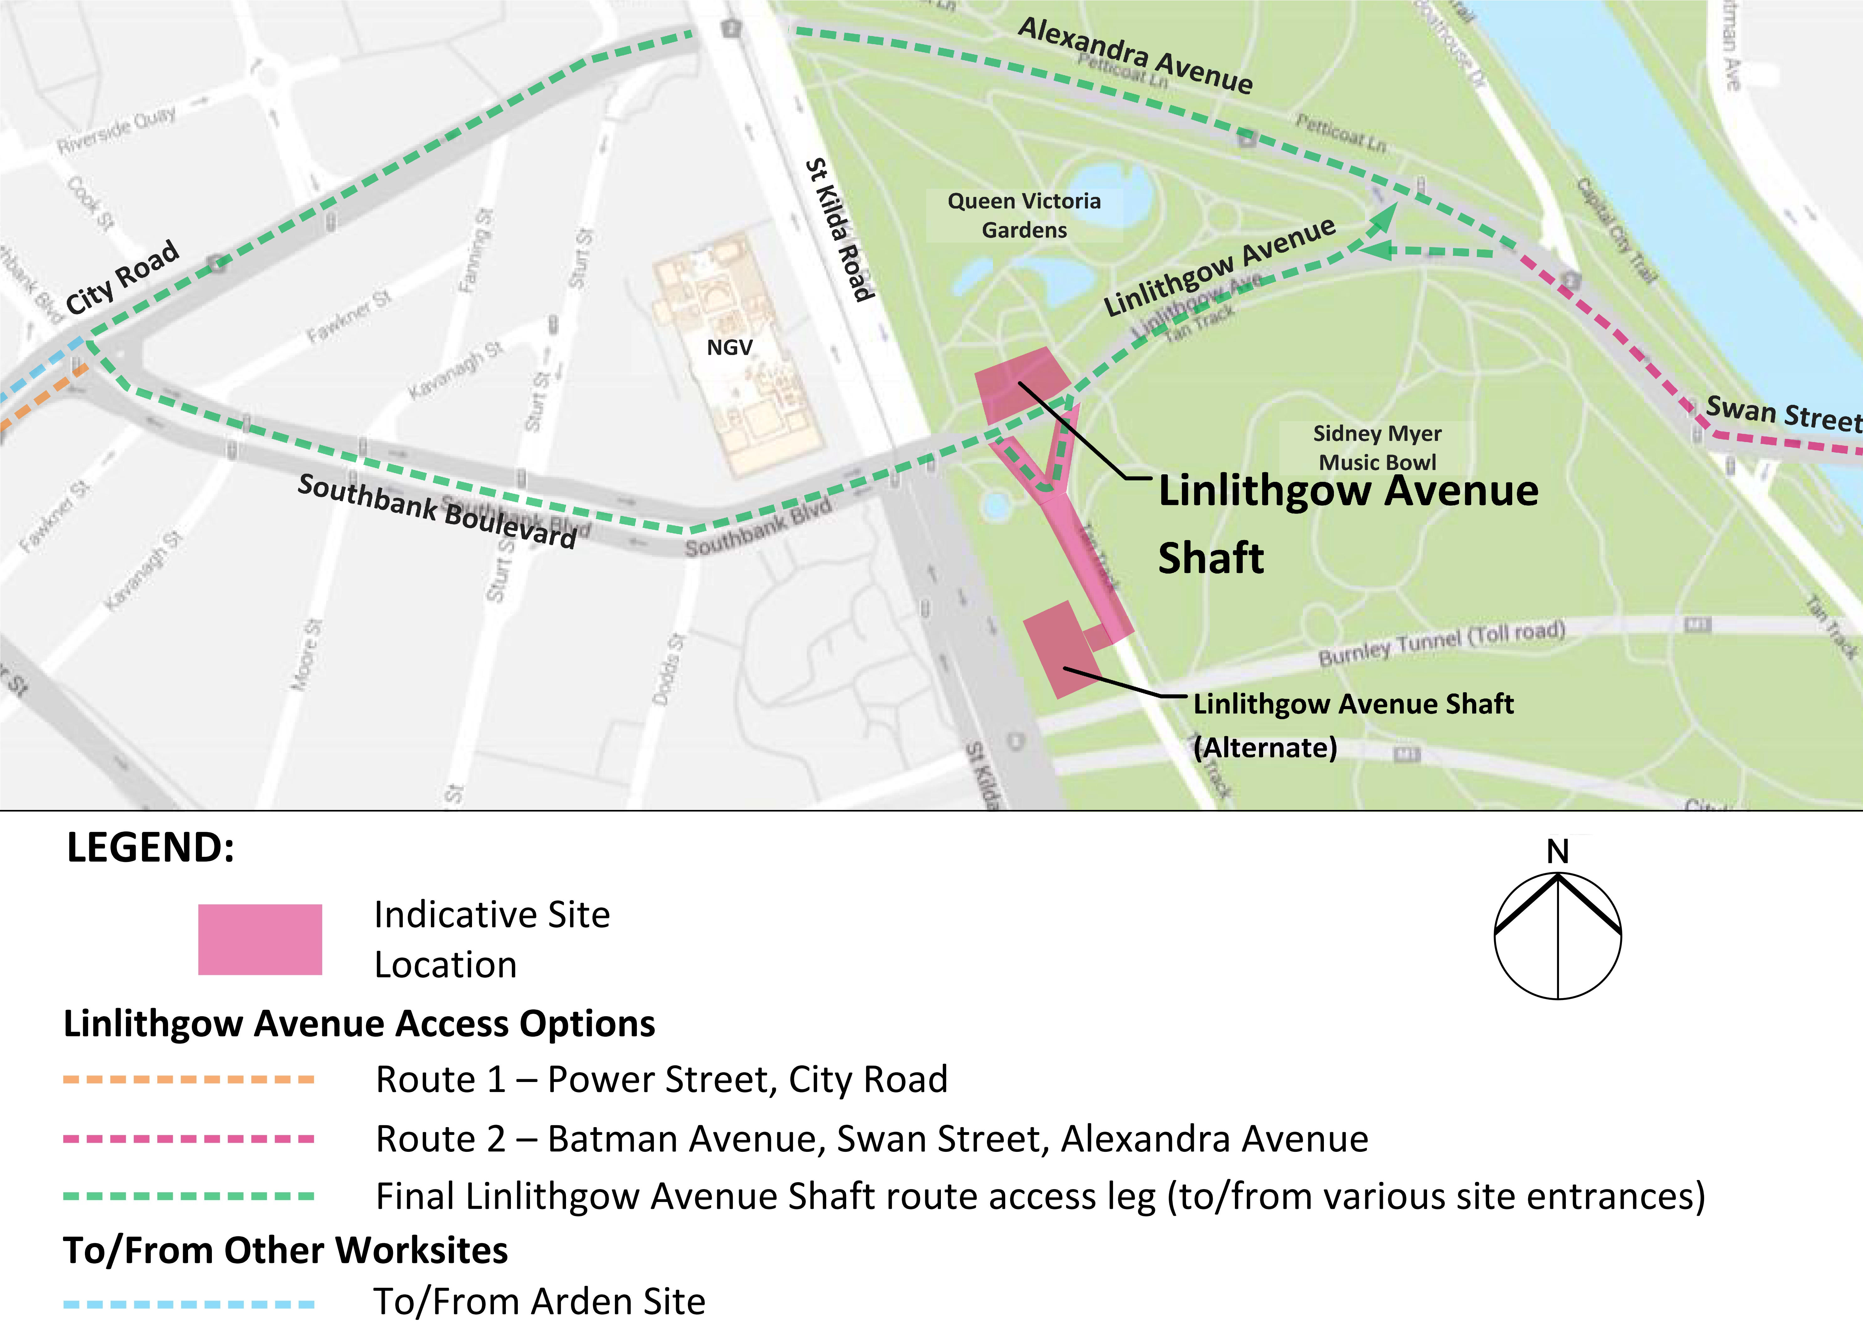
As noted in Section 8.7, impacts from additional construction traffic would be minimised through the implementation of a detailed traffic management plan that would divert traffic around the construction work sites and minimise truck movements through residential areas and during peak periods and at night time.
With the implementation of these measures, there would still be some disruptions to the local road network from additional construction traffic. However, the expected number of truck movements would be relatively small compared to daily truck volumes on the key traffic routes in the area such as St Kilda Road, Toorak Road, Domain Road and Linlithgow Avenue, all of which carry considerable daily traffic volumes. The distribution of construction traffic would be unlikely to significantly affect overall traffic operations in the area, particularly as it is expected that much of the construction traffic would occur outside of peak hours when other demands on the network are considerably lower.

Public Transport
There would be minimal impacts on public transport services from the proposed construction work sites. As a result, there are no recommended Environmental Performance Requirements for managing public transport operations in this precinct.

Active Transport
Measures would be implemented to direct pedestrians and cyclists safely around the construction work sites. Adopting these measures would ensure minimal impacts on pedestrian and bicycle movements and safety.

Operation
The existing transport networks adjacent to the Fawkner Park and Linlithgow Avenue construction work sites would be restored to their current functionality post-construction and the operation of Melbourne Metro would have minimal permanent impact on these networks. There would be no ongoing public transport or active transport impacts associated with Melbourne Metro’s operation in this precinct.

Alternative Design Options
The alternative locations for the emergency access shafts, which would involve co-locating an access shaft with a TBM launch site at Fawkner Park (if used) and a second emergency access shaft at Tom’s Block, would have no significant advantage or disadvantage over the Concept Design in terms of transport impacts.

Precinct 2: Western Portal (Kensington)

Construction
The main Melbourne Metro construction activities that could impact transport connectivity in Precinct 2 would be the major construction work site at 1-39 Hobsons Road in Kensington and the closure of Childers Street.

Additional Truck and Traffic Movements
Spoil removal and materials and equipment delivery activities would generate an average of 50 truck trips each day over 30 months travelling to and from the western portal site. Peak activity could be around 20 per cent higher (around 60 truck movements per day). TBM retrieval would also require very large trucks to access the retrieval site.
All access would be via Childers Street and Kensington Road to/from Dynon Road. Each of these roads has adequate capacity to accommodate this relatively small increase in truck numbers from the construction area.
Daily traffic volumes on many of the key access routes are quite high. For example, around 9,500 vehicles per day use Kensington Road and around 33,500 vehicles per day use Dynon Road. Even if all construction trucks used Kensington Road for access to the western portal construction works site, the 50 trucks would represent less than a one per cent increase in daily volumes. As much of the truck traffic would travel outside peak periods, this volume of construction traffic is very unlikely to significantly affect overall traffic operations in the area.
The impacts of this small amount of additional traffic would be minimised through the adoption of a detailed transport management plan. This would include minimising the impacts of truck activity on nearby residential properties during construction works associated with the 50 Lloyd Street Business Estate and by minimising construction truck movements during peak periods and at night time.
Proposed construction traffic routes have been developed for the western portal precinct that take advantage of the close proximity of CityLink and a number of major arterial roads. These routes aim to move truck traffic away from local streets and to these major connections as quickly as possible. These proposed routes are shown in Figure 8-3.
Figure 8-3 Precinct 2: Proposed construction vehicle access routes

Local Road Closures
Traffic would be disrupted as a result of the closure of the eastern end of Childers Street to allow for construction of the western portal decline structure. Vehicles accessing the 50 Lloyd Street Business Estate at the end of Childers Street would be encouraged to travel via Lloyd Street. For over-height vehicles that could not negotiate the low clearance bridges on Lloyd Street, access would be via Tennyson Street, Altona Street, Ormond Street and back to Childers Street and would involve temporary removal of the existing traffic barriers. This is expected to involve around 40 vehicles each day, with the majority of these travelling during the daytime.
The anticipated timeframe for the construction of the decline structure and the reconstruction of the Childers Street connection is around 12 to 18 months. During this time, there would be an increase in the volume of traffic travelling along Tennyson, Altona and Ormond Streets. Childers Street would be closed for as short a time as possible to reduce the period that trucks from the 50 Lloyd Street Business Estate would be diverted along alternative routes. There would also be up to three temporary weekend closures of Kensington Road.

Car Parking
Carparks along Childers Street that are currently used for South Kensington station and JJ Holland Park would be occupied temporarily for construction traffic and equipment manoeuvring. Options are being investigated to provide replacement parking in the vicinity of the station to minimise impacts on rail patrons driving to the station. It is expected that the contractor would be required to provide replacement car parking in the vicinity of the station during the construction phase.

Public Transport
The nearest train station to the proposed western portal site is South Kensington, an unstaffed station located on Childers Street. Bus route 402 traverses the western end of the precinct along Kensington Road. There are no tram services operating within the precinct. There would be some short occupations during construction of the rail connections (for example, weekend and extended Saturday night occupations), which would affect the Werribee and Sunbury Lines through South Kensington station.
To manage the potential impact of construction activities on public transport operations within this precinct, an Environmental Performance Requirement is proposed which would require bus replacement services to be operated to minimise disruption to rail customers. Following the implementation of these proposed measures, there would still be a minimal impact on public transport services during the construction period.

Active Transport
There is good provision of pedestrian infrastructure in the vicinity of the western portal precinct, although amenity is sometimes poor next to major roads. There are also a number of on-road and off-road bicycle routes in the vicinity. The recommended Environmental Performance Requirements include providing pedestrian and bicycle access through JJ Holland Park and maintaining pedestrian and bicycle access to South Kensington station. Adopting these measures would ensure minimal impacts on pedestrian and bicycle movements and safety.

Operation

Changes to the Road Network
Proposed permanent changes to the road network in Precinct 2 would include:
- Childers Street would be a two-way, two-lane road with speed control devices and a roundabout near Ormond Street
- Childers Street would have parallel parking along the northern side of the road and a small number of right angle parking spaces at the western end of Childers Street and between Tennyson and Ormond Streets
- The existing closures of Tennyson Street and Ormond Street would be reinstated once the construction works no longer occupy the eastern section of Childers Street
- A shared use path along the northern side of Childers Street (within the park) between Kensington Road and Ormond Street and bicycle lanes on both sides of the road between Ormond Street and Tennyson Street.
This road layout arrangement has been developed in accordance with current design standards and makes suitable provision for all road users to move through the area safely and efficiently.

Replacement Car Parking
The changes to the configuration of Childers Street would result in a loss of 56 car parking spaces on Childers Street. The need for replacement spaces would be determined in consultation with the City of Melbourne and PTV during the detailed design phase.

Public Transport
The proposed road functional layout at South Kensington station shows a loss of around 56 car parking spaces, which would reduce the available parking for rail passengers and users of JJ Holland Park.
There would be negligible impacts on bus services in this precinct as a result of Melbourne Metro’s operation. It is possible however, that following consultation with the City of Melbourne and PTV during the detailed design phase, replacement spaces might be found for some or all of these 56 car parking spaces.

Active Transport
A shared use path would be provided along the northern side of Childers Street as part of the reconstruction of the street post-construction. This path would connect to existing paths in JJ Holland Park. The eastern section of Childers Street would include on-road bicycle lanes defined by line marking.
There would no longer be a pedestrian path on the south side of Childers Street adjacent to the rail reserve from Kensington Road to South Kensington station. To the east of South Kensington station, a 2 m wide pedestrian path would be provided along Childers Street, connecting to Tennyson Street. A new pedestrian crossing would allow access from the shared use path (on the north side of Childers Street) to the existing South Kensington station pedestrian underpass. A new pedestrian plaza would be created at the entrance to South Kensington station.

Alternative Design Option
The Concept Design for the western portal precinct proposes a shorter decline structure, and locating a TBM retrieval box in the 50 Lloyd Street Business Estate. An alternative design option would consist of a longer decline structure and locating the TBM retrieval box opposite the pavilion on Childers Street. This alternative design option for the western portal shows a change to the configuration of Childers Street relating to parking arrangements, footpath and the shared use path:
- Childers Street is proposed to be a two-way, two-lane road with speed control devices
- Childers Street is proposed to have 90 degree parking along the southern side of the road with a net reduction of around 34 parking spaces between Ormond Street and Kensington Road
- The existing closures of Tennyson Street and Ormond Street are proposed to be reinstated once the construction works no longer require the eastern section of Childers Street
- There is proposed to be a shared use path along the northern side of Childers Street (within the park) between Kensington Road and Ormond Street and bicycle lanes on both sides of the road between Ormond Street and Tennyson Street
- The existing shared use path on the south side of Childers Street is proposed to be converted to a footpath
- Landscaping would be provided on the south side of Childers Street as part of the reinstatement works.
The lost parking spaces are located on the road reserve, not on the VicTrack land, and the need for replacement spaces would need to be determined following consultation with the City of Melbourne and PTV during the detailed design phase.

Precinct 3: Arden Station

Construction
The main construction activity that may impact transport connectivity in Precinct 3 is the use of publicly owned land as a major staging and construction work site for the northern section of Melbourne Metro.

Additional Truck and Traffic Movements
As the Arden station precinct is planned to be one of the major sites for the construction of Melbourne Metro, more truck activity would be anticipated at this site than in other precincts. Activity at this site would extend over a period of around four years with 24-hour, 7-day operations and an average of approximately 260 truck trips each day for spoil removal and materials and equipment delivery. At peak activity, this could increase to around 360 truck movements per day.
While this amount of construction traffic would cause some disruptions, the roads in the vicinity of the site have sufficient capacity to accommodate the additional traffic, particularly as it would be spread across a number of routes – minimising the impact on any particular street. The trucks would then move out of the local area onto the arterial and motorway network, with most of this activity occurring outside peak periods when these roads have adequate spare capacity to accommodate the additional traffic. As current activities on the site already generate truck traffic in the area, the net impact would be considerably less than the truck generation numbers indicate.
As discussed in Section 8.7, the impacts of additional traffic would be minimised through the adoption and implementation of a detailed transport management plan, which would include minimising truck movements during peak periods and avoiding truck movements at night time, where practical.
Proposed construction traffic routes that have been developed for the Arden precinct would move truck traffic away from local streets and to major arterial roads and CityLink as quickly as possible. These proposed routes are shown in Figure 8-4.
Figure 8-4 Precinct 3: Proposed construction vehicle access routes
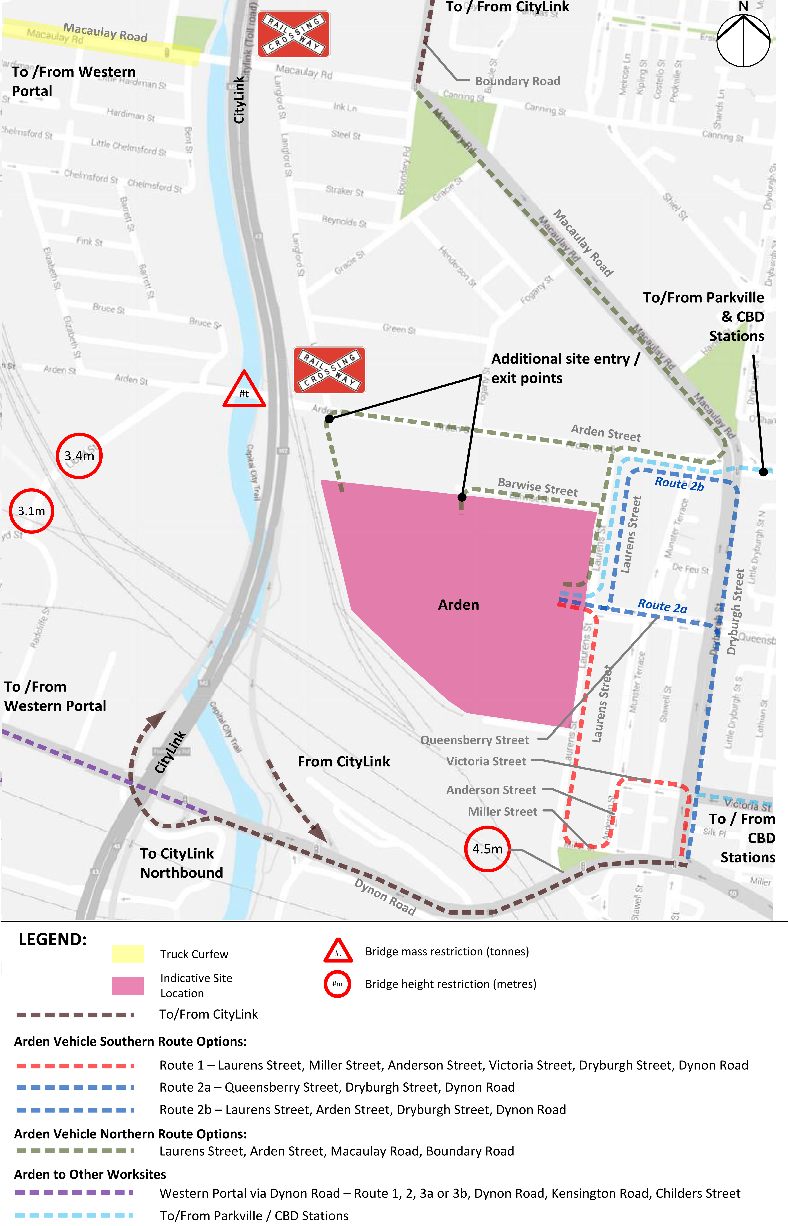
Daily traffic volumes on many of the key access routes are very high. For example, around 18,000 vehicles per day use Dryburgh Street and around 33,500 vehicles per day use Dynon Road. Even if all trucks used Dryburgh Street for access to the Arden station construction work site, the 360 trucks daily would only represent around a two per cent increase in daily volumes. As much of the truck traffic would travel outside peak periods, this volume of construction traffic is very unlikely to significantly affect overall traffic operations in the area.
Implementing transport management measures would deliver a safe and effective work site with minimal disruption to traffic and local residents.

Public Transport
There are no train stations, bus routes or tram routes within the precinct itself. Three bus services and a tram route operate just outside the precinct. There would be minimal impacts on these public transport services during Melbourne Metro’s construction. As a result, there are no recommended Environmental Performance Requirements for managing public transport operations in this precinct.

Active Transport
As the immediate area around the proposed Arden station is mostly industrial, there is currently relatively little pedestrian or bicycle infrastructure in the immediate vicinity. The bicycle network just beyond the precinct boundary is well established and includes part of the Capital City Trail (alongside Moonee Ponds Creek), local off-road paths and on-road bicycle lanes. While there would be minimal impacts on pedestrian and bicycle movements and safety in this precinct, the recommended Environmental Performance Requirements include taking suitable measures to direct pedestrian and bicycle movements safely around the construction work site and considering provision of alternative footpaths or shared paths around the construction work site to maintain pedestrian and cyclist safety.

Operation

Changes to the Road Network
The proposed future road network in Precinct 3 would include:
- On-street parallel parking along Laurens Street, including the retention of loading zones
- On-street bicycle lanes in both directions along Laurens Street
- A mid-block signalised pedestrian crossing on Laurens Street south of Barwise Street
- Provision of 20 additional right angle parking spaces along the south side of Barwise Street, adjacent to the proposed Arden station.
No changes are proposed for Arden Street, which would retain its four-lane undivided configuration with parallel parking and on-street bicycle lanes on both sides of the street.
The road layout plan for the Arden station precinct has been developed in accordance with current design standards and makes suitable provision for all road users to move through the area safely and efficiently. The future proposed development of the Arden-Macaulay precinct is likely to require further changes to the road network, but these would not be part of Melbourne Metro.

Replacement Car Parking
The recommended Environmental Performance Requirements for the operation of Melbourne Metro would include maximising the number of replacement car parking spaces along Laurens Street, including the retention or replacement of loading zones to service the needs of businesses in the precinct. The provision of a new high capacity railway station that provides connections across the broader metropolitan network would provide some compensation for any loss of parking in the precinct.

Public Transport
The proposed station at Arden would support the substantial redevelopment plans for the Arden-Macaulay precinct by providing a direct and frequent public transport connection to the Parkville precinct and the CBD. The implications of this improved connectivity are described in greater detail in Chapter 2 Project Rationale and Benefits.
There would be negligible impacts on tram and bus services in this precinct as a result of Melbourne Metro’s operation. To ensure effective integration and connectivity between transport modes, PTV and MMRA would review the existing tram and bus network in the area to realign routes, better coordinate services with the reconfigured metropolitan rail network and explore opportunities to provide tram and bus connections at Arden station.

Active Transport
Following the opening of Arden station, there is predicted to be about a 60 per cent decrease in passenger entries/exits during the AM two-hour peak period at North Melbourne station and about a 50 per cent decrease during the PM peak period (analysis based on 2031 demands). During the busiest two hours of the AM and PM peaks, a total of around 880 passenger entries and exits is predicted at Arden station, adding a large number of pedestrians to a previously industrial area with relatively poor walking infrastructure.
As noted throughout this EES, Melbourne Metro would be a catalyst for urban renewal of the area that would provide a range of commercial and housing types. Safety and amenity for pedestrians and cyclists would be an important feature of this redevelopment. In particular, the new Arden station could lead to Laurens Street being upgraded to provide a high amenity, pedestrian friendly environment (see Chapter 16 Landscape and Visual).
On-road bicycle lanes would be provided along Laurens Street and up to 50 bicycle parking spaces would be provided at the new station. The City of Melbourne and Metropolitan Planning Authority would continue to plan for urban renewal and growth in the area by investing in bicycle infrastructure to support people to ride to work, connect to public transport or travel around the Arden area.

Precinct 4: Parkville Station

Construction
The main construction activities that may impact transport connectivity in Precinct 4 are the construction of the new station and underground pedestrian connection, the closure of a section of Grattan Street and Barry Street for an extended period and Royal Parade and Elizabeth Street (north of Haymarket roundabout) being restricted to two traffic lanes in each direction during construction works.

Additional Truck and Traffic Movements
Spoil removal, along with materials and equipment delivery, in this precinct would generate an average of an additional 100 truck trips each day over four years. Peak activity would be higher at around 140 truck movements per day.
This volume of trucks would be readily accommodated by the major access roads to the precinct, with most truck activity expected to be outside peak periods when these roads have the capacity to accommodate the additional traffic without impacting on the operation of the access routes or key intersections.
Daily traffic volumes on these key access routes are very high. For example, around 18,000 vehicles per day use Grattan Street and around 24,000 vehicles per day use Royal Parade/Elizabeth Street. If all construction trucks used Royal Parade for access to the Parkville station construction work site, the 140 trucks would only represent less than a one per cent increase in daily volumes. As much of the truck traffic would travel outside peak periods, this volume of construction traffic would be unlikely to significantly affect overall traffic operations in the area.
Proposed construction traffic routes have been developed for this precinct that take advantage of the Preferred Traffic Routes and Traffic Routes within the precinct. These proposed routes are shown in Figure 8-5. The routes aim to move truck and other construction traffic away from local streets and to major connecting roads such as Flemington Road, Footscray Road, Elliott Avenue and Macarthur Road as quickly as possible.
Figure 8-5 Precinct 4: Proposed construction vehicle access routes
Access would still be required from a number of local streets, including Berkeley, Pelham, Leicester and Bouverie Streets. A number of different routes for local access movements are proposed, as there would be multiple access points to the station construction work site on Grattan Street. The contractor would be encouraged to access the site via the Grattan Street/Royal Parade intersection as much as possible.
The impacts of additional truck and construction traffic would be minimised through the implementation of a detailed transport management plan. This would include minimising truck movements during peak periods and at night time.

Local Road Closures
The construction of Parkville station would require the closure of Grattan Street between Royal Parade and Leicester Street for an extended period (Grattan Street currently carries around 18,000 vehicles per day). Royal Parade/Elizabeth Street would also be restricted to two traffic lanes, plus a tram lane and bicycle lane in each direction, during the works.
Traffic modelling indicates that the Grattan Street closure (and associated traffic management measures) would encourage traffic to divert away from the Parkville station precinct during the construction works, thereby minimising the impact on traffic operations at key intersections. However, there would be significant increases in traffic on roads in the area in the morning peak period, notably Swanston Street (near University of Melbourne) where traffic that would have travelled along Grattan Street would need to travel north and south along Swanston Street to move around the road closure. There would also be increases in traffic along Queensberry Street and Royal Parade, but the impacts on other roads such as Gatehouse Street and Elliott Avenue would be minor in the AM peak.
There would also be increased congestion at the Elgin Street/Swanston Street intersection and Cemetery Road East/College Crescent/Swanston Street roundabout. This congestion may cause additional queueing along College Crescent towards Royal Parade. Delays would occur at the north-west approach to the Haymarket roundabout (Flemington Road). Vehicles on Wreckyn Street and Grattan Street would experience longer delays, although the time differences are small in the context of an overall journey. Options are still under investigation to optimise the operation of the Haymarket roundabout and the Cemetery Road East/College Crescent/Swanston Street roundabout and reduce the delays along these key corridors.
It should be noted that a number of the roads affected are designated as SmartRoads Priority Routes for public transport (i.e. Royal Parade and Flemington Road). As such, the delays to traffic movements are considered less of a concern when associated with the development of a major public transport project providing public transport services.
In the AM peak period, travel time along Flemington Road/Peel Street and Royal Parade/Elizabeth Street would remain relatively similar, with a maximum increase in travel time of 20 seconds.
In the PM peak, College Crescent, Gatehouse Street, Elliott Avenue and Leicester Street would experience increases in traffic, although the major increases would still be on Swanston Street. The Cemetery Road East/College Crescent/Swanston Street roundabout may be a key point of congestion and would be likely to result in additional delays on the surrounding roads.
Delays would increase by up to one minute on all approaches to the Haymarket roundabout, with this congestion spreading further south along Elizabeth Street and Peel Street northbound. Delays are also predicted along College Crescent and Swanston Street.
As discussed in Section 8.7, travel demand management tools would be used to discourage traffic from travelling through the area, which would assist in reducing these impacts. Emergency access to the hospitals would be maintained at all times.
While these disruptions would affect travel in the area for a period of time, they should be seen within the context of Melbourne Metro being an important public transport project that would significantly improve the capacity and efficiency of the rail network across Melbourne.

Public Transport
The broader area in which the precinct is situated is well-served by bus and tram services. Consequently, construction activities in Precinct 4 would have the potential to impact on public transport operations:
- The closure of Grattan Street east of Royal Parade would require re-routing of the 401, 402, 403 and 505 bus services around the construction zone, potentially affecting the level of service on these services. Routes 401 and 402 are heavily patronised routes that offer a high level of access to the University of Melbourne
- Construction of the new tram stop in Royal Parade and associated roadworks would result in short-term disruptions to tram services.
Recommended Environmental Performance Requirements to manage public transport operations during Melbourne Metro’s construction phase would include:
- Developing options to divert bus services to minimise disruption to bus customers
- Managing the impacts of periodic closures of Royal Parade to minimise the impacts on tram services and minimise disruption to tram customers.
Following the implementation of these proposed measures, there would still be a moderate impact on public transport services during the construction period.

Active Transport
There is good provision of pedestrian infrastructure within the vicinity of the proposed Parkville station. There is a very high volume of pedestrian movement during both peak and off-peak periods around the university and hospital areas.
Cycling is a significant and growing transport mode in and around Parkville, with a particularly high number of cyclists using Royal Parade during the morning peak. To the north of Parkville, the municipalities of Moreland and Yarra have the highest mode shares for bicycle use in Melbourne. Significant numbers of bicycle commuters in these areas journey to work in Parkville or through the area to the CBD beyond.
Grattan Street provides a major east-west route linking cyclists with destinations in the Carlton area, with around 400 bicycles recorded in the morning two-hour peak period using this street, east of Royal Parade. Work trips account for 81 per cent of trips along Grattan Street, with tertiary students making 18 per cent of trips. The proposed closure of Grattan Street would impact on pedestrian and bicycle movements through the area. In particular, cyclists would divert from their regular routes, increasing bicycle traffic on adjacent roads that are currently less suitable cycling routes and less safe for cyclists.
Measures would be implemented to direct pedestrian and bicycle movements safely around the construction zone and to provide additional cycling infrastructure on alternative routes. Pedestrian access would be maintained to the university and health facilities adjacent to the construction work site and within the precinct throughout the construction phase.
Following the implementation of the proposed mitigation measures, there would still be a moderate impact on pedestrian and bicycle movements during the construction period.

Operation

Changes to the Road Network
Proposed permanent changes to the road network in Precinct 4 would include:
- Reduction in Royal Parade/Elizabeth Street traffic lanes to two through lanes in each direction in the vicinity of Grattan Street
- No right turn from Royal Parade (southbound) into Grattan Street
- Reduction to one through lane on Grattan Street (in each direction) between Flemington Road and Leicester Street
- A DDA-compliant tram superstop in Royal Parade, immediately north of Grattan Street
- Modifications to existing parking arrangements along Grattan Street, Royal Parade and Elizabeth Street to suit revised traffic arrangements and meet the needs of the hospitals and the university
- Closure of Barry Street south of Grattan Street adjacent to University Square consistent with current City of Melbourne plans for the area.
Traffic modelling shows that the total travel time experienced by all vehicles in the precinct in 2031 with the operation of Melbourne Metro would be similar to conditions in 2031 without the project.
Travel time along Flemington Road and Peel Street would remain relatively similar, with the exception of some increased delays on Flemington Road eastbound in the afternoon peak period. Travel times along Royal Parade and Elizabeth Street would decrease in the northbound direction and increase in the southbound direction. At some times during the day, Grattan Street eastbound between Flemington Road and Royal Parade would operate at its maximum capacity due to the lane reductions, which could adversely affect Wreckyn Street.
In both the AM and PM peaks, delays would decrease at the Haymarket intersection. However, that would be the result of upstream congestion reducing the flow of traffic to the roundabout. With Grattan Street reduced to one lane in each direction, vehicles would be expected to experience longer delays at the Elizabeth Street/Grattan Street/Royal Parade intersection.
The provision of a railway station in the precinct would provide a substantial improvement in public transport accessibility to the area, which should result in a reduction in many of the local road trips to the precinct. On this basis, the predicted relatively small increases in delays at the Elizabeth Street/Grattan Street/Royal Parade intersection should be considered to represent a worst case situation.
The recommended Environmental Performance Requirements for the operational phase of Melbourne Metro would include designing roadworks to maintain the safety and efficiency of movements along Grattan Street and to consider options to mitigate the increased congestion expected to occur as a result of the increased demands and network changes on Grattan Street and Royal Parade/ Elizabeth Street.
Overall, the road layout plan for the Parkville station precinct has been developed in accordance with current design standards and makes suitable provision for all road users to move through the area safely and efficiently.

Replacement Car Parking
Modifications would be made to existing parking arrangements along Grattan Street, Royal Parade and Elizabeth Street to suit the revised traffic arrangements and meet the needs of the area’s hospitals and university. The recommended Environmental Performance Requirements for managing traffic operations include optimising the number of replacement car parking spaces along Grattan Street, including the retention or replacement of short-term car parking and disability spaces in accordance with DDA requirements. The provision of a new high capacity railway station that provides connections across the broader metropolitan network would provide some compensation for the loss of parking in the precinct.

Public Transport
The proposed new station at Parkville would service the University of Melbourne, hospitals and research institutes within the precinct. The station would alleviate congestion on existing tram and bus links from North Melbourne station and the CBD.
The percentage of passengers entering/exiting the new Parkville station from trams or buses would be expected to be approximately 18 per cent. A DDA-compliant tram superstop in the centre of Royal Parade, just north of Grattan Street, would improve public transport access to the precinct and interchanges between the rail and tram networks, particularly for passengers with reduced mobility.
While there would be a reduction in the demand for the route 401 bus (between North Melbourne and the University of Melbourne) after Melbourne Metro commences, this service would continue to provide an important link to the area for Craigieburn and Upfield rail line passengers (as services on these lines do not run through the Melbourne Metro tunnels).
To ensure effective integration and connectivity between transport modes, PTV and MMRA are expected to review the existing tram and bus network in the precinct to realign routes, better coordinate services with the reconfigured metropolitan rail network and explore opportunities to provide tram and bus connections at Parkville station.

Active Transport
Pedestrian volumes would increase significantly in the area as a result of Melbourne Metro’s operation. When Parkville station opens, a total of around 12,000 passenger entries and exits are predicted for the busiest two hours during the AM peak period. During the PM peak, this would increase to around 13,000 passengers.
Parkville station would be designed to accommodate this high level of pedestrian activity safely and efficiently, and with a high degree of comfort and amenity. Station entrances would serve the health and education facilities in the precinct as well as the main north-south pedestrian route through the University of Melbourne campus. Entrances would also be well placed to serve the tram stop on Royal Parade and bus stops on Grattan Street. Pedestrian crossings on Grattan Street, Royal Parade and Elizabeth Street would be widened to 6m and re-positioned to provide for the expected increase in pedestrian flows. There would also be an unpaid pedestrian underpass beneath Royal Parade.
The station surrounds would include an expanded pedestrian environment with improved pedestrian crossings and wayfinding between the University of Melbourne and University Square (see Chapter 16 Landscape and Visual). Landscaping and tree replanting would restore and improve Grattan Street post-construction as an attractive, pedestrian-friendly zone with wide footpaths.
The proposed Parkville station would be close to some of the city’s most developed and well used bicycle infrastructure. Grattan Street and Royal Parade/Elizabeth Street provide segregated bicycle lanes and bicycle connections through the precinct, with particularly high quality connections towards the CBD. The area around the proposed station is one of Victoria’s busiest in bicycle traffic during peak commuting hours, with around 1350 cyclists travelling along Royal Parade/Elizabeth Street north-south between 7am-9am and around 400 cyclists travelling east-west along Grattan Street.
Access and amenity for cyclists would be enhanced with the provision of segregated on-road bicycle lanes on both sides of the road for the entire length of Grattan Street. The Royal Parade/Elizabeth Street corridor would also have segregated on-road bicycle lanes. Up to 50 bicycle parking spaces would be provided at the new Parkville station.

Alternative Construction Option
The choice of construction method for the Parkville station would make no difference to the transport connectivity impacts in this precinct.

Precinct 5: CBD North Station

Construction
The main construction activities with the potential to impact on transport connectivity in Precinct 5 are the mined cavern construction of the new station, the excavated station entrances, the excavated connection to Melbourne Central Station from CBD North station, the use of several areas adjacent to the station site as construction sites and the restoration of Swanston Street and La Trobe Street once construction activities have been completed. The mined cavern construction avoids the need for major disturbance to Swanston Street, enabling continued operation in its current format for the duration of the construction works.

Additional Truck and Traffic Movements
Spoil removal, along with materials and equipment delivery, in this precinct would generate an average of 150 truck trips each day over four years. During peak times of activity, this could increase to 210 truck movements per day.
Roads in this precinct are principally pedestrian, bicycle and public transport priority routes. There are no Preferred Traffic Routes or Traffic Routes within the precinct. The proposed construction traffic routes developed for the precinct focus on moving truck and other construction traffic as quickly as possible to Footscray Road and Batman Avenue via arterial roads such as Victoria Street, Wurundjeri Way and Dudley Street.
Figure 8-6 Precinct 5: Proposed construction vehicle access routes
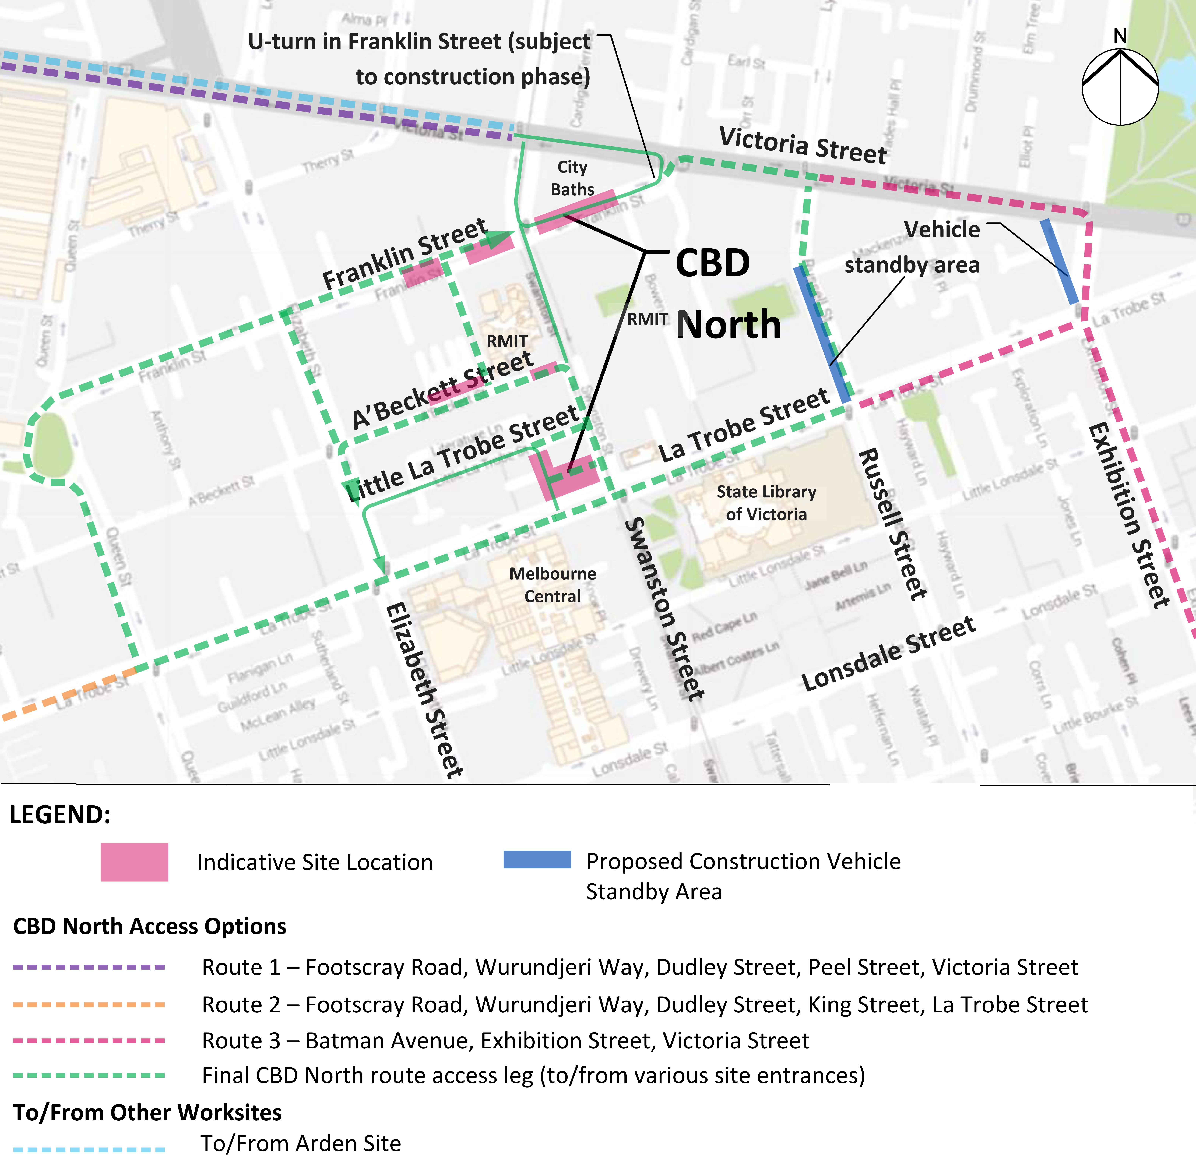
Daily traffic volumes on these key access routes are very high. For example, around 18,000 vehicles per day use La Trobe Street and around 27,000 vehicles per day use Victoria Street. Even if all trucks used La Trobe Street for access to the CBD North station construction work sites, the 210 trucks would only represent a one per cent increase in daily volumes. As much of the truck traffic would travel outside peak periods, this volume of construction traffic is very unlikely to significantly affect overall traffic operations in the area.
The impacts of this additional traffic would be minimised further through the implementation of a detailed traffic management plan that would include minimising truck movements during peak periods, safely managing conflicts with active transport modes, managing truck arrivals and departures to avoid trucks queueing in CBD streets, and minimising truck movements past residential areas at night time. The provision of truck holding areas (shown in blue in Figure 8-6) would actively manage the truck activity in the CBD and minimise truck queuing at inappropriate locations.

Local Road Closures
The proposed construction methodology for CBD North station would not require the closure of Swanston Street. However, Franklin Street, between Victoria and Swanston Streets, would need to be closed to enable construction of the station. The eastern end of A’Beckett Street would also be closed to all traffic other than construction traffic, but Stewart Street would be open to traffic.
Franklin Street, to the west of Swanston Street, would be kept open throughout Melbourne Metro’s construction phase, but would be reduced from two lanes in each direction to one lane in each direction.
Traffic would be diverted around the construction work sites to alternative routes, which would lead to some roads (such as Victoria Street and La Trobe Street) carrying increased traffic volumes, while other roads would have reduced traffic volumes. With some minor modifications, such as introducing Clearways along La Trobe Street during peak periods, this diverted traffic would not cause major delays or significant increases in traffic congestion.

Public Transport
Precinct 5 includes Melbourne Central station, which is part of the City Loop and is a key station in the metropolitan rail network. In 2011-12, Melbourne Central station was the metropolitan rail network’s third busiest station by annual patronage (14 million passengers) and the tenth busiest transfer station. The proposed CBD North station is located on the edge of the Free Tram Zone, and busy tram routes traverse the precinct along Swanston and La Trobe Streets. Swanston Street is the busiest tram corridor in the Melbourne tram network. High frequency bus services operate adjacent to the precinct along Lonsdale Street.
The number and frequency of public transport services – and high levels of public transport patronage in the precinct – mean that construction activities in Precinct 5 would be likely to impact tram services along Swanston Street and La Trobe Street from time to time as construction vehicles turn into and out of the construction work sites from these two streets. While transport management plans would be implemented to minimise disruption to these services, there would still be a moderate impact on public transport operations during the construction period.

Active Transport
The CBD North precinct is located within a busy pedestrian precinct, with large numbers of pedestrian movements generated by the Melbourne Central station and shopping centre, the RMIT campus, and the State Library of Victoria. There is good pedestrian footpath provision in the precinct, although some locations suffer from congestion at times. The streetscape around the precinct has a generally high level of accessibility, with most crossing locations having aural as well as visual signals for pedestrians. The provision of tactile paving is widespread and there are braille signs at signalised crossing locations.
CBD North station would be close to some of the city’s most developed bicycle infrastructure. La Trobe Street and Swanston Street provide segregated bicycle lanes and similar bicycle facilities exist to the north of the precinct towards Parkville. The area around the proposed station is one of Victoria’s busiest in bicycle traffic during peak commuting hours, with 800 to 1,000 cyclists travelling along Swanston Street north-south between 7am-9am and around 600 to 800 cyclists travelling east-west along La Trobe Street.
The very high levels of walking and cycling in the area indicates that construction activities in this precinct would need to be carefully managed to minimise disruption to pedestrians and cyclists, especially during peak periods. In particular, the proposed closure of Franklin Street would impact on pedestrian and bicycle movements through the area.
Pedestrian and bicycle paths would largely be maintained around construction work sites, with arrangements planned to direct pedestrian and bicycle movements safely and effectively around the sites. All existing bicycle lanes would remain open, including along Swanston Street and La Trobe Street, although the closure of Franklin Street would affect bicycle movements. A’Beckett Street would be closed to pedestrians as would the footpath on the south side of Little La Trobe Street and pedestrians would need to find alternate routes around these worksites.
Truck arrivals and departures would be actively controlled to avoid conflicts with bicycles, particularly those travelling along the La Trobe Street bicycle lanes. Following the implementation of these mitigation measures, there would still be a moderate impact on pedestrian and bicycle movements during the construction period.

Operation

Changes to the Road Network
Proposed permanent changes to the road network in Precinct 5 would include:
- Franklin Street would be closed between Swanston Street and Bowen Street, including the removal of car parking
- The Franklin Street connection to Victoria Street would remain as two-way access, but only as far as Bowen Street
- Franklin Street would have two lanes eastbound and one lane westbound west of Swanston Street, with both eastbound lanes required to turn left
- There would be a kerb extension on the south side of Franklin Street, west of Swanston Street, resulting in a loss of parking, and changes to A’Beckett Street to provide additional station access
- Minor changes would be made to existing parking arrangements along Swanston Street.
As outlined in Section 8.5.2, traffic demand in the CBD has been relatively static over recent years and future traffic growth in and around the precinct is likely to be close to zero. As a result, permanent changes to the road network due to Melbourne Metro would be expected to have little impact on traffic volumes and signal operations at intersections. However, the recommended Environmental Performance Requirements for the project would include monitoring of any change in travel patterns associated with the closure of part of Franklin Street.

Replacement Car Parking
Limited changes are proposed to car parking arrangements in the CBD North station precinct. In the context of the large number of car parking spaces available in the area (on-street and off-street), this reduction would be expected to have minimal impact.

Public Transport
The proposed new CBD North station is planned to be located under Swanston Street close to the existing Melbourne Central station to enable it to provide a key interchange point between Melbourne Metro and other rail services. The station would also augment existing stations in providing direct access to the northern extensions of the Hoddle Grid, as well as to eastern and central parts of the CBD.
The incorporation of Melbourne Metro tunnels into the metropolitan transport network would change the dynamic of public transport movements in the Melbourne CBD, as customers would be less reliant on the Swanston Street tram corridor for access between Parkville and the CBD. To ensure effective integration and connectivity between transport modes, PTV is expected to review the existing tram and bus network and around the precinct to potentially realign routes and better coordinate services with the new CBD North station. For example, additional trams would be likely to operate via La Trobe Street with a stop outside CBD North station.
There would be a negligible impact on bus services within the vicinity of the CBD North precinct as a result of the operation of Melbourne Metro.

Active Transport
When CBD North station opens, there would be a reduction in the number of passengers transferring between Melbourne Central station and adjoining tram/bus services (compared to 2012). There is predicted to be around 4,000 fewer transfer passengers (42 per cent) in the AM peak period and around 3,000 fewer passengers (32 per cent) in the PM peak period. The percentage of passengers entering/exiting CBD North station from tram or bus services would be approximately 20 per cent during the AM peak period.
A change in pedestrian movement patterns across the CBD North precinct would be likely following the opening of CBD North station. There is predicted to be a decrease of over 10,000 passenger entries/exits during the AM peak and a decrease of almost 12,000 entries/exits during the PM peak at Melbourne Central station, as these trips shift to the new CBD North station. More than 16,200 entries and exits would be expected during the AM and PM peak periods at CBD North station.
CBD North station would be designed to accommodate this high level of pedestrian activity safely and efficiently, and with a high degree of comfort and amenity. Franklin Street would be redesigned to maximise pedestrian space and amenity, and widened footpaths would improve pedestrian access and amenity along La Trobe Street (see Chapter 16 Landscape and Visual).
The bicycle network in the precinct would remain largely unchanged, with the La Trobe Street and Swanston Street bicycle lanes retained in their current configurations. The City of Melbourne would continue to plan for future growth in the area by investing in pedestrian and bicycle infrastructure to support people to walk or ride to work, connect to public transport or travel around the central city.
Monitoring of the changes in travel patterns associated with the closure of Franklin Street would include changes in pedestrian and cycling travel patterns.

Precinct 6: CBD South Station

Construction
The main construction activities with the potential to impact on transport connectivity in Precinct 6 are the mined cavern construction of the new station, the excavated station entrances, the connections to Flinders Street Station (cut and cover) and Federation Square (mined) from CBD South station, the use of the City Square as a construction work site, the temporary closure of a section of Flinders Street and the restoration of Swanston Street following the completion of construction activities. The mined cavern construction avoids the need for major disturbance to Swanston Street, enabling continued operation in its current format for the duration of the construction works.

Additional Truck and Traffic Movements
Spoil removal, along with materials and equipment delivery, in this precinct would generate an average of an additional 150 truck trips each day over four years. This could rise during peak activity periods to around 210 truck movements per day.
As with Precinct 5, roads in this precinct are principally pedestrian, bicycle and public transport priority routes. There are no Preferred Traffic Routes or Traffic Routes within the precinct. The proposed construction traffic routes developed for the precinct (see Figure 8-7) focus on moving truck and other construction traffic as quickly as possible out of the CBD using arterial roads such as Montague Street, Batman Avenue (the tolled extension of Exhibition Street) and Wurundjeri Way.
Daily traffic volumes on the key access routes to the arterial roads are very high. For example, around 20,000 vehicles per day use Flinders Street and around 13,000 vehicles per day use Collins Street. Even if all construction trucks used Flinders Street for access to the CBD South station construction work sites, the 210 trucks would only represent a one per cent increase in daily traffic volumes. As much of the truck traffic would travel outside peak periods, this volume of construction traffic is very unlikely to significantly affect overall traffic operations in the area.
Figure 8-7 Precinct 6: Proposed construction vehicle access routes
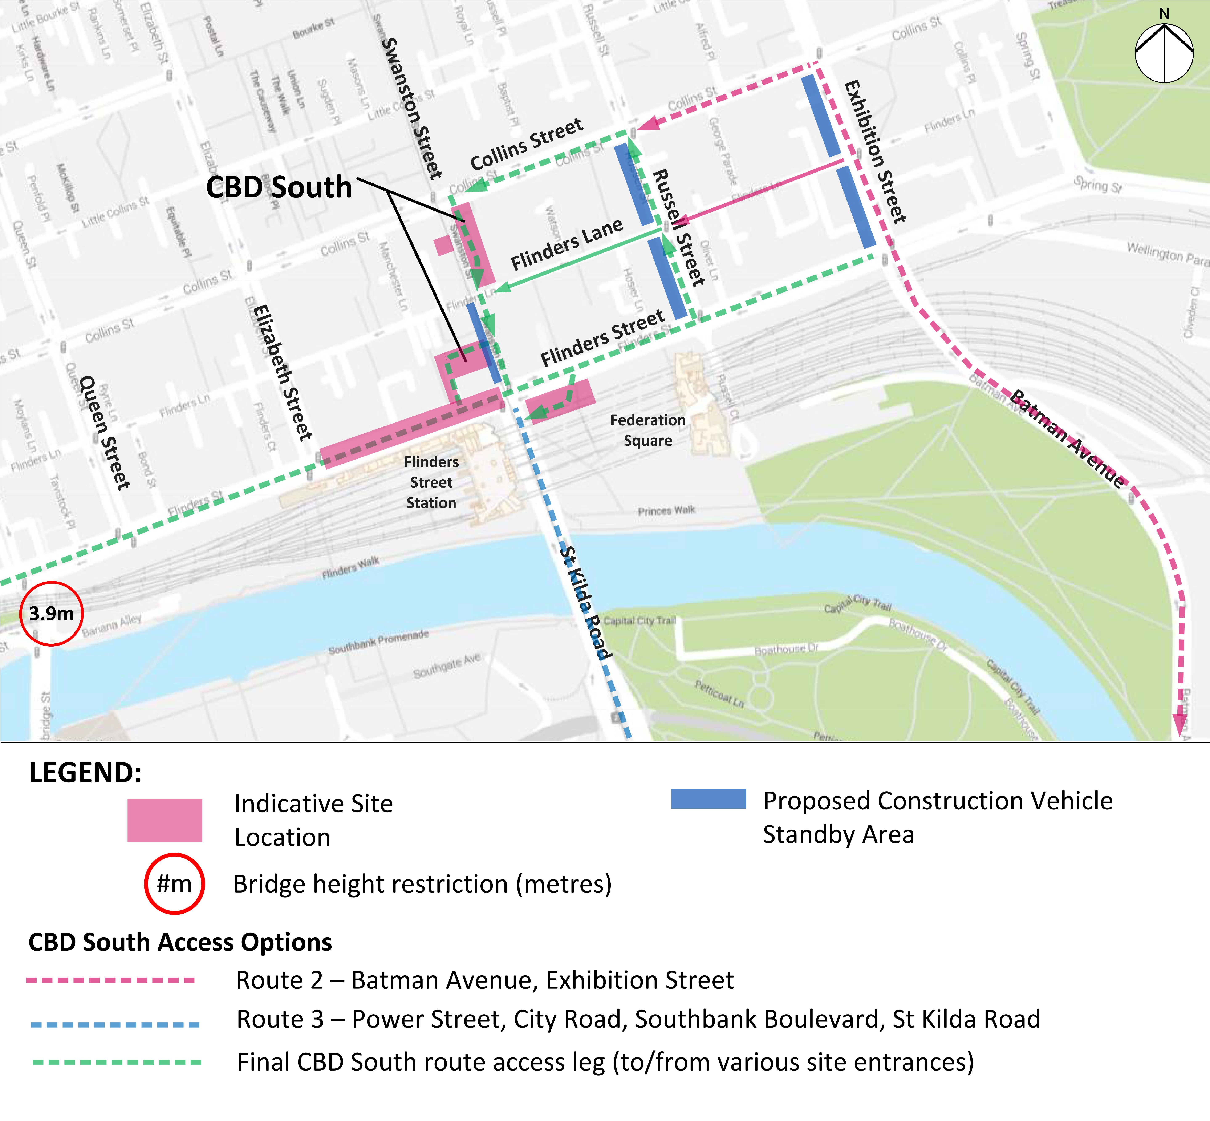
The impacts of this additional traffic would be managed by minimising truck movements during peak periods and past residential areas at night time, and managing truck arrivals and departures to avoid trucks queueing in CBD streets. The provision of truck holding areas (shown in blue in Figure 8-7) would actively manage the truck activity in the CBD and minimise truck queuing at inappropriate locations.

Local Road Closures
Short-term, partial closures of Flinders Street would be required to construct the cut and cover underground connection linking Flinders Street Station to the new CBD South station. Transport management plans would be implemented to minimise traffic disruption as a result of these closures. The connection to Federation Square is planned to be a mined connection requiring no road closures.

Public Transport
The number and frequency of public transport services – and high levels of public transport patronage - in the precinct mean that construction activities in this precinct are likely to impact on tram services along Swanston Street, Flinders Street and Collins Street from time to time.
This precinct includes Flinders Street Station, the busiest train station by annual patronage (26 million) in the metropolitan rail network. The station also provides tram and pedestrian connections to the wider CBD area.
The proposed CBD South station is located within the Free Tram Zone and several busy tram routes traverse the precinct along Swanston Street, Flinders Street, Elizabeth Street and Collins Street. Nine tram routes operate along Swanston Street and are in an exclusive tram lane for the majority of the route.
The construction works at CBD South station have the potential to have a significant impact on public transport operations for short periods of time. Construction traffic would need to be managed carefully to minimise any disruptions to tram services along Swanston Street, which is Melbourne’s busiest tram corridor. The partial closures of Flinders Street would need to be managed effectively to minimise impacts on Flinders Street tram services and tram and train users. The closures should be undertaken at periods of low seasonal activity to minimise the disruption to tram services.

Active Transport
The CBD South station precinct is a very busy pedestrian area, with a good provision of pedestrian infrastructure. The precinct has a high number of closely spaced signalised intersections that give pedestrians multiple crossing opportunities with relatively short waiting times. Pedestrian activity associated with Flinders Street Station is highest in the morning and evening peak periods. Surveys indicate that around one third of Flinders Street Station patrons are transfer passengers; of the remaining patrons, around 54 per cent depart the station by walking and around 14 per cent by tram.
Swanston Street is the main bicycle route through the CBD, providing segregated bicycle lanes and connections to the south of the CBD along St Kilda Road and to the Capital City Trail along the Yarra River.
While there are high levels of walking and cycling in the area, with careful management there is expected to be minimal impact on pedestrians and cyclists during the construction of Melbourne Metro. The implementation of measures to direct pedestrian and bicycle movements safely and effectively around construction work sites, and active management of truck arrivals and departures, would avoid conflicts with cyclists, including those travelling along the busy Swanston Street route.

Operation

Changes to the Road Network
No permanent changes are proposed to the road network in Precinct 6 as a result of the operation of Melbourne Metro.
As noted for Precinct 5, traffic demand in the Melbourne CBD has been relatively static over recent years and future traffic growth in and around the precinct is expected to be close to zero. As a result, the operation of Melbourne Metro would be expected to have little impact on traffic volumes and signal operations at intersections.

Public Transport
The proposed new CBD South station is planned to integrate with and augment Flinders Street Station, extending the station’s reach along the north-south axis of Swanston Street. Like CBD North station, CBD South station is expected to provide a dual role in providing direct access to the southern CBD and a critical interchange link to other heavy rail lines.
During the AM peak period, there is predicted to be an increase of around 4,000 passengers (57 per cent increase) transferring between Flinders Street Station and adjoining tram/bus services compared to the 2031 No Project scenario. During the PM peak, there would be a decrease of around 14,000 transfer passengers (48 per cent). This would be due to changes in travel behaviour as a result of the new rail corridor.
As noted under Precinct 5, the incorporation of Melbourne Metro tunnels into the metropolitan transport network would change the dynamic of public transport movements in the Melbourne CBD because customers would be less reliant on the Swanston Street tram trunk for access between Parkville and the CBD. Spare tram capacity would be redistributed towards the western end of the CBD and provide direct connections to Melbourne Metro tunnels.
There would be a minor impact on bus services within the CBD South station precinct, though some services are already being reviewed by PTV to align with Melbourne Metro’s operation. PTV is expected to review the existing tram and bus network in the precinct to potentially realign routes and better coordinate services with the new CBD South station.

Active Transport
When CBD South station opens, the modelling indicates that the number of passengers that would enter/exit Flinders Street would reduce from current levels by around 13,000 passengers during the AM peak period, and around 25,000 passengers during the PM peak period. More than 19,100 entries and exits would be expected during the AM peak period at CBD South station, with more than 20,800 entries and exits during the PM peak period. While these changes in passenger movements are quite large, the connectivity being provided between the two stations and the existing pedestrian networks around Flinders Street Station are expected to accommodate this level of demand.
While these pedestrian volumes would be spread across a number of access points, they would be expected to have a moderate impact on the pedestrian network around Flinders Street Station. This growth would be due not only to Melbourne Metro, but also to future population and employment growth, as well as changes to the rail network operations that would influence passenger journeys. The underground pedestrian connections would significantly reduce the number of trips occurring at surface level, resulting in a reduction in the number of pedestrians at existing pedestrian crossings.
CBD South station would be designed to accommodate this high level of pedestrian activity safely and efficiently, and with a high degree of comfort and amenity (see Chapter 16 Landscape and Visual). Melbourne Metro passengers would have direct access to walking links and public spaces in the area surrounding the station.
The bicycle network in the precinct would remain largely unchanged, with the Flinders Street, Collins Street, St Kilda Road and Swanston Street bicycle lanes retained in their current configurations. Up to 20 new bicycle parking spaces would be provided at the new CBD South station.
Cycling activity in the CBD has demonstrated strong growth in recent years and is expected to continue to grow, and the City of Melbourne would continue to invest in pedestrian and bicycle infrastructure to support people to walk or ride to work, connect to public transport or travel around the central city.

Precinct 7: Domain Station

Construction
The main construction activities with the potential to impact on transport connectivity in Precinct 7 (during construction of the proposed Domain station) are the reduction of St Kilda Road to a single road traffic lane in each direction, the closure of Domain Road between St Kilda Road and Dallas Brooks Drive, the relocation and removal of traffic islands, tram stops and car parking spaces along St Kilda Road, the use of temporary construction work sites on each side of St Kilda Road, and the restoration of St Kilda Road and Domain Road post-construction.

Additional Truck and Traffic Movements
Activity at this site would extend for a period of around four years with 24-hour, 7-day operations and an average of approximately 100 truck trips each day for spoil removal and materials and equipment delivery related to the construction of Domain station. Peak activity is expected to be higher at around 140 truck movements per day.
In addition to this, the proposed Domain (only) TBM launch site would generate an average of 140 truck movements per day over two years. If the option of Domain and Fawkner Park is used for the TBM launch sites, associated truck trips would reduce to 70 truck movements per day as some trips would occur at Fawkner Park (refer to Section 8.8).
The precinct is bordered by Kings Way/Queens Road (a Preferred Traffic Route) and traversed by St Kilda Road (a designated Traffic Route). Key local roads include Domain Road, Dorcas Street and Park Street. The proposed construction traffic routes developed for this precinct would use a number of routes to move truck and other construction traffic as quickly as possible to Kings Way, shown in Figure 8-8. Some car parking in the area would be impacted.
Daily traffic volumes on these key access routes are very high. For example, around 30,000 vehicles per day use St Kilda Road and around 77,000 vehicles per day use Kings Way. Even if all trucks used St Kilda Road for access to the Domain station construction work site, this number of trucks would represent less than a one per cent increase in daily volumes. As much of the truck traffic would travel outside peak periods, this volume of construction traffic is very unlikely to significantly affect overall traffic operations in the area.
The proposed construction traffic routes have been developed with the aim of minimising impacts on sensitive areas in the precinct. However, access would be required along Birdwood Avenue past the Shrine of Remembrance. Use of this route would be managed carefully to minimise impacts on users of the area, including minimising truck movements during daytime hours and at weekends when there is significant activity in the Domain Parklands and around the Shrine. Conversely, using this route at night time when there is limited activity at the Shrine would provide a good option to minimise impacts on residents in the Domain area as it avoids travel past residential properties.
Figure 8-8 Precinct 7: Proposed construction vehicle access routes
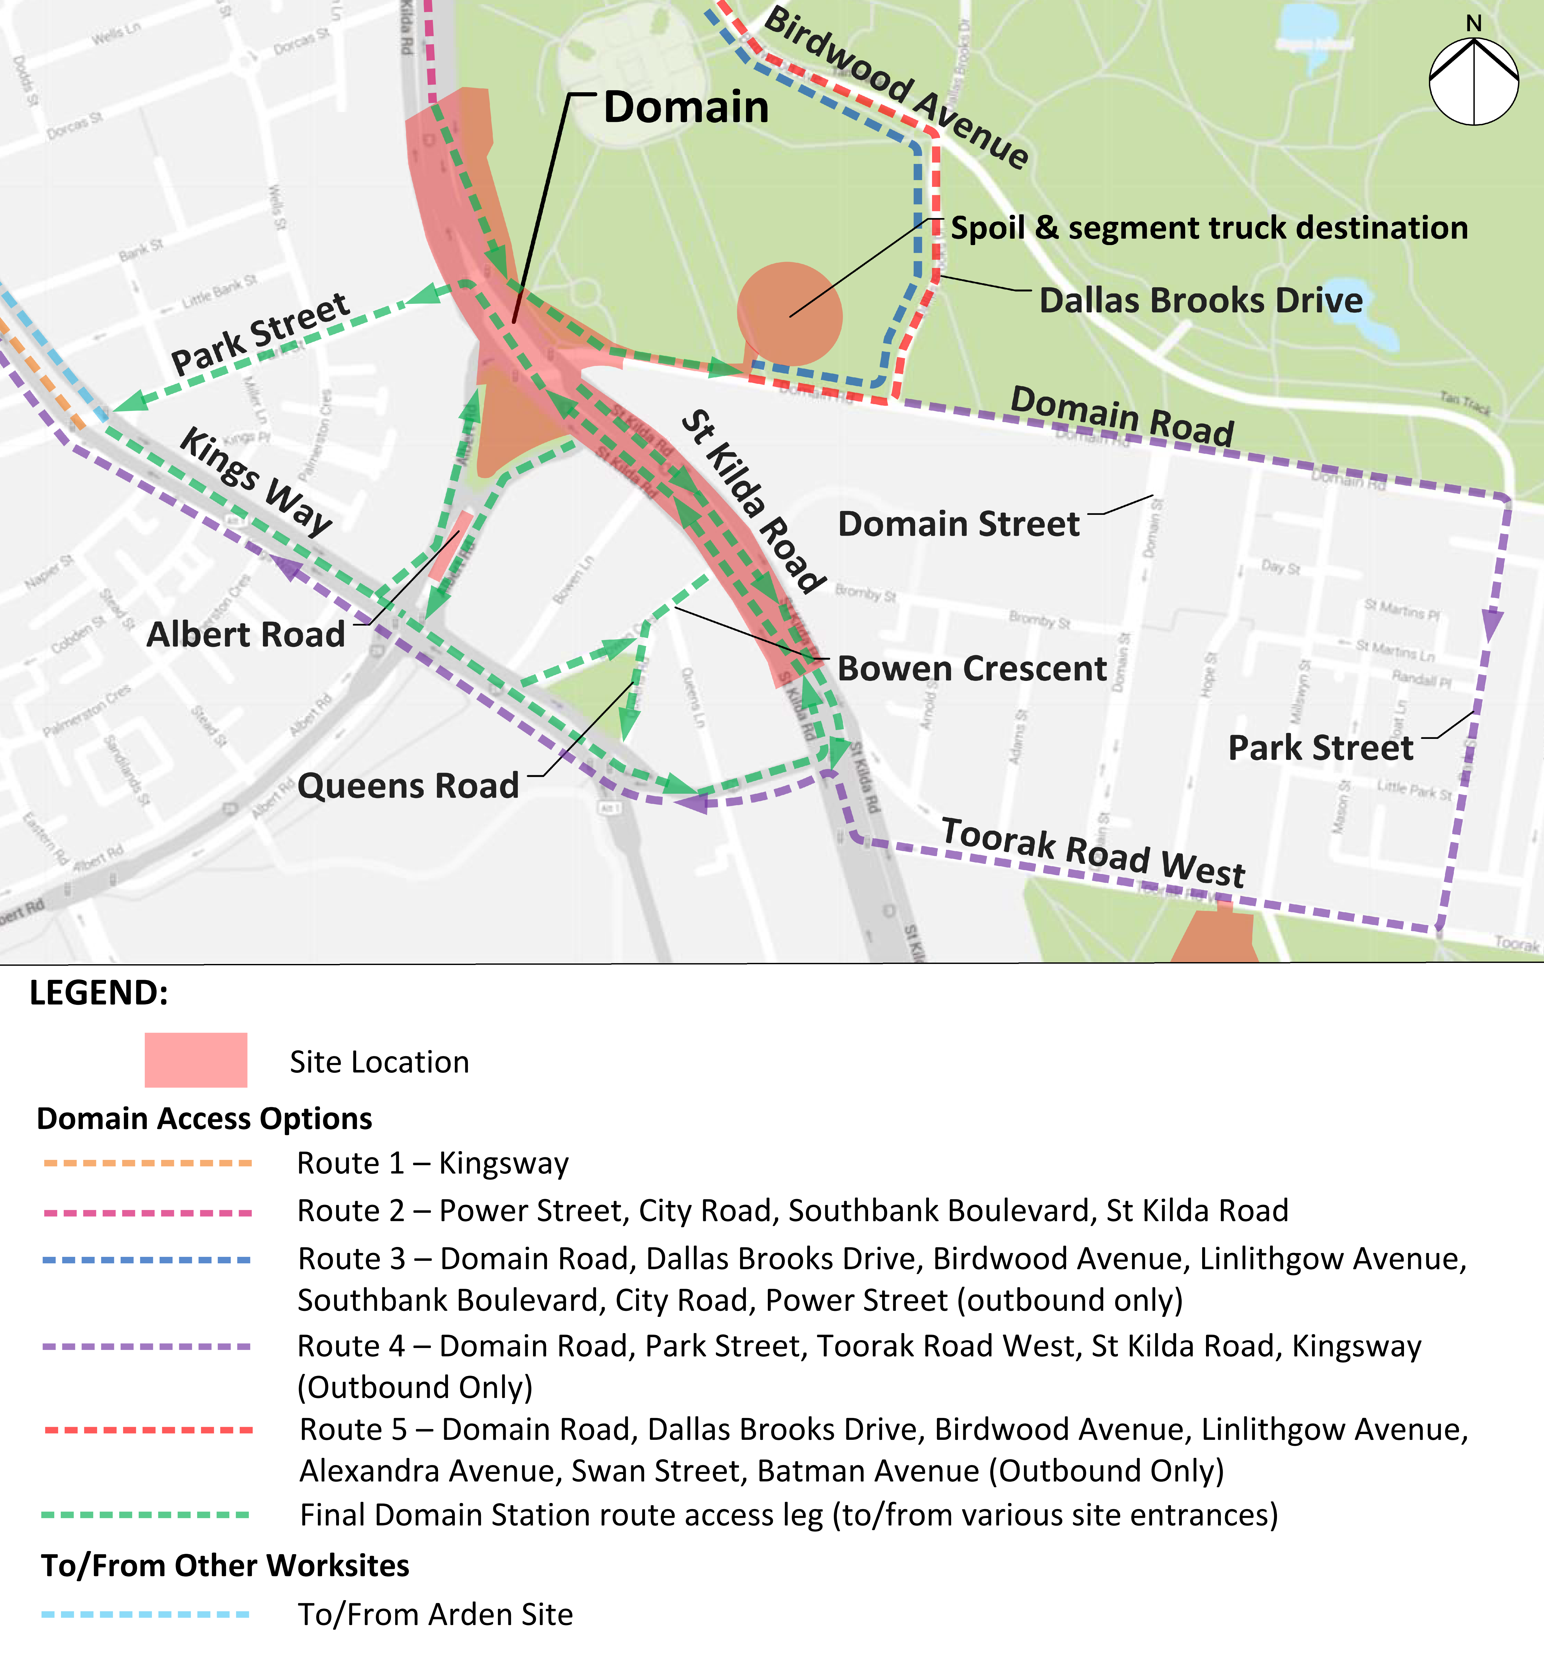
The impacts of this additional traffic would be minimised through the implementation of a detailed transport management plan. This would include:
- Planning and carefully managing access routes through sensitive areas to minimise impacts on residents and users of the area
- Minimising the use of Birdwood Avenue past the Shrine during daytime hours
- Encouraging the use of Birdwood Avenue for truck movements in the evening and at night to minimise impacts on residents in the Domain area
- Minimising truck movements through the Domain Road area at night time to avoid adverse impacts on residents
- Minimising truck movements during peak periods to avoid adverse impacts on peak period traffic.
- Maintaining access to the community facilities in Fawkner Park.
Traffic modelling indicates that transport management changes associated with the construction of Melbourne Metro would result in a medium impact on the operating conditions of the road network in and around the precinct. This analysis indicates negligible growth in total traffic volumes during construction, although some specific trips may record improvements or increases in travel times. For example, there may be a small increase in traffic volumes in the counter-peak direction (southbound) along St Kilda Road in the morning peak and a reduction in volumes in the peak direction (northbound).
Implementing transport management measures during construction would deliver safe and effective work sites with minimal disruption to traffic and local residents and providing safe passage through or around the site for pedestrians and cyclists.

Local Road Closures
The construction of Domain station would require the closure of Domain Road between St Kilda Road and Dallas Brooks Drive to trams and traffic for the period of construction of the station. The closure of Domain Road and associated transport management arrangements (such as advisory signs and notices in local newspapers) would result in some diversion of traffic away from Domain and Fawkner Park, resulting in less traffic traversing these areas during peak periods. The road closure would also require the route 8 tram to be re-routed to Toorak Road West (see below).
The construction approach would be to reduce St Kilda Road (currently three lanes each way) to one lane of traffic in each direction adjacent to the construction works to enable the works to be progressed faster and minimise the duration of traffic and tram disruptions. While this would reduce existing capacity along St Kilda Road, the traffic modelling indicates that during the construction phase there would be a decrease of approximately 1,000 vehicles in the north bound direction along St Kilda Road (north of Toorak Road) and 400 vehicles south bound along St Kilda Road (south of Dorcas Street) during the AM peak. In the PM peak, there would be reductions of approximately 700 vehicles in each direction along St Kilda Road, south of Dorcas Street. The modelling also suggests that these vehicles would divert from St Kilda Road to parallel routes, such as Kings Way and Punt Road.
To manage the impacts on traffic flows through the area, a travel demand management strategy would be implemented to advise the public of the potential increase in delays through the area and encourage people to choose alternate routes or to consider changing travel modes or their time of travel. A range of measures would be developed to manage travel demand and to facilitate the operation of alternative routes. For instance, Kings Way would be a key alternative route around the works area and measures are currently being investigated with VicRoads to improve the flow of traffic along this key corridor. Other routes include Canterbury Road, Beaconsfield Parade and, potentially, Punt Road (given current proposals to remove parking and expand Clearway arrangements to improve the operation of Punt Road).
However, reducing the capacity of these arterial links would still result in increased congestion and associated delays, particularly during peak periods. Travel times would increase along all travel routes in both directions during both peak periods, as a result of the closure of Domain Road and the proposed reduction in capacity of St Kilda Road. In the AM peak, the modelling indicates that there would be a travel time increase of approximately 50 seconds in the peak direction, with less delay in the opposing direction. In the PM peak, there would be an increase of up to 45 seconds in both directions in both peak hours. These increases relate to traffic merging on the approaches to the one lane sections of St Kilda Road and reduced travel speed through the one lane section.
The indicative program of works would comprise the following stages:
- Domain Road closed to trams and traffic between St Kilda Road and Dallas Brooks Drive for five years
- St Kilda Road to operate as two traffic lanes each way with one tram lane and a cycle lane each way for two weeks early 2017
- St Kilda Road to operate as one traffic lane each way (with one tram lane and a cycle lane each way) for approximately 18 months from December 2017 to June 2019 with numerous temporary changes to the tram, road, cyclist and pedestrian pathways
- St Kilda Road to operate as two traffic lanes each way (with one tram lane and a cycle lane each way) for approximately 18 months from June 2019 to December 2020 with numerous temporary changes to the tram, road, cyclist and pedestrian pathways.
The temporary road layout for St Kilda Road would provide a minimum of one tram lane, one traffic lane and a cycle lane in each direction between Kings Way and Park Street with a temporary DDA-compliant tram stop opposite Albert Road.
Overall, there would be a moderate risk of increased congestion in the Domain station precinct during construction following the implementation of traffic management measures. Queues and delays in this area would be expected to continue for the duration of the construction works.
The implementation of additional traffic management measures – such as improving capacity along potential diversion routes, providing information about alternative routes to motorists and encouraging people to use other travel modes – would assist in encouraging a reasonably high volume of traffic to divert to the wider network.

Public Transport
The precinct does not currently have immediate access to the metropolitan rail network and there is no train station located within the precinct.
The Domain tram interchange at the intersection of Park Street and St Kilda Road is a major junction in the Melbourne tram network. On a typical weekday, the interchange has an average of around 13,700 daily boardings and alightings. Nine tram routes operate directly through the interchange, and 55 services (peak direction) operate along St Kilda Road during the morning peak hour. Limited bus services operate along the St Kilda Road corridor, reflecting the importance of trams as the principal public transport mode.
Construction activities in Precinct 7 are expected to have a moderate impact on public transport operations including:
- Activities along St Kilda Road disrupting tram services along the busy Swanston Street - St Kilda Road corridor
- Changes to St Kilda Road tram routes requiring shut-down periods and affecting service frequency and reliability
- The route 8 tram along Domain Road needing to be re-routed along Toorak Road West back to St Kilda Road, adversely impacting current tram users along Domain Road and Park Street, but improving the service to users on Toorak Road West.
Recommended Environmental Performance Requirements to manage public transport operations during Melbourne Metro’s construction phase include preparing transport management plans to minimise disruptions to tram services during the construction period and optimising traffic signals along St Kilda Road to minimise delays to tram services, particularly at the busy Toorak Road West intersection. Potential changes to St Kilda Road tram routes would be developed and tested with key stakeholders to minimise service disruptions.

Active Transport
The precinct has a reasonably good standard of pedestrian connections and amenity, including generous footpath width and walking path routes through parkland.
The proposed Domain station would be close to some of the city’s most developed and well used bicycle infrastructure. St Kilda Road provides segregated bicycle lanes and bicycle connections through the precinct, including excellent connections to the north towards the CBD. The area around the proposed station is one of Victoria’s busiest in bicycle traffic during peak commuting hours, with around 1,100 cyclists travelling north-south along St Kilda Road between 7am-9am.
Albert Road and Park Street provide less used bicycle routes, but represent some of the only east-west roads in the immediate area suitable for bicycle traffic. Domain Road is an informal bicycle route between South Yarra and St Kilda Road.
Construction activities would make specific provision for pedestrian and bicycle movements through the precinct. Measures would be implemented to direct pedestrian and bicycle movements safely and effectively around construction work sites and to maintain pedestrian and bicycle routes through the construction area. However, there would be periods when bicycle paths would be restricted and riders would need to exercise extra caution when travelling through the works area. This is likely to encourage some cyclists to divert around the precinct.
Pedestrian footpaths would be maintained on both sides of St Kilda Road and Domain Road throughout the construction phase.

Operation

Changes to the Road Network
Proposed permanent changes to the road network in Precinct 7 are:
- Closure of the southern arm of Albert Road at its intersection with St Kilda Road, although access to buildings would be maintained
- Removal of the existing tram interchange and associated pedestrian crossings at Domain
- Removal of the existing tram stops between Bowen Lane and Bowen Crescent, and the southbound tram stop just north of Kings Way
- Provision of new tram superstops on St Kilda Road adjacent to Domain station and just south of Toorak Road West
- Provision of new pedestrian crossings along St Kilda Road, aligned with the new station and tram stops
- Removal of the existing outer separator traffic islands separating traffic lanes along St Kilda Road in the vicinity of Domain station
- Reconfiguration of traffic lanes along St Kilda Road between the intersections with Domain Road and Toorak Road West, with two options being considered:
  - Reduction in traffic lanes to two through lanes and one bicycle lane in each direction
  - Retention of three through traffic lanes in peak periods (parking lane becomes a Clearway) and one bicycle lane in each direction.
While the alternate St Kilda Road lane configurations have been modelled for the transport impact assessment in Technical Appendix D Transport, the assessment has assumed that the layout would be the three-lane configuration, with the parking lanes treated as Clearways and available to provide a third lane in the peak direction in peak periods. Should the parking lanes be retained in peak periods, operations would be less efficient with increased queues and delays.
Traffic modelling of the three-lane configuration indicates that traffic volumes would be similar to the scenario in 2031 without Melbourne Metro. In the AM peak, there would be a small increase in travel times northbound along St Kilda Road, while travel times for southbound traffic would decrease by up to 25 seconds. During the PM peak, travel times southbound would decrease slightly.
In the PM peak, there would be a decrease in travel times across the road network in comparison to the scenario without Melbourne Metro. This is due to the proposed increase in frequency of the phase accommodating the right turn movement at the intersection of St Kilda Road with Toorak Road and Kings Way, which would improve the efficiency of this key intersection.
Overall, this road layout would ensure that future operating conditions would be similar to the existing conditions.

Car Parking
The proposed three-lane configuration of St Kilda Road and the other changes to roads around the precinct would result in a reduction of around 150 car parking spaces in the area. While this is a significant number, the provision of a new high capacity railway station that provides connections across the broader metropolitan network would provide some compensation for the loss of parking in the precinct.

Public Transport
The proposed new station at Domain would provide a major interchange with the tram network, as well as providing direct access to the St Kilda Road corridor. Provision of direct access to the adjacent tram interchanges at street level would enhance pedestrian links with the surrounding area, enabling the station to provide heavy rail service to a broad catchment extending from Southbank and South Yarra to Albert Park.
When Domain station opens, about 4,300 people are predicted to transfer between the station and trams/buses. Around 50 per cent of all entries/exits to the station would be transfers from tram or bus services. A DDA-compliant tram superstop in St Kilda Road would improve interchanges between the rail and tram networks, particularly for passengers with reduced mobility.
To further ensure effective integration and connectivity between transport modes, PTV is expected to review the existing tram and bus network in the precinct to potentially realign routes and better coordinate services with the new Domain station. For example, the route 8 and route 55 trams would be expected to merge by 2031 to reduce the density of services along the Swanston Street corridor and increase the frequency of services to the west of the CBD, and connect through to the Domain station precinct and beyond. It is expected that the tram would return to its current route along Domain Road at the conclusion of the Domain station works.

Active Transport
The majority of the pedestrian network around the proposed Domain station would remain largely unchanged as a result of Melbourne Metro operations. However, the proposed station entrances and associated new pedestrian crossings on St Kilda Road would change pedestrian travel patterns in the precinct. These crossings would align with the new station and tram stops, improving safety and amenity for pedestrians crossing St Kilda Road.
When the station opens, over 8,000 passenger entries and exits are predicted in the AM and PM two-hour peak periods. Approximately 50 per cent of all entries and exits during both peak periods would be to/from the tram superstop in St Kilda Road. During the weekday peak periods, the station’s Shrine of Remembrance entrance would not be as widely used, but it would be more heavily used on weekends. The remainder of pedestrians would use the entries/exits at Albert Road plaza that service the offices and residential towers on the east side of St Kilda Road. The St Kilda Road underpass would include an access to the Domain station as well as an unpaid connection across St Kilda Road.
The station would be designed to accommodate this level of pedestrian activity safely and efficiently, and with a high degree of comfort and amenity (see Chapter 16 Landscape and Visual).
The bicycle network in the precinct would be modified due to the major changes proposed to the road network. Segregated on-road bicycle lanes would be provided for the entire length of the Domain station precinct, connecting to existing on-road lanes further north and south on St Kilda Road. This configuration would allow for potential future enhancements to the bicycle lanes along St Kilda Road. Bicycle parking spaces would be provided at the new Domain station.
The Cities of Melbourne and Port Phillip would continue to plan for future growth in the area by investing in pedestrian and bicycle infrastructure in the wider catchment to support the facilities provided by Melbourne Metro and encourage people to walk or ride to work, connect to public transport or travel around their local neighbourhoods.

Precinct 8: Eastern Portal (South Yarra)

Construction
The main construction activities that would impact transport connectivity in Precinct 8 are the widening of the existing rail corridor and associated construction of retaining walls, construction of an emergency access shaft and the TBM retrieval shaft, construction of a cut and cover tunnel and decline structure, realignment of railway tracks and the use of construction work sites at the South Yarra Siding Reserve and Osborne Street Reserve.

Additional Truck and Traffic Movements
Spoil removal, along with materials and equipment delivery, in this precinct would generate an average of 50 truck trips each day over 30 months, with peak activity periods likely to generate around 60 truck movements per day. TBM retrieval would also require very large trucks to access the construction site.
The proposed construction traffic routes developed for the precinct focus on moving truck and other construction traffic to Toorak Road as quickly as possible to avoid disruptions to local residents. Toorak Road could readily accommodate the expected level of construction traffic activity outside of peak periods, with active traffic management required during these times to minimise delays to tram movements and traffic flow along Toorak Road. Proposed traffic routes to and from construction sites are shown on Figure 8-9.
Daily traffic volumes on Toorak Road, the key access route to this site, are quite high with around 18,000 vehicles per day currently travelling along Toorak Road. With the expectation that all construction trucks would use Toorak Road for access to the eastern portal construction work site, the 60 average daily truck trips during times of peak activity represent a less than one per cent increase in daily volumes. As much of the construction traffic would travel outside peak periods, this volume of construction traffic is very unlikely to significantly affect overall traffic operations in the area.
Figure 8-9 Precinct 8: Proposed construction vehicle access routes
The impacts of additional construction traffic would be minimised through the implementation of a detailed traffic management plan. As the construction site would be located in a residential area, the impact of truck movements could be minimised by restricting operations to daylight hours, although during rail occupation periods there would likely be a need for 24-hour operation. Construction traffic operations would be kept outside of peak periods to minimise any impacts on the operation of the arterial roads in the area, particularly Toorak Road.
Given the relatively low numbers of truck movements in the precinct, the adoption of these measures would result in minimal impacts to local transport networks and local residents.

Public Transport
There is no train station within the precinct. South Yarra station – the eleventh busiest station in the metropolitan network and the sixth busiest transfer station – is located adjacent to the precinct’s northern boundary. The precinct is well served by trams, with several busy services running along Toorak Road and Chapel Street to the CBD. No bus services traverse the precinct, with the majority of nearby routes being well to the south or west. There would be minimal impacts on these public transport services during Melbourne Metro’s construction, except during rail occupations.
The project would require extensive modification in and around the South Yarra Siding Reserve. There would be a number of rail occupations during construction which would impact the Frankston, Cranbourne/Pakenham and Sandringham Lines including weekend occupations, Easter and Christmas shutdowns and overnight shutdowns.
There may also be occasional disruption to tram movements along Toorak Road due to truck movements, but these would be limited in frequency and duration. As a result, no Environmental Performance Requirements have been recommended to manage public transport operations in this precinct.

Active Transport
There is good provision of pedestrian infrastructure in the vicinity of the precinct. Toorak Road and Chapel Street are notable pedestrian environments connecting to the extensive commercial, retail and dining outlets on these streets.
An off-street path (Lovers Walk) runs adjacent to the Frankston/Cranbourne/Pakenham Lines between South Yarra station and Chapel Street. This path and the William Street bridge would be removed for the duration of the construction works. While alternative routes would be available, they are not as convenient or direct as these routes. In addition, changes to the operation of the streets in the precinct would potentially affect the safety and connectivity of pedestrian and bicycle movements through the area.
Measures would be implemented to direct pedestrian and bicycle movements safely and effectively around construction work sites.

Operation

Changes to the Road Network
As the construction works at the eastern portal would require the removal of the William Street bridge for the duration of the works, it would be necessary to reinstate the bridge at the completion of the works. This is the only work required in relation to the road layout in this precinct.

Public Transport
Once Melbourne Metro is operational, Frankston and Sandringham Line services would continue to operate through South Yarra station. Cranbourne/Pakenham services would no longer go through South Yarra station, but through the Melbourne Metro tunnels. This would release tracks from South Yarra to Caulfield, which would be used to segregate freight and V/Line movements. The Caulfield Underground Rail Loop (part of the City Loop) would be dedicated for Frankston services, providing additional capacity for growth on this line. In turn, the reconfiguration of the Frankston Line to operate via Caulfield Underground Rail Loop would enable the Cross-City Line (Werribee/Williamstown – Sandringham) to be reconfigured. This would provide additional capacity on the Frankston and Sandringham Lines via South Yarra.
During both AM and PM peak periods in 2031, with Melbourne Metro operating, a reduction of 44 per cent and 63 per cent respectively is predicted in the number of passengers transferring between South Yarra station and adjoining tram/bus services, compared to 2012. This is due to Cranbourne/Pakenham services no longer stopping at South Yarra station.
There would be negligible impacts to the tram network or bus services within the eastern portal precinct.

Active Transport
There are no planned permanent changes to the existing pedestrian or bicycle networks in the vicinity of the precinct. Following the completion of construction works, Lover’s Walk would be reinstated and upgraded to improve physical and visual amenity (see Chapter 16 Landscape and Visual).
In 2031, it is predicted that there would be around 20 per cent and 13 per cent reductions in total passenger entries/exits during the AM and PM peak periods respectively at South Yarra station compared to the scenario without Melbourne Metro. There would also be a decrease of approximately 39 per cent and 72 per cent in the number of passengers transferring at South Yarra station during the AM peak and PM peak periods respectively, compared to the scenario without the project. The predicted reduction in pedestrians using South Yarra station would have a beneficial impact on the pedestrian network around the station, although pedestrian volumes would still be much higher than current activity levels due largely to population growth.
The City of Stonnington would continue to plan for future growth in the area by investing in pedestrian and bicycle infrastructure to support people to walk or ride to work, connect to public transport or move around their local neighbourhoods.

Precinct 9: Western Turnback (West Footscray)

Construction
The main construction activities that may impact transport connectivity in Precinct 9 are the construction of a new platform and concourse at West Footscray station and new track and turnouts. The scale of these works and the availability of railway land within the precinct to accommodate the works would result in minimal impacts on traffic operations in the local area. Truck activity would be low and well within the capacity of the local road network.
Overall, the works would have minimal impacts on traffic operations, public transport operations and pedestrian and bicycle movements and safety, though there would be a need to manage the interfaces with existing users including the bicycle path on Cross Street.

Operation

Changes to the Road Network
No permanent changes are proposed to the road network or car parking in this precinct.

Public Transport
The operation of Melbourne Metro would require turning back some trains early on the Sunbury Line to run back towards the CBD to optimise the efficient use of Melbourne Metro corridor. These turnbacks would occur at West Footscray station, providing additional trains starting and terminating here that increase capacity and would not interrupt any trains running further along the line.

Active transport
There are no planned permanent changes to the existing pedestrian or bicycle networks in the vicinity of the precinct.

Environmental Performance Requirements
Table 8–4 shows the recommended Environmental Performance Requirements and proposed mitigation measures in relation to transport connectivity for the construction and operation phases for Melbourne Metro.
The risk numbers listed in the final column align with the list of transport risks provided in Technical Appendix B Environmental Risk Assessment Report.

Table 8–4 Environmental Performance Requirements for Transport Connectivity
Draft EES evaluation objective | Environmental Performance Requirements | Proposed mitigation measures | Precinct | Timing | Risk No.
Transport connectivity  – To enable a significant increase in the capacity of the metropolitan rail network and provide multimodal connections, while adequately managing effects of the works on the broader transport network, both during and after the construction of the project | Road Transport (Construction phase)  Develop and implement a transport management plan(s) in consultation with the relevant road management authorities to minimise disruption to traffic, car parking, pedestrian and bicycle movements during construction, including but not limited to:  - Management of any temporary or permanent full or partial closure of traffic lanes including (but not limited to):  - Childers Street, Kensington  - Royal Parade, Grattan Street and Barry Street, Parkville  - Franklin Street, A’Beckett Street and Little La Trobe Street at CBD North  - Flinders Street and Flinders Lane at CBD South  - Linlithgow Avenue, Melbourne  - St Kilda Road, Domain Road, Albert Road at Domain  - Toorak Road West at Fawkner Park  - Osborne Street, William Street in South Yarra  - Monitoring of travel behaviour changes caused by construction works, including pre-construction baseline data and periodic reporting on behaviour change. Use this data as an input to the design of transport networks following construction  - Traffic management plan(s) must be developed recognising other projects operating concurrently, where relevant  - Provision for a minimum of one lane for traffic in each direction on St Kilda Road to be maintained throughout the construction within the Domain station precinct  - Potential routes for construction vehicles travelling to and from all Melbourne Metro construction work sites, recognising sensitive receptors  - Provision of suitable routes for vehicles to maintain connectivity for road users to JJ Holland Park, South Kensington station and to the medical and educational facilities adjacent to the Parkville construction work site  - Provision of alternative routes for trucks accessing the 50 Lloyd Street Business Estate, Kensington | - Prepare Transport Management Plan  - Consult with relevant authorities  - Consult with emergency services | All | Construction | T001 – T007
- Provision of alternate parking where possible to replace parking lost from Childers Street, Laurens Street, Grattan Street, Domain Road, St Kilda Road and Albert Road during construction and preventing parking at undesignated locations on local roads
- Provision of car parking for construction workers where possible
- Provision of suitable routes for cyclists and pedestrians to maintain connectivity and safety for roads and shared paths to provide continued access, including (but not limited to): Childers Street, JJ Holland Park, South Kensington station, Laurens Street, Grattan Street, Swanston Street, Franklin Street, Flinders Street, St Kilda Road, Albert Road, Domain Road, Toorak Road and Fawkner Park
- Provision of complementary improvements to Kings Way, Canterbury Road and other roads to accommodate additional traffic that may use these roads, and to assist traffic flow in St Kilda Road for the duration of the works
- In consultation with emergency services, develop suitable measures to ensure emergency service access is not inhibited as a result of Melbourne Metro construction worksites
- Special arrangements for delivery or removal of large loads.
 | Public Transport (Construction phase)  - Develop and implement a plan for occupying railway land and tracks at the western portal, eastern portal and western turnback that minimises the disruption to railway services during construction. Plan to be developed to the satisfaction of VicTrack and MTM.  - Provide suitable routes for pedestrians to maintain connectivity, including DDA access for users of South Kensington station, Melbourne Central station, Flinders Street Station and around all construction sites generally.  - Develop and implement measures to minimise disruption to the tram and bus networks resulting from the construction of Melbourne Metro in consultation with the relevant road management authorities and to the satisfaction of PTV, including (but not limited to):  - Options to divert the 401, 402, 403, 505 and 546 bus services  - Tram routes on La Trobe Street and Swanston Street  - Tram routes on Flinders Street and Swanston Street  - Tram operations on Toorak Road and the diversion of the No. 8 tram route  - Periodic closures of Royal Parade tram route  - Tram routes on St Kilda Road  - Disruption to other tram routes through Domain tram stop  - Bus replacement services for disrupted rail customers. | - Prepare Transport Management Plan  - Prepare Rail Occupation Plan  - Consult with relevant authorities | All | Construction | T001 – T005, T008
 | Active Transport (Construction phase)  - Develop and implement transport management measures in consultation with relevant road management authorities for cyclists and pedestrians to maintain connectivity throughout construction for road and shared path users including (but not limited to): JJ Holland Park, South Kensington station, Laurens Street, Grattan Street, Franklin Street (including RMIT facilities), Swanston Street, Flinders Street, St Kilda Road, Domain Road, Domain Parklands, Albert Road, Toorak Road, Fawkner Park, Osborne Street, William Street and Chapel Street.  - Implement active control at construction work site access points to maintain safety by avoiding potential conflicts between trucks, pedestrians and cyclists.  - In consultation with the City of Melbourne, provide suitable routes for cyclists and pedestrians throughout construction and maintain connectivity for road and shared path users around of JJ Holland Park and South Kensington station. | - Prepare Transport Management Plan  - Consult with relevant authorities | All | Construction | T001 – T005
 | Travel Demand Strategy  In advance of construction works, MMRA to develop and implement a travel demand management strategy and appropriate tools to promote specific transport behaviour changes in response to road, bicycle and pedestrian paths closures/modifications and to reduce traffic congestion around construction sites, particularly in the vicinity of the Parkville and Domain Precincts where road closures and restrictions are proposed. The strategy must be consistent with the MMRA Community and Stakeholder Engagement Plan. | - Prepare Travel Demand Management Strategy and associated transport management measures  - Consult with relevant authorities | All | Construction | T001 – T007
 | Road Transport (Operational phase)  - Design all roadworks and shared path works to relevant design standards to maintain safety of movement in consultation with the relevant road management authorities as required.  - Develop and implement a plan to re-instate car parking on Childers Street, Kensington and Laurens Street, North Melbourne in consultation with the relevant road management authorities that:  - Minimises the permanent loss of parking where possible  - Ensures reinstated car parking does not encroach on JJ Holland Park  - Considers opportunities for replacement of any net loss of parking at nearby locations  - Reduces the risk of overflow parking in local streets from South Kensington station and activities at JJ Holland Park  - Replaces loading zones to service the needs of the existing businesses in the precinct where disrupted during construction.  - Develop and implement a plan for the reinstatement of Grattan Street, Parkville in consultation with the relevant road management authorities that includes:  - Optimal replacement of car parking spaces along Grattan Street to service the needs of the hospitals and the university, including the retention or replacement of specific short-term and DDA compliant parking  - Optimal design of the road network around Grattan Street associated with the changed demands and network changes on Grattan Street and Royal Parade/Elizabeth Street.  - Develop and implement a plan for the future use of the Franklin Street road reserve in consultation with the relevant road management authorities that includes:  - Optimising the design of the road network following the closure of Franklin Street between Swanston Street and Bowen Street  - Monitoring the change in travel patterns around the area associated with the closure of Franklin Street. | - Prepare car parking management plan for each precinct  - Consult with relevant authorities  - Design all works to relevant standards | All | Operation | T009 – T011
 | - Optimise the design of the reinstated St Kilda Road and apply the road users hierarchy in consultation with the relevant road management authorities to:  - Reduce delays and congestion  - Maintain safe operations through the precinct  - Determine the optimal parking provision in the area and replace any lost parking where possible. | - Consult with relevant authorities
 | Public Transport (Operational phase)  - Review, with PTV, the bus services in the areas around Arden, Parkville, CBD North, CBD South and Domain stations including a review of the route 401 bus frequency that would have reduced demand following implementation of Melbourne Metro.  - Optimise the design of Melbourne Metro stations to ensure integration with existing and planned future uses and so that they would provide connections:  - Between the new Parkville station and the new tram stop on Royal Parade  - For interchange between the new CBD North station and the existing tram and bus services along La Trobe Street and Swanston Street  - For interchange between the new CBD South station and the existing tram services along Flinders Street and Swanston Street  - Between the new Domain station and the new island platform trams stop in the centre of St Kilda Road and connections to the tram services along Domain Road  - Review, with PTV and Yarra Trams, the bus and tram services in the area to optimise the functionality of the CBD North and South stations and to reduce the reliance on the Swanston Street tram corridor. | - Review bus service plans  - Design to optimise form and function of stations and interfaces with other public transport services  - Consult with relevant authorities | All | Operation | T009 – T010
 | Active Transport (Operational phase)  - Develop and implement a permanent shared use path along the northern side of Childers Street, Kensington in conjunction with the relevant road management authority and the land manager prior to the removal of the shared use path on the southern side.  - Where practicable to do so, reinstate on-road bicycle lanes and bicycle parking provisions removed during construction in cooperation with the relevant road management authority and the local council.  - Review the provision of safe and effective bicycle lanes in and around the Melbourne Metro station sites in cooperation with the road authority and the local council.  - Provide wayfinding information to enhance connectivity for pedestrians and public transport users including (but not limited to) the following locations:  - Between Melbourne Central station and the new CBD North station.  - The underground connection between Flinders Street Station and the new CBD South station. | - Implement new shared path early  - Consult with relevant authorities  - Provide wayfinding information | All | Operation | T009 – T010

Conclusion
The impact assessment found that Melbourne Metro would be consistent with the draft EES evaluation objectives as it enables the metropolitan rail network to operate as a series of independent rail systems, thereby delivering a significant increase in the capacity of the rail network.
In addition:
- Melbourne Metro provides effective connections between transport modes, notably improving rail to tram connectivity and the accessibility of rail patrons to key destinations in the CBD and inner city areas that were previously not readily accessible by rail
- Melbourne Metro has been designed to manage the impacts of construction works on the operation of all transport modes in the vicinity of these works
- Melbourne Metro has been designed to manage the longer term impacts of the Project on the operation of all transport modes in the vicinity of the Project’s permanent structures and infrastructure changes.
The specialist assessment of the transport impacts of Melbourne Metro found that, following the adoption of mitigation measures, many of the transport connectivity risks associated with the Project would be reduced to medium or low. Medium residual risks would be associated with impeded traffic flows as a result of construction activities in Precinct 2 - Western portal, Precinct 4 - Parkville station, Precinct 5 - CBD North station, Precinct 6 - CBD South station and Precinct 7 - Domain station, and increased numbers of trucks removing tunnel spoil in Precinct 1 - Tunnels, Precinct 3 - Arden station and Precinct 7 - Domain station.
Managing these impacts is a crucial component of the delivery of Melbourne Metro. The recommended Environmental Performance Requirements developed for Melbourne Metro would be achieved by the proposed mitigation measures, such as implementation of detailed transport management plans that would include measures to direct traffic away from construction work sites to alternative routes and minimise truck movements during peak periods and at night past residential areas. The plans would also identify construction traffic routes for each precinct with the aim of moving this traffic away from local areas to the arterial road/motorway network as quickly as possible.
Achieving the recommended Environmental Performance Requirements would deliver safe and effective construction work sites across the Melbourne Metro alignment and minimise disruption to traffic and local residents. Adopting these requirements would also ensure that the Concept Design meets the objectives of the Transport Integration Act 2010.

Micro-simulation traffic models cover a small geographic area, modelling vehicle movements and operations including queues and delays. Mesoscopic traffic models cover a larger local area of operations and include aspects of strategic models such as route choice that are not available in micro-simulation models. Hybrid models can model different areas as either micro-simulation or mesoscopic areas within the same model.
Chapter 2 Project Rationale and Benefits includes a diagram of the current network configuration.
These changes are not part of Melbourne Metro. They would be considered and developed separately by PTV.

