# C:\Users\Patrick\SafeSync\Metuant client work\Melbourne Metro Rail Authority\Templates\MM Brand Decal1.jpgBiodiversity

## Overview

This chapter provides an assessment of the biodiversity impacts associated with the construction and operation of Melbourne Metro. The chapter is based on the impact assessments presented in Technical Appendices R and S *Arboriculture,* Technical Appendix T *Terrestrial Flora and Fauna* and Technical Appendix U *Aquatic Ecology and River Health*. All relevant references are provided in the technical appendices.

With approximately 180 years of urban development associated with the evolution of Melbourne, most of the original biodiversity values along the Melbourne Metro alignment have been significantly disturbed, modified or destroyed. Widespread clearing of native vegetation, the infilling of large areas of coastal and estuarine habitat for land reclamation programs and the realignment of water courses to facilitate drainage have all contributed to major changes in the natural environment within the area.

The highly disturbed and modified nature of the area in the vicinity of Melbourne Metro means the project would result in negligible impacts to the biodiversity of native terrestrial and aquatic flora and fauna. Melbourne Metro would not have a significant impact on threatened flora and fauna species or ecological communities protected under the Commonwealth EPBC Act or the Victorian Flora and Fauna Guarantee Act 1988.

Trees within the proposed project boundary include a mix of native and exotic street trees, trees in public open spaces and trees in heritage reserves and heritage parklands. The area supports populations of common native and introduced fauna that offer some experience of biodiversity values for inner city residents. Planted trees and other vegetation provide habitat for this urban wildlife.

Impacts to trees within the proposed project boundary have been avoided where possible through the development of the Concept Design and the adoption of proposed construction methods that aim to retain and protect trees where feasible. In instances where tree removal would occur or where construction works would be in proximity to trees, proposed mitigation measures would include:

* Preparing Tree Protection Plans in accordance with *AS4970-2009* Protection of Trees on Development Sites
* Offsetting in accordance with the Permitted Clearing of Native Vegetation – Biodiversity Assessment Guidelines where applicable
* Replacing trees post-construction where practicable
* Replacing trees removed from the public realm in accordance with the City of Melbourne’s and City of Port Phillip’s urban forest strategies (to achieve a minimum 40 per cent canopy cover by 2040) and with the City of Stonnington’s Street Tree Strategy. No trees would be impacted within the western turnback precinct, which is located in the City of Maribyrnong.

Measures would be taken to avoid the spread or introduction of weeds during construction activities.

The bored tunnel technique adopted for crossing beneath the Yarra River and Moonee Ponds Creek would avoid any direct impacts on aquatic fauna or flora, notably the EPBC listed Australian Grayling, which uses the Yarra River as a migratory pathway. Mitigation measures would also be implemented to ensure aquatic flora and fauna would not be impacted by site runoff or groundwater discharge (see Chapter 17 *Surface Water* and Chapter 18 *Groundwater*). Such measures would include:

* Materials handling in accordance with an approved construction site EMP
* Fully integrating the stormwater treatment system into the design of Melbourne Metro and achieving best practice sediment and runoff quality objectives in line with CSIRO guidelines
* Applying best practice sedimentation and pollution control measures in accordance with EPA guidelines
* Discharging tunnel, station box and portal construction water to sewer, as opposed to stormwater drains or waterways
* Ensuring that any contaminated groundwater encountered by the project is not released to stormwater or sensitive surface water bodies.

## EES Objectives

The EES Scoping Requirements set the following draft evaluation objective for the EES:

* *Biodiversity* – To avoid or minimise adverse effects on native terrestrial and aquatic flora and fauna, in the context of the Project’s components and urban setting.

In line with this objective, the existing conditions, potential biodiversity impacts and associated risks to terrestrial and aquatic flora and fauna in the proposed project boundary were assessed in relation to statutory flora and fauna issues. Additionally, arboriculture assessments were undertaken to identify potential impacts to trees associated with the construction and operation of Melbourne Metro.

Using this information, recommended Environmental Performance Requirements which specify the outcome to be achieved and proposed mitigation measures were identified to ensure that adverse effects to native terrestrial and aquatic flora and fauna and non-native trees would be avoided or minimised.

## Legislation and Policy

As discussed in Chapter 4 *EES Assessment Framework and Approach*, biodiversity impacts associated with Melbourne Metro would be managed in accordance with a range of Commonwealth and Victorian legislation, standards, policies and guidelines. The relevant legislation and policies are set out in Table ‎21–1.

Table – Biodiversity legislation and policy relevant to Melbourne Metro

|  |  |  |
| --- | --- | --- |
| 1. Legislation | 1. Policy/ guideline | 1. Comment |
| 1. Commonwealth | | |
| 1. Environment Protection and Biodiversity Conservation Act 1999 |  | 1. The Act states that ‘controlled’ actions (actions that are likely to have a significant impact on a Matter of National Environmental Significance) are subject to a stringent assessment and approval process. 2. MMRA referred the project to the Australian Government Minister for the Environment, who determined that the project was ‘not a controlled action if undertaken in a particular manner’. The ‘particular manner’ specified in the decision related to potential vibration impacts on Commonwealth heritage buildings (see Chapter 13 *Noise and Vibration*). |
| 1. State | | |
| 1. Flora and Fauna Guarantee Act 1988 |  | 1. The Act provides a framework for biodiversity conservation in Victoria. Threatened species and communities of flora and fauna, as well as threatening processes, are listed under this Act. The Australian Grayling and the Grey-headed flying-fox, which have the potential to be impacted by the project, are listed under the Act. 2. A Permit to Take is required to remove any protected flora from public land under s.47 of this Act. |
| 1. Planning and Environment Act 1987 |  | 1. In Victoria, planning schemes require planning approval to remove, destroy or lop native vegetation, with some exceptions. One indigenous scattered tree and a number of indigenous trees and shrubs may require removal from land within the Cities of Melbourne and Stonnington. The removal of this native vegetation would be subject to the requirements of the Permitted Clearing of Native Vegetation – Biodiversity Assessment Guidelines. |
| 1. Water Act 1989 |  | 1. The Act is the primary legislation covering the management of the State’s water resources. The reaches of the Maribyrnong River, Moonee Ponds Creek, Stony Creek, Albert Park Lake and Yarra River are designated waterways managed by Melbourne Water. Works on Waterways approval may be required if the beds and banks of these waterways would be impacted by construction activities. |
| 1. Wildlife Act 1975 |  | 1. The Act establishes procedures for the protection and conservation of wildlife, the prevention of wildlife extinction and the sustainable use of and access to wildlife. The Act also prohibits and regulates the conduct of persons engaged in activities concerning wildlife. Given the very small area of habitat impacted by Melbourne Metro and its developed urban setting, no permits or approvals are expected to be required under the Act. However, a permit would need to be held by the Environmental Officers/Wildlife Handlers responsible for pre-clearance surveys of trees being removed. |
| 1. *Environment Protection Act 1970* | 1. SEPP (Waters of Victoria) (WoV) | 1. The SEPP (WoV) provides the legal framework for the protection and rehabilitation of Victoria’s surface waters. No approval is required for Melbourne Metro. However, compliance with the SEPP is required under the Environment Protection Act 1970. |
| 1. DELWP Victorian Advisory Lists | 1. The DELWP Victorian Advisory Lists are not statutory lists of species for which conservation management is recommended. The presence, or likely presence, of a species listed on the DELWP Victorian Advisory Lists is used to determine whether species-specific habitat is required to be offset. Potential habitats for the Australian Grayling, Grey-headed flying-fox, Powerful Owl and Grey Goshawk (all included within the list) have been identified within the proposed project boundary. |
| 1. Local | | |
|  | 1. City of Melbourne: Tree Retention and Removal Policy 2012 | 1. This policy sets out standards for the priority status and approval of tree removals from land managed by the City of Melbourne in the context of development, as well as tree protection requirements for the successful retention of trees. |
|  | 1. City of Port Phillip: Greening Port Phillip. An Urban Forest Approach 2010 | 1. Trees managed by the City of Port Phillip are subject to this policy. The policy states that amenity value should be sought for a tree if it is significant (due to its size, prominence in the landscape, rarity or other highly esteemed social value) and would be removed as a result of a development application. Trees would be impacted in the Albert Road Reserve and on Albert Road. |
|  | 1. City of Stonnington: General Local Law 2008 (No.1) | 1. A permit is required to remove, damage, destroy or prune a tree listed on the Significant Tree Register and to carry out works within the root protection zone of a Significant Tree. No tree within the proposed project boundary is listed on the City of Stonnington’s Significant Tree Register. |

No applicable municipal laws within the City of Maribyrnong are relevant to the project.

## Methodology

### Assessment Approach

The biodiversity impacts of Melbourne Metro were informed by four impact assessments: a terrestrial flora and fauna impact assessment, an aquatic ecology and river health impact assessment and two arboriculture assessments. One arboriculture assessment addressed trees in the Cities of Melbourne, Port Phillip and Maribyrnong, while the other addressed trees in the City of Stonnington (no trees would be impacted within the western turnback precinct, which is located in the City of Maribyrnong).

Each investigation consisted of a desktop review of baseline and background data, and a field assessment to test and validate the desktop reviews. These investigations were undertaken to obtain information about existing biodiversity conditions within the proposed project boundary and how these conditions might be affected by Melbourne Metro.

Land within the proposed project boundary was assessed for the presence of native vegetation and the availability of habitat for threatened terrestrial flora and fauna species where interactions with the terrestrial or aquatic environment could be expected. Matters relating to the management of native vegetation in relation to relevant permit requirements were also investigated. The waterways beneath which the tunnels would pass (Yarra River and Moonee Ponds Creek) were assessed. The Maribyrnong River, located to the west of the western portal, was also assessed. These field assessments were sufficient to establish and validate the nature and extent of ecological characteristics within the proposed project boundary, given the urbanised nature of the locality.

Arboriculture impact assessments were also undertaken for each tree or tree group within the proposed project boundary. The ground-based, visual tree assessment included collection of size data (diameter of trunk at breast height, tree height and width) and condition data (health and structure), as well as an estimate of the anticipated useful life expectancy of each tree. These assessments have contributed to identifying the adverse effects on native terrestrial flora and fauna, as well as the potential landscape and visual impacts of tree removal. These impacts are discussed in Chapter 16 Landscape and Visual.

### Baseline and Background Data

Data sources used in the biodiversity assessments included:

* Biodiversity Interactive Map – This DELWP database comprises large scale mapping and classification of native vegetation across Victoria. It also classifies areas of mapped native vegetation according to their importance to biodiversity
* Victorian Biodiversity Atlas – This database, held and maintained by DELWP, comprises historical records of flora and fauna species from across the State. Records are added opportunistically, as flora and fauna surveys are conducted within Victoria for a variety of purposes. Records from within a 5 km radius of the proposed project boundary have been assessed for this report
* Protected Matters Search Tool – The Protected Matters Search Tool, provided by the Commonwealth Department of the Environment, lists any Matter of National Environmental Significance under the EPBC Act that could occur within an area
* Water Quality Data – Melbourne Water collects routine water quality data from each of the relevant waterways within the project boundary. Monthly data collected over the last three years has been reviewed in order to develop an understanding of the background water quality in each waterway
* City of Melbourne’s Urban Forest Strategy – provides individual tree data including species, location, age, trunk diameter and useful life expectancy
* Tree data provided by the Cities of Melbourne, Port Phillip and Stonnington.

## Existing Conditions

Melbourne Metro would be located wholly within the urbanised central area of Melbourne. With approximately 180 years of urban development associated with the evolution of the city, much of the original biodiversity values of the area have been significantly disturbed, modified or destroyed. Widespread clearing of the original native vegetation, the infilling of large areas of coastal and estuarine habitat for land reclamation programs in low lying areas and the realignment of water courses to facilitate drainage have all contributed to major changes in the natural character of the area. This has greatly altered, and in large part removed altogether, any habitat that once supported the rich diversity of species that originally inhabited the area. These areas have been cleared and now support buildings, parks, roads and other infrastructure.

The majority of the area within the proposed project boundary no longer supports the original biodiversity values of the area. There is very limited habitat remaining to support native flora and fauna, including current threatened species known to be present across the wider metropolitan area.

### Urban Environment (Parks, Streets and Backyards)

#### Native Flora

It is evident from aerial photography and field investigation that no significant areas of intact native vegetation (such as Ecological Vegetation Classes) remain within the proposed project boundary. There are some small areas where ‘native vegetation’ is present, existing as re-vegetation or landscaping (such as in the western and eastern portal precincts). However, the majority of the area within the proposed project boundary supports exotic tree cover or no tree cover.

Only one threatened flora species, small burr-grass (Tragus australianus), has been recorded within the past 30 years within one kilometre of the proposed project boundary. However, given the environmental disturbance that has occurred across all Melbourne Metro precincts and the absence of remnant ground cover, it is considered highly unlikely that any threatened flora species are present within the proposed project boundary.

#### Native Fauna

One threatened fauna species, the Grey-headed flying-fox, is known to forage within the proposed project boundary (in Precincts 7 and 8). The species is listed as Vulnerable under the EPBC Act and the Victorian Advisory List, and is also listed under the *Flora and Fauna Guarantee Act* *1988*. Moreton Bay figs (Ficus macrophylla) (not native to this part of Australia) are one of the species’ preferred food sources and are found in Fawkner Park. Melbourne Metro would not require the removal of any Moreton Bay figs from the park.

The Powerful Owl is considered likely to be present within the project boundary (in Precincts 7 and 8) and the Grey Goshawk is considered to possibly be present. Both species appear on the *Flora and Fauna Guarantee Act 1988* and are listed as Vulnerable on the Victorian Advisory List. These species are known to roost in large trees and forage in Melbourne’s urban parks, with the greatest potential for owls likely to be in the Royal Botanic Gardens. The areas impacted by Melbourne Metro are not considered prime breeding areas for these species.

The terrestrial flora and fauna impact assessment also examined the potential for migratory species to use habitat within the proposed project boundary. Listed and other important migratory species are known to traverse the broader metropolitan area in which Melbourne Metro would be located as part of their annual movement patterns. Given the lack of habitat resources within the project boundary – due to its inner city setting – and the lack of specific records found in the background data review, it was determined that no significant migratory species habitat would be impacted by Melbourne Metro.

Any trees requiring removal to facilitate the project would be subject to clearance procedures to ensure impacts to local biodiversity are managed. The removal of indigenous plant species, present as planted landscaping, would be offset in accordance with relevant policies. This would ensure no long-term decline in species distribution or survival for any listed threatened species.

### Rivers and Waterways

Melbourne Metro would involve tunnelling under the estuarine section of the Yarra River and Moonee Ponds Creek (a tributary of the Yarra River). The proposed project boundary is also near to the Maribyrnong River (a tributary of the Yarra River).

The alignment would cross beneath the Yarra River just upstream of Princes Bridge and under Moonee Ponds Creek downstream of Arden Street. The alignment would not cross the Maribyrnong River. At the western portal, the proposed project boundary extends near the eastern bank of the Maribyrnong River, upstream of Dynon Road, although at this point the existing rail infrastructure would be occupied and there would be no construction activity in the immediate vicinity of the Maribyrnong River bank.

The crossings beneath the Yarra River and Moonee Ponds Creek would be via bored tunnels with no direct impacts on the waterways. However, construction of the portals, stations and western turnback would result in open construction work sites with potential for runoff to local drainage systems and hence to waterways within or beyond the proposed project boundary. In addition to the Yarra River, Moonee Ponds Creek and Maribyrnong River, these waterways include:

* Albert Park Lake – located to the south-east of the proposed project boundary, within the stormwater catchment of Domain station
* Stony Creek – which receives stormwater runoff via the local drainage system from the Footscray area where the western turnback would be located.

All waterways are highly modified and have generally poor water quality in the vicinity of the project.

In relation to aquatic fauna, a range of species listed in the Victorian Biodiversity Atlas and the EPBC Act Protected Matters Search Tool have been identified as possibly being present in each of the waterways based on previous records and modelled distributions. This does not necessarily mean these species have been recorded in the waterways or are likely to be present; rather, it means that if habitat was suitable, they could be present based on their reported distribution. The Protected Matters Search Tool includes a buffer to the search zone, which means some species may be identified as possibly being within the proposed project boundary, but only because the buffer zones cover a location outside of the boundary with suitable habitat.

Additionally, the upper estuary and freshwater reaches of each of the waterways are home to a number of species that migrate through the estuaries for various life cycle requirements. Further information about species identified within the proposed project boundary, a summary of their movement requirements and a movement calendar are provided in Section 5 of Technical Appendix U Aquatic Ecology and River Health.

Chapter 18 Surface Water provides more information about the water quality of the rivers and waterways within and near to the proposed project boundary.

#### Yarra River

##### Aquatic Flora

The northern bank of the Yarra River in the area upstream of the Princes Bridge is a bluestone block construction and does not support any aquatic macrophytes or littoral vegetation. The southern bank supports cultivated lawn with some littoral/emergent macrophytes, namely Spiny Rush (Juncus acuta), present along the river’s edge (shown in the images below). Spiny rush is an introduced plant that is a declared noxious weed in Victoria. The overall aquatic habitat at this location is limited, with the small amount of fringing vegetation not likely to provide high habitat value for aquatic species.

Figure ‑ Vegetation present on the north (right) and south (left) banks of the Yarra River

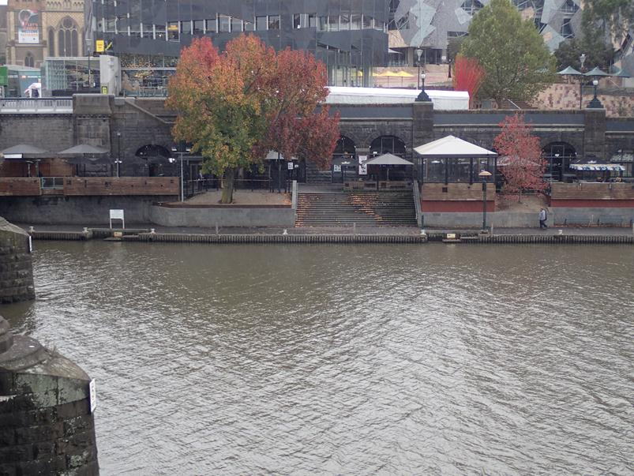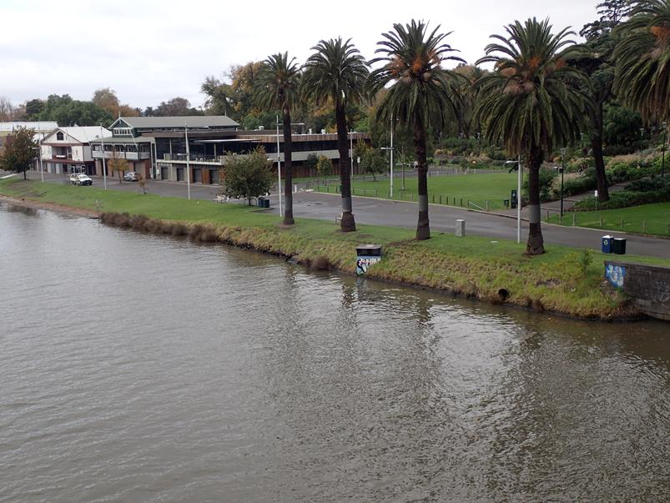

##### Aquatic Fauna

Resident estuarine fish species include Black Bream, Mulloway, Yellow-eye Mullet and occasionally Snapper. Parts of the estuary provide habitat for breeding, nursery areas for juveniles and foraging habitat for adults. For example, Black Bream spawn in the estuary at various locations depending on salinity, which in turn is driven by tidal influences and the volume of freshwater entering the estuary from the Yarra River upstream.

These species move up and down the estuary from Docklands through to the upper reaches (upstream of Hawthorn) depending on salinity, time of year and freshwater inflows. These species are likely to move through the proposed project boundary at various times of the year.

The upper estuary and freshwater reaches of the Yarra River are home to a number of species that migrate through the estuary for various life cycle requirements. Although movements of migratory species can occur in all months, the most critical times for movement tend to be from late winter to early summer. This period, which coincides with increased river flows and increasing water temperature, provides cues for triggering upstream movement of juveniles from marine environments through the estuary to the freshwater reaches of the Yarra River. Of these species, only the Australian Grayling and the Australian Mudfish (listed under the EPBC Act and the *Flora and Fauna Guarantee Act 1988*) are of conservation significance. Autumn is also an important time for Australian Grayling, when eggs/larvae drift downstream.

In addition, there are also occasional visitors from marine environments including the Australian fur seal and dolphins. These visitors would likely only remain in the Yarra River estuary for a few days at a time.

#### Maribyrnong River

##### Aquatic Flora

There is limited aquatic habitat in the vicinity of the proposed project boundary near the Maribyrnong River. Both the eastern and western banks have been stabilised with rocks (shown in the images below) and there are no emergent macrophytes in this area. The rock embankments appear to have been sprayed with herbicide to control weed growth (evidenced by the brown, dead grass along the top edge of the rocks).

Figure ‑ Maribyrnong River west of the proposed project boundary

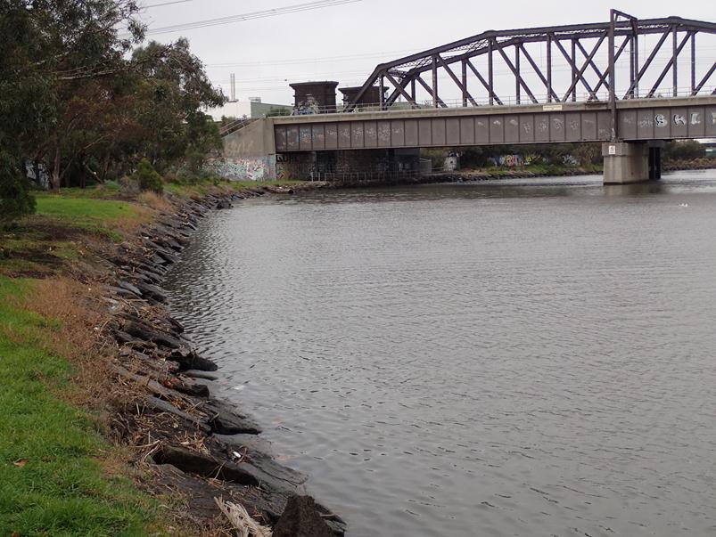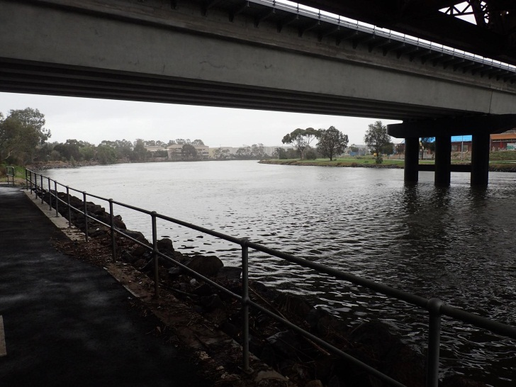

##### Aquatic Fauna

Resident estuarine species include Black Bream, Mulloway and Yellow-eye Mullet. Parts of the estuary may provide habitat for breeding, nursery areas for juveniles and foraging habitat for adults. For example, Black Bream may spawn in the estuary at various locations depending on salinity, which in turn is driven by tidal influences and the volume of freshwater entering the estuary from the Maribyrnong River upstream.

As with the Yarra River, the upper estuary and freshwater reaches of the Maribyrnong River are home to species that migrate through the estuary for various life cycle requirements, including the Australian Grayling. There are also occasional marine visitors to the river, such as dolphins.

#### Moonee Ponds Creek

##### Aquatic Flora

The riparian zone at Moonee Ponds Creek within the proposed project boundary is made up primarily of weedy shrubs with no obvious aquatic macrophytes. The majority of the channel is shaded in this area by CityLink with limited instream habitat (shown in the images below).

Upstream of the Melbourne Metro alignment, and away from the shading by CityLink, the channel is fringed by emergent macrophytes, mostly common reed (Phragmites australis). These relatively large reed beds may provide habitat for small bodied fish, aquatic macroinvertebrates, common amphibian species and small birds and represent an important habitat in the urban landscape.

##### Aquatic Fauna

A number of species listed in the Victorian Biodiversity Atlas have been identified as being present in Moonee Ponds Creek based on previous records. These species include Black Bream, Carp (Cyprinus carpio), which is an exotic pest species, and the Short-finned Eel (*Anguilla australis*), which is widespread and common in Victoria. For further information about species identified within the proposed project boundary, see Section 5 of Technical Appendix U Aquatic Ecology and River Health.

Figure ‑ Moonee Ponds Creek vegetation and bank condition at the alignment point (left) and upstream (right)

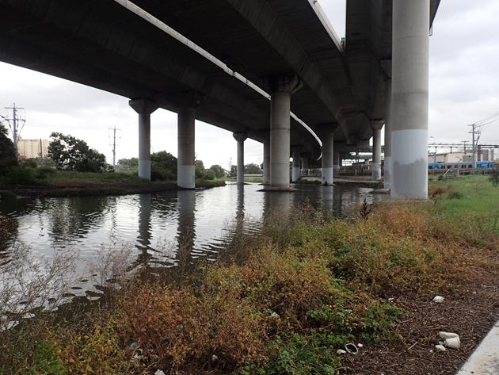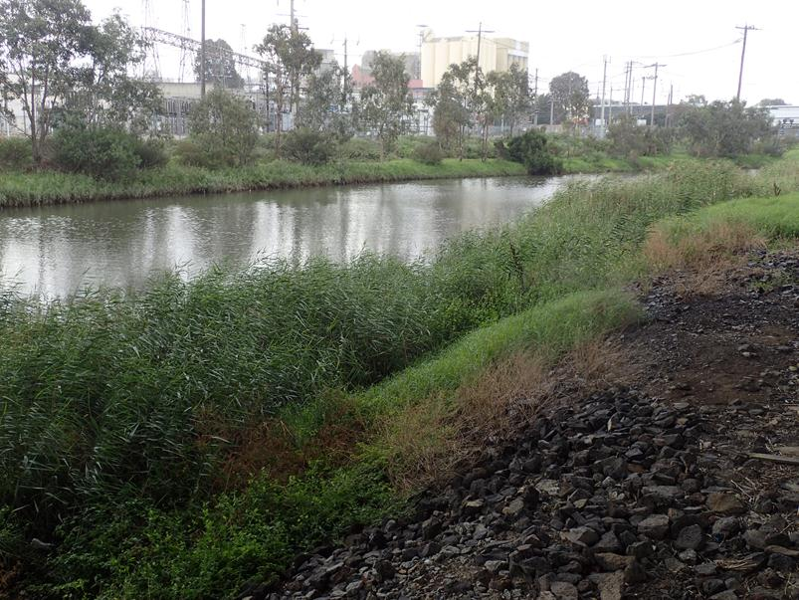

#### Albert Park Lake

##### Aquatic Flora

There is very limited aquatic habitat present in Albert Park Lake. The margins of the lake are nearly all concrete lined. Some aquatic habitat diversity would be provided by the fringing vegetation on the small islands to the eastern end of the lake.

##### Aquatic Fauna

A number of species listed in the Victorian Biodiversity Atlas have been identified as being present in Albert Park Lake based on previous records. However, these species are predominantly stocked, with the exception of Carp and the Short-finned Eel. For further information about species identified within the proposed project boundary, see Section 5 of Technical Appendix U Aquatic Ecology and River Health.

#### Stony Creek

##### Aquatic Flora

Stony Creek is a highly modified channel. South of Somerville Road, the creek runs through an earthen channel within a linear park. Instream habitat consists of shallow pools and constructed rock riffles. The riparian verge consists of scattered native and exotic trees and grass. Near Francis Street, the creek enters a concrete lined channel before a short estuary that joins the Yarra River just north of the West Gate Freeway. A large tidal lagoon, Stony Creek Backwash, is located at the confluence with the Yarra River.

Biodiversity values in Stony Creek are low and there is limited habitat suitable for native fish.

##### Aquatic Fauna

No estuarine fish or migratory species have been recorded in the Victorian Biodiversity Atlas from Stony Creek. The only aquatic species recorded is the common yabby (Cherax destructor). The concrete lined channel at the lower reaches of the freshwater section would act as a barrier to fish movement for most species, limiting the likelihood of migratory species.

## Risk Assessment

An Environmental Risk Assessment has been completed for the impacts of Melbourne Metro in relation to biodiversity. Further information about the risk assessment approach adopted for Melbourne Metro is included in Chapter 4 *EES Assessment Framework and Approach.*

Impact assessment must be informed by risk assessment so that the level of mitigation action relates to the likelihood of an adverse impact occurring.

Given the heavily urbanised area and modified waterways within the vicinity of the project, all biodiversity risks in relation to aquatic flora and fauna, river health and terrestrial flora and fauna were assigned initial risk ratings of medium or lower. The impact assessment focused on those risks that were assessed as having an initial risk level of medium.

Achieving the recommended Environmental Performance Requirements – and implementing the proposed mitigation measures – would reduce the residual risk ratings of these biodiversity risks to low or very low.

Some residual risk ratings remain high in relation to the landscape and visual amenity of removal of trees from the public realm in the Parkville station and Domain station precincts, the eastern portal precinct and the Tunnels precinct (in the Domain Parklands). These risks are discussed in greater detail in Chapter 16 *Landscape and Visual* and inTechnical Appendices R and S *Arboriculture.*

A full list of biodiversity risks, showing the initial and residual risk rating of each risk, is provided in Technical Appendix B *Environmental Risk Assessment Report,* Technical Appendix T *Terrestrial Ecology* and Technical Appendix U *Aquatic Ecology and River Health*.

The recommended Environmental Performance Requirements are listed in Section ‎21.18.

## Impact Assessment

The main biodiversity impacts expected from the construction of Melbourne Metro are:

* **Impacts on healthy mature trees (all precincts)** *–* Despite design efforts to avoid the removal of vegetation, the construction of the station boxes and eastern and western portals would require the removal of a number of planted mature trees (indigenous and exotic). Where practicable, trees would be replaced post-construction or ‘offset’ in accordance with the requirements of the *Permitted Clearing of Native Vegetation – Biodiversity Assessment Guidelines.* Trees would be protected, removed and reinstated in accordance with the relevant local government plans and strategies
* **Loss of plantings (landscaping) of indigenous and exotic species other than trees (Precincts 1, 2, 5, 6, 7 and 8)** *–* The extent and type of these plantings would be recorded to allow for replacement post-construction. Vegetation would be replaced post-construction or ‘offset’ in accordance with the requirements of the *Permitted Clearing of Native Vegetation – Biodiversity Assessment Guidelines.* Replacement programs and legacy plantings would be carried out in line with the relevant local government plans and strategies
* **Discharge of groundwater to river during construction and operation (all precincts)** *–* Groundwater would be discharged to sewer and there would be no groundwater discharged to the stormwater drainage system or directly to waterways that could degrade waterways and impact aquatic biodiversity in the receiving waterway
* **Runoff from construction work sites and truck routes entering stormwater system and waterways (all precincts)** *–* There would be an increase in exposed areas containing sediment and other contaminants, and the potential for deposition of sediment and other pollutants on road surfaces from truck movements required for construction. During high volume rainfall events, there would be the potential for flooding and runoff from these surfaces to enter the stormwater drainage system. This could result in a minor impact to water quality and aquatic biodiversity in receiving waterways, considering the contribution of pollutants from the entire catchment area.

Standard construction site management techniques (such as minimising the area of exposed ground, isolating site runoff from the existing drainage system, sediment containment, bunding and regular street sweeping) would be used to minimise the risk of contaminated runoff entering the stormwater drainage system. Construction activities would also be required to comply with the requirements of the *Environment Protection Act 1970* and SEPP (WoV).

Sections ‎21.8 to ‎21.16 describe these impacts in greater detail for each of the Melbourne Metro precincts.

Following the disturbance that would occur to facilitate Melbourne Metro’s construction, minimal impacts to biodiversity would be envisaged throughout Melbourne Metro’s operation. As such, many of the precincts would be subject to construction impacts only. Where operational impacts would occur (in the western portal, eastern portal and Arden station precincts), they are described under the relevant precinct sections.

Trees

Melbourne Metro would involve the removal of trees associated with the development all of the station boxes, as well as the eastern and western tunnel portals. Trees impacted by the project cover a range of species including native and exotic trees.

In the Arden station precinct, there are numerous native trees within the publicly owned land managed by VicTrack and currently used for light industrial purposes. Around 20 per cent of these trees have been assessed as reaching their Useful Life Expectancy (ULE) within 10 years.

In the eastern portal precinct, the trees that would likely be removed are largely introduced and include the Tree of Heaven (*Ailanthus altissima*), which is a declared noxious weed.

In the remaining precincts, the trees are largely introduced exotic plantings contained in boulevards such as Royal Parade and St Kilda Road, and in parklands such as the Domain Parklands and Fawkner Park.

The trees proposed to be removed include nine palm trees that could be suitable for relocation. Around half the trees likely to be removed within the public realm are either juvenile trees that do not contribute strongly to the biodiversity of the region, or trees that have been assessed as over-mature or in decline and already likely to be subject to removal within the same timeframe as the construction phase of the project. Recommended Environmental Performance Requirements have been developed to ensure:

* Quality soils are reinstated to sufficient volumes to support long-term viable growth of replacement trees and to achieve canopy size equal to or greater than typical mature examples of the species in Melbourne.
* Growing conditions are established or maintained to enable 90 per cent of replacement trees to establish and demonstrate good growth and vigour consistent with healthy examples of the replacement tree species within five years and to restore landscape values
* Trees are reinstated to align with local government urban forestry strategies regarding species selection to achieve enhanced diversification, use of quality tree stock from accredited suppliers and use of advanced or super-advanced trees at selected locations.

The recommended Environmental Performance Requirements also provide for measures to be taken during construction (such as maintaining good vehicle hygiene) to avoid the spread or introduction of weeds and pathogens.

### Key Benefits and Opportunities

Due to the relatively minor interactions that Melbourne Metro would have with biodiversity, few benefits and opportunities have been identified.

The key opportunity for biodiversity across Melbourne Metro is the re-establishment of plantings of suitable indigenous species in impacted areas. These plantings would be undertaken in consultation with the relevant local councils to ensure they are consistent with local strategies and policies, including strategies designed to increase urban forest diversity and canopy cover.

## Precinct 1: Tunnels

As the Melbourne Metro tunnels would be located underground, there would be minimal direct surface impacts to biodiversity resulting from the construction or operation of the rail tunnels. However, construction activities at ground level may interact with biodiversity in this precinct. The potential impacts of these works in relation to biodiversity have been assessed and are described below.

### Construction

#### Tunnel Construction

Groundwater inflow into the underground structures during construction of the tunnels may lower groundwater levels in the surrounding area (as described in Chapter 19 Groundwater). However, the groundwater analysis conducted for the EES has concluded that the small levels of predicted groundwater drawdown would not cause changes in groundwater/surface water interactions that could impact waterway biodiversity (see Technical Appendix O Groundwater). Furthermore, the Yarra River flow regime is dominated by tidal processes and is not sensitive to changes in groundwater/surface water interactions, so it is unlikely there would be significant impacts on flow regime through the estuary reach or any impact on aquatic biodiversity from this source.

The *Arboriculture* Impact Assessment (Technical Appendix R and S) concludes that base on a review of the existing conditions described in Technical Appendix O *Groundwater*, root growth of trees within all precincts is above, and therefore not reliant on, existing groundwater levels.

The TBM may generate noise and vibration that could impact on fish behaviour, including disruption to fish passage during critical migration periods. However, noise and vibration would not be expected to exceed background levels. Overall, the anticipated impact would be negligible.

#### Yarra River Crossing – TBM under the River

During construction of the tunnels, it could be necessary to stabilise sediments under the Yarra River. This would involve injecting grout into the sediments either from a barge located in the river or via injection from the TBM cutter head. If the former technique is used, the presence of a barge in the river may represent a behavioural barrier to fish passage and disturbance of the riverbed could release contaminated sediments to the water column.

The adoption of standard environmental management practices (mitigation measures that would reflect the relevant policy and legislative framework) would ensure that disturbance of riverbed sediments is minimised and no grout material released to the river. The timing of stabilisation activities should avoid the critical fish migration period of September to November and, ideally, the period when Australian Grayling eggs/larvae drift downstream. The presence of a barge in the river during the migratory period would be unlikely to represent a significant barrier to fish passage in the context of other craft that use the river on a daily basis. If the TBM cutter head injection technique is used, there would be no impact on the waterway or aquatic fauna. Both techniques would result in minimal or no impact on waterway values.

#### CityLink Tunnels Crossing – Above CityLink Tunnels

The location and form of the tunnels at shallow depths below the Domain Parklands would be unlikely to impact on trees, as the shallowest point below existing ground level would be beneath the zone of anticipated root growth. However, if ground stabilisation works are required to limit surface settlement and the potential for ground movement during tunnel boring, there is the potential for damage to or loss of trees within a band above the alignment of the shallow tunnel section. However, the trees present within the Domain Parklands above this section of tunnels are not native and do not provide significant habitat for native fauna. The trees provide landscape and visual amenity, which is discussed in Chapter 16 Landscape and Visual.

#### TBM Southern Launch Sites

In terms of aquatic flora and fauna, the surface water impact assessment (see Technical Appendix N Surface Water) has concluded that the two potential TBM southern launch sites (the TBM southern launch site would be located at either Domain or at both Domain and Fawkner Park) are located in areas that are not subject to significant overland flow or flooding. Consequently, direct rainfall would be the most likely source of runoff from construction areas. Standard construction site management techniques, including minimising the area of exposed ground, sediment containment and bunding would minimise the chance of contaminated runoff entering the stormwater drainage system and ultimately impacting on waterways.

Terrestrial biodiversity impacts for each of the potential TBM launch sites would be site-specific and are discussed below within the context of each site.

##### Fawkner Park Open Space and Tennis Courts

Construction activities in Fawkner Park would potentially require the removal of approximately 60 trees near the Toorak Road West boundary of the park to facilitate excavation of the TBM southern launch site and construction work site. These trees are predominately not native and are mostly juvenile specimens that could be easily replaced after construction. The park also includes many mature planted trees as well as a number of newly planted species as part of the City of Melbourne’s tree renewal program for the park.

Large mature tree specimens in the vicinity of the proposed works area at Fawkner Park include Moreton Bay figs (Ficus macrophylla), a sugar gum (Eucalyptus cladocalyx), English elms, English oaks and Canary Island date palms. The Moreton Bay figs provide foraging habitat for the Grey-headed flying-fox as well as a number of common birds and possums. A number of roosting records of the Grey-headed flying-fox are also present within the Victorian Biodiversity Atlas for Fawkner Park.

Impacts to the Grey-headed flying-fox would be low as none of the Moreton Bay figs would be removed. Large numbers of alternative food trees, other than those in Fawkner Park, are available within foraging distance of the flying foxes’ permanent roosting ‘camp’ at Yarra Bend Park, which is more than 5 km away. There are no longer any roosting areas for the species within Fawkner Park.

Proposed mitigation measures implemented during construction (such as the preparation of a Tree Protection Plan and the replacement of trees in accordance with local government laws, strategies and policies) would minimise any impacts.

Figure ‑ Moreton Bay Figs within Fawkner Park

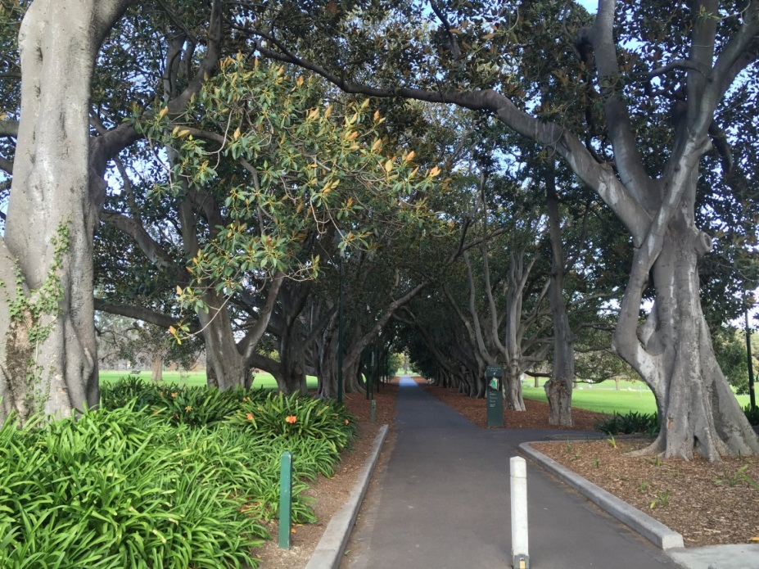

##### Domain Launch Site

The Domain launch site is discussed within Precinct 7 – Domain station in Section ‎21.14.

#### Emergency Access Shafts

##### Fawkner Park north-east location and Queen Victoria Gardens, adjacent to Linlithgow Avenue

Similarly to the TBM launch sites, the emergency access shaft sites would be located in areas that are not subject to significant overland flow or flooding. Direct rainfall would be the most likely source of runoff from construction areas. Standard construction site management techniques, including minimising the area of exposed ground, sediment containment and bunding, would minimise the chance of contaminated runoff entering the stormwater drainage system and impacting on waterways.

Seven exotic trees would need to be removed to facilitate work in the north-east of Fawkner Park for the emergency access shaft.

Six mature trees and one juvenile tree would need to be removed to facilitate construction of the emergency access shaft in Queen Victoria Gardens. None of these trees are native and they do not provide significant habitat for native fauna. Two of these trees (mature palms) could be relocated and reinstated post-construction.

### Alternative Design Options

#### CityLink Tunnels Crossing – Below CityLink Tunnels

If the tunnels pass beneath CityLink, the potential for loss or damage to trees within Domain Parklands associated with CityLink tunnels crossing is removed, as grouting would not be required with the deeper tunnel option.

#### Emergency Access Shafts

Alternative design options involve locating the emergency access shafts at the potential Fawkner Park TBM launch site and within Tom’s Block.

If either alternative design option is selected, construction would occur in open parkland, which is predominantly lawn surrounded by English elms. There is no native vegetation or suitable habitat for threatened species present and therefore impacts on native terrestrial flora and fauna would be negligible.

## Precinct 2: Western Portal (Kensington)

### Construction

A major construction work site would be located at 1-39 Hobsons Road in Kensington, to support activities at the western portal. This site would be used for site offices and facilities, laydown areas and materials and equipment storage.

The western portal precinct has historically been cleared of indigenous vegetation. There is no habitat for, or presence of, any EPBC Act or *Flora and Fauna Guarantee Act 1988* listed flora or fauna species in this location.

Planted vegetation includes a row of river sheoak (Casuarina cunninghamiana) along the southern perimeter of JJ Holland Park. To the south of Childers Street is a planted hedge of bottlebrush (Callistemon spp.). The garden beds between parking bays have been planted with juvenile water gums (Tristaniopsis laurina) and black-anther flax-lily (Dianella revoluta).

The area is likely to attract common urban birds including the introduced common mynas (Acridotheres tristis), native red wattlebirds (Anthochaera carunculata) and native Australian magpies (Craticus tibicen), but is unlikely to support significant habitat for threatened native fauna species due to its disturbed and modified nature.

Figure ‑ Hedge of callistemon to the south and river sheoak to the north of Childers Street

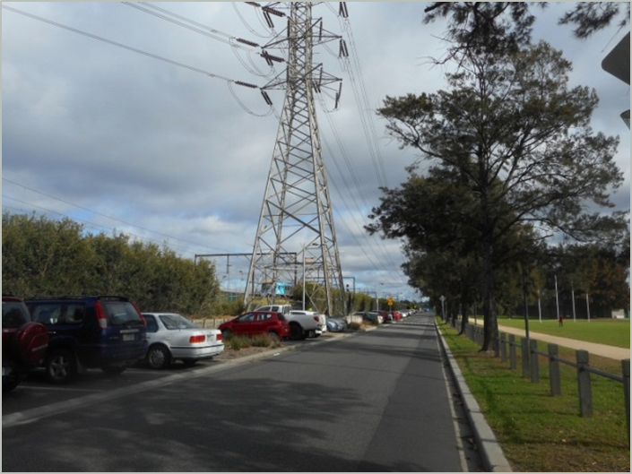

Some of the proposed construction work sites required to construct the western portal would be located in the floodplains of the Maribyrnong River and Moonee Ponds Creek. These areas may be exposed to overland flow and flooding and also to direct rainfall. During intense rainfall events and/or flooding of the Maribyrnong River or Moonee Ponds Creek, there would be potential for runoff from exposed areas containing sediment and other contaminants to enter the stormwater drainage system. This may impact on water quality and aquatic flora and fauna in receiving waterways. Standard construction site management techniques, including minimising the area of exposed ground, sediment containment and bunding, would minimise the potential impacts. These measures are discussed further in Chapter 17 Surface Water.

### Operation

During the operation of Melbourne Metro, runoff from the portal rail bed would collect at the base of the portal decline. This runoff could contain sediments and other contaminants typical of existing road and rail runoff. This water would be directed to a standard best practice stormwater treatment system sized appropriately for runoff volume and treated prior to discharge to the Maribyrnong River.

The quality of untreated runoff would be no worse than runoff from existing road and rail surfaces and once treated, water quality would be better than the majority of existing stormwater inflows to the Maribyrnong River (see Chapter 17 *Surface Water)*. On this basis, there would be a low likelihood of impacts on receiving waterways during operation at the western portal.

### Alternative Design Option

The alternative design option for the location of the Melbourne Metro substation in the western portal precinct is within the 50 Lloyd Street Business Estate. The potential impacts associated with this option are considered to be represented by the broader findings for the precinct, as summarised in the preceding sections.

An alternative design option for the decline structure, with the TBM retrieval box opposite the pavilion on Childers Street, is also under consideration. The potential impacts associated with this option are also considered to be represented by the broader findings for the precinct, as summarised in the preceding sections.

## Precinct 3: Arden Station

### Construction

Construction of the station at Arden and associated entrances would require the removal of trees from publicly owned (VicTrack) land and the Laurens Street road reserve. The balance of the publicly owned land would form a construction work site for the duration of the project and these works would be expected to require the removal of all trees from the land.

The Arden station precinct has been predominantly cleared of vegetation, with the site likely to have originally been an estuarine swamp, infilled as part of historical development. It does not support significant habitat for any threatened fauna species. The majority of trees are pepper corn trees and various gums that are exotic species and of limited habitat value.

Fifty two native trees are proposed to be removed from the Arden station precinct. Ten of these trees have been assessed as having a Useful Life Expectancy (ULE) of less than ten years. An additional native tree would potentially be removed in Langford Street, which has a ULE of less than ten years. Planning approval, with associated offsets, would be required for the removal of these trees. The loss of these trees is considered a ‘minor’ consequence in relation to native biodiversity.

Some of the construction work sites required for Arden station would be located in the floodplain of Moonee Ponds Creek. This area may be exposed to overland flows and flooding and also to direct rainfall. During high volume rainfall events and/or flooding of Moonee Ponds Creek, there would be potential for runoff from exposed areas containing sediment and other contaminants to enter the stormwater drainage system. This may impact on water quality and aquatic flora and fauna in receiving waterways. Standard construction site work management techniques, including minimising the area of exposed ground, sediment containment and bunding, would minimise the chance of impact.

Figure ‑ Arden station site: large river red gum in the background, pepper tree in the foreground

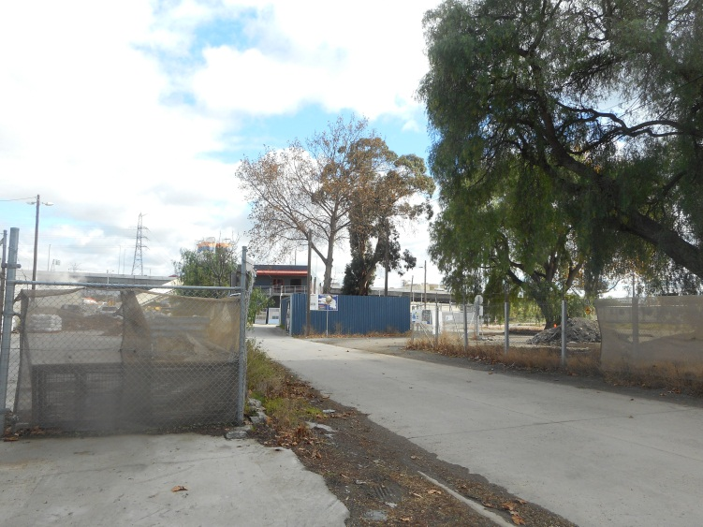

#### Arden Intake Substation

The electrical substation would be located on a vacant lot on the corner of Langford Street and Arden Street. The site has previously been developed and is highly disturbed and modified with the only ecology present being weeds, such as the exotic grass kikuyu, and a mix of exotic trees around the perimeter, including peppercorn trees and desert ash trees.

### Operation

The substation would be within the Moonee Ponds Creek floodplain and wholly within an area affected by a Land Subject to Inundation Overlay. During Melbourne Metro’s operation, there would be potential for flooding of the substation and release of toxic compounds from the transformers to Moonee Ponds Creek, which could result in a significant degradation in water quality and aquatic flora and fauna. A specific Environmental Performance Requirement and proposed mitigation measures have recommended that the design of the substation provide appropriate protection against floodwaters during operation to prevent the release of contaminants to Moonee Ponds Creek (see Chapter 17 Surface Water).

### Alternative Design Option

Two alternative options for the location of the substation would be within this precinct:

* Co-location at Metro Trains Melbourne’s traction substation
* Southern section of the precinct, between rail reserve to the west and Laurens Street to the east.

Both sites are highly disturbed and modified, with no indigenous vegetation remaining. Therefore, no impact on native flora and fauna is expected.

Both sites are located in the area covered by a Land Subject to Inundation Overlay and the same potential operational impacts as the Concept Design substation described in Section 21.10.2 would exist.

## Precinct 4: Parkville Station

### Construction

The Parkville station site supports avenues of exotic English elms (Ulmus procera). A garden of mature planted trees is present at the eastern end of the Parkville station area. Species include sheoaks and southern mahogany (Eucalyptus botryoides), which are native but not indigenous to the area.

As a top-down cut and cover construction method would be used to construct the station, removal of trees would be required. There is no habitat for, or presence of, EPBC Act or *Flora and Fauna Guarantee Act 1988* listed flora and fauna species in this location and much of the flora in the area consists of planted exotic species.

Due to the built up nature of this area, heavy vehicular traffic load and lack of native vegetation, it is considered that the Parkville station precinct does not support any threatened flora and fauna species.

The proposed construction zone would not be exposed to the risk of flooding and direct rainfall would be the most likely source of runoff generation. During rainfall events, there would be the potential for runoff from exposed areas containing sediment and other contaminants to enter the stormwater drainage system and hence impact on water quality and aquatic biodiversity in Moonee Ponds Creek. Standard construction site management techniques, including minimising the area of exposed ground, sediment containment and bunding, would minimise the potential of impact.

Figure ‎21‑7 Planted garden of mature trees at the eastern end of Parkville station precinct

Figure ‎21‑8 Avenues of English elms on Royal Parade

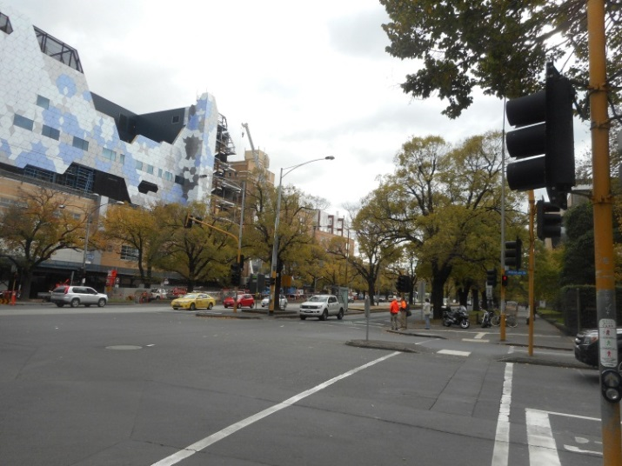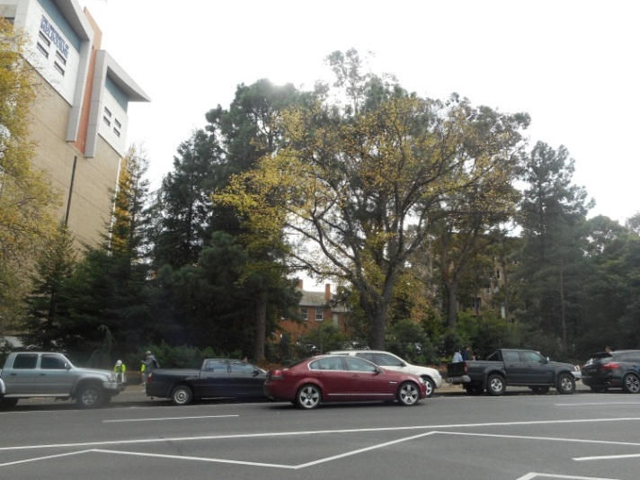

## Precinct 5: CBD North Station

### Construction

The CBD North station location supports planted trees. Species present include spotted gum (Corymbia maculata), plane trees and kurrajongs (Brachychiton populneus). Trees planted in front of the State Library of Victoria include nettle trees (Celtis australis). A number of firewheel trees (Stenocarpus sinuatus) have been planted in front of the RMIT buildings to the west of Swanston Street (as shown in Figure ‎21‑9).

CBD North station platforms would be located under Swanston Street, between Franklin and La Trobe Streets and would use a mined rather than top-down construction methodology. Construction of the station would require removal of spotted gums and kurrajong trees within the Franklin Street road reserve between Swanston and Bowen Streets and plane trees around the corner of Swanston and La Trobe Streets.

Due to the built up nature of the locality, heavy vehicular traffic load and lack of vegetation, this locality does not support any threatened flora and fauna species. There is no habitat for, or presence of, EPBC Act or *Flora and Fauna Guarantee Act 1988* listed flora and fauna species in this location. Although native, the tree species in the precinct are not indigenous to the area. The landscape and visual amenity of these trees are discussed in Chapter 16 Landscape and Visual.

The proposed construction zone would not be exposed to risk of flooding. Direct rainfall would be the most likely source of runoff generation. During intense rainfall events, there would be the potential for runoff from exposed areas containing sediment and other contaminants to enter the stormwater drainage system and impact on water quality and aquatic biodiversity in the Yarra River. Standard construction site management techniques, including minimising the area of exposed ground, sediment containment and bunding would minimise the potential for impacts.

Figure ‑ Planted firewheel trees located in front of the RMIT buildings to the west of Swanston Street

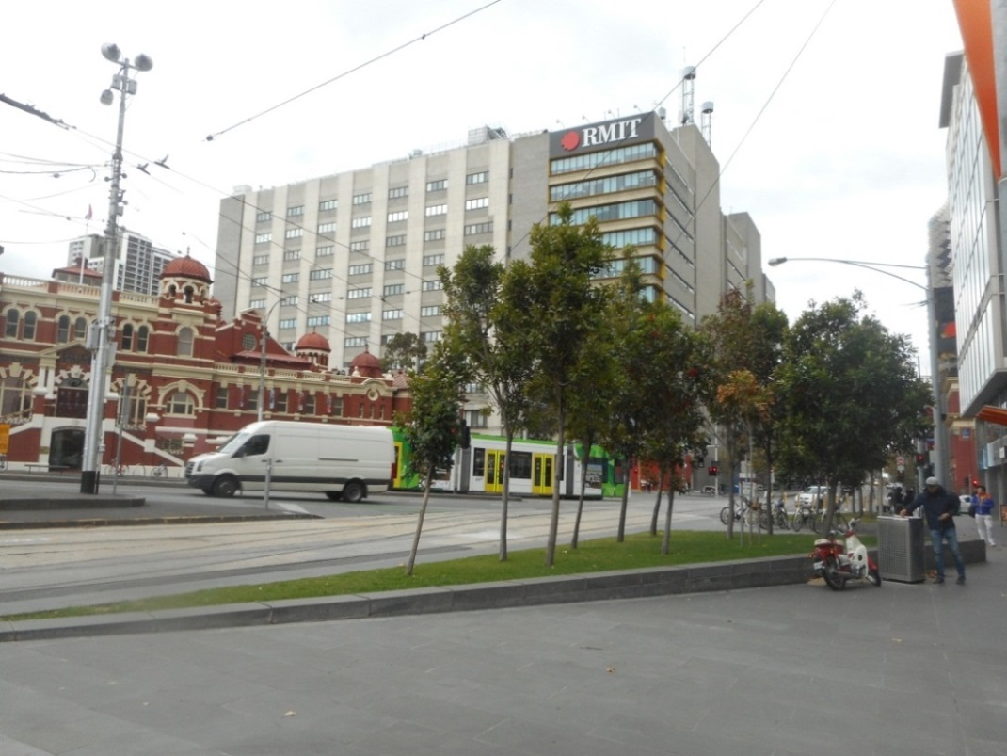

## Precinct 6: CBD South Station

### Construction

The CBD South station would be located under Swanston Street between Collins and Flinders Streets. The locality supports a mature avenue of London plane trees. Trees planted in the City Square include spotted gums (Corymbia maculata) and one English elm. Two lilly pilly trees (Syzygium spp) are planted in front of St Paul’s Cathedral.

As the station would be mined, construction of the station cavern would not require the removal of trees. The proposed station entrances and underground connections to Federation Square and Flinders Street Station would also not directly require the removal of trees. The Collins Street entrance at City Square and a construction work site within the City Square would require the removal of trees within the square.

Due to the built up nature of the locality, heavy vehicular traffic load and lack of vegetation, this precinct does not support any threatened flora and fauna species. There is no habitat for, or presence of EPBC Act or *Flora and Fauna Guarantee Act 1988* listed flora and fauna species in this locality.

The proposed construction zone is not exposed to risk of flooding and direct rainfall would be the most likely source of runoff generation. During intense rainfall events, there would be the potential for runoff from exposed areas containing sediment and other contaminants to enter the stormwater drainage system and impact on water quality and aquatic biodiversity in the Yarra River. Standard construction site management techniques, including minimising the area of exposed ground, sediment containment and bunding, would minimise the chance of impact.

## Precinct 7: Domain Station

### Construction

Construction of Domain station and associated entrances would require the removal of trees from the St Kilda Road reserve, all trees from the Albert Road Reserve for an entry plaza and a few trees in the south-west corner of the Shrine of Remembrance Reserve for the station entry on the east side of St Kilda Road. Trees would also need to be removed around the periphery of Edmund Herring Oval and part of the Toorak Road reserve.

The Domain station precinct is considered to potentially contain three threatened fauna species: the Grey Goshawk and Powerful Owl (both listed under the *Flora and Fauna Guarantee Act 1988* and the DELWP Victorian Advisory Lists) and the Grey-headed flying-fox (listed under the EPBC Act, *Flora and Fauna Guarantee Act 1988* and the Victorian Advisory Lists). These species may forage in some of the larger mature trees in the area. The species are all highly mobile and similar habitat is present throughout the Royal Botanic Gardens. Therefore, the project would have a minor impact on these species.

With regard to flora, no remnant vegetation or significant habitat for threatened species remains within the precinct. Trees planted on the embankment leading up to the Shrine of Remembrance include a wide variety of native and non-native species that have been planted as memorials to various military units and individuals. Species within the area include prickly paperbark (Melaleuca stypheloides), river red rum (Eucalyptus camaldulensis), English elm, English oak and Monterey cypress (Cupressus macrocarpa).

Trees present along St Kilda Road and Toorak Road West include English elms and plane trees. To the west of St Kilda Road, the Albert Road Reserve is planted with English elms and English oaks, with a ground cover of cultivated lawn. Exotic English elms and plane trees provide limited habitat for threatened fauna species.

Some of the construction areas required for the Domain station are in areas where overland flooding could occur. As such, these areas may be exposed to overland flow and also to direct rainfall. During intense rainfall events and/or overland flow, there would be the potential for runoff from exposed areas containing sediment and other contaminants to enter the stormwater drainage system and impact on water quality and aquatic biodiversity in Albert Park Lake. Standard construction site management techniques, including minimising the area of exposed ground, sediment containment and bunding, would minimise the potential impacts.

Figure ‎21‑10 Albert Road Reserve planted with English elms and English oaks eastern end of Parkville station precinct

Figure ‎21‑11 River red gums planted on the embankment lawn of the Shrine of Remembrance English elms on Royal Parade

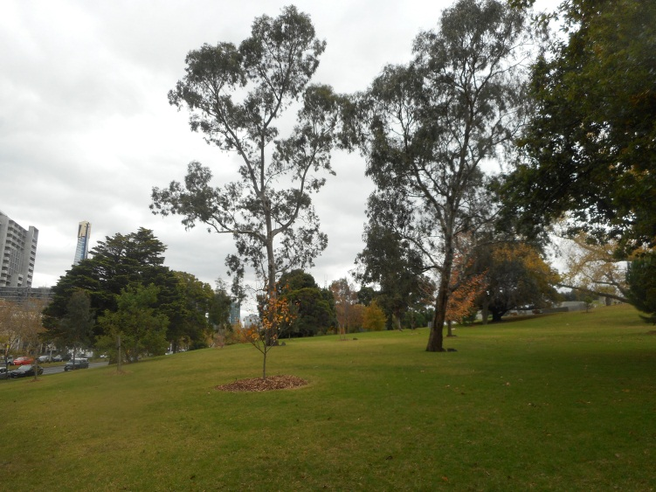 This illustration shows Albert Road Reserve planted with English elms and English oaks

## Precinct 8: Eastern Portal (South Yarra)

### Construction

The construction of the eastern portal would involve major construction activities in South Yarra Siding Reserve and Osborne Street Reserve for TBM retrieval. The area would be subject to advanced ground treatment to stabilise soils for the decline structure and construction work site. Removal of approximately 218 trees (largely exotic or non-indigenous) and surrounding vegetation would be required. Of these, 29 are planted ‘indigenous’ trees that would require a permit for removal and relevant offset. These ‘indigenous’ trees tend to be smaller and are likely to have been established more recently.

This precinct is considered to potentially provide seasonal foraging habitat for two threatened fauna species: the Grey Goshawk (listed under the *Flora and Fauna Guarantee Act 1988* and the DELWP Victorian Advisory Lists) and the Grey-headed flying-fox (listed under the EPBC Act*, Flora and Fauna Guarantee Act 1988* and the Victorian Advisory Lists). Flying foxes are highly mobile and similar habitat is present throughout suburban Melbourne, including the Royal Botanic Gardens, parks and backyards. The project is considered to have a minor impact on the species due to limited tree removal in the context of the wider habitat available throughout Melbourne.

The eastern portal site contains planted vegetation along Osborne Street including silky oak (Grevillea robusta), river red gums, cootamundra wattle (Acacia baileyana), southern blue gum (Eucalyptus globulus) and narrow-leaf peppermint (Eucalyptus radiata). The South Yarra Siding Reserve also contains a mix of planted species, such as a very large sugar gum as well as lemon-scented gums (Corymbia citriodora), spotted gums (Corymbia maculata), river red gums, sweet pittosporum, peppertrees and kurrajongs. Vegetation present along Lovers Walk includes peppertrees, cherry plums (Prunus cerasifera), large leaf privet (Ligustrum lucidum) and English elms. Many of the trees within this precinct are exotic species and there are also many mature native trees.

It is not considered that any of the vegetation present provides significant habitat for threatened fauna species, but some may be used for seasonal foraging by native and exotic species. The condition of the impacted trees varies (as discussed in Technical Appendix S Arboriculture). The design process for Melbourne Metro has carefully considered the amenity value of vegetation in the area and has minimised vegetation removal where possible. The large sugar gum has been flagged for retention given its dominating presence in the area. The landscape and visual amenity provided by the trees are discussed in Chapter 16 Landscape and Visual.

The proposed construction zone would not be exposed to flooding risk and direct rainfall would be the most likely source of runoff generation. During intense rainfall events, there would the potential for runoff from exposed areas containing sediment and other contaminants to enter the stormwater drainage system, potentially impacting on water quality and aquatic biodiversity in the Yarra River. Standard construction site management techniques, including minimising the area of exposed ground, sediment containment and bunding, would minimise the chance of impact.

|  |  |
| --- | --- |
| Figure ‑ Large sugar gum present within South Yarra Siding Reserve | Figure ‑ Vegetation present along Lovers Walk |

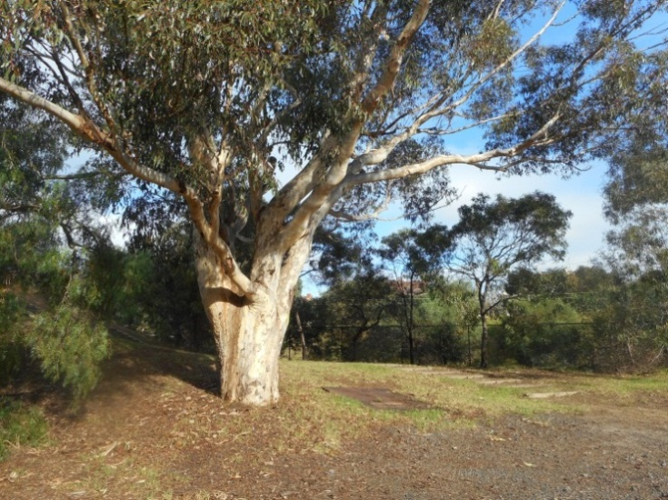 This illustrations shows Vegetation present along Lovers Walk

## Precinct 9: Western Turnback (West Footscray)

### Construction

The western turnback at West Footscray would be located in a highly disturbed and modified landscape recently ‘revitalised’ as part of the new West Footscray Station upgrade. The area is generally characterised by the pedestrian rail interchange and associated landscaping. While some native-themed planting would be removed, the plantings are generally too young to provide any useful habitat.

The proposed construction zone would not be exposed to flooding risk and direct rainfall would be the most likely source of runoff generation. During intense rainfall events, there would be the potential for runoff from exposed areas containing sediment and other contaminants to enter the stormwater drainage system and impact on water quality and aquatic ecology in Stony Creek. Standard construction site management techniques, including minimising the area of exposed ground, sediment containment and bunding, would minimise the chance of impact.

Figure ‑ General environment of the western turnback

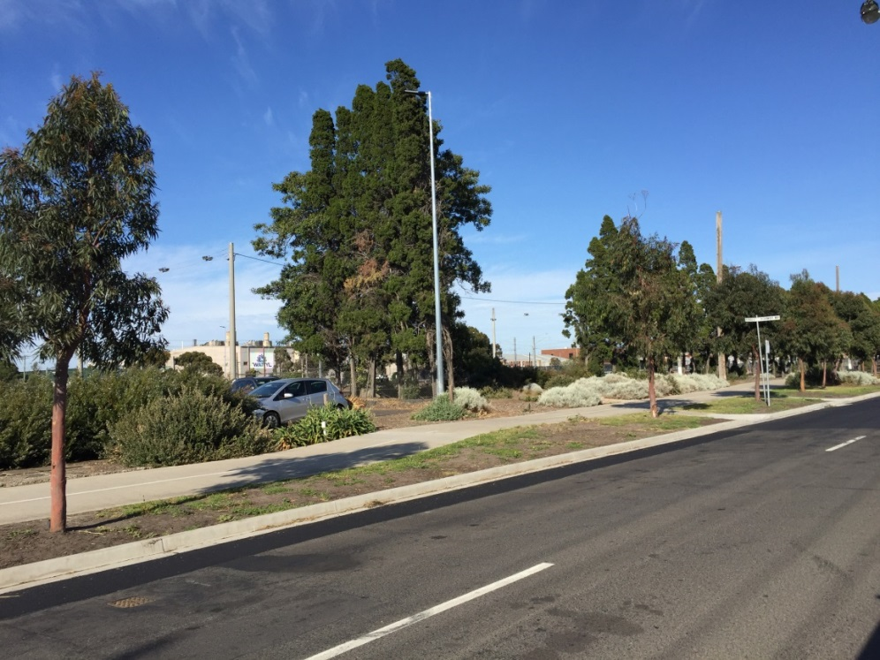

## Early Works

Early works would seek to modify existing services as they relate to water, sewerage, drainage, power, telecommunications and tramways. Most of the activities associated with the early works component of Melbourne Metro would be small scale and located in previously developed areas, thereby limiting potential impact to biodiversity. Some requirements may impact the root zone of existing street trees. However, it is considered unlikely that many indigenous street or amenity trees would be impacted.

With regards to aquatic flora and fauna, many of the early works activities would occur in the Moonee Ponds Creek and Maribyrnong River floodplains, with parts of the works in areas covered by a Land Subject to Inundation Overlay in the Melbourne Planning Scheme. Potential impacts are the same as those described in Section ‎21.9.

## Environmental Performance Requirements

As noted in Section ‎21.7, existing and regularly used measures are available to avoid or minimise impacts to biodiversity from the project. The following table shows the recommended Environmental Performance Requirements for Melbourne Metro and proposed mitigation measures in relation to biodiversity.

The risk numbers listed in the final column align with the list of biodiversity risks provided in Technical Appendix B *Environmental Risk Assessment Report.*

Table – Environmental Performance Requirements for Biodiversity

|  |  |  |  |  |  |
| --- | --- | --- | --- | --- | --- |
| 1. Draft EES evaluation objective | 1. Environmental Performance Requirements | 1. Proposed mitigation measures | 1. Precinct | 1. Timing | 1. Risk No. |
| 1. **Biodiversity** 2. – To avoid or minimise adverse effects on native terrestrial and aquatic flora and fauna, in the context of the project’s components and urban setting | 1. Where ‘unavoidable’ native vegetation (as defined under relevant policy) needs to be removed, meet the requirements of the *Permitted Clearing of Native Vegetation – Biodiversity Assessment Guidelines.* | 1. Develop and implement measures to minimise impacts on all native vegetation and fauna habitat through detailed design and construction as per the other Environmental Performance Requirements listed in this table. 2. Minimise removal of existing vegetation. 3. Offset loss of existing vegetation with replacement planting at a ratio >1:1. 4. Offset loss with a more ecologically relevant planting mix that achieves the amenity purpose. | 1. All | 1. Construction | TE005 TE006 |
| 1. Develop and implement measures to avoid the spread or introduction of weeds and pathogens during construction, including vehicle hygiene. | 1. Prepare a detailed re-instatement and revegetation plan to the satisfaction of MMRA. | 1. All | 1. Construction | TE001 TE002 TE005 TE006 |
| 1. Prior to site clearance for construction, all vegetation being removed is to be inspected by a suitably experienced and qualified environmental officer for habitat features and fauna occupancy. Where non-listed species (native and exotic) are encountered, any individuals will be encouraged to leave the tree or vegetation. Where nests/young are encountered, they will be relocated to a similar tree (or habitat) in close proximity. 2. Prior to site clearance for construction, develop a translocation plan for the management of listed fauna species if encountered. |  | 1. All | 1. Construction | TE001 to TE006 |
|  | 1. During detailed design, review potential tree impacts and provide for maximum tree retention where possible. 2. Prior to construction of main works or shafts, develop and implement a plan in consultation with the relevant local council that identifies all trees in the project area which covers:  * Trees to be removed or retained * Condition of the trees to be removed * Options for temporary re-location of palms and reinstatement at their former location or another suitable location. | 1. Palms should be moved with large root balls by an experienced transplanting contractor to peripheral zone of construction and managed during works to remain in viable condition. 2. *Precinct 1 – Tunnels* Investigate retention of Bunya-bunya Pine on the western side of the Fawkner Park East emergency access shaft sub-precinct, and removal of lemon scented gum on the east side of the proposed Fawkner Park construction work site. 3. *Precinct 6 – CBD South station* Investigate retention of the row of plane trees closest to the west side of City Square to further limit tree removals from the precinct. 4. *Precinct 7 – Domain station* Investigate relocation of vehicle access to east side of Oval to limit tree removals to juvenile Queensland kauri and retain and protect mature elms within the Shrine Reserve. | 1. All | 1. Design/ Pre-construction | AR001 to AR013 |
| 1. Reinstate quality soils to sufficient volumes to support long-term viable growth of replacement trees. | 1. *Precinct 1 – Tunnels* Utilise strict monitoring of volume loss, TBM operations and ground monitoring during tunnelling eliminating or, as far as possible, reducing the extent of soil stabilisation works. 2. *Precinct 4 – Parkville station and Precinct 7 – Domain station* For construction of Parkville and Domain stations, ensure sufficient soil volume is provided at minimum depth of 1 m above the station box. 3. For construction at Tom’s Block, remove stabilised soil profile and reinstate topsoil to a depth of 2 m. | 1. All | 1. Construction | AR001 AR002 AR007 AR008 |
|  | 1. Prior to construction commencing of main works or shafts in affected areas, prepare and implement Tree Protection Plans for each Precinct in accordance with AS4970-2009 *Protection of Trees on Development Sites*, addressing the detailed design and construction methodology of the project. 2. Within precincts 1, 4 and 7, a Tree Protection Plan must be developed for each heritage place as relevant to the satisfaction of Heritage Victoria or the responsible authority. | 1. Develop and implement measures to minimise impacts on all native and non-native vegetation and fauna habitat through detailed design and construction methodology, including:  * Minimising the removal of mature trees * Protecting trees (native and exotic) where they occur in close proximity to work areas * Minimising footprint and surface disturbance/compaction of temporary and permanent works * Fencing defined protected areas and no go zones for protected native vegetation * Managing the spread and introduction of weeds and pathogens during construction * Appointing a site ecologist and qualified wildlife handler (if separate to site ecologist) * Wildlife handler to hold appropriate permits for works that may impact on habitat for protected fauna.  1. Areas for site offices, car parking, machinery access and stockpiling are to be contained within designated areas that are clearly demarcated. | 1. All (except western turnback | 1. Construction | AR001 to AR013  TE001 TE003 |
|  | 1. Re-establish trees to replace loss of canopy cover and achieve canopy size equal to (or greater than) healthy, mature examples of the species in Melbourne. Consult with the City of Melbourne, the City of Port Phillip, the City of Stonnington, the Shrine of Remembrance and Shrine Trustees and Heritage Victoria as applicable. 2. Policy documents that must be followed to re-establish trees and valued landscape character include:  * The City of Melbourne’s Tree Retention and Removal Policy and Urban Forest Strategy * The City of Port Phillip’s Community Amenity Local Law No. 1 and Greening Port Phillip – An Urban Forest Approach * The City of Stonnington’s General Local Law 2008 (No 1) and City of Stonnington Street Tree Strategy * Any associated precinct plans * Specific policies of the Domain Parklands Conservation Management Plan (CMP), for trees within Domain Parklands * Shrine of Remembrance: Shrine of Remembrance CMP (Lovell Chen, 2010) or any future review and the Shrine of Remembrance Landscape Improvement Plan (rush Wright Associates, 2010) | 1. As above, for Tree Protection Plan. 2. Installation of effective watering systems to support healthy growth and vigour in replacement trees. 3. Reinstatement of trees to align with Council urban forestry strategies regarding species selection to achieve enhanced diversification; use of quality tree stock from accredited suppliers; and use of advanced or super-advanced trees at selected locations. 4. Prepare a detailed reinstatement and revegetation plan to the satisfaction of MMRA. 5. *Precinct 3 – Arden station* Investigate opportunities for additional street tree plantings to Laurens Street. 6. *Precinct 4 – Parkville station* Plant new trees to replace previously removed elms in central portion of Elizabeth Street north, within widened central median. 7. Investigate the opportunity to undertake a block replacement program for all trees in the southern section of Royal Parade which would secure the long-term viability of an important urban tree plantation. 8. *Precinct 7 – Domain station* Develop an integrated replanting response to both municipal areas of St Kilda Road as part of a long-term replacement strategy for the boulevard. | 1. All | 1. Pre-construction | AR001  TE002 TE004  TE005 TE006 |
|  | * South African Soldiers Memorial: Any relevant CMP for the South African Soldiers Memorial * Fawkner Park Conservation Analysis (Hassell, 2002) and the Fawkner Park Masterplan (City of Melbourne, 2005) * The preferred future character of the University of Melbourne, for trees in the grounds of the University of Melbourne. |  |  |  |  |
| 1. For City of Melbourne trees that are to be retained and protected, a bank guarantee or bond of the trees value will be held against the approved Tree Protection Plan for the duration of the works in accordance with the city of Melbourne Tree Retention and Removal Policy. |  | 1. All (except western turnback) | 1. Construction | AR001 to AR013   1. TE001 TE003 |
| 1. Refer also to the recommended Environmental Performance Requirements in relation to surface water impacts. These requirements and proposed mitigation measures are provided in Chapter 17. | | | | | |

## Conclusion

The assessments of the potential adverse impacts of Melbourne Metro on native terrestrial and aquatic flora and fauna (including arboriculture) have established that there would be minimal impact to biodiversity. All biodiversity impacts were deemed negligible, with the exception of the removal of a single mature indigenous red gum tree in the Arden station precinct, which was deemed minor.

While Melbourne Metro would require the removal of some native vegetation, achieving the recommended Environmental Performance Requirements – and implementing the proposed mitigation measures – would ensure that adverse effects on native terrestrial and aquatic flora and fauna would be avoided, and that the project would meet the draft evaluation objective for biodiversity set by the EES Scoping Requirements.